A Research report on Data

Centre design for University of Manchester

Programme: BSc (Hons) Cloud Computing
Module: Data Centre Technologies
Module code: ACUA6000
Lecturer: Koushik Modak
Student: Marin Zaharidov, 1814694
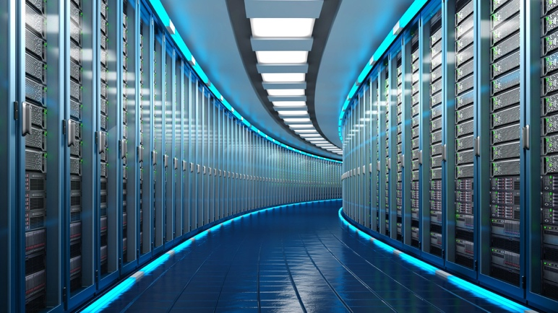

Abstract— The present server farms have gotten exceptionally unpredictable and have totally incorporated themselves into each aspect of their addressed association. Associations require Internet confronting administrations and applications to be accessible at any piece of the day or night. These associations have understood that with concentrated processing and profoundly accessible parts, their mechanical presence with clients can be extraordinarily upgraded. The production of a framework supporting such high accessibility takes various parts and assets to work ideally. [1]
I. INTRODUCTION
M
any companies use central data centers to avoid building and maintaining separate data centers, and are looking for and adopting new methods to improve data center energy efficiency. From large enterprises, market sharing companies, and even social media, the amount of data generated has increased in different aspects. Although the Internet has brought good news to the world with the connectivity and speed it provides, only with the help of data centers, thousands of gigabytes of data can still be generated and stored and can be quickly retrieved from anywhere.

The data center is indispensable, and more importantly, having an environmentally friendly and low-maintenance data center. [1]

BACKGROUND

The data center is an industrialized structure of various scales, which can be equipped to meet the different needs of servers and related network hardware. There are many different types of servers, such as mail servers, game servers, application or database servers, and web servers. A server is a device or program that allows data to be shared or communicated over a network via satellite or fiber optic cable, which helps to enable the server to directly communicate with other servers anywhere in the world.
Because data centers play a vital role in obtaining global information, they need to operate in an optimal way. One of the requirements of these data centers is the need for stable and sophisticated power supplies. The goal of the data center is to be up and running 24 hours a day. Another set of requirements is related to the physical requirements of the equipment storage environment. These are the need, for example, a well-designed climate control environment that controls temperature and humidity. The data center must also consider the threat of loss from internal and external factors. This leads to the need for multiple levels of security to prevent catastrophic events. Data centers need well-trained personnel to manage these sensitive devices, and backups must be always secured to prevent any data or service loss. Data centers can be located anywhere in the world and can be trusted 24 hours a day. Careful management of your needs will help ensure the quality of your services.[2]

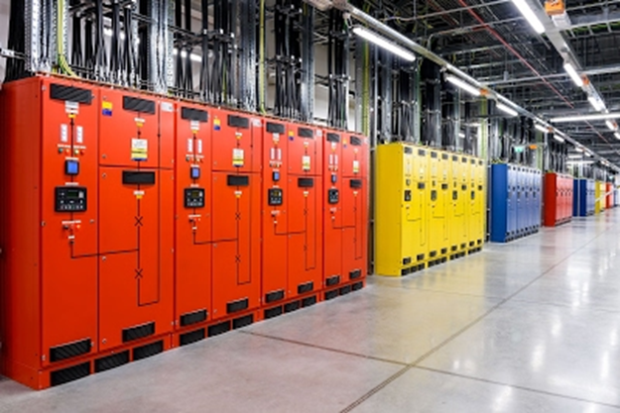Figure 1. Example of Data Center

Why we need Data Centers?

With the growing demand for Internet-based businesses and the need for continuous communication via email and all kinds of social media, data centers have emerged. These growing businesses and social networking sites must be able to provide continuous Internet services to meet the needs of consumers around the world. What follows is the need to store a lot of information to support your business processes. The data center provides a secure off-site location to store large amounts of information. As companies begin to integrate more automated or redesigned processes into their daily operations, the increasing demand for fast Internet connections, the desire for continuous business operations, and the increasing demand for storage space have led to the construction of these dedicated facilities with thousands of servers. All of this now makes otherwise inaccessible markets accessible at any time, allowing them to expand and develop their business. [2]

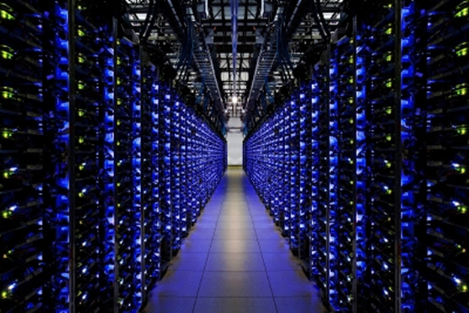Figure 2. Example of Data Center

THE 4 Vs

The worth of the new information will come from the crossing point of rich information types. To acknowledge esteem, IT should incorporate and total this information such that leaders can use for examination to drive business improvement. The four Vs are:

1. Volume, characterized as the complete number of bytes related with the information.

2. Speed: Defined as the rate at which information is devoured. As the exchange volume expands, the worth of a solitary information point will in general decrease more rapidly over the long haul.

3. Assortment: Defined as the intricacy of this sort of information.

4. Inconstancy characterized as various methods of deciphering the information.

Another significant factor is the utilization of "green" advances to lessen energy utilization and further develop energy proficiency. In the realm of server farms, space, power utilization, security and equipment are cost boundaries to adding esteem, of which the greatest expense is the worker. [2]

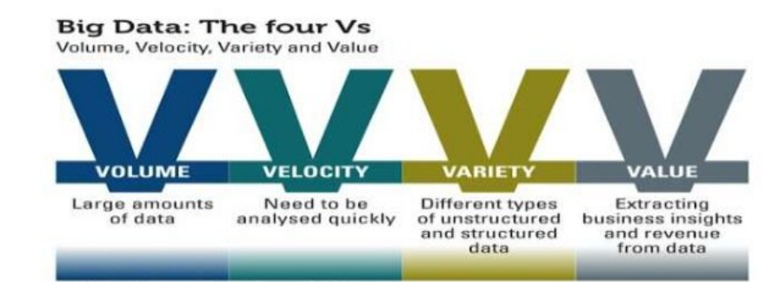
Figure 3. Definition 4 Vs

RESEARCH METHODOLOGY

Qualitative research methodologies are best for many thorough descriptions of educational processes and occurrences. Case studies, phenomenological studies, ethnographic studies, narrative studies, and mixed methods studies are all common qualitative designs. The approach is like a rigorous art, with the researcher serving as both instrument and analyzer, and the product is frequently a strong narrative in the form of a story. Grounded theory, which emphasizes the emergence of meaning hidden in data, is one significant approach for making sense of qualitative data.
In our situation, qualitative data analysis is required for Data Center design, which is aided by software that are useful for activities such as coding, retrieval, sorting, and other sorts of pattern searching. [3]

DESIGN

Planning a cutting-edge server farm isn't just quite difficult for engineers, yet in addition an endeavor to anticipate what's to come. The server farm should give the assets to run the present status of the application, however it should likewise give extra potential to forthcoming undertakings and prerequisites.

• not with standing energy productivity, power conveyance, and thickness, there are numerous different issues that should be considered in the server farm configuration measure. When planning server farms today, there are numerous advancements that can work on the effectiveness of server farm foundation gear, for example, cooling or force supplies.

• Uninterruptible Power supply (UPS) hardware is additionally a kind of gear with the possibility to further develop productivity, however notwithstanding workers, cooling hardware is as yet the principal power purchaser. Effective equipment gear and tasks that permit thought of the unique conduct of the server farm can save energy, yet in addition assist with working on the warm steadiness of server farm activities. Server farm plan techniques and cycles are evolving quickly, and new advances keep on arising, particularly in server farm cooling. [3]

UPS gadgets produce a lot of warmth that should be shipped from the server farm, notwithstanding the workers. Fundamentally, as per the actual law of energy saving, the energy that enters the framework is equivalent to the energy that leaves the framework. On account of a server farm, this implies that the energy of the burned-through power is typically the type of warmth moved by hot air or water. [12]

Virtualization of the Data Center

The virtualization was initially acquainted with work on the upkeep and adaptability of the worker. Virtualization permits administrators to relocate virtual machines to various workers ceaselessly the movement of execution administrations. The relocation permits the virtual exchange of the machine between workers inside a period of-administration idleness (in milliseconds) and a couple of moments of modest reach. Recent trends have applied this concept to move as many virtual machines as possible to a single server and that is not currently needed and turn off "empty" servers. This is generally known as server integration and allows considerable energy savings. [11]

HVAC (Heating, Ventilation, and Air Conditioning) systems

The refrigeration data center and the coolant of the server room must eliminate this heat from all devices on the server and data center. In this task, the cooling system requires considerable energy, but also needs an intelligent design option to avoid faults or heat problems.
If the data center is located at a place where the annual air temperature often falls below a threshold, you can use free cooling to provide the refrigeration of the data center and air conditioning. [3]

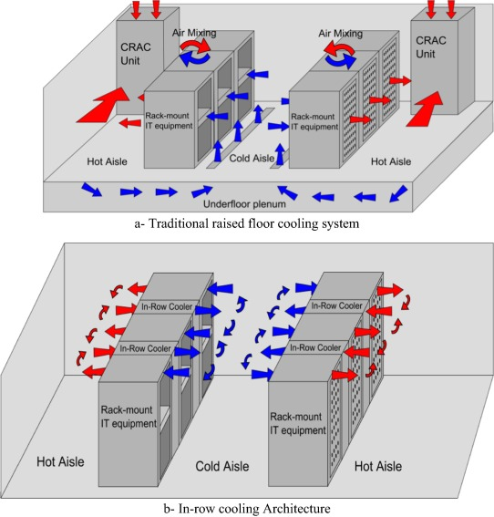
Figure 4. Cooling system design
Small data center or individual server room Apply air conditioning to the room with the computer room air conditioning unit (CRAC). The air conditioning of the server room is responsible for removing the heat generated by all electrical devices in the server room. The Crah unit in the server room must take care of this elimination. There are several different approaches to distribute the cold air provided by the Crah unit. The cold air that comes out of Crah enters the bed raised and leaves it in the containment of cold passages. The server removes the air and uses it to cool the electrical components. [3]
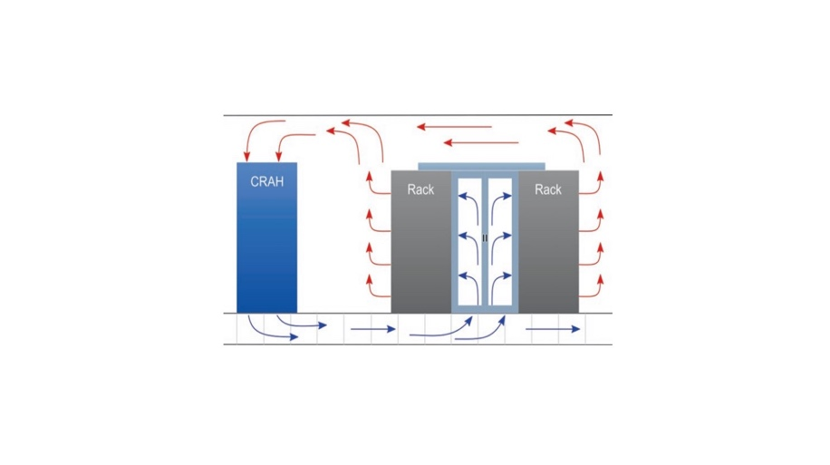
Figure 5. CRAC structure

The increase in energy demand and the increase in the thermal density of data centers lead to additional research on energy savings technology. The development of server integration and dynamic load management has arisen in combination with the success of virtualization technology. Server integration technology attempts to concentrate applications that run on virtual machines as less servers as possible. You can deactivate the server that does not handle the virtual machine or put it in suspension mode. With the request, the dynamic use of virtual machines can result in significant differences in the active servers in the data center. [3]

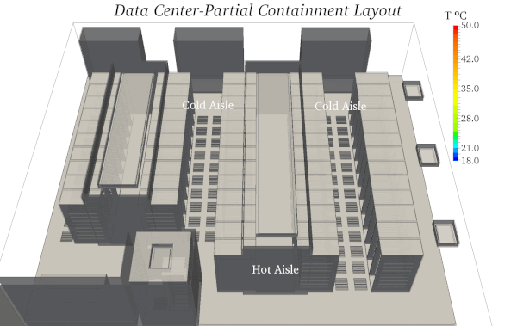
Figure 6. Data Center thermal design

SAFETY and SECURITY

Safe data centers should be constructed in the correct location using the corresponding configuration. Safety has limited damping areas, blocking barriers and entry points throughout the site. A cured core is required with a safety layer, safety device, surveillance chamber and dissuading movement for the detection of pumps. Building it is necessary to protect the machine, and the building must have a safe air handling.
• Data center recovery plan: resume the operation of the data center.
• The site's site is a backup data center to the main data center.
• Information for planning management and important applications.
• Data security arranging: Ensure information from inside and outer dangers. The conceivable unwinding includes forestalling risky occasions and limiting misfortunes and misfortunes related with the event. Preferably, it is liked to forestall occasions, yet given its range, yet it is difficult to forestall cataclysmic events. It is difficult to forestall occasions like tropical storms and tremors, however thinking about the principal proper addresses and plans, it is feasible to decrease the effect of those occasions. Ideally, intelligent decisions can avoid or minimize losses. As an example, we have selected a building that makes a flood easy to occur in flood and healing facilities, such as the implementation of a building with an earthquake, which facilitates it occurring in the flood. [5]

SECURITY
All the systems that support and exist within the data center are protected by security. Within the data center, there are many different types of security, ranging from the physical security of the building to staff safety and access. Because there is so much data around this topic, it was decided that it would be a useful topic to cover in a lecture about its integration into the data center. The issue was also picked because it is inextricably linked to the data center's infrastructure system, which aids in data center management.[5]
The research purpose is to provide insight into the critical systems that surround security. The most important feature of a data center is physical security.
In several ways, data centers appear themselves as safe sites by putting high-quality locking mechanisms in place, high-tech access authentication systems in place, and monitoring systems in place to prevent harmful activity both outside and inside the data center. As solutions to every business will be presented design with a variety of concepts, each with its own set of advantages. [5]

Another important aspect of data center security is the prevention of heat and water. If these two preventative procedures aren't in place, the data center could be vulnerable to fires and flooding.
In a data center environment, these two dangers present difficulties to manage. Typically, fire suppression systems employ water sprinklers to extinguish fires as soon as they are detected. Water is difficult to utilize in the data center because of the high number of electrical components, and data loss is a significant concern.
Water, on the other hand, can be a problem since it can short circuit electrical components beneath raised flooring without causing any noise or warning.[6]

Safety and Risk Management

When a risk occurs, the threat finds the way to commercial infrastructure and the environment and occurs when vulnerability is exploited to allow violation of the threat. Understanding the threat and its possibilities is an important part of risk management. You can increase the impact value for assets and estimate the amount of risk of damage.
IT systems and services consist of many relevant components. To understand this relationship, these dependent components and entities should be identified. [5]
Divide a service or system in that component facilitates the specification of the asset hierarchy and the level. The components can be hardware, software and connections, but entities can be human, operational images and organizations: all can be classified as assets. It is important to classify these assets and group them into categories and qualify them. To clearly identify the level of risk, each asset must be assigned a value. One of the important steps to perform safety risk assessments is to determine the value of the assets that require protection.
Another important topic is to have a quick and fast mechanism for threats. Building a very smart system to predict if the next impact can be made, it will develop disaster recovery behavior and improve your business continuity plan.
It is impossible to provide total security for all risks, but it is possible to provide effective security for most risks. [6]

Threats Damage to organizational assets, reasons behind threats, examples of sources of threats, examples of sources of threats are human and computer attacks and malicious access. The "threat source" that can be caused by the last humanity or nature can be cautious as human error, ignoring and training, such as piracy, cyber-attacks and accidents.

Cloud infrastructure services are provided in North America, South America, Europe, Asia, and Australia. These locations are divided into regions. You can choose where to place your application to meet your latency, availability, and durability requirements. Region is the deployment area of ​​GCP resources in the region. Think of a zone as a single fault domain within the zone. To deploy fault-tolerant applications with high availability and help prevent unexpected failures, deploy applications across multiple zones in one region. [6]
In modern data centers, they are installing the first battery-based system to replace generators in hyperscale data centers. The system will help keep our users' searches, emails and videos mobile without the pollution associated with burning diesel and can also be used as an asset to strengthen the network. The first major company to promise to use 24/7 carbon-free power operations in all our data centers and campuses around the world, and we are working hard to complete it by 2030. This high-end system is the quality of our ultra-large data center shifts flexible scheduling to accommodate IT tasks in the most abundant low-carbon energy era.
We do not store each user's data on one machine or a group of machines but distribute all data (including our own) on multiple computers in different locations. Then we divide and replicate data between multiple systems to avoid single points of failure. We randomly name these data blocks as an additional security measure so that the human eye cannot read them. [5]
When you work, our server will automatically back up your critical data. So, when an accident occurs, if your computer crashes or is stolen, you can restart and run in a few seconds. [6]

Finally, we strictly monitor the location and status of each hard drive in the data center. We destroy obsolete hard drives in an arduous multi-step process to prevent data access. The data center is protected by multiple layers of security to prevent any unauthorized access to your data. We use a secure perimeter defense system, comprehensive camera coverage, biometric authentication, and staff available 24/7. In addition, we enforce strict access and security policies in the data center and ensure that all employees receive security-focused training. [6]

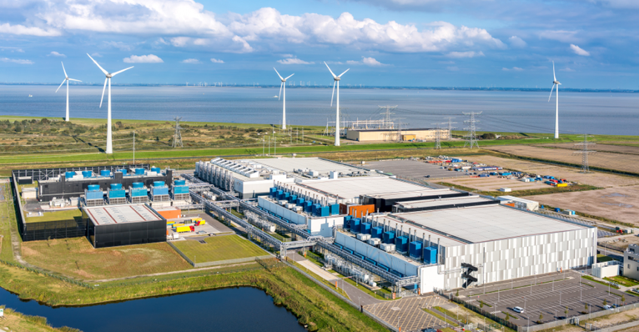
Figure 6. Energy Saving Data Center in Europe

ENERGY SAVING

Energy and cost savings A US General Services Administration (GSA) case study related to Google products shows that by switching to Google applications, they can reduce office computing costs, energy use and carbon emissions by 6590%. Additionally, our research shows that companies using Gmail have reduced the environmental impact of their email services by 98% compared to companies using email on local servers. [4]
We use detailed measurement standards and continue to promote double the effort with half the effort, serve more users, and reduce energy waste. [4]

Role of the Cloud

In the past, companies could choose to build their own data center or use a managed service provider or a managed service partner. Following the later route changed the ownership and economics of running the data center, but the long waiting time required to deploy and manage the technology still exists. The rise of Infrastructure as a Service (IaaS) from cloud providers such as Amazon Web Services and Microsoft Azure provides companies with an option to configure virtual data centers in the cloud with just a few clicks of the mouse. [8]

DISASTER RECOVERY

We have also taken strong disaster recovery measures. For example, if there is a fire or any other interruption, we will automatically and seamlessly switch data access to another data center so that our users can continue to work without interruption. Even in the event of a power outage, our emergency backup generator can continue to power our data center. A disaster recovery (DR) site is a facility that an organization can use to restore and restore its technical infrastructure and operations when your main data center is unavailable. [9]

Many mechanisms can be established within the data center to avoid disasters from happening, but if these systems do not perform as intended, they are of no use to the data center.
Another essential aspect of disaster recovery systems to consider is how data centers test and create test processes to guarantee that the systems adopted perform as expected.
Systems such as onsite data backups and offsite storage solutions will be reviewed, along with the advantages and disadvantages of each. Other than record technology, solutions based on removable media will be examined, as well as how they integrate into the data center today. Data on contacts, emergency staff contact information, and recommendations on how to restore the data center's functionality in the event of a major disaster should be preserved in safe areas to help with these test procedures.[9]
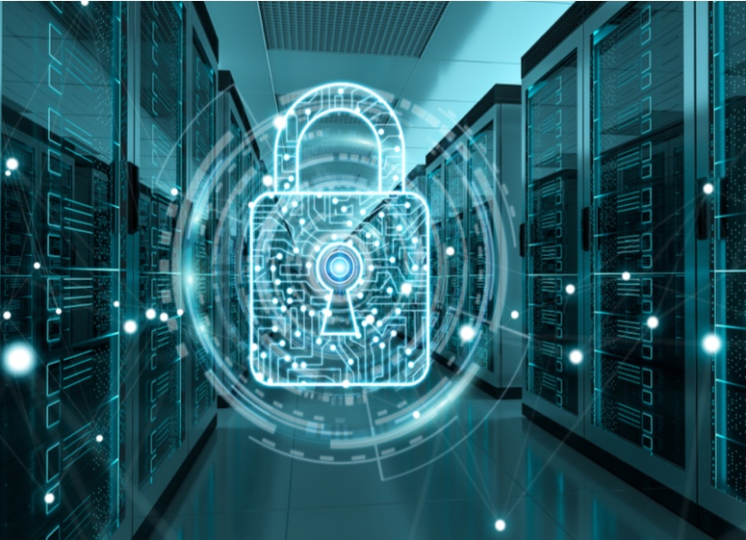

Figure 7. Security for Data Center

SAN (Storage Area Network), NAS and NVMe

A Storage Area Network (SAN) is a customized, high-speed network that allows users to access storage at the block level. Hosts, switches, storage elements, and storage devices are often connected utilizing a variety of technologies, topologies, and protocols in SANs. SANs can also connect numerous locations. A storage area network (SAN) delivers storage devices to a host in such a way that they appear to be locally attached. The usage of various types of virtualizations allows for this streamlined presentation of storage to a host. [7]

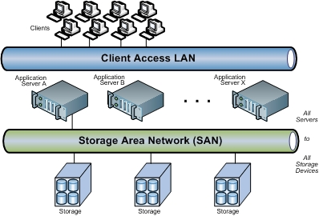
Figure 8. SAN example

Network-attached storage (NAS) is a file-level storage system that allows networked devices to access stored data more easily. Along with storage area networks (SAN) and direct-attached storage, NAS is one of the three basic storage topologies (DAS). NAS provides networks with a single storage access point with built-in security, management, and fault tolerance. [7]
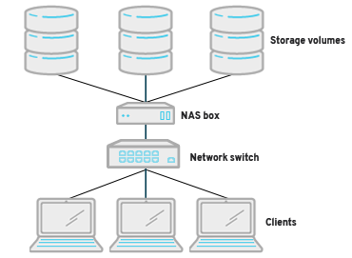
Figure 9. NAS example

And most popular now is Nonvolatile memory express (NVMe).
In an increasingly digital world, everything is getting faster, which means that data must move faster. Traditional storage protocols such as Small Computer System Interface (SCSI) and Advanced Technology Attachment (ATA) have been around for decades and are reaching their limits. NVMe is a storage protocol designed to speed up the transmission of information between the system and solid-state drives and greatly increase the speed of data transmission.
SAN is generally used to:
Improve application availability (e.g., multiple data paths)
Improve application performance (e.g., offload storage functions, isolate networks, etc.)
Improve utilization and storage efficiency (for example, consolidate storage resources, provide tiered storage, etc.) and improve data protection and security. [7]

The SAN also often plays an important role in the organization's business continuity management (BCM) activities. SAN is usually based on Fiber Channel (FC) technology, which uses Fiber Channel Protocol (FCP) for open systems and proprietary variants for mainframes. In addition, the use of Fiber Channel over Ethernet (FCoE) makes it possible to move FC traffic over existing high-speed Ethernet infrastructure, and to converge IP and storage protocols on a single cable. [7]

Other technologies can also be used, such as Internet Small Computing System Interface (iSCSI), which is often used in small and medium organizations as a cheaper alternative to FC, and InfiniBand, which is commonly used in high-performance
computing environments. In addition, gateways can be used to move data between different SAN technologies. [7]
Example for a Data Center Architecture.
A big company network with a main campus site in the university connecting small, medium, and large sites is depicted in the sample high-level topology diagram shown in Figure 10.
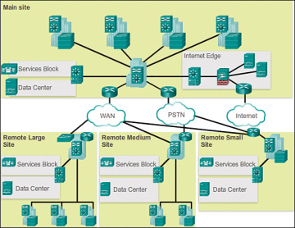
Figure 10. Network Design in Campus site.

Figure 11 shows another example three-layer hierarchical network design. It's worth noting that each structure employs the same hierarchical network paradigm, which includes access, distribution, and core layers.[14]

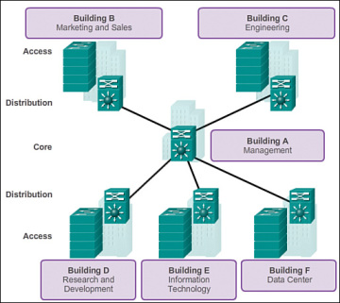
Figure 11. Three Layer Network Design.

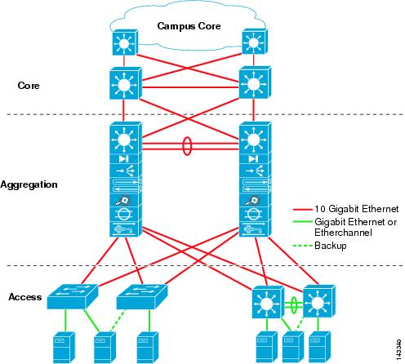
Figure 12. Basic Layer Design [15]
A "collapsed core" is the point at which the dispersion layer and center layer capacities are executed by a solitary gadget. The essential inspiration for the fell center plan is decreasing organization cost, while keeping up with the greater part of the advantages of the three-level hierarchical model. [14]

The model in Figure 13 has imploded the appropriation layer and center layer usefulness into multi-facet switch gadgets. [14]
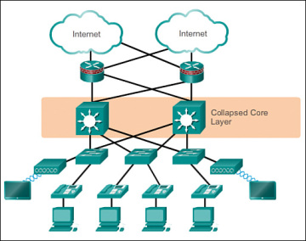
Figure 13. Collapsed Core Layer
The progressive organization model gives a particular structure that permits adaptability in network plan and works with simplicity of execution and investigating.[14]

CONCLUSION

Each industry, including medical care, promoting, retail, and so on, produces a huge number of gigabytes of new data in different structures, like client information, income, online media, business recordings, and so forth, to give some examples. It is significant that every one of the information produced all throughout the planet is put away in a profoundly secure where the necessary information can be recuperated in a brief time frame. The server farm makes the way for various freedoms for the utilization of innovation. Be that as it may, building a server farm with ideal assets is the greatest test, and various techniques to further develop server farm proficiency have been utilized and examined. Many organizations utilize focal server farms to abstain from building and keeping up with isolated server farms. Accordingly, the server farm offices have turned into a shelter for this innovation. Many huge organizations are searching for and taking on new techniques for building server farms to accomplish the "green" Internet. [13]

REFERENCES

[1] C. Mahood, Data center design & enterprise networking. 2017.
[2] O. Geet, Data center optimization strategies, 1st ed. 2019.
[3] A. Santos, P. Gaspar and H. Souza, "New Data Center Performance Index: Perfect Design Data Center—PDD", Climate, vol. 8, no. 10, p. 110, 2020. Available: 10.3390/cli8100110.
[4] M. ., "DESIGN OF GREEN DATA CENTER", International Journal of Research in Engineering and Technology, vol. 03, no. 05, pp. 373-377, 2014. Available: 10.15623/ijret.2014.0305068.
[5] W. Du, "Design and Implementation of Data Center Network Security", Advanced Materials Research, vol. 694-697, pp. 2308-2312, 2013. Available: 10.4028/www.scientific.net/amr.694-697.2308.
[6] F. Fang and X. Yu, "Design and Implementation of Next-Generation Data Center Infrastructure", Applied Mechanics and Materials, vol. 513-517, pp. 1316-1319, 2014. Available: 10.4028/www.scientific.net/amm.513-517.1316.
[7] D. Guides and D. Center, "Data Center Design Guides", Cisco, 2021. [Online]. Available: https://www.cisco.com/c/en/us/solutions/design-zone/data-center-design-guides/data-center-design-guides-all.html. [Accessed: 20- Aug- 2021].
[8] S. Shapiro, "Data Center Design: Which Standards to Follow?", Data Center Knowledge, 2021. [Online]. Available: https://www.datacenterknowledge.com/archives/2016/01/06/data-center-design-which-standards-to-follow. [Accessed: 20- Aug- 2021].
[9] "Data and Security – Data Centers – Google", Google Data Centers, 2021. [Online]. Available: https://www.google.com/about/datacenters/data-security/. [Accessed: 20- Aug- 2021].
[10] C. Center, "What Is Data Center Security?", Cisco, 2021. [Online]. Available: https://www.cisco.com/c/en/us/solutions/security/secure-data-center-solution/what-is-data-center-security.html. [Accessed: 20- Aug- 2021].
[11] "Data Center & Network Infrastructure Solutions | CDW", Cdw.com, 2021. [Online]. Available: https://www.cdw.com/content/cdw/en/solutions/data-center-and-network-infrastructure.html. [Accessed: 20- Aug- 2021].
[12] J. Kerravala, "What are data centers? How they work and how they are changing in size and scope", Network World, 2021. [Online]. Available: https://www.networkworld.com/article/3599213/what-are-data-centers-how-they-work-and-how-they-are-changing-in-size-and-scope.html. [Accessed: 20- Aug- 2021].
[13] K. Rusdiana, l. linawati and I. Oka Widyantara, "Green Data Center Design of Udayana University", Majalah Ilmiah Teknologi Elektro, vol. 15, no. 2, pp. 39-44, 2016. Available: 10.24843/mite.1502.07.
[14] C. Press, "Hierarchical Network Design Overview (1.1) > Cisco Networking Academy Connecting Networks Companion Guide: Hierarchical Network Design | Cisco Press", Ciscopress.com, 2021. [Online]. Available: https://www.ciscopress.com/articles/article.asp?p=2202410&seqNum=4. [Accessed: 24- Aug- 2021].
[15]"Data Center Architecture Overview", Cisco, 2021. [Online]. Available: https://www.cisco.com/c/en/us/td/docs/solutions/Enterprise/Data_Center/DC_Infra2_5/DCInfra_1.html. [Accessed: 24- Aug- 2021].

