CertHE Computing Skills for Workplace
Software Solutions for Business

Student name: Haseeb Khan
Student ID: 2505377
Module code: ACCA4026
Assignment title: Component 1- Coursework: Portfolio
Lecturer: Osman Elgawi
Date of submission: 22nd March 2026
Campus: University of Wales, Birmingham Campus



Contents
CertHE Computing Skills for Workplace 1
Task 1: e-Commerce Website Builders 3
Task 2: Mind Mapping 4
Task 3: Office Applications 6
Task 4: Communication and Collaboration Applications 11

Task 1: e-Commerce Website Builders

E-commerce web site constructors are websites that facilitate building and operation of online stores without necessarily having advanced knowledge in programming. [3] With these tools, businesses can easily create an online presence since they come with ready templates, integrated payment systems, and inventory management systems. With the advancement of digital commerce, these tools are now necessary to those companies that like to compensate broader audiences and simplify their operation.

Shopify
Shopify is one of the most popular online shops that enables companies of any scale to build, operate and tailor-made online stores without the need to know the code. [1] It helps in the sale of digital and tangible products, which is why it can be a universal resource to the business models of various types. Shopify has become known as a good and convenient tool that aids the companies in the development of professional online shops.

Features
Shopify has a drag-and-drop website builder, which is easy to use to create websites. It has inventory management tools that monitor the product and stock level, and all stores are mobile friendly. Moreover, Shopify also offers an in-built payment gateway where companies can transact their operations safely.

Strengths
The simplest part of Shopify is named among its greatest strengths, since there is no need to know any coding. It also possesses a robust app ecosystem, where users can add functionality by means of extensions. Moreover, it is very scalable, and this ensures that it can be applied in growing businesses, which require time to expand.

Weaknesses
Shopify has certain disadvantages to its advantages. It has a monthly subscription fee and this can be very expensive to small businesses. Moreover, there can be transaction fees in case the users do not use the own Shopify payment system.

Wix
Wix is a widely used cloud-based web-site building service that enables the user to develop HTML5 and mobile-friendly websites with the help of easy drag-and-drop features. [2] It also has AI-powered design features, which makes it especially appropriate to those who are beginners and small businesses that want to have a simple means of creating an online presence.

Functionality: Wix has a drag-and-drop interface like Shopify, and in-built marketing capabilities, including email marketing and search engine functionalities. It also offers numerous customisable design templates so that the user can create attractive websites.

Strengths: Wix is very user friendly and inexpensive compared to most of the competitors. It is flexible and can be customised to enable users to create unique websites without the need of technical knowledge.

Weaknesses: Wix is however typically less scalable than Shopify and is primarily not pointed out in large or rapidly growing companies. It is also less developed in terms of advanced e-commerce features, and thus it might not be useful in more sophisticated online stores.

Conclusion
Shopify and Wix are both important in assisting the novice user and business to create an online presence. They make it easier to build and run online stores since they do not require coding skills to perform some of the critical tasks including transactions and inventory.
Whereas Shopify is more scalable and suitable to large companies, Wix is the perfect choice when one is starting out and has small operations. Altogether, the e-commerce platforms can be seen as enhancing business operations through better digital presence, greater customer engagement, and making online selling more accessible.

References:
[1] Shopify Inc., "What is Shopify and How Does it Work?", 2025. [Online]. Available: https://www.shopify.com/. [Accessed: Mar. 25, 2026].
[2] Wix.com Ltd., "Wix eCommerce: Create an Online Store", 2025. [Online]. Available: https://www.wix.com/ecommerce. [Accessed: Mar. 25, 2026].
[3] A. Chaffey, "Digital Business and E-Commerce Management," 7th ed.,

Task 2: Mind Mapping

What is a mind map?
Mind mapping is a pictorial method in the arrangement of information, ideas and concepts around a central theme. It implies drawing a diagram in which the central idea is put in the middle, and subtopics which are related to it are in a hierarchical and branch form. The way the mind processes information is natural to the human brain, and therefore, it is easier to process the complex relationships and come up with new ideas using this approach. Tony Buzan popularised the concept of mind mapping and highlighted the potential of the mind mapping concept to promote creative thinking and memorising.
Mind mapping is also regarded as a brainstorming tool, planning and problem-solving tool that is also common in a business setting. Organisations usually handle huge volumes of information and complicated operations and mind mapping assists to divide them into manageable parts. Visualisation enables employees to find links, rank activities and build organised plans in a more efficient manner [4].
These are some of the main advantages of mind mapping in business operations, which are the better generation and creativity of ideas. Mind maps can be used by the team during brainstorming sessions to gather and arrange ideas in a short time without limiting the creativity. This fosters involvement and enables a more cooperative way of solving problems. As an illustration, a mind map can be used when a team is developing a new product or service by exploring various features of the target market, features, pricing, and marketing strategies.
The other significant benefit is that it plays a part in decision making. Mind maps give a clear picture of all the factors that are of interest and thus the managers can scrutinise all the options and make effective decisions. Decision-makers can see possible risks and opportunities because they can visualise the relationship between various elements. It is especially handy in the strategic planning, where several variables should be taken into consideration [5].
Mind mapping also brings more communication and understanding in organisations. Sophisticated concepts may not be easy to describe through text, but a visual image makes it easier. This is particularly useful during the presentation of information to the stakeholders or the training of the employees. An example is a mind map that an organisation can employ to map out business process or an organisational structure so that employees can find it easier to understand their roles and responsibilities [8].
Also, mind mapping enhances productivity and organisation. Organising the work and thoughts visually, the employees may rank their tasks and spend their time more efficiently. This minimises the level of confusion and makes sure that key tasks are undertaken effectively. Moreover, digital mind mapping utilities enable users to update and modify maps very easily, and hence, they are flexible and dynamic in their usage in business.
The usefulness of mind mapping in business has been further advanced by the modern software applications like the XMind and mind meister. The features these tools offer include cloud storage, real-time collaboration, and the integration with other applications giving teams the option to work together without any problem, no matter where they are. This has made mind mapping to become a very crucial tool in any contemporary organisation to facilitate innovation, planning, and proper communication.
What are the benefits of using a mind map in business?
Some benefits could be enhancing decision making, organising lots or complex information, greatly helps with planning and improves brainstorming ideas. Businesses use mind mapping tools to plan strategies, manage projects, and visualise workflows more efficiently [6].

References:
[6] A. Osterwalder and Y. Pigneur, "Business Model Generation," Wiley, 2010.

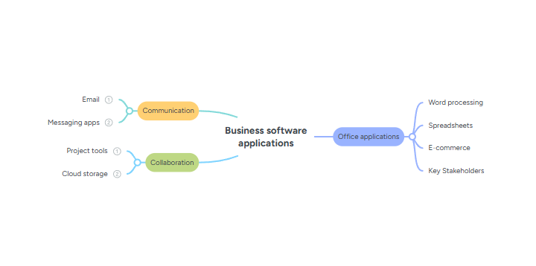
Task 3: Office Applications

Introduction
Office software applications are very important in the current business practice, as they help organisations to generate, organise, archive, handle, and report the available information. They are used to increase the productivity and the communication and to facilitate the process of decision making. Such office programs as Microsoft Word, Microsoft Excel, Microsoft PowerPoint, and Microsoft Access are among the most popular. These tools have distinct features, which assist in various business functions [7].
This section will discuss these four applications in greater detail explaining their main characteristics, advantages and disadvantages. It will also reveal practical application when testing chosen features in excel.

Word in Business Operations- Microsoft.
One of the most widely used word processing systems in the business world is Microsoft word. It is mostly applied on the preparation of professional documents, i.e. reports, letters, contracts, and policies [8].
Its popularity is possibly based on easy interface and its strong formatting tools that enable the user to create organised and appealing to the eye documents.
The application of the uniform formatting with the help of styles and templates can be considered one of the most important aspects of Microsoft Word. Companies usually need documents to be designed in a certain way in terms of branding and formatting, and Word can make this easy as one can use reusable templates. This saves time in addition to providing uniformity in all organisational documents. Furthermore, the mail merge feature is quite useful in the business case, as it allows creating personalised documents in large volumes. As an example, a firm can design hundreds of bespoke letters or emails to clients by taking a standard template and inserting information in a spreadsheet.
The other feature of Microsoft word is its ability to collaborate with other applications. By connecting it to cloud services and other applications such as Microsoft Teams, several attendees will be able to collaborate on one document at the same time [9].
This becomes particularly useful in contemporary working environments where the teams can be located at a distance. The teamwork and document review processes can be facilitated due to the real-time editing, commenting, and track changes features.
Microsoft word has some limitations despite these benefits. It is not specifically aimed at working with large data sets or doing sophisticated data analysis, which limits its application to data-driven activities. Also, when the documents are exchanged between different systems or the versions of the software, the problem of formatting can occur, which can influence document consistency.
Microsoft Excel in Business Operations.
Microsoft Excel is an effective data analysis and financial management tool. Budgeting, forecasting and performance analysis are some of the tasks that are widely used in businesses. The large capacity of Excel to process large amounts of data and make complicated operations makes it a crucial decision-making tool [10].
The large number of functions and formulas is one of the strong points of Excel. There are also functions like IF, which enable the user to make logical comparisons and automate decision-making. An example of how a business can use the IF function is to classify the performance of the employees or if the sales targets are reached. This will save the human calculation and will greatly reduce chances of human error.
The other notable thing about excel is its ability to visualise data. The charts and graphs can be produced by the user to display the data visually and it is much easier to find the trends and patterns. This comes in handy especially when a manager is required to analyse the performance data and make informed decisions. Moreover, Excel contains more sophisticated applications like Pivot Tables which enable users to summarise and analyse big data in a short time.
Goal Seek, included in the What-If Analysis tools of Excel, is a very useful feature as far as business analysis is concerned. Goal Seek enables the user to know the input value that would be needed to reach a desired output. As an example, Goal Seek can be used by a business to determine how many units to sell to reach some target profit. Such an analysis is essential to strategic planning and financial forecasting.
Excel also supports Microsoft teams, which allows users to share spreadsheets and work collaboratively in real time. This will improve communication and make certain that the team members can access and update information effectively.
Excel is not without its weaknesses though. It is also complex and may prove difficult to beginners especially in cases of advanced functions and big data. Also, feeding wrong formulae may produce wrong results and this can be disastrous to business decision making. Consequently, to make use of the software, the users would need to be well versed with it.
Business Communication using Microsoft PowerPoint.
Microsoft PowerPoint is popular in making presentations used to pass across information in a visual form. It is a very important element in the business environment where any type of communication is central to business meetings, training and presentations to clients [11].
PowerPoint enables one to integrate text, pictures, charts and multimedia contents to make interesting presentations. This aids in better comprehension of the audience, especially in case of a complicated information. Templates and themes are used to make sure that the presentations look professional, which is relevant in business.
PowerPoint is compatible with other Microsoft Office applications as one of its main strengths. As an illustration, the Excel data can be placed into the PowerPoint slides in either chart or table format that will give an easy and effective approach to data presentation. Also, PowerPoint is integrated with Microsoft Teams, thus giving the possibility to do the presentations remotely. This has gained more significance within the remote work and virtual meetings.
Although PowerPoint has its advantages, it can prove to be useless when it is not used appropriately. Stuffing too much text or too many animations may be distracting to the audience and will diminish the strength of the presentation. Moreover, the success of a PowerPoint presentation is usually determined by the skill of the presenter, i.e. it is the way he/she delivers that will result in a successful communication.
Microsoft Access in Data Management.
Microsoft access is a database management system that is applied to store and arrange structured data. It applies mostly in the handling of high amount of information like customer records, inventory information and transaction records.
Access enables users to establish relational databases, in which information is grouped in a variety of tables, which are interconnected. This structure enhances better data organisation and redundancy. It is simplified to analyse and control data because users can generate queries that can be used to seek specific information stored in the database. Also, there is the benefit of forms that offer intuitive user interface where user can input, and update information and the report gives user the ability to present information in a systematic format.
The Access can be applied to create customer relationship management systems, inventory tracking or sales tracking systems in a business environment. Its ability to integrate with other Microsoft office applications adds more functionality to it where data can be imported and exported. Access is not without limitations, however. It needs some degree of technical skills, thus not so easy to approach by beginners. It also does not fit the needs of very large-scale databases or systems with very complex requirements where more sophisticated database solutions may need to be used. It also does not have the real-time collaboration functionality that it has.
Practical Application of Excel Features
IF function Microsoft excel
The IF function in Microsoft Excel is one of the most flexible and commonly used functions for making decisions and analysing conditions. It allows you to take different actions or return different values depending on whether a specific condition is met.
At its core, the IF function checks a logical expression or condition. This condition can include comparisons like greater than (>), less than (<), equal to (=), not equal to (<>), or combinations of these.
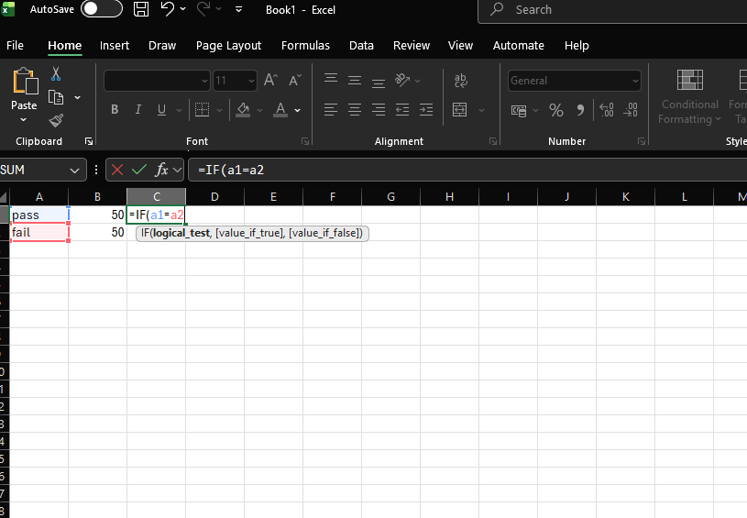
Here I used an example to demonstrate the IF function.

How does this help businesses?

Automating Decision Making
Putting sales transactions in categories of Approved or Pending automatically through preset criteria is an effective means of simplifying a business process. Organisations can establish rules in form of specific symbols like the IF function in spreadsheet software or systems where they can approve transactions under a specific value or raising red flags on transactions surpassing credit limits.
This helps in eliminating the manual process of reviewing all the transactions so that the employees can concentrate on the more demanding tasks that demand human skills. Besides the time saved, automation will greatly minimise the chances of human error. When it comes to large amounts of data, manual processes are also quite likely to experience inconsistencies. Under automated classification, all transactions are compared on the same basis and the accuracy and consistency at the board level is guaranteed. This comes in especially handy when it comes to financial business where even minor mistakes can be of great importance.
The IF function allows businesses to operate dynamically on using data through dynamic response to alterations in input values. The system automatically changes the status of transactions when new data are added to it without further manipulation. This real time responsiveness enables companies to track performance in a better way and make faster decisions. Moreover, routine decision automation produces actionable information. With the help of the analysis of the transactions frequently marked as pending, businesses can determine patterns, amend their policies, or redefine their criteria. All in all, the use of simple logical functions increases productivity, decision-making, and helps organisations to survive in the rapidly evolving business environment.

Goal Seek
Goal Seek is a tool that comes with Microsoft Excel and Google Sheets that helps you find the right input value to get a certain result in a formula. It figures out what input is needed (like unit sales) by working backward from a desired outcome (like a target profit). You can find this tool in the Data tab under "What-If Analysis." It lets you quickly and automatically tests single-variable problems repeatedly.

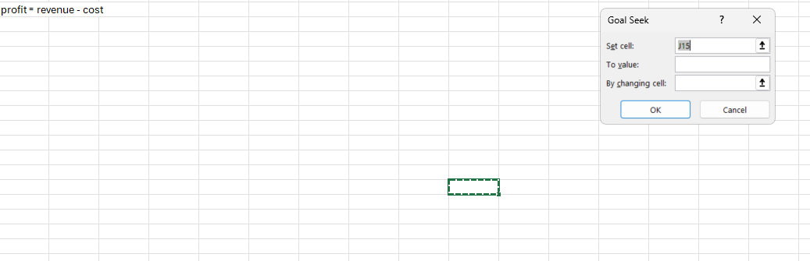
The practical application of Excel features illustrates the way the tools may be used within the real-world business environment. The IF command is a basic but strong program that enables users to computerise decision-making procedures. As an illustration, the IF function can be used by a business to measure the performance of employees according to a certain set of criteria, which can be sales targets or performance scores. Automation of such decisions helps businesses to save time and be consistent when evaluating them.
Goal Seek on the other hand is a more developed feature that helps in making strategic decisions. It enables the users to carry out What-If Analysis to establish the input value that should be attained to gain a specific outcome. As an example, Goal Seek can be used by a company to determine the number of products that should be sold to make a certain profit. Such analysis is very critical in terms of planning and forecasting since it assists business establishments to explain the correlation between various variables and make decisions.

Finally, Microsoft Word, Excel, PowerPoint, and Access are the tools which facilitate different parts of business processes such as creation of documents, data analysis, presentations, and data management. Their compatibility with Microsoft Teams only makes them even more useful in terms of collaboration and communication and, thus, essential in contemporary work environments. Excel as a tool used in decision-making and efficiency enhancement is demonstrated by practical use of the Excel features including the use of IF and Goal Seek. Although all the applications have their limitations, their integration allows the organisations to work more efficiently and address the needs of the business, which is rapidly evolving. These apps still greatly help with business making management of products or sales or even setting up plans way easier and since they are rapidly improving it ensures that businesses will runway more efficiently in the coming years.

Task 4: Communication and Collaboration Applications
Analysis of Communication and Collaboration Applications
In contemporary business world, communication and cooperation is fundamental in organisational success [12].
As remote and hybrid working become more prominent, digital tools have grown in importance to facilitate interaction between teams and exchange information and collaborate effectively. The communication application and collaboration platform that has been widely used are WhatsApp and Microsoft Teams. The two tools are important in increasing productivity, but they are used in various ways in the operations of the business.
Application in Communication: WhatsApp.
WhatsApp is an application that is popular in sending messaging which allows sending of text messages in real time, voice, video and sharing of files. It is especially lokpriy within the business setting because of its simplicity, accessibility and prevalence. WhatsApp is a quick communication tool that is used by many organisations to connect the team members where small businesses or informal work settings are involved [13].
Instant messaging is also one of the main characteristics of WhatsApp that enables people to interact in real-time. This greatly enhances responses and it makes it easier than the traditional email communication to make decisions more quickly. Moreover, WhatsApp also allows group chats, meaning that teams can converse as a team, and provide updates in one centralised location. It is a very convenient feature to arrange the work and make sure that no team members are left uninformed.
File sharing is another significant attribute that allows a user to transmit documents, pictures and videos with ease. This facilitates teamwork, since employees can share information within a short time without having to employ any other medium. Moreover, WhatsApp is end-to-end encrypted, and this means that messages and data are safe, and this is essential in upholding confidentiality in business communications.
WhatsApp can also be used on multiple platforms such as smart phones and desktops hence it is a versatile communication tool. It is simple and requires minimal training and hence organisations can adopt it on a short time. WhatsApp productivity is also improved according to the user experiences as it improves the possibility of instant communication and lessening the delays in decision making processes.
Nonetheless, regardless of its benefits, there are several drawbacks of WhatsApp in a business environment. It does not have sophisticated organisational capabilities like organised channels, task management and other business tools integration [14].
Also, controlling big teams may be a challenge because of the overload of messages and valuable information may be lost in the hustle and bustle of group conversations. Thus, WhatsApp can be efficiently used to facilitate fast communication, but more complicated collaboration is not yet to be supported by this application.
Collaboration Practice: Microsoft Teams.
Microsoft Teams is an all-inclusive teamwork tool that is meant to promote team building in contemporary organisations. It is a combination of communication, file sharing and project collaboration that has been integrated into a single environment that is very suitable in business.
The chat, voice calls, and video conferencing are some of the most important features of Microsoft Teams that allow provision of real-time communication. This enables the communication of teams no matter where they are located physically. Teams also facilitates online meetings and webinars so that organisations could carry out training, presentations and discussions remotely.
File sharing and co-authoring is another important feature as it enables people to collaborate on the same document at once. This saves the necessity of having numerous versions of files and helps to make sure that all members of the team are operating under the latest information. Teams is also compatible with Microsoft 365 packages (Word, Excel, and PowerPoint) and this boosts productivity further.
Channel and workspace are also available on Microsoft Teams, and these are useful to structure communication and collaboration by project or department. This is an ordered system that enhances clarity and minimizes confusion as opposed to the traditional messaging platforms. Besides, Teams also gives the security measures, including encryption, and access control that guarantee the safety of sensitive business information.
One of the strengths of Teams is the possibility of centralising the communication and collaboration in a single platform. Organisations can chat, conduct meetings, deal with files and tasks using a single system instead of having many tools. This decreases inefficiencies and enhances workflow.
Nonetheless, Microsoft Teams is also limited in some ways. It has numerous features which may complicate usage among new users necessitating training and familiarisation. The interface is also cluttered to some users especially when handling several channels and conversations. Irrespective of these difficulties, Teams is still among the most efficient collaboration tools in the contemporary companies.
Comparison and Evaluation
Comparing WhatsApp with Microsoft Teams, it is evident that the two are used differently while running business activities. WhatsApp is a mostly communication tool, aimed at fast and informal communication whereas Microsoft Teams is a collaboration tool, aimed at organized team-play and project management.
WhatsApp is very good in simplicity and speed hence suitable to quick update and informal communication. Microsoft Teams, in turn, is a more holistic solution, and it includes more advanced capabilities, like document collaboration, meetings, and other integrations with other business solutions.
Businesswise, the two tools are normally used hand in hand by organisations. Communication can be facilitated with the help of WhatsApp, whereas formal cooperation and management of the projects should be implemented with the help of Teams. This interface enables businesses to enjoy the merits of individual platforms.

Collaboration tool features

This is one of the features which give team members the ability to access and make changes to files in real time. The updates are automatically saved, and all users can see the changes right away.

Reference List
[1] Shopify Inc., “What is Shopify and How Does it Work?” 2025. [Online]. Available: https://www.shopify.com/. [Accessed: Mar. 24, 2026].

[2] Wix.com Ltd., “Wix eCommerce: Create an Online Store,” 2025. [Online]. Available: https://www.wix.com/ecommerce. [Accessed: Mar. 24, 2026].

[3] D. Chaffey, Digital Business and E-Commerce Management, 7th ed. Harlow, UK: Pearson, 2019.

4] B. Hanington and B. Martin, Universal Methods of Design Expanded and Revised. Beverly, MA, USA: Quarto Publishing Group USA, 2019. [Online]. Available: ProQuest Ebook Central. [Accessed: Mar. 20, 2026].

[5] I. Clarke and W. Mackaness, “Management ‘intuition’: An interpretative account of structure and content of decision schemas using cognitive maps,” Journal of Management Studies, vol. 38, no. 2, pp. 147–172, 2001.

[6] A. Osterwalder and Y. Pigneur, "Business Model Generation," Wiley, 2010.

[7] A. F. Tony-Okeme, Microsoft Office Application Competencies Possessed by Office Technology and Management Students for Employability and Self-Reliance. Ph.D. dissertation, Kwara State University, Nigeria, 2021.

[8] B. G. Wilson, Exploration of Mind Mapping as an Organisational Change Tool. Pepperdine University, 2016.

[9] R. Mercurio and B. Merrill, Beginning Microsoft 365 Collaboration Apps. New York, NY, USA: Apress, 2021.

[10] M. D. Kumar, “A study on importance of Microsoft Excel data analysis statistical tools in research works,” Journal of Management & Educational Research Innovation, vol. 1, no. 3, pp. 25–33, 2023.

[11] E. Knight, S. Paroutis, and L. Heracleous, “The power of PowerPoint: A visual perspective on meaning making in strategy,” Strategic Management Journal, vol. 39, no. 3, pp. 894–921, 2018.

[12] J. Waldeck, C. Durante, B. Helmuth, and B. Marcia, “Communication in a changing world: Contemporary perspectives on business communication competence,” Journal of Education for Business, vol. 87, no. 4, pp. 230–240, 2012.

[13] R. Das et al., “Efficiency of mobile video sharing application (WhatsApp®) in live field image transmission for telepathology,” Journal of Medical Systems, vol. 44, no. 6, p. 109, 2020.

[14] M. Mars and R. E. Scott, “WhatsApp in clinical practice: A literature review,” in The Promise of New Technologies in an Age of New Health Challenges, 2016, pp. 82–90.

