.

Eigp 2 – individual report
Gemma Dunlop
University of Wales Trinity Saint David
Web Development
James Williams
23 March 2020

Table of Contents
1. Introduction 3
2. Management and Operations 3
2.1. Team Working and Collaboration 3
3. Overall Skills needed for the Project 4
4.1. Business Premises 5
4.2. IT/Production Facilities 5
4.3. Codes of Conduct 5
4.3.1. Association of Computing Machinery (ACM) 5
4.3.2. The British Computer Society Code of Conduct 6
5. Development 7
5.1. Project Table 11
5.2. Project_Colour Table 11
5.3. Project_Images Table 11
5.4. Project_Object Table 12
5.5. Project_Size Table 12
6. Div Digital Website 14
6.1. Home Page 14
6.2. Services Page 16
6.3. Contact Page 17
6.4. Portfolio Page 17
7. Conclusion 18
Bibliography 19
Appendix 1: CPD Review 20
Reflection 20
Networking 21
Team Working 23
Team Progress Sheets 23
Gantt Charts 28
Appendix 2: Code Extracts 29
Div Digital Website Code 29
Slideshow 29
Nav bar 32
Home Page 37
Contact.php 38
Services.php 39
Portfolio.php 40
BRD Sports Shop Page Code 41
Product.php 41
Shop.php 43
Shop_products.php 45

Table of Figures
Figure 1: Div Digital Logo Designs. 7
Figure 2: Div Digital Final Logo Design. 7
Figure 3: Div Digital Final Logo Design. 7
Figure 4: Login Page Database Tables. 8
Figure 5: Site Plan of the BRD Sports Website. 9
Figure 6: Visio Plan of BRD Sports Website. 9
Figure 7: Shop Page of the BRD Sports Website. 10
Figure 8: Project Page of the BRD Sports Website. 10
Figure 9: Project Table of the BRD Sports Database. 11
Figure 10: Project_Colour Table of the BRD Sports Database. 11
Figure 11: Project_Images Table of the BRD Sports Database. 11
Figure 12: Project_Object Table of the BRD Sports Database. 12
Figure 13: Project_Size Table of the BRD Sports Database. 12
Figure 14: Div Digital Facebook Page. 13
Figure 15: Div Digital Instagram Page 13
Figure 16: Home Page of the Div Digital Website. 14
Figure 17: Home Page of the Div Digital Website. 14
Figure 18: Home Page of the Div Digital Website. 15
Figure 19: Services Page of the Div Digital Website. 16
Figure 20: Services Page of the Div Digital Website. 16
Figure 21: Contact Page of the Div Digital Website. 17
Figure 22: Portfolio Page of the Div Digital website. 17

Introduction
This report contains a Management and Operations business plan which is a contribution to a New Custom Website innovation plan for the company BRD Sports who are based in The Gower, Swansea. BRD Sports is a Mountain Boarding Centre providing lessons and courses for people of all ages and abilities.
An initial business plan was created by the whole project team, which was given the group name Div Digital. The plan provided an overview on why the website was being designed, main tasks, possible issues, skills required and a timeline.
The goal and vision for the project was considered prior to the development of the website for the customer. The owner of BRD Sports Ben Room wanted a new responsive website to improve on their existing website with the addition of a new online shop to increase revenue by selling merchandise such as clothing and mountain boards Div Digital considered the customer vision and target market for BRD Sports which is young adults and children and decided to create a 360 design for the home page to appeal to this age group and encourage them to spend more time on the web pages.
Detailed team progress sheets and Gantt charts are included in the Appendix to provide a clearer picture of the project.

Management and Operations
Whilst working on the website project it is important that the project team works together effectively and helps each other in order that the website is resigned the best it can be. For this collaboration to be facilitated, the team leader – the author – ensured communicating team progress towards project goals at each stage of the project.

Team Working and Collaboration
Div Digital project team hold team meetings every week for two hours in order to communicate ideas and issues concerning the redesign of the website.
The regular meetings have been effective as they allow the project team to give individual updates on our project and discuss the next stage. Team meetings benefit the project team by providing a way of identifying milestone achievements; information is shared, and issues and problems are brought to the team. The meetings must be effective in order to be beneficial [1].
Meetings allowed the project team to be open with one another, collaborate and offer suggestions on the making the website redesign more effective. One problem that the team faced was that at times achieving the target of holding meetings each week was challenging. For example, during December meetings were cancelled due to Christmas holidays which meant, the product progressed more slowly than it should have at the start. However, this slippage of time was overcome by holding longer meetings in January.
After each meeting team progress sheets were made using a template and Microsoft Word to track team progress and identify areas where the team were falling behind schedule.
The team communicate regularly on Slack which was effective to collaborate online with occasional written communication by email. A limitation the team found using Slack was the inability to video conference without having to pay. To solve this problem, the team used Discord for video conferencing. Face-to-face and video conferencing were better methods of communication than Slack as reactions could be gauged and the team could stream individual screens live to share website designs.
Gantt chart was made using Microsoft Project to ensure the project was progressing at an acceptable rate to meet the final deadline The project management tool known as the Gantt chart is used as a standard globally, despite the method being old [2]. The Gantt chart is an essential tool used by project teams to give a graphical, visual view of the project team’s tasks and enable them to be viewed against time [3]. The use of Gantt chart is the second tool which is used the most, with a ratio of 64% [4] in cases where project management software is used as a tool.
The use of Gantt charts was effective as it was easy to schedule tasks and visually represent time scales. It illustrated how the project would progress from the start which simplified the process. This avoided the team being overwhelmed with information overload which increased the team’s motivation.
The use of the chart meant every team member knew what they were doing as well as the name of each team member who was responsible for completing the other tasks. It helped to set realistic timeframes for each task and being highly visible it was easy to identify areas where we were working too slowly on the project. Sometimes a task was carried out by a different person to that named on the Gantt chart. The reason for this tended to be lack of time for the original person to complete the task so another member of the team could help or complete it instead. Supporting each other in this manner helped the team overcome any time slippage. The team members allocated to each task changed slightly as the team got to know each other and understand each other’s skills and knowledge. To date, the team have met our target deadlines for each task.

Overall Skills needed for the Project
All team members require web development skills for the website redesign. Every member has these skills as all the team are studying the Web Development course. Naturally, some team members have additional skills due to experience gained outside of university, such as from a previous college course or employment. The team used the additional knowledge to our advantage by assigning the team members with those skills to tasks requiring expertise in their field. Each team member had different talents and brought their skills to the table. There is a large shared knowledge between the team which was used to boost productivity.
The main skill gap area for the team was the lack of business skills. The whole team has attended Master Classes about running a business and understands the theory, but none of us have had experience of owning or running a business but are gaining experience from setting up this business.
No member of the team had experience with JavaScript frameworks, which was needed in order to create the 360-degree image. Additional research was done by the person in charge of front-end development in order to solve this skill gap specifically to learn how to use 3js before the 360 design could be created.

Business Premises
The project team do not require business premises in order to complete the project as the team members are all in the same lectures in university and meet regularly each week.
The team communicates regularly online using Slack and written email. The team will continue collaborating in this manner with voice and video conferences and organising face-to-face meetings each week until the project is complete.
Currently, Div Digital is a start-up company meeting at university or public places and ongoing costs are minimal. However, if the business expanded, it would need to look for premises. Web development companies that have offices will pay rent, business rates and utilities like any other business which would make up most of its ongoing expenses. Other expenses such as office supplies would be minimal. Costs like project management software are provided free of charge by the university, however if the business is going forward then these costs would have to be considered along with cloud storage, time tracking software and time management software.

IT/Production Facilities
The team’s production facilities were:
Visual Studio,
Chrome,
MariaDB,
PhpMyAdmin, and
360-degree camera for website images.

Codes of Conduct
The project team adhere to the following codes:

Association of Computing Machinery (ACM)
The website project adheres to professional Computing Institute’s standards such as the Association of Computing Machinery (ACM) [5] that has designed a code of ethics and obligations that computer professionals should follow:
- Use of the computer systems created in a socially responsible manner.
- Develop systems to a good standard that are safe for the public to use.
- Qualifications represented honestly and any conflicts of interest notified. Facts about the system must be accurate.
- Follow patent and copyright law. Licences for software.
- Work must be original and not stolen or copied from someone else.
- Confidentiality of customer and user information respected.

The British Computer Society Code of Conduct
The British Computer Society Code of Conduct (BCS) [6] sets the standards for UK computing. Any code breaches can lead to disciplinary action.
- Public Interest – Third party rights respected. Professional work carried out so not to discriminate.
- Professional Competence and Integrity – Work undertaken must be to the ability of professional competence without false representation of skills or exaggerating own skills. Responsibility for developing own knowledge and skills. Ethical behaviour and rejecting bribes.
- Duty to Relevant Authority – Professional responsibility for the quality of work undertaken.
- Duty to the Profession – Maintain BCS and the IT reputation. Work undertaken with integrity.

Development
The author assisted Shamuel Hashan with the design and choice of the Div Digital logo. Several logos were designed as shown in figure 1.


Figure 1: Div Digital Logo Designs.
The final logo as shown in figure 2 as it had the most professional appearance.
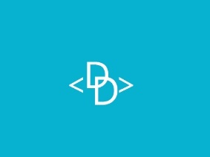
Figure 2: Div Digital Final Logo Design.
The author worked on the testing of the front end of the project website with Rhys Davies to see if it worked and to see if there were any improvements that needed to be made. The homepage is shown in figure 3.
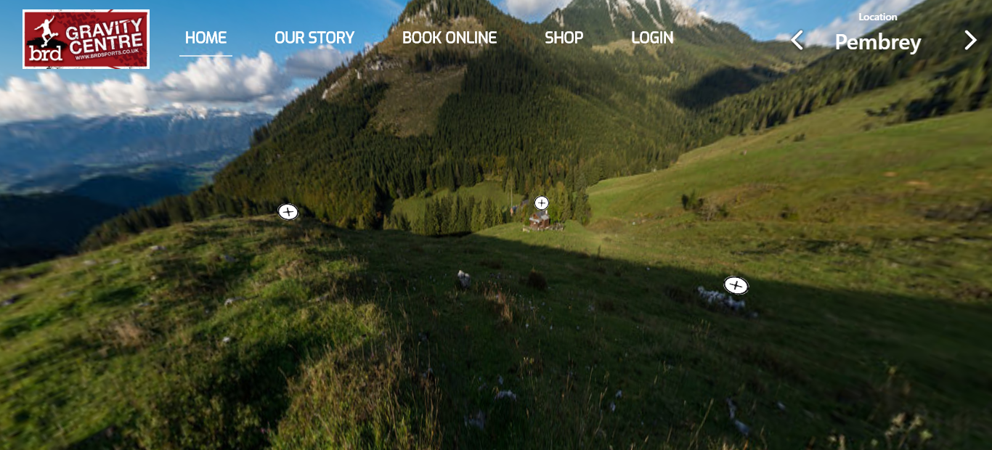
Figure 3: Div Digital Final Logo Design.
The responsiveness of the homepage was tested by the author on several different devices. On a mobile device, it was discovered on testing that one of the buttons wasn’t working. The code was changed to fix this.
A few minor changes were made to the homepage after being designed. The main change was the plus sign buttons on the 360 images were made larger. This was because the author felt the buttons would not be obvious to IT novices that they were buttons to click on to bring up posters linking to different pages on the website.
Mark Huntly, Connor Ellement and the author planned which fields and tables were needed to be included in the login page of the website for backend as shown below.
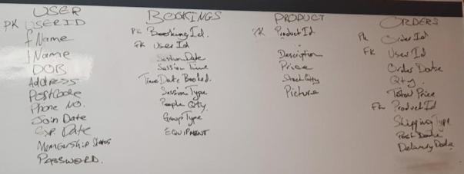
Figure 4: Login Page Database Tables.
The team met the owner of BRD Sports Ben Room on 25th February 2020 to update him on the progress of the website so far. He approved of the design so far with a few suggestions for very minor changes.
To build the BRD website, a site plan was created. The team brainstormed their ideas and created a simple outline of the pages as shown below. Different ideas were discussed about what everyone wanted to be included on the pages, their ideas after analysing other websites and a general discussion of the customer’s requirements.
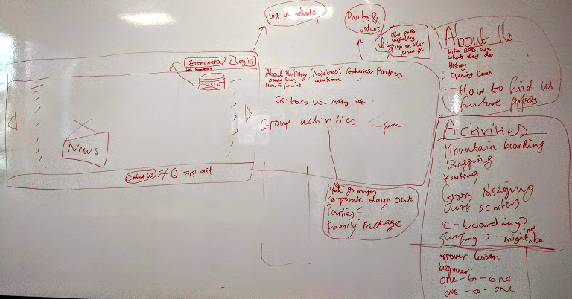
Figure 5: Site Plan of the BRD Sports Website.
After the project team meeting, the author created a simple outline of the pages for the website using Visio, as shown below. With this outline in place, the team could continue making notes for each page to add information such as images, text, links, videos.
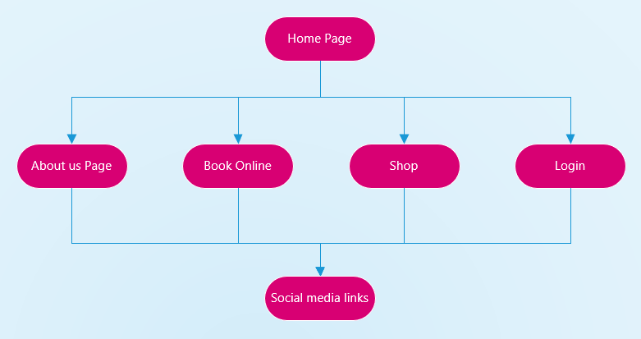
Figure 6: Visio Plan of BRD Sports Website.
The author wrote the code using HTML, PHP and CSS (see appendix) for the online shop for the BRD website project together with other members of the project team – Rhys Davies and Mark Huntly. The website shop page for BRD merchandise is shown below. More items will be added as the online store continues to be built.
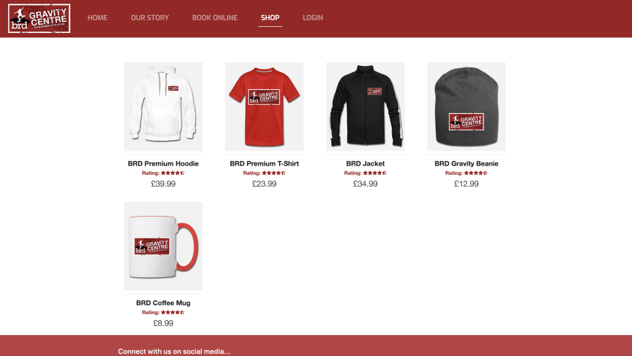
Figure 7: Shop Page of the BRD Sports Website.
Clicking on a specific item of merchandise takes the user to the product page where the customer can view the product selected in more detail as shown below. This page is still under construction and in time a shopping basket will be added for the shopper to add an item to cart.
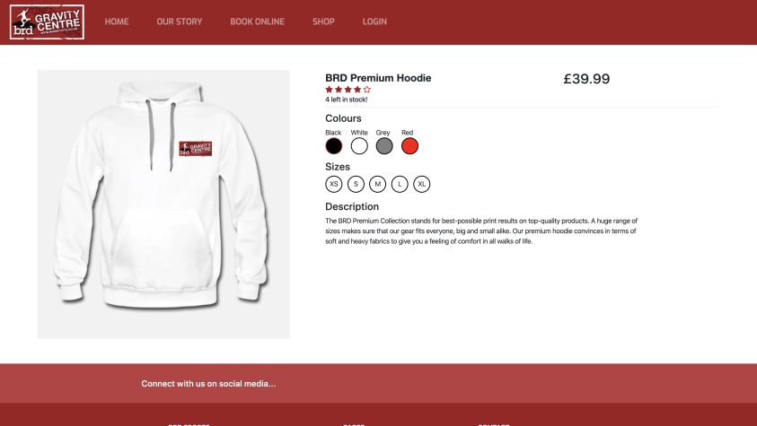
Figure 8: Project Page of the BRD Sports Website.
The following screenshots show the tables created using phpMyAdmin in order to create the Shop page.

Project Table
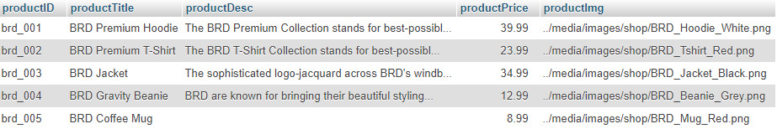
Figure 9: Project Table of the BRD Sports Database.

Project_Colour Table
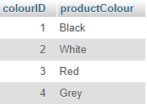
Figure 10: Project_Colour Table of the BRD Sports Database.

Project_Images Table
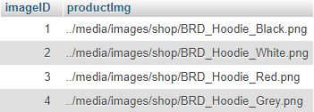
Figure 11: Project_Images Table of the BRD Sports Database.

Project_Object Table
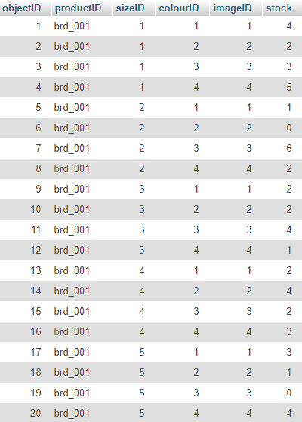
Figure 12: Project_Object Table of the BRD Sports Database.

Project_Size Table
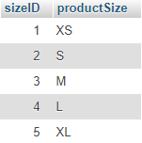
Figure 13: Project_Size Table of the BRD Sports Database.
A Facebook page was created by the author to promote the Div Digital project team as shown in figure 14.
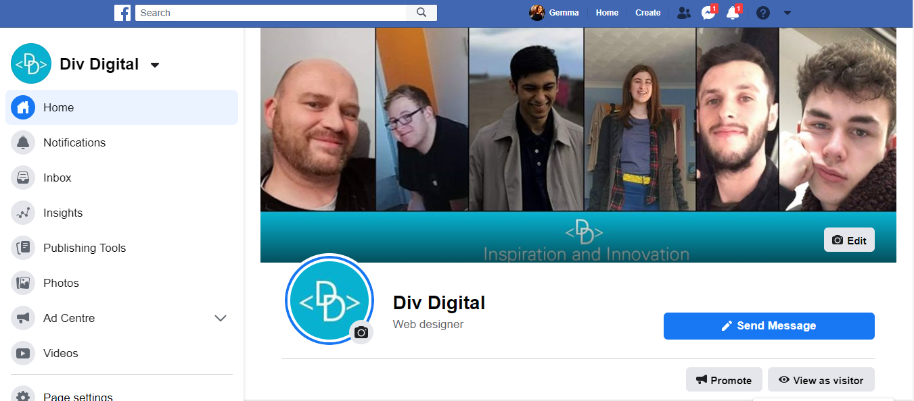
Figure 14: Div Digital Facebook Page.
An Instagram page was created by the author to promote the Div Digital project team as shown in figure 15.
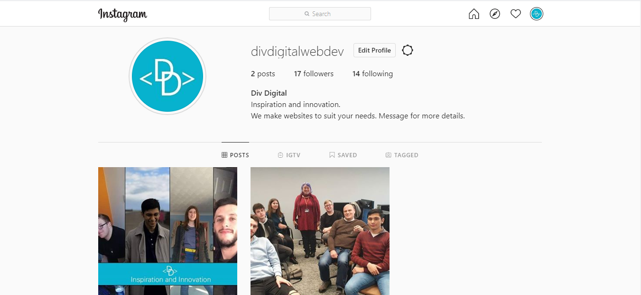
Figure 15: Div Digital Instagram Page

Div Digital Website
A website was created to advertise Div Digital. The author created the home page, the services page, the contact page and the portfolio page (still in progress) of this website. The website includes a slideshow to give an overview of the website, containing images of the team. Below the slideshow are links to the services page which explains what web services div digital can provide to the customer.

Home Page
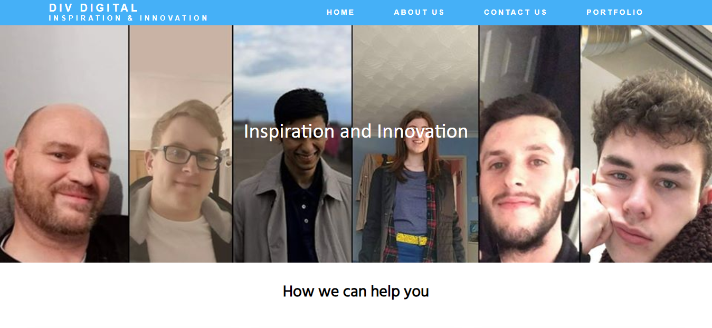
Figure 16: Home Page of the Div Digital Website.
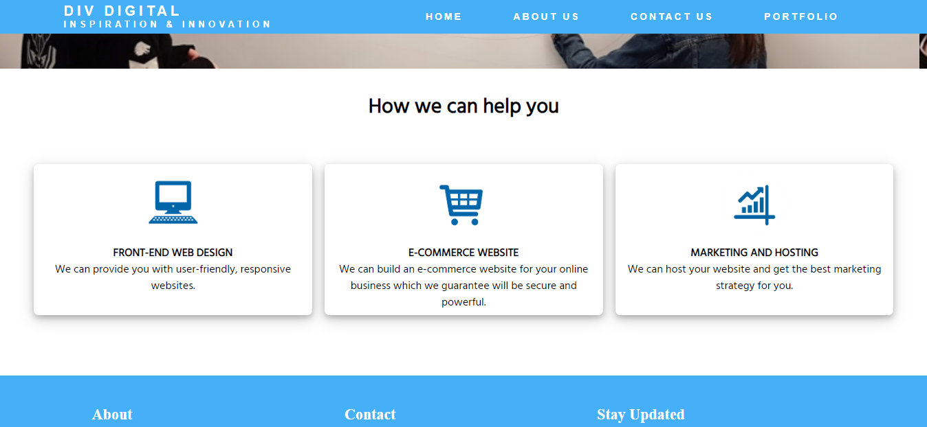
Figure 17: Home Page of the Div Digital Website.
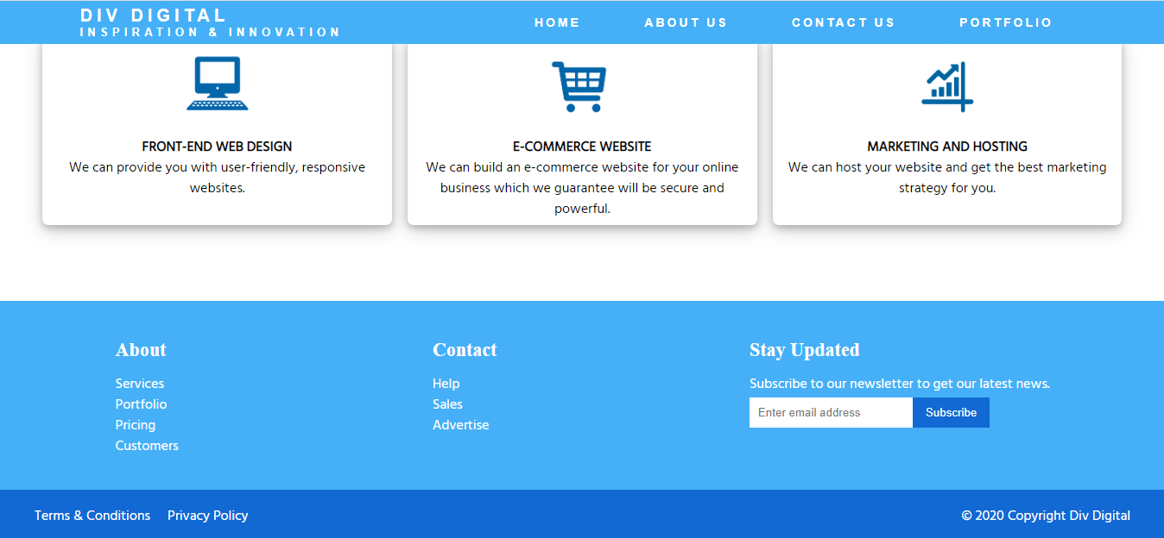
Figure 18: Home Page of the Div Digital Website.

Services Page
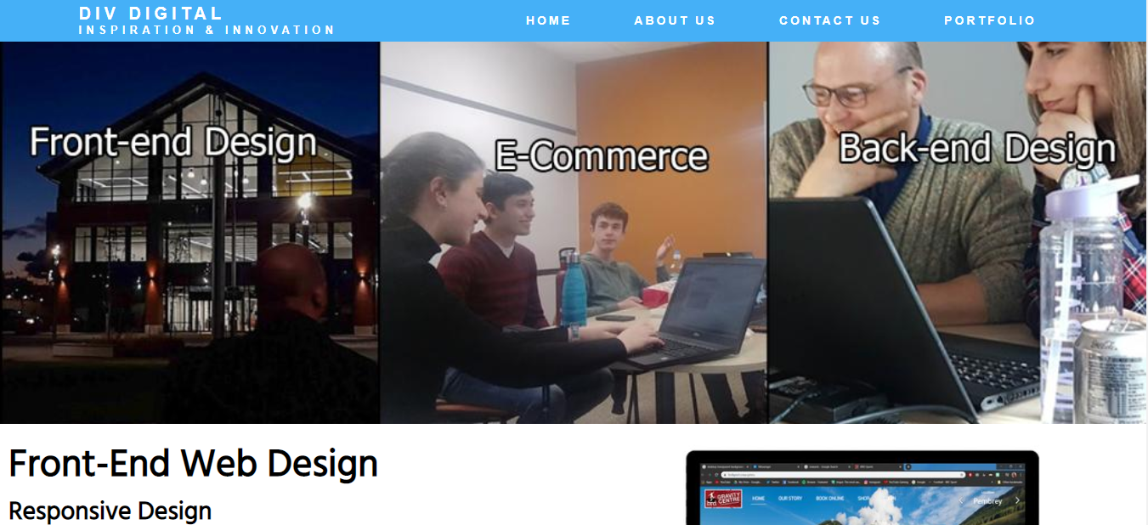
Figure 19: Services Page of the Div Digital Website.
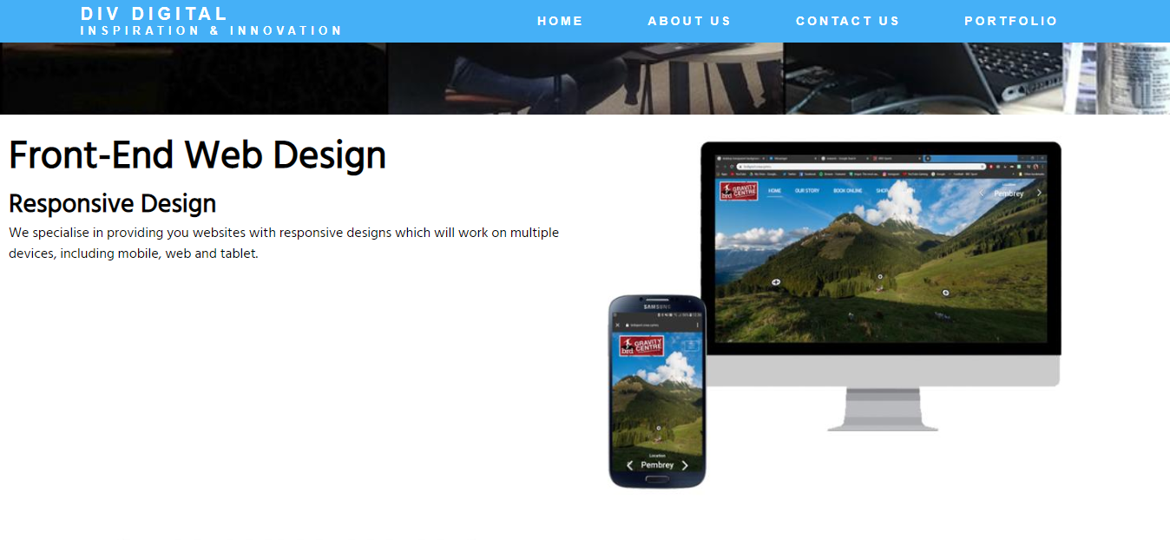
Figure 20: Services Page of the Div Digital Website.

Contact Page
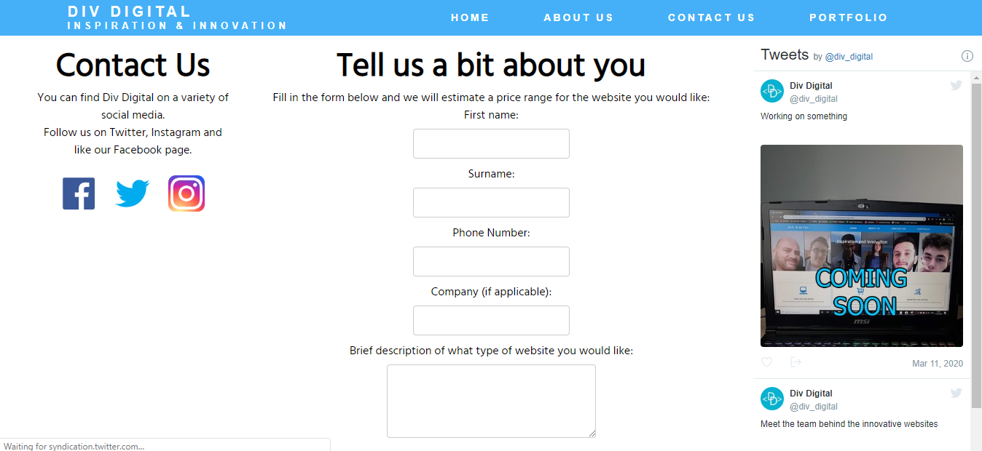
Figure 21: Contact Page of the Div Digital Website.

Portfolio Page
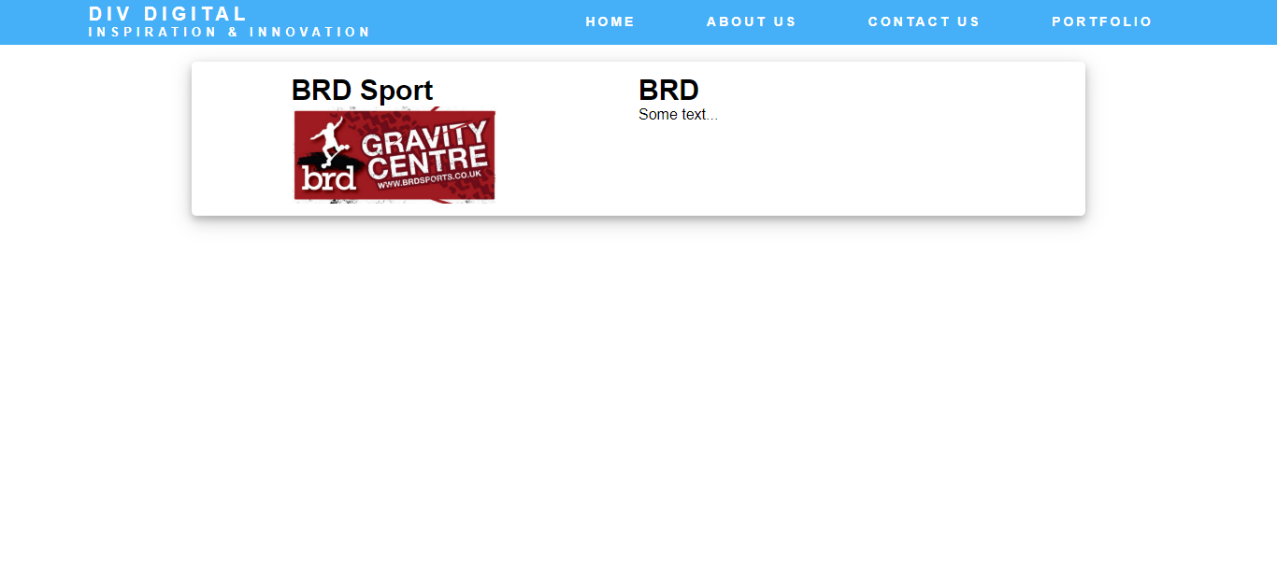

Figure 22: Portfolio Page of the Div Digital website.

Conclusion
The project team have worked effectively together to design and build the pages of the BRD Sports website. The pages are still under construction for full functionality such as completion of the online shop by adding more content and an option for the user to purchase an item. The homepage 360 innovative design is complete. A domain and server have been created, login and registration pages using MySQL and a shop page created using PHP and MySQL. The Login page is nearing completion which will be connected to the online shop.
The project team continue to meet regularly with the owner of BRD Sports and correspond by email and IM to gain approval.
It may be necessary to implement modifications to fit the website with BRD Sports organisation and structure, but the project is on schedule to be delivered on time.

Bibliography

[1] | D. Brownlee, “The secrets to running project status meetings that work!,” in PMI® Global Congress 2008, North America, Denver, CO, 2008.
[2] | Gantt.com, “What is a Gantt Chart?,” Gantt.com, 2016. [Online]. Available: https://www.gantt.com/.
[3] | J. M. Wilson, “Gantt Charts: A centenary appreciation,” European Journal of Operational Research, vol. 149, no. 2, pp. 430-437, 2003.
[4] | D. F. White, “Current practice in project management - An empirical study,” International journal of project management, 2012.
[5] | A. o. C. M. (ACM), “Layout 1,” 22 June 2018. [Online]. Available: http://www.acm.org/binaries/content/assets/membership/images2/fac-stu-poster-code.pdf. [Accessed 22 June 2018].
[6] | T. B. C. S. C. o. C. (BCS), “BCS Code of Conduct,” [Online]. Available: https://www.bcs.org/membership/become-a-member/bcs-code-of-conduct/.
[7] | G. D. Service, “Data Protection - GOV.UK,” [Online]. Available: https://www.gov.uk/data-protection.
[8] | G. Legislation, “Computer Misuse Act 1990,” [Online]. Available: http://www.legislation.gov.uk/ukpga/1990/18.
[9] | G. Legislation, “Copyright, Designs and Patents Act 1988,” [Online]. Available: http://www.legislation.gov.uk/ukpga/1988/48/contents. [Accessed 30 01 2020].
[10] | J. Kyrnin, “The Legalities of Linking,” WEB DESIGN & DEV, 25 June 2019.

Appendix 1: CPD Review

Reflection
The employability skills developed through undertaking the project were:
- As a team, verbal communication skills were developed in team meetings and communicating with the customer. Written communication skills were gained using a white board in meetings. As team leader team progress sheets were created along with Gantt Charts.
- Interpersonal skills were developed due to the interaction with other members of the project team, working together effectively and interacting with each other. Working as a team involved listening to other people’s ideas, expressing appreciation of other people’s ideas and work and resolving team issues and disputes. This included liaising with the customer and negotiation. The team meetings held by Div Digital encouraged collaboration and team building. As team leader, the author developed the skills of supporting other members of the team and showing appreciation, resolving disputes and supporting team members struggling with their tasks. The uniqueness and diversity of the team helped to design the website effectively but at times lead to conflict which as team leader helped develop skills in conflict resolution. All the team developed team working skills and recognised the importance of responsibility and dependability.
- The employability skills of problem solving were developed, for example problems with the code such as the functionality of the slideshow.
- Organising and planning the project served to gain employability skills. Planning meetings and tasks for each team member to complete was achieved by creating a Gantt chart. Leadership skills were required occasionally when a team member was struggling/falling behind with their work and needed support.
- The technical skills were web development skills. HTML/CSS, JavaScript, PHP, phpMyAdmin, responsive design, analytical skills, visual design, choosing the right design appropriate to enhance the look and feel of the website. How to use project management software to create Gantt charts for the purpose of streamlining the project. Team software communication tools, such as Slack and GitHub.
- Social media skills. The author made the Facebook page and Instagram page and learned how to make a business page on both social medias in order to contribute to the marketing of the project.
- The author learned how to integrate Div Digital Twitter posts into the Div Digital website.
- Time management skills. As managing time and work was crucial for the success of the project, deadlines had to be respected and the use of Gantt charts and progress sheets was used to facilitate this.

Networking
The author attended the following Paul Hardward (Techhub Swansea) enterprise masterclasses.
Talk 1: Money, Shares, Value, Deals What is money anyway?
The value of money and understanding shares and cryptocurrency.
Talk 2: Founders and Investors. How many founders is good?
Founders of business ideas and to target investors.
Talk 3: Why Companies Die
The different reasons why different companies succeed and fail and identifying the signs of failure.
Talk 4: Products, Sales, Markets and Timing.
Developing a new product and finding a market for it.
Talk 5: Viable Businesses.
Launching and running a viable company which can adapt to survive with minimal admin.
Talk 6: Resilience
Being strong, resilient and adapting to change in a business.

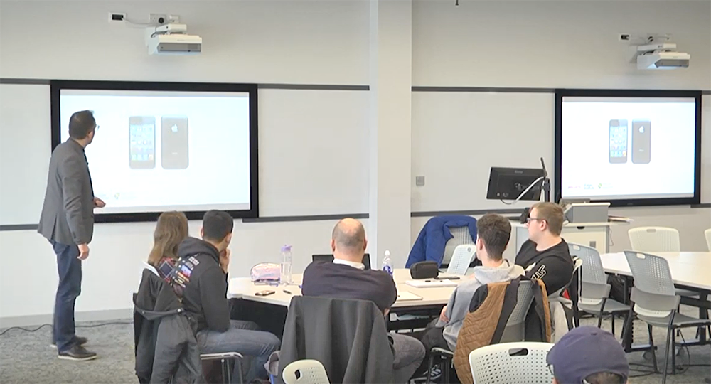
Image of Paul Harwood Masterclass
The author attended a visit and tour at the BT tower in Swansea on the 4th March 2020. The tour by Dan Hawkes (test facility lead at BT) included looking at the BT Test Centre’s activities and projects including a review of how traditional contemporary and new technologies are tested.

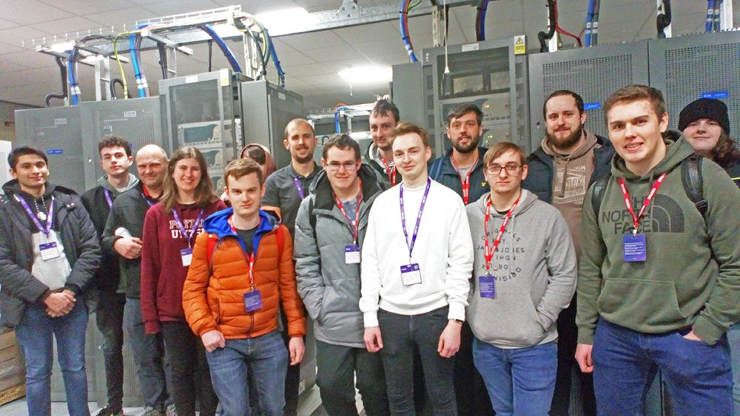
Image of BT Tower Tour.

Team Working

Team Progress Sheets

Team Progress Sheet 1
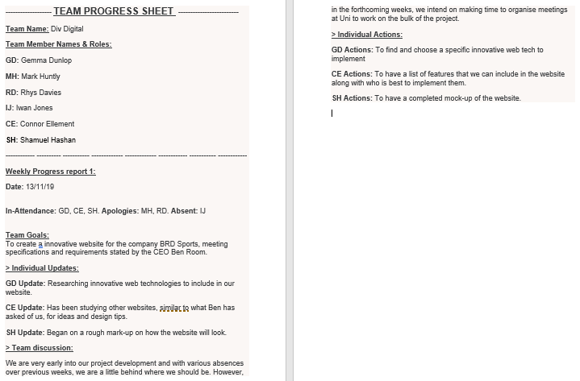

Team Progress Sheet 2
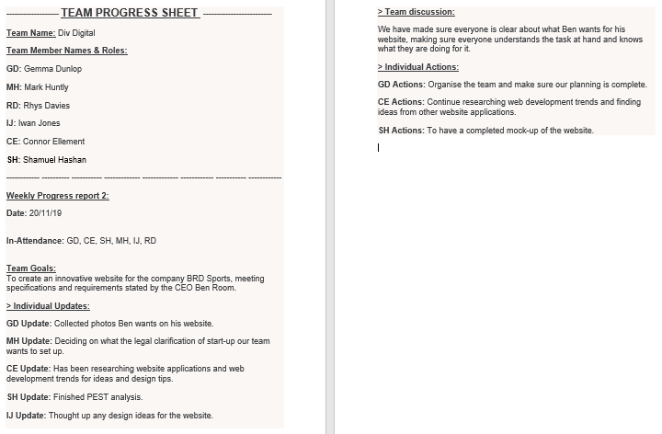

Team Progress Sheet 3
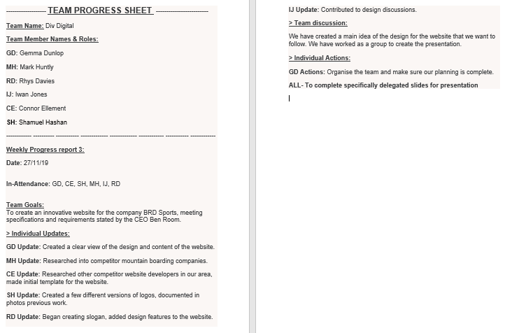

Team Progress Sheet 4
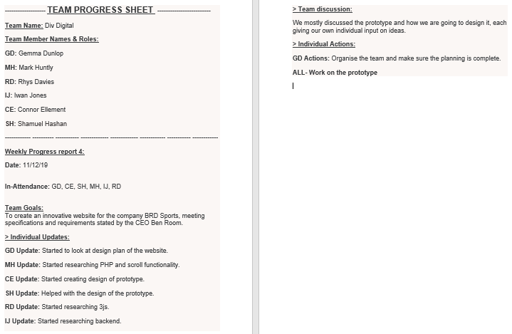

Team Progress Sheet 5
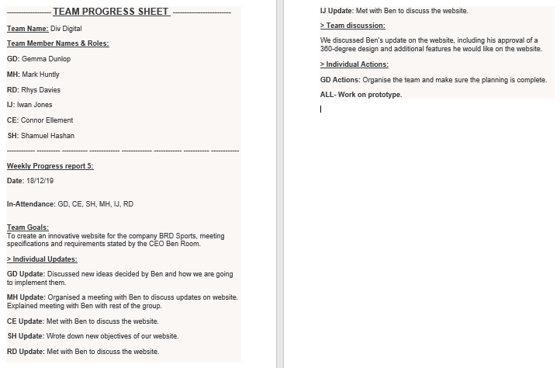

Team Progress Sheet 6
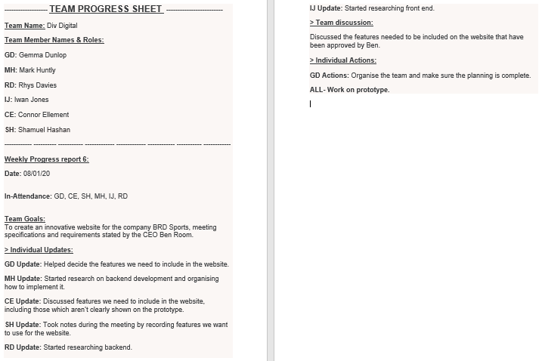

Team Progress Sheet 7
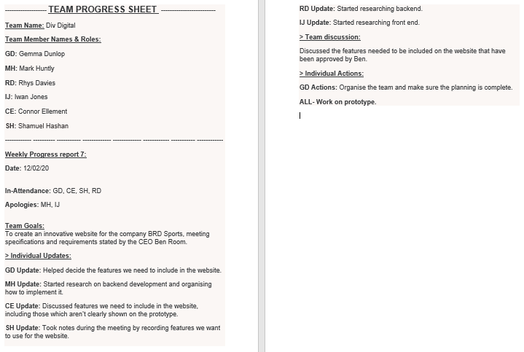

Team Progress Sheet 8
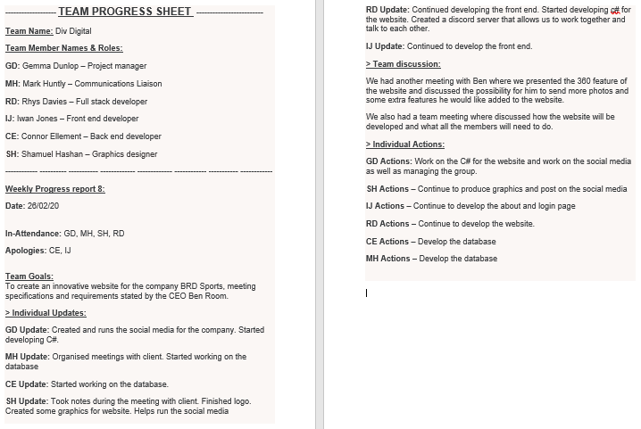

Team Progress Sheet 9
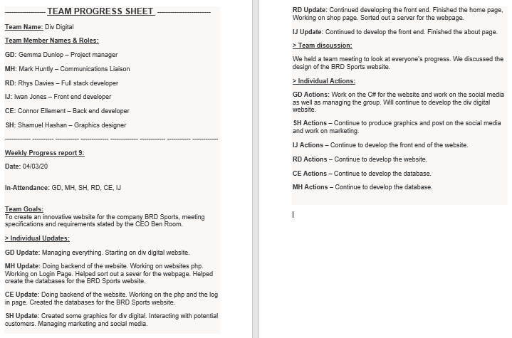

Gantt Charts
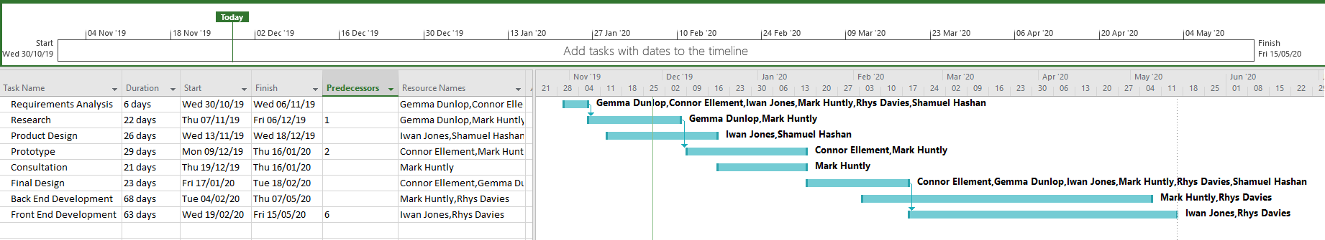

Appendix 2: Code Extracts

Div Digital Website Code

Slideshow

HTML
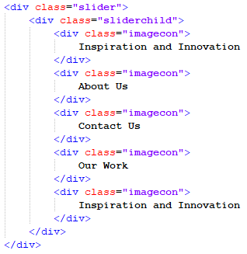

CSS
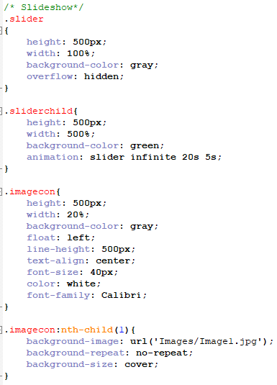
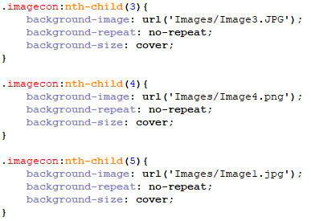
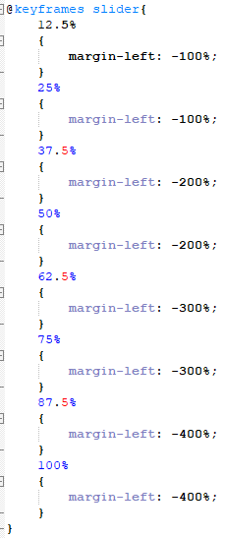

Nav bar

HTML
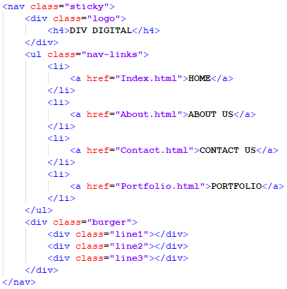

CSS
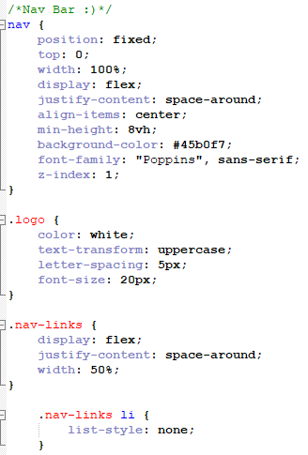
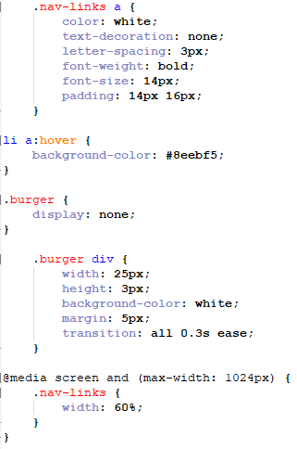
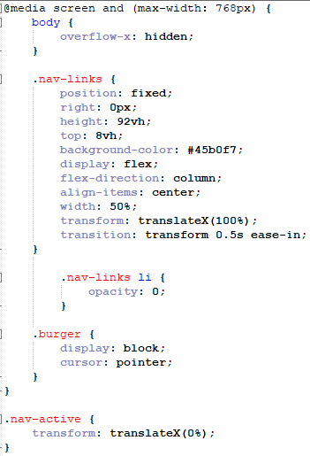
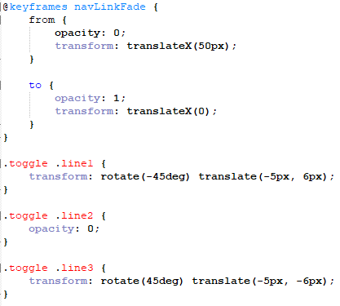

JavaScript
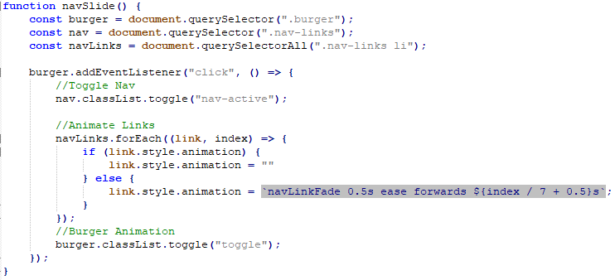

Home Page

HTML
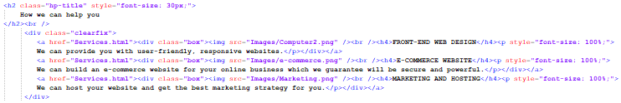

CSS
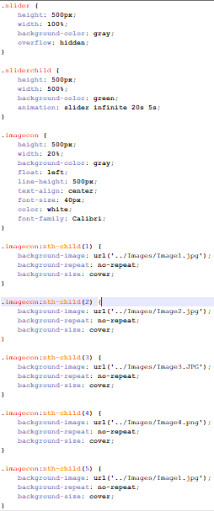

Contact.php

HTML
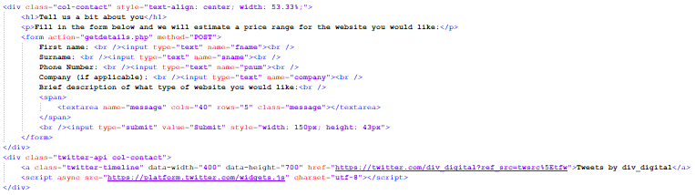

CSS
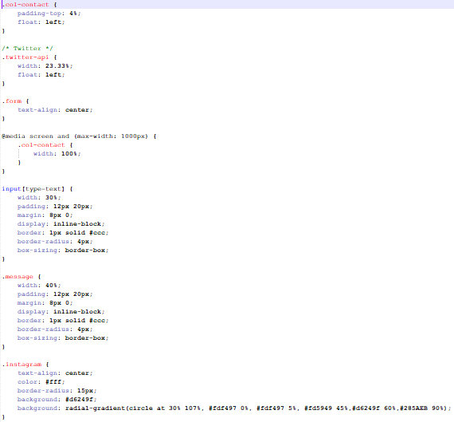

Services.php

HTML
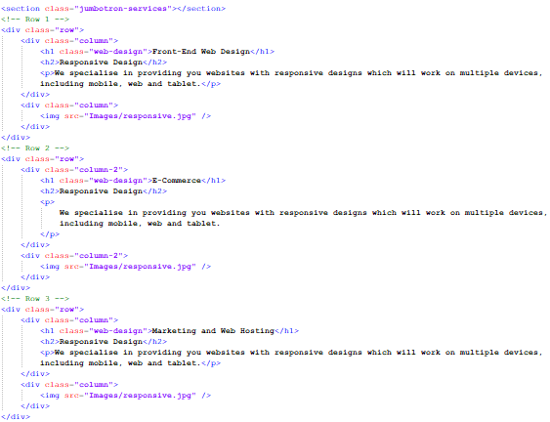

CSS
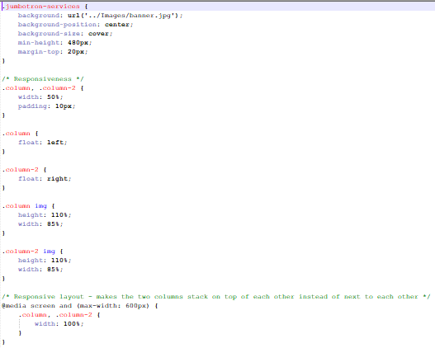

Portfolio.php

HTML
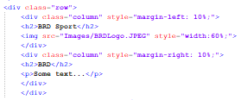

CSS
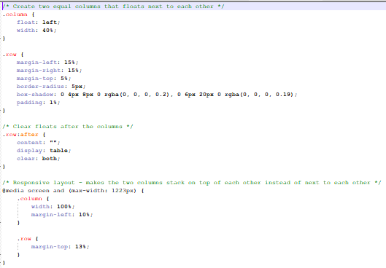

BRD Sports Shop Page Code

Product.php

HTML/PHP
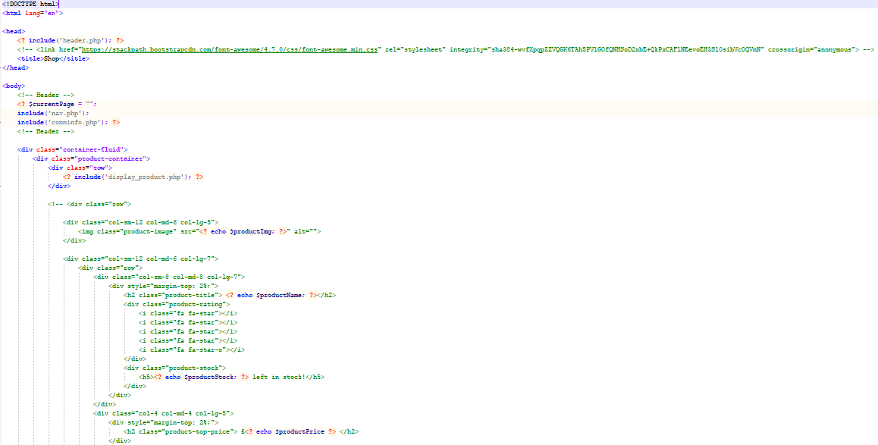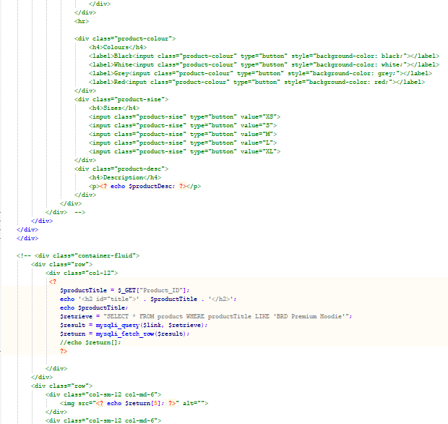
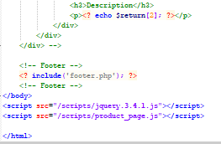
Conninfo.php

PHP
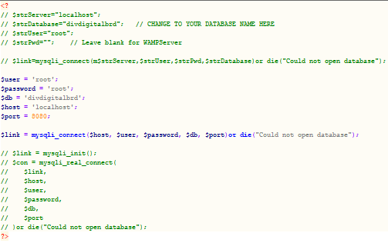

Shop.php

HTML/PHP
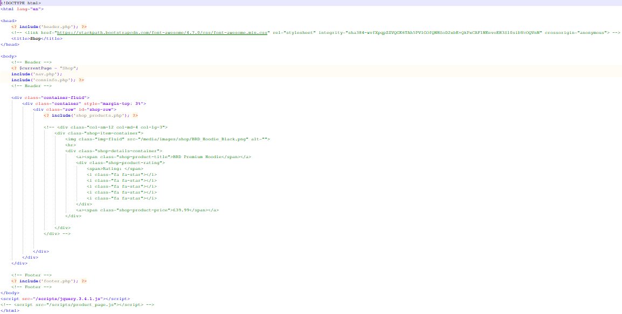

CSS
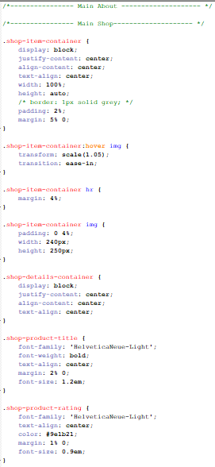
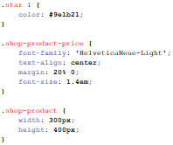

Shop_products.php

PHP
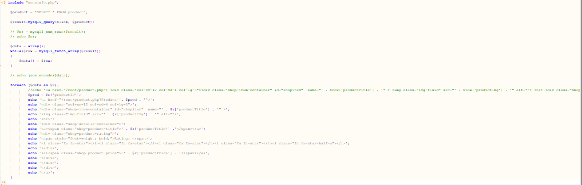

CSS


