University of Wales Trinity Saint David

School of Engineering

CFD Ahmed Body

Advanced Computational Methods
M6X00408

Timothy Jones
1701384

26/01/2020
Contents
1 Introduction 1
2 Literature Review 1
3 Methodology 2
3.1 Base Case 2
3.2 Domain Independence Study 8
3.3 Mesh Strategies 9
3.3.1 Global Element size 10
3.3.2 Density boxes 10
3.3.3 Prism layers 12
3.3.4 Global Scale factor 14
3.4 Turbulence Models 15
3.5 Solver Settings 16
4 Conclusion 17
5 References 18

Introduction
The aim of this assignment is to understand the CFD process using the Ahmed body. The Ahmed body is widely used to validate aerodynamic principles through the use of a model with changeable characteristics such at the slant on the back of the body (Meile, Brenn, Reppenhagen, Lechner, & Fuchs, 2011). A base case will be made demonstrating the geometry and mesh strategies used as well as the fluent setting. After this has been demonstrated, an independence study will be undertaken to acknowledge how various domains sizes impact the coefficients of lift and drag. Analyse how the type of mesh used, density and location to depict areas of turbulent flow. Experiment with difference turbulent models and solver setting to discover the how making these changes affect the air flow.

Literature Review

Computational fluid dynamics (CFD) consists of various equations being solved simultaneously to simulate the flow of fluids and their interactions with a chosen body with predefined boundary conditions. The foundations of CFD are based the navier-strokes equation which presents incompressible fluid flow (Hosch, n.d.). The navier-strokes equations are based on the conservation laws surrounding momentum, energy and mass to produce the continuity equation as well as energy and momentum equations. To solve these equations a technique called discretization must be used to define the location of elements in which the calculations will take place using the finite volume method (Zuo).
Following the finite volume method, the size of elements is specified by the grid or mesh chosen within the domain. How coarse or fine the mesh at specific locations would be determined by an object’s effect on fluid flow. Areas of turbulence and changing flow need a finer mesh to capture data precisely. Whereas simple geometries and areas located away from a main body where flow is undisturbed can be given a coarse mesh (Zuo).
The amhed body doesn’t present all the key features to visually represent a car, although the shape and rear slant enable the body to demonstrate the essential aerodynamic features to calculate its relative drag coefficient (Thacker, Aubrun, & Leroy, 2013).

Methodology

Base Case

Creating the appropriate domain depends on the desired results. The scale of the domain would increase or decrease the number of cells within the mesh. A greater domain would be accurate and capture all the flow around the ahmed body but take time to solve. Alternatively, a smaller domain would improve time efficiency but forfeit accuracy to produce a simple model quickly. The domain in this study should reach a respectable level accuracy relative to the given standard lift and drag values as effectively as possible.
- Initial domain justification
Firstly, to set up the fluid flow simulation of the Ahmed body the domain and geometry must be created. The domain is the volume of space in which the fluid will flow through, simulating the body if it were placed in a wind tunnel. A study into automotive aerodynamics suggest when creating a domain to locate the vehicle with 3 times its length in front and 5 times its length trailing the body (Lanfrit, 2005).
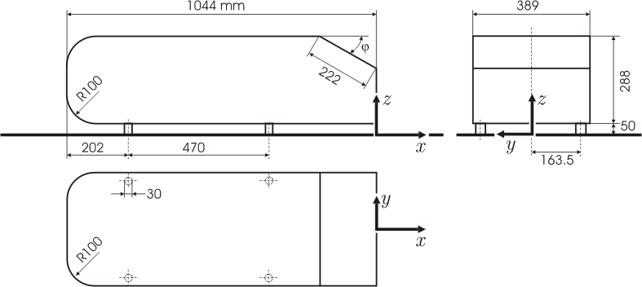

Figure 1 (Ahmed Body Design) (Tudor, 2019)

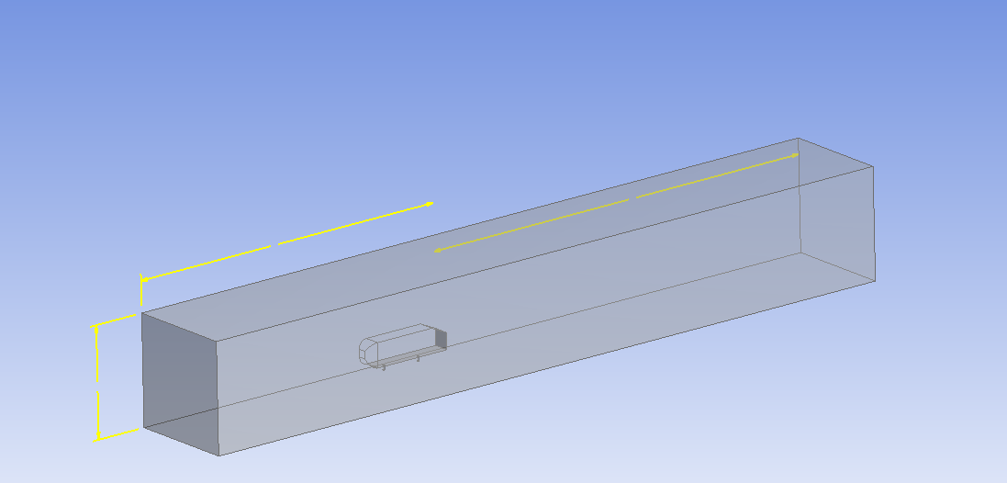
Figure 2 (Initial Domain)

Using the dimensions of the ahmed body shown in figure 1 with a car length of 1044mm to create a domain with 5m behind the body and 4m to the back of the body to have 3m leading the ahmed body. The width and height for the initial domain is set at 1.3m.

- Producing mesh strategy for base case
To discover the optimal domain an appropriate mesh must be built around the ahmed body in order to interpret the data accurately. A coarse mesh would affect the results shown in the fluent solver, presenting the issue of distinguishing the results due to a changing domain to the fineness of the mesh running the simulation. As this is domain independent study once the appropriate mesh is assembled it will be used on all the domains to effectively scrutinise the changes purely through domain alone.

Upon opening ICEM CFD which is software used to produce the mesh, a body is created spanning the volume to encapsulate the space in which set the air will flow and mesh will be built within. This volume is set at the global geometry of the mesh. As shown in figure 3 the global element size is set to 0.15m with a scale factor of one. A small global mesh is used to span the whole volume relatively accurately before determining a more efficient mesh in the mesh independent study.
The parameters are set up to all triangles and to be patch independent. The method in which the mesh is built is using the robust octree method.
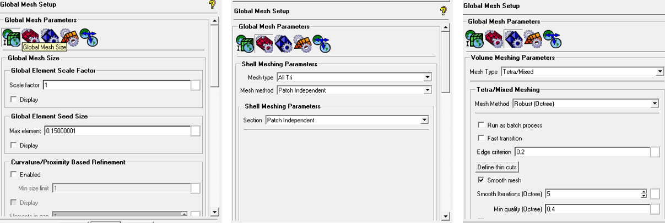
Figure 3 (Global geometry)

To encapsulate specific areas of activity around the ahmed body can be done using density boxes. A density box creates a volumetric body in which the size of cell can be adjusted to create smaller cells to better calculate the coefficients of lift and drag.
As the ahmed obstructs the flow of air in the wind tunnel a density box is located around the whole body 2.5 times in the x, y and z dimension. The cell size within this density box is 0.025m.

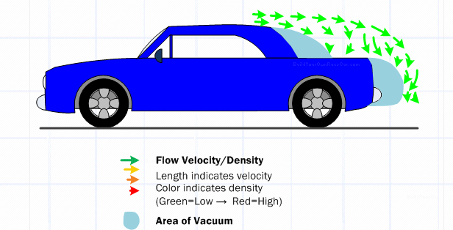
Figure 4 (Aerodynamic Principles) (Build Your Own Race Car)

As air flow increases around a vehicle the empty spaces created contain turbulent air flow called eddy’s represent in figure 4 (Build Your Own Race Car, n.d.). Using this information another density box is added around this rear section of the ahmed body with equal to one car length and extended by a factor 1.5 in the y and z dimension. Due to the vacuum and turbulences in this region that affect lift and drag the cell size is 0.01m to capture the rapid changes in the air flows velocity.

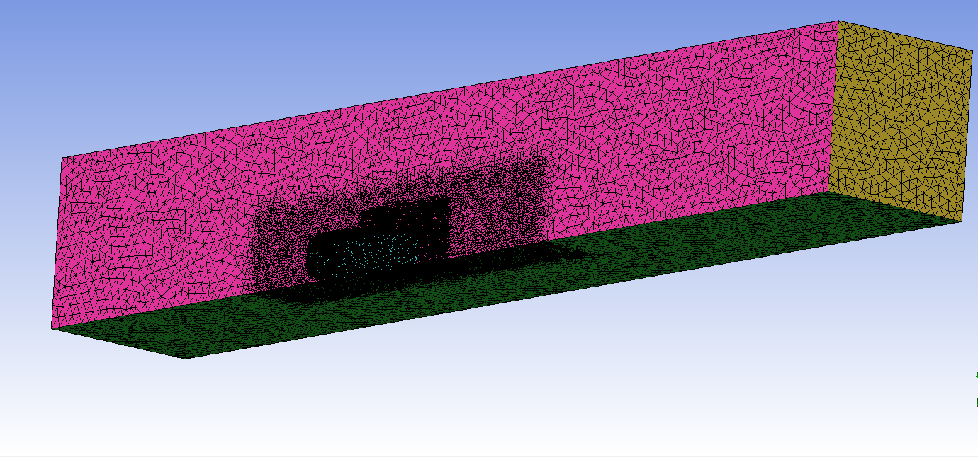
Figure 5 (Mesh density and position)

Due to the no slip boundary condition there are sharp velocity gradients at a point where a solid and fluid meet (Katopodes, 2019). As there is this change in velocity along the surfaces of the ahmed body a total of 5 prism layers at 0.01m have been added to the mesh.
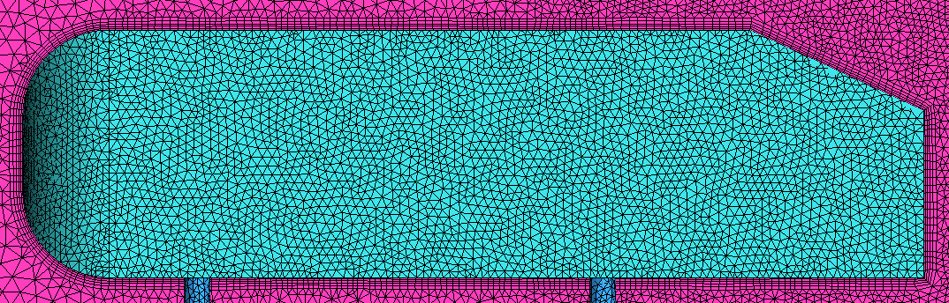
Figure 5 (prism Layers)

- Fluent setting for base case
After the mesh has been generated the mesh is imported into fluent. Fluent is used to model the flow and turbulence for fluids (ANSYS, 2020). In this application the ahmed body can simulated for a given velocity of 40 m/s to determine the coefficient of lift and drag created by the 25-degree slant on the body.
Throughout the set up of fluent, the original setting where possible have been kept as default to study different turbulence model later in the study. For the initial model K-Epsilon is used, as it’s the most commonly used model where turbulent flow is present (Simscale, n.d.). K-Epsilon is used throughout the domain and mesh independent studies. The settings within K-Epsilon are realizable with non-equilibrium wall functions.

Ahmed Body | Wall
Internal body | Interior
Inlet | Velocity Inlet
Outlet | Pressure Outlet
Symmetry | Symmetry
Topside | Wall
Floor | Wall
Legs | Wall
Table 1 (Boundary Conditions)
The velocity inlet’s parameters contain a velocity component in the x axis at 40 m/s. The outlet is specified as a pressure outlet set to atmospheric pressure. Wall boundary condition causes each part to act as a wall. Using the reports section within fluent is used to determine the projected surface area of the Ahmed body and legs in the x direction to set as a reference value. These simulations were solved as coupled as it is robust solving steady state flow scenarios rather than being used to solve for transient flow (eneagrid.enea.it, 2009). Cd and Cl monitors are set up to analyse on the Ahmed body and legs. To update fluent to these setting its initialized as a hybrid, then the number of iterations it set and run until the solution is converged.

Cl | Cl % | Cd | Cd% | Total difference %
0.36123 | 4.704348 | 0.30919 | 3.408027 | 4.056187291
Table 2 (1st domain coefficients)

Cl = | 0.345 | Cd= | 0.299

Table 3 (Cl & Cd of the ahmed body)

The results for the first domain already produce coefficients of lift and drag within 5% error of the given coefficients. The next stage of the process is to change the domain to see how the results vary with different domains. As the results are producing within the range a smaller domain will be selected in the intension of reducing the number of elements and retaining a similar level or accuracy based on the post processing from the 1st domain.

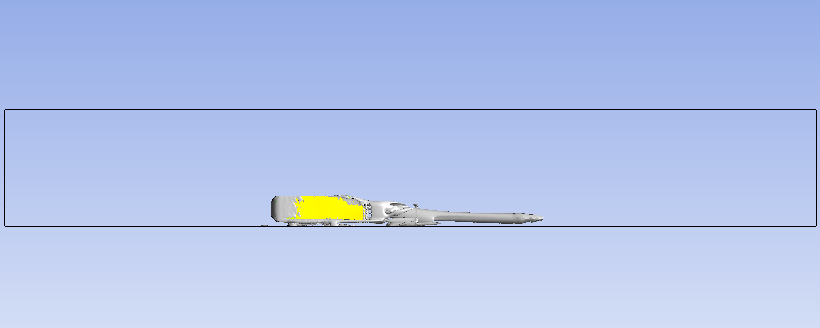
Figure 6 (Vortex Post-processing)
Figure 6 shows a vortex of a strength of 0.01. At this strength it displays turbulent flow close to the Ahmed body, as well as a wake trail produced by the back of the body.

Domain Independence Study

The 2nd domain is created following the results of the 1st domain. The domain behind the body is shortened by 2.5m so that it covers the entirety of the vortex at this strength.
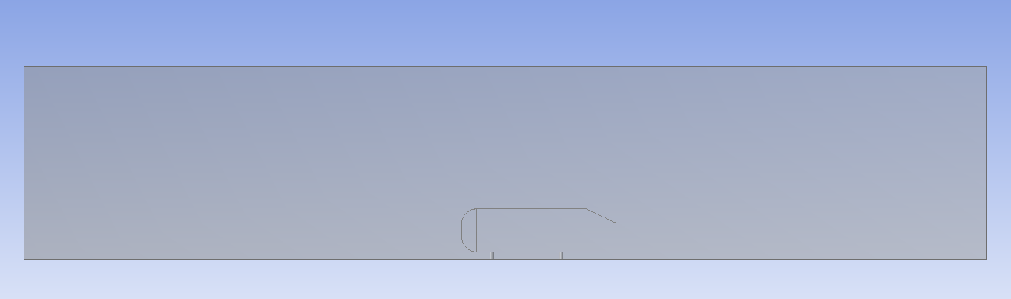
Figure 7 (2nd Domain)

Domain |  | Cl | Cl % difference | Cd | Cd % difference | Total % difference
Front (m) | Behind (m)
3 | 5 | 0.36123 | 4.704348 | 0.30919 | 3.408027 | 4.056187291
3 | 2.5 | 0.31851 | 7.678261 | 0.28528 | 4.588629 | 6.133444816
3 | 2.75 | 0.27259 | 20.98841 | 0.27551 | 7.856187 | 14.42229654
3 | 3 | 0.37169 | 7.736232 | 0.30742 | 2.816054 | 5.276142698
3 | 3.25 | 0.36234 | 5.026087 | 0.29877 | 0.076923 | 2.551505017
1.5 | 3.25 | 0.32567 | 5.602899 | 0.30761 | 2.879599 | 4.241248606
2 | 3.25 | 0.37497 | 8.686957 | 0.31037 | 3.802676 | 6.244816054
Table 4 (Domain)
Table 4 shows the change in the back of the domain in intervals of 0.25 until 3.25m which was within 2.55%. As it is within a well-respected amount of error there was no need to extend behind the rear of the body and focus in front of the body.

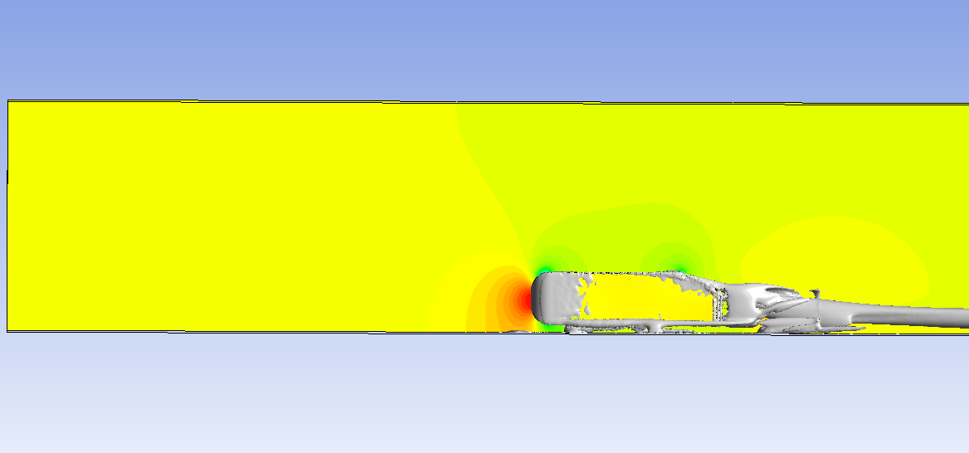
Figure 8( Pressure Contour)

Figure 8 is a pressure contour on the symmetry plane. High pressure is built up on the nose of the Ahmed body as velocity decreases was it comes in contact with the body. There is a substantial distance between the pressure contours and the inlet. Therefore, the domain was decreased to smaller dimensions. The percentage in error increased as the domain was shortened concluding that the domain should remain at 3m in front at 3.25m behind.

Mesh Strategies
The mesh independent study will utilise the optimum domain discovered in the domain independent study. This mesh strategy investigation is a continuation of the mesh presented in the base case. Depending on the task presented will result in different mesh refinements. A finer mesh theoretically displays more accurate results. However, the finer the mesh computational time increases (AUTODESK.Support, 2015). Different mesh strategies are needed to implement mesh fineness in areas of significance. Doing so will reduce computational time. If the whole domain was set to a single fine mesh, it would drastically increase time at no greater accuracy to the results.

Global Element size

Global Element size | Cl | Cl % difference | Cd | Cd % difference | Total % difference
0.15 | 0.36234 | 5.026087 | 0.29877 | 0.076923 | 2.551505017
0.2 | 0.35052 | 1.6 | 0.30748 | 2.83612 | 2.218060201
0.25 | 0.35052 | 1.6 | 0.30748 | 2.83612 | 2.218060201
0.3 | 0.35052 | 1.6 | 0.30748 | 2.83612 | 2.218060201
0.4 | 0.35414 | 2.649275 | 0.31421 | 5.086957 | 3.868115942
Table 5 (Global Element Size)
From 0.2 – 0.3 there was no change in coefficients therefore its optimum global mesh is 0.3 being that it matches the accuracy of a slightly finer mesh with less elements and computational time. It can be assumed that from the global element size being able to reach 0.3, the locations of interest which dramatically effect lift and drag coefficients are contained elsewhere within the density boxes.

Density boxes

Figure 9 displays mesh density represented by the red dots, a velocity contour and a vortex with a strength of 0.01. This figure is useful to locate areas interest against the current mesh, such as the nose of the Ahmed body in which there are changes in from low to high velocities as well as turbulent flow on the surface.

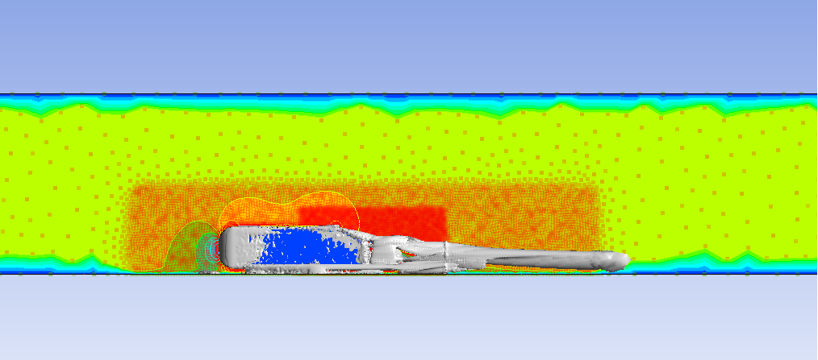
Figure 9 (Mesh, Vortex & Velocity Contor)
An additional density box equal to half the length of the density box to the rear of the body is placed at the front. The dimensions of the box were increases by 1.5 in the z axis and then subsequently in the x axis. The reasoning for the z axis is shown in figure 10. A plane positioned parallel to the width of the body contains velocity vectors distributing outwards as the air interacts the body.

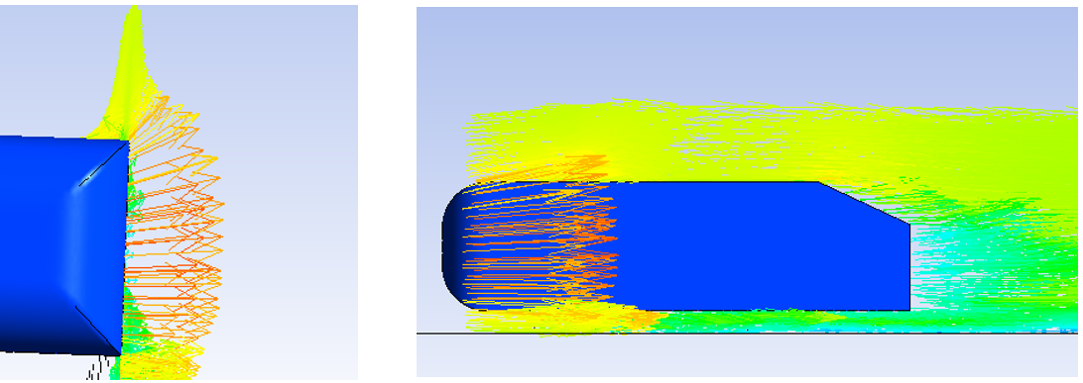
Figure 10 ( Velocity Vector)
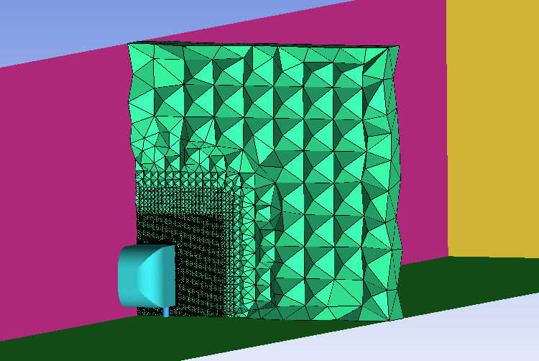
Figure 11 (Cut Plane Mesh)
Table 6 (Density Boxes)
Density box | Cl | Cl % difference | Cd | Cd % difference | Total % difference
0.5 x body | 0.36267 | 5.121739 | 0.30267 | 1.227425 | 3.17458194
1.5 x in z | 0.33691 | 2.344928 | 0.30122 | 0.742475 | 1.543701226
1.5 x in x | 0.37632 | 9.078261 | 0.3061 | 2.374582 | 5.726421405

Increasing in the z axis decreases the error in lift and drag and the extension in x axis made no increase in the accuracy. Therefore, moving forward only the increase in z axis has been used.

The standard of mesh currently being produced is highly similar to that of 2 peer reviewed journals. In both of these studies they have used the Ahmed body with the same 25-degree slant. The mesh structure in figures 12 & 13 compared to figure 14 capture the same regions of fine mesh needed to produce respectable values for lift and drag.
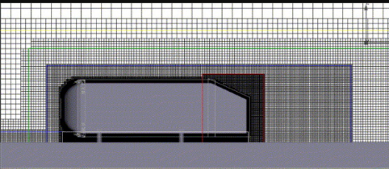
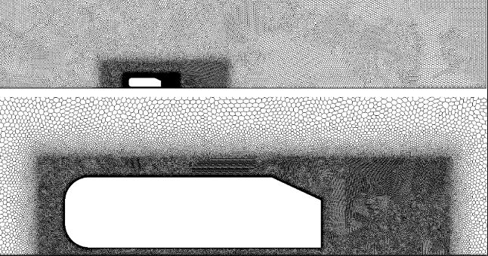
Figure 13 (Fares, 2006)
Figure 12 (Corallo, Sheridan, & Thompson, 2015)
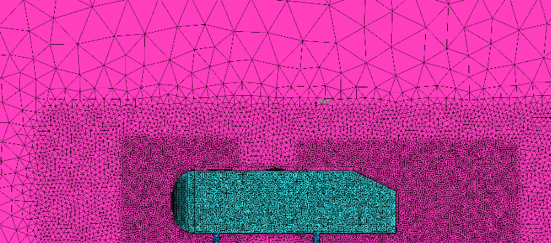
Figure 14 ( Mesh Location and Density)

Prism layers

Another journal that looks into the affects of lift and drag displays areas of greater turbulence, creating a vortex at the edge of the slant and on the surface of the slant displayed in figure 15. At a strength of 0.1 in figure 16 displays similar findings validating the mesh currently being used.
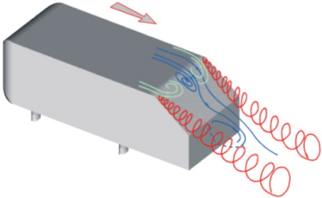
Figure 15 (Guilmineau, 2008)
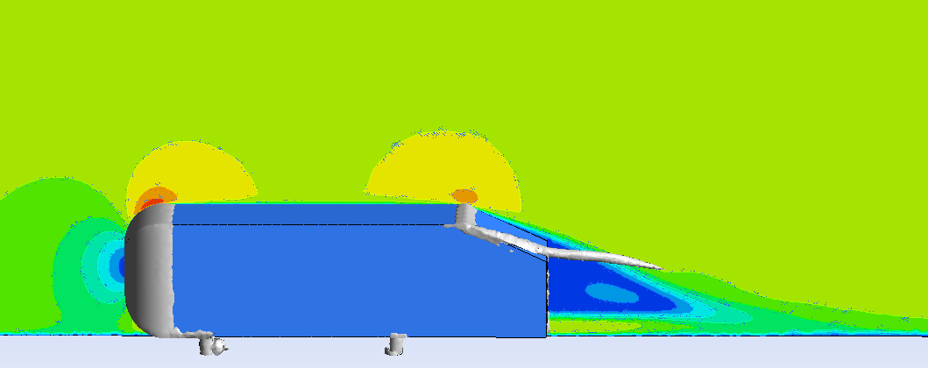
Figure 16 (0.1 vortex)
These areas of greater vortex strength and acceleration in velocity in close proximity to the Ahmed body present the case to study prism layers further. Currently 5 prism layers have been used since the base case. The number of layers has been experimented with to see how these areas capture change in air flow differently.

Prism Layers | Cl | Cl % difference | Cd | Cd % difference | Total % difference
1 | 0.36674 | 6.301449 | 0.30628 | 2.434783 | 4.368115942
2 | 0.35607 | 3.208696 | 0.31205 | 4.364548 | 3.786622074
3 | 0.34125 | 1.086957 | 0.30425 | 1.755853 | 1.421404682
4 | 0.36576 | 6.017391 | 0.30182 | 0.943144 | 3.480267559
5 | 0.33691 | 2.344928 | 0.30122 | 0.742475 | 1.543701226
6 | 0.34821 | 0.930435 | 0.30206 | 1.023411 | 0.976923077
7 | 0.36461 | 5.684058 | 0.30199 | 1 | 3.342028986
Table 7 (Prism Layers)

Although there is some distribution of results with varying prims layers there is a general trend can be seen. Increasing prism layers decreases the percentage error. Anomalous results such as these within a CFD process could be due to the quality of mesh not aligning properly an obscuring the results as theory suggest a finer mesh as referred to in 3.3 (AUTODESK.Support, 2015).

Global Scale factor

Global scale factor reduces or increases the size of every element within the domain. Following on from 6 prism layers with a percentage of error of 0.97 %. As this is extremely accurate to the actual values for lift and drag it would be beneficial to increase the scale factor to determine if less elements could achieve similar result. Increasing scale factor as shown in figure 17 demonstrates a trend that an increasing scale factor has a great percentage of error.
To see the effects of a reduced scaled factor 0.6 was computed but contained 20,000,000 + elements compared to that of 4,700,000 elements with a scale factor of 1. Therefore, it was not solved as the time taken would not outweigh any further accuracy. A factor of 0.9 didn’t display any improvement to the current mesh.

Global Scale Factor | Cl | Cl % difference | Cd | Cd % difference | Total % difference
0.9 | 0.35459 | 2.77971 | 0.30345 | 1.488294 | 2.13400223
1 | 0.34821 | 0.930435 | 0.30206 | 1.023411 | 0.976923077
1.1 | 0.35325 | 2.391304 | 0.30195 | 0.986622 | 1.688963211
1.3 | 0.37465 | 8.594203 | 0.32236 | 7.812709 | 8.203455964
1.5 | 0.35055 | 1.608696 | 0.33023 | 10.44482 | 6.026755853
2 | 0.4091 | 18.57971 | 0.3738 | 25.01672 | 21.79821628
Table 8 (Global Scale Factor)

Figure 17 ( Global Scale Factor)

Turbulence Models

All the turbulence models all attempt to capture the complexity of turbulent air flow but as simply as possible only retaining the underlaying physical properties due to its complexity (Sodja, 2007). Each model varies as the number of equations used per model changes and many have different functions within a turbulence model.

Turbulence Models | Cl | Cl % difference | Cd | Cd % difference | Total % difference
Spalart- Allmaras | 0.37804 | 9.576812 | 0.32624 | 9.110368 | 9.343589744
K-Omega | 0.34881 | 1.104348 | 0.30367 | 1.561873 | 1.333110368
k-kl omega | 0.46909 | 35.96812 | 0.5431 | 81.6388 | 58.80345596
K-Epsilon standard | 0.38094 | 10.41739 | 0.33851 | 13.21405 | 11.81571906
K-Epsilon Realizable | 0.36925 | 7.028986 | 0.3159 | 5.652174 | 6.34057971
K-Epsilon Realizable Non-equilibrium wall functions | 0.34821 | 0.930435 | 0.30206 | 1.023411 | 0.976923077
Table 9 (Turbulence Models)

Within K-Epsilon, the difference between standard and realizable was 5% difference and with non-equilibrium wall functions the percentage error reduced to 0.97 % total difference. This shows how each model best describes different turbulence models. Figures 18 & 19 show the 2 models with greatest error displayed the air floe around the body. They both calculate the air flow in areas of acceleration differently resulting in their percentage difference from desirable coefficient values.

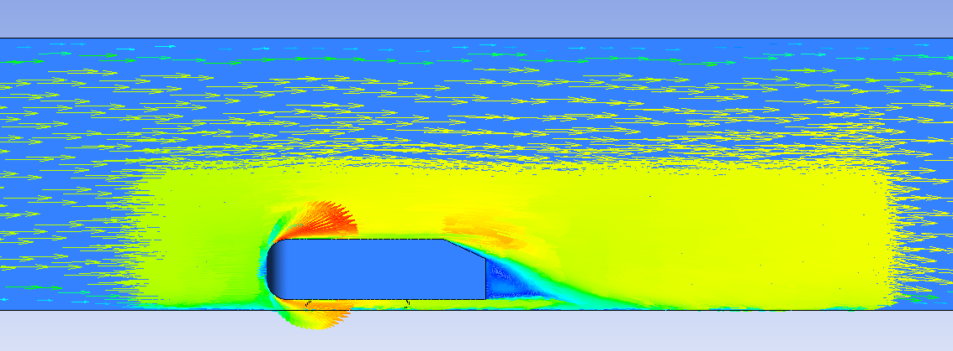
Figure 18 ( K-Epsilon Standard)

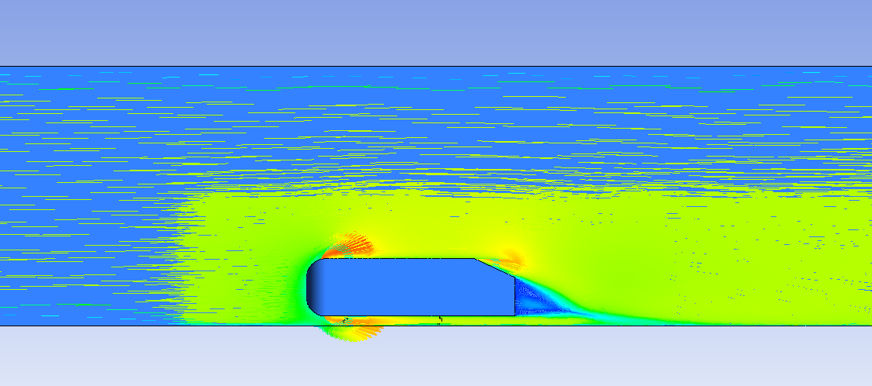
Figure 19 ( Spalart – Allmaras)
K-Epsilon set to realizable with non eqilibrium wall functions was the most succesful turbulence model experimented with. This model is validated by figure 21 replicating the air flow behind the body descibed by the diagram froma study into the Ahmed body.
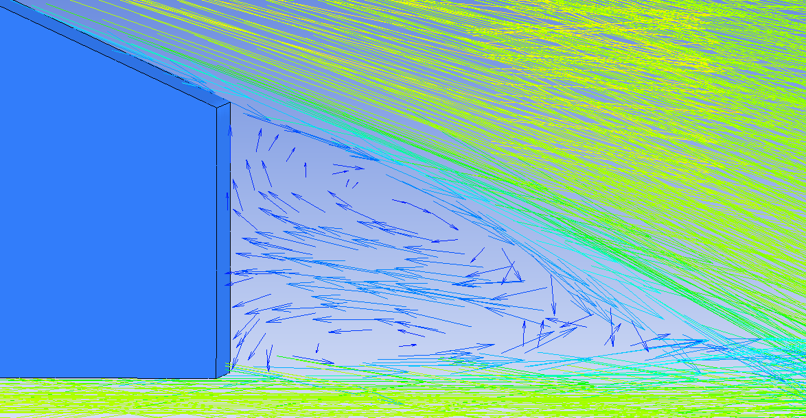
Figure 20 ( K-Epsilon, realizable, non equilibrium wall functions)
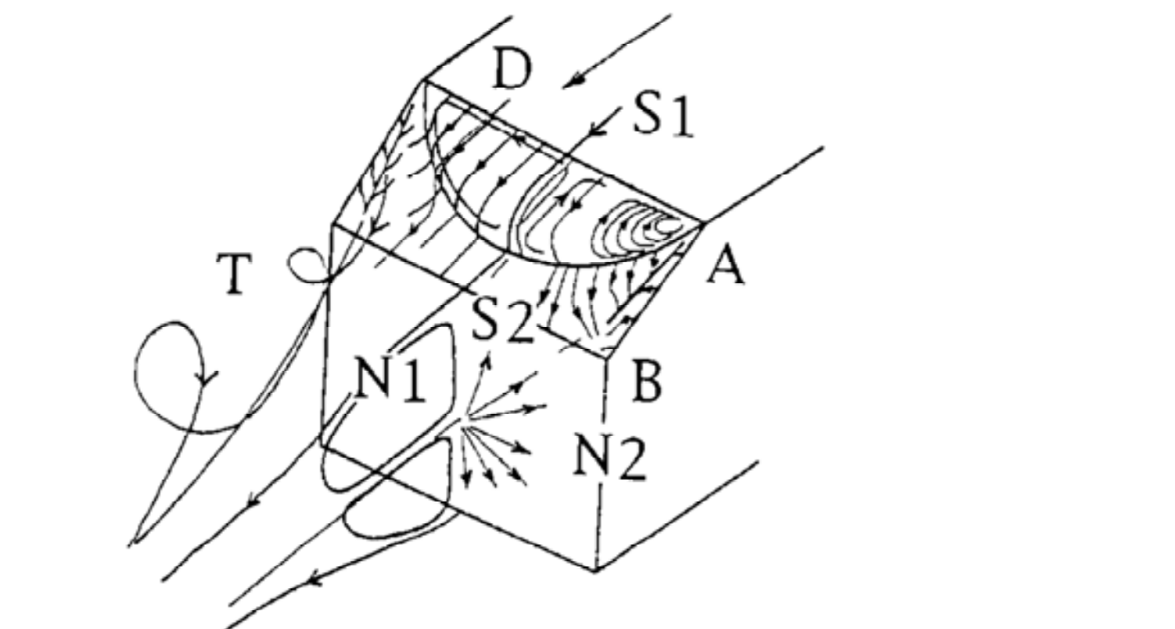
Figure 21 (Uruba & Hladik, 2009)

Solver Settings

Within Fluent the mesh created can be converted into polyhedral. A polyhedral mesh solves at a faster rate to that of the octree method used throughout, but combines elements together in order to solve quicker. This method comes at a cost as proven in table 10 where the results increase in error to 6 % from 0.97% previously.
Solver setting | Cl | Cl % difference | Cd | Cd % difference | Total % difference
Polyhedral | 0.37872 | 9.773913 | 0.30587 | 2.297659 | 6.035785953
Table 10 (Polyhedral)

Conclusion

The results produced by fluent are highly dependent of the geometry and mesh produced. A geometry shouldn’t interact with the values of the results. Smaller geometries could restrict air flow and pressure and act differently to the scenario under question, discrediting the results. The mesh is very influential to the results depicting locations for refinement and computational time. Turbulence models and solver setting also play apart as the correct model need to represent the turbulence present. During these experiments over each of these areas it was found that the optimum domain tested was 3m in front of body and 3.25 to the rear. The mesh contained 3 density boxes. One density box around the whole body and the wake trail. The other 2 at the front and rear in area of changing velocities. 6 prism layers were decided upon before the % difference did not improve by a significant amount as well as a scale factor of 1. The turbulent model suited to the Ahmed body was K-Epsilon, realizable with non-equilibrium wall conditions.

References
ANSYS. (2020). ANSYS Fluent. Retrieved from ANSYS: https://www.ansys.com/products/fluids/ansys-fluent
AUTODESK.Support. (2015, May 26th). How to perform a mesh convergence study. Retrieved from Autodesk: https://knowledge.autodesk.com/support/simulation-mechanical/learn-explore/caas/sfdcarticles/sfdcarticles/How-to-Perform-a-Mesh-Convergence-Study.html
Build Your Own Race Car. (n.d.). Aerodynamic Principles. Retrieved from Build Your Own Race Car: https://www.buildyourownracecar.com/race-car-aerodynamics-basics-and-design/
Corallo, M., Sheridan, J., & Thompson, M. C. (2015). Effect of aspect ratio on the near-wake flow structure of an Ahmed body. Journal of Wind Engineering and Industrial Aerodynamics.
eneagrid.enea.it. (2009). Choosing the pressure velocity coupling method. Retrieved from eneagrid.enea.it: https://www.afs.enea.it/project/neptunius/docs/fluent/html/ug/node785.htm
Fares, E. (2006). Unsteady flow simulation of the Ahmed reference body using a lattice Boltzmann approach. Computers & Fluids, 940-950.
Guilmineau, E. (2008). Computational study of flow around a simplified car body. Journal of Wind Engineering and Industrial Aerodynamics, 1207-1217.
Hosch, W. L. (n.d.). Navier strokes equation. Retrieved from Encyclopedia: https://www.britannica.com/science/Navier-Stokes-equation
Katopodes, N. D. (2019). Free-Surface Flow.
Lanfrit, M. (2005, February 9th). Best practice guidelines for handling Automotive External Aerodynamics with Fluent. Retrieved from www.southampton.ac.uk: https://www.southampton.ac.uk/~nwb/lectures/GoodPracticeCFD/Articles/Ext_Aero_Best_Practice_Ver1_2.pdf
Meile, W., Brenn, G., Reppenhagen, A., Lechner, B., & Fuchs, A. (2011). Experiments and numerical simulations on the aerodynamics of the Ahmed body. Institute of Fluid Mechanics and Heat Transfer.
Simscale. (n.d.). K-epsilon. Retrieved from Simscale: https://www.simscale.com/docs/content/simulation/model/turbulenceModel/kEpsilon.html
Sodja, J. (2007). Turbulence models in CFD. University of Ljubljana Faculty for mathematics and physics.
Thacker, A., Aubrun, S., & Leroy, A. (2013). Experimental characterization of flow unsteadiness in the centerline plane of an Ahmed body rear slant.
Tudor, T. (2019). Advanced Computational Methods. Retrieved from UWTSD Moodle: https://moodle.uwtsd.ac.uk/course/view.php?id=2498
Uruba, V., & Hladik, O. (2009). Ahmed Body Wake. Fluid Dynamics, Institute of Thermomechanics.
Zuo, W. (n.d.). Introduction of Computational Fluid Dynamics. Retrieved from Technical University of Munich: http://wwwmayr.informatik.tu-muenchen.de/konferenzen/Jass05/courses/2/Zuo/Zuo_paper.pdf

