To develop and test replacement propellant

Luke James Savin 1810328

Contents
Table of Figures 2
Introduction 3
Background to the Proposed Research 4
NRN41 FN/B 4
Vihtavouri 4
Vihtavouri N140 4
Vihtavouri N165 4
Vihtavouri N310 4
Vihtavouri N330 4
Aims & Objectives 6
Experimental Design 7
Fragment Simulating Projectile 7
Diagnostics 8
Data Evaluation 8
Resources & Planning 9
Resources Required 9
Risks & Limitations 9
Gantt Chart 10
Conclusion 11
References 12
Annex A – Gantt Chart 13
Annex B – Ethics Form 14

Table of Figures

Figure 1: Experiment Set [11] 6
Figure 2: Fragments [12] 6

Introduction

In an explosive experiment, a by-product of the explosion is fragmentation that can cause severe injury or damage to the chamber if left unmitigated. To understand the behaviours of these fragments, AWE developed a test to simulate the damage caused by fragments. The test involved fining different shaped projectiles into ductile witness plates, which were either made from steel or aluminium. However, since the trial was last fired, the propellant used to fire the fragment is no longer manufactured, and as such, tests can no longer commence. Therefore, a replacement propellant is required that can produce the same result as the previous propellant and be more sustainable.

This report discusses the propellant used in the trial and the potential replacement propellant. It will also describe a test method that will compare the old propellant with the new.

Background to the Proposed Research

NRN41 FN/B

The original propellant used for the experiment was NRN41 FN/B, and Muiden Chemie manufactured it in the Netherlands [1]. NRN41 FN/B was a double-base propellant that was commonly found in the filling of 7.62mm ammunition [2]. NRN41 has also been used in similar experiments, ‘The projectiles were propelled using a standard 30mmRARDEN percussion cartridge filled with a known quantity of NRN41 propellant.’ [3]. However, the report goes on to state that, ‘The precise quantity of propellant in the cartridge was varied from round to round.’ As a result, this then produced velocities in the range of ‘700-2000m/s.’ [3].

A new propellant is now needed as NRN41 is no longer in production due to increased sensitisation once it goes past its shelf life. If stored past the 10-year shelf life, the stabilisers, diphenylamine and centralite, break down the nitrates ester. This can then cause an autocatalytic reaction and or detonation. [1] [4]

Vihtavouri

Vihtavouri is a propellant manufacturer in Finland that produces propellant for various weapons and calibres. Due to the variety of available propellants and their applications, it was decided that four Vihtavouri propellants will be tested.

Vihtavouri N140
The N140 propellant was initially developed for 7.62 ammunition but was also used in .223 and .308. Vihtavouri manufactures the propellant to the size of ‘1,0 mm length and 0,9 mm diameter’ with a tubular shape [5].

Vihtavouri N165
The N167 propellant has a slightly larger size grain 1,3 mm length x 1,0 mm diameter than the N140. However, it does not have a tubular shape, and it is often used ‘magnum rifle calibers with heavy bullets.’ [6]

Vihtavouri N310
The N310 is a ‘fastest burning handgun powder’ used in ‘calibers from .32 S&W Long Wadcutter up to .45 ACP’. Like the N140 propellant, the N310 is a ‘single-base, tubular powder type with grain dimensions of 0,7 mm length and 0,6 mm diameter.’ [7]

Vihtavouri N330
The N330 propellant is commonly used in handgun ammunition but can also be used for ‘light target to heavier high-velocity loadings.’ It is manufactured to consist of a solid grain size of 1mm x 0.8mm. [8]

Powder | Burning Rate (N110 = 100) | Length (mm) | Diameter (mm) | Bulk Density (g/l) | Moisture Content (%) | Energy Content (J/g)
N140 | 54 | 1,0 | 0,9 | 910 | 1,1 | 3700
N165 | 43 | 1,3 | 1,0 | 920 | 1,1 | 3500
N310 | 310 | 0,7 | 0,6 | 560 | 1,2 | 4100
N330 | 198 | 1,0 | 0,8 | 620 | 1,1 | 4100
Table 1: Vihtavouri Propellant Comparison [9]

Aims & Objectives

This project aims to test four new propellants using the Fragment Simulating experiment to help identify a replacement for the NRN41 propellant. By reproducing the same experimental conditions as before
The objectives are:
- Changing the mass of propellant in the cartridge and measuring the velocities of the fragment,
- Measure the depth of penetration from the fragment into a well-characterised material,
- Measure the yaw angle of the fragment as it travels to determine its effect on the penetration depth.

Experimental Design

Fragment Simulating Projectile
To find a suitable replacement from the NRN 41, the propellants will be tested using the Fragment Simulating Projectile experiment. The results from these tests will be compared to the NRN41 propellant.

The Fragment Simulating Projectile experiment was 'simulated case fragment projectiles launched into well characterised ductile target material' [10]. This was to replicate a fragmentation attack on the material used as mitigation within the chamber. The trial would involve using a "0.5" Browning assembly, fitted with either a standard rifled barrel or a smooth bore barrel (0.515"), with the aid of a sabot" [10]. The gun will be aimed at a well-characterised material such as aluminium or steel target.

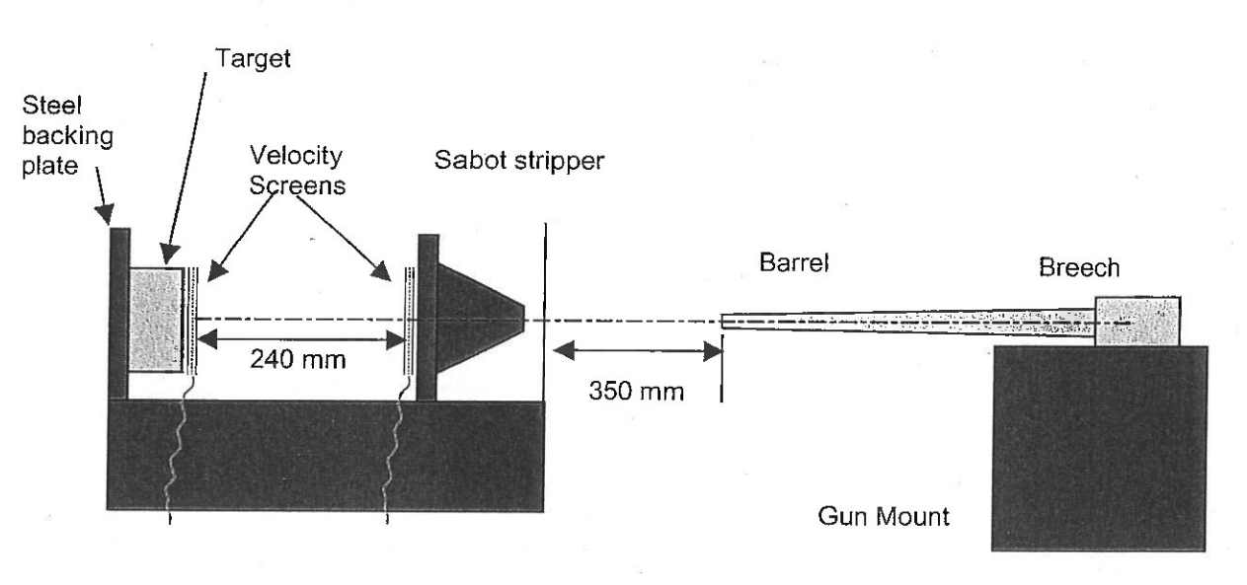
Figure 1: Experiment Set [11]

The sabot can take three types of simulated fragments: Flat Disk, Right angel Cylinder, and Long rod, as shown in figure 2. The fragments will be made to the same material and size to get repeatable results.
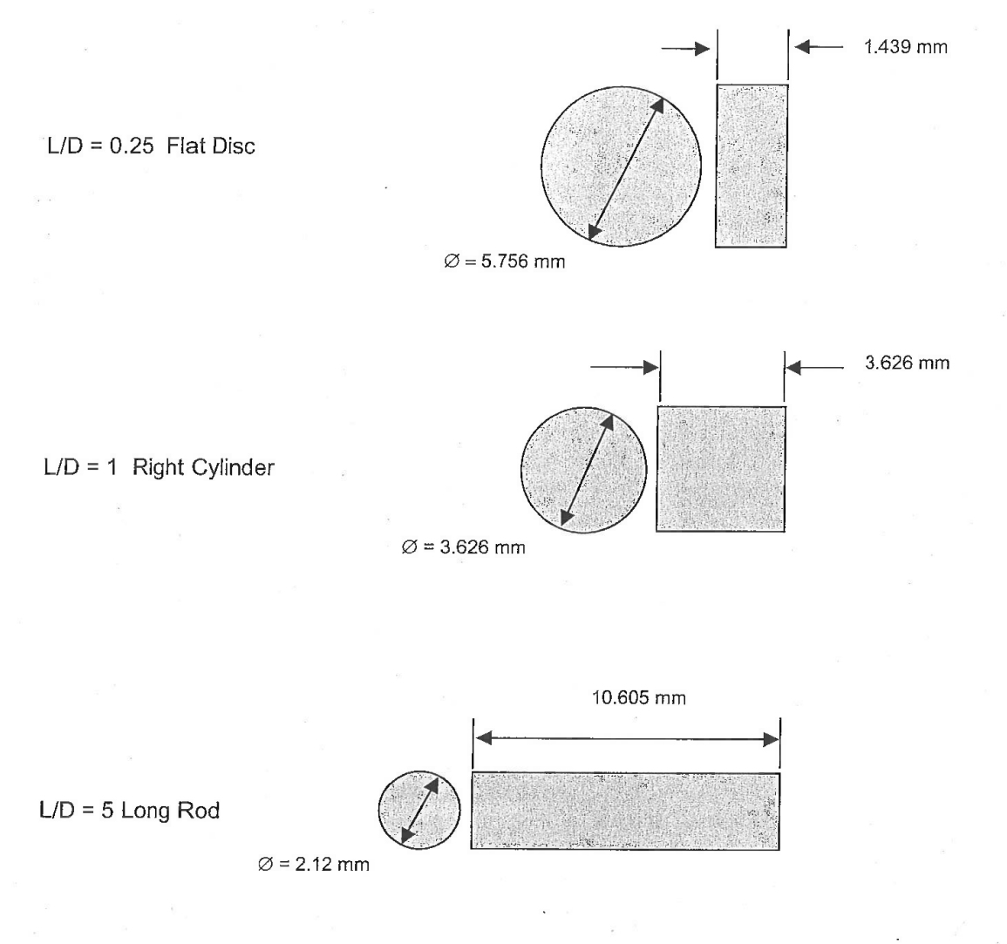
Figure 2: Fragments [12]

Diagnostics

A high-speed camera will be used to record the flight of fragments that will be triggered using a laser once the fragment has crossed its path. The camera will be able to determine the fragment's velocity and yaw angle. The yaw angle will also be recorded, as it could affect the penetration depth. At the end of the trial, the witness plates will be cut to measure the fragment's depth.

Data Evaluation

The cartridges will be filled with different amounts of propellant to obtain various velocities, 10g, 12g, 14g, 16g, 18g. Each mass will be tested three times, with the different types of fragments having 45 shots for each propellant.

Resources & Planning

Resources Required

Due to the other trials that are planned at AWE, there is no available time that the chambers are free to be used during the required time. For this reason, it has been decided that the trial will have to be moved off-site to an external company. As AWE already has a contract set up with a company called COTEC to allow the use of their chambers and facilities, the firing will occur at this location. COTEC have also stated that they are also able to provide the 0.5" browning gun and high-speed camera.

Four propellants will be required for testing: Vihtavouri N165, N330, N140 and N310. It was calculated that 700g of each propellant would be needed to fire three shots of each fragment, varying at different propellant masses.

The targets that the fragments will be fired into will be made from Q1N steel, as it is a well-characterised material. To make the plates more manageable to cut, they will be manufactured into 35mm thick sheets.

A small team of two people will be needed to carry out the assembly and firing.
- A Trials Conducting Officer (TCO) to lead the trial.
- Explosive Technician from COTEC to fill the cartridges and assist the TCO

Risks & Limitations

To avoid any health and safety risks that may occur throughout the project, a safe system of work (SSoW) will be written to include step-by-step instructions on how to assemble the trial and a risk assessment. Along with this, it will be required to follow the risk assessment that COTEC has provided.

The most significant risk involved in the trial is the possibility of a misfire of the gun. In the event of a misfire, there will be a 30-minute cool-down period before approaching the gun or the target.

The other significant risk is data loss from faulty diagnostics or poor setup. The diagnostics will be tested before each shot during the trial. In the event of discovering the diagnosis is not working correctly, the trial will be paused, and the issues will be fixed before carrying on. Data loss can also occur by it becoming corrupt. Data loss in this way will be prevented by backing up the data on two portable USB sticks and taken back to AWE to be analysed.

Gantt Chart

The Gantt chart (Annex A) has been created to show the time scale to complete the project. It spans over four months, starting with the project's research at the end of June to the report write-up that ends in October. The write-up of the project paperwork, such as the safe system of work, will overlap the manufacture and delivery of components due to the constraints of the long lead time in manufacturing.

A day has been allocated to the delivery of the component and explosives. Two weeks have been given for the diagnostic setup and firing of the trial. These two weeks will allow for a firing a week and the allowance for any issues that may occur during this time. The following few weeks will commence of the write up of the report.

Conclusion

This report has laid out the proposal for the Fragment Simulation Experiment to use as a basis to test four new propellants, Vihtavouri N140, N165, N310 and N330, as a replacement for the current propellant NRN41. The project aims to build on the research already carried out on previous tests by firing fragments into a well-characterised material (Steel Q1N). This will allow the return of Fragment simulation experiments as a recurring trial for AWE.

References

[1] | S.Dooley, “Suitablity supply and Replacement of Propellnnt Used in HD Powder Gun,” AWE, Aldermaston, 2010.
[2] | T. T. S. R. J. Nguyen, “Approaches to Reducing the Temperature Sensitivity of Propulsion Systems for Artillery Ammunition.,” 1994.
[3] | P. J. H. R. I. B. C. S. J. F. a. P. J. C. Malcolm D. Cook, “Fragment Impact Characterization Of Melt-Case and PBX Explosive,” American Institute of Physics, 2001.
[4] | J.Dixon, “Explosive Data Sheet for NRN41 FN/B Propellant,” BAE Systems, Euxton, 2000.
[5] | “N140 rifle powder - Vihtavuori,” Vihtavuori, 2022. [Online]. Available: https://www.vihtavuori.com/powder/n140-rifle-powder/. [Accessed 10 02 2022].
[6] | “N165 rifle powder - Vihtavuori,” Vihtavuori, 2022. [Online]. Available: https://www.vihtavuori.com/powder/n165-rifle-powder/. [Accessed 10 02 2022].
[7] | Vihtavuori, “N310 handgun powder - Vihtavuori,” 2022. [Online]. Available: https://www.vihtavuori.com/powder/n310-handgun-powder/. [Accessed 10 02 2022].
[8] | Vihtavuori, “N330 handgun powder - Vihtavuori,” 2022. [Online]. Available: https://www.vihtavuori.com/powder/n330-handgun-powder/. [Accessed 10 02 2022].
[9] | Vihtavuori , “Vihtavuori Reloading Guide 2021 UK,” 2022. [Online]. Available: https://www.vihtavuori.com/wp-content/uploads/2018/07/Vihtavuori-IP-brochure-2018_ENG_www.pdf. [Accessed 10 02 2022].
[10] | S. M. S. F.Daykin, “Fragment Simulating Projectile Studies Series 2,” AWE Report, 2001.
[11] | S. M. S. F.Daykin, “Fragment Similating Projectile Studies,” AWE, Aldermason, 2002.
[12] | F. M. S.Dooley, “Assessment Of Fragment Mitigation Ising Tungsten Alloy Fragment Simulating Projectiles,” AWE, Aldermaston, 2006.

Annex A – Gantt Chart

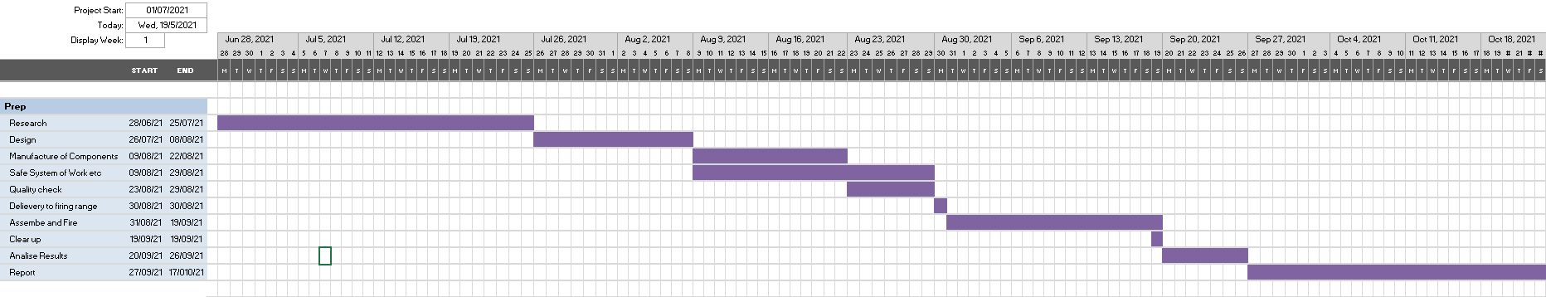

Annex B – Ethics Form

APPLICATION FOR ETHICAL APPROVAL

In order for research to result in benefit and minimise risk of harm, it must be conducted ethically.

The University follows the OECD Frascati manual definition of research activity: “creative work undertaken on a systematic basis in order to increase the stock of knowledge, including knowledge of man, culture and society, and the use of this stock of knowledge to devise new applications”. As such this covers activities undertaken by members of staff, postgraduate research students, and both taught postgraduate and undergraduate students working on dissertations/projects.

The individual undertaking the research activity is known as the “principal researcher”.

This form must be completed and approved prior to undertaking any research activity.

SECTION A: About You (Principal Researcher)
1 | Full Name: | Luke Savin
2 | Student Number: | 1810328
3 | Email address: | 1810328@student.uwtsd.ac.uk
4 | Programme of Study: | OME
5 | Director of Studies/Supervisor: | Kapilan Radhakrishnan

SECTION B: Internal and External Ethical Guidance Materials
 | Please list the core ethical guidance documents that have been referred to during the completion of this form (including any discipline-specific codes of research ethics, location-specific dodes of research ethics, and also any specific ethical guidance relating to the proposed methodology). Please tick to confirm that your research proposal adheres to these codes and guidelines. You may add rows to this table if needed.
1 | UWTSD Research Ethics & Integrity Code of Practice | ☒
2 | UWTSD Research Data Management Policy | ☒
3 |  | ☐

SECTION C: Details of Research Activity
1 | Indicative title: | To Design and Develop an experiment for newly established explosives
2 | Proposed start date: | 10/02/2022 | Proposed end date: | 01/11/2022
Introduction to the Research (maximum 300 words in each section)
Ensure that you write for a Non-Specialist Audience when outlining your response to the three points below:
- Purpose of Research Activity
- Proposed Research Question
- Aims of Research Activity
- Objectives of Research Activity
Demonstrate, briefly, how Existing Research has informed the proposed activity and explain
- What the research activity will add to the body of knowledge
- How it addresses an area of importance.
3 | Purpose of Research Activity  The purpose of this project is to identify a replacement propellant for a Simulated Fragment Test that preforms the same as the current propellant that is being used.  (this box should expand as you type)
4 | Research Question  What is a suitable replacement propellant for NRN41 for use in a Simulated Fragment Experiment?  (this box should expand as you type)
5 | Aims of Research Activity  The purpose of this project is to identify a replacement propellant for the Simulated Fragment Test that preforms the same as the current propellant that is being used by achieving the same velocities and depth of penetration.  (this box should expand as you type)
6 | Objectives of Research Activity  •Changing the mass of propellant in the cartridge and measuring the velocities of the fragment,  •Measure the depth of penetration from the fragment into a well-characterised material,  •Measure the yaw angle of the fragment as it travels to determine its effect on the penetration depth.  (this box should expand as you type)
Proposed data collection methods (maximum 600 words)
Provide a brief summary of all the methods that may be used in the research activity to collect data, making it clear what specific techniques may be used. If methods other than those listed in this section are deemed appropriate later, additional ethical approval for those methods will be needed. You do not need to justify the methods here, but should instead describe how you intend to collect the data necessary for you to complete your project.
7 | To measure the velocity, each shot will be filmed using a high-speed camera that will be triggered using a laser. When the fragment is crosses the laser the high-speed camera will begin recording. From the recordings, the yaw angle of the fragment will also be logged to determine how much of an effect it has on the penetration  The target plates that each shot will be fired into will be made from Q1N steel as it a well characterised material.  (this box should expand as you type)

SECTION D: Scope of Research Activity
 | Will the research activity include: | YES | NO
1 | Use of a questionnaire or similar research instrument? | ☐ | ☒
2 | Use of interviews? | ☐ | ☒
3 | Use of focus groups? | ☐ | ☒
4 | Use of participant diaries? | ☐ | ☒
5 | Use of video or audio recording? | ☒ | ☐
6 | Use of computer-generated log files? | ☐ | ☒
7 | Participant observation with their knowledge? | ☐ | ☒
8 | Participant observation without their knowledge? | ☐ | ☒
9 | Access to personal or confidential information without the participants’ specific consent? | ☐ | ☒
10 | Administration of any questions, test stimuli, presentation that may be experienced as physically, mentally or emotionally harmful / offensive? | ☐ | ☒
11 | Performance of any acts which may cause embarrassment or affect self-esteem? | ☐ | ☒
12 | Investigation of participants involved in illegal activities? | ☐ | ☒
13 | Use of procedures that involve deception? | ☐ | ☒
14 | Administration of any substance, agent or placebo? | ☐ | ☒
15 | Working with live vertebrate animals? | ☐ | ☒
16 | Procedures that may have a negative impact on the environment? | ☒ | ☐
17 | Other primary data collection methods. Please indicate the type of data collection method(s) below. | ☐ | ☒
 | Details of any other primary data collection method:  (this box should expand as you type) | ☐ | ☒

If you have ticked NO to every question then the research activity is (ethically) low risk and you may skip section E and continue to section F.

If YES to any question, then no research activity should be undertaken until full ethical approval has been obtained.

SECTION E: Intended Participants
 | Who are the intended participants: | YES | NO
1 | Students or staff at the University? | ☐ | ☒
2 | Adults (over the age of 18 and competent to give consent)? | ☐ | ☒
3 | Vulnerable adults? | ☐ | ☒
4 | Children and Young People under the age of 18? (Consent from Parent, Carer or Guardian will be required) | ☐ | ☒
5 | Prisoners? | ☐ | ☒
6 | Young offenders? | ☐ | ☒
7 | Those who could be considered to have a particularly dependent relationship with the investigator or a gatekeeper? | ☐ | ☒
8 | People engaged in illegal activities? | ☐ | ☒
9 | Others. Please indicate the participants below, and specifically any group who may be unable to give consent. | ☐ | ☐
 | Details of any other participant groups:  (this box should expand as you type) | ☐ | ☐

Participant numbers and source
Provide an estimate of the expected number of participants. How will you identify participants and how will they be recruited?
10 | How many participants are expected? | One or two to help assist in the set up of the experiment  (this box should expand as you type)
11 | Who will the participants be? | Employees of AWE and COTEC to help assist in the set up of the experiment  (this box should expand as you type)
12 | How will you identify the participants? | They work for the companies  (this box should expand as you type)

 | Information for participants: | YES | NO | N/A
13 | Will you describe the main research procedures to participants in advance, so that they are informed about what to expect? | ☐ | ☐ | ☒
14 | Will you tell participants that their participation is voluntary? | ☐ | ☐ | ☒
15 | Will you obtain written consent for participation? | ☐ | ☐ | ☒
16 | Will you explain to participants that refusal to participate in the research will not affect their treatment or education (if relevant)? | ☐ | ☐ | ☒
17 | If the research is observational, will you ask participants for their consent to being observed? | ☐ | ☐ | ☒
18 | Will you tell participants that they may withdraw from the research at any time and for any reason? | ☐ | ☐ | ☒
19 | With questionnaires, will you give participants the option of omitting questions they do not want to answer? | ☐ | ☐ | ☒
20 | Will you tell participants that their data will be treated with full confidentiality and that, if published, it will not be identifiable as theirs? | ☐ | ☐ | ☒
21 | Will you debrief participants at the end of their participation, in a way appropriate to the type of research undertaken? | ☐ | ☐ | ☒
22 | If NO to any of above questions, please give an explanation
 | (this box should expand as you type)

 | Information for participants: | YES | NO | N/A
24 | Will participants be paid? | ☐ | ☐ | ☒
25 | Is specialist electrical or other equipment to be used with participants? | ☐ | ☐ | ☒
26 | Are there any financial or other interests to the investigator or University arising from this study? | ☐ | ☐ | ☒
27 | Will the research activity involve deliberately misleading participants in any way, or the partial or full concealment of the specific study aims? | ☐ | ☐ | ☒
28 | If YES to any question, please provide full details
 | (this box should expand as you type)

SECTION F: Anticipated Risks

 | Outline any anticipated risks that may adversely affect any of the participants, the researchers and/or the University, and the steps that will be taken to address them.
1 | Risks to participants  For example: sector-specific health & safety, emotional distress, financial disclosure, physical harm, transfer of personal data, sensitive organisational information. If you have identified in section D that there are no participants then enter N/A and go skip to question 3.
 | Risk to participants:  N/A  (this box should expand as you type) | How you will mitigate the risk to participants:  (this box should expand as you type)
2 | If research activity may include sensitive, embarrassing or upsetting topics (e.g. sexual activity, drug use) or issues likely to disclose information requiring further action (e.g. criminal activity), give details of the procedures to deal with these issues, including any support/advice (e.g. helpline numbers) to be offered to participants. Note that where applicable, consent procedures should make it clear that if something potentially or actually illegal is discovered in the course of a project, it may need to be disclosed to the proper authorities
N/A

(this box should expand as you type)
3 | Risks to the investigator  For example: personal health & safety, physical harm, emotional distress, risk of accusation of harm/impropriety, conflict of interest
 | Risk to the investigator:  Physical injury due to unintentional initiation of explosives or gun misfires  (this box should expand as you type) | How you will mitigate the risk to the investigator:  Investigator is a fully trained explosive worker.  Working to COTEC risk assessment  (this box should expand as you type)
4 | University/institutional risks  For example: adverse publicity, financial loss, data protection
 | Risk to the University:  Adverse publicity from injury from unintentional initiation  Damaged equipment  Loss of data  (this box should expand as you type) | How you will mitigate the risk to the University:  Working to COTEC risk assessment  Data will be backed up and the USB will be encrypted  (this box should expand as you type)
5 | Environmental risks  For example: accidental spillage of pollutants, damage to local ecosystems
 | Risk to the environment:  Potential damage to the environment due to waste  (this box should expand as you type) | How you will mitigate the risk to environment:  Waste will be disposed of through the correct disposal route  (this box should expand as you type)

SECTION G: Feedback, Consent and Confidentiality

If you have identified in section D that there are no participants then enter skip this section and continue to section H.

1 | Feedback  What de-briefing and feedback will be provided to participants, how will this be done and when?
N/A

(this box should expand as you type)
2 | Informed consent  Describe the arrangements to inform potential participants, before providing consent, of what is involved in participating. Describe the arrangements for participants to provide full consent before data collection begins. If gaining consent in this way is inappropriate, explain how consent will be obtained and recorded in accordance with prevailing data protection legislation.
N/A

(this box should expand as you type)
3 | Confidentiality / Anonymity  Set out how anonymity of participants and confidentiality will be ensured in any outputs. If anonymity is not being offered, explain why this is the case.
N/A

(this box should expand as you type)

SECTION H: Data Protection and Storage

 | Does the research activity involve personal data (as defined by the General Data Protection Regulation 2016 “GDPR” and the Data Protection Act 2018 “DPA”)? | YES | NO
1 | “Personal data” means any information relating to an identified or identifiable natural person (‘data subject’). An identifiable natural person is one who can be identified, directly or indirectly, in particular by reference to an identifier such as a name, an identification number, location data, an online identifier or to one or more factors specific to the physical, physiological, genetic, mental, economic, cultural or social identity of that natural person. Any video or audio recordings of participants is considered to be personal data. | ☐ | ☒
 | If YES, provide a description of the data and explain why this data needs to be collected:
2 | N/A  (this box should expand as you type)
 | Does it involve special category data (as defined by the GDPR)? | YES | NO
3 | “Special category data” means sensitive personal data consisting of information as to the data subjects’ –  (a) racial or ethnic origin,  (b) political opinions,  (c ) religious beliefs or other beliefs of a similar nature,  (d) membership of a trade union (within the meaning of the Trade Union and Labour Relations (Consolidation) Act 1992),  (e) physical or mental health or condition,  (f) sexual life,  (g) genetics,  (h) biometric data (as used for ID purposes), | ☐ | ☒
 | If YES, provide a description of the special category data and explain why this data needs to be collected:
4 | N/A  (this box should expand as you type)

 | Will data from the research activity (collected data, drafts of the thesis, or materials for publication) be stored in any of the following ways? | YES | NO
5 | Manual files (i.e. in paper form)? | ☒ | ☐
6 | University computers? | ☐ | ☒
7 | Private company computers? | ☒ | ☐
8 | Home or other personal computers? | ☐ | ☒
9 | Laptop computers/ CDs/ Portable disk-drives/ memory sticks? | ☒ | ☐
10 | “Cloud” storage or websites? | ☐ | ☒
11 | Other – specify: | ☐ | ☒
12 | For all stored data, explain the measures in place to ensure the security of the data collected, data confidentiality, including details of backup procedures, password protection, encryption, anonymisation and pseudonymisation:
Data collected will be stored on an encrypted memory stick to transfer from COTEC to AWE. When it arrives at AWE it will be stored on a password protected Computer.

(this box should expand as you type)

 | Data Protection
 | Will the research activity involve any of the following activities: | YES | NO
13 | Electronic transfer of data in any form? | ☐ | ☒
14 | Sharing of data with others at the University outside of the immediate research team? | ☐ | ☒
15 | Sharing of data with other organisations? | ☐ | ☒
16 | Export of data outside the UK or importing of data from outside the UK? | ☐ | ☒
17 | Use of personal addresses, postcodes, faxes, emails or telephone numbers? | ☐ | ☒
18 | Publication of data that might allow identification of individuals? | ☐ | ☒
19 | If YES to any question, please provide full details, explaining how this will be conducted in accordance with the GDPR and Data Protection Act (2018) (and/or any international equivalent):
 | N/A
20 | List all who will have access to the data generated by the research activity:
The principal researcher
Line Manager
Industrial partner
External examiner

(this box should expand as you type)
21 | List who will have control of, and act as custodian(s) for, data generated by the research activity:
The principal researcher.

(this box should expand as you type)
22 | Give details of data storage arrangements, including security measures in place to protect the data, where data will be stored, how long for, and in what form.
Data collected will be stored on an encrypted USB for transfer and then be saved on a password protected computer on a government secured site. The data will be stored until the completion of the project and then deleted.

(this box should expand as you type)
22 | Confirm that you have read the UWTSD guidance on data management (see https://www.uwtsd.ac.uk/library/research-data-management/) | ☒
23 | Confirm that you are aware that you need to keep all data until after your research has completed or the end of your funding | ☒

SECTION I: Declaration
The information which I have provided is correct and complete to the best of my knowledge. I have attempted to identify any risks and issues related to the research activity and acknowledge my obligations and the rights of the participants.

In submitting this application I hereby confirm that I undertake to ensure that the above named research activity will meet the University’s Research Ethics and Integrity Code of Practice which is published on the website: https://www.uwtsd.ac.uk/research/research-ethics/
 | 1 | Signature of applicant: | Luke Savin | Date: 10/02/2021
2 |  | Director of Studies/Supervisor: |  |  | Date:
3 |  | Signature: |  |  | Date:

FOR INTERNAL USE ONLY:
 | Ethical approval given
1 | Signature of assessor: |  | Date:
2 | Name:
3 | Role:

