Fault Diagnostics and Condition Monitoring
The Concepts involved in Condition Based Monitoring
ANG12809789
Table of Contents
Introduction 2
P-F diagrams and task frequency 3
Temperature measurements 5
Dynamic monitoring 6
Oil analysis 7
Corrosion monitoring and Non-Destructive testing 9
Conclusion 10
Advantages: 10
Disadvantages: 10
Bibliography 11

Introduction

This report will explain what condition based monitoring (CBM) is and the tasks involved to give warnings as to the catastrophic failures, so that controls can be put in place. The Report will also cover the following points to give a detailed conclusion as to the main aspects within CBM.
- Equipment failure,
- Potential failure and how to avoid it,
- P-F diagrams and task frequency,
- Temperature measurements,
- Dynamic monitoring,
- Oil analysis,
- Corrosion monitoring,
- Non- destructive testing.

The sources used for my references will be listed after to strengthen this report and also to give a range of industrial views. These sources of information will have in text reference citations as well as a bibliography so that credit is given to the information provided.
Condition Based Monitoring (CBM) is a type of predictive maintenance that involves using sensors to measure the status of an asset over time while it is in operation. The data collected can be used to establish trends, predict failure, and calculate remaining life of an asset. With CBM, maintenance is only performed when the data shows that “performance is decreasing or a failure is likely”. Rather than at specified intervals like with preventive maintenance. (Inspectioneering, 2019)
Condition data can then be gathered at certain intervals, or continuously (as is done when a machine has internal sensors). Condition-based maintenance can be applied to mission critical and non-mission critical assets. Unlike in planned maintenance (PM), where maintenance is performed based upon predefined scheduled intervals, condition-based maintenance is performed only after a decrease in the condition of the equipment has been observed. Compared with preventive maintenance, this increases the time between maintenance repairs, because maintenance is done on an as-needed basis.
CBM has a number of benefits as it works while the equipment is in service, it doesn’t interrupt equipment operation and It can also help ensure equipment reliability and worker safety which reduces failure rates and “unscheduled downtimes”. However, because maintenance activities are scheduled ahead of time, CBM is usually less costly than preventive maintenance.
This method also has some limitations. The tools used to monitor equipment for CBM can have an expensive upfront install fee. Employees must be trained to use CBM technology effectively, which can cost time and money. Furthermore, the sensors employed might not work in harsher operating environments and can have trouble detecting fatigue damage. Evidence to back this information will be provided within the below report.

P-F diagrams and task frequency

The P-F Curve and the P-F Interval:
Condition-monitoring maintenance task intervals must be properly understood and task intervals should be determined based on the expected P-F interval. The P-F interval governs the frequency with which the predictive task must be done.
The horizontal (X) axis of the P-F Curve represents time-in-service for an asset, or asset component. The vertical (Y) axis represents some measure of performance, rate, condition or suitability for purpose. The curve shows that the performance or condition of an asset or component declines over time leading to functional failure, i.e. loss of function for which it was intended as shown in Figure 1.
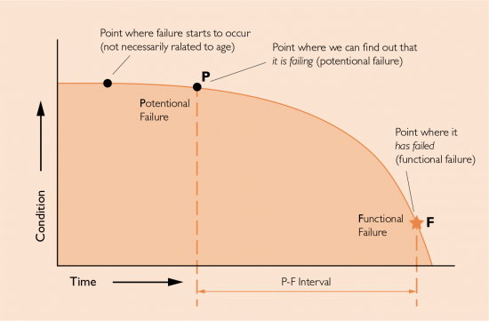

Figure 1
The P-F Interval is the key. It may be days, weeks or months, but whatever it is, it must provide a sufficient “window” of time between the latest inspection and functional failure to prioritise, plan and execute the necessary maintenance activities before the failure (Figure 2). The longer the P-F Interval, the better it will be.
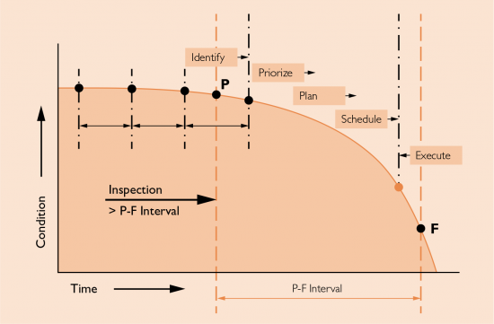
Figure 2

Maximising the P-F Interval Using Condition-Based Maintenance Technologies:
The method and frequency of inspection makes a difference in the length, and therefore the utility of the P-F Interval. Generally, technologically-based Condition-Based Maintenance (CBM) methods (on-line inspections) provide the greatest P-F Intervals (Figure 3), and are less disruptive than alternative time-based, shutdown inspections. The avoidance of off-line inspections, which often cause loss of production, can make CBM methods economically feasible.
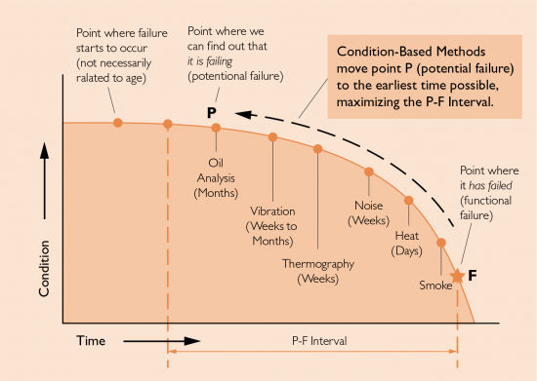

Figure 3

Temperature measurements

Temperature is one of the most frequently measured environmental variables. Temperature sensors devices used to measure the amount of heat energy that allows to detect a physical change in temperature can be used in a wide range of applications. It has found its way into manufacturing processes, for example; agriculture, room automation and healthcare, among other main industries. These sensors can measure the temperature of solids or liquids and are available in different options, e.g. as a stand-alone device or a built-in element.
The sensors can also be placed in manufacturing environments such as automotive. Many companies such as Wall Colmonoy are using this method to determine task based frequency, and when temperatures are at certain levels a SPC approach is used to set control limits. The equipment this is monitored by is a bearing temperature rig with different loading set ups such as single load discs, two load disks and also three load disks. (As pictured below figure 4)
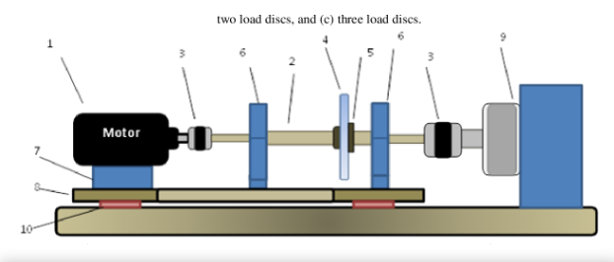

Figure 4

The importance and reasoning behind Temperature based monitoring methods are critical. Below are 3 points to give greater detail to back this up:
1. The faults to be detected (e.g., the temperature based method is much more effective than the vibration method in detecting the lack of lubrication and hence much longer detection horizon, though it falls short in the detection of physical bearing damages) and the use of the bearing temperature rise curve as a health assessment method instead of using equilibrium temperature of bearing surface. In this trend the temperature rise curve can be considered as a bearing transient thermal signature, BTTS that differs according to bearing condition.
2. The understanding of the differences of the heat generation mechanisms due to the normal operation and malfunction of the target system.
3. The availability of temperature sensing devices with improved accuracy and response time those are able to detect the difference between bearing temperature rise curves (transient thermal signatures) in different bearing conditions.

Dynamic monitoring

Vibration Monitoring is a form of condition based monitoring that involves listening to vibrations in an operating piece of equipment in order to determine whether abnormal vibration patterns exist. Vibration monitoring is an important part of effective asset integrity management, because changes in vibration levels can be indicative of advanced wear and a number of other problems, including equipment coming loose from mountings or malfunctioning parts. Information gathered while monitoring for vibration inconsistencies can be used while planning predictive maintenance activities.
“Vibration-based condition monitoring systems have been used for bearing fault detection over several decades” (Moussa, 2014). However, they are effective mainly in the detection of physical bearing damages such as cracks and spalls, and may not be easily used to detect several other undesirable conditions, in particular the lack of lubrication which eventually leads to physical damages of the bearing components.
Even though, the vibration-based methods are still the most popular approaches whereas temperature readings are used only for complementary purposes. The most popular bearing assessment method, the envelope analysis, has proved effective for detecting localized bearing faults according to major vibration based monitoring specialists such as the Mechanical and Aerospace engineering University of Ottawa.


Figure 5
(FMS, 2019)

Oil analysis
Online testing: This allows for instant alerts: sensors will detect problems not readily detectable via vibration or other indicators. Accuracy cannot be guaranteed in every case, but the early warning it provides will prompt on-site or off-site sample testing, after which the diagnostics and repairs can be dealt with on-site straightaway if the most likely fault is apparent. Online testing technology is relatively new, but tools such as a Metallic Wear Debris Sensor offer advantages, including real-time analysis and highly flexible interfaces.
On-site testing: This solution enables equipment to be monitored very frequently. The best testing kits and portable instruments offer laboratory-like accuracy. Sensor readings can be assessed quickly, if necessary triggering the next stage – off-site sample analysis. Having all the testing facilities to hand at the site is the best insurance against an expensive technical failure. Less accessible sites, especially mines, have the most to gain from this monitoring method.
(Laboratories, 2018)
On-site fuel laboratories enable operators to perform a range of tests, including for metal contaminants and particle count. Parker’s Oil check is an example of an easily operated handheld tool for comparing new and used oils, giving the user valuable advance warning of engine failure. Similarly, viscosity can be tested on-site using a Heated Viscometer, which an independent report has shown to be as accurate as laboratory analysis. As well as monitoring changes in lubricating oil viscosity, it also verifies that the fuel is the correct grade for storage and purifiers.
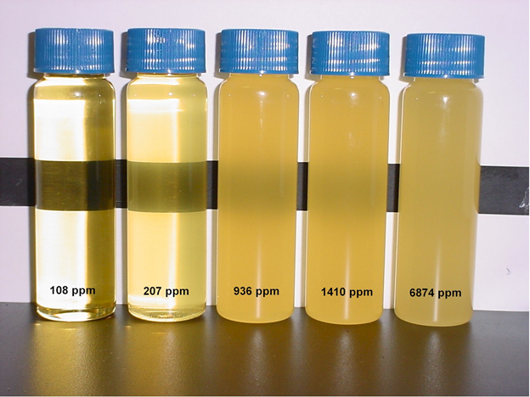
Figure 6
(Laboratories, 2018)

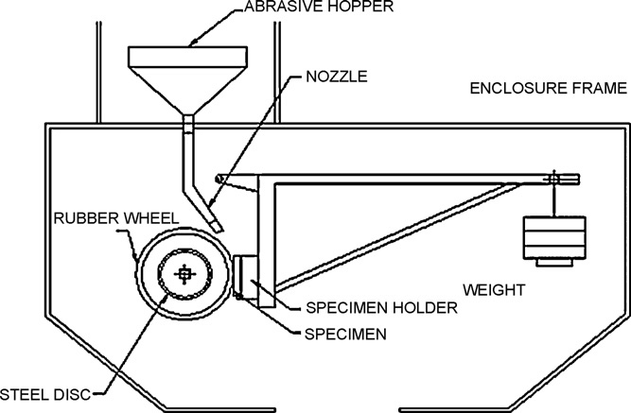
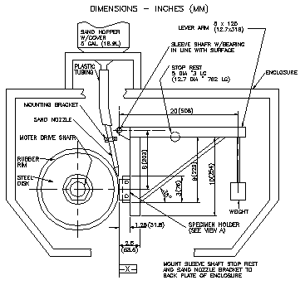
There are also other methods of metallic wear such as the “dry sand/rubber wheel method” (International, 2016) where the laboratory in Wall Colmonoy utilise an International standard procedure to ensure that the test method specifies all of the set conditions needed to verify actual metallic wear data to customers in the automotive and aerospace industries all over the world.
(International, 2016)
Due to the International standard certain details of the procedure cannot be shared, but ultimately the adjusted volume loss (AVL) is as follows, this will determine the metallic wear:
Figure 6.2
Figure 6.1
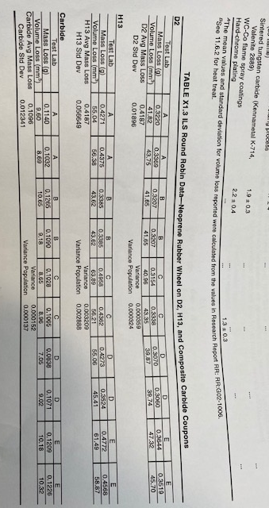
AVL = Measured volume loss X 228.6mm / Wheel diameter after use
Volume Loss, mm3 = Mass loss (g) / Density (g/cm3) x1000
See below table of the test results:

(International, 2016)

Corrosion monitoring and Non-Destructive testing

Corrosion Monitoring is a process that evaluates and monitors equipment components, structures, process units, and facilities for signs of corrosion. Monitoring programs aim to identify certain conditions in order to extend the life and serviceability of assets while increasing safety and reducing replacement costs. Corrosion monitoring covers all types of corrosion and materials.
It is important as Corrosion is a major threat to the oil and gas, petrochemical and other process-intensive industries and is responsible for countless of pounds in damage and maintenance costs. Additionally, ageing equipment becomes more susceptible to corrosion and loses its ability to withstand harsh operating environments (e.g. high temperature and pressure). The purpose of a strong corrosion monitoring program is to improve safety, reduce maintenance and inspection costs, and maximise efficiency. (Global, 2018)
How corrosion monitoring performed: Corrosion monitoring covers a broad range of techniques that involve measuring, controlling, and mitigating corrosion. These techniques can be broadly classified into two types: inspection and monitoring.

Inspection Techniques: Before inspection techniques are applied, it’s important to document the operating parameters of equipment that may be increasing the likelihood of corrosion development. These parameters include, but are not limited to, pH, flow rate (velocity), pressure, and temperature of the system.

Non-destructive testing (NDT) and inspection techniques are performed to locate and identify the type of corrosion damage. Common NDT methods used to detect corrosion include ultrasonic testing, radiographic testing, and magnetic flux leakage.

Monitoring Techniques: Once corrosion is identified, corrosion measurement techniques may be used to gather information about the corrosive environment. This is accomplished by the use of probes, which can be mechanical, electrical, or electrochemical devices that monitor changes in corrosivity during operation. Furthermore, corrosion measurement techniques can be used to provide direct and indirect information about a process while on-stream (i.e. during operation) or off-stream. (Global, 2018)

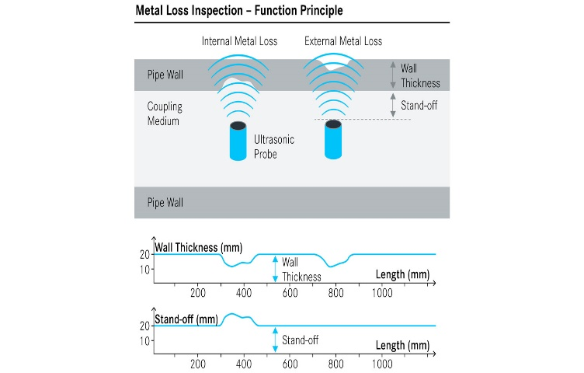
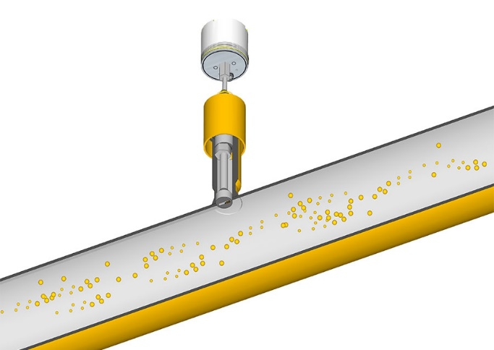
Figure 8
Figure 7

Conclusion
The goal of condition based maintenance is to monitor and spot upcoming equipment failure so maintenance can be proactively scheduled when it is needed – and not before. Asset conditions need to trigger maintenance within a long enough time period before failure, so work can be finished before the asset fails or performance falls below the optimal level.

When carried out correctly, condition-based maintenance is a minimally disruptive form of maintenance that lessens overhead costs, risk to workers, and downtime due to unexpected breakdowns. Maintenance managers should be aware, however, that setting up a CBM program can be costly, and the changes required to set up the strategy could be met with resistance or confusion. To conclude all strategies requires a great deal of expertise to analyse the data and condition information presented.

Advantages:
- CBM is performed while the asset is working, which lessens the chances of disruption to normal operations
- Reduces the cost of asset failures
- Improves equipment reliability
- Minimises unscheduled downtime due to catastrophic failure
- Minimises time spent on maintenance
- Minimises overtime costs by scheduling the activities
- Minimises requirement for emergency spare parts
- Optimises maintenance intervals (more optimal than manufacturer recommendations)
- Improves worker safety
- Reduces the chances of collateral damage to the system

Disadvantages:
- Condition monitoring test equipment is expensive to install, and databases cost money to analyse
- Cost to train staff–you need a knowledgeable professional to analyse the data and perform the work
- Fatigue or uniform wear failures are not easily detected with CBM measurements
- Condition sensors may not survive in the operating environment
- May require asset modifications to retrofit the system with sensors
- Unpredictable maintenance periods

To conclude in a continuous growing market globally productivity is playing a huge role to stay competitive, and for many manufacturing companies productivity can be achieved through availability and this can be increased through adopting the efficient maintenance practices, by focusing on different types of strategies of maintenance.

Bibliography
Anon., 2020. Asset management , file:///C:/Users/kaineangus/Downloads/Asset_Management_Council_1702_eBook1%20(1).pdf: s.n.
Anon., n.d. Condition based maintenance and monitoring software. [Online]
Available at: https://www.fiixsoftware.com/condition-based-maintenance/
Anon., n.d. Overview of Corrosion Monitoring. [Online]
Available at: https://inspectioneering.com/tag/corrosion+monitoring
BLANN, D. R., n.d. Maximizing the P-F Interval Through Condition-Based Maintenance. [Online]
Available at: https://www.maintworld.com/Applications/Maximizing-the-P-F-Interval-Through-Condition-Based-Maintenance
Dekys, V., n.d. Condition Monitoring and Fault Diagnosis. [Online]
Available at: https://www.researchgate.net/publication/314717337_Condition_Monitoring_and_Fault_Diagnosis
FMS, P., 2019. Dynamic Monitoring. [Online]
Available at: https://www.google.co.uk/search?q=dynamic+monitoring&rlz=1C1GCEB_enGB884&source=lnms&tbm=isch&sa=X&ved=2ahUKEwiCq6iEwYrnAhWStHEKHZU3CooQ_AUoAXoECA0QAw&biw=843&bih=959#imgrc=qGQ08MSXKbhwuM:
[Accessed 17 Jan 2020].
Global, N., 2018. Iltrasonic tech. [Online]
Available at: https://www.google.co.uk/search?rlz=1C1GCEB_enGB884&biw=843&bih=910&tbm=isch&sa=1&ei=LZohXpjGL8W68gKlpbXICw&q=detect+corrosion+include+ultrasonic+testing&oq=detect+corrosion+include+ultrasonic+testing&gs_l=img.3...62044.88821..89801...2.0..0.106.251.2j1..
[Accessed 17 Jan 2020].
Inspectioneering, 2019. Overview of Condidtion Based Monitoring. Integripedia, pp. 1-2.
International, A., 2016. Standard Test Method for Measuring Abrasion Using the Dry Sand/Rubber Wheel Apparatus, West Conshohocken: G65-16.
Laboratories, M., 2018. Routine Oil Analysis. [Online]
Available at: https://www.google.co.uk/search?rlz=1C1GCEB_enGB884&biw=843&bih=959&tbm=isch&sa=1&ei=aZchXu2XOsfOgQbty7zQDw&q=oil+analysis&oq=oil+an&gs_l=img.3.0.0i67l2j0l8.417961.419365..420988...0.0..0.104.435.6j1......0....1..gws-wiz-img.......0i24.XXUnTnhMzAQ#imgrc=p
[Accessed 17 Jan 2020].
Looney, M., n.d. An Introduction to MEMS Vibration Monitoring. [Online]
Available at: https://www.analog.com/en/analog-dialogue/articles/intro-to-mems-vibration-monitoring.html#
Moussa, W., 2014. Thermography-Assisted Bearing Condition. Ottawa, Canada: s.n.
S.K.Sethiya, 2017. Condition Based Maintenance (CBM). [Online]
Available at: http://citeseerx.ist.psu.edu/viewdoc/download?doi=10.1.1.120.2857&rep=rep1&type=pdf
[Accessed 2020].

