UNIVERSITY OF WALES TRINITY SAINT DAVID
LONDON CAMPUS
Assignment 2
Learning in the Digital Era
Video Link: https://youtu.be/zoDBP3paV8Y?si=qriTJ9E0hx2I8mNy
https://youtu.be/zoDBP3paV8Y
Module Name: Learning in the Digital Era
Module Code: ACCA 4025

Student Name: Archana Gurudas Salgaocar
Student ID: 2514522
Group:3

Lecturer’s Name: Fahad AhmedAssignment
Table of Contents
Introduction 2
Main Body 2
GIBB’s REFLECTIVE MODEL 4
Brief explanation: 5
TASK 1: SELF EVALUATION 7
Brief explanation on one strength and one weakness based on my self-evaluation. 7
Traits Gained from Self Evaluation 8
Brief explanation on traits gained from the self-evaluation 8
Brief explanation on PDP using SMART GOALS 10
TASK 3: UNIT 4 TOPIC SUMMARY 12
Brief explanation on Topic 1: Learning to Learn at UWTSD 12
Key Skills Developed 12
Conclusion 14
References 15
Gibbs' Reflective Model 15
Task 3 15
Video link 16

Introduction
Hi, I am Archan Salgaocar. I am a student of USWTD for computer skills in the workplace. I'm going to give a presentation about my project on learning in the digital era, my self-evaluation and professional development plan drawn after evaluation, and the summary of the assigned topic.

Main Body
Completing this task was a life-altering event. I learn a lot about myself by studying the topic, which is quite beneficial. I will go through the work I've completed.
Video Link: https://youtu.be/zoDBP3paV8Y
https://youtu.be/zoDBP3paV8Y?si=qriTJ9E0hx2I8mNy

Slide 1 COVER PAGE
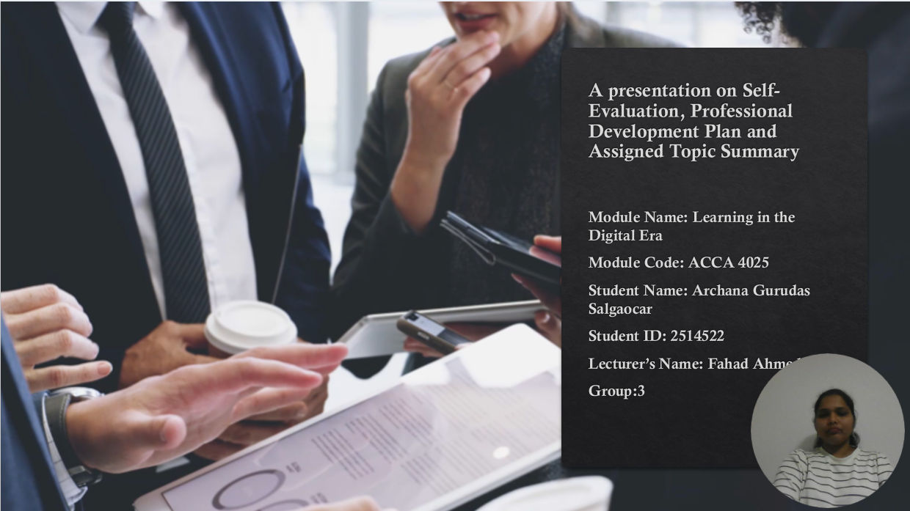

Slide 2 CONTENTS
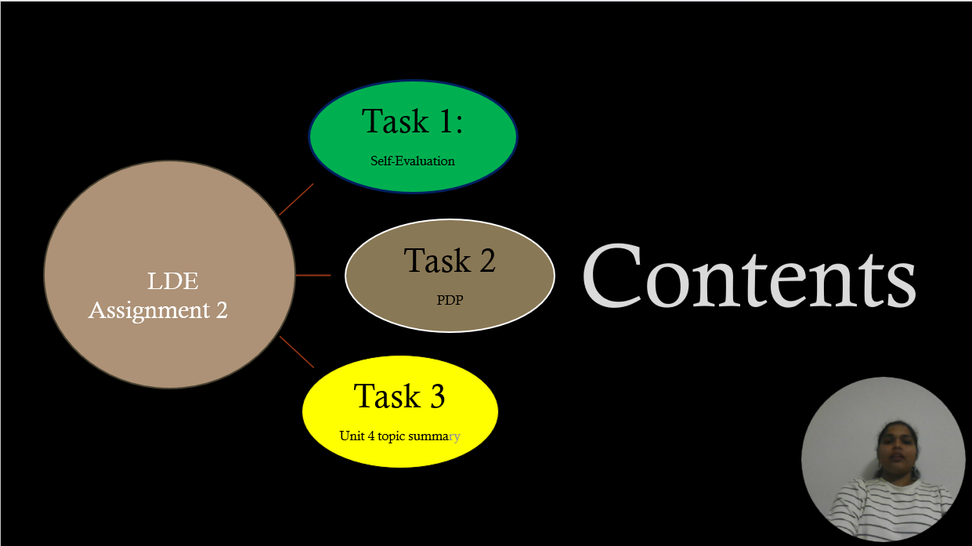

Slide 3 INTRODUCTION


Slide 4 MAIN BODY 

GIBB’s REFLECTIVE MODEL
Slide 5 GIBB’s REFLECTIVE MODEL
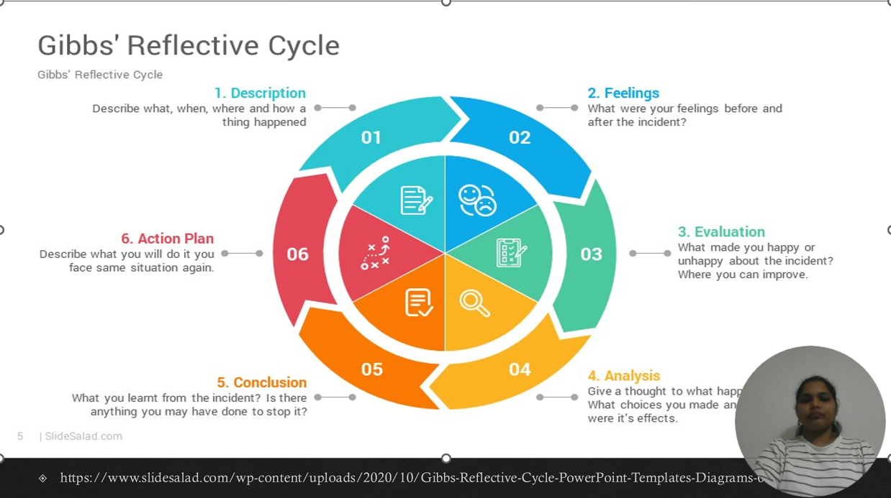

Brief explanation:
Gibbs' Reflective Model:
Gibbs’ Reflective Cycle consists of six key steps that guide structured reflection:
- Description – Outline what happened during the experience without judgment.
- Feelings – Describe your emotional response and thoughts at the time.
- Evaluation – Assess what was good and bad about the experience.
- Analysis – Explore why things happened the way they did and understand the causes.
- Conclusion – Summarize what you learned from the experience.
- Action Plan – Identify what you will do differently in the future to improve [1].

Slide 6
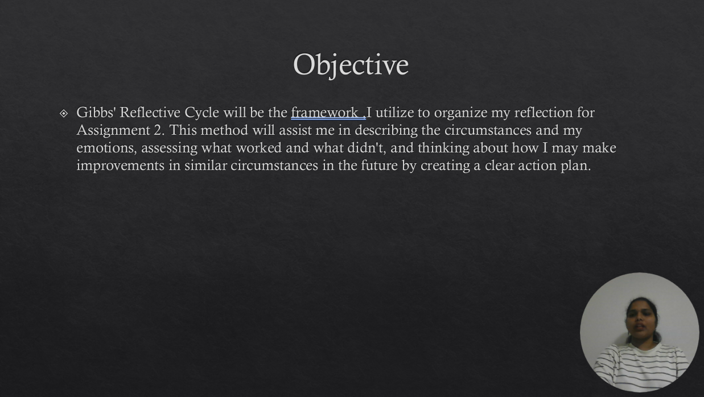

Gibbs' Reflective Cycle is a straightforward and useful concept that facilitates structured introspection. It consists of six steps: summarizing what transpired, examining your emotions, assessing the circumstances, figuring out why things happened the way they did, drawing conclusions about what you learned, and ultimately formulating a plan of action for the future. The concept aids in transforming experiences into valuable learning and promotes candid introspection [2].
I intend to use Gibbs' approach to gradually direct my reflection for Assignment 2. I'll begin by describing the circumstances and my feelings at the time. After that, I'll examine what worked and what didn't and consider the causes in further detail. I will then make some judgments on what I discovered and what I might do differently in the future. Having an action plan at the end will enable me to establish specific objectives for improvement in comparable circumstances. My contemplation will be more structured and significant if I use this cycle.

TASK 1: SELF EVALUATION

Slide 7 TASK 1: SELF EVALUATION
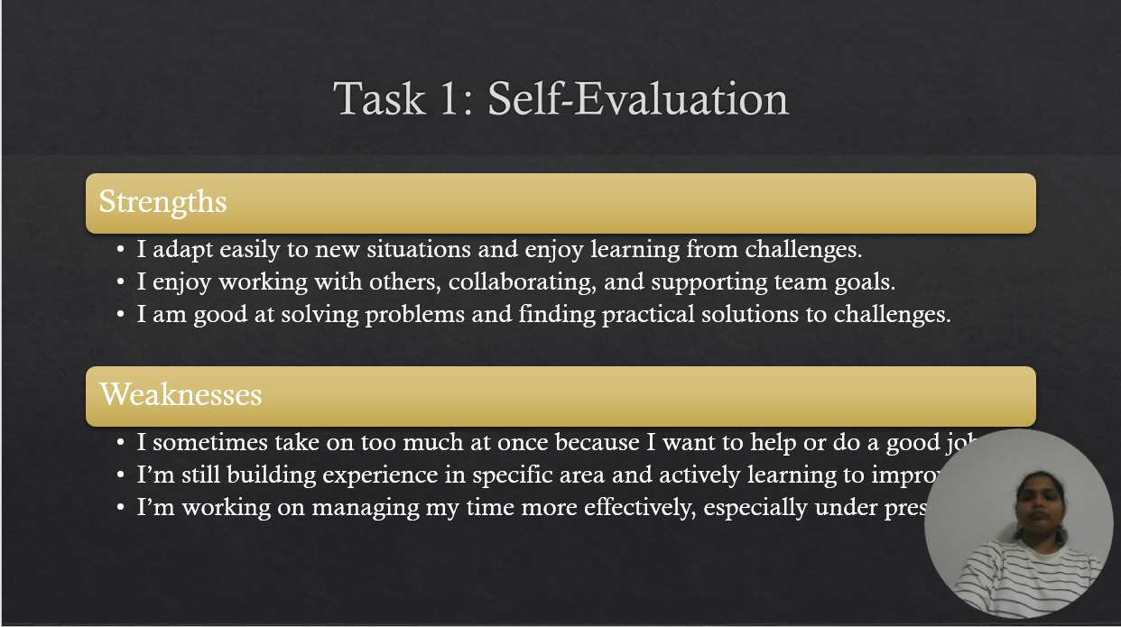

Brief explanation on one strength and one weakness based on my self-evaluation.
Strength.: Adaptability
My ability to rapidly adjust to changing circumstances is one of my greatest assets. When something changes or I encounter something new, I don't give up. Rather, I make an effort to grow from it and solve problems as I go. This helps me deal with difficulties and maintain my optimism even when things become a little erratic.
Weakness: Taking on Too Much
My tendency to take on more than I can manage is a weakness I've identified in myself. Usually, I do this because I want to do the best job I can or because I want to help others. However, there are instances when it causes me stress or makes things more difficult than they need to be. I'm discovering that it's acceptable to establish boundaries and improve my time management in order to avoid overcommitting.

Traits Gained from Self Evaluation

Slide 8 TRAITS GAINED FROM THE SELF EVALUATION
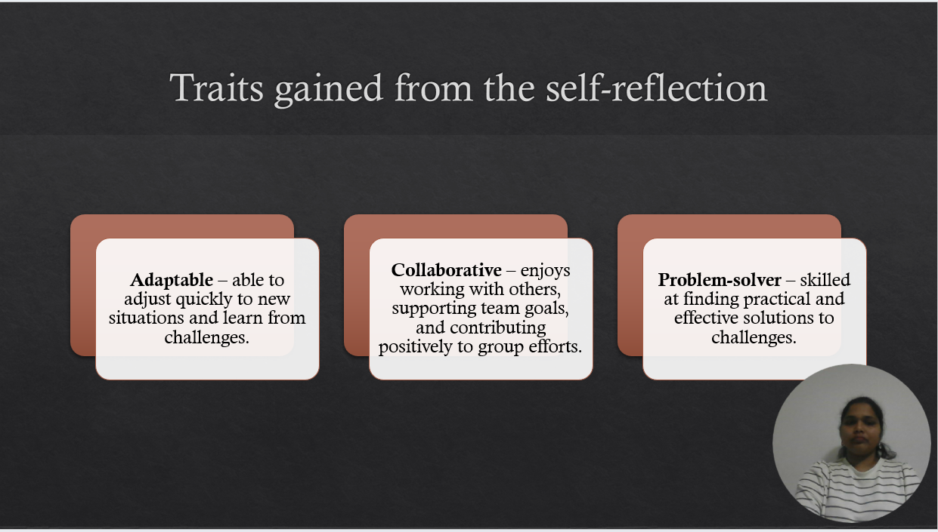

Brief explanation on traits gained from the self-evaluation.
Traits gained as my strength
Adaptive
Adaptability is the ability to deal with change. You adapt fast and remain receptive to learning when new tasks, situations, or obstacles arise. This keeps you self-assured in strange situations.
Collaboration
This indicates that you collaborate well. You enjoy working as a team, interacting, exchanging ideas, and assisting the group in achieving its objectives. You have a beneficial impact on the success of the organization and respect teamwork.
Problem-solving
This quality demonstrates your ability to comprehend problems, analyse them, and develop workable solutions. You don't get stuck easily since you can solve problems and go past challenges.

Traits gained which I need Improvement.
Takes on Too Much
Sometimes you take on more work than you can manage because you want to be helpful or perform well. This may cause you to feel anxious or overburdened, but it also demonstrates your drive and commitment.
Insufficient Experience in Certain Fields
You still need to practice some skills or tasks. This only indicates that you are still learning and are conscious of your areas for improvement, not that you are incompetent.
Effective Time Management
Effective time management may be difficult for me, particularly if I have a lot of work or deadlines. But acknowledging this is just the beginning and already trying to improve my organising and planning abilities.

TASK 2: PROFESSIONAL DEVELOPMENT PLAN
Slide 9 PROFESSIONAL DEVELOPMENT PLAN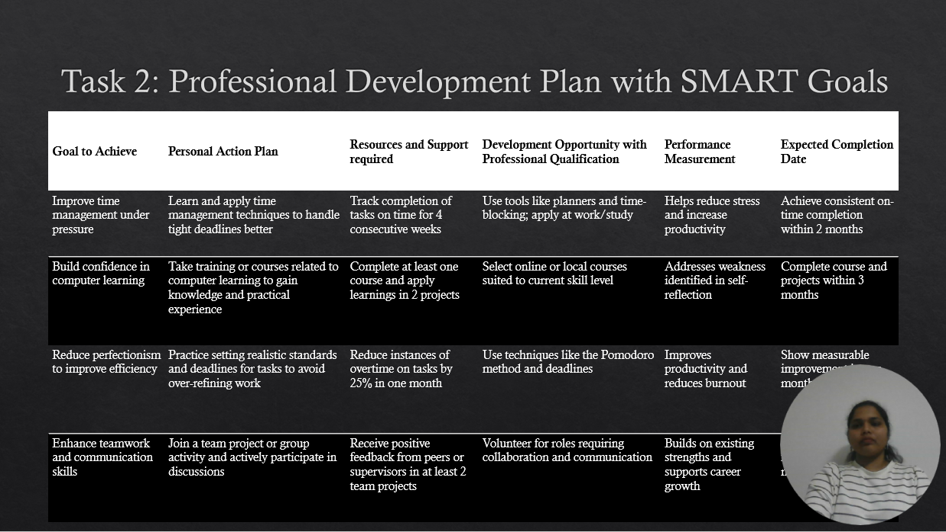

Brief explanation on PDP using SMART GOALS
Using the SMART framework (Specific, Measurable, Achievable, Relevant, Time-bound), this approach focuses on establishing precise, measurable goals to enhance abilities and work habits.
Boost Time Management in Stressful Situations
- Learn and use time management strategies to better manage pressing deadlines.
- For four weeks in a row, monitor the timely fulfilment of tasks.
- Utilize time-blocking tools and calendars to boost productivity and lower stress.
- Within two months, strive for regular on-time completion.
Gain Self-Assurance in Computer Learning
- Attend classes or training to acquire information and useful skills.
- Finish at least one course and use what you've learned in two projects.
- Choose classes based on your present level of expertise.
- Finish the course and all associated assignments in three months.
Increase Productivity by Reducing Perfectionism
- To prevent over-refining work, practice establishing reasonable timelines and standards.
- In a month, try to cut the amount of overtime on jobs by 25%.
- To increase productivity and lessen burnout, apply strategies like the Pomodoro technique.
- Within a month, demonstrate quantifiable progress.
Improve My Communication and Teamwork Skills
- Participate more in conversations and team initiatives or group activities.
- Get compliments on at least two team initiatives from supervisors or peers.
- To enhance your abilities and promote professional development, volunteer for positions that call for teamwork.
- Within the next three months, get compliments.

In order to help you advance professionally and successfully accomplish your objectives, this plan outlines specific actions, resources required, methods for tracking progress, and due dates.

TASK 3: UNIT 4 TOPIC SUMMARY
Slide 10 UNIT 4 TOPIC SUMMARY
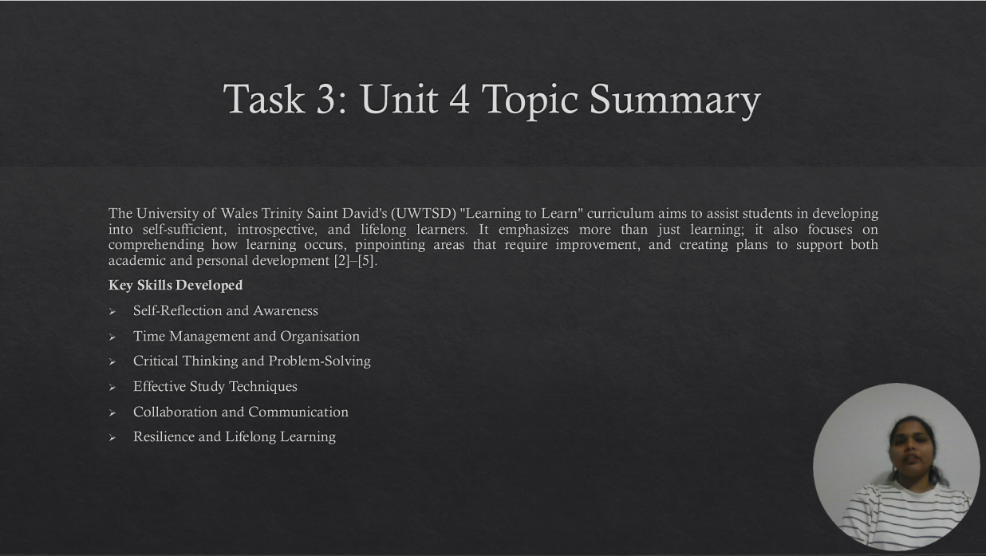

Brief explanation on Topic 1: Learning to Learn at UWTSD
The University of Wales Trinity Saint David's (UWTSD) "Learning to Learn" curriculum aims to support students in developing into autonomous, introspective, and lifelong learners. It emphasizes understanding how learning occurs, pinpointing areas for development, and creating tactics to support both academic and personal growth in addition to knowledge acquisition [3]– [5].
The module teaches students to consider how they learn, set reasonable objectives, and use strategies that improve the efficiency and enjoyment of learning.

Key Skills Developed
Self-Reflection and Awareness
- encourages students to assess their learning styles, areas of strength, and areas for improvement [3][5].
- aids in determining the most effective learning methods and preferred learning styles (visual, auditory, and kinaesthetic) [3].
- encourages planning for self-improvement and the creation of personal goals.
Time Management and Organisation
- Students acquire the skills necessary to manage deadlines, prioritize assignments, and make efficient study plans [3][5].
- explains how to track assignments using digital apps, planners, and calendars [3].
- lowers academic stress and increases productivity.
Critical Thinking and Problem-Solving
- enhances the capacity to analyse data, challenge presumptions, and draw logical conclusions [6].
- aids pupils in assessing the reliability of sources and making wise choices.
- promotes the use of logic in the resolution of both academic and practical issues.
Effective Study Techniques
- teaches techniques including spaced repetition, mind mapping, active reading, and taking notes [4][5].
- Students have the ability to modify methods for various disciplines and forms of evaluation.
- emphasizes the importance of frequent review to solidify knowledge.
Collaboration and Communication
- encourages collaborative problem-solving, peer review, and cooperation [3][5].
- improves one's capacity for clear idea communication and productive teamwork.
- promotes introspection on individual contributions and group dynamics.
Resilience and Lifelong Learning
- increases adaptability, perseverance, and receptivity to criticism [4][6].
- helps students get ready for independent study after graduation.
- promotes a growth mentality by seeing obstacles as chances to improve.
At UWTSD, the Learning to Learn module gives students the tools they need to succeed academically and personally. It enables students to take charge of their education and embrace lifelong learning by encouraging self-awareness, critical thinking, organization, teamwork, and resilience. [3]– [6].

Conclusion
Slide 11 CONCLUSION

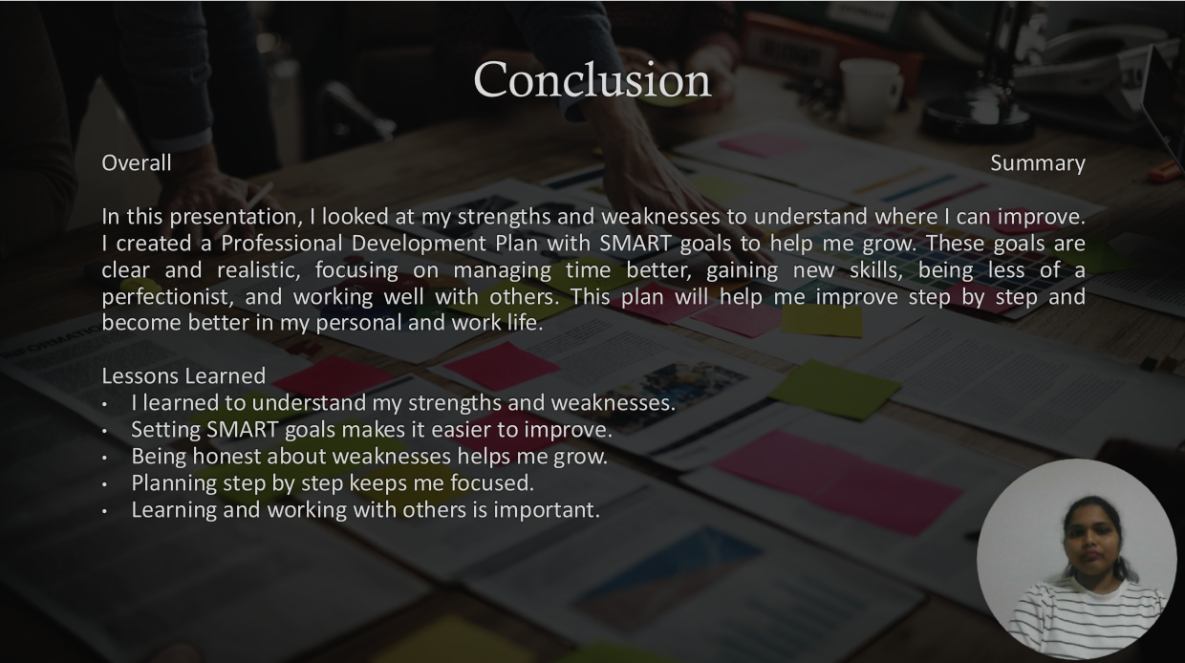

Brief explanation:
Overall Summary
In this presentation, I looked at my strengths and weaknesses to understand where I can improve. I created a Professional Development Plan with SMART goals to help me grow. These goals are clear and realistic, focusing on managing time better, gaining new skills, being less of a perfectionist, and working well with others. This plan will help me improve step by step and become better in my personal and work life.
Lessons Learned
I learned to understand my strengths and weaknesses.
Setting SMART goals makes it easier to improve.
Being honest about weaknesses helps me grow.
Planning step by step keeps me focused.
Learning and working with others is important.
Slide 12 References
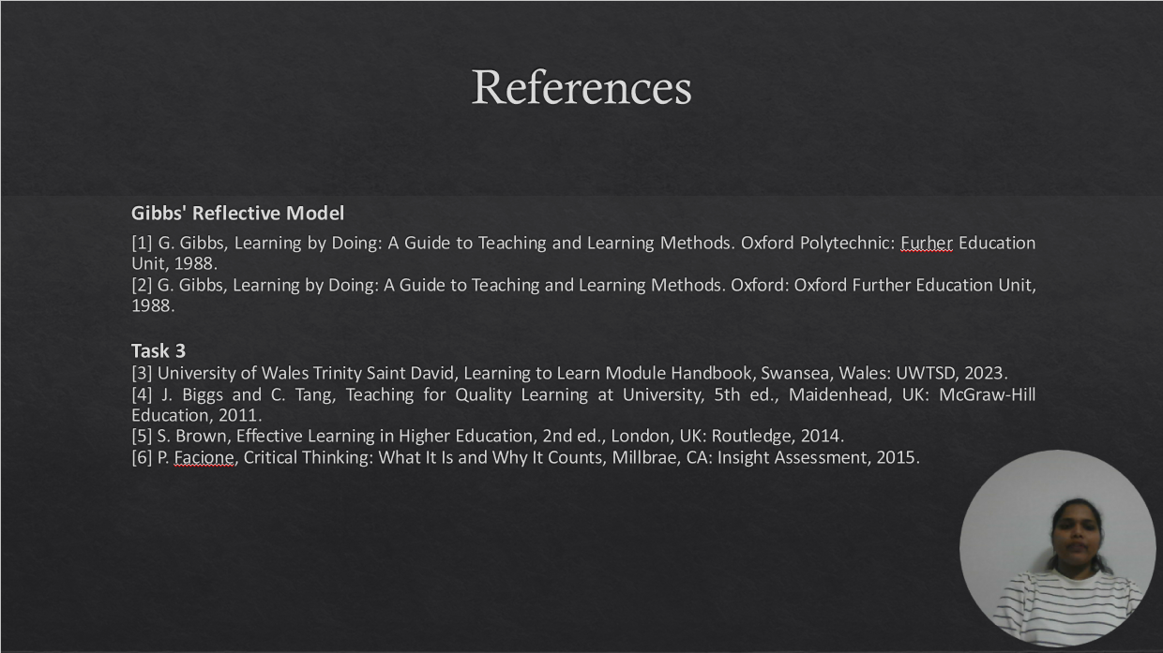

References

Gibbs' Reflective Model
[1] G. Gibbs, Learning by Doing: A Guide to Teaching and Learning Methods. Oxford Polytechnic: Furher Education Unit, 1988.
[2] G. Gibbs, Learning by Doing: A Guide to Teaching and Learning Methods. Oxford: Oxford Further Education Unit, 1988.

Task 3
[3] University of Wales Trinity Saint David, Learning to Learn Module Handbook, Swansea, Wales: UWTSD, 2023.
[4] J. Biggs and C. Tang, Teaching for Quality Learning at University, 5th ed., Maidenhead, UK: McGraw-Hill Education, 2011.
[5] S. Brown, Effective Learning in Higher Education, 2nd ed., London, UK: Routledge, 2014.
[6] P. Facione, Critical Thinking: What It Is and Why It Counts, Millbrae, CA: Insight Assessment, 2015.

Video link
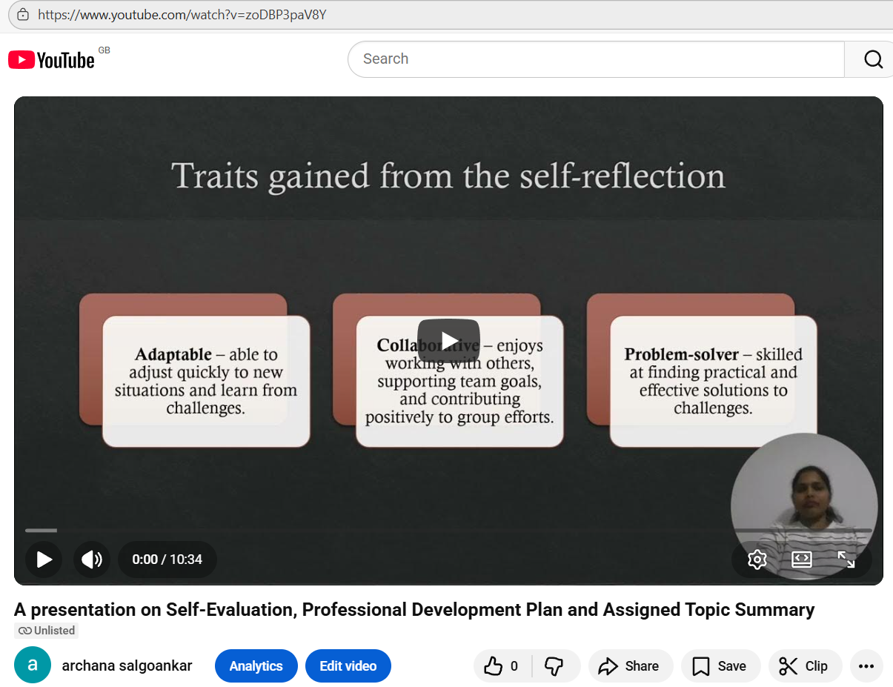

https://youtu.be/zoDBP3paV8Y
https://youtu.be/zoDBP3paV8Y?si=qriTJ9E0hx2I8mNy

Slide 13


