

BA BUSINESS MANAGEMENT
Component 1: Written Report

Module: Entrepreneurship
Code: LCBB5001
Lecturer: Nishi Ramsurrun
Student: Cristina-Loredana Balaban 2030114

20th of December 2023

Table of Contents
Business Description / Market Opportunity 3
Industry Analysis 5
Operations and Management Team Plan 8
Marketing Plan and Strategy 11
Financial Plan 12
Closing Summary 15
Reference List 16

Business Description / Market Opportunity
Starting a UK fast-food restaurant called Savorious in Northampton is a business opportunity. Savorious will provide high-quality food delivery at low prices to become the area's top fast-food chain. The goal is a Prime Cost Ratio below 52% for cost-effectiveness and profitability. Savorious is a fast-food chain that serves unique dishes without a lot of service. Increasing demand for convenient eating options aligns with the business's focus on fast and timely meal delivery, according to market research. Savorious' mission is to serve delicate and excellent meals, building a strong brand. Offering affordable menu choices with high-quality ingredients underpins this objective. The business aims to raise sales by 21% over three years, suggesting a focus on sustainable growth.
Savorious's business opportunity stems from the consumer need for fast and convenient dining. A fast-food restaurant catering to Northampton's busy people will do well in this bustling city. People and families looking for fast, pleasant, and high-quality meals are the target market. Market research shows consumers choose time-saving dining options. With busy schedules, people prefer fast-food restaurants with a range of menu alternatives (Quang et al, 2018). Savorious offers a variety of high-quality quick cuisine to capitalize on this trend. Northampton's fast-food business has many competitors with diverse cuisines and service levels. Savorious emphasizes fast meal delivery, value-driven pricing, and superior ingredients. This difference is vital in a market with many options where consumers value quality and convenience more. Savorious's recipes, culinary preparation processes, and restaurant branding are its IP. The business's competitive advantage is its unique menu offerings and rapid delivery. To run the restaurant legally, food safety, licensing, and labour laws must be followed.
The company description of Savorious emphasizes its ownership structure. This structure allows strategic collaborations and investments in the future and flexibility in decision-making. Organizational transparency and accountability are ensured by clear ownership and decision-making authority. Savorious's business description and market potential analysis show how the fast-food restaurant fits within Northampton's dynamic dining industry. Savorious wants to grab a large market share by satisfying busy consumers' changing needs with efficient meal delivery, value-driven pricing, and quality. Industry analysis, operational plans, marketing tactics, and financial predictions will follow in the business plan, giving a complete picture of the business's potential in the competitive fast-food industry.

Industry Analysis
Northampton's fast-food business is competitive and active. Businesses catering to on-the-go dining thrive in the city's diverse population and busy lifestyle. Industry size, growth rate, and sales estimates imply a robust market with strategic entry and expansion prospects.

VRIO Analysis
A VRIO (Value, Rarity, Imitability, and Organization) analysis evaluates Savorious' industry strategic resources and skills.
- Value: Savorious delivers value with rapid meal delivery, a varied variety of high-quality fast food, and competitive prices.
- Rarity: Savorious's products are rare due to their premium ingredients and efficient delivery.
- Imitability: Although efficient distribution can be replicated, the unique recipes and branding make it difficult to mimic.
- Organization: Savorious's professional management team and efficient operations boost its organizational capability.

Porter's Five Forces Analysis
1. Threat of New Entrants:
Newcomers pose a moderate danger to Northampton's fast-food business. Despite financial and brand-establishing constraints, the comparatively low entry barriers may attract new companies looking to capitalize on the expanding demand for quick-service meals (Bertozzi et al., 2018).
2. Bargaining Power of Suppliers:
Food suppliers may have moderate bargaining leverage, especially for expensive ingredients. Strong supplier connections and a diversified supply chain help reduce this risk.
3. Bargaining Power of Buyers:
Fast-food buyers have a lot of options and may easily switch restaurants, giving them significant bargaining power. Savorious must prioritise customer satisfaction, quality, and innovative services to keep customers (Bertozzi et al., 2018).
4. Threat of Substitutes:
The threat of substitutes is moderate because consumers may pick home-cooked meals or other cuisines. Savorious's varied menu and fast delivery can counter this threat.
5. Competitive Rivalry:
Many restaurants compete for market share in the fast-food industry. Savorious emphasizes delivery, quality ingredients, and value-driven pricing.

Target Market, Segmentation, Targeting, and Positioning Strategy
Target Market:
Savorious targets families and people who want fast, high-quality dining. Time-conscious professionals, students, and families are the target population.
Segmentation:
Demographics, psychographics, and behaviour segment the market. Savorious targets urbanites of all ages. Psychographic ally, the brand targets quality and convenience lovers. Behaviour-based segmentation analyses fast-food consumption and menu diversity (Shabbir & Kassim, 2019).
Targeting:
Savoury utilizes specialized targeting to offer a unique value proposition through efficient food delivery, excellent ingredients, and affordable pricing. Savorious wants to gain a competitive edge by understanding its target market's different needs.
Positioning:
Savoury promotes itself as a fast-food restaurant that surprises. It emphasizes quality products and fast delivery to offer quick meals and a gastronomic experience.

Competitor Analysis
The Northampton fast-food business has many rivals, each with pros and cons. Competitor A's broad menu and brand loyalty make client retention difficult. However, Savorious emphasizes delivery and innovative menu items to stand out. Price-sensitive buyers choose Competitor B because of its affordability. Savorious counters this competition with competitive pricing and a diverse menu. Competitor C serves a speciality cuisine. Savorious wants to attract more customers by offering more fast food.
Savorious faces a lively and competitive fast-food industry in Northampton. VRIO analysis and Porter's Five Factors model assess strategic resources, competitive factors, and market dynamics (Bertozzi et al., 2018). Success in the industry depends on Savorious's differentiating strategy, target market segmentation, and competitive positioning. Understanding competitive factors and market trends helps Savorious capitalize on opportunities and manage threats to become Northampton's top fast-food restaurant.

Operations and Management Team Plan
The operational plan for Savorious, the fast-food restaurant in Northampton, outlines the daily business procedures. Everything from obtaining supplies to shipping the finished product is included. Savorious knows a strong supply network ensures premium ingredients. Reliability, quality, and demand will be considered when choosing suppliers. Strong supplier ties enable a consistent supply of ingredients, ensuring menu consistency and quality (Quang et al, 2018). The menu items are made by trained cooks following standardized recipes. Each order must be efficient and consistent to fulfil Savorious' high requirements. Staff training will emphasise quality and rapid preparation, and the kitchen layout will be optimized for workflow.
Efficiency in delivery is essential to Savorious's strategy. For fast and accurate order fulfilment, the restaurant will buy a trustworthy delivery fleet and hire a specialized workforce. Order tracking and delivery optimization technology streamlines and improves customer service. Dine-in, takeaway and delivery are Savorious' business streams. The average transaction value will be increased by upselling and upgrading. For cost-effectiveness, operational efficiency will be optimized to utilize economies of scale. Savorious will reduce waste with powerful inventory management solutions to avoid revenue loss. Quality control will be enforced throughout the production process to reduce product defects. Order processing accuracy will be stressed in employee training to reduce errors and customer unhappiness.
Founder and CEO:
The creator and CEO has ten years of food and hospitality expertise and a Business Management degree. The CEO knows consumer preferences and industry trends from his successful companies. The imaginative leadership of the CEO drives Savorious's mission to become Northampton's top fast-food restaurant.
Head Chef:
The head chef should hold a Culinary Degree with seven years of experience in renowned restaurants. Should bring culinary expertise and a passion for creating unique and delectable dishes. The head chef plays a pivotal role in menu development, ensuring that Savorious offers a diverse and appealing range of fast-food options.

Operations Manager:
The operations manager is an experienced professional with an operations Management degree. With 5 years of restaurant management expertise, the operations manager optimizes productivity, streamlines processes, and ensures daily operations run smoothly. Savorious's quality and consistency depend on the operations manager.
Marketing and Sales Manager:
The marketing and sales manager has an MBA in Marketing. The marketing and sales manager promotes Savorious strategically, having developed and implemented food sector marketing tactics. Brand awareness, promotional efforts, and customer acquisition depend on the marketing and sales manager.

Entrepreneurial Capabilities and Competences
Management's skills show their entrepreneurialism. Academic credentials provide a solid foundation, while professional experience gives them fast-food business knowledge. Previous successes demonstrate their capacity to overcome obstacles and seize chances, ensuring Savorious's success in the competitive Northampton market. The operating plan emphasizes a well-structured supply chain, efficient production, and effective delivery services for Savorious' success (Barringer and Ireland, 2019). With its diversified experience and entrepreneurial skills, the management team can guide the business to its goals. Strategic leadership and operational expertise helped Savorious become Northampton's top fast-food restaurant.

Marketing Plan and Strategy
Savorious, a Northampton fast-food restaurant has a thorough marketing plan to build a strong brand, attract a varied client base, and sustain growth. Savorious's marketing strategy promotes awareness, interest, and involvement. The approach uses online and offline media to reach a wide audience.
Positioning and Differentiating Propositions
Savorious differentiates itself in the market by promising not just fast food but a whole dining experience. The value propositions that set us apart from the competition are our commitment to prompt food delivery, our commitment to using only the highest quality ingredients, and our approach to pricing. Savorious aspires to be the first name people think of when they think of fast, high-quality meals.
Marketing Mix - The Four P’s:
- Product: Menu selections at Savorious range from fast food standards to original recipes. The product stands out from the crowd thanks to its high-quality ingredients and convenient shipping options.
- Price: Value-driven pricing ensures affordability without compromising quality. Strategic promotions and discounts will attract and maintain customers.
- Promotion: The promotional mix comprises online and offline tactics. Social media ads, influencer relationships, and an easy-to-use online ordering platform will be used (Genoveva and Siam, 2019). Offline promotion will include community events, collaborations, and traditional advertising.
- Place: The distribution technique maximizes access. Savoury will offer dine-in, takeaway and fast delivery. Alliances with food delivery services will expand their reach.

Market Entry
Savorious will enter the market gradually. Soft launches build anticipation and allow for tweaks. A full-scale launch with focused marketing will boost brand visibility as it grows. The customer-centric sales procedure ensures a smooth order-to-delivery experience (Genoveva and Siam, 2019). Online orders will be made easy with an easy-to-use platform and efficient in-house and third-party delivery. To improve sales, customer feedback will be implemented.

Financial Plan
The marketing strategy of Savorious is crucial to its financial survival. Branding boosts client loyalty, repeat business, and word-of-mouth marketing. Online promotion efficiency reduces traditional advertising expenditures, obtaining a Prime Cost Ratio of less than 52% (Barringer and Ireland, 2019). Marketing expenses and promotional budgets are included in the financial plan. Both launch and ongoing marketing campaigns are included. Brand equity, customer acquisition, and long-term profitability are the marketing budget's goals.

Balance Sheet
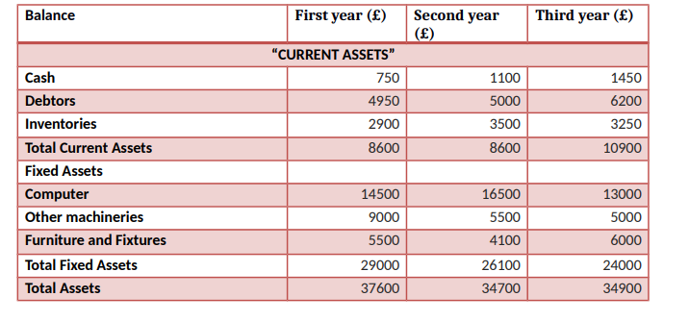
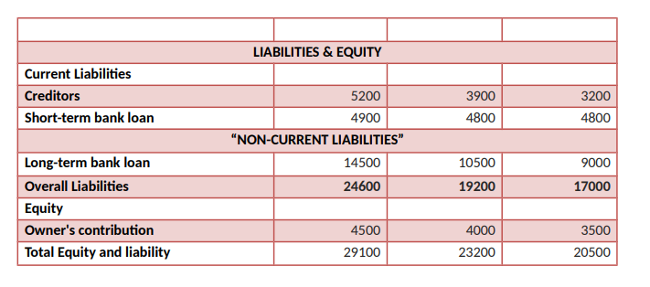

Break-even analysis
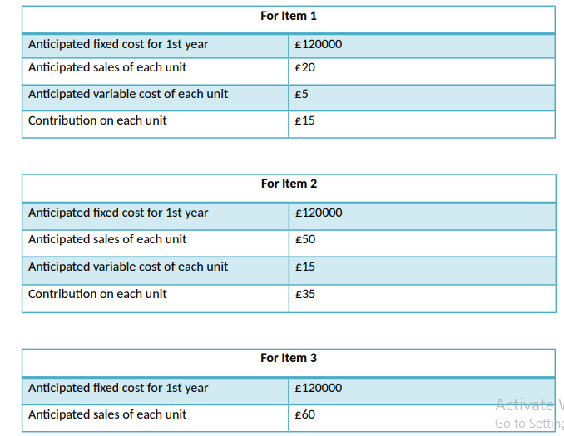
The six-month cash budget forecast details revenues, expenses, and cash flows. It includes marketing strategy-based sales estimates that account for seasonality and market trends. Marketing initiatives are funded by the budget to maintain a strong market presence. Sales and financial sustainability are linked in the financial plan. Savorious balances revenue and cost-effectiveness by connecting sales projections with marketing strategy. A consistent flow of clients and sustainable financial performance result from intelligent marketing channel deployment.

Closing Summary
In conclusion, Savorious' marketing plan and strategy focus on brand equity, customer acquisition, and financial sustainability. Integration of online and offline channels and phased market entry show a comprehensive awareness of the competitive landscape. The financial strategy carefully integrates marketing expenses into the budget, acknowledging their importance to revenue and long-term performance.
Savorious wants to be Northampton's signature fast-food chain and brand for quality and convenience.

Reference List
Barringer, B., Ireland, D., (2019), Entrepreneurship: Successfully Launching New Ventures. Sixth edition; Global edition. Harlow, England: Pearson.
Bertozzi, F., Ali, C.M. and Gul, F.A., (2018), Porter’s five generic strategies; A case study from the hospitality industry. International Journal for Research In Mechanical & Civil Engineering (ISSN: 2208-2727), 3(2), pp.09-23.
Genoveva, G. and Siam, S.T., (2019), Analysis of marketing strategy and competitive advantage. Journal of Economic & Management Perspectives, 11(1), pp.1571-1579.
Oliver, R. (2021) How Popular Are Meal Kits? Industry Statistics In 2021 And Beyond, Truly Blog Behind Ordinary. Available at:
https://trulyexperiences.com/blog/meal-kits-industry-statistics/
(Accessed:10 December 2023).
Quang, N., Nisar, T.M., Knox, D. and Prabhakar, G.P., (2018), Understanding customer satisfaction in the UK quick service restaurant industry. British Food Journal, 120(6), pp.1207-1222.
Shabbir, M. S., & Kassim, N. M. (2019), Entrepreneur as an Individual Review of Recent Literature on Entrepreneurial Skills. Opción: Revista de Ciencias Humanas y Sociales, (89), 220.

