

Module Name: Managing Enterprise
Module Code: BMSW4011
Assignment Name: Business Plan and Reflection
Student Name: Ozma Nasir
Student Number:2433556
Lecturer: Melanie Squire
Deadline: 6th March 2026
Wordcount: Business Plan 1100
Reflection 464
AI Acknowledgement:
I confirm that I have not presented any AI generated materials as my own work.
I confirm that I have copies of my drafts, notes, and other resources I used, which I may be asked to provide in evidence.

Business Plan: Pure Vanity Lounge Ltd

Contents

- Business Proposition

2. The Story and Founder's Passion
3. Business Ownership Structure
4. Strategic Direction
5. Physical Location and Premises
6. Human Resources Plan
7. Marketing and Promotion Strategy
8. Market Research and Analysis
9. Financial Planning
10.Competitive Analysis
11. Critical Business Appraisal
12. References

Business Plan: Pure Vanity Lounge Ltd

1. Business Proposition
Pure Vanity Lounge Ltd (PVL) is a premium medical aesthetic clinic situated Cardiff, offering non-surgical aesthetic and body contouring treatments: anti-wrinkle injections, dermal fillers, advanced skin rejuvenation (chemical peels, microneedling). Clients complete a mandatory consultation with a registered medical professional. The clinic layout will reflect a “clean beauty” ethos – calming and minimalist, targeting clients aged 22 - 60 who seek safe and high-grade, treatments with clear pricing and exceptional aftercare.

2. The Story and Passion
PVL was created from my own personal beauty salon employment, witnessing an increasing demand for aesthetic treatments, but concerns over inadequate regulated practitioners, hard-hitting sales, and bad results, that compromised facial harmony. It emphasised the demand for a clinical quality where ethical practice, artistic subtlety and safety before profit (Nuffield Bioethics (No Date). I am passionate about inspiring clients to feel their best through aesthetic improvements respecting their unique facial and body features.

3. Business Ownership
Rationale, Pros, and Cons:
- Rationale: PVL will operate as a limited liability as personal assets are protected if the company experiences legal action or debts.

- Pros:
  - Limited Liability: Financial risk is confined to company.
  - Credibility: “Ltd” status boosts professional credibility with investors and suppliers.
  - Tax Efficiency: Withdrawing profits through dividends and salary.
  - Continuous Existence: Irrespective of changes in ownership.

- Cons:
  - Administration: Complicated and expensive to set up and operate, filing of yearly accounts and confirmation statements with Companies House.
  - Public Disclosure: Financial data is available, reducing confidentiality.
  - Regulatory Compliance: Abide by the (Companies Act 2006).

4. Mission, Aims, SMART Objectives & USP
- Mission Statement: “To inspire trust through ethical, professional medical aestheticians, where natural results, client safety and excellent care are our top priorities.”
- Aim: To become Cardiff’s most trustworthy and advocated premium medical aesthetic clinic within three years.

- SMART Objectives:
  - Financial: Reach a gross profit margin of 50% by the end of Year 1.
  - Customer: Achieve 4.8-star Google My Business rating from 60+ verified reviews in year 1.
  - Operational: Implement a digital client management system for records, consultations, and aftercare within 6 months of trading.
  - Growth: Add 2 new advanced treatment e.g. Morpheus and Laser Hair Removal within the first 18 months.
- USP: “The Specialist-Led Lounge.” PVL offers compulsory consultations with a qualified medical prescriber, ensuring treatment plans are medically rigorous, tailored, and achieve harmonious and subtle results, furthering trust and client approval, as USP is crucial (Stanley, 2022).

5. Physical Location
- Location: Charles Street, Cardiff, CF10 2GA.
- Rationale: In the heart of Cardiff’s affluent professional and shopping area, offering high footfall for PVL’s target demographic. Easily accessible via public transport, and great proximity to high-end hair and nail salons. A ground-floor unit with distinct branding would give visibility while providing an exclusive experience.
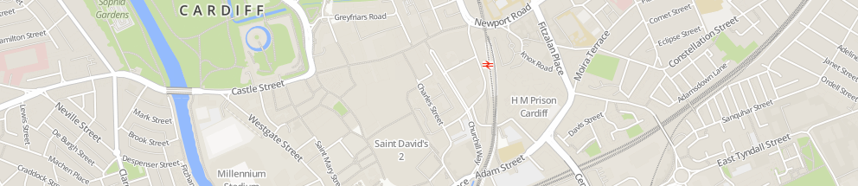
Figure 1: Proposed location area

6. Human Resources
PVL will initially employ 3 full-time staff:
- Clinic Manager: Runs operations, compliance, marketing and finance.
- Aesthetic Nurse Prescriber: Runs consultations, manages clinical governance and all prescription-based treatments.
- Aesthetic Practitioner: Delivers skin treatments, supports consultations, and manages client aftercare.
Sourcing: Via professional medical aesthetic recruitment agencies e.g. Sterling Cross and target advertising on professional job boards e.g. British Association of Medical Aesthetic Nurses.

Organisation Chart:
Company Director
|
Clinic Manager
|
--------------------------------------------------------------------------------
| |
Aesthetic Nurse Prescriber Aesthetic Practitioner

7. Marketing Activities
- Branding: A minimalist logo and soft neutrals with accent colours communicating luxury and clinical trust.

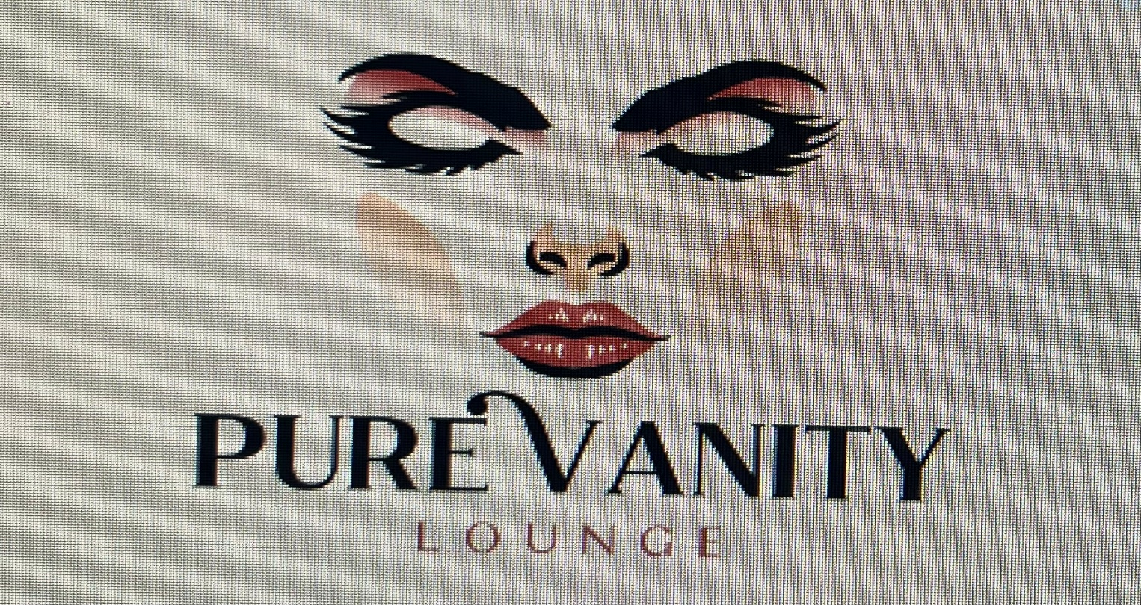
Figure 2: Proposed logo

- Digital Presence:
  - SEO-optimised website www.purevanitylounge.com with treatment information, practitioner qualifications, and appointment portal.
  - Social Media: Instagram (pure_vanity_lounge) and Facebook. Aesthetic educational posts and video content, client endorsements, before and after images.
  - Example Facebook Launch Post: “Welcome to Pure Vanity Lounge – where expertise meets elegance. Book your free, no-obligation consultation with our Nurse Prescriber and discover a new standard in aesthetic care. #CardiffAesthetics #PureVanityLounge”
- PR Initiatives: Promotional event for local beauty bloggers; pitching professional commentary on aesthetic safety to Welsh media.
- Traditional Collateral: Business cards and leaflets for circulation in affiliate businesses e.g. dental clinics and hotel spas.

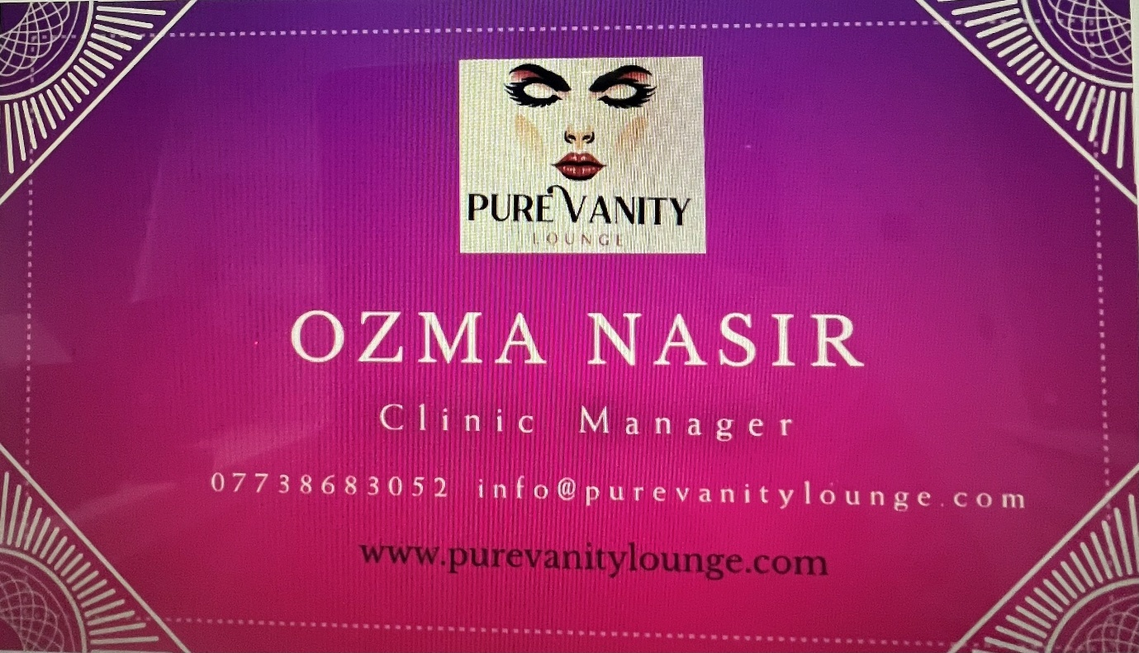
Figure 3: Proposed Business Card

8. Market Research
Primary Research:
- Method: Online survey of 100 individuals in Cardiff (aged 22-60) See Appendix A
- Findings: 68% mentioned “practitioner qualification” as their main decision factor. 72% were discouraged by clinics that forced for immediate treatment during consultation. A readiness to pay a 15-20% premium for a “medical, no-pressure environment” was stated.
- Application: This backed our USP of the compulsory, non-sales specialist-led method supporting our premium pricing approach.

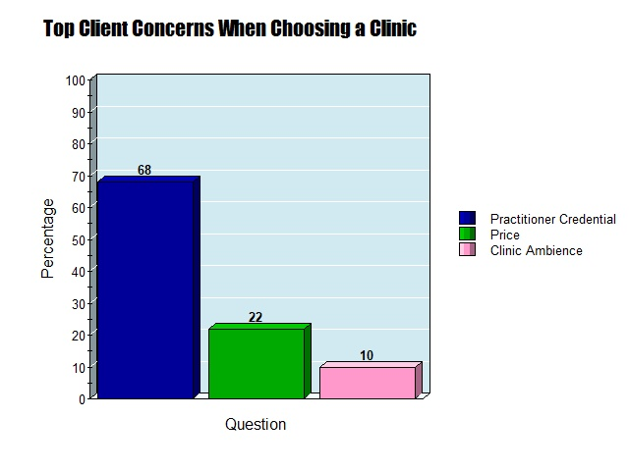
Figure 4: Survey Results - Top Client Concerns When Choosing a Clinic

Secondary Research:
- The UK non-surgical aesthetic market was valued at £11.49 billion in 2024 and is predicted to increase (Harris, 2024).
- A report by Richards (2025) highlighted significant public concern over practitioner training and regulation, validating our safety-first messaging.

9. Financial Resources
- Start-up Costs: £95,000 for clinic fit-out (£40k), initial stock & medical equipment (£30k), legal registrations (£5k), marketing launch (£10k), and 3-month operational buffer (£10k).
- Monthly Running: Rent (£2,500), Wages (£8,000), Utilities & Insurance (£500), Consumables & Stock (£3,000), Marketing (£1,000), Miscellaneous (£500). Total £15,500.
- Sources of Finance: £50,000 director investment (personal savings), £45,000 start-up loan (British Business Bank, 2025).
- Feasibility: The loan is realistic based on a solid business plan and good credit.
12-Month Cash Flow Forecast (Summary):
Month | Cash Inflow | Cash Outflow | Net Cash Flow | Opening Balance | Closing Balance
Month 1 | £8,000 | £20,000 | -£12,000 | £95,000 | £83,000
Month 6 | £18,000 | £16,000 | £2,000 | £75,000 | £77,000
Month 12 | £25,000 | £17,000 | £8,000 | £80,000 | £88,000
Narrative (See Appendix B): The forecast shows an initial cash outflow for launch expenses. Breakeven is forecasted in Month 8 with positive cash flow increasing subsequently as clients increase. Initial capital is adequate to cover the projected shortfall.

10. Competitor Analysis - Cardiff
Competitors & Analysis:
High-street chains (i.e. Laser Clinics UK): Competitive pricing but can feel transactional.
Solo practitioners (i.e. Elevate Medical & Aesthetics Clinic): offer personal service but lack full clinic facilities.
Premium clinics (i.e. Cardiff Cosmetic Clinic): align with our model but often lack our specific “specialist-led” USP.
- Pricing: Market research shows anti-wrinkle treatments range from £180-£300 per area. PVL will price at the upper mid-range (£250) to reflect premium.
- Learning: Emphasising our medical governance in marketing is crucial to differentiate.

11. Critical Appraisal (SWOT) & Conclusion
- Strengths: Strong USP, qualified medical team, premium location, ethical business model.
- Weaknesses: High initial investment, dependence on key clinical staff, premium pricing may limit market segment.
- Opportunities: Growing market, increasing consumer awareness of safety, potential for expanding treatments and additional locations.
- Threats: Intense local competition, cost of living affecting disposable income, changes in industry regulation.
Conclusion: PVL is a viable business proposal. The SWOT confirms a strategic position exists, strengths and opportunities outweigh weaknesses and threats, which can be mitigated by robust employment contracts and financial intelligence. The market demand, with a safety-focused model that addresses documented client worries, offers a strong foundation for success. The financial projections, while cautious, support a path to profitability.

Reflection on Entrepreneurial Skill Development
During the Managing Enterprise module BMSW4011, I applied and developed existing and new entrepreneurial skills in effective ways. Existing skills in critical writing and structured research from academic terms one and two were directly applied to the above business plan, however, I was overwhelmed by the heavy workload involved in viability assessments and financial projections, subjects where previously, I only gained theoretical understanding. The method of collating market research, mainly primary data compilation and evaluation, was a completely new area; creating questionnaires, interpreting answers, and enabling those results to genuinely influence my business plan, clarified the significance of an assumption-based approach to a data-driven strategy.
The greatest development of my transformative skills happened during the preparation of the Angel investor pitch. I had to transition from converting technical detail into a market-facing, persuasive pitch for investment. This strengthened my capacity to define and convey competitive advantage under stress. I learned to pinpoint the “hard-hitting facts” that strikes a chord with an investor i.e. the transferable market scope, the demand for a specialist-led model, and the validity of my USP, and present them with conviction and conciseness. Additionally, the financial demonstration, although challenging, improved my financial knowledge in a real-world setting. Progressing from theoretical models to creating a 12-month cash flow forecast instilled a practical understanding of cash flow, profitability thresholds, and the financial impact of pricing and cost decisions
The skill that has had the greatest effect on me is the amalgamation of critical evaluation into a creative idea. At first, Pure Vanity Lounge was conceived by bridging a deep passion for beauty with identified unmet market needs. The module pushed me to methodically challenge this notion via tools like SWOT analysis, competitive analysis, and financial risk simulation. This combination demonstrated that actual entrepreneurship is not about the firm confidence in an idea, but about the process of continuously improving an idea through repeated testing and feedback. The defining moment was realising my data contradicted my pricing strategy, forcing a change in direction. This highlighted that user research must take precedence over internal guesswork.
This skill is effective as it characterises the main attitude of a strong entrepreneur. It shifts business innovation from a direct, personal enthusiasm direction to a continuous, data-driven one. It has encouraged a discipline of looking for contradictory information and accepting constructive criticism as a vital means for developing robustness, instead of deeming them as threats. This approach will be instrumental in any future business enterprise, empowering me to assess creative ambitions with practical flexibility, the crucial blend for steering ambiguity and accomplishing profitable growth. The module has primarily changed my perspective from having an excellent business proposal to having a validated opportunity, with the evidence and strategy to implement it successfully with greater confidence.

Reference list
  - BAMAN. (2026). Practitioner Finder. [online] Available at: https://www.baman.org.uk/practitioner-finder/map/south+wales/
[Accessed 4 Feb. 2026].

  - British Business Bank. (2025). Start Up Loan. [online] Available at: https://www.british-business-bank.co.uk/start-your-journey/finance-finder/start-up-loan. [Accessed 4 Feb. 2026].

  - Get More Google Business Reviews with These 16 Tried & True Tactics. [online] Available at: https://www.wordstream.com/blog/ws/2020/09/16/get-more-google-reviews.

  - GOV.UK (2006). Companies Act 2006. [online] Legislation.gov.uk. Available at: https://www.legislation.gov.uk/ukpga/2006/46/contents. [Accessed 4 Feb. 2026].

  - Cardiff Cosmetic Clinic. (2026). Skin Aesthetics Trusted Leaders | Cardiff Cosmetic Clinic. [online] Available at: https://www.cardiffcosmeticclinic.com/ [Accessed 4 Feb. 2026].

  - Cosmetic procedures: Ethical issues. (No Date) Available at: https://www.nuffieldbioethics.org/wp-content/uploads/Cosmetic-procedures-full-report.pdf [Accessed 4 Feb. 2026].

  - Elevate Medical & Aesthetics Clinic. (2026). Treatment Prices | Elevate Medical & Aesthetics Clinic in Cardiff​. [online] Available at: https://www.elevateclinic.uk/prices/price-list/ [Accessed 4 Feb. 2026].

  - Harris, S. (2024). UK aesthetics industry statistics. [online] PolicyBee news and risk advice. Available at: https://www.policybee.co.uk/blog/aesthetics-industry-statistics. [Accessed 4 Feb. 2026].

  - Laser Hair Removal Treatments | Laser Clinics United Kingdom. [online] Available at: https://www.laserclinics.co.uk/laser-hair-removal/. [Accessed 4 Feb. 2026].

  - Parrish, R. (2024). What is a SWOT analysis? Plus a SWOT analysis template. [online] Simply Business UK. Available at: https://www.simplybusiness.co.uk/knowledge/strategy/how-to-do-business-swot-analysis-template/ [Accessed 4 Feb. 2026].

  - Richards, M.A. (2025). Why Cosmetic Training is more important than ever. [online] Cosmetic Courses. Available at: https://cosmeticcourses.co.uk/why-cosmetic-training-is-more-important-than-ever [Accessed 4 Feb. 2026].

  - Rightmove.co.uk. (2025). House Price History. [online] Available at: https://www.rightmove.co.uk/house-prices/details/0ddf5605-79d9-4419-a038-8fdf8196d5db [Accessed 4 Feb. 2026]

  - Sterlingcross.com. (2026). Page Restricted. [online] Available at: https://www.sterlingcross.com/?source=google.com. [Accessed 4 Feb. 2026].

  - Stanley, J. (2022). The Importance Of Having A USP In Business. [online] Real Business. Available at: https://realbusiness.co.uk/importance-usp-business. [Accessed 4 Feb. 2026].
  - web@digitalnrg.co.uk (2025). Why Social Media Is Essential for Your Business. [online] DNRG. Available at: https://www.digitalnrg.co.uk/why-social-media-is-essential-for-your-business/ [Accessed 4 Feb. 2026].

