8th October 2023

Dissertation Proposal

Peolita Douglas
Student Number: 1911615

Title:

Title of Dissertation is : Understanding the Gender Pay Gap Within Birmingham City Council

Introduction

What is your research about, why is it important, define gender pay gap, structure of your proposal

The topic is regarding gender gap pay, the research shows a number of cases where Birmingham City Council specifically declaring bankrupt and payout claims. This has caused bankruptcy and conflict to the local council reputation. (BBC, 2023).

There will be an introduction regarding to why I have chosen the questions of gaps in between gender and why this has happened, introduction may include information and references from online reports and articles that involved with the Birmingham City Council.

Background
‘Researchers have been trying to identify forms of workplace discrimination, particularly gender- and race-based discrimination practices in the United States and across the globe. These studies have mostly investigated single types of discrimination, such as the pay gap, access to promotion, access to authority and others. Very few studies have taken the challenge of conducting a meta-analysis of past studies that estimate the effect of gender-based discrimination on women in the workforce’, (Alkedry, 2016). This is relevant because there is a large research analyses globally and there is valid point in this review that there has been no challenge to the topic of discrimination and pay internationally, due to finding various feedback in other countries.

The research of equal claim from cases regarding equal pay from 2012, reports have been showing alongside, cases have been reopened recently. A summary of all the methods that may have been used in the activity of the research, there maybe some specific techniques such as analysing the charts or comparing the feedback of journals regarding each question.

‘Various methods can be used to measure the earnings of women relative to men.
The preferred method is to use hourly earnings excluding overtime for full-time.
employees. Including overtime can skew the results because men work relatively
more overtime than women, this reference demonstrates how authorities measure and monitor the wages of men and women, however there is still justification why women were still paid low, yet they are in the same job status and doing the same overtime’. National Statistics (2008).

Globally there was research of women not being paid equally has stemmed from World War II, there is also research in some countries the laws were addressed for the first time to offer equal pay and equality to female workers.

Khairy, Mohamed (2015), quotes ‘ There has been several attempts to approve equal pay between men and women since 1919, equal pay for women and men became a global agreement in 1951, as senior positions were given to women during World War II. To review the main trends in wages in developed, emerging and developing.
countries- the "gender pay gap" index, which measure inequality in wages.
between men and women: women’s average wages are between 4 to 36 per cent,
less than men, but the gap widens in absolute terms for higher-earning women’.

Although this shows opportunity for females to have lead roles imposition, and the law changes for equality this was only done for a couple of decades only due to losing men in the World Wars, therefore society had no choice but to regrow the population of men and giving overhead positions to women were qualified, stated,

‘Women’s contribution to the war was not properly organised until 1941, when the labour shortages became apparent. From December 1941, women aged 19-30 were conscripted for war work and by 1943, 17 million women were either in the forces or engaged in work for the war. Government propaganda urged women to aid the war effort’. IWM, (2023).

The council said the agreement would avoid "lengthy and costly" employment tribunal hearings "which could have continued for several more years".
The agreement covers about 11,000 cases, dating back to 2008 (BBC, 2013)

‘The gender pay gap measures the difference between average (median)
hourly earnings of men and women, usually shown by the percentage men
earn more than women’. (2022)

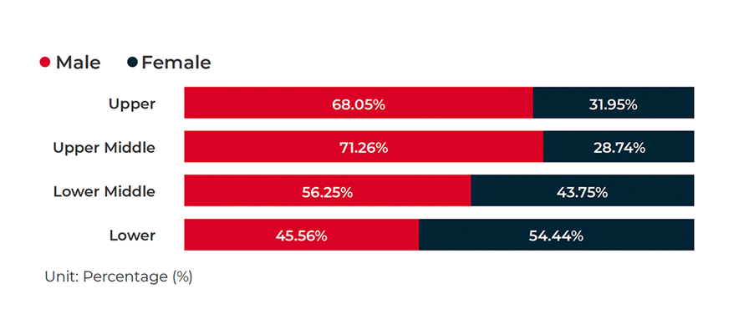
MHR 2022 Gender Pay Report

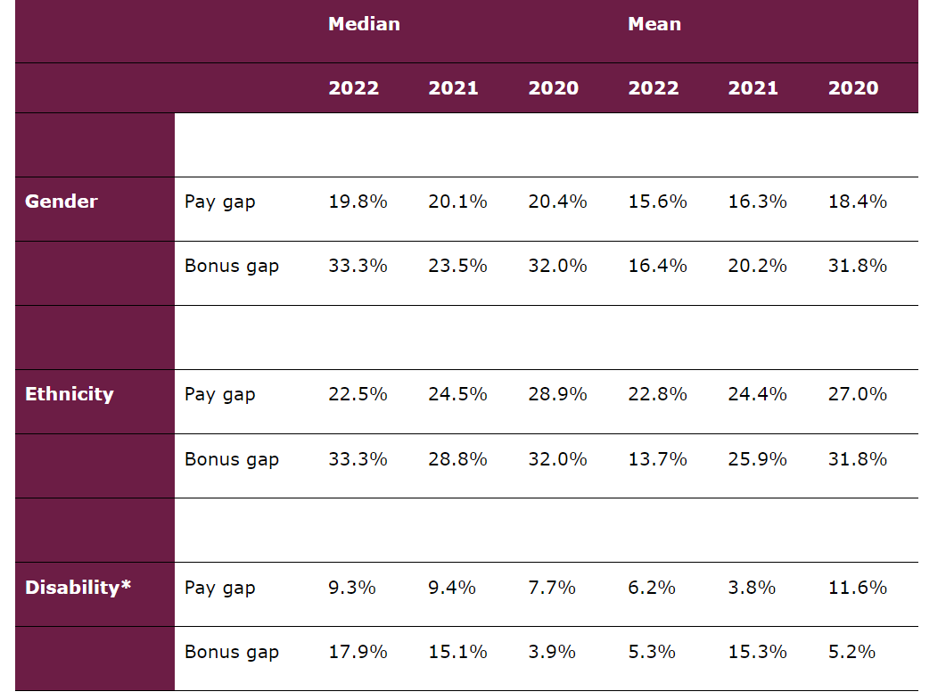

https://www.fca.org.uk/data/fca-pay-and-bonus-gap-data-2022 (Accessed 11th October 2023)

Research problem:

This research was chosen so that the future generation of females and males can be socially, and culturally aware in their careers of their working equality rights. Housing and Communities have been affected also due to these claims, the people of the low spectrum of work within local council have also had questions of feeling exploited, failure of job security , and being mistreated with no equality.

This is relevant because people have been affected as half of the population has been affected, in terms of gender specifically women, cultures has been affected. And majority of women have been affected throughout decades. There has been a series of questions to the head of departments why it has lasted this long to make action within Birmingham City Council.

Research aim, objectives, questions:

The purpose of my research is to research , to find if there is any understanding or conclusion to why there is a Gender Pay Gap within the Birmingham City Council. This has been a popular topic recently in the social media and news articles, with enquiries. The aim of this research is to provide a theoretical explanation for widening gender pay gap in Birmingham City Council.

Research objectives

- To critically understand the concept of gender pay gap
- To uncover the factors that influence gender pay gap through systematic review process
- To provide a theoretical framework on the future of gender pay gap in the Birmingham city Council

Research questions
Based on the research aim and objectives above, the following research questions are presented.

- What is gender pay gap?

‘Gender pays gap is the percentage difference between average hourly earnings for men and women. The gap between men and women's earnings for both full and part-time work has fallen from 27.5% in 1997 to 18.4% in 2017’.

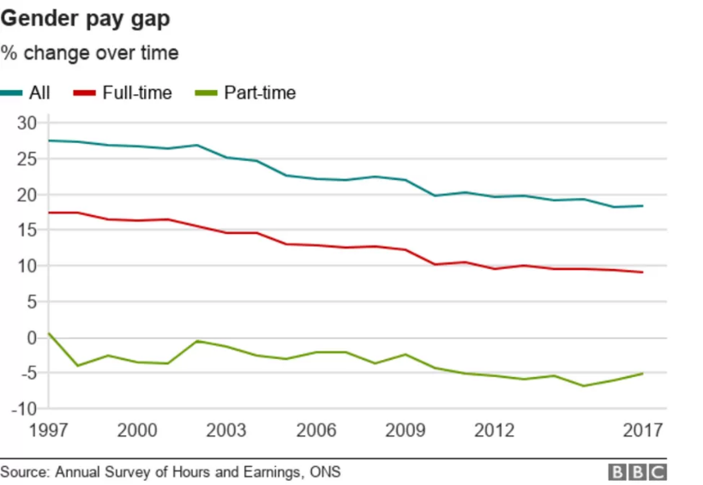

https://www.bbc.co.uk/news/business-42918951 (Accessed 11th October 2023)

‘The gender pay gap is calculated as the difference between average hourly earnings (excluding overtime) of men and women as a proportion of average hourly earnings (excluding overtime) of men’s earnings’.

- What are the factors that influence gender pay gap in Birmingham city council?

There is a predominance of women in BCC and Local Government occupying part time roles that also tend to have a lower skills requirement and are consequently lower graded such.

- What is the future of gender pay gap in Birmingham city Council?

Implication of the study

From the questions the key terms will be a discussion of the inner-city community regarding the gender pay gap. Question two defines how research may imply that women are not important regarding the equality factor within the public sector and society, this is a challenge to review noticing that the time scale of this has lasted so long, this is shown through charts over the last three decades monitoring the wage pay between men and women in Birmingham City Council.

Resource list is from articles, journals and charts (images), listed below as followed,

The main proposed method used will be secondary data, which is various resources of files, reports.

Journals of research:

- 27 January 2021
- DOI: 10.1111/gwao.12890 /Equal pay behind the “Glass Door”? The gender gap in upper management in a male-dominated industry Charlotte Kräft (Accessed 25th September 2023)

- Business and Politics (2023), 25, 17–33 doi:10.1017/bap.2022.21
RESEARCH ARTICLE

- Can We Talk About Pay Discrimination/Equal Pay/Strategic Compensation Practices? An Exploratory Study on Framing
Gender Pay Inequity
Amber N. W. Raile* , Caroline Graham Austin and Virginia K. Bratton (Accessed 26th September 2023)

- Equal play, equal pay’: moral grounds for equal pay in football
- Alfred Archer & Martine Prange
To cite this article: Alfred Archer & Martine Prange (2019) ‘Equal play, equal pay’: moral grounds for equal pay in football, Journal of the Philosophy of Sport, 46:3, 416-436, DOI:10.1080/00948705.2019.1622125
(Accessed 27th September 2023)

- Birmingham city council report, published 28th June 2023 , Birmingham City council statement on Equal Pay Update,
(Accessed 27th September 2023)

- Report The Equality Act 2010 (Gender Pay Gap Information) April 2017
(Accessed 25th September 2023)

- Gender and Ethnicity pay gaps – Birmingham AC.UK- Report 2010
(Accessed 24th September 2023)

- There would be an introduction about the struggle of equal pay in the 1960s- article- striking women. https://www.itv.com/news/central/2023-06-28/birmingham-city-council-face-650-million-cost-as-new-equal-pay-claims-surface (Accessed 27th September 2023)

- https://www.birmingham.gov.uk/news/article/1353/birmingham_city_council_statement_on_equal_pay_update (Accessed 27th September 2023)

- https://www.bbc.com/news/uk-england-birmingham-66042403.amp
(Accessed 26th September 2023)

- BIRMINGHAM CITY COUNCIL
(JEWELLERY QUARTER BIRMINGHAM)
(CONTROLLED ZONE) ORDER 1992
(Accessed 24th September 2023)

- Reforming Equal Pay Laws Get access Arrow
Sandra Fredman
Industrial Law Journal, Volume 37, Issue 3, September 2008, Pages 193–218, https://doi.org/10.1093/indlaw/dwn008
Published: 01 September 2008
(Accessed 27th September 2023)

- Birmingham, B. ‘But some are more equal than others’ – The Equal Treatment Directives and equalising the state pension age. Pensions Int J 10, 262–274 (2005). https://doi.org/10.1057/palgrave.pm.5940294 (Accessed 27th September 2023)

- 08 February 2005 Published
01 June 2005 DOI https://doi.org/10.1057/palgrave.pm.5940294 (Accessed 27th September 2023)

- https://journals.sagepub.com/doi/full/10.1177/08912432211001304 March 2021

- https://journals.sagepub.com/doi/full/10.1177/0261018319897038

- Gender Wage gap widens even as low-wage workers see strong gains
Women are paid roughly 22% less than men on average, March 2023

- file:///C:/Users/User/OneDrive/Desktop/Equality_in_Employment_Monitoring_Report_2021_to_2022__AF_.pdf
(Accessed 27th September 2023)

- https://www.gov.uk/government/publications/beis-gender-pay-gap-report-and-data-2022 (Accessed 29th September 2023)

- Performing Professional Discrimination in their Future Careers , Natasha Brewis, 2010

- Insights into Birmingham City Council’s Spending
Power, Revenue Funding and Spending between 201011 and 2019-2020
Tomlinson, Charlotte ; Pugh, Alice; Taylor, Abigail; Riley, Rebecca , (Journal) 2022

- CIP 2B Gender Equality Report (Report) 2020
- Undoing Men’s Privilege and Advancing Gender Equality in Public Sector Institutions, Michael Flood and Bob Pease (2023)
- Women and men at work Alison Andrew (IFS; UCL), Oriana Bandiera (LSE), Monica Costa-Dias (University of Bristol; IFS) and Camille Landais (LSE) , 2021
- Through the looking glass on gender pay gap transparency, 2016 (Article)
- Practical guidance to integrate gender into public financial management Emilie Combaz 2014
- Decertifying Gender: The Challenge of Equal Pay Emily Grabham1 Accepted: 29 November 2022 / Published online: 23 March 2023 The Author(s) 2023
- Pay transparency intervention and the gender pay gap: Evidence from the UK 2022
- Equal Pay what is fair pay, (Report) 2012
- Birmingham City Council Gender Pay Gap Report 2022
- Why is Gender Pay Gap Higher in the Private Sector , 2014
- The Equal Treatment Directives and equalising the state , 2005
- Examples of PFM impacts on gender 2015
- Digital Development and the digital gender gap K4D 2021
- COVID 19, Flexible Working and Implications for Gender Equality In the United Kingdom 2021
- Birmingham JOURNAL Keith E jolles
- Birmingham declares bankruptcy over equal pay claims | Fortune
- HR Magazine - Despite Birmingham equal pay case, councils never intend to pay staff unfairly according to PPMA
- University College Gender Pay Gap Statement
- University of Birmingham Gender Pay Report 2022
- (Journal) Blau Kahn The Gender Wage Gap Extent Trends and Explanations (2017)
- Structural Transformation and the Gender Pay Gap 2023
- Gender Pay Report 2021
- A Systematic Review of the Gender Pay Gap and Factors That Predict It Sebawit G. Bishu and Mohamad G. Alkadry 2016
- The gender pay gap in the UK, Leaker 2008
- https://www.theguardian.com/society/2023/aug/30/women-still-have-right-to-equal-pay-says-uk-government-despite-scrapping-of-eu-law
- https://www.mylearning.org/stories/women-at-war-the-role-of-women-during-ww2/743
- https://www.personneltoday.com/hr/bankrupt-councils-equal-pay/
- Brigid Francis-Devine December The Gender Gap Pay 2022

Research methodology to be used (including ethics)

Some research of gap pay between gender wage may involve other references from outside the U.K to show the popular narrative of gender pay in general, to demonstrate how the economics of gender pay is worldwide topic of interest. With the secondary data this is used to present how the research relevant in the present when finding a conclusion why did gap pay last so long.

There will be shown secondary data is the main collected data used to address the topic, alongside other people’s previous journals, charts that monitor the timeline of the gender gap within Birmingham city council. An analysis adding my own insight and feedback to the research found.

The reason secondary data is valuable because the literature that has been researched is relevant and collected data regarding gender gap and Birmingham City Council specifically, this is valid as cases, references, charts have already been collected from other sources of information. This is known as systematic secondary data.

There will also be a analyse and feedback regarding bar charts, or workforce monitoring data of gender gap shown through Birmingham citcy council, gender gap reports online (2018, 2019, https://www.birmingham.gov.uk/downloads/file/20634/gender_pay_gap_report_2022 -)

Risks

The risk of this practically, my work could be lost and I would have to start all over again, should my laptop get stolen or elements of research be lost I would have to make sure I have back up data, technology can fail as a student when doing a large topic.

Another practical would be should I get sick and need to leave to recover I would have to catch up on this work.

Timeline (Gantt chart)



