An Assessment of the Use of Non-Human Animals in Research and Experimentation
Eve Clinton

Introduction
Non-human animals have been used for human benefit since around 8000 BCE (Animal Power in prehistoric times n.d) with animal testing specifically being seen as far back as in the work of early Greek physician-scientists, such as Aristotle and Erasistratus (Hajar, 2011). As humanity advances technologically, the need for non-human animal testing has been questioned, with a movement for non-human animal liberation from such research forming in the 1970s (Singer, 1985) and extending to the present day. Since this movement started there has been action to reduce experimentation on non-human animals, such as the UK banning cosmetic non-human animal testing in 1998 (The Human Society, n.d), however testing for other means such as medical still occurs and is a highly debated issue.
In this essay I will assess some of the key justifications for the use of non-human animals within two main topic outlooks: scientific and moral. These two topics do have some overlap however mostly hold separate reasons for justifying using non-humans in research. By assessing both of these areas I reach the conclusion that the justifications surrounding non-human experimentation are outdated and most non-applicable when considering the means available to humans to gather the information gained from testing that don’t involve the use of non-animals. We are not yet at a stage where non-human animal use in research can be completely eradicated, however it remains important to work to reduce the suffering caused until humanity no longer relies on non-humans for their benefit.
A Scientific Outlook
Each year over 100 million animals are used and/or killed for experimentation and testing across the world (RSPCA, n.d). One of the main justifications for such a figure is that experiments on live animals are ‘necessary for the advance of science’ and can be acceptable if ‘suitably controlled’ (Scruton, 2000). This argument relies on the knowledge gained from this research being significantly useful and unachievable from other methods. There is validity to this as there are many cases where medical substances haven’t been circulated due to dangers shown in testing, however, there have also been cases where the results from non-human animal testing have been non-applicable to humans. Having cases from both sides support the view that using non-human animals for experimentation is no more useful than flipping a coin to determine the safety of human use of a drug, a conclusion drawn from a study looking into the clinical trial results of head injury, respiratory distress syndrome, osteoporosis, stroke, and haemorrhage treatments compared to the results from non-human animal testing (Akhtar et al., 2009).
Supporting the case that non-human animal testing is necessary is the unfortunate results from the drug thalidomide. The ‘wonder drug’ was never tested on animals and so the harmful effects were unknown until thousands of children had already been born with missing limbs (See Image 1) or other malformations when used in the 1950s-60s to relieve symptoms of morning sickness (Hajar, 2011). This is one of a number of examples illustrating how the absence of animal testing can have extremely damaging consequences. However, animal testing is not perfect, with one huge downfall being the differing biology between human and non-human animals resulting in the body chemically reacting to diseases and medications differently. In the 2000s the drug Vioxx was said to be safe for human use due to success in non-human testing on monkeys and other animals, however it caused 140,000 heart attacks and stokes in the US alone and more worldwide (Archibald, 2009). This can be assumed to be a result of the differences in biology; differences in which, it has been put forward, outweigh any similarities to humans and therefore is likely the main reason many clinical trials on humans fail (Akhtar, 2015). These examples show that while there is validity to the view that animal testing has the potential to provide important insights into the safety of drugs, there is also a significant lack of ability to use results to predict the response of the human body to said drugs, therefore making the animal testing obsolete.
It is also important to note that the biological differences between humans and non-humans are not just significant chemically. Claudius Galen is well known for his work involving anatomy. He created his diagram of the human body (See Image 2) which proved to be entirely incorrect when later researchers such as Leonardo da Vinci and Andreas Vesalius compared his work to autopsies of humans which they conducted (Body worlds, 2018). Galen used Barbary apes and pigs to draw his conclusions which explains why he would be wrong with his conclusions. This further proves that the use of non-humans poses as a hinderance to research and therefore their use is not vital to scientific discoveries.
Additionally, to assess ‘necessity’ of non-human animal testing, the viability of alternative research methods needs to be addressed as it would assume logical to adopt these methods if proven to be the same or similar level of usefulness as live animal testing. Sonali K. Doke and Shashikant C. Dhawale (2015) outline the alternatives that are available to animal testing. Computer models have proved useful in predicting biological activity and mapping receptor sites for drugs, resulting in only confirmatory results being needed from non-human animal testing rather than the whole process being done using testing. Researchers at Oxford reported that a computer model they developed proved to be a ‘powerful methodology’ in drug trials and can contribute to a reduction of no-human animal testing, and furthermore showed to outperform the result of animal testing with an accuracy of 89-96% (Passini et al., 2017). Furthermore, there has also been success using lab grown cells and tissue cultures (See Image 3) which have been central to developments in treatment for cancers, sepsis, kidney disease and AIDS (Cruelty Free International, n.d). While these methods may not yet be perfected and applicable to all research, overwhelmingly this evidence shows that there are extremely viable and, in some cases, better methods of conducting scientific research than non-human animal testing.
To conclude this section, non-human animal testing is not completely ‘necessary’ in science, therefore this justification is non applicable. With 90% of tests successful in non-human animal testing failing when applied to humans (Kretzer, 2022), there is little need for the continuation of a clearly flawed and unreliable research method. The number of non-human animals used in research can be greatly reduced if more effort and research is put into the further development of alternative methods. It is undeniable that at this point in our technological advancement it may not be possible to completely eliminate non-human animal testing, however with the proof that other methods are available comes the obligation to reduce the suffering caused to non-human animals.
A Moral Outlook
Some of the moral justifications for non-human animal testing surround the idea that there is a clear distinction of value between human and non-human lives. Various models of difference of capacity have been proposed in order to try and justify that humans have moral status and non-human animals do not, such as language, family ties, problem solving, amongst others (Gruen, 2021). There are varying degrees of acceptance of these models.
It seems the root of arguments using differences between humans and non-humans as justifications for non-human experimentation, is speciesism. ‘Speciesism’ was coined by Richard Ryder in 1970. The term refers to discriminatory behaviour towards other species in favour of one’s own, much the same as racism is based on unfair treatment of a race due to feeling your race is superior (Singer, 1975). By concluding that human life is of more value than non-human life due to differences in capacity and justifying experimentation, one is displaying speciesism. This view is unsupported when you consider many non-human animals have the capacities said to be uniquely human. It has been clearly observed that chimpanzees, elephants, wolves, among other non-humans form complex relationships with their kin (See Image 4), with orangutans being raised by their mothers for up to 10 years (Gruen, 2021). Furthermore, all major vertebrate taxa have been documented to show problem solving, such as solving food orientated puzzles (Rowel et al., 2021). If these capacities are what exempt humans from being used for experimentation without consent, then as the logic follows, non-humans who display these capacities should also be exempt. This is not the case.
Carl Cohen (1986) argues in favour of speciesism and non-human animal experimentation, taking a utilitarian stance. The overall gains from non-human animal experimentation, such as eradicating diseases, outweigh any suffering caused according to Cohen. There is merit to this stance considering many of the diseases which pose major threats to the human population, such as polio, smallpox, diphtheria, cholera and measles, have been eradicated through the use of non-human animal experimentation (Russell & Burch, 1959). However, Cohen’s input in the matter was almost 40 years ago and significant technological advancement regarding disease studies and eradication has been made since, such as the computer programmes previously discussed. It is fair to conclude this justification is outdated and no longer applicable.
Professor James Parratt, a Christian researcher, supports Cohen’s justification. He adopts the view that the medical discoveries stemming from non-human research benefit both humans and non-humans, citing cattle being used to eradicate East Coast Fever and treatment for parasitic infections in sheep has been developed (1995). It is undeniable that non-humans have received some long-term benefits from testing, however issues arise when we consider the motivations for these benefits. Parratt has used examples of domesticated non-humans in which humans use for profit, either as food and/or for their producs, e.g. sheep for wool and meat (See Image 5 and Image 6). Therefore showing that the wellbeing of non-humans is not being considered for any other reason than human gain. To claim non-humans benefit greatly from testing and therefore it is justified, goes against the idea of equal consideration of interest. While we cannot know exactly what a non-human values, we can assume it has an interest of survival and to not suffer. Some believe what makes humans distinct from non-humans is our ability to perceive and desire and be conscious of said desires (Korsgaard, 1996), but non-humans are more fixed in their immediate needs. Surely we can conclude that it is out duty as moral beings to value the immediate interests on non-human animals as we would our own and therefore the justifications put forward by Cohen and Parratt are unsupported in their arguments.
Overall, the moral justifications for using non-human animals in research are also mostly unsupported and don’t provide a substantial argument for the continued suffering caused. Placing humans as superior to non-humans due to ability and capacity is merely a biased view and speciesism and hold no real foundation. Any claimed benefits to the non-humans are outside the non-humans’ scope of interest and therefore also cannot act as substantial justification, especially when considering humans also benefit due to our use of non-humans for the gain of our own species.
Conclusion
To conclude, the justifications for non-human animal testing seem to be based on ignoring unfavourable facts, therefore making them inapplicable. It is clear that at the stage of technological advancement humans are currently at it is unachievable to completely eradicate all non-human animal testing as in some areas it is still required, for example for supporting and confirming the results gathered from computer programmes, however justifications made for the continued use of these experiments and research projects over the alternatives offered are insufficient when reviewed.
Justifications claiming human superiority over non-humans as an acceptable reason to continue experimentation are based in speciesism and cannot be justified to the extent where the suffering caused by non-human experimentation and testing is excusable. It has been proven that many of the capacities which some claim make humans distinct from other animals are shown in non-humans. The only difference that is mostly irrefutable is the human ability to conceive ideas and be conscious of our desires, and therefore that difference makes it so humans must be held responsible for minimising the suffering we cause to non-animals, not because we are superior but because we have the ability to.

Reference List
Akhtar A. (2015). The flaws and human harms of animal experimentation. Cambridge quarterly of healthcare ethics: CQ: the international journal of healthcare ethics committees, 24(4), 407–419. https://doi.org/10.1017/S0963180115000079
Akhtar, A.Z., Pippin, J.J. and Sandusky, C.B. (2009) “Animal Studies in spinal cord injury: A systematic review of Methylprednisolone,” Alternatives to Laboratory Animals, 37(1), pp. 43–62. Available at: https://doi.org/10.1177/026119290903700108
“ALTERNATIVES TO ANIMAL TESTING” (no date) Cruelty Free International [Preprint]. Cruelty Free International. Available at: https://crueltyfreeinternational.org/about-animal-testing/alternatives-animal-testing (Accessed: November 8, 2022).
Animal Power in prehistoric times (no date) Animal Power in Prehistoric Times - Electricity &amp; Alternative Energy - Alberta's Energy Heritage. Government of Alberta. Available at: http://www.history.alberta.ca/energyheritage/energy/human-and-animal-power/animal-power-in-prehistoric-times/default.aspx (Accessed: November 6, 2022).
Archibald, K. (2009) “Animal Testing: Science or Fiction?” Ecologist: Informed by Nature [Preprint]. Available at: https://theecologist.org/2009/mar/24/animal-testing-science-or-fiction (Accessed: November 7, 2022).
Caruana, L. (2020) “Different religions, different animal ethics?,” Animal Frontiers, 10(1), pp. 8–14. Available at: https://doi.org/https://doi.org/10.1093/af/vfz047
Cohen C. (2986) The Case for the Use of Animals in Biomedical Research. New England Journal of Medicine. 315, pp. 865-870. Available at: https://www.wellbeingintlstudiesrepository.org/cgi/viewcontent.cgi?article=1001&context=moreaexp
Doke, S.K. and Dhawale, S.C. (2015) “Alternatives to animal testing: A review,” Saudi Pharmaceutical Journal, 23(3), pp. 223–229. Available at: https://doi.org/https://doi.org/10.1016/j.jsps.2013.11.002
Frey R. G. (1988). Moral standing, the value of lives, and speciesism. Between the species : a journal of ethics, 4(3), 191–201. Available at: https://doi.org/10.15368/bts.1988v4n3.8
Gruen, Lori, "The Moral Status of Animals", The Stanford Encyclopedia of Philosophy (Summer 2021 Edition), Edward N. Zalta (ed.), Available at: https://plato.stanford.edu/archives/sum2021/entries/moral-animal/ (Accessed: November 9, 2022)
Hajar R. (2011). Animal testing and medicine. Heart views: the official journal of the Gulf Heart Association, 12(1), 42. https://doi.org/10.4103/1995-705X.81548 (Accessed: November 7, 2022)
Korsgaard, C. (1996). The Sources of Normativity, Cambridge: Cambridge University Press
Kretzer, M. (2022) “Experiments on Animals Fail 90% of the Time. Why Are They Still Done?,” People for the Ethical Treatment of Animals [Preprint]. PETA. Available at: https://www.peta.org/blog/experiments-on-animals-fail-90-of-the-time-why-are-they-still-done/ (Accessed: November 8, 2022).
Laboratory animal welfare - animal research and testing (no date) RSPCA. RSPCA. Available at: https://www.rspca.org.uk/adviceandwelfare/laboratory?gclid=CjwKCAiA9qKbBhAzEiwAS4yeDSMK6RjQ_W6nb_qfMmFp1VePl3T0ume-gAh-NtEqe6hR9W0x00ndJBoCSDcQAvD_BwE (Accessed: November 7, 2022).
Parratt, J. (1995) ‘Not a Sparrow Falls – the use of animals in medical research’. Christian Impact, Tape 950422aw
Passini, E. et al. (2017) “Human in silico drug trials demonstrate higher accuracy than animal models in predicting clinical pro-arrhythmic cardiotoxicity,” Frontiers in Physiology, 8. Available at: https://doi.org/10.3389/fphys.2017.00668
Reagan, T. (1983) The Case for Animal Rights. University of California.
Rowell, M. K., Pillay, N., & Rymer, T. L. (2021). Problem Solving in Animals: Proposal for an Ontogenetic Perspective. Animals : an open access journal from MDPI, 11(3), 866. https://doi.org/10.3390/ani11030866
Russell, W.M.S. and Burch, R.L. (1959). The Principles of Humane Experimental Technique. 239pp. London, UK: Methuen Available at: https://tnprc.tulane.edu/about-animal-research-medicine#:~:text=Virtually%20everyone%20alive%20today%20has,of%20cancer%20and%20heart%20disease. (Accessed: November 8, 2022)
Scruton, R. (2000) Animal Rights and Wrongs . 3rd edn. London: Metro Books.
Singer, P. (1975) 'All Animals are Equal': Animal Liberation. New York, pp. I-23.: Available at: https://homepages.wmich.edu/~baldner/singerallanimalsareequal.pdf
Singer, P. (1985) In defence of animals: The animal rights movement. Oxford, UK: Blackwell.
Singer, P. (1979 [1993]), Practical Ethics, second edition, Cambridge: Cambridge University Press; first edition, 1979.
The history of anatomy - from the beginnings to the 20th century (2018) Body worlds. Körperwelten . Available at: https://bodyworlds.com/about/history-of-anatomy/ (Accessed: November 8, 2022).
Timeline: Cosmetics testing on animals (no date) The Humane Society of the United States. Available at: https://www.humanesociety.org/resources/timeline- cosmetics-testing-animals#:~:text=1998%3A%20The%20United%20Kingdom%20bans,for%20cosmetic%20products%20and%20ingredients (Accessed: November 9, 2022).
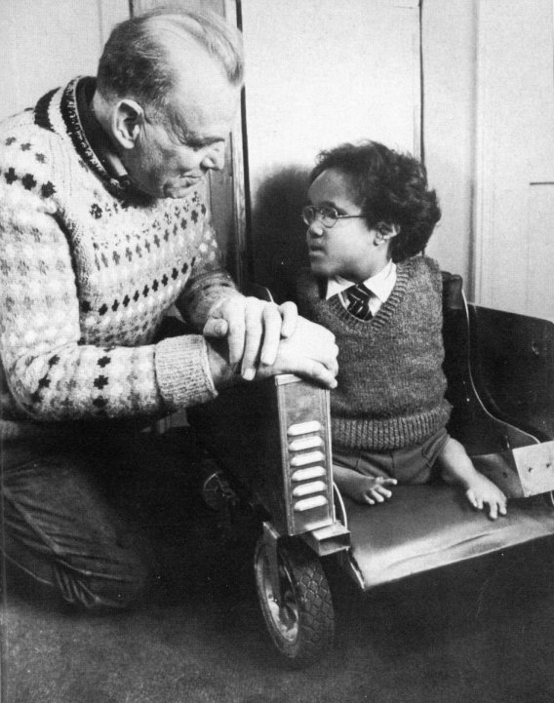
Appendix
Image 1
Wallace, M. and Robson, M. (1972) Terry Wiles, a child born with no limbs, sat in a chair with his father kneeling next to him, The Terry Wiles Website. Available at: http://www.terrywiles.20m.com/photo.html (Accessed: November 8, 2022).

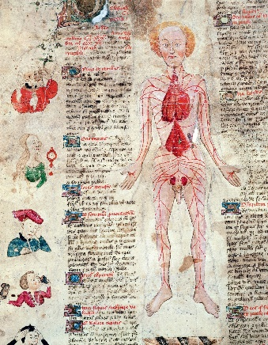
Image 2
Bridgeman, ACI (no date) Galen's view of the circulatory system in 'De Arte Phisicali et De Cirurgia' (1412) by John Arderne, National Geographic. Available at: https://www.nationalgeographic.co.uk/science/2018/02/this-english-doctor-upended-everything-we-knew-about-the-human-heart (Accessed: November 9, 2022)

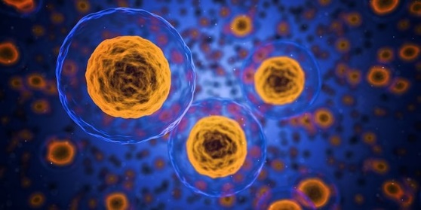
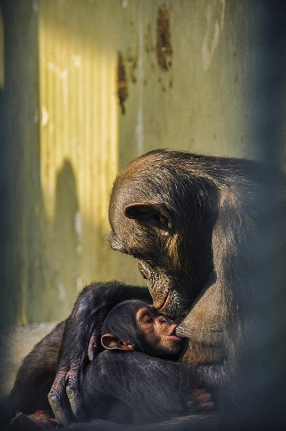
Image 3
qimono (no date) Image of cells, Pixabay. Available at: https://pixabay.com/illustrations/cells-human-medical-biology-health-1872666/ (Accessed: November 8, 2022).

Image 4
Cengiz, D.T. (no date) Mother chimpanzee Jane looks down to her breastfeeding infant at the Faruk Yalcın Zoo, in Danica, Turkiye, We Animals Media. Available at: https://stock.weanimalsmedia.org/search/?searchQuery=chimpanzee&assetType=default (Accessed: November 9, 2022).


Image 5
Zorlu, H. (2022) Meat being cut , We Animals Media. Available at: https://stock.weanimalsmedia.org/search/?searchQuery=sheep&amp;assetType=default (Accessed: November 9, 2022).
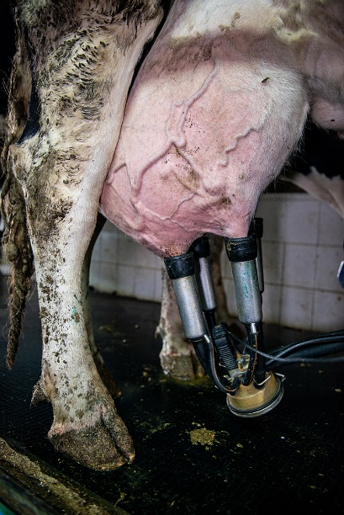
Image 6
Zorlu, H. (2022) Cow being milked , We Animals Media. Available at: https://stock.weanimalsmedia.org/search/?searchQuery=cow&assetType=default (Accessed: November 9, 2022).

