Name: Andreea-Iuliana MironStudent number: 2232376
E-portfolio report
Learning in the Digital Era – BMPL4007/BMPS4009

Table of Contents

Task 1 – Written summary 2
Task 2 – Mind map 3
Task 3 – Presentation 4
Task 4 – Reflection 5
Reference list 6


Task 1 – Written summary
In recent years, online learning has become an increasingly popular option for students preparing for higher education in the UK. This summary will discuss the benefits and challenges of online learning, as well as strategies for success, drawing on information from various sources.
Online learning offers several benefits for students preparing for higher education in the UK. According to the textbook “Successful Online Learning: Managing the Online Learning Environment Efficiently and Effectively” by Amanda Sturgill and Michele Estes, online learning can be more flexible than traditional classroom learning, allowing students to work at their own pace and on their own schedule. Online learning can also provide opportunities for students who may not have access to traditional classroom settings, such as those with disabilities or those living in rural areas.

However, online learning also presents several challenges. A credible journal article from the European Journal of Open, Distance and E-Learning emphasizes the importance of self-regulation skills, including time management and motivation, in order to succeed in online learning. The article suggests that students can develop these skills by setting goals, creating a schedule, and seeking support from peers and instructors.

Another challenge of online learning is the lack of face-to-face interaction with instructors and peers. According to a newspaper article from The Guardian, this can be particularly challenging for international students who may be less familiar with the UK education system and culture. The article suggests that international students should seek out online communities or forums where they can connect with peers and instructors.

In conclusion, online learning offers flexibility and accessibility for students preparing for higher education in the UK, but also presents challenges that require self-regulation skills and social support. By developing these skills and seeking out opportunities for interaction and support, students can succeed in online learning and prepare for success in higher education and beyond.
(308 words )

Task 2 – Mind map

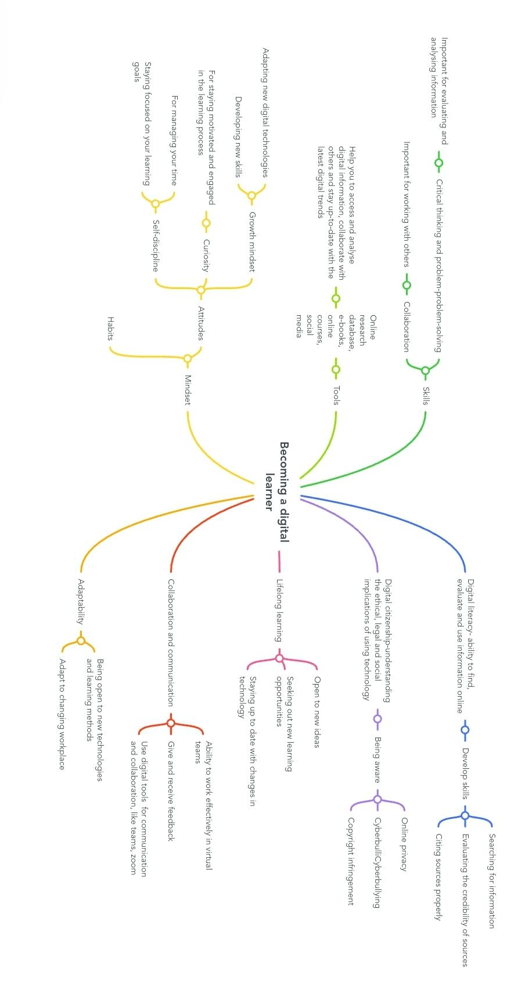

Task 3 – Presentation
Please follow this link to my presentation

https://uowtsd-my.sharepoint.com/:p:/g/personal/2232376_student_uwtsd_ac_uk/EQvt9MzU-DJDiQGVbUFc854BGdNooWZ4V5mSEkkrtqODBA?e=pLeFQV

https://uowtsd-my.sharepoint.com/:p:/g/personal/2232376_student_uwtsd_ac_uk/EQvt9MzU-DJDiQGVbUFc854BIg4sAu340vA2B9CWSxCpnQ?e=Nc5dfw

Task 4 – Reflection
Borton’s reflective tool is a helpful framework for exploring my experiences of starting university, getting to grips with online learning, and writing my first assignments. As I reflect on these experiences, I realise that I have learned a lot about myself and my approach to learning.
When I first started University , I felt excited and nervous at the same time. I was excited about the new opportunities and challenges that awaited me, but I was also nervous about the unknown. According to Elias and Purcell(2018), starting university is a significant transition that can be stressful for many students.
One of the biggest adjustments I had to make was getting used to online learning. I had never taken an online course before, and I found it challenging to stay motivated and engaged. However I discovered that there are many online resources available to support my learning. According to Hara and Kling (2017), online learning can be just as effective as traditional classroom learning when students are provided with adequate support.
Writing my first assignments was also a learning experience for me. I had to learn how to research and write in a new academic style, which was different from what I had been used to in college, such as Cite them right to learn about academic writing conventions and citation styles. According to Goodfellow and Lea (2013) online resources can provide valuable support for students who are learning new writing skills.
In conclusion, using Borton’s reflective tool has helped me to gain insight into my experiences and to identify areas where I can continue to develop my skills and knowledge. By taking advantage of the resources available to me , I feel more confident in my ability to succeed in university.
(291 words)

Reference list
- Sturgill, A., & Estes, M. (2018). Successful Online Learning: Managing the Online Learning Environment Efficiently and Effectively.
- Zhu, Y., & Li, H. (2019). Self-Regulated Learning in Online Learning Environments: A Review and Synthesis. European Journal of Open, Distance and E-Learning, 22(2), 17-30.
- Paton, G. (2021, August 19). International students in the UK struggle to adjust to remote learning. The Guardian. Available at: https://www.theguardian.com/education/2021/aug/19/international-students-uk-struggle-adjust-remote-learning
(Accessed on 1st March 2023)
- Beetham, H.& Sharpe, R. (2013) Rethinking Pedagogy for a digital age: Designing and delivering E-Learning (2nd edition.)
- Have, S., & Kenyon, C. (2007). Heutagogy: A Child of Complexity Theory. Complicity: An international Journal of Complexity and Education, 4(1), 111-118
- Siemens, G. (2005). Connectivism: A Learning Theory for the Digital Age. International Journal of Instructional Technology and Distance Learning, 2(1), 3-10
- Harris, S., & Moran, R. (2011). Managing cultural differences
- Katzenbach, J. R., & Smith, D. K.(2015) The wisdom of teams: Creating the high-performance organisation. Harvard Business Review Press.
- Elias, R. Z., & Purcell, R. (2018). Starting university: The role of orientation in supporting students’ academic adjustment. Journal of further and higher education, 42(10), 1363-1375
- Hara, N., & Kling, R. (2017). Online learning communities: common ground and critical differences in designing technical environments. Teachers College Record, 119(4), 1-23.
- Goodfellow, R., & Lea, M. R.(2013). Literacy in the digital university: Critical perspectives on learning, scholarship, and technology.

