

Due date: 12/01/2024
ELECTRONIC SYSTEMS DESIGN – ACDA6002
14 Day Weather and Air Quality Measurement and Logging System
Student Name: Adam Cross
Student Number: 2106959
Lecturer: Steve Mosey

Contents
Table of Figures 2
Abstract 3
Introduction 3
Literature Review 3
Component Selection 5
Microcontroller Selection 5
Enclosure 7
Non-Volatile Memory 8
Battery Selection 10
Sensor Selection 10
Temperature and Humidity Sensor 10
Wind Speed and Direction Sensor 12
Airborne Particle Count and VOC Sensor 14
Sunlight Brightness Sensor 15
UV Level Sensor 16
GPS Sensor 17
Connectors 18
Circuit Design 19
Zener Clamp 19
I2C Sensors 19
Wind Speed and Direction Sensors 20
UV Level Sensor 22
GPS Sensor 22
LED Status Lights 23
Power Circuit 24
Structure Diagram 24
Software Flow Charts 24
EasyPC Design 26
Build Costs 29
Suggested Improvements 30
Conclusion 30
References 31

Table of Figures
Figure 1 - Microchip Advanced Part Selector Tool [7] 6
Figure 2 - Microcontroller Comparison Table [7] 6
Figure 3 - Proteus Circuit Design 19
Figure 4 - Zener Clamp Circuit 19
Figure 5 - I2C Devices Circuitry 20
Figure 6 - Wind Vane and Anemometer Circuit [42] 20
Figure 7 - Resistor Position Values [42] 21
Figure 8 - Wind Speed and Direction Sensor Circuits 21
Figure 9 - UV Level Sensor Circuit 22
Figure 10 - GPS Sensor Circuit 22
Figure 11 - LED Status Light Circuit 23
Figure 12 - Power Circuit 24
Figure 13 - Structure Diagram 24
Figure 14 - System Start Flow Chart 24
Figure 15 - Data Upload Mode Flow Chart 25
Figure 16 - Data Acquisition Mode Flow Chart 26
Figure 17 - EasyPC Schematic Diagram 26
Figure 18 - PCB Design Top Layer 27
Figure 19 - PCB Design Bottom Layer 27
Figure 20 - PCB 3D View Front 28
Figure 21 - PCB 3D View Back 28
Figure 22 - JLCPCB Order [84] 28
Figure 23 - JLCPCB Order Cost [84] 29
Figure 24 - Prototype Build Costs 29

Abstract
This report contains the design of an 8-bit PIC microcontroller-based weather and air quality monitoring system. The purpose of the system is to collect and record a diverse range of environmental data from various sensors over a 14-day duration. The system, powered by an independent power source, is tailored for amateur weather forecasters to aid in their predictions, allowing the user to store and access the data via USB on computer software. This system can measure the following variables: temperature, humidity, wind speed, wind direction, airborne particle count, sunlight brightness, UV levels, GPS position and VOC level.

Introduction
A microcontroller-based weather and air quality monitoring system is a specialised device built to capture, record, and analyse environmental data via a variety of sensors. The systems are used globally by both professional weather forecasters and amateurs alike.
The purpose of the system outlined in this report is to take a variety of measurements and log the data over a 14-day period to an independently powered device, intended for use by amateur weather forecasters to aid in their predictions.
The portable and adaptable system must acquire the following set of data:
- Temperature
- Humidity
- Wind Speed
- Wind Direction
- Airborne Particle Count
- Sunlight Brightness
- UV Levels
- GPS Position
- VOC Level
This data is to be collected and stored efficiently to non-volatile memory which can be easily accessed, read, and cleared when connected to a computer via USB.

Literature Review
Shown in Table 1 below is a selection of weather and air quality monitor/logger systems used by amateur weather forecasters. The table shows the key features of these systems and the type of sensors that can be used to measure various weather conditions. All 3 systems come with an LCD display that is portable and connects to the external weather station via 2.4 GHz Wi-Fi for live data feedback. Some have solar panels that are either used to solely power the device or are used as a backup to charge an on-board battery, of which 2 of the devices use 2 x AA batteries and 1 device uses a CR123 lithium battery.
Key variables measured by these devices are:
- Temperature
- Humidity
- Light Intensity
- Barometric Pressure
- Wind Speed
- Wind Direction
- UV Levels
- Rainfall
The measuring range for each variable is of interest and will be closely considered when designing the system detailed in this report.
Table 1 - Portable Weather Measurement Systems
Brand | ACCUR8 |  | Davis Vantage Vue |  |  | Pro Signal
Model | DWS7100 |  | 6250UK |  |  | PSG04173
Model | 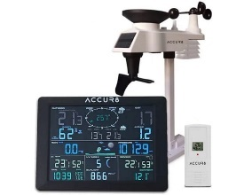 |  | 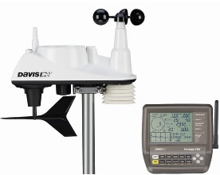 |  |  | 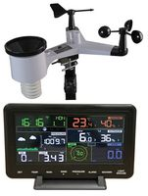
Features | 2.4GHz Wi-Fi |  | 2.4GHz Wi-Fi |  |  | 2.4GHz Wi-Fi
Features | Solar powered |  | Solar powered
Features | App Connectivity |  | App Connectivity |  |  | External LCD Display
Features | External LCD Display |  | External LCD Display
Sensors | Temperature | -40°C - 60°C | Temperature |  | -40°C - 65°C | Temperature | -40°C –60°C
Sensors | Humidity | 10% - 99%RH | Humidity |  | 0% - 100%RH | Temperature
Sensors | Light Intensity | 0 – 200klux | Dew Point |  | N/A on datasheet | Humidity | 10% - 99%RH
Sensors | Barometric Pressure | 300 - 1100hpa | Barometric Pressure |  | N/A on datasheet | Barometric Pressure | 700 - 1100hpa
Sensors | Wind Direction and Speed | 0 – 50m/s | Wind Direction and Speed |  | 2 – 200mph | Wind Direction and Speed | 0 – 100mph
Sensors | Rainfall | 0 - 9999mm | Rainfall |  | 0.2mm resolution | Rainfall | 0 – 6000mm
Sensors | UV Levels | 1 to 15+ |  |  | 0.2mm resolution | Light Intensity | 0 – 200klux
Sample Rate | Temperature | N/A on datasheet | Temperature | 10s |  | Temperature | 16s
Sample Rate | Humidity | N/A on datasheet | Humidity | 50s |  | Temperature
Sample Rate | Light Intensity | N/A on datasheet | Dew Point | N/A on datasheet |  | Humidity | 16s
Sample Rate | Barometric Pressure | N/A on datasheet | Barometric Pressure | N/A on datasheet |  | Barometric Pressure | N/A on datasheet
Sample Rate | Wind Direction and Speed | N/A on datasheet | Wind Direction and Speed | 2.5s |  | Wind Direction and Speed | N/A on datasheet
Sample Rate | Rainfall | N/A on datasheet | Rainfall | 20s |  | Rainfall | N/A on datasheet
Sample Rate | UV Levels | N/A on datasheet | Rainfall |  |  | Light Intensity | N/A on datasheet
Dimensions | 330 x 280 x 150mm |  | 329 x 146 x 340mm |  |  | 250 x 164 x 192.7mm
Power | Solar powered |  | Solar powered |  |  | Solar powered
Power | 3 x AA batteries |  | CR123 lithium battery |  |  | 3 x AA batteries
Cost | £133.29 |  | £433.33 |  |  | £118.80
Webpage | [1] |  | [2] |  |  | [3]
Datasheet | [4] |  | [5] |  |  | [6]

Component Selection

Microcontroller Selection
The microcontroller unit (MCU) chosen for the portable 14-day weather and air quality measurement and logging system is the Microchip PIC18F24K50. The selection process involved the use of Microchip's advanced part selector tool, as illustrated in Figure 1. This tool generated a list of suitable PIC microcontrollers based on the minimum requirements outlined in Table 2.
This PIC18F24K50 was selected for the following reasons:
- 8-bit architecture. Popular and widely used due to simplicity, cost effectiveness, established reliability and energy-efficient design.
- Multiple peripheral integrations for use with chosen sensors, including UART and I2C.
- 28-Pin PDIP through hole design allows easy integration to PCB board
- 48MHz clock frequency ensures sufficient performance.
- Compatible with USB and SPI for external SD card storage of data
- Simple to program and compatible with multiple compilers
- Wide operating voltage, 1.8 – 5.5VDC.
- Operating temperature range of -40 - 125°C.
- Has a built-in real-time clock (RTC)
- 8-bit and 16bit timers.
Table 2 - Microcontroller Requirements
Component |  | Digital | Analog | I/O
Temperature & Humidity | Digital 2 in 1 Sensor | 2 |  | I2C
Wind Speed & Wind Direction | 2 in 1 Anemometer and Wind Vane | 1 | 1 | Inputs
Airborne Particle Count & VOC Level Sensor | 2 in 1 Sensor | 2 |  | I2C
Sunlight Sensor | Breakout board | 2 |  | I2C
UV level sensor | Breakout board |  | 1 | Input
GPS Sensor | Breakout board | 4 |  | UART/EN/PPS
Start Button | Latching | 1 |  | Input
LED | Run Indicator | 1 |  | Output
USB | Serial Interface | 3 |  | VCC, D+, D-
SD Card | Serial Interface | 4 |  | MOSI, MISO, SCK, CS
Total Pins Required
Digital |  | 16
Analog |  | 2
Power Pins |  | 2
Total |  | 20
Peripherals/Modules Required
ADC |  | 2
I2C |  | 1
SPI |  | 1
USB |  | 1

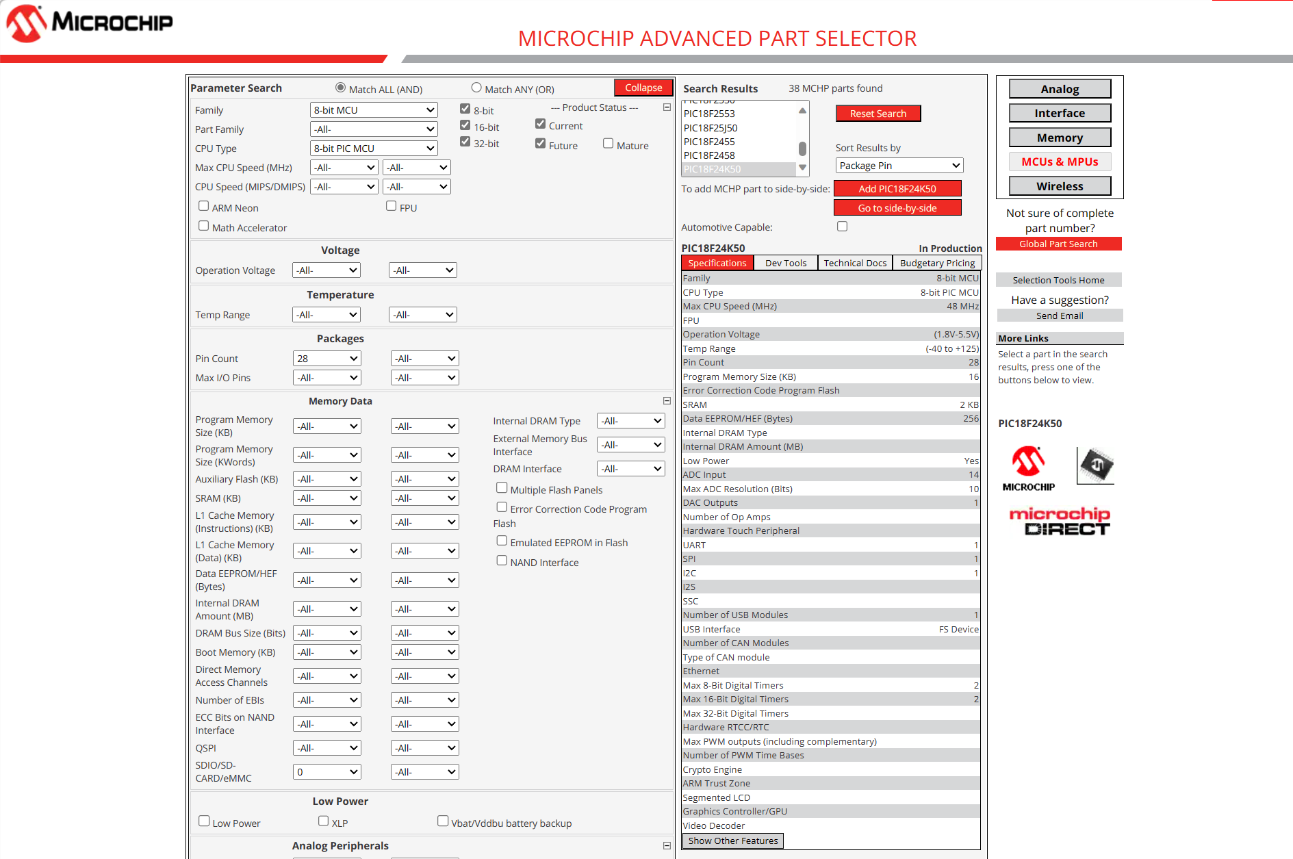
Figure 1 - Microchip Advanced Part Selector Tool [7]
Four appropriate MCUs were entered into a comparison table using Microchip’s side-by-side comparison tool, Figure 2. This facilitated the process of comparing the functionalities of each MCU to select the most appropriate for the given task.
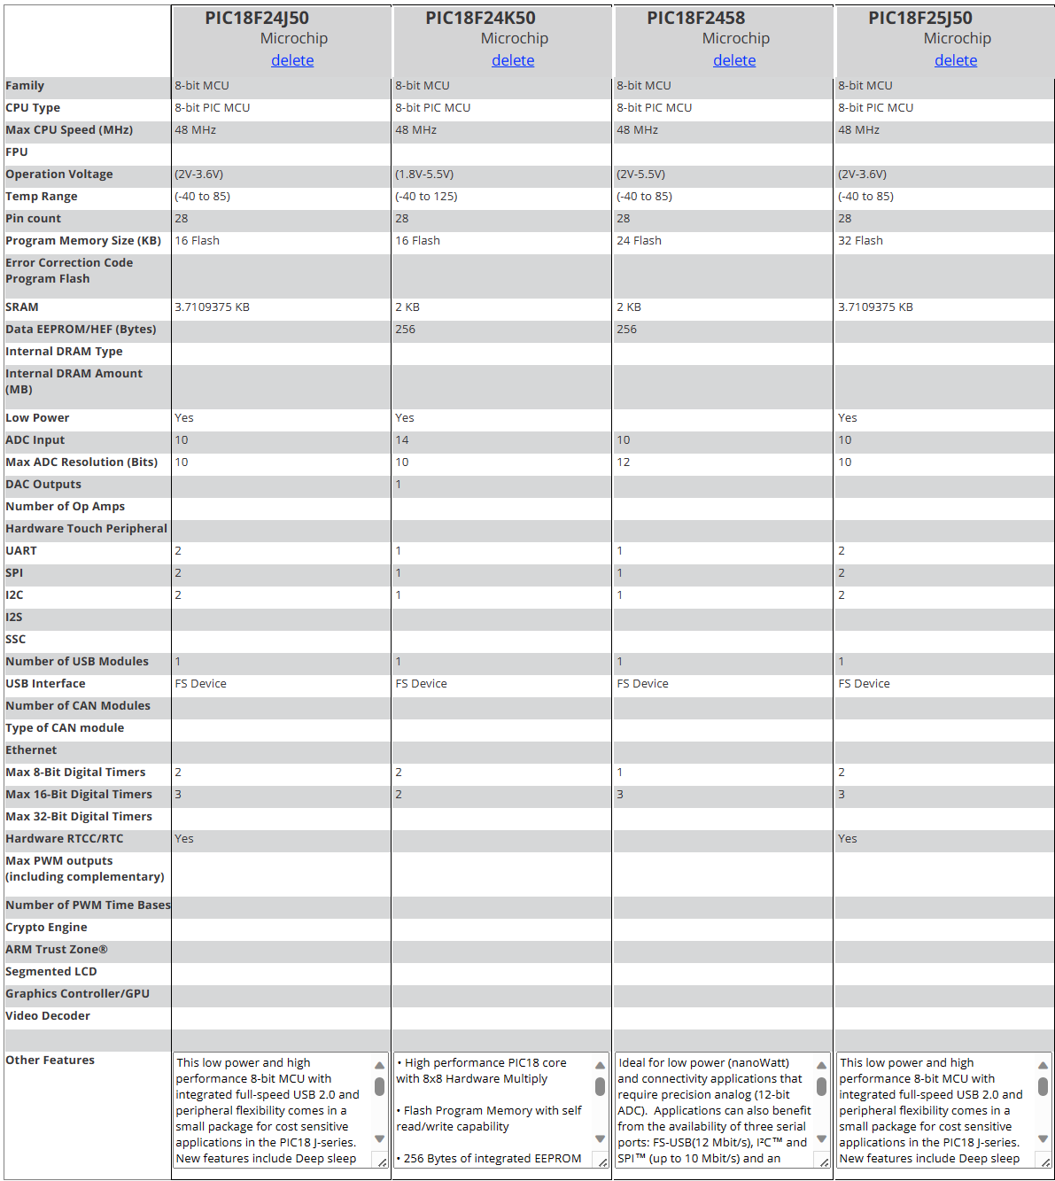
Figure 2 - Microcontroller Comparison Table [7]

Enclosure
Having compared the 3 types of enclosures in Table 3, the chosen enclosure is the Hammond Manufacturing 1554W2GYCL due to its watertight IP68 and polycarbonate design, which provides durability as well as translucency which is especially important for use with the sunlight brightness sensor. Furthermore, it is large enough to mount the PCB alongside any breakout boards and comes with multiple mounting options.
The Deutsch - TE Connectivity enclosure is the cheapest option but is a bare unit designed to be used with DTM header connectors specific to Deutsch - TE Connectivity, so although the price looks appealing, choosing this enclosure would be an exclusive tie to their products.
The Lincoln Binns enclosure is a feasible option with a durable aluminium design, but unfortunately is not waterproof and would therefore not protect the PCB from environmental conditions.
Table 3 - Enclosure Comparison
Enclosure | Hammond Manufacturing  1554W2GYCL | Lincoln Binns E-Case B Enclosure | Deutsch PCB Enclosure  EEC-325X4B
Enclosure | 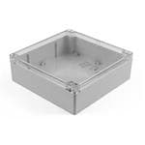 | 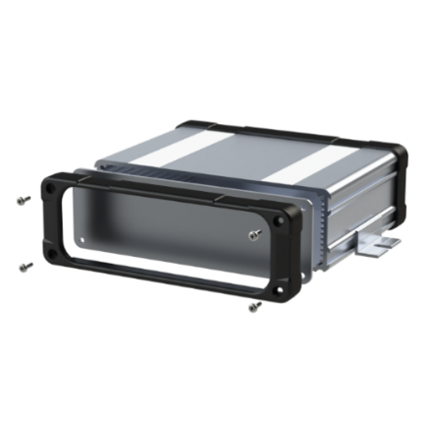 | 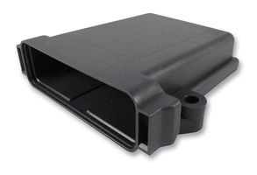
Features | - 180mm x 180mm x 60mm  - IP68 protection  - Ideally suited for mounting PCBs  - Clear polycarbonate design  - NEMA 4, 4X, 6, 6P, 12, 13 | - Aluminium 6063  - 1.5mm thickness  - Carrier plate for mounting up to 100mm wide PCB  - Customisable size and cut outs for connectors | - Thermoplastic  - IP68 protection  - 133mm x 118mm x 36mm  - Only accepts snap- in header  - Automotive specific
Price | £28.90 | £24.09 | £11.86
Webpage | [8] | [9] | [10]
Datasheet | [11] | [12] | [13]

Non-Volatile Memory
To preserve battery life, the sample period of each sensor was carefully selected to ensure enough data is gathered to provide quality weather analysis, while also being efficient. The memory requirements in bytes per sensor, shown in Table 4 are based on the range of measurement and the resolution of each sensor.
Table 4 - Memory Requirements
Parameter | Range | Resolution | No. of possible values | No. of bits required | No. of bytes required
Temperature | -20°C - 70°C | 0.5°C | 180 | 8 | 1
Humidity | 0%RH - 100%RH | 2%RH | 50 | 5 | 1
Wind Speed | 0 - 50m/s | 0.5m/s | 100 | 7 | 1
Wind Direction | 0 - 337.5° | 22.5° | 16 | 4 | 1
Airborne Particle Count Sensor | 0 - 1000µg/m^3 | 10µg/m^3 | 100 | 7 | 1
VOC Sensor | 1 - 500 | 10 | 50 | 9 | 1
Sunlight Sensor | 0 - 120,000 lux | 200 lux | 600 | 6 | 1
UV level sensor | 0 - 15mW/cm^2 | 0.1mW/cm^2 | 150 | 8 | 1
GPS Sensor | 0 - 40075km longitude | 1 metre | 400,750,00 | 26 | 4
GPS Sensor | 0 - 20037.5km latitude | 1 metre | 20,037,500 | 25 | 4
Total number of bytes per sample |  |  |  |  | 16

Having calculated the number of bytes required per sensor, the following calculations were used to determine the storage capacity required for the 14-day (336 hours) period.
The following calculation is used to determine the memory requirement for each sensor,
$$\frac{Seconds per hour}{Sample period of sensor} ×336 hours=Number of samples$$

Temperature,
$$\frac{3600 seconds}{60 seconds}=60 samples/hour$$
$$60 ×336=20,160 samples over 14 days$$
$$20,160 ×1 byte=20,160 bytes$$
Humidity,
$$\frac{3600 seconds}{60 seconds}=60 samples/hour$$
$$60 ×336=20,160 samples over 14 days$$
$$20,160 ×1 byte=20,160 bytes$$
Wind Speed,
$$\frac{3600 seconds}{2 seconds}=1800 samples/hour$$
$$1800 ×336=604,800 samples over 14 days$$
$$604,800 ×1 byte=604,800 bytes$$
Wind Direction,
$$\frac{3600 seconds}{2 seconds}=1800 samples/hour$$
$$1800 ×336=604,800 samples over 14 days$$
$$604,800 ×1 byte=604,800 bytes$$

Airborne Particle Count,
$$\frac{3600 seconds}{60 seconds}=60 samples/hour$$
$$60 ×336=20,160 samples over 14 days$$
$$20,160 ×1 byte=20,160 bytes$$
VOC Level,
$$\frac{3600 seconds}{60 seconds}=60 samples/hour$$
$$60 ×336=20,160 samples over 14 days$$
$$20,160 ×1 byte=20,160 bytes$$
Sunlight Brightness,
$$\frac{3600 seconds}{60 seconds}=60 samples/hour$$
$$60 ×336=20,160 samples over 14 days$$
$$20,160 ×1 byte=20,160 bytes$$
UV Level,
$$\frac{3600 seconds}{60 seconds}=60 samples/hour$$
$$60 ×336=20,160 samples over 14 days$$
$$20,160 ×1 byte=20,160 bytes$$
GPS Position,
$$\frac{3600 seconds}{3600 seconds}=1 sample/hour$$
$$1 ×336=336 samples over 14 days$$
$$336 samples ×8 bytes=2688 bytes$$

Total bytes required for 14-day cycle = 1,333,248 bytes
To store the captured data to non-volatile memory, a Kingston SDIT/8GB Industrial SD Card [14] will be used due its low cost (£8.39) and high performance, this will be mounted to a breakout board to save PCB space, via a 9-pin surface mount Wurth Elektronik memory card connecter to interface the SD card with the MCU. It is important to use an industrial SD card for this application due to the wide operating temperature range that it may be subjected too. 8GB is more than enough to store the anticipated 1.33MB data acquisition over the 14-day period and is much more cost effective when compared to other options such as the Innodisk DS2A-128I81C1B, 128MB Industrial SD Card, at £21.59 [15]. Both are rated to the same operating temperature of -40°C to 85°C.

Battery Selection
Table 5 below shows a selection of batteries that could be used to power the system. The battery will be housed within the PCB enclosure to ensure protection against the environment. The voltage required to power the MCU and chosen sensors is 5VDC, this will be regulated using a 7805 linear voltage regulator [16], that has a 7-25VDC input voltage and 4.8-5.2VDC regulated output voltage. Therefore, the most suitable battery supply is the Overlander 8.4V SubC 3800mAh (NiMH) battery. It is the most expensive, but it provides twice the current capacity which will extend the battery life considerably and meets the minimum input voltage requirements of 7V for the 7805 linear regulator. The battery will connect to the PCB via a 2 pin Molek KK header.
Table 5 - Battery Comparison
Battery | Panasonic CR123A 3V | Overlander 8.4V | RS RRO 3.2V 18650 | GP Batteries 9V
Battery | 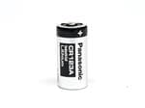 | 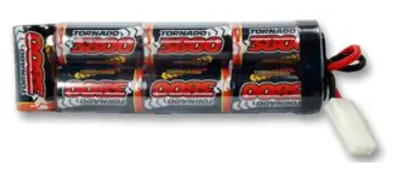 | 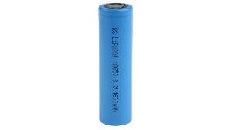 | 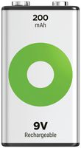
Features | - 1550mAh (LiMnO2)  - Non-Rechargeable | - 3800mAh (NiMH)  - Rechargeable  - SubC 1.2V | - 1500mAh (Lithium)  - Rechargeable  - 18650 3.2V | - 200mAh (NiMH)  - Rechargeable  - 6LR61 9V
Price | £6.35 | £18.05 | £8.01 | £9.99
Webpage | [17] | [18] | [19] | [20]
Datasheet | [21] | [22] | [23] | [24]

Sensor Selection
All external sensors will connect to the PCB enclosure via Multicomp PRO MP-T21 Series connectors. Wire harnesses along with Molex KK connectors will be used to connect the sensors and breakout board sensors to the PCB board via PCB header connectors. Molex KK connectors are cheap, reliable, and freely available.

Temperature and Humidity Sensor
When comparing the range of temperature and/or humidity sensors on the market in Table 6 and Table 7 below, it was decided that the most suitable sensor is the Amphenol T9602-5-D, digital I2C temperature and humidity sensor. Although this device doesn’t have as wide temperature measurement range as the dedicated temperature sensors or the other combined sensor, it can still operate in -40°C to 80°C environments and provides accurate temperature measurement between -20°C and 70°C which is ample for this amateur weather station. This device uses a simple two-wire interface that allows multiple devices to communicate with each other without the need for individual inputs to the MCU for each sensor, thus saving on MCU input requirements. Furthermore, this sensor is capable of measuring both variables while being relatively cheap when compared to the other sensors, making it a cost-effective component.
Table 6 - Temperature Sensor Comparison
Sensor | Texas Instruments LM35AH | Carel Stainless Steel PTC Thermistor | WIKA RTD Sensor
Sensor | 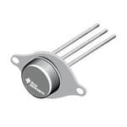 | 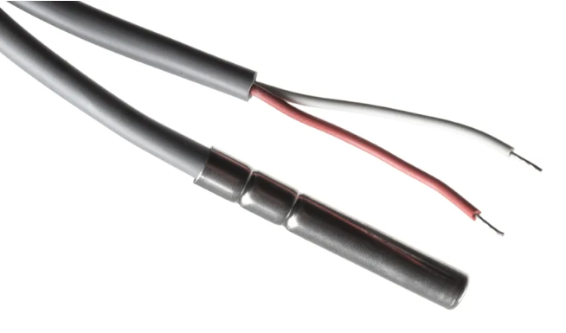 | 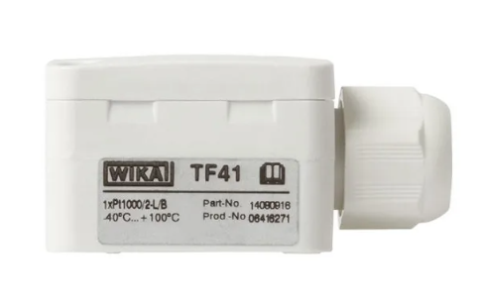
Type | Analog | Analog | Analog
Pros | - Operating range 4V – 30V  - Operating temperature range -55°C - 150°C  - Less than 60µA current drain  - Highest temperature range | - Operating temperature range -50°C - 100°C  - Can be externally mounted to maintain IP rating of PCB enclosure  - IP67  -High sensitivity  - Simple voltage divider circuit required | - Operating temperature range -40°C - 100°C  - Can be externally mounted to maintain IP rating of PCB enclosure  - IP65  - Simple voltage divider circuit required
Cons | - PCB mounted, thus would have to be exposed to the elements | - Response not as linear as RTD | - Slow response time
Price (ex. VAT) | £24.73 | £24.04 | £27.37
Webpage | [25] | [26] | [27]
Datasheet | [28] | [29] | [30]

Table 7 - Humidity Sensor Comparison
Sensor | TE Connectivity Temperature & Humidity Sensor | TE Connectivity Humidity Sensor | Amphenol T9602-5-D Temperature and Humidity Sensor
Sensor | 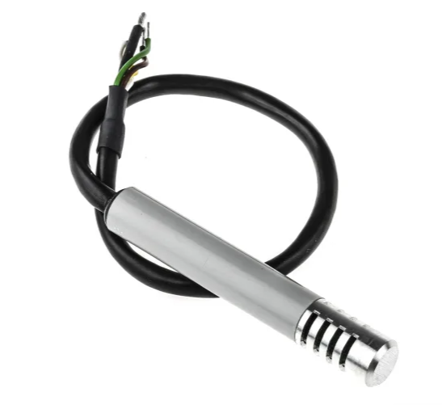 | 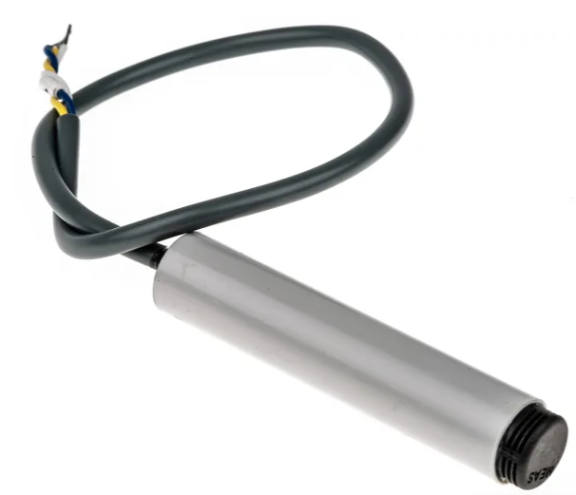 | 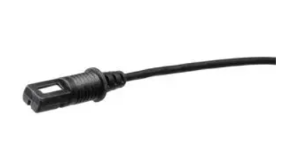
Type | Analog | Analog | Digital (I2C)
Pros | - 3V – 10V supply  - Measurement range  -40°C - 85°C  - Measurement range  1 - 99%RH  - Relative humidity accuracy ≤ +/- 3%RH  - 26mV/%RH  - 2 in 1 sensor provides simple interface  - Can be externally mounted to maintain IP rating of PCB enclosure | - 3V – 10V supply  - 1 - 100%RH  - Relative humidity accuracy ≤ +/- 3%RH  - Operating temperature range -40°C - 60°C  - 26mV/%RH  - Can be externally mounted to maintain IP rating of PCB enclosure | - 3.3V/5V supply  - Measurement range  -20°C - 70°C  Measurement range  0 - 95%RH  - Relative humidity accuracy ≤ +/- 2%RH  - Temperature accuracy  ≤ +/- 0.5°C  - IP67  - Operating temperature range -40°C - 80°C  - Can be externally mounted to maintain IP rating of PCB enclosure
Cons | - Expensive | - Expensive  - Standalone device, doesn’t measure temperature | - Up to 116 second temperature response time
Price (ex. VAT) | £99.23 | £52.35 | £36.16
Webpage | [31] | [32] | [33]
Datasheet | [34] | [35] | [36]

Wind Speed and Direction Sensor
Having compared several sensor options to measure wind speed and direction, shown in Table 8 and Table 9 below, the chosen sensor is the SparkFun Electronics SEN-15901 wind speed and direction sensor, shown in Table 8. Although the details provided for this particular sensor are not thorough, this product seems the best suited firstly due to the cost. Secondly, it is 5V compatible, the wind vane is easy to configure via a voltage divider circuit and the built in wind cup anemometer provides a digital reed switch output that is proportional to the wind speed which will be simple to interface with the MCU. It also has a built-in rainfall sensor that won’t be used for this project but could be utilised in future projects.
Sensors shown in Table 9 were not chosen due to cost as well as the complex interfaces they use, such as NMEA 2000 CAN protocol and RS485 protocol. This protocol would have required external circuitry to convert the RS485 in to a UART signal that is compatible with the MCU.
Table 8 - Wind Speed Sensor Comparison
Sensor | OMEGA WMS-23  Wind Speed and Direction Sensor | Adafruit 1733 Anemometer | SparkFun Electronics  SEN-15901  Wind Speed and Direction Sensor
Sensor | 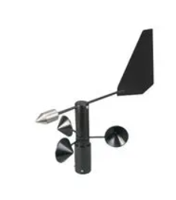 | 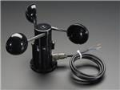 | 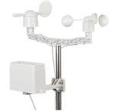
Type | Analog | Analog | Analog & Digital
Pros | - 0 – 100mph range  - Accuracy ≤ 3%  - Dual 4-20mA output for wind speed and direction  - 3° wind direction accuracy | - 0.4V – 2V output proportional to speed  - 70 m/s maximum wind speed  - 0.1m/s resolution  - Accuracy ≤ 1m/s | - 5V supply  - 2 in 1 device  - 16 wind positions via wind vane  - Anemometer for wind speed measurement
Cons | - 12VDC power supply  - Extremely expensive  - Operating temperature range -40°C - 40°C | - Requires 7V supply | - No information regarding minimum or maximum wind speed measurement  - No accuracy information  - No resolution information
Price (ex. VAT) | £1,015.68 | £52.35 | £36.16
Webpage | [37] | [38] | [39]
Datasheet | [40] | [41] | [42]

Table 9 - Wind Direction Sensor Comparison
Sensor | DFRobot SEN0482  Wind Vane | Carlo Gavazzi DWSDDAC13 Wind Vane | Quark-Elec  Wind Speed and Direction Sensor
Sensor | 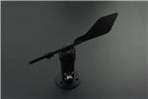 | 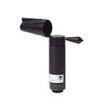 | 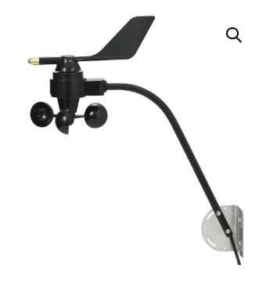
Type | RS485 | Digital | NMEA 2000 (CAN)
Pros | - 16 wind directions  - ≤0.3m/s start-up wind speed  - Fast response | - 0 -360° | - 0 to 359°  - 0 – 55m/s  - IP66  - 27mA power consumption
Cons | - 7 – 24VDC  - RS485 | - Extremely expensive  - 12 – 24VDC  - IP54 | - NMEA 2000 data interface gateway required  - Expensive
Price (ex. VAT) | £35.99 | £1357.02 | £199
Webpage | [43] | [44] | [45]
Datasheet | [46] | [47] | [48]

Airborne Particle Count and VOC Sensor
Having initially compared stand-alone airborne particle count sensors in Table 10 below, a sensor was located, that could provide VOC levels and airborne particle count using I2C protocol, with its own built-in fan to provide sufficient airflow for measurement. The sensor is also relatively cheap at £23.07 and will therefore prove to be very cost effective as it can provide two measurement variables in one complete unit. The raw signal of the VOC pixel is processed by an internal microcontroller to provide a VOC index which describes the current VOC status in a space, relative to the sensor’s past 24 hours history [49]. This could be situated in a separate box with holes in to allow circulation of air.
Table 10 - Airborne Particle Count Sensor Comparison
Sensor | Sensirion SEN54-SDN-T Particulate Matter and VOC Air Quality Sensor | TERA Optical Particulate Matter Sensor | Omron B5W-LD0101-1  Air Quality Sensor
Sensor | 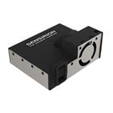 | 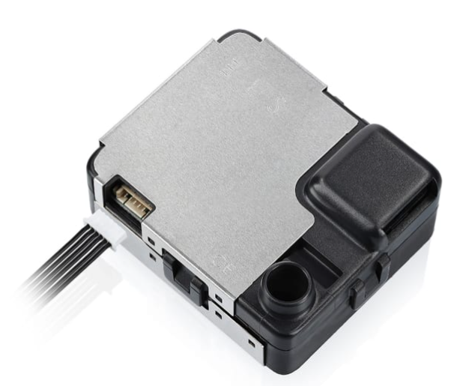 | 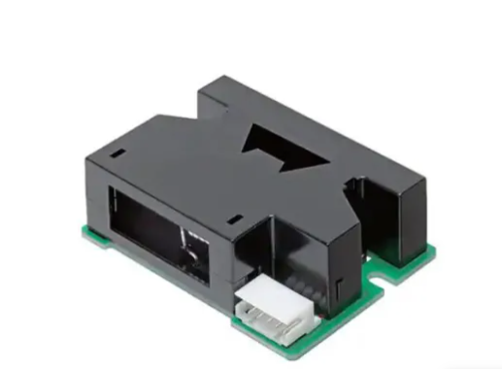
Type | Digital (I2C) | Digital | Digital
Pros | - 4.5V- 5V supply voltage  - Built in fan  - 0 – 500 VOC index output  - 0.3 - 10µm particle detection  - 0 - 1000µg/$m^{3}$ mass concentration  - Operating temperature range -40°C - 70°C | - 5V supply  - 0.3 - 10µm particle detection  - Operating temperature range -20°C - 70°C  - 0 - 1000µg/$m^{3}$ mass concentration | - 5V supply  - Simple digital interface
Cons | - Requires airflow, will therefore need to be mounted in an external box to prevent water ingress into PCB enclosure  - Operating temperature range -10°C - 50°C | - Requires airflow, will therefore need to be mounted in an external box to prevent water ingress into PCB enclosure  - Requires separate UART module unlike I2C bus | - Operating temperature range 0°C - 45°C  - Can only distinguish between 0.5µm or 2.5µm particles  - Requires airflow, will therefore need to be mounted in an external box to prevent water ingress into PCB enclosure
Price (ex. VAT) | £23.07 | £77.63 | £11.48
Webpage | [50] | [51] | [52]
Datasheet | [53] | [54] | [55]

Sunlight Brightness Sensor
Lux is a measurement of brightness that tells us the number of lumens falling on a square meter, also measured in foot-candles (square foot). Lux on the planet can range from less than 1 lux at nighttime, to 100,000 lux on a bright summer’s day [56]. It was therefore important to select a sensor that could measure this vast change in brightness. Having compared sensors in Table 11 below, the most suitable sensor is the Adafruit 4162, due to its cost, 5V supply voltage, I2C protocol which will allow easy integration with other I2C sensors and its vast measurement range of 0 – 120,000 lux.
Table 11 - Sunlight Brightness Sensor Comparison
Sensor | LDR Sensor | Optical Sensor (Adafruit 4162) | Optical Sensor (Adafruit 4161)
Sensor | 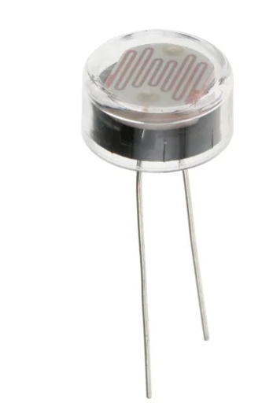 | 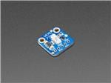 | 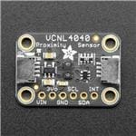
Type | Analog | I2C | I2C
Pros | - Cheap  - Operating temperature range -60°C - 75°C  - Easy to interface via voltage divider | - 5V supply voltage  - 0 – 120klux range  - Will interface easily with other I2C devices  - Cheap | - 5V supply voltage  - Will interface easily with other I2C devices  - 0.0125 – 6553 lux range  - Cheap
Cons | - Could be stored in external enclosure on breakout board, otherwise PCB enclosure will need to be transparent  - 0 – 1076 lux (1000 foot-candles) range | - Could be stored in external enclosure on breakout board, otherwise PCB enclosure will need to be transparent | - Could be stored in external enclosure on breakout board, otherwise PCB enclosure will need to be transparent
Price (ex. VAT) | £2.17 | £3.96 | £4.76
Webpage | [57] | [58] | [59]
Datasheet | [60] | [61] | [62]

UV Level Sensor
Having compared several UV light sensors in Table 12 below, it seems the most suitable sensor for this application is the DFRobot ML8511-SEN0175, it comes at a slight cost compared to the other options but is 5VDC compatible meaning it can be powered from the same source as all other sensor on the PCB. Furthermore, it has a wide spectral detection range and an analog voltage output that is within the limits of the MCU I/O pins.
Table 12 - UV Level Sensor Comparison
Sensor | Adafruit 1918 UV Light Sensor | DFRobot ML8511-SEN0175 UV Light Sensor | SparkFun Electronics VEML6075-SEN-15089 UV Light Sensor
Sensor | 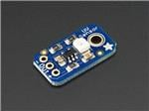 | 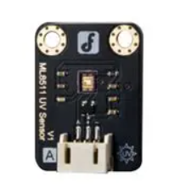 | 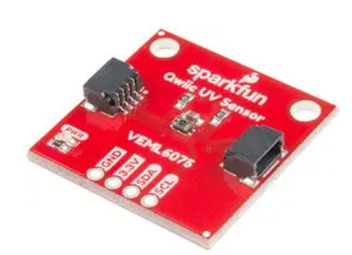
Type | Analog | Analog | Digital (I2C)
Pros | - Operating temperature range -30°C - 85°C  - UV-A and UV-B sensitivity region  - 240nm – 370nm spectral detection range  - Built in op-amp to amplify signal level from the photodiode | - 5VDC Supply  - UV-A and UV-B sensitivity region  - 280nm – 390nm spectral detection range  - 300µA current consumption  - Operating temperature range -20°C - 70°C  - 1 – 2.8VDC output dependent on light intensity | - UV-A and UV-B sensitivity region  - 330nm – 365nm spectral detection range  - Operating temperature range -40°C - 85°C
Cons | - Output voltage range not specified on datasheet | - More expensive than other options | - 1.7 – 3.6VDC Supply
Price (ex. VAT) | £5.20 | £9.55 | £6.28
Webpage | [63] | [64] | [65]
Datasheet | [66] | [67] | [68]

GPS Sensor
Having compared 3 GPS sensor options in Table 13 below, the chosen sensor is the DFrobot TEL0094 GPS module. It is the cheapest option of the 3 and has extremely good error rate of 0.5PPM, meaning it has an accuracy of 0.5mm per 1,000 metres travelled. It has 56 channels, meaning it can simultaneously track multiple satellites, although it does consume slightly more power when compared to the other options, this can be mitigated by shutting down the module between data gathering to improve the system battery life, further helped by the built in RTC crystal and capacitors to allow it to start quickly to gather GPS data.
Table 13 - GPS Sensor Comparison
Sensor | DFRobot TEL0094 GPS Module | Adafruit 5440 GPS Module | Seeed Studio GPS Module
Sensor | 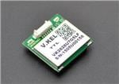 | 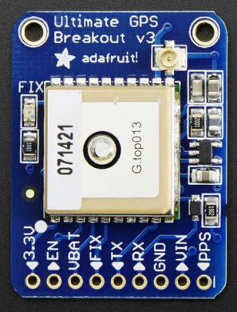 | 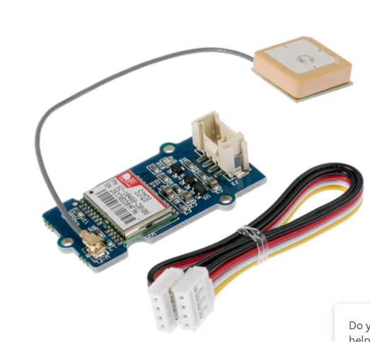
Type | Digital (UART) | Digital (UART) | Digital (UART)
Pros | - 0.5PPM precision  - 56 channels  - Built in antenna  - Built in LNA  - Optional data refresh rate 1Hz – 10Hz  - 3.3 - 5.5V supply  - Built in RTC crystal and capacitors (2-hour duration)  -162dBm sensitivity  Operating temperature range -40°C - 85°C | - 165dBm sensitivity  - 66 channels  - 20mA consumption  - 3.3 - 5V supply  - Optional data refresh rate 1Hz – 10Hz  - Built in LNA | - 50 channels  - 40mA consumption  - Operating temperature range -40°C - 85°C  - 160dBm sensitivity
Cons | - 50mAh consumption slightly higher than other options | - RTC battery compatible but not built in  - Costs slightly more than other options | - 2.75 – 3.6V supply
Price (ex. VAT) | £11.96 | £23.95 | £16.52
Webpage | [69] | [70] | [71]
Datasheet | [72] | [73] | [74]

Connectors
Table 14 below shows a range of connectors that could be used in this project. Having compared all three, the Multicomp PRO MP-T21 Series connector has been selected for its cost-effectiveness, waterproofing capabilities with an IP68 rating, ensuring a secure and tight connection against dust and water even during continuous immersion. Additionally, its broad operating temperature range enhances its versatility and the ease of availability for purchase on CPC Farnell makes it a convenient choice.
Table 14 - Connector Comparison
Connector | Multicomp Pro  MP-T21 Series | Hirose HR10 Series | Souriau UTS Series
Connector | 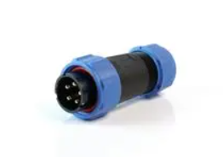 | 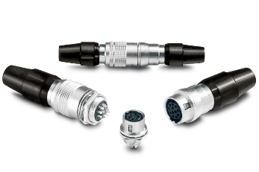 | 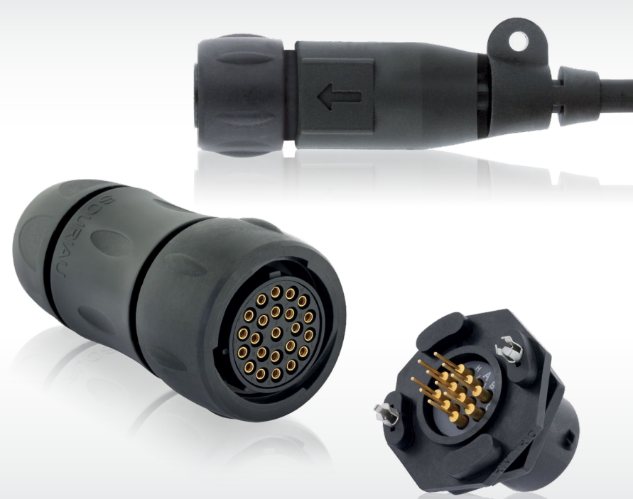
Features | - 2 – 12 contacts  - IP68  - Operating temperature  - 25°C - 85°C  - Nylon 66 material | - 4 – 10 contacts  - No IP rating  - Operating temperature  - 25°C - 85°C | - 2 – 32 contacts  - IP68  - Operating temperature  - 40°C - 105°C  - UV resistant
Price Comparison  4-pin male connector | £5.75 | £12.51 | £15.03
Webpage | [75] | [76] | [77]
Datasheet | [78] | [79] | [80]

Circuit Design
Figure 3 shows the circuit design in Proteus prior to building the schematic and PCB on EasyPC. As the MCU has one Master Synchronous Serial Port module (MSSP), the SPI SD card and I2C devices cannot connect to the same hardware pins without a bus switch or multiplexer. Therefore, general purpose I/O pins can be assigned for SCLK, MOSI and MISO connections to the SD card and data transmission is setup via bit banging, which utilises software to generate the required signals.
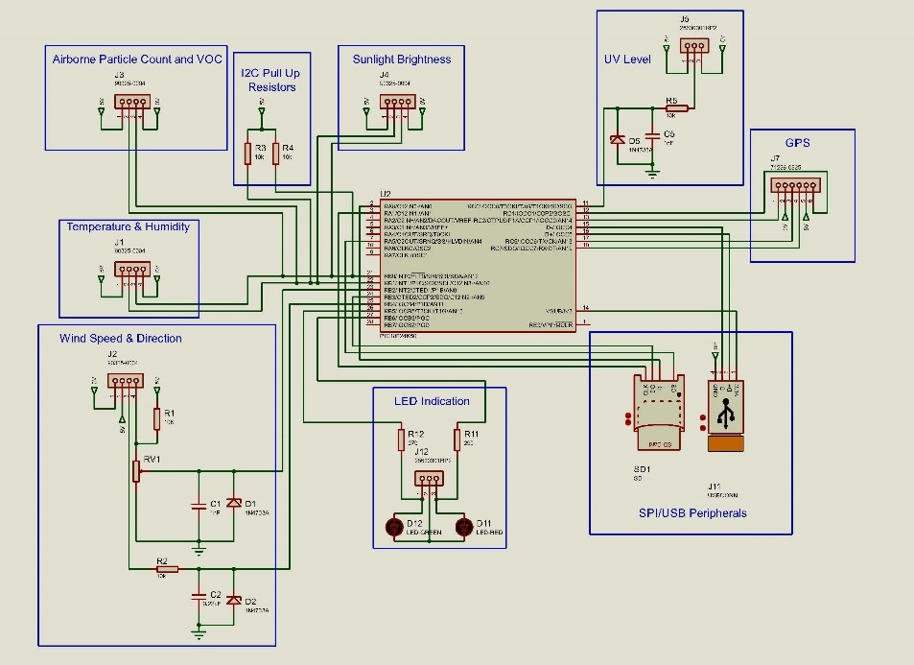
Figure 3 - Proteus Circuit Design

Zener Clamp
Figure 4 shows the clamp circuit used on analog input devices to the limit the current and voltage onto the MCU input pin. The current is limited to 500µA using a 10KΩ resistor and a 5.1V Zener diode ensures the voltage cannot exceed 5.1V, the capacitor provides additional smoothing to attenuate high frequency noise from the signal.
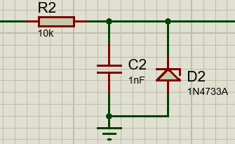
Figure 4 - Zener Clamp Circuit

I2C Sensors
The following sensors, shown in Figure 5, are connected to the MCU via synchronous serial communication protocol Inter-Integrated Circuit (I2C). The slave devices all connect along two data buses, serial data (SDA) and serial clock (SCL) lines and are controlled and communicated with by the master device (MCU).
The master device starts the communication by initiating a high-to-low voltage transition on the SDA line while the SCL line is high, a stop condition ends the communication by driving the SDA line low-to-high while the SCL line is high. Each device has a unique 7-bit or 10-bit address that is used to identify it on the bus and data is sent in bytes (8 bits) of data, the first byte contains the 7-bit address of the intended device along with a read/write bit indicating whether the master wants to read or write to the device. The MCU will address each slave device at the predetermined sample rates to collect the required data from each device.
Pull up resistors of the value of 10KΩ are connected to the SDA and SCL lines to ensure the lines are pulled high when not actively being driven low by a device on the bus.
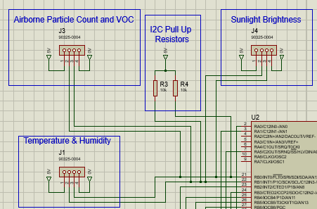
Figure 5 - I2C Devices Circuitry

Wind Speed and Direction Sensors
Wind speed and direction is measured via 2 independent sensors that connect to the board via a 4 pin PCB header. 5VDC is supplied to the wind vane sensor via pin 1 through a voltage divider circuit of which a fixed resistor value of 10KΩ is used. The wind vane has 8 switches each connected to a resistor of differing value, with a fixed magnet that can close two switches at once, allowing 16 different positions to be indicated.
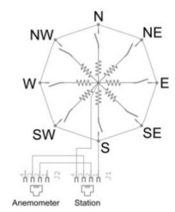
Figure 6 - Wind Vane and Anemometer Circuit [42]
Figure 7 below shows the change in resistance dependent on the wind vane position. The following equation would be used to determine the position based on the voltage drop across the potential divider circuit,
$$Vout=Vin ×\frac{Rwind}{Rwind+R1}$$
Therefore, for a wind direction of 90°, the voltage input to the ADC of the MCU would be,
$$Vout=5VDC ×\frac{1KΩ}{1KΩ+10KΩ}$$
$$Vout=0.4545V$$
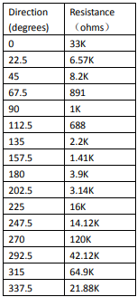
Figure 7 - Resistor Position Values [42]
Pin 2 of the 4 pin PCB header provides 5VDC to the anemometer, it measures wind speed by closing a contact as a magnet moves past a switch. The datasheet states that a wind speed of 2.4KPH or 1.49MPH causes the switch to close once per second [42]. This feedback is fed to a digital pin on the MCU, to measure a wind speed range of 0-50m/s (0-111.8MPH) the frequency range of the anemometer is approximately 0-75Hz. As the frequency range is much higher than the sampling frequency, the MCU Capture/Compare/PWM (CCP) module will be used to measure the signal [81].
The following equations are used to calculate the RC network values to limit current to 500uA and attenuate possible high frequency noise.
$$R1=\frac{5V}{500×{10}^{-6}}=10kΩ$$
$$C=\frac{1}{2π×10000Ω×75}=0.212µF or 0.22µF capacitor$$
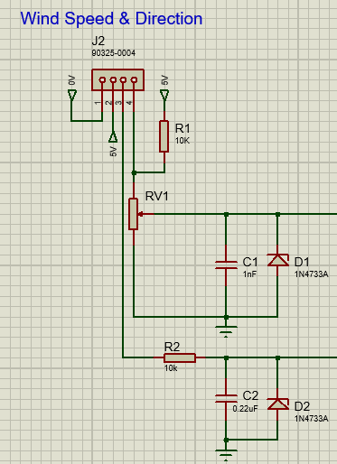
Figure 8 - Wind Speed and Direction Sensor Circuits

UV Level Sensor
The UV level sensor is supplied with 5VDC and provides a linear analog output dependent on UV intensity (mW/cm^2). At 0mW/cm^2 the output voltage of the sensor is 1VDC and at 15mW/cm^2 the output voltage is 2.8VDC.
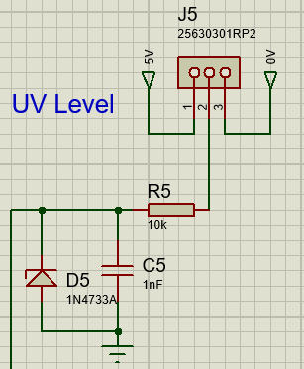
Figure 9 - UV Level Sensor Circuit

GPS Sensor
The GPS sensor is supplied with 5VDC and communicates with the MCU using asynchronous communication, UART at a default baud rate of 9600bps, see Figure 10. The interface has two data lines, receive (RX), and transmit (TX), and are labelled with respect to the device itself, thus RX from the GPS connects to TX of the MCU and vice-versa.
The enable pin (EN) will be used to send a digital logic level high output signal to the GPS module to wake it, take the required latitude, longitude and UTC data and put it back to sleep to save battery consumption. The GPS contains a pulse-per-second (PPS) output that can be configured with the MCU to trigger an interrupt routine on the rising edge of the PPS signal to synchronise its internal clock with the accurate time information from the GPS module.
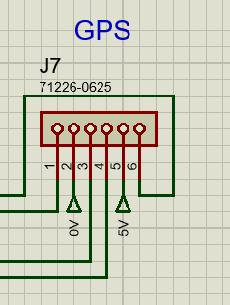
Figure 10 - GPS Sensor Circuit

LED Status Lights
The LED status lights situated in the weather station housing and will be configured using two digital 5V output pins. As per the brief, the green LED will illuminate once every 10 seconds for a period of 1 second when the system is on and healthy, the red LED will illuminate when there is a problem.
The following values are taken from the datasheet of the chosen LED [82],
Forward current – 10mA
Forward voltage red – 2.1V
Forward voltage green – 2.3V
Source voltage – 5V
$$R=\frac{Vsource-Vled}{Iled}$$
$$Red Resistance Value=\frac{5V-2.1V}{0.01A}= 290Ω$$
$$Green Resistance Value=\frac{5V-2.3V}{0.01A}= 270Ω$$
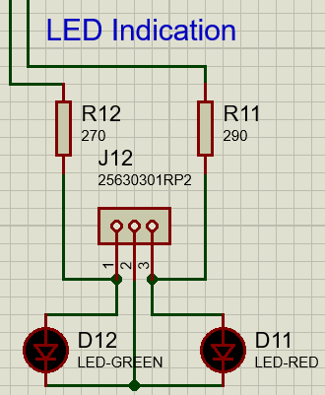
Figure 11 - LED Status Light Circuit

Power Circuit
Shown in Figure 12 below is the power circuit for all sensors and the MCU. The 8.4V battery connects to the PCB via a 2pin connector and is protected with a diode and a 1.5A fuse, to protect the circuit in case the 7805 linear regulator was to fail. A SPST switch mounted on the casing of the unit allows the user to turn the weather station on and off. The 7805 regulator will regulate the battery voltage, providing a constant 5V power supply at 1.5A to the circuit. As there is little difference between the input and output voltage, the heat generated will be negligible [16].
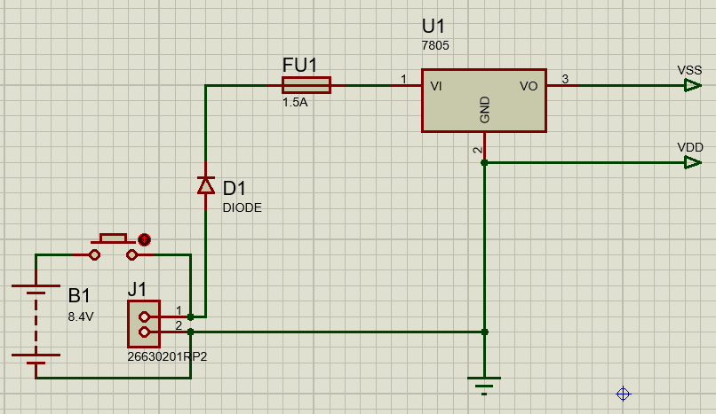
Figure 12 - Power Circuit

Structure Diagram
Figure 13, shows the structure diagram for the MCU, including I/O port configuration and its peripherals.
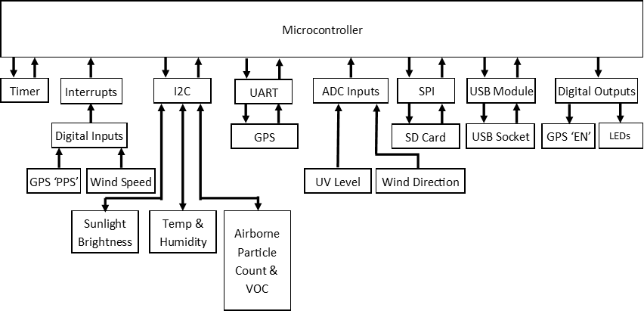
Figure 13 - Structure Diagram

Software Flow Charts
Figure 14, shows the main flow chart for the weather system, this is where the device is powered on, everything is initialised, and the device will look to see if it is connected to a PC via USB or not. If it is, it will go into data upload mode, shown in Figure 15. If it is not, it will go into data acquisition mode shown Figure 16.
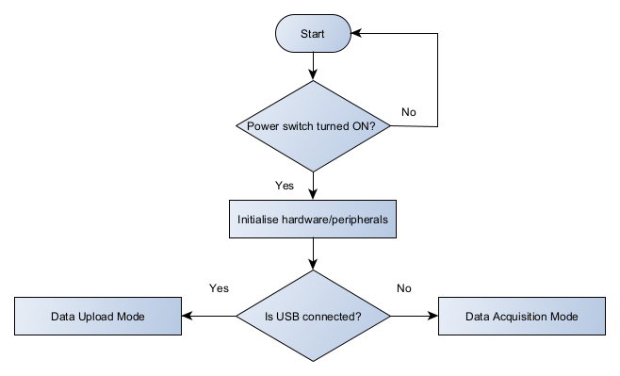
Figure 14 - System Start Flow Chart
Figure 15 illustrates system operation when connected to PC software via USB. In data upload mode, the user can read data from the SD card, where the device will perform cyclic redundancy checks to verify accuracy of data. After confirming the correct reception of all data, the device will allow the user to connect sensors while simultaneously connected to the software for testing purposes. Finally, the user can clear stored data on the SD card.
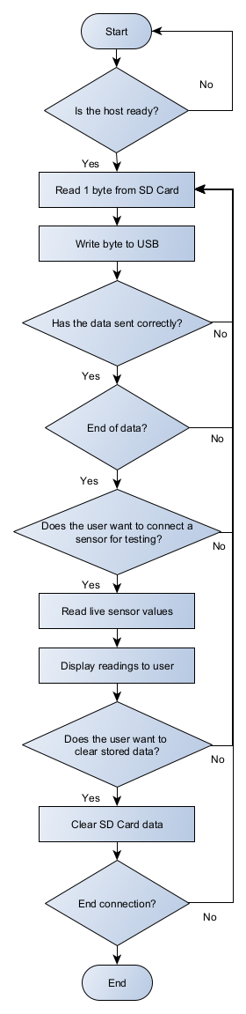
Figure 15 - Data Upload Mode Flow Chart

Figure 16 shows how the system will function in data collection mode. Readings will be taken from the sensors as set intervals, thus if the time is equal to the sampling time/interval, sensor readings will be taken and stored to the SD card. The green LED will flash at every 10 second interval and will remain on for 1 second to indicate system operation. If errors occur, the red LED will constantly illuminate until rectified.
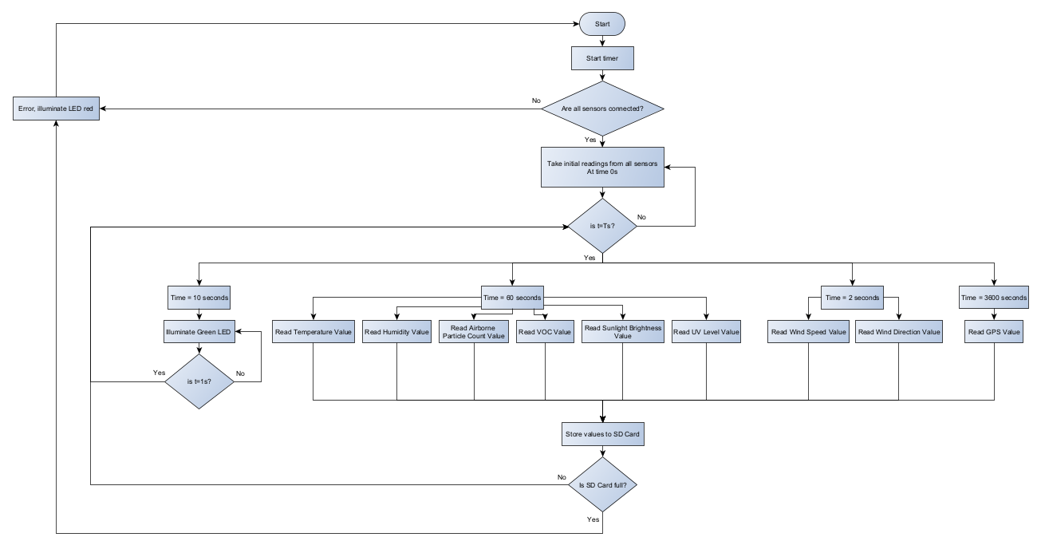
Figure 16 - Data Acquisition Mode Flow Chart

EasyPC Design
Figure 17 shows the schematic diagram created using EasyPC software. The light blue lines illustrate the signal nets, yellow are power lines and dark blue are ground connections.
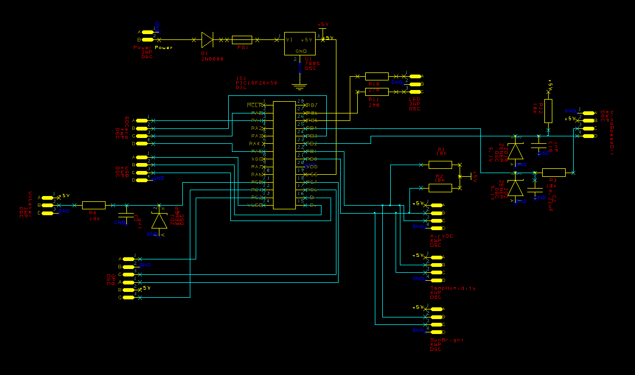
Figure 17 - EasyPC Schematic Diagram

The top and bottom layers of the PCB design are shown in Figure 18 and Figure 19 respectively. Where possible, best practices were followed when designing the PCB, such as routing the traces at a 45° angle, the use of a copper ground pour to create a low-impedance ground plane and the use of standardised trace widths for signal, power, and ground traces. The ground pour covers the top layer of the PCB and is connected to each of the four, 3.5mm mounting holes, it helps to reduce ground loops, dissipates heat, and shields the board from electromagnetic interference (EMI). Through-hole vias were used were necessary, these are holes which facilitate the passage of traces between the top and bottom layer of the board to prevent trace crossing. Additionally, each component name is printed on the circuit board, and all align vertically to aid reading [83].

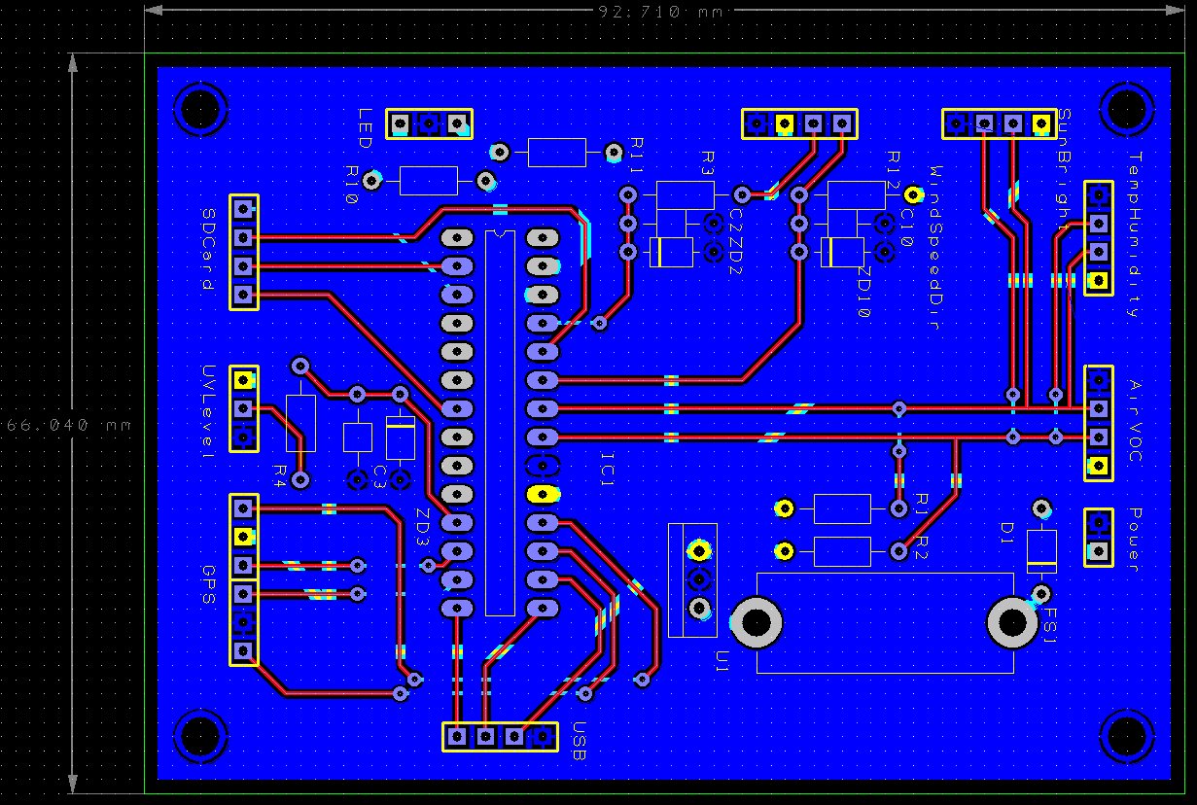
Figure 18 - PCB Design Top Layer
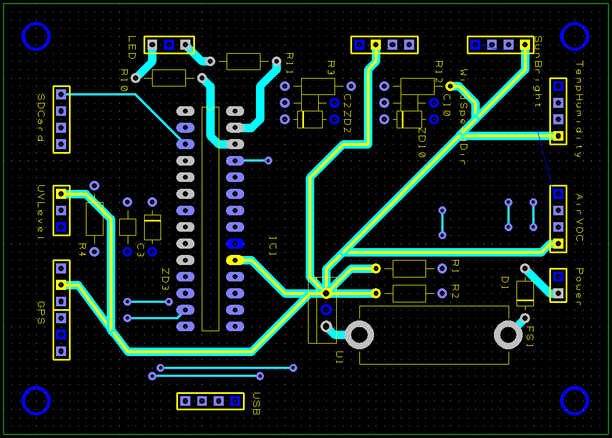
Figure 19 - PCB Design Bottom Layer

Figure 20 and Figure 21 show a 3D view of the PCB design. External sensors and breakout boards connect to the board via wire harnesses and Molek KK PCB headers that enable them to communicate with the MCU.
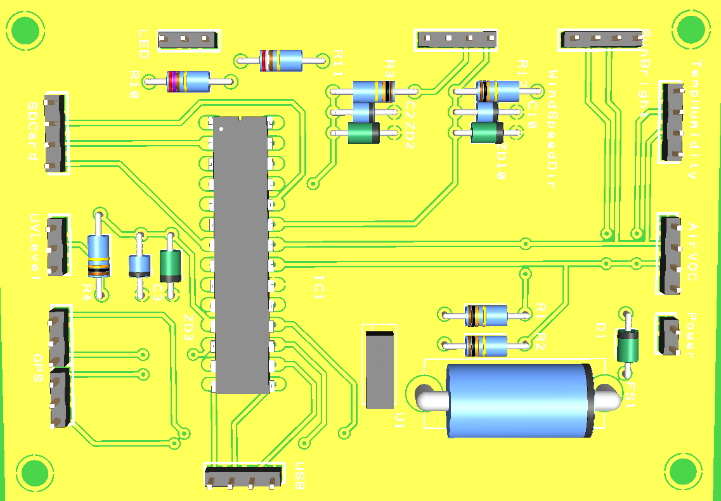
Figure 20 - PCB 3D View Front
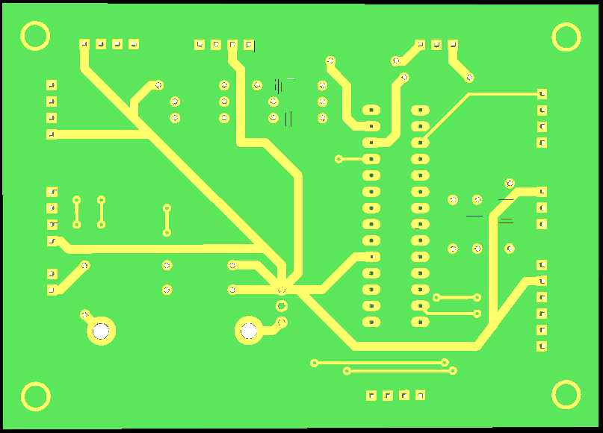
Figure 21 - PCB 3D View Back
Gerber files containing the complete description of the PCB design were uploaded to JLCPCB to obtain a build cost for the 92.71 x 66.04mm PCB, see Figure 22 and Figure 23. The calculated price is for a minimum order quantity of 5 including shipping fees.
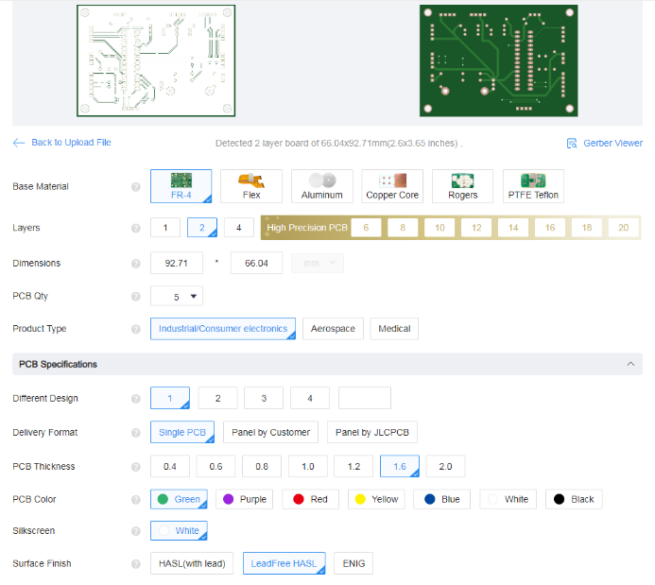
Figure 22 - JLCPCB Order [84]
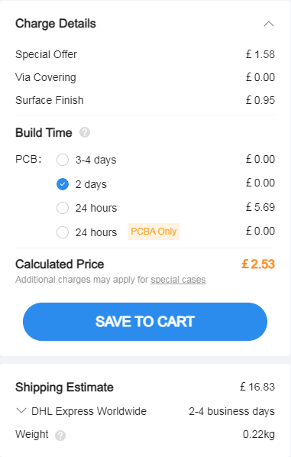
Figure 23 - JLCPCB Order Cost [84]

Build Costs
An excel sheeting detailing the prototype build costs has been generated, as illustrated in Figure 24. The overall project cost amounts to £392.53, inclusive of 20% VAT.
Figure 24 - Prototype Build Costs

Suggested Improvements
Following extensive research into portable weather measurement systems and associated sensors and having constructed a PCB design, outlined below are some proposed improvements for the next iteration:
- Separate power supplies to prevent possible interference between digital and analog circuitry.
- Bluetooth or Wi-Fi functionality could be added to allow the user to view live weather data on an external display or mobile application, such as the devices covered in the literature review.
- Further functionality could be added to the final product to measure more weather variables like the ACCUR8 DWS7100 device shown in Table 1 that measures barometric pressure and rainfall.
- The chosen enclosure and the 2 alternative enclosures, unfortunately block UV radiation as they are constructed with polycarbonate, polyamide thermoplastic and aluminium. Although the chosen enclosure is clear, it is UV stabilised for outdoor use, meaning it blocks the entire UV spectrum, therefore a workaround would have to be considered when bringing this product to market to allow the UV sensor to detect UV radiation while also being housed in an enclosure.
- If bringing this product to market, thorough consideration would have to be given to the VOC and airborne particle count sensor, as this requires airflow but must also be protected from harsh weather conditions and moisture that could damage the electronics.

Conclusion
The design of the microcontroller-based portable weather measurement system detailed in this report presents a broad and versatile solution for acquiring in-depth meteorological information.
The system can measure all parameters set out in the brief via a variety of sensors. These sensors utilise multiple communication methods including analog, digital, I2C and UART. All data is saved to non-volatile memory in the form of an SD card, which can be externally read and cleared when connected to a computer via USB.
The Hammond Manufacturing 1554W2GYCL polycarbonate enclosure paired with robust Multicomp PRO MP-T21 Series connectors, ensure durability, portability, and crucial protection for the system. Furthermore, incorporating the outlined improvements could transform this into a comprehensive solution ideal for use by amateur weather forecasters.

References
[1] “ACCUR8 DWS7100 7-in-1 Complete WiFi Weather Station With Light Intensity, UV Monitoring & Weather Alerts | Weather Shop UK.” Accessed: Dec. 12, 2023. [Online]. Available: https://www.weathershop.co.uk/accur8-7-in-1-wifi-weather-station
[2] “Davis Vantage Vue 6250UK Weather Station - Free 3 Year Extended Warranty | Weather Shop UK.” Accessed: Dec. 12, 2023. [Online]. Available: https://www.weathershop.co.uk/davis-vantage-vue-weather-station
[3] “PSG04173 Pro Signal, Weather Station, Wireless, Solar Powered | Farnell UK.” Accessed: Dec. 12, 2023. [Online]. Available: https://uk.farnell.com/pro-signal/psg04173/solar-powered-wifi-weather-station/dp/3479187?st=wind%20sensor
[4] “ACCUR8 DWS7100 7-in-1 Complete Solar-Powered WiFi Weather Station with Light Intensity, UV Monitoring & Weather Alerts Product Images”, Accessed: Dec. 12, 2023. [Online]. Available: www.weathershop.co.uk
[5] “Davis Vantage Vue 6250UK Datasheet.” Accessed: Dec. 12, 2023. [Online]. Available: https://www.weathershop.co.uk/productpdf/download/file/id/80/name/Davis_Vantage_Vue_6250UK_-_Highly_Accurate_%2526_Robust%252C_Optional_Mobile_Phone_AppWebPC_Connectivity.pdf/
[6] “Solar Powered Wireless Wi-Fi Weather Station,” Pro-Signal, 2023.
[7] “MAPS - MCUs & MPUs page.” Accessed: Dec. 12, 2023. [Online]. Available: https://www.microchip.com/maps/microcontroller.aspx
[8] “1554W2GYCL Hammond Manufacturing | Mouser United Kingdom.” Accessed: Dec. 18, 2023. [Online]. Available: https://www.mouser.co.uk/ProductDetail/Hammond-Manufacturing/1554W2GYCL?qs=ahcBuItHZ3yxVdNACW62lQ%3D%3D
[9] “E-Case B Extruded Aluminium Enclosure Kit | Lincoln Binns Ltd.” Accessed: Dec. 18, 2023. [Online]. Available: https://lincolnbinns.com/shop/aluminium-enclosures/e-cases/e-case-b-enclosure-kit.html
[10] “EEC-325X4B Deutsch - Te Connectivity | New Low Price.” Accessed: Dec. 18, 2023. [Online]. Available: https://uk.farnell.com/deutsch/eec-325x4b/pcb-enclosure-thermoplastic-black/dp/2138242
[11] “Type 4X, 6P Polycarbonate & General Purpose ABS Enclosures 1554 Series”, Accessed: Dec. 18, 2023. [Online]. Available: https://www.hammfg.com/electronics/small-case/plastic/1554
[12] L. B. Ltd‎, “E-Case B Enclosure Kit Product Images,” 2023. [Online]. Available: https://lincolnbinns.com/e-case-b-enclosure-kit.html
[13] “HD10 Series STRIKE Series EEC Enclosure and Flange Receptacle,” Deutsch Industrial.
[14] “SDIT/8GB Kingston | Mouser United Kingdom.” Accessed: Dec. 13, 2023. [Online]. Available: https://www.mouser.co.uk/ProductDetail/Kingston/SDIT-8GB?qs=17ckDYBRdem92F6opNyrzQ%3D%3D
[15] “DS2A-128I81C1B Innodisk | Mouser United Kingdom.” Accessed: Dec. 13, 2023. [Online]. Available: https://www.mouser.co.uk/ProductDetail/Innodisk/DS2A-128I81C1B?qs=Li%252BoUPsLEnt6jSmyCQRHfA%3D%3D
[16] “µA7800 SERIES POSITIVE-VOLTAGE REGULATORS,” 2003, Accessed: Dec. 14, 2023. [Online]. Available: www.ti.com/sc/package.
[17] “CR-123APA/1B Panasonic Industrial Devices | Mouser United Kingdom.” Accessed: Dec. 14, 2023. [Online]. Available: https://www.mouser.co.uk/ProductDetail/Panasonic-Industrial-Devices/CR-123APA-1B?qs=1eQvB6Dk1vgSDof8%2F5%252BA3g%3D%3D
[18] “Premium Sport 8.4V 3800mAh Sub C NiMH RC Battery Pack - Overlander | CPC.” Accessed: Dec. 14, 2023. [Online]. Available: https://cpc.farnell.com/overlander/1592/battery-sub-c-8-4v-3800mah-nimh/dp/BT04702
[19] “RS PRO, 3.2V, 18650, Lithium Phosphate Rechargeable Battery, 1.5Ah | RS.” Accessed: Dec. 14, 2023. [Online]. Available: https://uk.rs-online.com/web/p/speciality-size-rechargeable-batteries/1834304
[20] “Recyko Pre-Charged NiMH Rechargeable 9V Battery, 200mAh - Gp Batteries | CPC.” Accessed: Dec. 14, 2023. [Online]. Available: https://cpc.farnell.com/gp-batteries/gprhv208r088/gp-recyko-200-9v-card-of-1/dp/BT07137?st=9v%20battery
[21] “CR123A Features & Benefits”, Accessed: Dec. 14, 2023. [Online]. Available: www.na.industrial.panasonic.com/products/batteries
[22] “Product Specification: SubC 3800mAh 1.2V,” Overlander Batteries.
[23] “RS PRO Rechargeable Lithiumion Iron Phosphate Battery (LiFePO 4 ),” RS Article:1834304.
[24] “GP Batteries GP20R8H.” Accessed: Dec. 14, 2023. [Online]. Available: https://www.farnell.com/datasheets/3978333.pdf
[25] “LM35AH Texas Instruments | Mouser United Kingdom.” Accessed: Dec. 10, 2023. [Online]. Available: https://www.mouser.co.uk/ProductDetail/Texas-Instruments/LM35AH?qs=QbsRYf82W3FvJrSoiAPPjQ%3D%3D
[26] “PTC015W000 | Carel Stainless Steel PTC PTC Thermistor, 1kΩ, -50°C Min, +100°C Max, 6mm Probe | RS.” Accessed: Dec. 10, 2023. [Online]. Available: https://uk.rs-online.com/web/p/thermistors/0163407
[27] “14386512 | WIKA RTD RTD Sensor, 2 Wire, M16, +100°C Max | RS.” Accessed: Dec. 10, 2023. [Online]. Available: https://uk.rs-online.com/web/p/rtd-sensors/2691025
[28] “LM35 LM35 Precision Centigrade Temperature Sensors,” 1999, Accessed: Dec. 10, 2023. [Online]. Available: www.ti.com
[29] “Carel Stainless Steel PTC Thermistor.” Accessed: Dec. 10, 2023. [Online]. Available: https://docs.rs-online.com/2840/0900766b8126a2a5.pdf
[30] “Ambient Temperature Sensor, Model TF41.” Accessed: Dec. 10, 2023. [Online]. Available: https://docs.rs-online.com/d68f/A700000009901866.pdf
[31] “HPP809A031 | TE Connectivity Temperature & Humidity Sensor, Voltage Output, Through Hole Mount, Analogue, ±5%RH | RS.” Accessed: Dec. 10, 2023. [Online]. Available: https://uk.rs-online.com/web/p/temperature-humidity-sensor-ics/8937373?gb=s
[32] “HPP805A031 | TE Connectivity Humidity Sensor, Voltage Output, Through Hole Mount, Analogue, ±5%RH, 3 Pins | RS.” Accessed: Dec. 10, 2023. [Online]. Available: https://uk.rs-online.com/web/p/temperature-humidity-sensor-ics/8937247?gb=s
[33] “T9602-5-D Amphenol Advanced Sensors, Temperature and Humidity Sensor, T9602 Series, 0% to 100% RH | Farnell UK.” Accessed: Dec. 10, 2023. [Online]. Available: https://uk.farnell.com/amphenol-advanced-sensors/t9602-5-d/humidity-temp-sensor-digital-0/dp/2845666
[34] “HTM2500LF-Temperature and Relative Humidity Module,” 2012, Accessed: Dec. 10, 2023. [Online]. Available: www.meas-spec.com
[35] “HM1500LF Relative Humidity Module Specifications,” TE Connectivity, 2018.
[36] “Telaire T9602 Humidity and Temperature Sensor,” Amphenol Advanced Sensors.
[37] “WMS-23 Omega, Anemometer, 0m/H to 100m/H, -40 °C | Farnell UK.” Accessed: Dec. 10, 2023. [Online]. Available: https://uk.farnell.com/omega/wms-23/air-velocity-114-h-x216-w-mm/dp/3870587?st=wind%20sensor
[38] “1733 Adafruit | Mouser United Kingdom.” Accessed: Dec. 10, 2023. [Online]. Available: https://www.mouser.co.uk/ProductDetail/Adafruit/1733?qs=GURawfaeGuCpPUIILe%252BhBw%3D%3D
[39] “SEN-15901 SparkFun | Mouser United Kingdom.” Accessed: Dec. 10, 2023. [Online]. Available: https://www.mouser.co.uk/ProductDetail/SparkFun/SEN-15901?qs=YwPsRIUVAOdCNLFQoffCEg%3D%3D
[40] “Wind Monitor Stations.” Accessed: Dec. 10, 2023. [Online]. Available: https://www.farnell.com/datasheets/3621896.pdf
[41] “Anemometer Wind Speed Sensor,” adafruit.
[42] “SEN-15901 Weather Meter Kit.” Accessed: Dec. 10, 2023. [Online]. Available: https://www.mouser.co.uk/datasheet/2/813/DS_15901_Weather_Meter-2489718.pdf
[43] “SEN0482 DFRobot | Mouser United Kingdom.” Accessed: Dec. 10, 2023. [Online]. Available: https://www.mouser.co.uk/ProductDetail/DFRobot/SEN0482?qs=pBJMDPsKWf0sMyKW4dLbgQ%3D%3D
[44] “DWSDDAC13 Carlo Gavazzi | Mouser United Kingdom.” Accessed: Dec. 10, 2023. [Online]. Available: https://www.mouser.co.uk/ProductDetail/Carlo-Gavazzi/DWSDDAC13?qs=xZ%2FP%252Ba9zWqb0E5cuRsw5mg%3D%3D
[45] “QK-AS06 Wind Sensor with NMEA 0183 output.” Accessed: Dec. 10, 2023. [Online]. Available: https://www.quark-elec.com/product/as06-wind-sensor/?currency=GBP&gclid=CjwKCAiA98WrBhAYEiwA2WvhOq_LNas91jCatwgWQXUFAKhfnfr-HlSfQDUSaBLxV-Gwq5iiZVH1IxoCQakQAvD_BwE
[46] “RS485 Wind Direction Transmitter”, Accessed: Dec. 10, 2023. [Online]. Available: https://www.mouser.com/new/dfrobot/dfrobot-rs485-wind-direction-transmitter/
[47] “Wind Vane DWS-D-DAC13,” Carlo Gavazzi.
[48] “QK-AS06 Manual QK-AS06 Manual NMEA 0183 Wind Sensor (Anemometer)”.
[49] “What is Sensirion’s VOC Index?” Accessed: Dec. 10, 2023. [Online]. Available: https://sensirion.com/media/documents/02232963/6294E043/Info_Note_VOC_Index.pdf
[50] “SEN54-SDN-T Sensirion | Mouser United Kingdom.” Accessed: Dec. 10, 2023. [Online]. Available: https://www.mouser.co.uk/ProductDetail/Sensirion/SEN54-SDN-T?qs=doiCPypUmgETgnCgwG%2FXqw%3D%3D
[51] “TERA Sensor Next-PM, Particle Matter / Dust Air Quality Sensor | RS.” Accessed: Dec. 10, 2023. [Online]. Available: https://uk.rs-online.com/web/p/environmental-sensor-ics/1953770?cm_mmc=UK-PLA-DS3A-_-google-_-CSS_UK_EN_PMAX_Catch+All-_--_-1953770&matchtype=&&gad_source=1&gclid=CjwKCAiA98WrBhAYEiwA2WvhOg_92N9sZdNsOceWDDSZk0k0Wd9MVKAsrbml-BT5r-aLZ0tiS44L_hoCIxIQAvD_BwE&gclsrc=aw.ds
[52] “Omron B5W-LD0101-1, Air Quality Sensor | RS.” Accessed: Dec. 10, 2023. [Online]. Available: https://uk.rs-online.com/web/p/environmental-sensor-ics/2042713?cm_mmc=UK-PLA-DS3A-_-google-_-CSS_UK_EN_PMAX_Catch+All-_--_-2042713&matchtype=&&gad_source=1&gclid=CjwKCAiA98WrBhAYEiwA2WvhOvLvYJ4LZV3et1CZPWHOw7jxrpz-KrUNbvMWFPZ04n80ickDlbtseBoCZaIQAvD_BwE&gclsrc=aw.ds
[53] “Datasheet SEN5x”, Accessed: Dec. 10, 2023. [Online]. Available: www.sensirion.com
[54] “TERA Technical specifications”, Accessed: Dec. 10, 2023. [Online]. Available: www.tera-sensor.com
[55] “B5W-LD0101-1/2 Highly Sensitive and Compact Air Quality Sensor,” Omron.
[56] “How to Measure Light Intensity: Understanding & Using a Lux Meter.” Accessed: Dec. 10, 2023. [Online]. Available: https://bioslighting.com/how-to-measure-light-intensity/architectural-lighting/
[57] “NORPS-12 Luna Optoelectronics | RS.” Accessed: Dec. 10, 2023. [Online]. Available: https://uk.rs-online.com/web/p/colour-light-sensor-ics/9146714?gb=s
[58] “4162 Adafruit | Mouser United Kingdom.” Accessed: Dec. 10, 2023. [Online]. Available: https://www.mouser.co.uk/ProductDetail/Adafruit/4162?qs=unwgFEO1A6urZiNnCPSvkw%3D%3D
[59] “4161 Adafruit | Mouser United Kingdom.” Accessed: Dec. 10, 2023. [Online]. Available: https://www.mouser.co.uk/ProductDetail/Adafruit/4161?qs=d0WKAl%252BL4KYSXIse1Xv7Uw%3D%3D
[60] “Plastic Package Cds Photocells NORPS-12 WWW.LUNAINC.COM,” Luna Optoelectronics, 2016.
[61] “Adafruit VEML7700 Lux Sensor-I2C Light Sensor”, Accessed: Dec. 10, 2023. [Online]. Available: https://www.adafruit.com/product/4162//3-29-19
[62] “Adafruit VCNL4040 Proximity Sensor”, Accessed: Dec. 10, 2023. [Online]. Available: https://learn.adafruit.com/adafruit-vcnl4040-proximity-sensor
[63] “1918 Adafruit | Mouser United Kingdom.” Accessed: Dec. 12, 2023. [Online]. Available: https://www.mouser.co.uk/ProductDetail/Adafruit/1918?qs=GURawfaeGuCujPszkmg6xA%3D%3D
[64] “Gravity Analogue UV Sensor, ML8511 - Dfrobot | CPC.” Accessed: Dec. 12, 2023. [Online]. Available: https://cpc.farnell.com/dfrobot/sen0175/gravity-analog-uv-sensor-ml8511/dp/SC15114?st=uv%20sensor#anchorTechnicalDOCS
[65] “Qwiic UV Light Sensor Board, VEML6075 - Sparkfun Electronics | CPC.” Accessed: Dec. 12, 2023. [Online]. Available: https://cpc.farnell.com/sparkfun-electronics/sen-15089/uv-light-sensor-breakout-veml6075/dp/MK01012?st=uv%20sensor
[66] “GUVA-S12SD UV-B Sensor Features Applications,” Roithner Laser Technik, 2011.
[67] “SEN0175 Datasheet.” Accessed: Dec. 12, 2023. [Online]. Available: https://www.farnell.com/datasheets/2700161.pdf
[68] “UVA and UVB Light Sensor with I 2 C Interface”, Accessed: Dec. 12, 2023. [Online]. Available: www.vishay.com/doc?91000
[69] “TEL0094 DFRobot | Mouser United Kingdom.” Accessed: Dec. 12, 2023. [Online]. Available: https://www.mouser.co.uk/ProductDetail/DFRobot/TEL0094?qs=lqAf%2FiVYw9jr%2FwqtsE4kSg%3D%3D
[70] “5440 Adafruit | Mouser United Kingdom.” Accessed: Dec. 12, 2023. [Online]. Available: https://www.mouser.co.uk/ProductDetail/Adafruit/5440?qs=vvQtp7zwQdM1WimlzkTkHg%3D%3D
[71] “Seeed Studio 113020003 GPS Module | RS.” Accessed: Dec. 12, 2023. [Online]. Available: https://uk.rs-online.com/web/p/gnss-gps-modules/1793714?gb=s
[72] “TEL0094 Datasheet,” V.KEL.
[73] “Adafruit Ultimate GPS ”, Accessed: Dec. 12, 2023. [Online]. Available: https://learn.adafruit.com/adafruit-ultimate-gps
[74] “E-1612-UB Ultra High Sensitivity and Low Power GPS Receiver Module General Description,” Seeed Studio.
[75] “Multicomp Pro | The Engineer’s Choice.” Accessed: Dec. 14, 2023. [Online]. Available: https://multicomp-pro.com/
[76] “HR10 series - HIROSE Electric Group [Connector].” Accessed: Dec. 14, 2023. [Online]. Available: https://www.hirose.com/product/series/HR10
[77] “UTS Series | SOURIAU SUNBANK Connection Technologies.” Accessed: Dec. 14, 2023. [Online]. Available: https://www.souriau.com/en-en/products/connectors/circular-connectors/uts-series
[78] “Circular Connectors and Sets IP68 Material and Specifications,” Multicomp Pro, 2023.
[79] “HR10 Series High Performance Miniature Circular Connectors,” 2023, Accessed: Dec. 14, 2023. [Online]. Available: https://www.hirose.com/en/product/series/HR10
[80] “UTS SERIES Waterproof Plastic Connectors IP68 and IP69K,” Esterline Connection Technologies.
[81] “TB3275 Using the CCP Module,” Microchip, 2020.
[82] “Dialight 559 Series Snap-in LED Datasheet.” Accessed: Dec. 17, 2023. [Online]. Available: https://www.farnell.com/datasheets/1948894.pdf
[83] “PCB Design Guidelines For Reduced EMI,” Texas Instruments, 1999.
[84] “PCB Prototype & PCB Fabrication Manufacturer - JLCPCB.” Accessed: Dec. 18, 2023. [Online]. Available: https://jlcpcb.com/

