UNIVERSITY OF WALES TRINITY SAINT DAVID

Programme: BA (Hons) Leadership and Management Skills for the workplace

Module: Strategic Management for SMEs

Module Code: BMSW6104

Name: Jane

Nakitto

Stud ID: 2008466/ WC: 4700

Submission: 05/05/2023

Table of Contents
Executive Summary 3
Introduction 4
Background of chosen business 5
Main body 5
Internal Analysis 6
SWOT analysis 6
VRIN 7
9M model 8
Balanced scorecard model 9
External analysis 11
PESTLE 11
Industry analysis 12
Porters five forces model 12
Strategic option analysis 16
Ansoff matrix model 17
SFA Framework 18
Mandelow’s Stakeholder analysis 19
Conclusion and recommendations 22
References 24

Executive Summary

In this report, researcher has chosen a SME known as happy beds through which various strategic development regarding the business has been scrutinised. The application as part of the strategic development process which was undertaken and discussed was SWOT analysis, internal analysis through 9M model, VRIN, Porters value chain model, balanced scorecard, benchmarking, PLCM to determine business’s internal strength and weakness internally. Apart from that, external analysis, the field of study has carried out PESTLE along with Posters five forces to carry out industry analysis. Further, company’s strategic option also has been analysed through Ansoff Matrix followed by SFA framework as part of strategic direction. As part of stakeholder analysis Mandelow’s Stakeholder Matrix is adopted to justify the acceptability of strategic option and finally few recommendations are made to aid the chosen business.

Introduction

Strategic management is unique process to set and reach out to goals and objective set by the business organisation hence, it incorporates evaluating external and internal elements which impacts company’s overall competitiveness and performance. It also enables business to align and implement best management practice as well as resources within the company (Backhouse, 2021). On the other hand, SMEs stand for small-medium size enterprise that generally hold less than 500 employees. SMEs consider as heart of UK economy as its make-up 99% of the national business population. When strategic management and SMEs comes under one umbrella that s can ensure high profitability, employee satisfaction, increased retention, gain knowledge and skills, maximised efficiency and so on (Weltman and Lasser, 2022). Hence, to demonstrate that the field of study has chosen “Happy Beds” a SME through which internal, external, industry analysis, growth choices and strategy option will be carried out via SWOT analysis, 9M model, Porters value chain model, balanced scorecard, benchmarking, VRIN, PLCM to determine business’s internal strength and weakness, PESTLE, Ansoff Matrix, Mandelow’s Stakeholder Matrix and so on. The aim of this report is to analyse current strategic direction for “Happy Beds” as well as analyse how the business can develop its strategy in future to sustain in the competitive business environment. The report includes three-chapter introduction, main body and conclusion where few recommendations are developed at the end of the report. All the information gathered here are referenced accordingly as per the university guidelines to avoid collusion.

Background of chosen business

Happy beds started its journey back in 2010 from Norther England and expanded it further sales through its own website in 2012. Since then, the business remained true to its core value that ensure good night sleep does not have to be pipe dream for everyone. As a result, since 2010 the business is expanding constantly and ensure its growth through range of products. The biggest strength of the business is, its listening to the customers and showcasing affordable and dreamy bed for everyone. Running with 135 employees and one store located in Dewsbury the business has online multichannel platform meet the consumer demand (Happy beds, 2023).

Main body

In this part of the report, the field of study will add various strategic aspects incorporated with chosen business “Happy Beds” with the help of range of strategic theories, models and tools.

Internal Analysis

SWOT analysis

SWOT stands for strength, weakness, opportunity anD threat which is a framework to help understand and assess the external and internal forces of business that may pose risk or create opportunities for business organisation (yuldashev, Saidov and Samiev, 2022). SWOT analysis for Happy beds is discussed below;

Strength | Weakness | Opportunity | Threat
- Happy beds is UK based multi-channel retailer that has huge range of beds, mattresses, bedding products and bedroom furniture (Happy beds, 2023).  - It offers its product nationwide along with Scottish Island and Highlands (Happy beds, 2023).  - It offers multichannel trading through Amazon, Ebay, Tesco Direct and its own website (Happy beds, 2023).  - Effective online presence (Happy beds, 2023). | - Less employees where the business has only 135 members (Happy beds, 2023).  - Fear of investment.  - Commission share with third part online retailers (Happy beds, 2023).  - Lack of equity capital (Happy beds, 2023). | - Generated £5 million profit and opportunity to earn more (Happy beds, 2023).  - Getting positive review that has open door for business (Happy beds, 2023).  - Rated 4.4 based on 9511 reviews in Trust pilot (Happy beds, 2023).  - Fastest delivery methods (Happy beds, 2023).  - Survived effective during the time of Covid-19 and ready to beat future unprecedented time due to its strong online presence (Happy beds, 2023). | - Ikea a market giant in the UK where customer can buy beds online as well as from physical store (Happy beds, 2023).  - Another online based furniture retail “Wayfair” got very popular in recent times with huge customer base (Happy beds, 2023).

VRIN

It’s a strategic tool which is used to evaluate and assess the overall resource of the business (Seminara, 2016).

Value | Rare | Inimitable | Non-substitutable
- Positive brand image (Paul, 2020).  - High rating (Paul, 2020).  - Competitive price (Happy beds, 2023).  - Defined CSR function (Paul, 2020).  - Brand sustained for long time (since 2010) (Happy beds, 2023). | - National presence (Paul, 2020).  - Multichannel supply chain (Paul, 2020).  - Exiting website (Paul, 2020).  - Great adaptability over time (Paul, 2020).  - Taking calculated risks (Happy Beds, 2023). | - High brand appeal (Paul, 2020).  - Consistence of repeat purchase (Paul, 2020).  - Less risk poses by physical store such as rent (Paul, 2020).  - Competitive pricing (Paul, 2020).  - Great customer experiences (Paul, 2020). | - Financial strength (Happy beds, 2023).  - Revenue of £5 million (Happy beds, 2023).  - Technological interrogation (Paul, 2020).  - Distribution channel with market giant Amazon, Ebay and Tesco Direct (Paul, 2020).  - Non-substituble corporate leadership (Paul, 2020).  - Great human resource (Paul, 2020).

9M model

The 9Ms sets out resource planning framework that carry out resource audit checklist for business resources through Manpower, Money, Method, Men and women, Machines, Measurement, Materials, Market and Management (Tom, 2016). 9M model of happy beds is given below;

Manpower | Currently holding 135 employees.
Money | £5 million revenue with 102% increase in revenue (Happy beds, 2023).
Method | Multichannel distribution and supply chain (Paul, 2020).
Men and women | Diverse team with equality (Happy beds, 2023).
Machines | Natural filling and unique blend of cashmere, cotton, silk and wool (Happy beds, 2023).
Measurement | Labour cut over time (Mark, 2022).
Materials | Own developed furniture and made in Britain (Happy beds, 2023).
Market | Own website, Amazon, Tesco Direct, Ebay offering products nationwide (Happy beds, 2023).
Management | Management includes Senior PPC manager, HR manager, Marketing and brand manager, Customer service specialist and Business development manager (Happy beds, 2023).

Balanced scorecard model

Balanced scorecard model refers to strategic management performance metric which identify and improve different internal business functions and its result to external outcome (Solntsev, 2023). Balanced scorecard model of Happy beds is discussed below;

Learning and growth: Happy beds always carry out marketing research and identify trends to meet customer demand. Over the time the business has cut down its labour and keep only efficient one to ensure its growth in market (Happy beds, 2023).

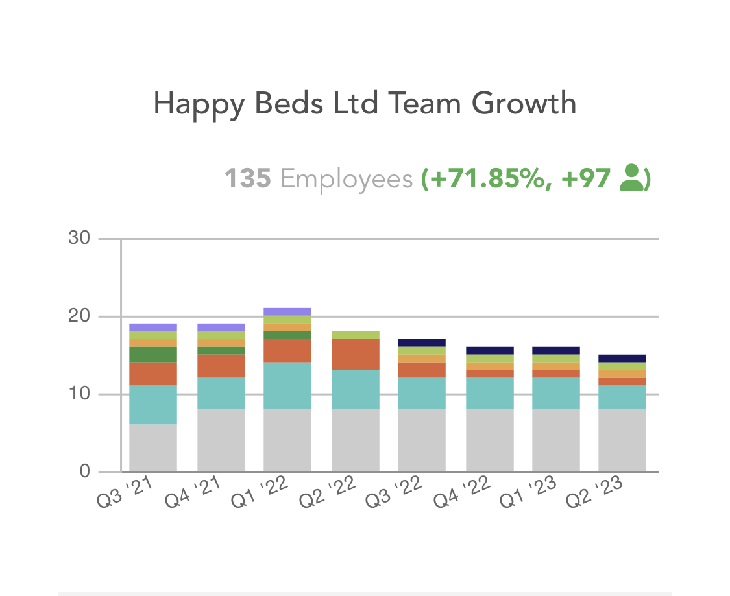

Happy Beds Team Growth (Source: Happy Beds, 2023)
Business process: To ensure the business process effectiveness Happy Beds have right set of human resources who delivery reviews its sales and profitability in wider multichannel distribution. The team of the business highly effective to keep track on delays, gaps, shortage and waste (Mark, 2022).

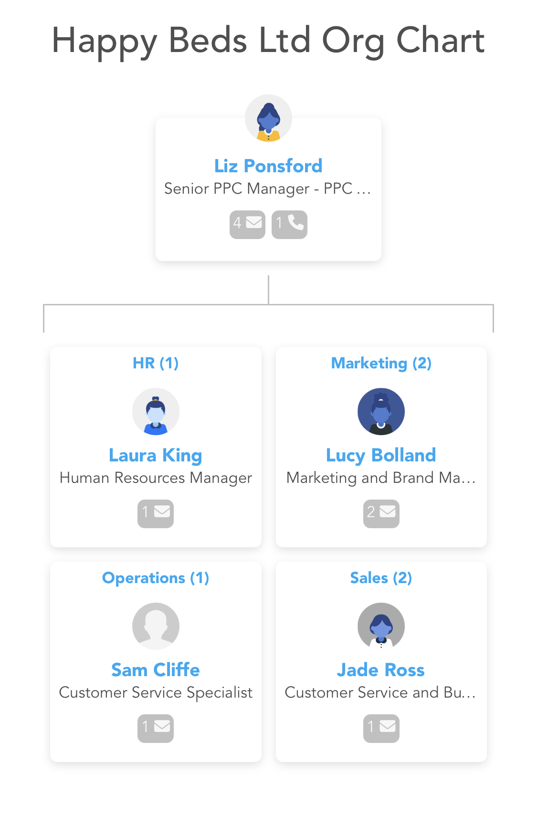
Happy Beds Organisational chart (Source: Happy Beds, 2023).

Customer perspective: through this Happy bed collect and investigate customer satisfaction level in terms of price, quality, trend, services and so on. The effective way that Happy Beds judge and analyse it, via Trust Pilot review where the business has Rated 4.4 based on 9511 reviews (Happy Beds, 2023).

Financial data: as per financial data of the business is concern it has generated £5 million review since 2010 and in 2021 business ensured 102% increase in revenue along with 80% growth in sire traffic, hired 17 new marketing staff for business in 2021 (Mark, 2022).

External analysis

PESTLE

As per the external analysis PESTLE will be sued which sets our six elements within external environment such as political, economic, social, technological, legal and environment framework to justify how these forces can impact business externally.

Political | - High taxation.  - Changing nature of Laws and legislation.  - Brexit.  - Trade restriction.  - Prime minister reform (Dinçer and Yuksel, 2020)  All these political aspects have impacted Happy beds but still the business has flourished over time (Happy beds, 2023).
Economical | - Economical regressions.  - Cost of Living.  - High energy cost.  - Fuel crisis. Inflation (Dinçer and Yuksel, 2020)  High interests etc. has impacted the business in negative ways (Mark, 2022).
Social | - consumer interest and trends has change over time (Dinçer and Yuksel, 2020) as a result to meet their demand happy beds developed hand tuffed surface, fibre cover, coil spring, reflect foam to meet consumer’s needs (Happy beds, 2023).
Technological | - Happy beds have ensure high research and development within the market to beat its rivals (Happy beds, 2023).  - Great online presence in major market giant websites (Happy beds, 2023).  - Fastest online order deliveries (Happy beds, 2023).
Legal | - Due to cost of living Happy beds has shrink in compare to 2021/2022 where the sales volume rose by 102% now its dropped to 73% (Happy beds, 2023).
Environmental | - A great CSR compliance are seen within the process of Happy beds operation where the business is ensuring less pollution, less waste to landfill and regenerating resources (Happy Beds, 2023).

Industry analysis

Porters five forces model

This model analyses and identifies five competitive forces which shape the industry as well as help determines industry’s strength and weakness (Nguyen, 2020). Porters five forces model regarding Happy beds is discussed below

Threat of new entrants

It reflects how new players within the market can impose threats towards existing market players. If the industry is profitable then barriers to enter within the industry will be hard (Nguyen, 2020) which is discussed below;

Threat of new entrants

Here are some elements which can minimise the threat of new entrants for Happy beds,

- Entry within the UK market need substantial resource and capital investment as a result Happy bed is in good place as business is running since 2010 and new entrant within the market is very low (Mark, 2022).
- Happy beds face low threat of new entrants as after Brexit regulatory framework impose certain challenges towards new business to enter within the market (Nguyen, 2020).
- Customer are less tending to buy from new business as in the UK psychological switching of cost is high and existing brands like happy beds already developed loyal consumers base (Nguyen, 2020).
- The distribution channel within the UK is restricted as result it will discourage new entrants (Nguyen, 2020).
- The way Happy beds is getting benefitted through threats of new entrants are; loyalty consumers, developed long term contractual relationships, high investment is research and development, competitive price etc. (Happy beds, 2023).

Threat of substitute products or service

The overall availability of substitute service or products within the market makes competitive environment highly challenging which is happening with Happy beds as there are lots of consumers can choose alternative product from other business for cheaper price (Happy beds, 2023). The threat of substitute towards services or products increases when there is cheaper substitute is available from another nation, psychological switching from one brand to another is low and substitute products of service offers superior performance and quality. On the other hand, the threat of substitute is low when switching cost from one brand to another is high, consumers cannot derive the same quality from substitute products (Nguyen, 2020). Here, the way Happy beds tackle threat of substitute products or services are;

- Happy beds minimise the threat of substitute service or products via clearly emphasising betterment than another available substitute.
- Happy beds offer convincing reason towards consumers via offering a high value money and better experiences.
- Happy beds raise high switching costs via working on loyalty.
- Finally, Happy beds focus highly on quality, maximise value of money and develop strong differentiation basis to discourage consumers from using substitute products (Happy beds, 2023).

Rivalry among existing firms

The rivalry among existing firms demonstrates the number of rivals which can give tough competition to Happy beds shows the business will face strong pressure from the rival company which can intern limiting the potential growth. Profitability within the such industries is low as many business adopt aggressive pricing and targeting tactics against each other. Rivalry among existing firms would be low if there are only limited number of players within the market, if the industry is developing fast, having a clear market leader, offered product are highly differentiated and exit barrier is low similarly there are some other elements which can maximise the rivalry among existing firms for Happy beds such as intense rivalry among existing firms, if the market players are highly diverse, if consumers are loyal towards existing brands, if low price is variable towards consumers (Nguyen, 2020). Hence, how Happy beds tackle this discussed below;

- Happy beds focus highly on implicit expectations and needs of consumers to strengthen on the differentiation basis.
- It raises the switching costs via developing longer tem consumer relationship.
- Happy beds invest high on R&D to meet new consumers’ needs and segments.
- Happy beds have collaborated with Amazon, E-bay and Tesco Direct to reach more consumers (Happy beds, 2023).

Bargaining power of suppliers

Bargaining power of suppliers is something that reflects the pressure which exerted via suppliers on the business. It could be various strategies such as minimising product availability, quality or maximise the prices. When suppliers hold strong bargaining power then it costs the buyers as well as high bargaining power of suppliers can maximise the competition within the industry and also lower the growth and profit (Nguyen, 2020) of business like Happy beds similarly weak power of suppliers could make the industry highly attractive due to its high profitability along with growth potential.

In the case of Happy beds overall bargaining power could be if,

- Suppliers hold concentrate into one region.
- If suppliers focus is higher than buyers.
- The force is strong when the switching cost is high for buyers.
- When there are few suppliers and demand for the offered service or products is high.
- Other elements which also increase Happy beds bargaining power if suppliers hold high product differentiation (Nguyen, 2020).

On the other hand, bargaining power of suppliers would be low if,

- Suppliers are not linked.
- Switching cost is relatively low.
- Product lack differentiation.
- Substitute product are available.
- When market is price sensitive as well as hold adequate market knowledge.
- Less threat of forward integration via suppliers (Nguyen, 2020).

Taking that into consideration how Happy beds tackle the bargaining power of suppliers is,

Happy beds bolster its position by having own sourcing and all the parts are made in Britain and ensure trust-worthy service with high quality products. As a result, five-year guarantee of all products are offered since, July 1st, 2016. If in any case, if there is manufacturing fault, Happy beds replace the parts for free, replace the defective items, pay the cost of returns and postage as well as ship the replacement parts (Happy beds, 2023).

Bargaining power of buyers

This is something that indicates, pressure which consumers exert over the business organisation to get the high-quality items are reasonable pries with effective customer services. This force directly influence Happy beds capability to achieve the objectives of the business. Strong bargaining power is something which lowered the profitability as well as turn the industry more competitive. Whereas, when power of buyer is weak then it can make the industry less competitive and maximise the profitability and growth opportunities (Nguyen, 2020) for Happy beds. Hence when it comes to dealing with bargaining power of buyer’s Happy beds ensure;
- Happy beds manage the bargaining power via diversifying consumers base such as introducing new products which is cheaper than the rivals, targeting new market segment and adopting different strategies towards product diversification.
- Happy beds also embed innovation and offer excellent consumer experiences which can raise switching costs that would ultimately minimise the bargaining power. Happy beds lines for customer service is open six days week and warehouse operating team are available five days in a week to support consumers (Happy beds, 2023).

Strategic option analysis

Strategic option analysis is a method that work on the complex issues as well as it’s an approach which designed to support clients with complicates problem (Hou et al, 2018). The Strategic option analysis for Happy beds is discussed below with the help of Ansoff matrix model.

Ansoff matrix model

Ansoff matrix model consider as fundamental framework which designed to determine market and product growth strategy. This model support Happy beds to find opportunities to ensure revenue growth. These consist, product development, market penetration, diversification and market development (Chintalapati, 2020).

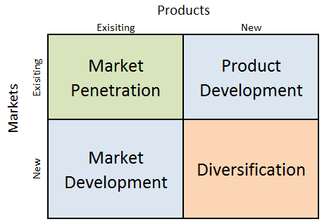
With the help of Ansoff matrix, Happy beds uses and adopt all four growth strategies within an integrated manner. These are,
Market penetration: market penetration considers as selling existing products towards existing markets where Happy beds ensure market penetration efficiently. As a result, the business provides consumers with well-designed catalogue and carry out e-marketing with various post and promotion towards existing and potential consumers. Amazon and E-bays cloud based program also help Happy beds with high number of post on feed and recommendation where most of the new customer shop from Happy beds. Google ads is another way the business set up click to buy ad where Happy beds pay little amount of money and ensure high growth. Trust pilot review of the business is very good also which influences customer to choose the brand (Happy beds, 2023).
Product development: when it comes to product development it ensures selling new products to existing market which is major growth strategy for happy beds. The home improvement and furnishing business has more than 5000 types of products to choose from and lunches 500 products each year (Happy beds, 2023).

Market development: this is sort of strategy which is linked with finding new markets for existing products. Through market development happy beds has collaborated with Amazon, E-bay and Tesco Direct to reach more consumers. It also offers its exiting website to reach new and potential consumers (Happy beds, 2023).

Diversification: it is something that incorporate developing new items to sell to new market which is consider as risky strategy. However, to sustain within the market Happy beds offer range of services such as help to buy, product care, bed buying guide, replacement and return guide, manufacturer guarantee and so on. moving house less stressful is one of the stark example of the business where Happy bed with deliver all the furniture at customer new home and assemble with next day delivery (Happy beds, 2023).

SFA Framework

SFA Framework was first developed by G. Johnson and Kevan Scholes which is an effective tool to analyse overall strategic possibilities. The SFA stands for suitability, feasibility and acceptability (Hashem, 2021).

Suitability: this is extent which identifies strategic opportunities which is highly suitable for the business (Hashem, 2021). When it comes to Happy beds happy bed revenue has failed to grow at the beginning due to less respects towards SEO. However the business has joined “Liberty” an independent marketing agency back in 2016 to works on their SEO, PPC and the content which help the business to find simple solution for cross departmental goals. As a result, Happy beds has encountered huge revenue generation of £500m and sustain well during pandemic (LDM, 2023).

Feasibility: this indicates to what extent strategic options are feasible (Hashem, 2021). Digital presence of the business was very weak at the beginning however strategic alliances with EBay, Amazon in 2018 and Tesco Direct in 2020 has prompt the professional communication of the business with collaborative and creative spirit (Happy beds, 2023).

Acceptability: it indicates the strategic choice set via examining two criteria such as financial criteria and how choices offered are fits towards stakeholders (Hashem, 2021). Hence, when it comes to the acceptability to meet changing consumer demand happy beds developed hand tuffed surface, fibre cover, coil spring, reflect foam to meet consumer’s needs. A great CSR compliance are seen within the process of Happy beds operation where the business is ensuring less pollution, less waste to landfill and regenerating resources (Happy Beds, 2023) has helped business to fulfil financial growth and meet consumer’s choices. However, it was happened due to support offered by world leading networking agency “Liberty” (LDM, 2023).

Mandelow’s Stakeholder analysis

Mandelow’s Stakeholder analysis matrix is considering as simple graphic representation of stakeholder analysis which two axes along with chart that divided into four categories. Here, the position of the each stakeholder over the matrix allows the management to figure out important stakeholders and high priority of the project as well as help business to analyse what stakeholder will be less influenced and low impact (Demir et al, 2015). The two axes of the matrix incorporate;

Interest: this is horizontal axis (known as x-axis) that identifies the level of interest which each stakeholder likely to present. A stakeholder holding prime interest within the project or business will be on right hand at the end of interest axis whereas one with low interests will be towards left hand side of the chart (Demir et al, 2015).

Power: this is a vertical axis (known as y-axis) of the chart that portrays how much power one each stakeholder can hold to impact the project. The more power stakeholder represents the higher the placement they would hold at the bottom of the axis has little or no power (Demir et al, 2015).

As far as MSA is concern, Manoeuvring stakeholder over the chart create four areas of the matrix through which help management to prioritise and organise four area of stakeholders within the project. These includes;

High power, low interest

Stakeholder with high power and low interest may less likely to have direct role towards the project. In the scenario of Happy beds, it has 135 employees with 11 management team who hold significant power even if they do not engage in daily work. Management team of the business here ensure all the process work done accordingly as well as cut labour if they are not suitable. Customers interest towards Happy beds is rising where the business ensures 102% profit growth during 2021/2022 (Happy beds, 2023).

Low power, low interest

When it comes to Low power, low interest; stakeholders with low interest less likely to prioritise the project and they required effective monitoring to ensure progress of the business. These stakeholders are employees working within the business where Happy beds always ensure effective monitoring and daily handover system to ensure smooth operations (Happy beds, 2023).

High power, high interest

The stakeholders with high power and high interest plays crucial role to the business. In the case of Happy beds close management and management involvement are there in every stage of the business process. stakeholders holding high power are the head of the department who is running the business and ensure overall business operation is a success (Happy beds, 2023).

Low power, high interest

Low power, high interest stakeholders may have high involvement within the project who can influence business significantly however these stakeholders hold less power within the project direction. Here, Happy beds typically keep these stakeholders up to date development within the business even they are unable to influence the outcome of the development (Happy beds, 2023).

Conclusion and recommendations

To sum up, there are vast amount of strategic analysis has been undertaken as part of the strategic development process where the field of the study has discussed and carried out theoretical framework towards Happy beds such as SWOT analysis, internal analysis through 9M model, Porters value chain model to determine business’s internal strength and weakness internally. Apart from that, external analysis has also been carried out through, PESTLE along with Porters five forces. On the other hand, company’s strategic option also has been analysed through Ansoff Matrix followed by SFA framework as part of strategic direction. As part of stakeholder analysis Mandelow’s Stakeholder Matrix is adopted to justify the acceptability of strategic option and finally strategic direction of the business along with few recommendations are made to aid the chosen business which is given below;

The best strategic direction can be set for the Happy beds based on section 2 which is ensure effective implementation of Ansoff Matrix.

Market penetration | Product development | Market development | Diversification
- Happy beds need to strengthen its market penetration to compete with market giant like IKEA, Wayfair etc.  - Email marketing, catalogue serving of the business need to more strong to ensure high profitability.  - Strong online presence along with social media adoption need to be ensured by business.  - Keeping eye on rivals all the time will be the key to success.  - Adopting change management over time is key to survive and sustain for Happy beds. | - Happy beds currently has 5000 different types of furniture and accessories as well as the business offer 500 products every year.  - To understand the changing needs business needs to develop more products (Happy beds, 2022).  - Convertible sofa, beds range need to maximised.  - Discount and clearance would grab high attention of consumers.  - Adding point based card to ensure repeat business.  - Happy beds needs to find new market as well as should go global.  - Carry out marketing testing would highly recommended for the business. | - Through market development happy beds has collaborated with Amazon, E-bay and Tesco Direct to reach more consumers. It also offers its exiting website to reach new and potential consumers (Happy beds, 2022).  - Happy beds needs to link itself with Wayfair, Habitat, Next, M&S, Argos to ensure more profit generation.  - Happy beds need to develop easy fix furniture like IKEA.  - Happy beds need to ensure 7 days’ customer services instead of 5 to reach more consumers. | - to sustain within the market Happy beds offer range of services such as help to buy, product care, bed buying guide, replacement and return guide, manufacturer guarantee and so on. moving house less stressful is one of the stark example of the business where Happy bed with deliver all the furniture at customer new home and assemble with next day delivery (Happy beds, 2022).  - Happy beds needs to focus more on serving not on selling.  - The business need to build lasting relationships

To ensure the effective outcome of the strategic direction Happy beds need to develop time frame and it could be short term and long term goal-based time frame. For short term the business can carry out questionnaire survey’s towards small group to understand their presence, quality, design of the products and find the weaknesses and in terms of long term, Happy beds need to review each consumer comments on social media and developed value-based proposition to beat the rivals. By ensuring that the business would be able to maximise its revenue in ethical ways and if its not followed Happy beds will not be able to sustain within the market for long (Mark, 2022).

References

Backhouse, D. (2021). STRATEGIC MANAGEMENT : competitiveness and globalisation. S.L.: Cengage Learning Australi.

Chintalapati, S. (2020). BankBuddy.ai—Business Expansion and Marketing Dilemma: A Case Study to Discuss the Ansoff Growth Matrix Concepts Combined with Business Expansion Strategies for Expanding into Emerging Markets. Emerging Economies Cases Journal, 2(1), p.251660422092999.

DinçerH. and Yuksel, S. (2020). Handbook of research on decision-making techniques in financial marketing. Hershey, PA: Business Science Reference, an imprint of IGI Global.

Demir, S.T., Bryde, D., Fearon, D. and Ochieng, D.E.G. (2015). Three Dimensional Stakeholder Analysis 3dSA: Adding the Risk Dimension for Stakeholder Analysis. SSRN Electronic Journal.

Hou, W., Lovett, S. and Rasheed, A. (2018). Stock option pay versus restricted stock: A comparative analysis of their impact on managerial risk-taking and performance extremeness. Strategic Organization, p.147612701880415.

Happy Beds. (2023) Who We Are | About Us | Happy Beds. [online] Available at: https://www.happybeds.co.uk/who-we-are#:~:text=Originally%20founded%20in%202010%20in%20Northern%20England%2C%20Happy [Accessed 04 May 2023].

Hashemkhani Zolfani, S., Bazrafshan, R., Akaberi, P., Yazdani, M. and Ecer, F. (2021). COMBINING THE SUITABILITY-FEASIBILITY-ACCEPTABILITY (SFA) STRATEGY WITH THE MCDM APPROACH. Facta Universitatis, Series: Mechanical Engineering, [online] 19(3), p.579.

Liberty Digital Marketing. (2023). Happy Beds Multichannel Case Study. [online] Available at: https://www.libertymarketing.co.uk/case-study/happy-beds-multichannel-case-study/ [Accessed 05 May 2023].

Mark S. Bradford Telegraph and Argus. (2022). Happy times for bed firm as sales soar in its 11th year of trading. [online] Available at: https://www.thetelegraphandargus.co.uk/news/19620031.happy-beds-batley-reports-huge-growth-sales/. [Accessed 29 April 2023].

Nguyen, T.T.T. (2020). Management education as an industry and MBA as a product: revisiting joint MBA programs using Porters five forces model. Global Business and Economics Review, 19(3), p.356.

Paul F. (2020) www.furniturenews.net. Happy Beds applauded for online growth. [online] Available at: https://www.furniturenews.net/news/articles/2020/09/1431487488-happy-beds-applauded-online-growth [Accessed 05 May 2023].

Seminara, S.G. (2016). Enrico Berti. Aristote – Métaphysique Epsilon. Vrin : Paris 2015. Journal of Ancient Philosophy, 10(1), p.92.

Solntsev, I.V. (2023). Application of the balanced scorecard and the cost-benefit model for evaluate of social projects. Management Sciences, 13(1), pp.83–94.

Tom Spencer. (2016). 9 M’s Resource Audit Checklist. [online] Available at: https://www.spencertom.com/2016/04/04/9-ms-resource-audit-checklist/ [Accessed 03 April. 2020].

Weltman, B. and Lasser, J.K. (2022). J.K. Lasser’s small business taxes 2022 : your complete guide to a better bottom line. Hoboken, New Jersey: John Wiley & Sons, Inc.

Yuldashev, N., Saidov, M. and Samiev, S. (2022). OPPORTUNITIES FOR THE FORMATION OF THE ELECTRICITY MARKET IN UZBEKISTAN: SWOT ANALYSIS. Economics and education, 23(1).

