Name: Bethan Moyle

Student Number: 1707952
__________________________________________________________

WORKSHEET 4 – TESTING (Dice Duel)

- Original code:
import random

dice1 = [random.randint(1,6), random.randint(1,6), random.randint(1,6)]
dice2 = [random.randint(1,6), random.randint(1,6), random.randint(1,6)]
player = 0
comp_score = 0

ready = input("Are you ready to roll your dice? (y/n) :")
ready = ready.lower()

if ready == "y":

for i in range(0,5,1):
print(f"Round{i +1}\n")
print(f"Your rolled.....{dice1}\n")
print(f"Now the computer will roll {dice2}\n")

total_D1 = sum(dice1)
total_D2 = sum(dice2)

print(f"You rolled a total of {total_D1} and the computer rolled a total of {total_D2}\n")

if total_D1 > total_D2:
print("You Won! :)\n")
player = player + 1
elif total_D1 == total_D2:
print("Its a Draw!\n")
else:
print("You lost :(\n")
comp_score = comp_score + 1

print(f"Finishing scores: Player :{player} Computer:{comp_score}")
if player > comp_score:
print(f"You won the game")
elif player == comp_score:
print("Its a draw, Boring!")
else:
print("The Computer Won!")

else:
print("Ok, Bye!")

- Code Testing
For each test below (i – ix), run your code and show the results of the scenarios below. Present a screenshot of what happened when the programme ran. Did the programme behave correctly or did it do something unexpected, and if so, why?

Part a)
- Computer wins round
- User wins round
- Draw
- “Go again” – enter y
- “Go again” – enter n
- “Go again” – enter Y
- “Go again” – enter b

Part b)
- Show score/score tracking (depending on how you have implemented your program)
- Show an overall win (however this is achieved eg first to 5, best of 12 etc)

Part c)
x. Analyse your code and write a short paragraph commenting on the efficiency of the original code. Could efficiency be improved and if so comment on what is currently inefficient?

Template for tests:
Test:

Screenshot(s) of output:

Result: Did the programme behave as expected ie syntactically and logically correct?
YES/NO (delete as appropriate)
If YES, comment on what happened.
If NO, what went wrong and why? Suggest how things could be improved

(Copy and paste box above for each of the rest of the tests)

Test:

Computer wins round
Screenshot(s) of output:
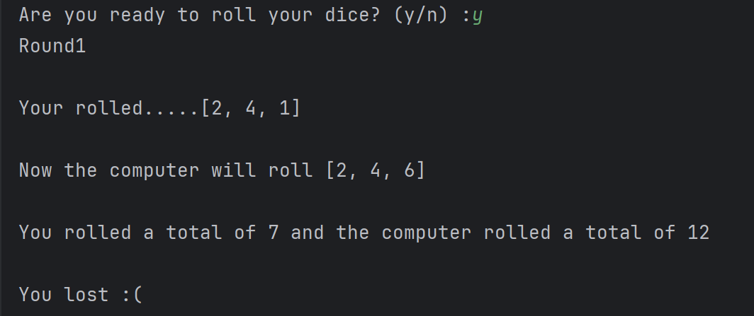
Result: Did the programme behave as expected ie syntactically and logically correct?
YES/NO (delete as appropriate)
If YES, comment on what happened.

The program ran through 5 times (5 rounds) and added the total number the dice produced, showing the winning totals. Although each round produced the same result so there is both a logical and syntax error, this is because the loop only randomises the “dice” list once. This could be corrected by placing the dice roll in a while loop at the beginning of the round.

Test:

User wins round

Screenshot(s) of output:
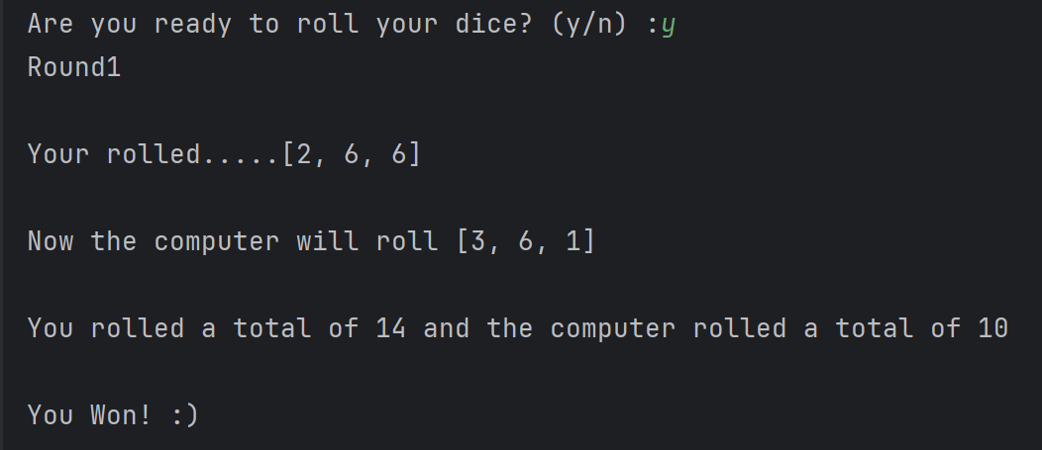
Result: Did the programme behave as expected ie syntactically and logically correct?
YES
If YES, comment on what happened.

The program produced random numbers for 3 dice, then totaalled the amounts to check who had the larger number. In this run, the user won the dice roll and the program gave the correct output.

Test:

Draw
Screenshot(s) of output:
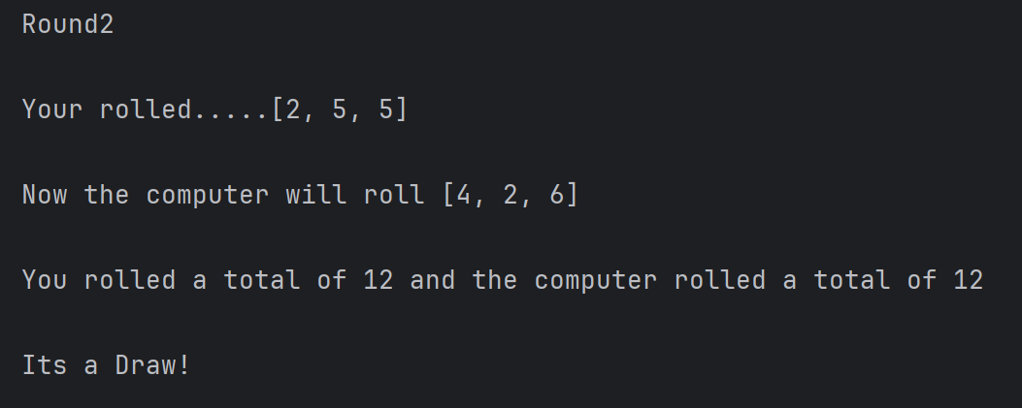
Result: Did the programme behave as expected ie syntactically and logically correct?
YES
If YES, comment on what happened.

The program identified when both the user and computer totalled the same score and produced an output identifying a draw.

Test:
“Go again” – enter y

Screenshot(s) of output:
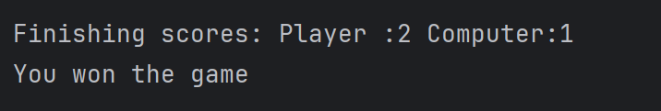
Result: Did the programme behave as expected ie syntactically and logically correct?
NO (delete as appropriate)
If NO, what went wrong and why? Suggest how things could be improved

The program did not offer to run again, it automatically runs through 5 rounds without user input after the initial “are you ready” check. This can be changed by using a while loop instead of using a for loop and allowing the user to decide whether they want to continue.

Test:
“Go again” – enter n

Screenshot(s) of output:
Result: Did the programme behave as expected ie syntactically and logically correct?
NO (delete as appropriate)
If NO, what went wrong and why? Suggest how things could be improved

The program did not offer to run again, after the first initial “are you ready” prompt it automatically ran through all five round without further user input and then exited the program. This could be resolved by using a while loop instead of a for loop and allowing the user to decided when to exit after each round.

Test:

“Go again” – enter Y

Screenshot(s) of output:
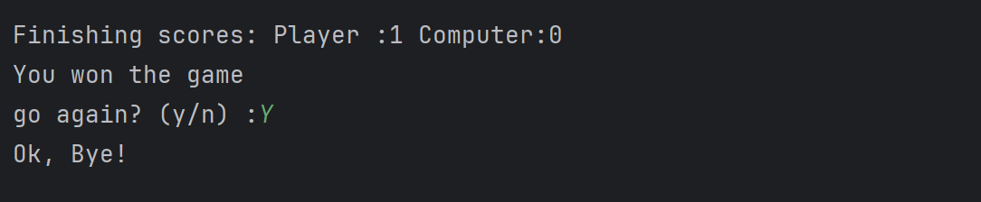
Result: Did the programme behave as expected ie syntactically and logically correct?
NO (delete as appropriate)
If NO, what went wrong and why? Suggest how things could be improved

The program identified the input “Y” as the same as “n”. this is because the program is not converting inputs into lowercase. This can be corrected by adding “ .lower() “

Test:
“Go again” – enter b

Screenshot(s) of output:
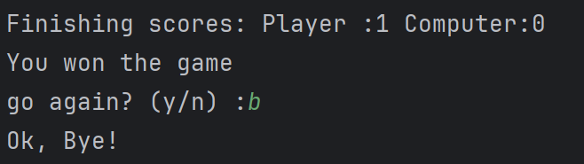
Result: Did the programme behave as expected ie syntactically and logically correct?
NO (delete as appropriate)
If NO, what went wrong and why? Suggest how things could be improved

The program did not recognise that “b” as an invalid input. It validated only “y” and classified any other inputs as “n”. this can be improved with a loops to validate and allow the user to re-enter a valid choice.

Test:

Show score/score tracking (depending on how you have implemented your program
Screenshot(s) of output:

Result: Did the programme behave as expected ie syntactically and logically correct?
YES
If YES, comment on what happened.

The program shows the total ending score for each round but does not display the total scores again when the user exits the loop.

Test:
Show an overall win (however this is achieved eg first to 5, best of 12 etc)

Screenshot(s) of output:

Result: Did the programme behave as expected ie syntactically and logically correct?
YES
If YES, comment on what happened.

The program tracked and displayed each players round wins.

Test:
Analyse your code and write a short paragraph commenting on the efficiency of the original code. Could efficiency be improved and if so comment on what is currently inefficient?
The original program lacked proper input validation, particularly for the ready variable. The user could enter any value and the program would only proceed if the input was exactly “y”, otherwise it would terminate. This reduced usability and made the program less robust. The main body of the program was placed inside a single IF statement and used FOR loop to run a fixed number of five rounds. This limited the user’s control over the game and all rounds were played automatically in one sequence rather than allowing the user to decide whether to continue after each round. This made the gameplay less interactive. The original code also contained repetitive output statements for displaying scores and results, which increased the length of the program and reduced readability.

In the improved version, a while loop combined with the “not in” operator is used to validate user input. This ensures only “y” and “n” are accepted and repeatedly prompts the user until a valid response is entered. This improves both reliability and user experience. The program structure has been redesigned to use a loop that continues rounds until the user chooses to stop. This is achieved by using a second while loop controlled by the “finished” variable. As a result the user now has full control over how many rounds they wish to play, making the game more interactive and engaging. The improved version also separates the game flow more clearly with distinct sections for input validation, gameplay and results. The final scores are displayed only once after the user exits the loop, reducing unnecessary repetition and improving overall code readability.

- Consider the results of the above tests and your analysis of program efficiency and revisit your original code in order to address any tests that failed and/or improve code efficiency.

(Note: you may not be able to solve all of the problems that were encountered, but solve as many as you can.)

Paste your full revised code here :

import random
dice1 = [random.randint(1,6), random.randint(1,6), random.randint(1,6)] #randomises dice numbers
dice2 = [random.randint(1,6), random.randint(1,6), random.randint(1,6)]
player = 0 #player score tracker
comp_score = 0 #computer tracker
count = 1 #round counter
ready = input("Are you ready to roll your dice? (y/n): ").lower() #user input to start game
while ready not in ("y", "n"): #input validation check
ready = input("Error, please enter y/n: ").lower()
else:
if ready == "n":
print("Ok, maybe another time") #Output if the user says No
elif ready == "y": #Dice Game starting point if user says Yes
finished = "y" #seperate to continue looping through the game until user wants to exit
while finished == "y":
print(f"Round {count}\n")
print(f"Your rolled.....{dice1}\n")
print(f"Now the computer will roll {dice2}\n")
total_D1 = sum(dice1)
total_D2 = sum(dice2)
print(f"You rolled a total of {total_D1} and the computer rolled a total of {total_D2}\n")
dice1 = [random.randint(1, 6), random.randint(1, 6), random.randint(1, 6)]
dice2 = [random.randint(1, 6), random.randint(1, 6), random.randint(1, 6)]
#Result output
if total_D1 > total_D2:
print("You Won! :)\n")
player = player + 1
elif total_D1 == total_D2:
print("Its a Draw!\n")
else:
print("You lost :(\n")
comp_score = comp_score + 1
count = count + 1
finished = input("Go again? (y/n): ").lower()
else:
# Overall winner showings and final score
print(f"Here are the Final Scores: Player {player} Computer {comp_score}\n")
if player > comp_score:
print(f"You won the most rounds")
elif player == comp_score:
print("Its a draw, Boring!")
elif player < comp_score:
print("The Computer Won the most rounds!")
else:
print("Ok, maybe another time")

