
MSc Computing Portfolio

Cloud Engineering Principles and Practice
Module Code: ACCA7027

Student Name: Tassavar Ahemad Kureshi
Student ID: 2530068
Lecturer: Renuga Jayakumar
Submission Date: 28th April 2026

Table of Contents
1. Introduction
2. Cloud Technology: Docker and Containerisation
2.1 Principles of Virtualisation
2.2 Principles and Benefits of Containerisation
2.3 Dockerfile: Building a Docker Image
2.4 Images and Publishing to DockerHub
2.5 Docker Volumes
2.6 Docker Networking
2.7 End-to-End Demonstration Summary
3. Cloud Computing Concepts
3.1 Load Balancing, Scalability and Application Gateways
3.2 Why Load Balancing and Scaling are Complementary
3.3 Benefits of Combining All Three
4. Driving Forces and Serverless Computing
4.1 Main Driving Forces for Cloud Expansion
4.2 Serverless Functions Explained
4.3 Serverless vs Containerisation: Critical Comparison
5. Conclusion
6. References

1. Introduction

Cloud computing has significantly impacted on how systems can be built, delivered and scaled by companies. Containerisation through Docker has become the de facto method of deployment over virtual machines, providing portability, better resource utilization and deployment time. The report goes on to investigate the aspects of containerisation using Docker through hands-on deployment of a web application by the name of TaskCloud; showing how a Dockerfile can be created, an image published, volumes persisted, and how a network can be set up - these are all then tested on a Docker Desktop v29.2.1 on a Windows 11 environment, publishing the image to the Dockerhub under 2530068/taskcloud-app:v1.0. The report then evaluates the three fundamental concepts of cloud computing; Load Balancing, Scalability and Application Gateways before critically assessing Serverless computing versus containerisation as a reaction to the trends driving cloud adoption. All tests were performed and verified in a live environment before submission.

Arguably, the most significant cloud implication of virtualisation is shared tenancy. Organizations share a single physical server to host their virtual machines, where each machine thinks that it has dedicated hardware when in fact it shares the physical hardware of that server with potentially several other organizations' virtual machines. Each of Amazon EC2, Microsoft Azure VMs and Google Compute Engine operate using shared tenancy. The economic benefit of shared tenancy has helped democratise the cloud: the startup can access enterprise level computing for $0.02 per hour compared with spending thousands of pounds for dedicated server [2]. Virtualisation decreased infrastructure provisioning time from weeks to minutes-the original key value proposition for cloud services. The other great value of virtualisation is the support of live migration for Type 1 hypervisors, which allows running virtual machines to be moved to another physical server without any down-time. This allows cloud providers to carry out hardware maintenance without customers noticing it.

2. Cloud Technology: Docker and Containerisation

2.1 Principles of Virtualisation
Virtualization means moving a hardware platform into software form. A single machine (host) running multiple isolated computational instances on that platform [1]. Abstracting the applications from hardware enables greater resource usage efficiency, increased operational efficiency. This is the primary concept for all contemporary cloud platforms.
There are two forms of hypervisor which embody virtualisation technologies. Type 1 (bare metal) hypervisors (e.g. VMware ESXi and Microsoft Hyper-V) are run directly on the host hardware without a host OS. This offers lower latency and better multi-tenant security as the OS is not interacting directly with the hardware in a virtualised manner and therefore Type 1 is ubiquitous throughout the enterprise [2]. Type 2 hypervisors (e.g. Oracle Virtual Box) are run as part of a guest OS and present extra latency as hardware requests must traverse two OS layers but provide increased developer efficiency for testing locally.
A VM encompasses an entire guests OS, a virtualized CPU, a chunk of memory, and storage. This does provide effective separation between each OS and the resources in use, but there is a significant overhead associated with running a complete OS. A common Linux VM might require 1-2 GB of RAM and take from 30 seconds up to minutes to start up [1]. This overhead makes this kind of approach strategically untenable from a cloud native viewpoint where speed and density are critical and is something that containerisation addresses head on as shown below in figure 1.
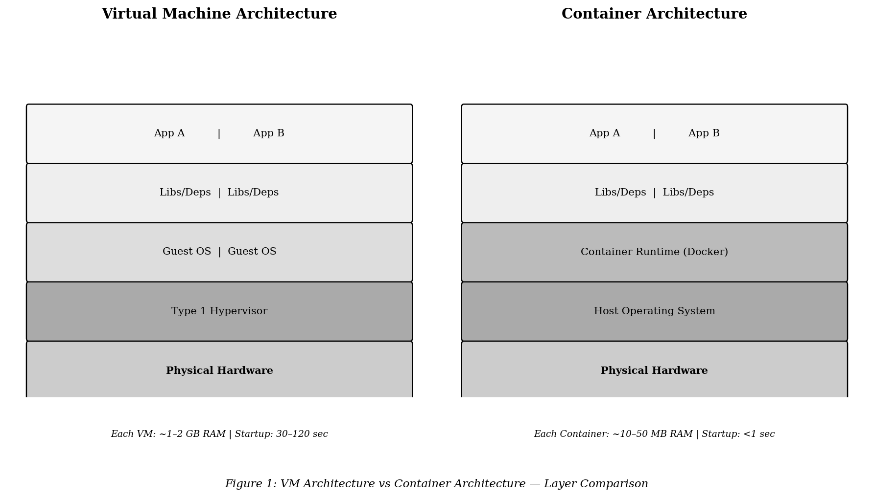
Figure 1: VM Architecture versus Container Architecture — Layer and Resource Comparison

2.2 Principles and Benefits of Containerisation
Containerization bundles a process along with all the necessary runtime libraries, executables, and configuration information it requires, into a portable unit that can be run on any machine that has a container runtime [3]. Unlike virtual machines, containers do not emulate entire operating systems. They use the same Linux kernel on the host, and use features such as Linux namespaces (for isolating processes from one another) and c groups (for controlling the amount of resources a container uses) [2]. Docker is composed of four components; a Docker Engine (the core runtime), a background service called the Docker Daemon (docker) which handles images, containers, volumes and networks, the Docker CLI (command line interface for the daemon), and a Docker Hub which is a cloud service with over 100,000 images stored within it [3]. The operational advantages are immense; Portability means that an application behaves exactly the same in the production environment as it did in the development environment (and that a development server does not need to be exactly the same as a production server); Isolation of processes stops a single application from accessing another application's data; Resource efficiency means that thousands of applications can be running on a single server where only a few dozen VMs would normally fit (typically only 10-50MB per container compared to 1-2GB per VM [2]). Launch times are in milliseconds rather than minutes, which leads to much faster development and recovery from faults. Netflix uses Docker to deploy their 1000+ micro services several times a day, and Spotify have been able to provide a consistent development environment across hundreds of engineers using Docker [4]. Docker is made even more useful on an enterprise scale by an orchestration engine. Kubernetes was originally developed inside of Google, and it can automate the deployment and management of large numbers of containers across thousands of nodes. It works by means of declaring the desired state of an application (e.g., "ensure there are always 5 instances of the taskcloud-app process running"), Kubernetes is continually reconciling the current state with the desired state, automatically replacing failed containers, load balancing across running healthy instances, etc. [3] This coupling of Docker-packaging and Kubernetes-orchestration is the current de facto cloud-native architecture and is available in managed form through AWS EKS, Azure AKS and Google GKE. The impact is that engineering teams can deploy applications robustly, and to a scale that could only be achieved through years of manual effort on traditional servers.

2.3 Dockerfile: Building a Docker Image
A Dockerfile is a plain text file of instructions executed in sequence for building a Docker image [3]. Each command results in an unchangeable read-only layer, and if layers remain unchanged after a rebuild, they will be cached and a subsequent build can be sped up by using the cached layers. The project itself, TaskCloud, consists of an index.html and a Dockerfile, which was created in VS Code.
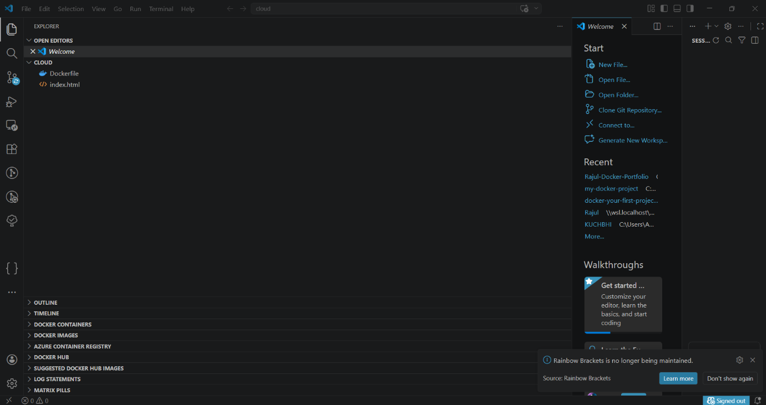
Figure 2: VS Code — TaskCloud project structure

The complete Dockerfile is:
FROM nginx:alpine
COPY index.html /usr/share/nginx/html/index.html
EXPOSE 80
CMD ["nginx", "-g", "daemon off;"]
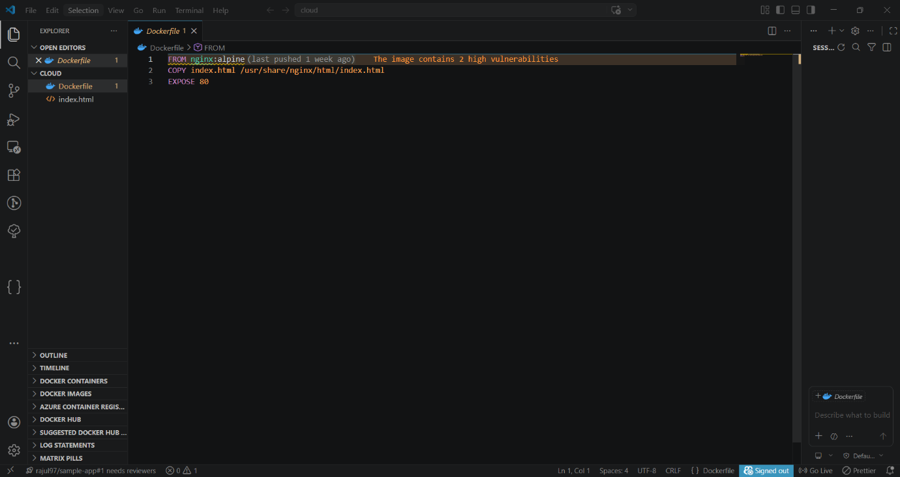
Figure 3: TaskCloud Dockerfile
FROM nginx:alpine chooses the official Nginx web server running on Alpine Linux (which is about 7MB, while other alternatives built on Ubuntu are over 130MB), which both reduces the size of the image and limits the attack surface. COPY places the HTML file into the Nginx web root. EXPOSE 80 informs orchestration platforms like Kubernetes which port the application uses. CMD starts Nginx in foreground mode, whereas if it were run as a daemon, the container would exit immediately as soon as the process was running [3]. A highly valuable advanced practice in Dockerfiles to be aware of is that of multi-stage builds, which were implemented in Docker 17.05. Multi-stage builds essentially allow a single Dockerfile to specify multiple FROM instructions each designating a separate build stage. The most common scenario is the use of an extremely heavy build environment (e.g. Node:18) tocompile the application's code and to install application dependencies within the build stage, which copies only the compiled build artifacts into a small, final production environment (e.g. Nginx:alpine). This practice strips away all compilers, build tools, and development packages from the production image, leading to dramatically smaller image sizes and attack surfaces [3]. In the case of the TaskCloud application, the single-stage build is appropriate due to the simple nature of serving a static HTML file; however, for JavaScript applications deployed in production, this pattern frequently reduces image sizes from 1.2 GB to less than 100 MB, impacting not only deploy times, registry costs and pull times during scaling events, but also requiring quick image pulls to create new instances.
The image was built using:
docker build -t taskcloud-app .
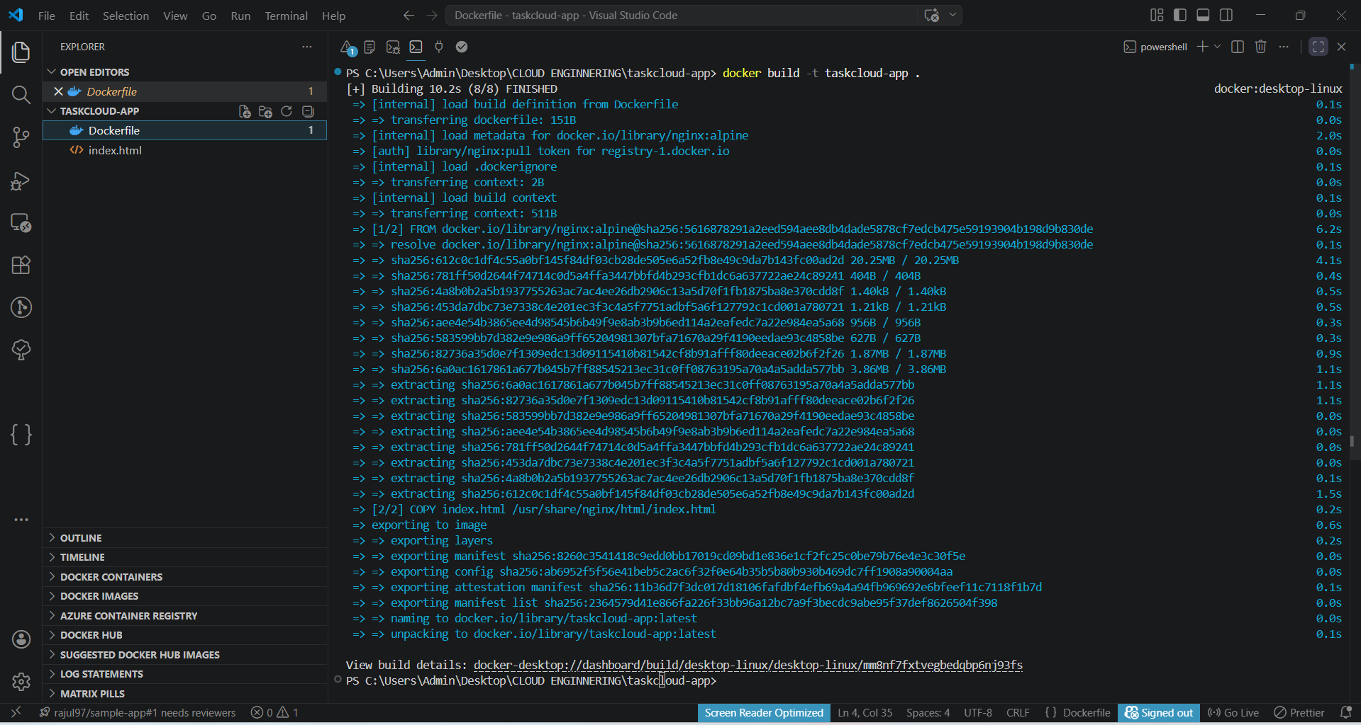
Figure 4: docker build output confirming successful image creation

The container was launched with:
docker run -d -p 8080:80 --name taskcloud-web taskcloud-app
The -p 8080:80 flag maps host port 8080 to container port 80, enabling browser access at http://localhost:8080.
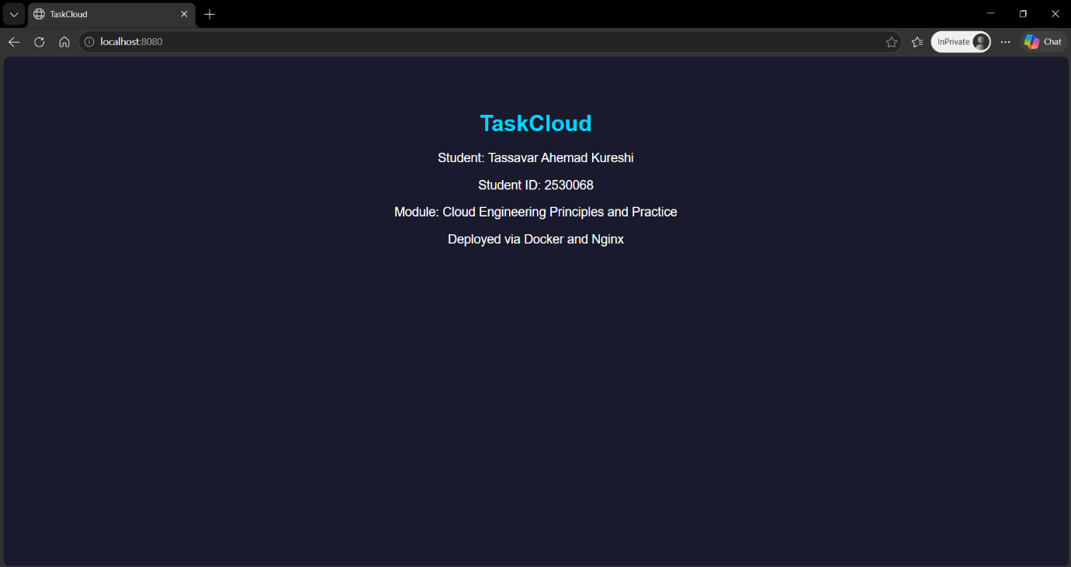
Figure 5: TaskCloud application running in browser at localhost:8080

2.4 Images and Publishing to DockerHub
A Docker image is a read-only layered filesystem using a union file system with copy-on-write semantics [4]. Unchanged layers are reused from cache rather than rebuilt, significantly accelerating CI/CD pipelines. The docker images command confirmed taskcloud-app:latest with image ID 2364579d41e8 and size 92.6 MB.
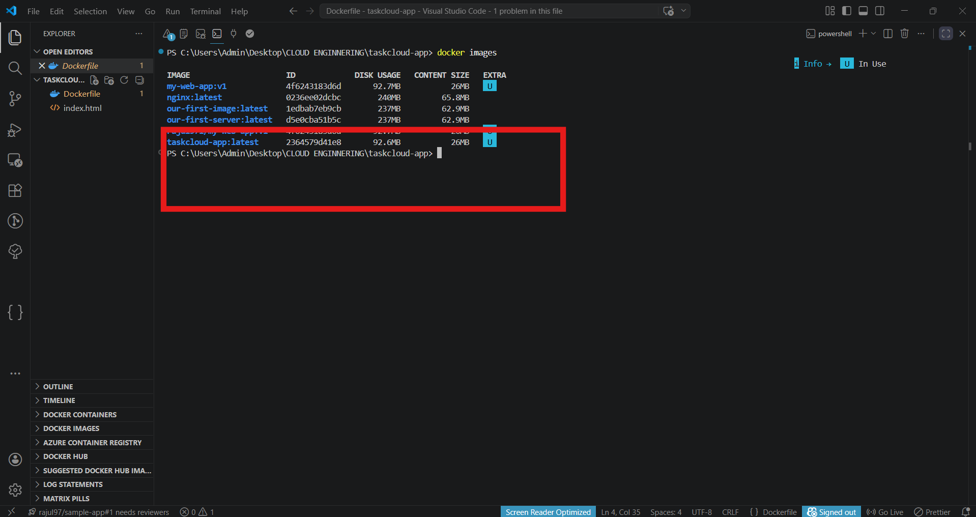
Figure 6: docker images listing confirming taskcloud-app:latest

DockerHub- Docker's official cloud registry; a place to store version and share container images with teams around the world. The TaskCloud image was pushed to:
docker login
docker tag taskcloud-app 2530068/taskcloud-app:v1.0
docker push 2530068/taskcloud-app:v1.0
The terminal confirmed Login Succeeded for username 2530068, followed by successful push of all 10 layers to docker.io/2530068/taskcloud-app with digest sha256:2364579d41e8.
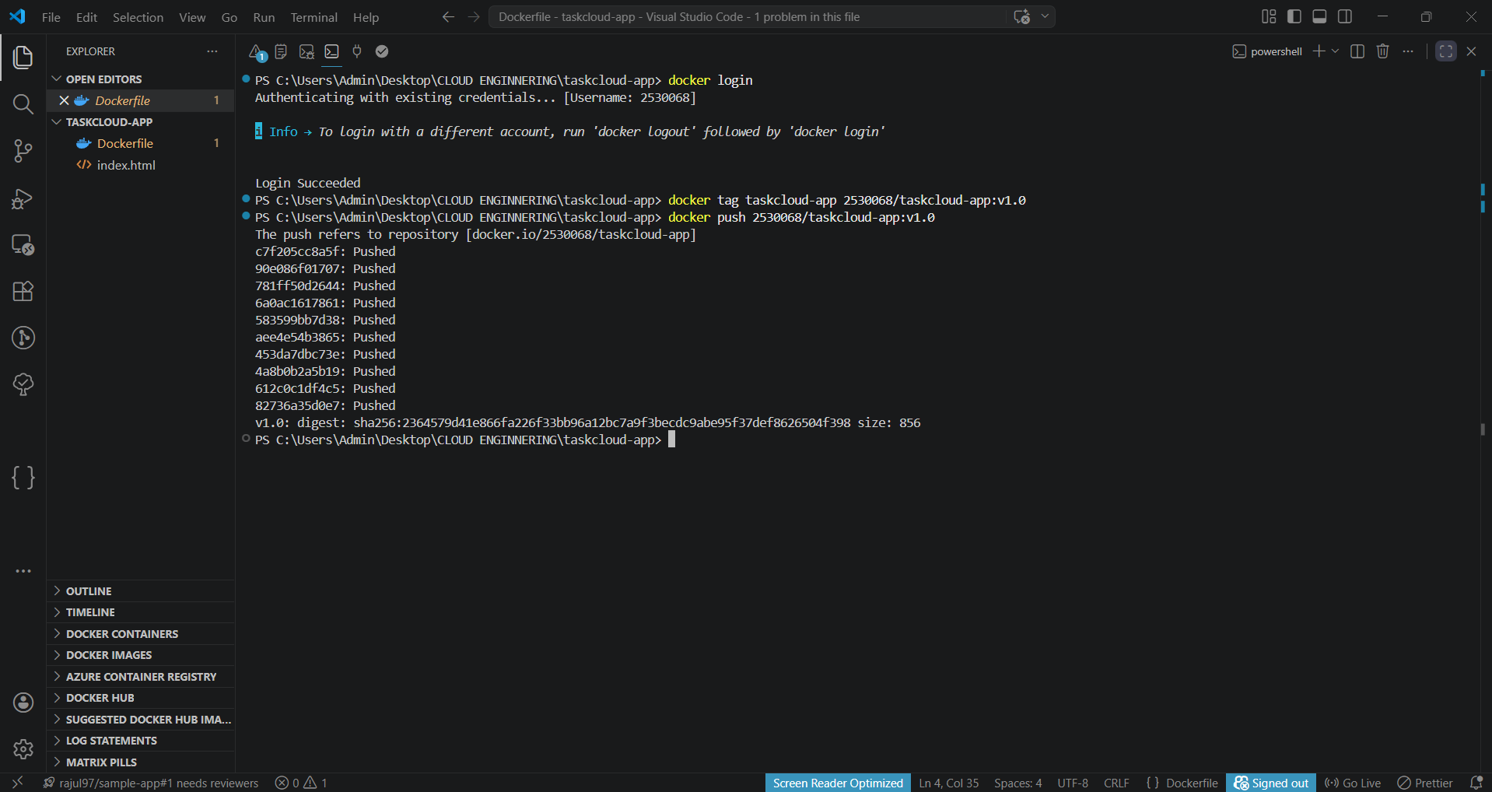
Figure 7: docker push output confirming successful upload to DockerHub
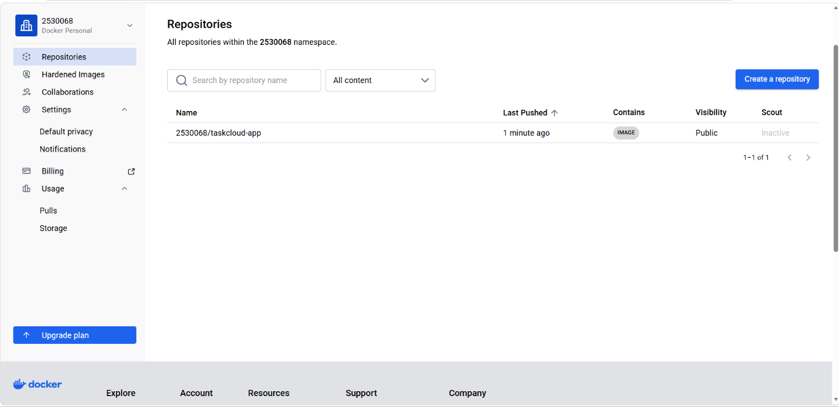
Figure 8: DockerHub repository page confirming 2530068/taskcloud-app is publicly accessible

Using the v1.0 semantic version tag has benefits in terms of controlled deployment rollbacks – fetching an old tag instantly reverts the application to the previous state without any code changes [4]. Organizations that need better control on security and compliance requirements also use other solutions for the private container registries besides DockerHub, these private container registries usually run within their own infrastructure or cloud. AWS ECR, Azure ACR, and Google Artifact Registry all provides managed private registries with features like vulnerability scanning, role based access control, geographically replicating the containers. Private container registries are tightly integrated with respective cloud's container orchestration Services such as an AWS ECS task will retrieve image from ECR without having to manually configure an access configuration, since an IAM role can be used [4]. A second important feature would be the image vulnerability scanning; which is part of the DockerHub premium subscription as well as the private registry services. The analysis of the image layers against a CVE database is performed automatically before the deployment to production, creating a security gate: "It will automatically scans each layer of the images you push against common vulnerabilities and exposures (CVE) databases and will report the security vulnerabilities on these images prior to deployment in the production environments."

2.5 Docker Volumes
However, containers are ephemeral – anything that is written in a container will be lost forever as soon as the container stops or gets deleted [5]. Docker volumes give persistence, i.e. They exist irrespective of a container’s life cycle. This becomes even more impactful with containers when we discuss orchestration tools. Kubernetes (initially built at Google internally) makes it possible to automatically schedule, distribute load and manage the health of thousands of containerized application instances spread across potentially many thousand nodes. The process itself is what is called declarative; you simply declare how the desired state should look like (i.e., 'let me have five copies of taskcloud-app run for me’) and Kubernetes keeps watching how the actual system looks like, ensuring that if a taskcloud-app instance dies, it is automatically restarted and in case of a sudden burst of traffic, it will scale up (increase the number of taskcloud-app instances to say, eight in this example). The combination of packaging applications using containers and orchestrating them using Kubernetes constitutes the industry standard architecture for cloud-native applications, readily available as a managed service on AWS (EKS), Azure (AKS), or GCP (GKE). The bottom line is that Engineering teams can deliver their applications at scales that took them years of manual engineering effort to scale manually using a traditional server setup. A named volume was created and verified:
docker volume create taskcloud-data
docker volume ls
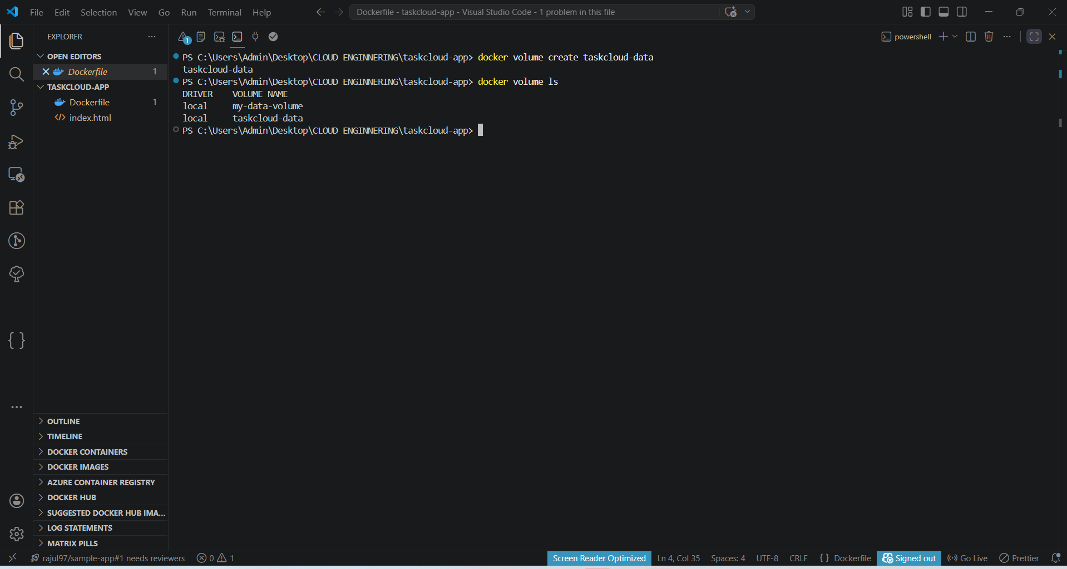
Figure 9: docker volume ls confirming taskcloud-data

The volume is mounted into a container using:
docker run -d -p 8080:80 -v taskcloud-data:/usr/share/nginx/html taskcloud-app
The main difference between named volumes and bind mounts is that named volumes are entirely managed by Docker, they are located at /var/lib/docker/volumes/, are independent of the host environment and portable, whereas bind mounts need their paths to be absolute and exist in the host with the exact same relative paths. One production usage is to keep the MySQL data using a named volume mounted to /var/lib/mysql, so the records persist even after the new container images get released and are redeployed.5

2.6 Docker Networking
The Docker's networking allows for constrained communication between containers and other components, with 4 types of driver available [6]. The bridge (the default) creates an isolated virtual network automatically mapping the container's name in the connected containers. The host shares network stack of host machine without the isolation between container and host. The overlay provides network for multi-host, e.g., on Docker Swarm cluster. None disables the network. A custom bridge network was created:
docker network create taskcloud-net
docker network ls
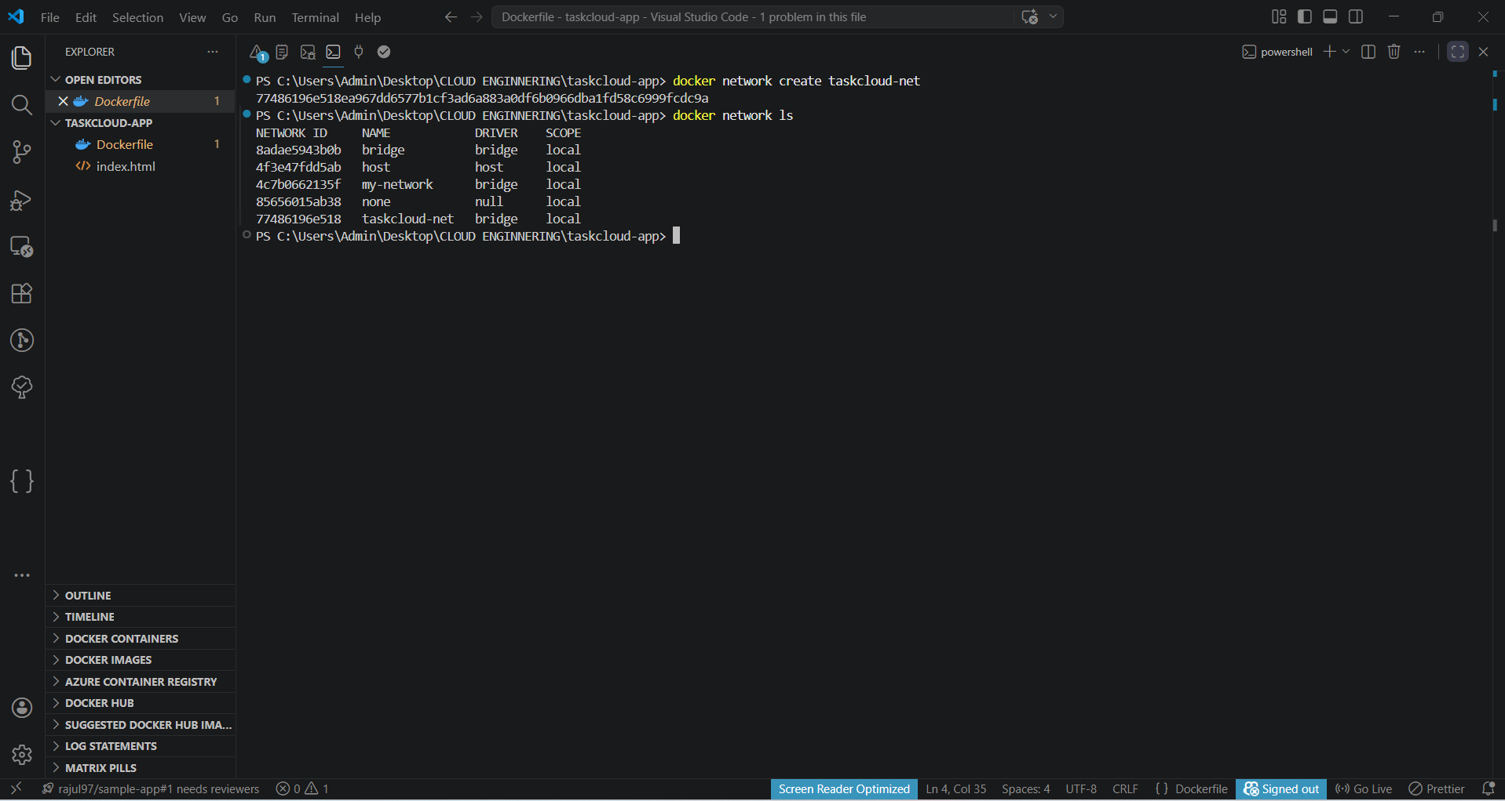
Figure 10: docker network ls confirming taskcloud-net bridge network

Containers attach to this network at runtime:
docker run -d --name web --network taskcloud-net taskcloud-app
docker run -d --name db --network taskcloud-net mysql:8.0
With custom bridge networks DNS resolution becomes automatic. The web container can reference the db container simply by "db" rather than by its IP address which would otherwise change after each container restart [6]. Custom networks also add segmentation, as only containers connected to taskcloud-net can talk on this network so limiting attack surface for lateral movement, rather than on the default bridge. Docker’s native DNS on custom bridge networks is a very powerful capability when running multi container architectures. A web application container communicating with a database container will just be able to reference the database container by "db", rather than having to care about any changing IP address that the container may have assigned on container restart [6]. With overlay networks this DNS capability extends across multiple docker hosts in a swarms cluster, one container running on host A and another running on host B are able to communicate using the container name, as if they are in the same host, allowing very geographically diverse micro service architectures to exist. So micro services running in different datacenters or in different cloud provider regions will be able to talk using encrypted tunnel traffic, without needing a vpn setup.

2.7 End-to-End Demonstration Summary
This is a total picture of the TaskCloud workflow as described by Figure 11 above. Figure 11 shows the entire lifecycle of Docker from code-to-registry.
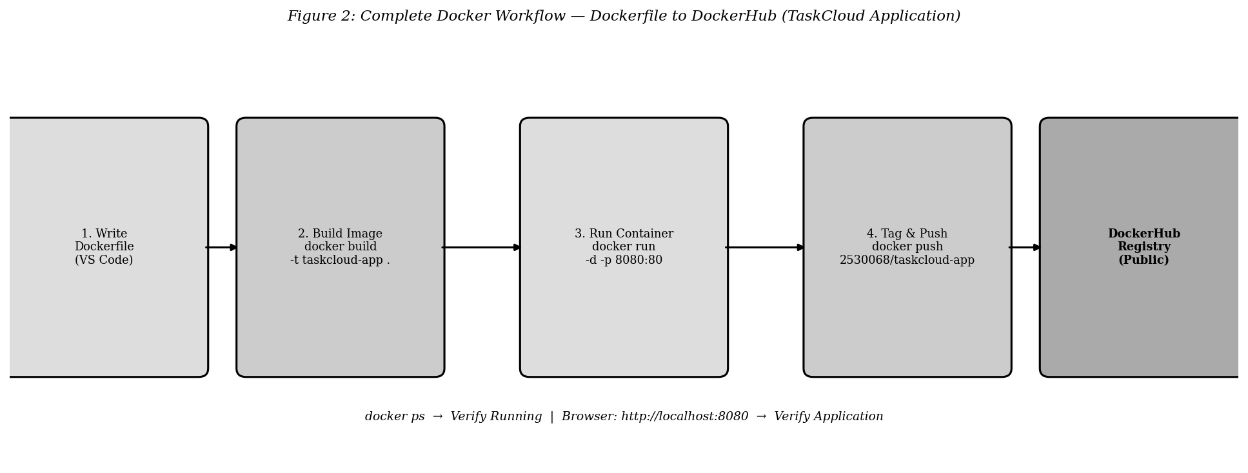
Figure 11: Complete Docker Workflow — Dockerfile to DockerHub (TaskCloud Application)

The docker ps command confirmed container 4bb7c93928e6 running on port 0.0.0.0:8080->80/tcp.
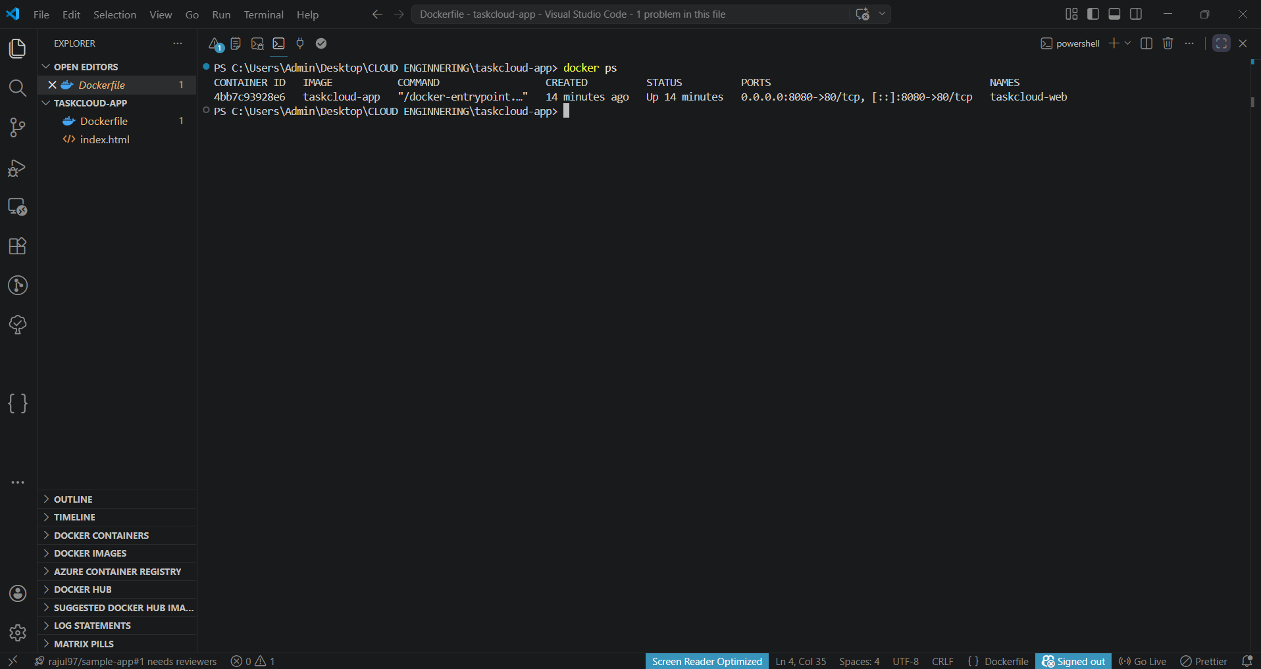
Figure 12: docker ps confirming taskcloud-web container active
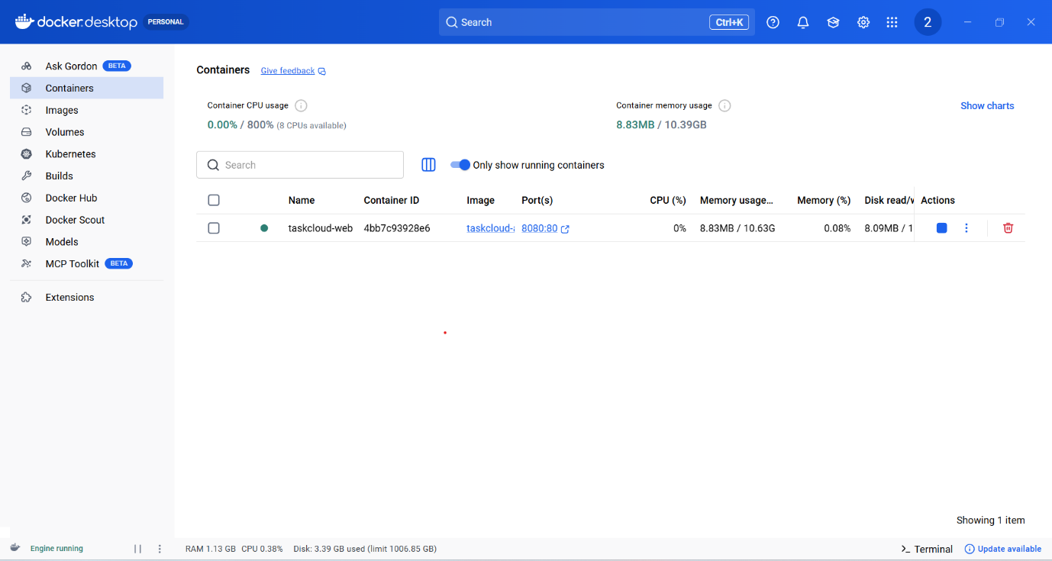
Figure 13: Docker Desktop confirming 8.83 MB memory footprint
Docker Desktop verified resource consumption as 8.83MB RAM of 10.63 GB, showing the resource efficiency benefits in comparison to a VM equivalent of 1-2 GB. The named volume, taskcloud-data, and custom bridge network taskcloud-net were created, the final image then pushed to DockerHub as 2530068/taskcloud-app:v1.0.
VIDEO DEMONSTRATION: https://youtube.com/@tjkureshi_?si=xd8SlGYRF0vgArEi

3. Cloud Computing Concepts

3.1 Load Balancing, Scalability and Application Gateways
Here are a few examples to illustrate the above, we take the case of a global e-commerce platform which processes five million transactions a day and has massive spike during sale events.

Load Balancing. Load balancing distributes traffic across a set of backend instances, allowing it to bypass potential bottlenecks and ensuring it avoids single points of failure [7]. In cases where an instance becomes unavailable, load balancers will automatically distribute traffic to a new set of available instances. In Microsoft Azure, Azure Load Balancer exists at layer 4 of the OSI model (operating on TCP/UDP traffic on a per source IP/port basis), and Azure Application Gateway exists at layer 7 (operating on HTTP/S traffic based on URL paths and Host names) [7]. At Layer 7 AWS's Application Load Balancer (ALB) offers path-based routing (/api/ to API servers, /static/ to CDN pools), WebSocket and HTTP/2, and their Layer 4 Network Load Balancer (NLB) handles sub millisecond latency and millions of requests per second and the outdated Classic Load Balancer is not available to new deployments. Distribution algorithms available at the above mentioned load balancing services can include round robin, least connections and IP hash which allows sticky sessions by distributing requests to the same server based on the clients IP address. Health checking is another one of the fundamental parts of load balancing that is commonly underestimated and is the basis for system resilience [7]. Both Azure Load Balancer and AWS Application Load Balancer send requests to the instances registered to them using periodic health checks which typically involve an HTTP GET request sent to a specially provided health endpoint (such as /health), and the instance will be removed from the set of servers distributing load. Health checking interval, timeout and the number of required failures need to be configured with great care; if the health check interval, timeout and the number of required failures is set to values that are too stringent healthy but temporarily slow servers will be prematurely removed during garbage collection pauses and startup initialisation. Conversely, if they are set too loosely to lenient, already degraded servers will continue to receive live traffic, decreasing user experience. Best practice for production web applications commonly suggests health checking interval of 30 seconds, timeout of 5 seconds and number of failed health checks before an instance is considered down of two Scalability. Scalability is the capacity of a system to maintain performance by dynamically adjusting resources in response to demand [8]. Vertical scaling increases resources on a single instance — limited by maximum hardware specifications and requiring downtime. Horizontal scaling adds additional instances — preferred in cloud environments for its linear cost model, fault tolerance, and theoretically unlimited capacity. Azure Virtual Machine Scale Sets (VMSS) implement metric-driven autoscaling: adding three instances when average CPU exceeds 70% for five consecutive minutes, removing one when CPU falls below 25% for fifteen minutes, with minimum of three and maximum of 100 instances enforced. AWS Auto Scaling Groups provide equivalent functionality with CloudWatch metric triggers [8]. Critical operational consideration: aggressive scale-in thresholds cause premature instance termination followed immediately by scale-out events — termed instance flapping — mitigated through configured cooldown periods.

Application Gateways. The application gateway is an L7 load balancer and allows greater control over HTTP traffic [9]. As well as URL path-based routing (e.g. /api/ will route to API servers, /static/ will route to CDN pools), the Azure application gateway provides the ability to handle SSL/TLS at the edge thus relieving some of the crypto computation overhead from backend servers (saving up to 20-30% CPU usage on each); includes a WAF (Web Application Firewall) that is able to filter against OWASP Core Rule Set to block SQL injection attacks, cross site scripting and protocol violations before the requests are routed to application code; and session affinity routing to ensure that identical requests originating from the same browser are routed to the same instance [9]. The AWS ALB offers similar facilities along with gRPC routing and can route directly to lambda functions.

3.2 Why Load Balancing and Scaling are Complementary

The load balancer and the auto-scaling component are so dependent on each other, that one alone is of little value [7]. A load balancer may spread the traffic across existing resources, but will fail once the available pool of resources can no longer handle the volume and the number of resources can not be automatically increased. Conversely, auto-scaling can scale up resources in response to traffic load but the new resources cannot be routed any requests as the load balancer cannot automatically register them to start load balancing them.

In a case like a flash sale in which traffic spikes tenfold in two minutes auto-scaling will detect CPU threshold increases and will create 20 new instances within approximately 3 minutes, and concurrently the load balancer will discover that they are healthy through its health check mechanism, and begin sending appropriate traffic to them. When a system is load balanced and scaled it is able to absorb a tenfold traffic increase while remaining at response times of less than 300ms, something not possible when a load balancer and auto-scaling components are not coupled [8]. In the absence of scaling the load balancer is only distributing traffic across the fixed pool of resources, which gets quickly overloaded. In the absence of a load balancer the scaled resources don't actually get any traffic routed to them.

This dependency on operational state is also extended during a scale-in event (i.e. Reducing the number of instances when demand is reduced). This is where connection draining plays a key role [8]. When the auto-scaling rules decide to terminate a specific instance it must not be terminated immediately, if this were to occur any request that has just been dispatched to that particular instance would error out, as the connection is abruptly terminated and that request fails. The connection drain mechanism is configurable on both Azure and AWS load balancers and essentially means that the load balancer stops sending new requests to the instance marked for deletion and allows any in-flight requests to finish up to a configured time limit (usually 300 seconds). It's not until all of the connections are closed or the time limit has passed that the instance will terminate. This graceful scale-in means the transition out is invisible to users.

3.3 Benefits of Combining All Three
The combination of Application Gateway, load balancing and auto-scaling produces a resilient, intelligent, cost effective and high-performing system unobtainable by a single technology. Example: A live video streaming service broadcasting to 10M simultaneous users for the Super Bowl. The Application Gateway is responsible for all incoming https traffic; terminating SSL at the edge remove cryptographic overhead on backend servers; real-time blocking of credential-stuffing attacks using WAF rules; routing any /stream request to a dedicated high-bandwidth video server or a /account request to a user management server. Least-connections balancing directs the 10M concurrent requests to the server pool efficiently, avoiding any bottleneck; The auto-scaling component continuously monitors simultaneous connections; When the number of simultaneous connections exceeds 8M, 30 more virtual machines are spun up within 4 minutes to maintain 99.99% service availability and 200ms stream initialisation times; Once event traffic reduces, any surplus capacity is terminated to reflect true operational costs rather than being over-provisioned [9].

4. Driving Forces and Serverless Computing

4.1 Main Driving Forces for Cloud Expansion
The growth in cloud computing is a structural change in enterprise technology driven by economic, operational and technology forces acting in tandem [10]. Cost savings are the most obvious benefit of the shift, enabling organisations to move from capital expenditure on purchasing, maintaining and depreciating physical servers to operational expenditure through pay-as-you-use infrastructure services. Organisations no longer need to wait for long lead times to procure hardware, they have no need to bear the cost of idling resources during times of low demand and access to enterprise grade infrastructure is available regardless of company size at consumption-based prices. Worldwide public cloud services are estimated to have consumed $591 billion in 2023 with a forecast growth of $679 billion for 2024 [10]. Flexibility and scalability is a second driver; infrastructure capacity can be scaled up and down in minutes, whereas physical hardware can take weeks to order and implement. Extending services globally can be achieved by adding cloud infrastructure in faraway data centres whereas previously, this was a years-long endeavor. Increased speed of digital transformation has occurred from 2020 due to the requirements of remote working leading to increased workload migration within compressed timeframes. This has cemented cloud platforms as a mechanism for business continuity, not simply as a way to reduce IT expenses [11]. The rise of the internet of things means large bursts of data are generated from billions of devices that can be accommodated in the elastic scalability offered by cloud infrastructure. DevOps practices and continuous integration and delivery have increased release frequency to many times per day compared to a previous quarterly cycle. Time to market has been reduced through a smaller change size and consequently risk for each release [11]. Increasingly, security and compliance requirements are driving adoption [10]. Major cloud providers have accreditations in a range of industries that align with their offerings including PCI DSS (payment card data), HIPAA (healthcare data), ISO 27001 (information security management) and SOC 2 Type II (service organisation controls) compliance which it would be difficult and extremely expensive for most smaller organisations to attain alone. To achieve enterprise level compliance requires constant auditing, security personnel, extensive physical security and IT department resources to manage on-premises servers effectively. With the shared responsibility model, the cloud provider takes responsibility for security of the infrastructure itself; hence, organizations gain access to certified infrastructure at a reduced cost compared to running its own servers. As the benefits of utilizing services from multiple cloud providers, so called multi-cloud adoption, become evident. Many enterprises are now utilizing services from a number of different cloud providers, often spreading workloads to avoid vendor lock in, gain better pricing or enhance redundancy [11].

4.2 Serverless Functions Explained
Function as a Service (FaaS) is the formal term for serverless computing. Serverless is a cloud computation model that allows execution of events without the need to provision, manage, and scale servers; the infrastructure provisioning, capacity planning, and patching are entirely the provider's responsibility [12]. Developers simply provide code in the form of small, individual functions- essentially atomic units of business logic- which execute in response to a triggered event without need to set up a server or environment. The term 'serverless' is technically a misnomer as servers are provisioned, but by the provider, and fully abstracted from the user.

AWS Lambda is currently the market leader of FaaS. It provisions functions on an ad hoc basis and execute them in stateless, event driven environments which may be triggered by many kinds of events, for example an HTTP request via the API Gateway, the upload of a file into S3, or a DynamoDB Stream event. Each function call incurred a cost of a number of invocations and GB seconds of execution. At present Lambda provides an entire million monthly calls for free, alongside a whopping 400,000 GB seconds, so is more than economical for event-driven processing at any volume other than extremely large batch operations or heavy user-facing requests. Azure functions offer similar capability with its 'declarative bindings' approach. A simple Blob Storage trigger for Azure functions with CosmosDB output requires no code to link storage services to functions, which streamlines complexity. The execution model also poses problems for stateful tasks and long running processes. Each Lambda function can only run for up to 15 minutes, therefore any longer execution must be chained with other function calls using AWS Step Functions. AWS step functions are serverless orchestration service that controls several Lambda invocations through a state machine. [12] equivalent function orchestration is provided with Durable Functions by Azure Functions. This limitation isn't a problem for typical event-driven requests such as image resizing, data validation or API requests, most requests complete in milliseconds or seconds but serverless is not suitable as a replacement for large batch processing tasks or the construction of data processing pipelines or long lived web socket connections. Understanding this limit to function execution is critical when deciding when a serverless approach is truly the most operational option or when a containerised or VM-based solution will be the correct one.

An obvious issue with this type of model is cold start latency; the time delay between the initial invocation of an unused Lambda function to the function itself running. The latency is dictated by the runtime, amount of code and is in the order of 100 milliseconds to just over a second [12]. The execution delay of a cold start cannot be tolerated by synchronous user-facing APIs; AWS offers provisioned concurrency which makes a minimum number of function instances available at all times for an increased cost in order to reduce latency to sub-10ms.

4.3 Serverless vs Containerisation: Critical Comparison
Serverless and containers are often presented as competing models, but a careful examination of these models show that they are indeed complementary with each being suitable for different workloads [13]. The biggest differences are in the deployment model; containers are always active processes that keep themselves warm to enable sub-millisecond response latency whereas serverless functions will not be active unless triggered and immediately go dormant when not called unless using provisioned concurrency. Scalability differs as serverless will scale to thousands of parallel invocations and back from zero without user configuration within milliseconds, but with containers this requires autoscaling configuration which introduces provisioning latency as the new instances must pass health checks. State is managed differently; containers can store in-memory state that remains available for the next request whereas serverless functions are intrinsically stateless requiring persistent state to be managed elsewhere (e.g. DynamoDB or Redis) which introduces extra latency [13]. Vendor lock-in is a major strategic difference as container images can be migrated to different clouds with minimal or no code changes (Docker containers adhere to the OCI specification). Serverless functions are intrinsically bound to provider specific trigger types, runtimes and other service integrations making them much harder to migrate between clouds. The cost model also differs; serverless scales very cost-effectively with variable workloads whereas containers are generally more economical with higher consistent traffic loads. Driver alignment: serverless is better aligned to both cost efficiency (zero infrastructure during idle periods) and speed to market (no infrastructure to provision/manage). Containers are better aligned to portability, control, compliance and performance where extreme fine-grained control of execution environment is necessary and a sub-millisecond response latency required (unachievable with serverless where cold starts occur). We see convergence through technologies like AWS Fargate and Azure Container Instances, which aim to bring the benefits of serverless to containers [13]. Experience & complexity also differ greatly. For containers developers are responsible for a Dockerfile, building the image, storing it, and then deploying it via configurations etc.; it is non-trivial, but offers complete control. For serverless, the developer simply writes their code and deploys; there is no infrastructure to manage. This allows serverless to be good for simple, low bandwidth, rapidly deployed components, such as webhook event handlers or small engineering teams, though increases in complexity mean that containers become a more viable option. Local testing can be very difficult with serverless as event triggers are external to the environment whereas containers are identical on your local machine to production.

5. Conclusion
This report has proven that Docker containerisation provides a reproducible, portable and efficient foundation for deployment which has come to define a de-facto standard for cloud-native delivery. The actual TaskCloud example of creating Dockerfiles, building and completing image builds at 10.2 seconds, deploying and running at 8.83 Mb RAM and using persistence of volumes, user-defined bridge networking and finally publishing to DockerHub as 2530068/taskcloud-app:v1.0 is a physical illustration of the removal of environmental differences with container reduction in infrastructure requirements as much as is possible with Virtual Machines.
Load Balancing and Auto-scaling are complementary techniques where the capacity and distribution aspect are architecturally intrinsically linked, and as such cannot be said to have any use without each other. Application Gateways offer L7 Routing and WAF and TLS Offloading, providing application specific, Enterprise class deployment features to services; they therefore supplement the containerisation itself, they do not replace it. The "serverless" or "function as a service" model offers different strengths over containerisation, serving an 'event-driven', intermittent workload, whereas the containers are well-suited for constantly running, stateful applications. Both use cost efficiency, flexibility and speed of delivery as core principles of adoption, although by different routes in terms of architectural compromises made for workload characteristics, latency considerations and legal and compliance demands.

6. References
[1] A. Beloglazov, J. Abawajy and R. Buyya, "Energy-aware resource allocation heuristics for efficient management of data centers for cloud computing," Future Generation Computer Systems, vol. 28, no. 5, pp. 755–768, 2022.
[2] P. Mell and T. Grance, "The NIST Definition of Cloud Computing," NIST Special Publication 800-145, 2021. [Online]. Available: https://doi.org/10.6028/NIST.SP.800-145
[3] Docker Inc., "Docker Overview," Docker Documentation, 2024. [Online]. Available: https://docs.docker.com/get-started/overview/
[4] Docker Inc., "Docker Hub Quickstart," Docker Documentation, 2024. [Online]. Available: https://docs.docker.com/docker-hub/
[5] Docker Inc., "Use volumes," Docker Documentation, 2024. [Online]. Available: https://docs.docker.com/storage/volumes/
[6] Docker Inc., "Networking overview," Docker Documentation, 2024. [Online]. Available: https://docs.docker.com/network/
[7] Microsoft Azure, "What is Azure Load Balancer?," Azure Documentation, 2024. [Online]. Available: https://learn.microsoft.com/en-us/azure/load-balancer/load-balancer-overview
[8] Amazon Web Services, "What is Amazon EC2 Auto Scaling?," AWS Documentation, 2024. [Online]. Available: https://docs.aws.amazon.com/autoscaling/ec2/userguide/what-is-amazon-ec2-auto-scaling.html
[9] Microsoft Azure, "What is Azure Application Gateway?," Azure Documentation, 2024. [Online]. Available: https://learn.microsoft.com/en-us/azure/application-gateway/overview
[10] Gartner, "Gartner Forecasts Worldwide Public Cloud End-User Spending to Reach $679 Billion in 2024," Gartner Press Release, 2023. [Online]. Available: https://www.gartner.com/en/newsroom/press-releases/2023-11-29
[11] S. Marston, Z. Li, S. Bandyopadhyay, J. Zhang and A. Ghalsasi, "Cloud computing — The business perspective," Decision Support Systems, vol. 51, no. 1, pp. 176–189, 2021.
[12] Amazon Web Services, "AWS Lambda Developer Guide," AWS Documentation, 2024. [Online]. Available: https://docs.aws.amazon.com/lambda/latest/dg/welcome.html
[13] L. Wang, M. Li, Y. Zhang, T. Ristenpart and M. Swift, "Peeking Behind the Curtains of Serverless Platforms," in Proc. USENIX Annual Technical Conference, pp. 133–146, 2022.

