

Module:
Human Capital Management
Module code:
LCMB7023
Assignment title:
Individual Report – H.R Strategy
Student:
Mohammed Masoom
Student No:
2223129

AI Acknowledgement
I confirm that I have used the AI tool (Grammarly) to identify any grammatical errors in my report on 09th February 2026. Nonetheless, I can assert that there is no AI-assisted writing in the report, and I have appropriately referenced all the references.
Contents
Introduction 1
Building a Culture of Innovation & Future Work Practices 2
The state of culture and work in tech companies 2
Proposed Culture and Structure Innovation 4
Future of Work Model suggested 6
Evidence of Motivation and optimal performance 6
Part 2: Reflection 8
Reflective Cycle 8
Relevance in the age of AI 9
Conclusion 11
References 12

Introduction
One of the emerging technology firms is Aether Innovations, a fast-growing firm with 300 employees, but it is now facing serious operational and human capital issues. They are the lack of revenue growth, high turnover rates, and the decreasing number of satisfied customers that put the ability to continue innovation and competitiveness in the market into question.
This report, as the new Human Capital consultant, presents an integrated HR approach, to be able to rectify the practice of the people with the organisational performance. The second option has been chosen, and that is Building a Culture of Innovation and Future Work Practices, which will be discussed. These realistic business challenges will be addressed by applying contemporary HRM theories to the targeted cultural initiatives, structural changes, and an enabling hybrid employment model that is aimed at changing employee motivation, overall productivity in innovation, and customer perfection.
The report is divided into two sections. The first part analyses the prevailing trends in the tech industry and suggests innovation-oriented measures, a future-of-work model, and their motivational effects. The second part is a personal reflection on learning modules and the application of AI. The possible benefits of the built blueprint are synthesised into a conclusion.

Building a Culture of Innovation & Future Work Practices

The state of culture and work in tech companies
The culture and work practices in the organisational setting have changed dramatically after the pandemic in the technology sector (Ahmad and Chowdhury, 2024). But the same issues have continued to affect the performance, especially in fast-growing companies such as Aether Innovations. Such common pitfalls as departmental silos, employee burnout, and the inability to sustain cohesion in a hybrid or remote workplace all lead to the high turnover rate, the stagnation of innovation, and the loss of customer satisfaction (Bhakuni, 2025).
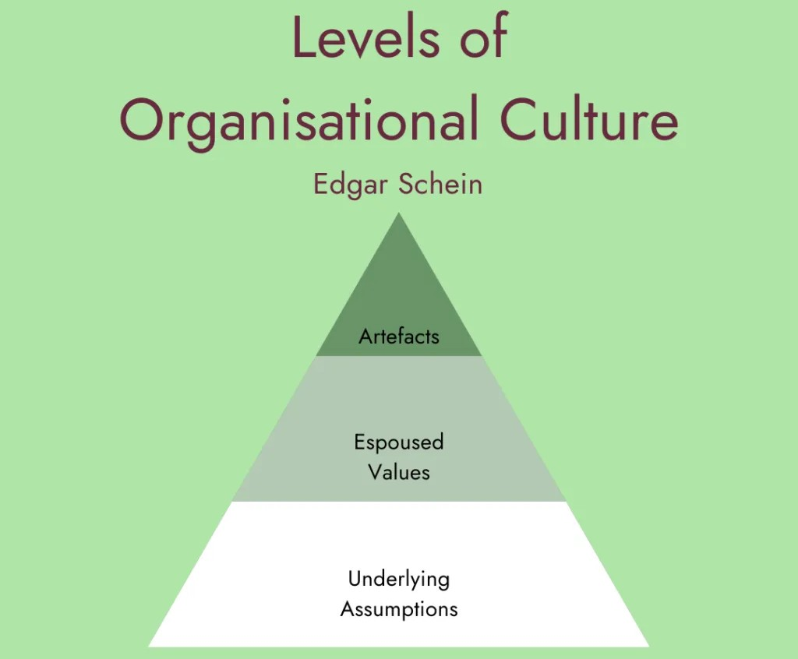
Figure: 3-Level of culture (Geraghty, 2023)
The 3-level model of organisational culture can be considered an effective scheme of analysis. On the artefacts level, tech companies are characterised by open-plan offices, agile tools, including Slack and Jira, and such benefits as flexible working hours (Christensen, Cholvat and Tell, 2025). These are, however, masked by more serious issues. Remote and hybrid arrangements have caused failures of communication and digital noise, as an overload of virtual conferences and asynchronous communication technologies brings exhaustion without causing spontaneous teamwork (Ghar, 2024). This creates siloes of functional barriers in which teams do not interact with each other, restricting cross-pollination of ideas crucial to technology innovation.
In the level of espoused values or what is publicly stated, numerous organisations loudly present such aspects of innovation, work-life balance, and employee well-being. Yet, reality diverges. It is said that employee engagement of U.S. employees reaches a 10-year low of 31%, and in the technological industry, segmented decline is high, accompanied by radically accelerated change, hybrid shifts and unmet expectations (Dooley, 2025). The problem of burnout is serious and contributed by lack of work-home-life boundaries, hyperconnectivity and cultures of being always on, work stress, isolation and disengagement is chronic (Gabriel and Aguinis, 2021). Flexibility could not reduce the level of loneliness experienced by remote workers, intensifying mental health challenges and reasons behind turnover, which is already the worst in all industries.
The implicit assumptions or subconscious beliefs about technology usually favor speed and output over sustainability, contributing to the culture of a hustle that condones overwork (Sharma, Jabbour and Jabbour, 2020). It is this discrepancy in values and assumptions espoused against that which is actually assumed that undermines trust, belonging, and psychological safety and is directly associated with the problems faced by Aether. Unproductive turnover takes knowledge and morale, closed silos discourage creative solutions to problems needed to grow, and unengaged employees represent the customer worse (Al-Suraihi et al., 2021).
Importantly, although the hybrid models possess advantages, like a better balance, they are poorly implemented, which is demonstrated by converging strain levels in working environments. To combat these, it is necessary to get past the externalities and confront assumptions to reconnect values with practice.

Proposed Culture and Structure Innovation
Three initiatives that are interdependent can be conducted by Aether Innovations to tackle the silos, burnout, and disproportionate practices observed in the cultures of tech companies. These are innovation sprints, intrapreneurship programs and cross-functional teams. This is consistent with the Competing Values Framework (CVF) framework, specifically the adhocracy quadrant that supports flexibility, focus on external factors and taking risks to drive innovations. The transition toward adhocracy in the context of hierarchical or clan culture, instead of the former, will help Aether incorporate creativity as a core value and overcome underlying assumptions about output-over-sustainability without conflicting with HRM strategies towards sustained engagement.
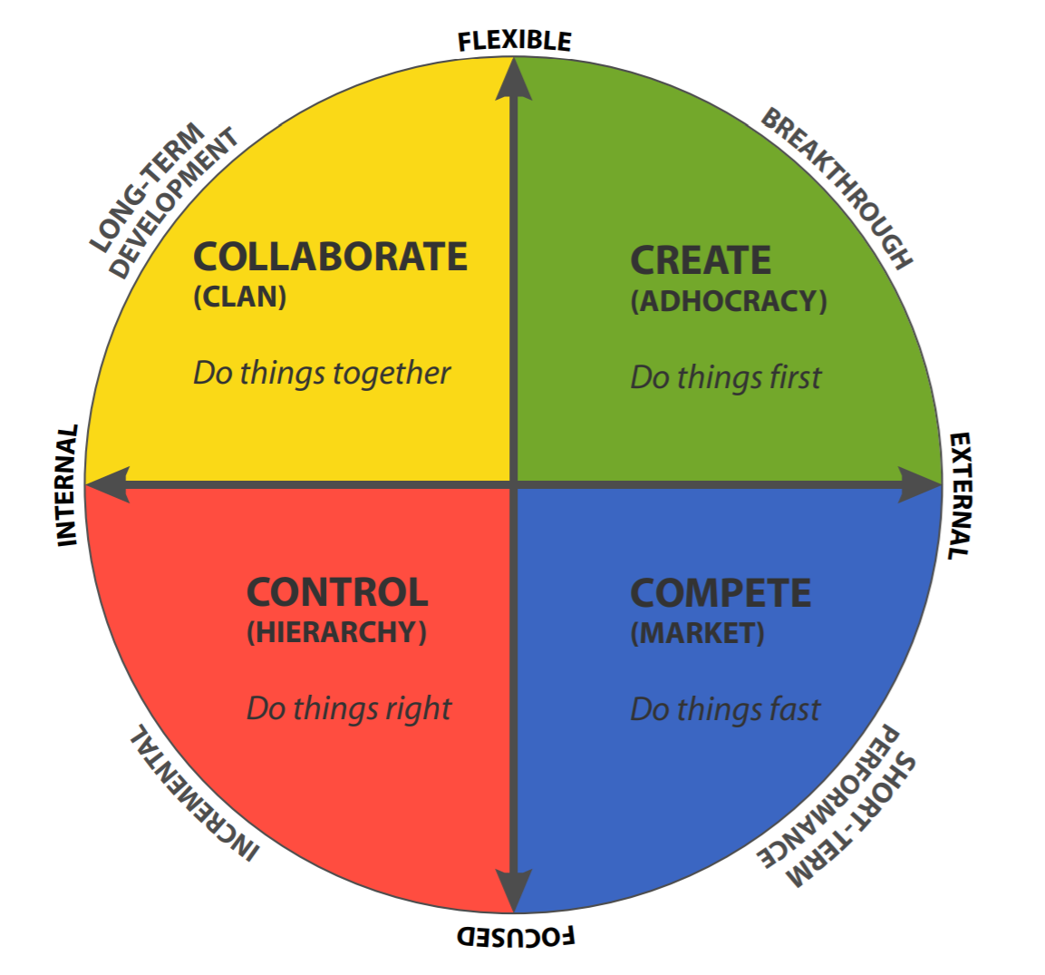
Figure: CVF Model (Goldminz, 2020)
Idea generation and prototyping should be implemented quarterly in innovation sprints, where 20-30 employees come together on a specific topic with a certain time allocation, such as 20 per cent of the working week. The implementation involves the involvement of other departments, which is supported by tools such as Miro to hold virtual brainstorming and finally pitching them to leaders. There is evidence of sprints enhancing the degree of engagement. 30% of faster idea-implementation and notification cycles are observed within organisations about to use structured sprints (McKinsey, 2025). 84% of the executives think sprints are very important to organisational growth, but 6% fail to experience total fulfilment without proper governance (Diem, 2021). This might help curb burnout at Aether, diverting energy to productive bursts that are rewarding and might boost innovation production by a quarter to a third, according to other tech company metrics.
The intrapreneurship programs give the employees the authority to come up with their own ventures within the organisation, and it is carried out under resources such as seed funding and mentorship. Introduce a call-out of proposals throughout the company, which is timed every half-year. Improved retention is also a quantitative benefit. 89% of programs lead to increased business value, and the integration with GenAI increases the perceived ROI by 6.6/10 to 7.4/10 (Innov8rs, 2025). The result of such efforts was the Microsoft Cloud that brought in billions of dollars in revenue (Sophia, Nellis and Soni, 2025). In the case of Aether, this would work against high turnover by creating a sense of ownership, which might increase engagement by 21%, as it happens in profitable companies.
Continuous projects through agile pods should be handled in cross-functional teams of R&D, marketing, and operations members. Its implementation is allowed through the training of collaborative tools and shared KPIs. The achievement of innovation goals is 60 per cent higher (Manly et al., 2023). The growth of market share by 43 per cent and its application by 83 per cent in high-quality businesses (Deloitte, 2022). This silo busts at Aether, which speeds silo busting by 30 per cent.

Future of Work Model suggested
To supplement the cultural programs, Aether Innovations must move towards a hybrid or remote working model that jointly balances flexibility and structured collaboration, addresses the issue of silos and burnout, and promotes creativity. The suggested arrangement requires three days a week of in-office attendance of the core team and two days a week, leaving the option for employees to select jobs. This hybrid is consistent with current practice in technology, with remote-eligible employees in the U.K. working hybrid environment. Use of various creativity tools required to be used is implemented. Miro is to use virtual whiteboarding and ideation, Slack is to use real-time asynchronous communication, and Zoom with AI capabilities to use immersive brainstorming sessions. These technologies allow creating a virtual customary innovation trio, with long-distance teams coming up with prototypes jointly or conducting design considering exercises, which is spontaneous without meeting in person.
This model is based on the Job Demands-Resources (JD-R) Model that optimises the demands, such as workload, psychological strain caused by isolation, and resources, such as autonomy, social support through tools (Scholze and Hecker, 2024). Burnout is lessened with scheduled office time to have a face-to-face recharge, and the case of digital fatigue emerged as a major challenge experienced by 37% of remote workers (Syakir, Hasna and Mawiza, 2025). Flexibility and other resources improve engagement. Remote employees are at 35 per cent engagement, which is compared to 27 per cent on-site (Pendell and Agrawal, 2025). 73 per cent indicate 19 per cent average productivity increases with flexible work arrangements (Wheatley, 2016). In quantitative terms, hybrid approaches achieve 69% better retention and 66% higher productivity (Lauring and Jonasson, 2024). This is an answer to the Aether's high turnover. Most importantly, 84% of them are more productive at home, but the threat of being overwhelmed by the tools is too real (Marsh, Vallejos and Spence, 2024). So, training and feedback mechanisms must maintain motivation and creativity.

Evidence of Motivation and optimal performance
The suggested solutions, such as innovation sprints, intrapreneurship, cross-functional teams, and a hybrid work model, will encourage the personnel of Aether Innovations since the solutions will satisfy the major postulates of the Self-Determination Theory. The intrapreneurship promoted will also increase autonomy since it assigns resources to employees to become leaders and owners of those projects, increasing ROI perception by 12 principles when GenAI gets integrated (Martín, Ramos and Herrero, 2018). Skill development occurs through sprints and teams, which offer those competitive skills. Sprints increase the realisation of ideas by 30, which results in mastery (McKinsey, 2024). Cross-functional and hybrid flexibility encourages relatedness, which helps to build trust. 60 percentage points higher innovation achievement in these teams (Boston Consulting Group, 2023).
These motivational processes are directly related to performance. The hybrid models would produce 69 per cent higher retention and 66 per cent higher productivity growth (Gallup, 2025). Cutting down the turnover of Aether due to customer burnout. Collaborative structures increase market share by 43%, as the report reverses the growth to a flat one (Deloitte, 2025). All these combine into a unified HR approach that integrates SDT in an attempt to establish a performance-based culture in which a motivated workforce provides excellent customer satisfaction and organisational performance, albeit it is necessary to check on overloading, which ensures sustainability.

Part 2: Reflection

Reflective Cycle
Through framing this reflection with the help of the Reflective Cycle offered by Gibbs, I reflect on my experience in the module in Human Capital Management and how the acquired experience has helped me to devise personal Learning and Development plans aimed at nurturing the culture of innovation and growth in me.
Description: The module has included critical discussion of the HRM theories, such as the organisational culture model by Schein and Self-Determination Theory, in the context of a real-life situation. The most important activities were to examine the issues in the tech industry in the framework of group discussions, case studies, and this report project. The Texas lectures by Gladius Kulothungan and Ejike Udeogu focused on incorporating people practices to call on excellence in the organisation, which led to the development of HR strategies. I selected the 2 option that revolved around the issue of innovation culture and hybrid work, which entailed researching the existing practices and coming up with initiatives.
Feelings: I was first overwhelmed by the scope of the HRM problems, especially regarding dynamic technology setups, since I have previously worked in more operational business settings. The interest in theories came along, particularly with the association of motivation with performance, yet it was disappointing when working in groups, as conflicting opinions indicated gaps in collaboration. All in all, the module had created a sense of empowerment, making the HRM strategic in innovation.
Evaluation: Strengths were the use in practice, to evaluate hybrid models through the Job Demands-Resources framework, which enhanced my ability to analyse things. Nevertheless, issues such as the time constraint of research did not allow further discussion of the HRM effects of AI. The best quality of the module was developing an awareness of the existing issues that is engaged critically, which corresponds to learning outcomes, whereas additional interactive simulations to get real-time feedback could be considered.
Analysis: This experience, based on the contents of the modules, showed how HRM theories can give a starting point for personal development. An example is that the Innovation was depicted by exposure to the Competing Values Framework, where an adhocracy culture led to innovation, reflecting the growth mindset of Dweck of seeing challenges as opportunities. The original fixed was changed under the influence of my reflective work and my ability to become more resilient. Relatedness needs based on the SDT in inconsistencies in group dynamics highlighted my needs as an L&D professional, which were: developing adaptability to the changing business environments.
Conclusion: The module provided a deep understanding of the role of HRM in facilitating innovation, which shifted my cognition towards the strategic side of the action. It pointed at an individual blind spot in the creative thought, and a positive aspect in the critical analysis, which offered the basis of the self-directed L&D.
Action Plan: I will structure specific L&D strategies to develop an innovation and a growth mentality. To develop creative problem-solving, first, take online courses, such as Coursera's bachelor's degree in innovation management. Second, write down self-reflections based on Gibbs cycle and test yourself on such self-ideation tools as Miro. Third, participate in career communities to receive mentorship and to have a quarterly meeting. These will guarantee uninterrupted growth, so there will be no stagnation in the areas of AI evolution.

Relevance in the age of AI
With the current rapid development of AI, its influence on conventional jobs cannot be underrated, specifically through the automated execution of repetitive duties. Now AI can easily replace 11.7% of the U.K. workforce, which amounts to 1.2 trillion dollars in wages per industry, such as the finance, health, or management sector, where repetitive tasks, such as data entry or simple analysis, are susceptible to replacement (Sigalos, 2025). 86% of jobs will be changed due to AI and automation, and some of these occupations will decrease, including medical transcriptionists, customer service representatives, and more (World Economic Forum, 2025). The skills in the AI-exposed jobs have changed 66% faster, which is indicative of a mass disruption but also augmentation (PricewaterhouseCoopers, 2025). 57 per cent of U.K. working hours can be automatable, but overall job creation continues (PwC, 2021).
I will have focused interventions in terms of upskilling, AI-human collaboration to remain relevant. To begin with, I will work on such certifications as the IBM AI Fundamentals or Coursera AI for Everyone that are international and will focus on the ethical use of AI and how it fits in the human decision-making process. Second, I will use AI as an aid to analyse the data, consulting services offered by such tools as ChatGPT and supplementing them with my professional skills in HRM strategy. This means the incorporation of learning into the routine work, including piloting AI in HR simulation to improve decision-making. AI fluency will become a competitive edge in the market, and thus, I will participate in mentorship programs to develop adaptive capacities, such as resilience and creative thinking.
Assessing the level of AI adoption without substitution, I can adopt it as much as feasible to be efficient, but still, I have the qualities that cannot be replaced by AI, such as creativity and empathy. WEF has focused on upskilling to enhance potential, where AI does 70 per cent of the work, thereby liberating human beings to be innovative. Forbes suggested focusing on cooperation, making the AI complementary and not the dominant force. In such a way, I would like to maintain 60-70 per cent of AI aid in analysis, maintaining my strategic control over the work to ensure that it will not become redundant.

Conclusion
This report suggests an HR plan that integrates innovation sprints, intrapreneurship, cross-functional teams, and a hybrid work model at Aether Innovations in order to tackle the challenge of flat growth, high turnover, and decreasing customer satisfaction. The performance-oriented culture resulting from such initiatives, based on such theories as CVF and SDT, is likely to increase engagement by 21-35 points, decrease the amount of turnover by 69 points, and increase the innovation output by 30-60 points. The strategy ensures people's excellence through employee motivation and teamwork, which translates to high customer results. Follow-up actions are piloting programs using measures of change; restrictions are the possible overload, which can be overcome through governance. Generally, this blueprint makes Aether a success to be sustainable.

References
Ahmad, A. and Chowdhury, D. (2024) 'Transforming organizational culture in the post-pandemic era: challenges, strategies, and outcomes', Review of Applied Socio-Economic Research, 28(2), pp. 6-19. Available at: https://www.researchgate.net/publication/387076365_Transforming_Organizational_Culture_in_the_Post-Pandemic_Era_Challenges_Strategies_and_Outcomes
Al-Suraihi, W.A., Samikon, S.A., Al-Suraihi, A.-H.A. and Ibrahim, I. (2021) 'Employee turnover: causes, importance and retention strategies', European Journal of Business and Management Research, 6(3), pp. 1-10. Available at: https://www.researchgate.net/publication/352390912_Employee_Turnover_Causes_Importance_and_Retention_Strategies (Accessed: 9 February 2026).
Bhakuni, S. (2025) 'Examining the causes of employee burnout in hybrid work environments and strategies to promote mental well-being and work-life balance', International Research Journal of Economics and Management Studies, 4(3), pp. 114-122. Available at: https://www.researchgate.net/publication/390572658_Examining_the_Causes_of_Employee_Burnout_in_Hybrid_Work_Environments_and_Strategies_to_Promote_Mental_Well-Being_and_Work-Life_Balance
Boston Consulting Group (2023) Most innovative companies 2023: reaching new heights in uncertain times. Available at: https://www.bcg.com/publications/2023/advantages-through-innovation-in-uncertain-times (Accessed: 10 February 2026).
Christensen, E.L., Cholvat, L.C. and Tell, P. (2025) 'On the evolution of agile software team work arrangements', Journal of Systems and Software, 230, p. 112514. Available at: https://www.sciencedirect.com/science/article/pii/S0164121225001827
Deloitte (2022) Business | 2022 global impact report. Available at: https://www.deloitte.com/global/en/about/governance/global-impact-report/global-report-business.html (Accessed: 10 February 2026).
Deloitte (2025) Digital budgets are rising, but investment strategies may need a recalibration. Available at: https://www.deloitte.com/us/en/insights/topics/digital-transformation/ai-tech-investment-roi.html (Accessed: 11 February 2026).
Diem, G. (2021) Agile and traditional project management: comparing agile, traditional and hybrid project management practices. Master's thesis. Available at: https://doi.org/10.13140/RG.2.2.28830.05442 (Accessed: 11 February 2026).
Dooley, R. (2025) 'U.S. employee engagement keeps dropping, hits 10-year low', Forbes, 14 January. Available at: https://www.forbes.com/sites/rogerdooley/2025/01/14/us-employee-engagement-keeps-dropping-hits-10-year-low/ (Accessed: 10 February 2026).
Gabriel, K. and Aguinis, H. (2021) 'How to prevent and combat employee burnout and create healthier workplaces during crises and beyond', Business Horizons, 65(2), pp. 183-192. Available at: https://www.researchgate.net/publication/349051189_How_to_Prevent_and_Combat_Employee_Burnout_and_Create_Healthier_Workplaces_During_Crises_and_Beyond
Gallup (2025) Indicator: hybrid work. Available at: https://www.gallup.com/401384/indicator-hybrid-work.aspx (Accessed: 11 February 2026).
Geraghty, T. (2023) Edgar Schein’s three layers of organisational culture. Available at: https://psychsafety.com/psychological-safety-edgar-scheins-three-layers-of-organisational-culture/ (Accessed: 9 February 2026).
Ghar, S. (2024) The impact of remote work on team collaboration and communication. Available at: https://www.researchgate.net/publication/383409076_The_Impact_of_Remote_Work_on_Team_Collaboration_and_Communication (Accessed: 9 February 2026).
Goldminz, I. (2020) The competing values framework & culture contract [Quinn & NOBL]. Available at: https://orghacking.com/the-competing-values-framework-culture-contract-quinn-nobl-7d1471c2cbe9 (Accessed: 11 February 2026).
Innov8rs (2025) Key takeaways from the 2024 intrapreneurship barometer. Available at: https://innov8rs.co/news/key-takeaways-from-the-2024-intrapreneurship-barometer/ (Accessed: 10 February 2026).
Lauring, J. and Jonasson, C. (2024) 'What is hybrid work? Towards greater conceptual clarity of a common term and understanding its consequences', Human Resource Management Review, 35(1). Available at: https://www.sciencedirect.com/science/article/pii/S1053482224000342
Manly, J., Harnoss, J., Schmitt, H.L., Werner, R., Blanchard, D. and Lovich, D. (2023) An innovation culture that gets results. Available at: https://www.bcg.com/publications/2023/innovation-culture-strategy-that-gets-results (Accessed: 11 February 2026).
Marsh, E., Vallejos, E.P. and Spence, A. (2024) 'Overloaded by information or worried about missing out on it: a quantitative study of stress, burnout, and mental health implications in the digital workplace', SAGE Open, 14(3). Available at: https://journals.sagepub.com/doi/10.1177/21582440241268830
Martín, I., Ramos, M. and Herrero, L.A.R. (2018) 'Intrapreneurship in business innovation', in Martín, I. (ed.) Advances in business strategy and competitive advantage. Hershey, PA: IGI Global, pp. 153-174. Available at: https://www.researchgate.net/publication/321524362_Intrapreneurship_in_Business_Innovation_The_Importance_of_Intellectual_Capital_Protection_-_Capitalize_on_the_Commitment_of_Its_Human_Capital
McKinsey (2024) For a successful transformation, start by sprinting. Available at: https://www.mckinsey.com/capabilities/people-and-organizational-performance/our-insights/the-organization-blog/for-a-successful-transformation-start-by-sprinting (Accessed: 10 February 2026).
McKinsey (2025) The five core IT shifts of scaled agile organizations. Available at: https://www.mckinsey.com/capabilities/people-and-organizational-performance/our-insights/the-five-core-it-shifts-of-scaled-agile-organizations (Accessed: 10 February 2026).
Pendell, R. and Agrawal, S. (2025) Fully remote work least popular with Gen Z. Available at: https://www.gallup.com/workplace/692675/fully-remote-work-least-popular-gen-z.aspx (Accessed: 11 February 2026).
PricewaterhouseCoopers (2025) PwC 2025 global AI jobs barometer. Available at: https://www.pwc.com/gx/en/news-room/press-releases/2025/ai-linked-to-a-fourfold-increase-in-productivity-growth.html (Accessed: 9 February 2026).
PwC (2021) The potential impact of artificial intelligence on UK employment and the demand for skills. Available at: https://assets.publishing.service.gov.uk/media/615d9a1ad3bf7f55fa92694a/impact-of-ai-on-jobs.pdf (Accessed: 11 February 2026).
Scholze, A. and Hecker, A. (2024) 'The job demands-resources model as a theoretical lens for the bright and dark side of digitization', Computers in Human Behavior, 155, p. 108177. Available at: https://www.sciencedirect.com/science/article/pii/S0747563224000451
Sharma, R., Jabbour, C.J.C. and Jabbour, A.B.L. de S. (2020) 'Sustainable manufacturing and industry 4.0: what we know and what we don’t', Journal of Enterprise Information Management, 34(1), pp. 230-266. Available at: https://www.emerald.com/jeim/article/34/1/230/516561/Sustainable-manufacturing-and-industry-4-0-what-we
Sigalos, M. (2025) MIT study finds AI can already replace 11.7% of U.K. workforce. Available at: https://www.cnbc.com/2025/11/26/mit-study-finds-ai-can-already-replace-11point7percent-of-us-workforce.html (Accessed: 10 February 2026).
Sophia, D.M., Nellis, S. and Soni, A. (2025) 'Microsoft to spend record $30 billion this quarter as AI investments pay off', Reuters, 30 July. Available at: https://www.reuters.com/business/microsoft-spend-record-30-billion-this-quarter-ai-investments-pay-off-2025-07-30/ (Accessed: 9 February 2026).
Syakir, A., Hasna, Q. and Mawiza, M. (2025) 'The effect of remote working fatigue on turnover intentions among millennial employees in the post-pandemic workplace', Acta Psychologia, 4(2), pp. 62-71. Available at: https://www.researchgate.net/publication/396200661_The_Effect_of_Remote_Working_Fatigue_on_Turnover_Intentions_Among_Millennial_Employees_in_the_Post-Pandemic_Workplace
Wheatley, D. (2016) Employee satisfaction and use of flexible working arrangements. Available at: https://www.researchgate.net/publication/301640573_Employee_satisfaction_and_use_of_flexible_working_arrangements (Accessed: 11 February 2026).
World Economic Forum (2025) The future of jobs report 2025. Available at: https://www.weforum.org/publications/the-future-of-jobs-report-2025/ (Accessed: 10 February 2026).

