MODULE CODE: LCBB4002
COMMUNITY ENGAGEMENT
Name:Cosmina Andrei

Reflective Evaluation
The purpose of this task is to assess my ability to reflect on practice and learn from my experience. I will reflect on the development of effective self-management, communication, team working, leadership and interpersonal skills.
Through my activity I learn to give time to myself and managing better my time. From this experience I learn to focus more in the main idea and structure better the subject.
Also, searching on website about the company was easily because it is a very popular company and I found the right information from different website. That helps me to write clearly about the company, his strategy and learn more about this company. Having a clearly understand of the subject helps me to know how the big company works and their strategy in business.



Accessed online (opportunitydesk.org)
This task will help me to develop my personal skills, have a better understanding of development, improve my knowledge and build my confidence. Personal development is the process of self-improvement, which enables me to build my awareness, knowledge and skills.
I learn to know my goals, and that will me to be focused in what I want to improve, to be aware of my weakness and know my strengths. Knowing my weakness will help me to know where I have to improve, to work more and be a better version of me. That will build my confidence and motivated me to be focused in what I want to learn and stimulate me to do my best. For example, I want to become a good manager but I don’t have a previous experience, so I start the course to learn new knowledge and studying a related subject at University. I have to know my weakness, which areas I have to improve and be motivated to learn more about this course. I need to gain practical experience to progress in my career. By doing what I like, I have to be focused on my plan, and do concrete action that will put me on the right track to achieve my goals.
I have to be focused on my study and search new information about my course, if that suit me and is convenient for me. To be a better version of me, I have to know my goals and be stimulated to reach them, and know I’m on the right track. Also, I have to know my weakness and accept the failure, it is ok sometimes to do mistakes and learn from them. Nobody is perfect and it is important to offer yourself compassion and understand it is ok sometimes to fail, that will not stop you there, just learn to no give up and move forward with your hopes and be strong to take this like a lesson and continue learn.
I believe it is very important for our self to be positive, know yourself and don’t stop at the first obstacle. Continue on your goals, stand up and give yourself the chance to be a better version and reach your goals. To achieve my knowledge, I learn also to track my development, to know where I did good and where I didn’t, and what areas I need be focused more. If I see the positive results of my efforts, I can definitely feel good and that will be stimulated me to do more and that will build my confidence. Also, see where didn’t work well I can put in place new actions to achieve my objective.
Accessed online(reed.co.uk/career-advice)

To know my learning style, I focused on Honey and Mumford style and that help me to know better strategy on my learning.
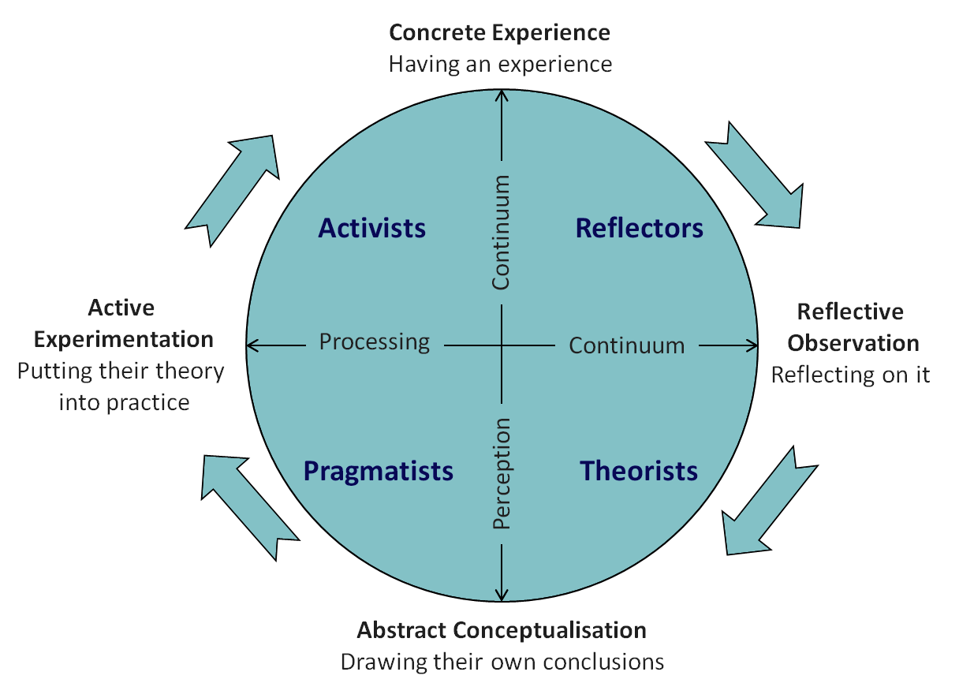accessed online(emtrain.eu)
Honey and Mumford learning styles were developed by Peter Honey and Alan Mumford in 1986. They help people know them self and their type of learning by giving a questionnaire that probes general behavioural tendencies. That helps people to find ways to use new methods to improve their learning, improves learning skills and awareness. They create 4 learning styles: activists, they are people learning by doing, theorists ,people who need models, ideas ,truth to learn better, pragmatists is people who have the capacity to put what they learned in practice, taking time to learn and the last style is reflectors who learn by watching and contemplating what happened. Accessed online (resources.eln.io).
I found myself reflector style of learning because I like paired discussion, self-analysis questionnaires, personality questioners, observing activities, coaching. I learn from my style of learning how to gain a better understanding from a number of different perspectives first and it is very important how to manage my time for effective learning.
Another theory is Kolb’s experiential learning which works in two levels: a four stage cycle of learning and four separate learning styles.

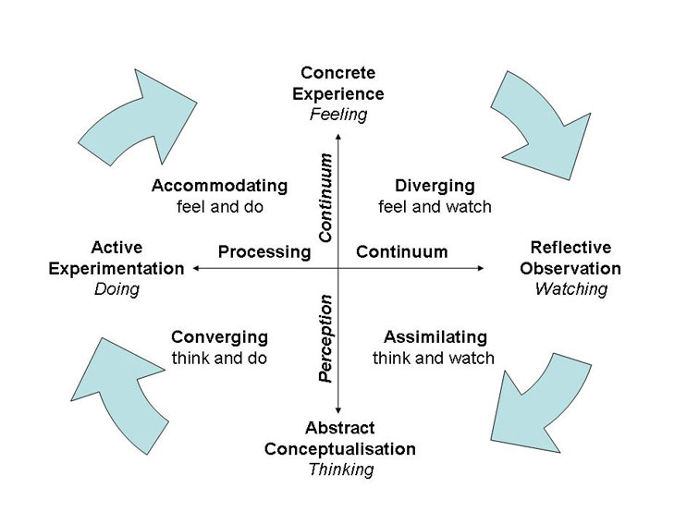Accessed online (simplypsychology.org)

‘Learning is the process whereby knowledge is created through the transformation of experience’ accessed online (simplypsychology.org, Kolb 1984,p.38).Kolb believed that people cannot improve their knowledge at the same time (think and feel).From Kolb’s theory I learned that every person have different types of learning and is important to know yours, that will help you to gain better understand of yourself and improve you skills. Having a better understand how to learn, know the strategy to learn quickly, improve your time management and know how to organize you.
The Kolb learning style is: diverging is for people who learn better by feeling and watching, assimilating is for people how will learn better by watching and thinking, converging is for people who doing and thinking will help understand better and the last one is accommodating for people who will learn by doing and feeling.
I found myself in ‘diverging’ type of learning because while I was doing my first project , I liked firstly work in groups, communicate with my colleagues about what company I will choose for the first project and listen with an open mind and receive personal feedback.
I observe that I can do my best in situations that require ideas and gather new information by talking with people. I believe it is important to know you’re learning style and that will help you to perform and achieve your goals. Having a better understand of yourself will help you in future to know the strategy that enable to learn better.
From my experience I can reflect my learning approach to Kolb’s theory and learn from it. I regular review my strengths and weakness, learn from my mistakes and improve my abilities and learn from what I have done. I make sure that I work in areas where I want to improve, for example in my time management, be more organized and that will give time to succeed on my course. I motivated myself to move forward and endure my goals remain relevant to me. Accessed online (simplypsychology.org).
Examples of key issues encountered during the role play was the lack of experience so I could not do it like a properly manager. I found it difficult because I do not have the experience and I was struggling to give the best situation for the customers. I believe one success was to do my best, to gain confidence for the company and manage to satisfy the customer’s needs. I think one are for development is gain more confidence, to be able to do my job and that will be by giving time to myself to gain more information, to improve my knowledge and be facilitator in my job.
Furthermore, I believe it is important to learn from your experience and also from others experience that will enable you to do your best in career and be a better version of yourself.
Having a better understand of my strengths and weakness, will help me to prioritise my goals, focused on my learning and improve my knowledge.
I learn from my experience to allocated more time to my study, I know my learning style and the strategy to learn better. From My role play I learn to be confident on my job and that will enable me to offer the best service for customers. It is essential to know how to prioritise your time for thinks you have to learn, that will help you have an organised work and be focused to gain more knowledge.
I gain the confidence for my next project, to know how to prioritise my time, focus on my study and motivated to learn new knowledge that will make me a good manager on my job.

References:
https://www.simplypsychology.org/learning-kolb.html
https://www.skillsyouneed.com/
http://resources.eln.io/honey-and-mumford-learning-styles/

