Mood Board

For the mood board, I was inspired by the following when it comes to my idea. Firstly, is the Xenomorph as found in the ‘Alien’ franchise. A lot of my idea came from Alien. Secondly is the Demogorgan from the show ‘Stranger Things’. This inspired part of one of my creature designs, which has to do with the tail/appendage on said creature design. I also put some textures for the skin possibilities for the creature. For the interior of my scene location I took inspiration from the well known sci-fi space stations/bases as you see in media.
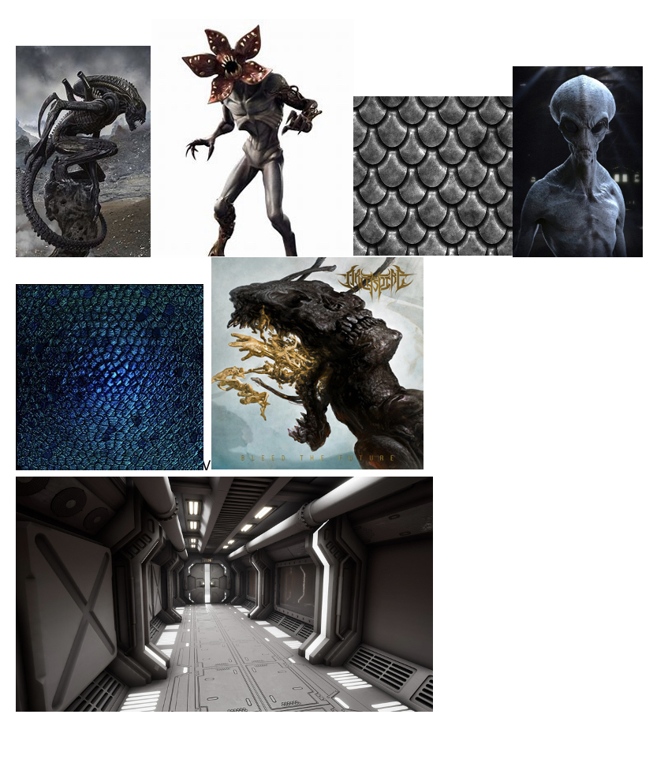
Script

INT. SPACESTATION.
Opens with shot of the wall (camera close to the ground) with footsteps echoing. A red light fades on and off. A foot comes into frame as the main character passes by the camera. (Extreme close up)
Camera cuts to the back of the main characters legs as they continue walking slowly. (Close up)
Cut to a side profile of the characters head and shoulders (Close up shot). Camera follows for a few seconds as the main character keeps her focus forward. There is fear on her face.
Cuts to the front of the main character (Close up with sight over her shoulder). Camera moves downward, showing the main character is holding a wrench in both hands, shaking.
Cuts back to front view of the main character, the camera staying on her for a while. As the camera focuses on the main characters face, a tail drops into frame at the top of the doorframe further back into the corridor (Out of focus).
The tail moves, and soon after a figure emerges, crawling over the doorframe (Out of focus).
The figure crawls along the ceiling, silently. The character is unaware of this and continues to walk.
The creature crawls into a vent and is out of the frame. Not long after this banging from the vents occur, causing the main character to stop and look up frantically.
The banging continues for a few seconds until it abruptly stops. The main character holds onto her position for a few seconds until breathing out heavily in relief.
The figure drops in front of the main character, she jolts and freezes, as the figure rises slowly.
Cuts to facing the back of the main character looking up at the now revealed creature, looming over her.

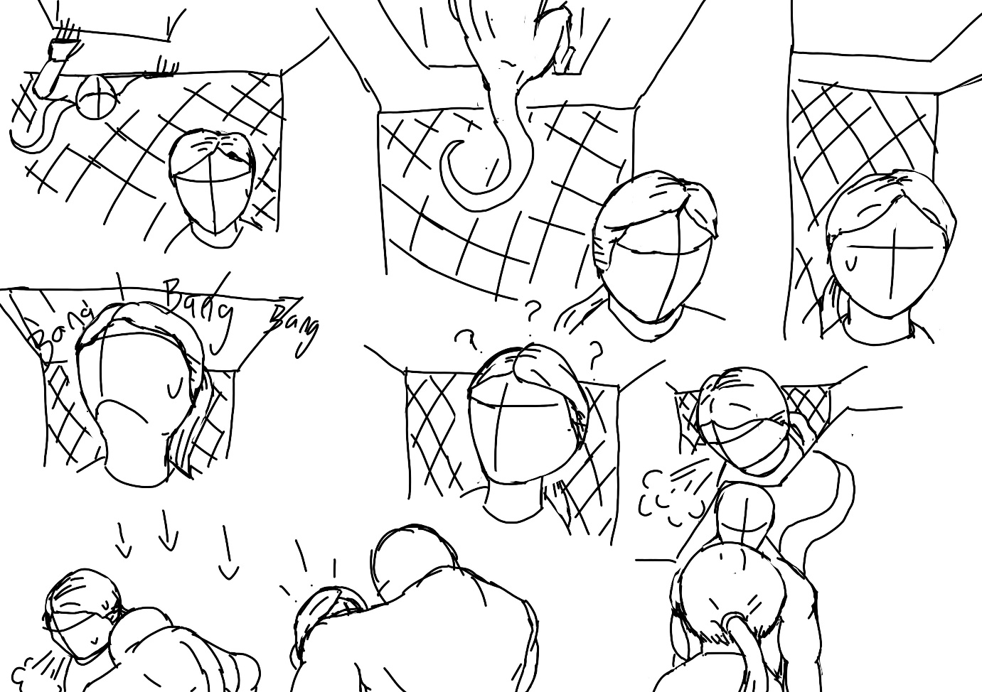
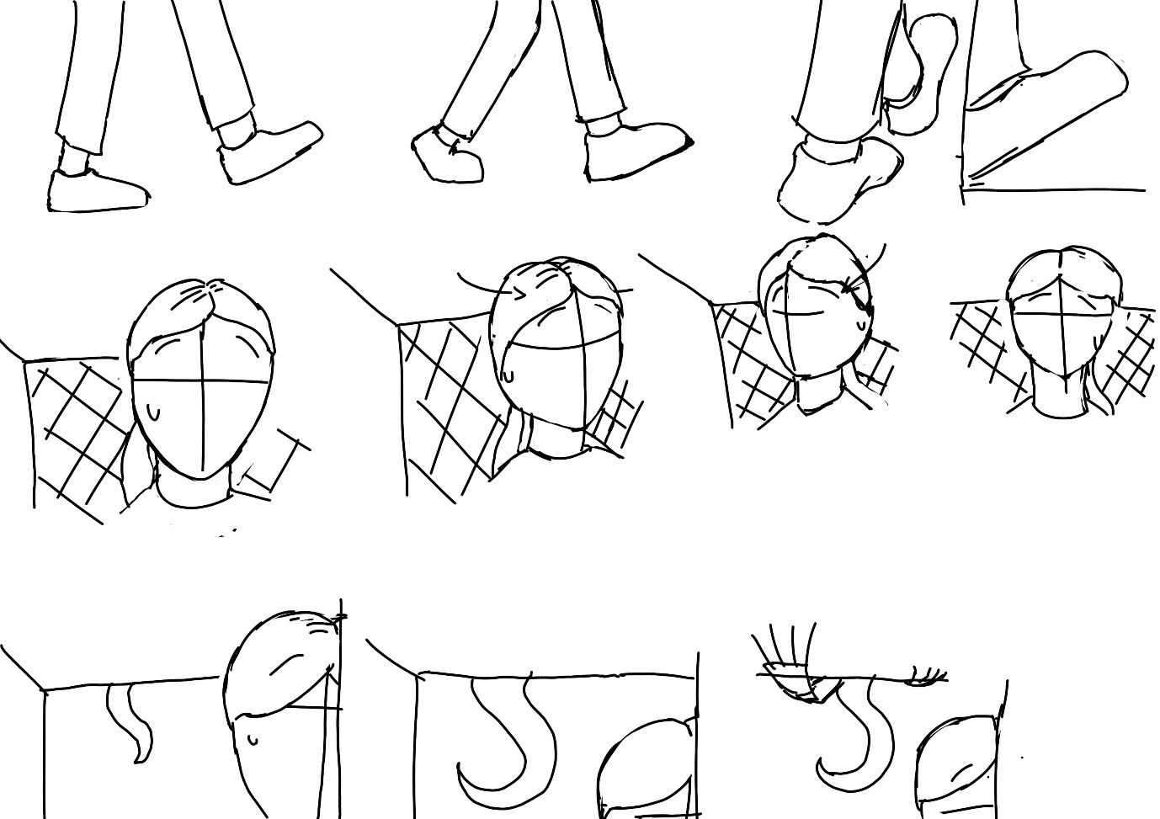
Thumbnails

Animatic
(Double click to open) Here is the animatic for the animation. I used the thumbnails for this animatic as it was the basis of what my animation would look like.

Storyboards
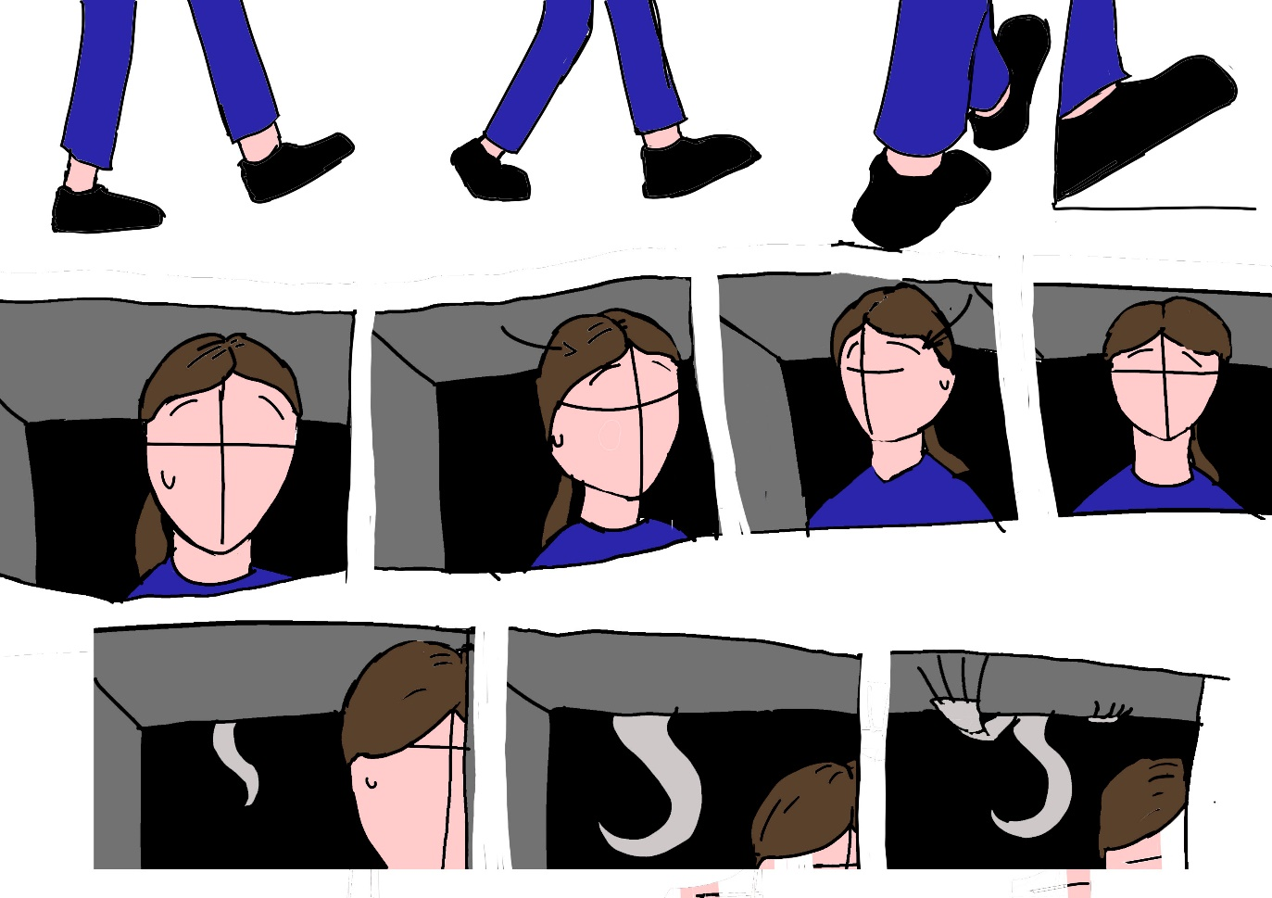
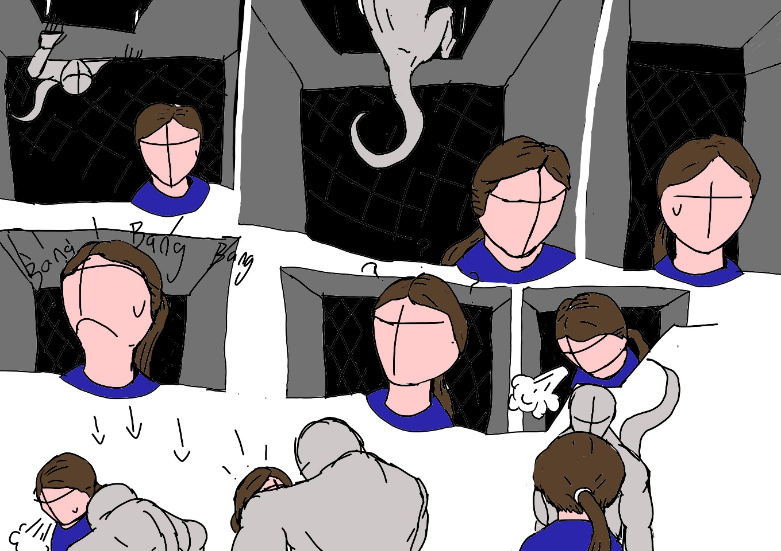
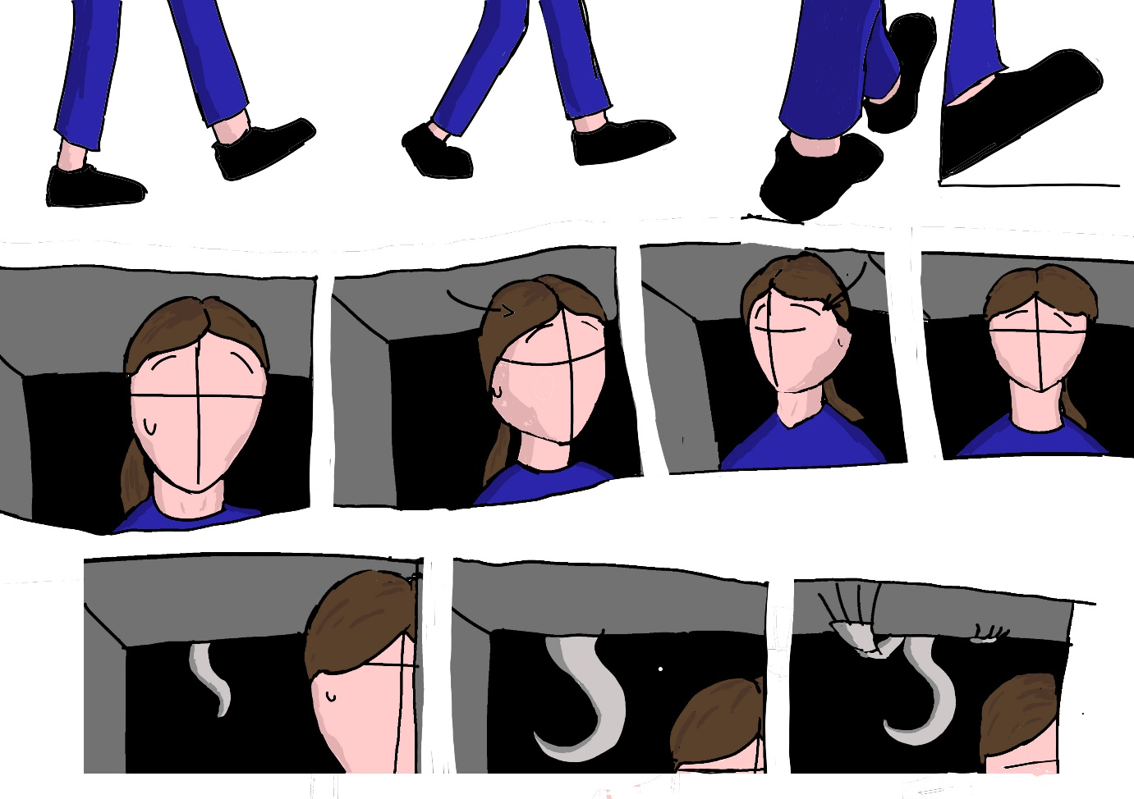
Storyboard + Shading
I decided to do show both storyboards, although they have slight differences as I wanted to show how shading can make an image have that mucg more depth.
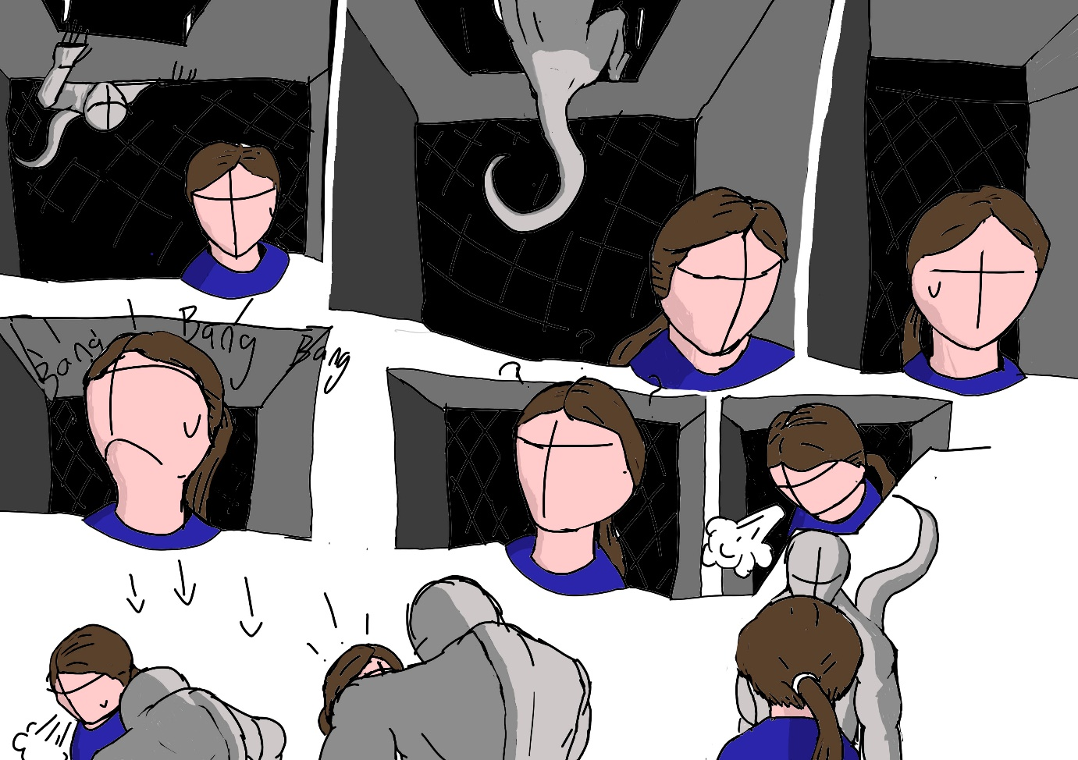
Title Cards
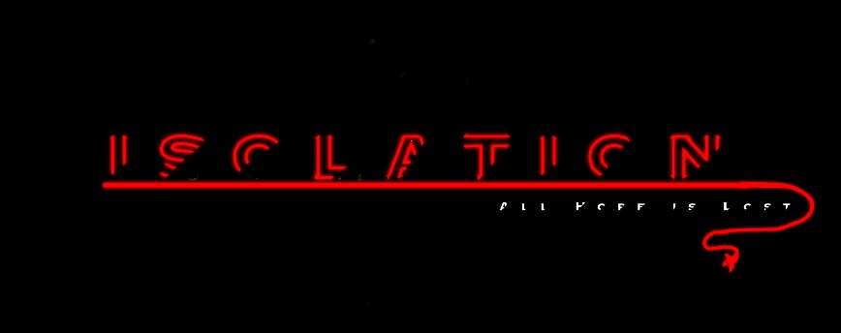

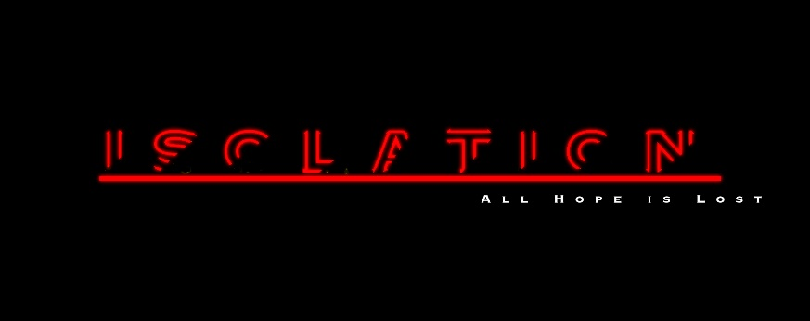

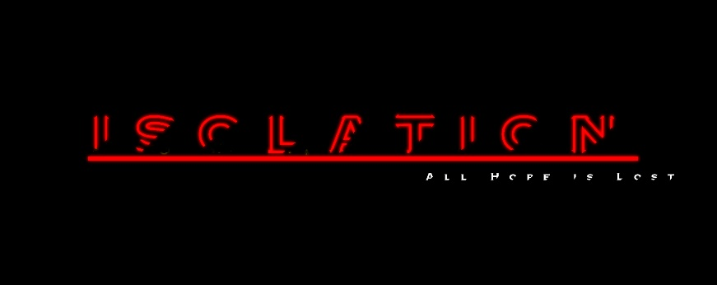
Here are the title card variants for my animation. I am incredibly proud of the final result of this piece of work, due to the eye-catching nature I feel it has.

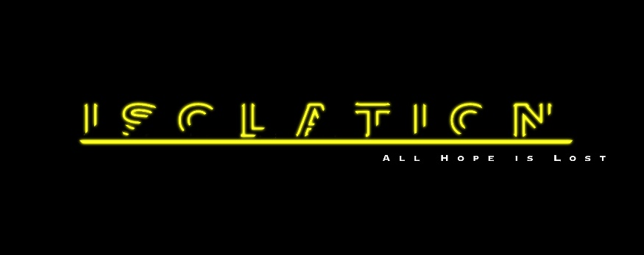

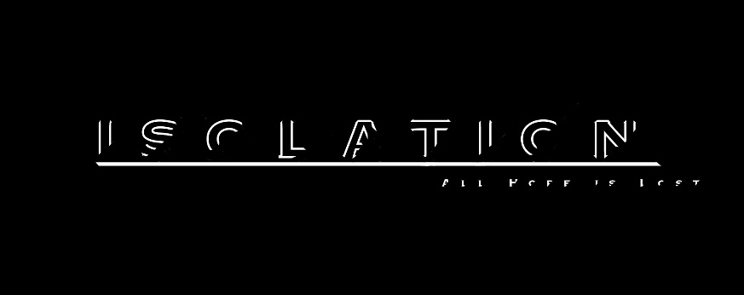

Character and Creature Designs
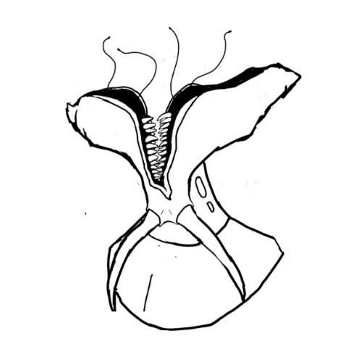
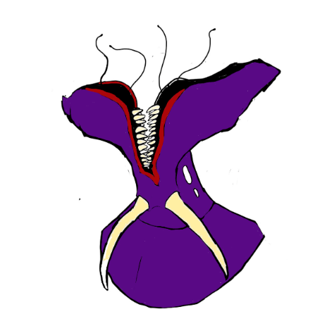

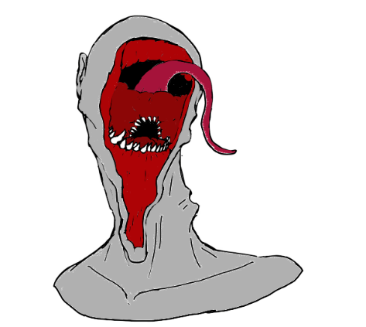
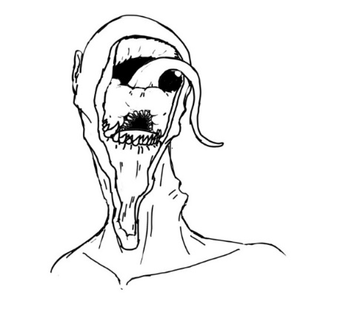

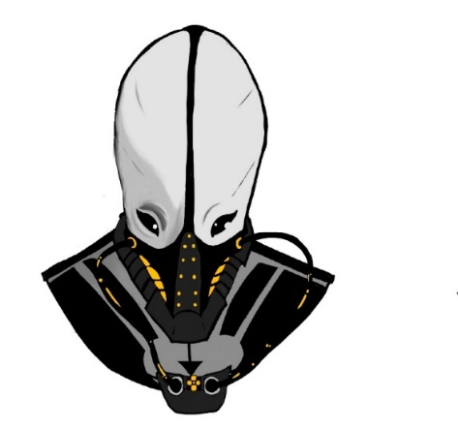
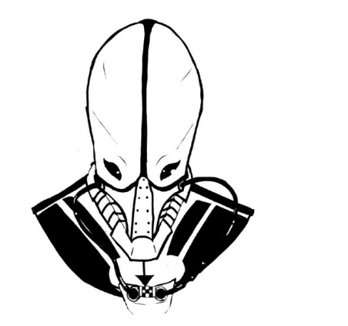

These are the creature designs I came up with when brainstorming different aspects I could draw from. Each has it’s own vibe, such as one being more insectoid, the other being more monstrous and the last being one of an intelligent and calculated alien. I kept both the uncoloured and coloured variations to show the difference and I can say I enjoy each for their own reasons, but I would say my favourite is the second, the more monstrous design, as it’s what I like in a creature design myself.

3D Environment Blocked Out
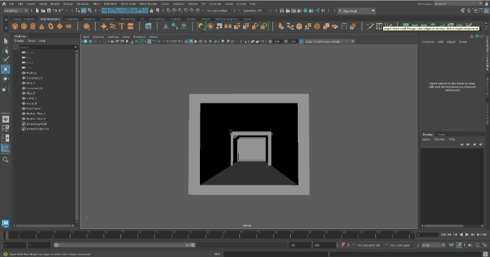

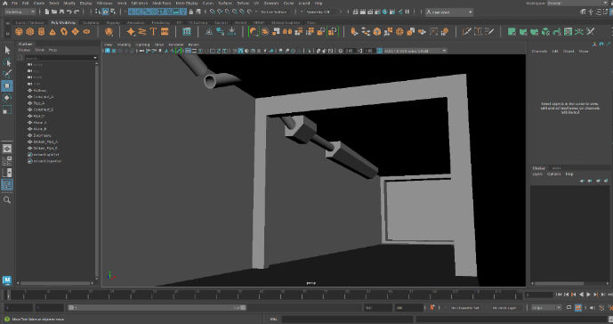

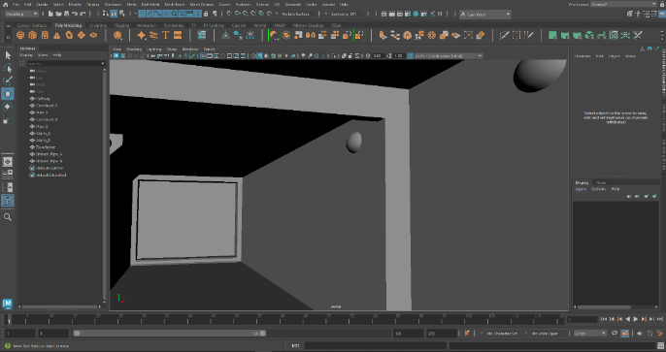

This is the 3D blocked out scene for what I want the environment to look like. Its based in one hallway, and will be similar to other sci-fi space stations in that, as I said before, it being a clean, metallic, greyish-silver look with different panelling and pipes going throughout.

