Preliminary Site Appraisal and Feasibility Study
Proposed Restaurant, Ice Cream Parlour and Manager’s Apartment
Swansea Foreshore

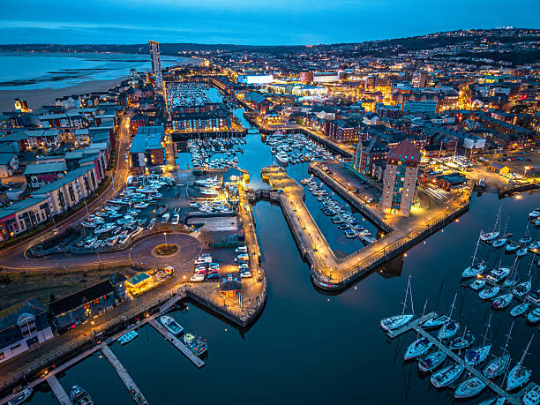
(istock,2025)

Student Name: Harvey Dixon
Student Number:2521025
Module Title: Fundamentals of construction
Submission Date: 30th April

Contents
1. Introduction 3
2. Site Background and Context 3
2.1 Site Location 3
2.2 Historical Development of the Site 3
2.3 Surrounding Land Use 4
3. Desk-Based Site Investigation and Constraints 5
3.1 Geological and Ground Conditions 5
3.2 Contamination Risk 5
3.3 Hydrology and Flood Risk 6
3.4 Environmental and Heritage Constraints 6
4. Regulatory and Requirements 7
5. Preliminary Foundation Recommendation 7
5.1 Development Overview 7
5.2 Foundation types 7
5.3 Recommended Foundation Type 8
6. Conclusion 9
7. References 10
8. Appendices 12

1. Introduction
This report sets out a preliminary study of the Site in the scenario and goes into full details within the investigation. Within this scenario there is a proposed restaurant, ice cream parlour, and manager’s apartment on Swansea foreshore. The study has been undertaken from the perspective of a junior construction professional and is intended to inform early-stage decision-making regarding site suitability, constraints, and development feasibility.

2. Site Background and Context

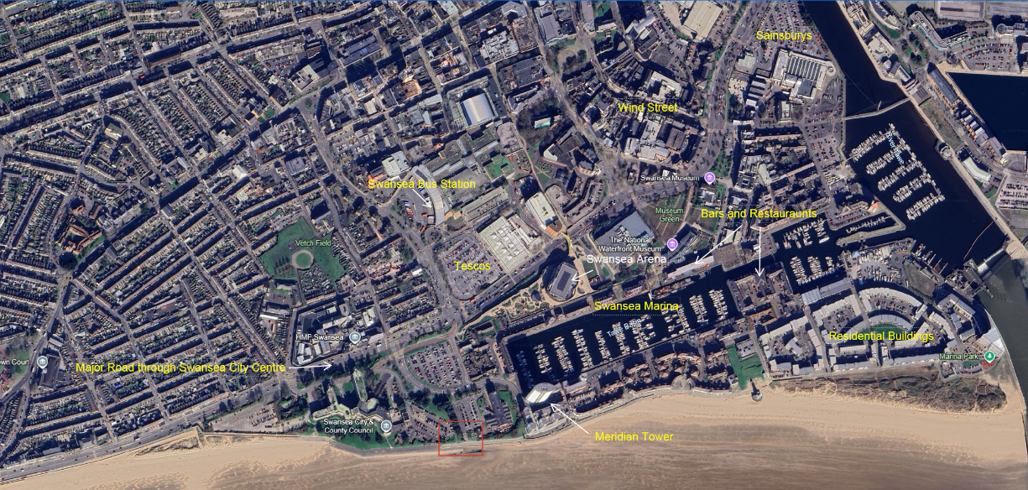
2.1 Site Location
Labelled map of site location, (Google Earth, 2024)
In the image above it shows the location of the site in the relation to Swansea city centre. It is situated on the Swansea Bay Coastline, directly adjacent to the Swansea City & County Council building and occupies a prominent position between the primary road through Swansea centre (A4067) and Swansea Bay Beach. To the east of the site is the Swansea Marina that includes infrastructure such as access to major marine facilities in South Wales Aswell as pedestrian and cycle routes, marina facilities, hotels, and tourism use. In the local area there is also multiple residential buildings that are placed in arms reach of all the luxuries that people desire today. The site is also near transport connections such as Swansea bus station (0.4 miles) and Swansea train station (1 mile).

2.2 Historical Development of the Site
The site of the proposed development lies within the Swansea marina/waterfront which was an area with rich maritime history of the Swansea Dockland.In the 18th/19th Century the Docks were linked to the smelting of copper internationally as “Small ships could sail up the river to deliver the ore directly to the copper works and carry away the refined metal.” (Swansea Museum, N.D.) The Smelting of copper was so prominent in this area as the Swansea Valley were rich with Coal which was ideal as it takes “Three to four tons of coal was needed to smelt one ton of copper ore.” (Swansea Museum, N.D.). As a result of the booming trade coming out of the Swansea valleys the Swansea Harbour trust thought significant dock construction was necessary to keep up with the demand. The construction of the North Dock was completed in 1852 which was soon followed by the South Dock (as seen in the image below) which completed in 1859 which required extensive infilling of the foreshore to meet its purpose. Following the industrial decline during the 20th century and the reduction of coal exports resulted in the west Docks to decline. (Swansea Docks, N.D.).
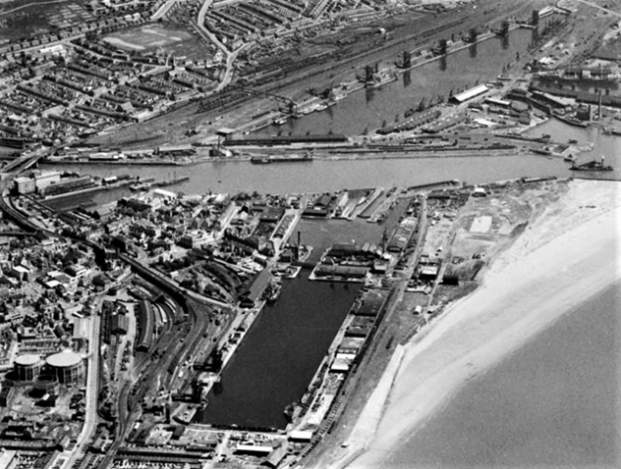
(Swansea Docks, N.D.)
The previous history of the land such as the infilling of the docks it could lead to a high possibility of hazardous substances or objects being buried under the ground which consequently would increase the risk of contamination as the substances seep out of the ground. The conditions of the ground could also be at risk as the infilling of the dock happened many years ago so we do not know the full extent to the type of material used, as a result of the varied material it could lower the grounds bearing capacity as the soft/loose material won’t be able to support the structural loads required.

2.3 Surrounding Land Use
Where the site is located on the SA1 waterfront it presents significant site constraints due to its dense mixed-use environment, which consists of apartments, hotels, an operational marina, and other leisure activities. As a collective these factors are quite sensitive to any noise, dust or visual impact that would arise from the construction of the proposed restaurant and facilities. Another implication that needs to be considered is the busy road network situated near the site along with the concentrated footfall from the marina and its facilities, to deal with this there needs to be a detailed traffic management plan, and all deliveries and site movements need to be closely monitored. The penultimate factor that should be considered is the noise and vibration restriction that would apply due to the proximity of site to residential buildings, this would affect aspects of the project like the working hours and methods of construction used. As a collective these factors would increase risk to the programme and may lead to additional costs which are associated with mitigation measures.

3. Desk-Based Site Investigation and Constraints

3.1 Geological and Ground Conditions
The geological make-up in the region would typically consist of boulder clay which has come from the melting of glaciers (The Geological Society, N.D). the Borehole assessment from a nearby site showed that the made ground in the first 0.5m was ashes then following to a depth of 1.5m there was a metre thick of loose, fine-medium sand. At the depth of 2.55m soft sandy clay became present and continued all the way down to 7m deep. The past use of the land also appeared 3.5m as traces of Bricks were found. Nearing the bottom of the borehole at 18.5m the main made ground was stiff boulder clay. The findings would suggest that the ground would have a low load bearing capacity due to its soft, fine and loose sand/clay which poses a substantial risk of Total settlement such as Consolidation settlement which “occurs because water is gradually squeezed out from between the soil particles which reduces the void space leading the soil moves downwards.” (A. Lees, 2019). This risk could lead to the possibility of deeper foundations and piles that would spread the load down to the stiff boulder clay found at deeper levels.

3.2 Contamination Risk
As previously mentioned in section 2.2 the site used to be a part of the Swansea Docklands and its industrial waterfront which highlights high likelihood of ground contamination. Typical harmful materials/substances that would have been used in the Docklands would consist of fuels, heavy metals and even asbestos from old buildings. Further from the borehole study the type of made ground increases the uncertainty as traces of bricks would suggest that materials are often deposited in an uncontrolled manner which may contain hazardous substances. This would suggest quite a high contamination risk which could have implications of construction such as the controlled disposal of any hazardous substances found.

3.3 Hydrology and Flood Risk
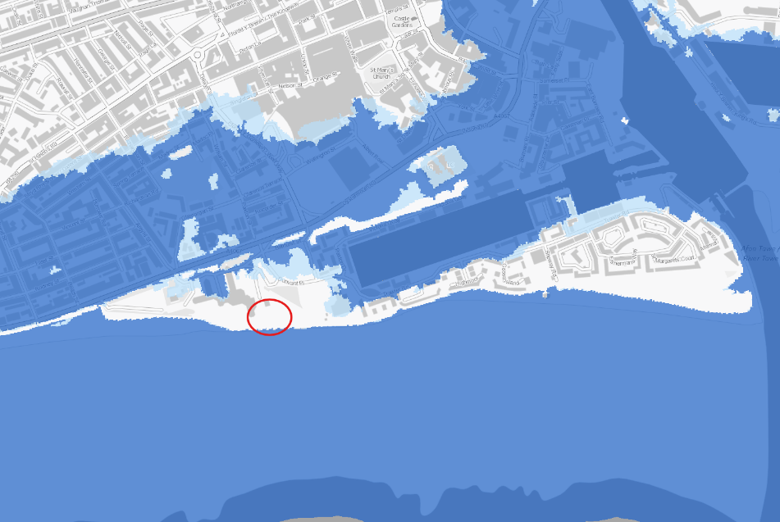
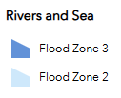
Flood map of Swansea Bay (Natural resources wales,2026)

In the image above it highlights the location of the site in relation to the flood risk map of Swansea, it is evident that it is surrounded by flood zone three which suggests that despite the site having immediate flood defence the surrounding area is extremely liable to flooding. In addition, with the site being located extremely close to the sea it is also susceptible to the influence of the tide and its fluctuations especially during the excavation of foundations and piling as the ground water levels could rise which could be influential as “A high ground water table can result in increased water pressure on the foundation, which can lead to the settlement of the foundation.” (WAB Design, 2023) Climate change is also a pressing matter as in the distant future the average sea level will by at least a foot (Lindsey. R, 2023). This would suggest the longevity of the site could be at a slight risk considering its geographical location.
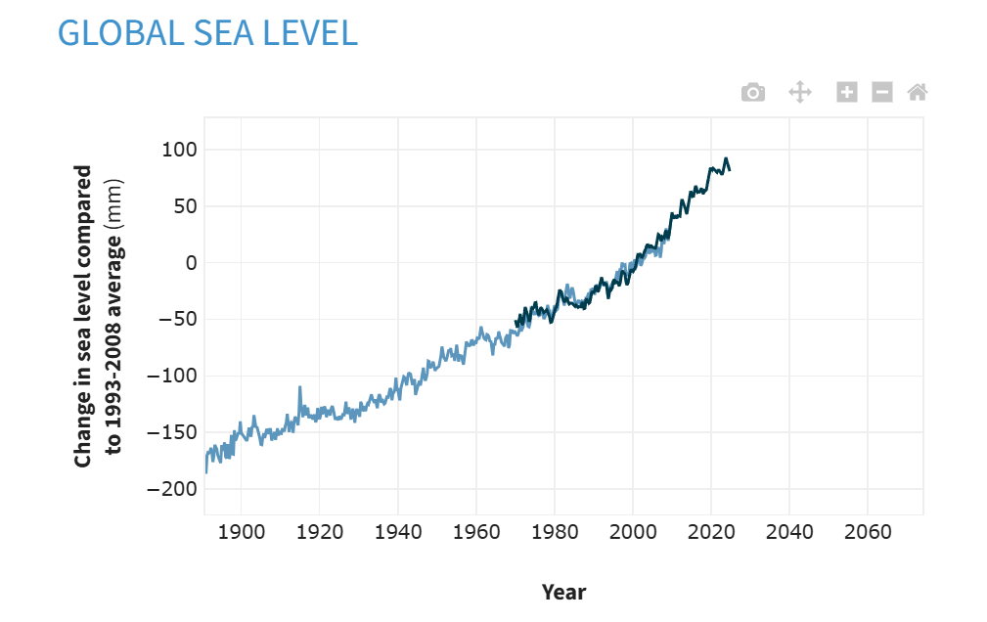
Graph to show Sea level rise over time (Lindsey. R, 2023)

3.4 Environmental and Heritage Constraints
First, during the construction process there could be an environmental risk to the marine ecosystems e.g. there could be pollution from plant or general activity Aswell as sedimentary run off into the sea. As SA1 waterfront is a high-value waterfront development the development will have to fit into the characteristics of the area and not be a hindrance/inconvenience in ways such as obstruction of views or cause excessive traffic or footfall which could upset residents. Due to the areas rich historical value, there is a chance there is remnants of dock infrastructure beneath the ground which could attract Archaeological interest and cause constraints on planning permission and additional delays and costs to the programme.

4. Regulatory and Requirements
Building regulations like Approved Document A are key as they specify regulations for the structure and ensures that foundations are suitable for all the anticipated loads and the ground conditions are suitable. (HM Government, 2013). Whereas Approved document C is relevant as it focuses of site preparation and contaminants as the site has a history of industry use which increases the likelihood of contaminants in the ground. (HM Government, 2013) This site should also comply with the code of conduct BS EN 1997 (Eurocode 7), which denotes requirements for the geotechnical design and highlights in section 3.2 what should be included in ground investigations of a site in detail (BS EN 1997-1, 2004). Following on, the local planning authority which would be Swansea council in this case would be key as it is the governing body have control over aspects of construction from planning application to local land charges (Swansea.GOV, 2026). Natural Resource Wales also would have an influential role for aspects such as the risk of flooding and potential land contamination which is applicable to the scenario with the site being located on the Swansea Bay waterfront near the old dockland. (Natural Resource Wales, 2026)

5. Preliminary Foundation Recommendation

5.1 Development Overview
The general scope of the development in question is a building containing a restaurant, café bar, ice-cream parlour, fully fitted kitchen and food stores on the ground floor then on the second floor there is a manager’s apartment, meeting rooms and a staff welfare area. Therefore, it would suggest that the anticipated loads would include aspects like floor slabs, roof etc as well as variable loads from customer occupancy, kitchen equipment, and residential use. As a result, these loads must be transferred to the ground using an appropriate foundation solution.

5.2 Foundation types
The first option would be Shallow foundations, which tend to be wider than they are deep which means that cheaper and quicker to build. This type of foundation would be more commonly utilised in smaller, lighter buildings. One of the main types of shallow foundations being Strip footings that overlap one another which allows the foundation to be useful in supporting load-bearing walls. Mat foundations would be a foundation that is able to support several columns and walls under an entire structure, this style would be seen where the soil pressure has a low bearing capacity. (Forestell. T, 2021)
Deep foundations on the other hand would be a type of foundation that “extends several meters below the ground surface and transfers the weight of a building down to the earth.”(AARSLEFF, 2025) These foundations are used in sites with low quality soil and bore down to more harder layers to offer structural support for heavy buildings as well as handling any ground movements. These would typically be seen on sites with challenging ground conditions.

5.3 Recommended Foundation Type
(Reinforcement Products online. 2021).
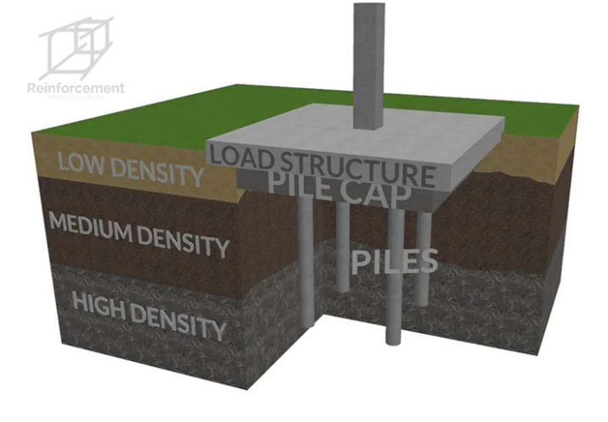
Deep foundations that send piles deep into the ground (as shown in the drawing on the left) would be the most suitable option. Section 3.1 states how the borehole ground investigation of the site’s location suggests that no solid ground was made until 18.5 m deep which completely rules out the reliability of short foundations. CFA (Concrete filled auger piles) is where an auger is sent down to the depth specified and concrete is then pumped into the space created by the auger, the auger is then removed, and rebar cage is added to reinforce the pile, and the pile is left to set. This would allow the load to be distributed to the layers of Stiff boulder clay located 18.5 m deep which consequently would improve the load-bearing capacity of the foundations. The sites proximity to the coast also presents high flood risk and higher water levels render the short foundations ineffective as there could be difficulty where the water table is high (The Austin Company, 2024) so the CFA would be preferable as it would easily be able to reach the depth of the more reliable ground at 18.5m Aswell as offering a clean and controlled installation which is key in a site located near residential building. A limitation of using these CFA piles would be that it requires a larger piling rig which could prove a logistical challenge with considering the site in question isn’t that spacious.
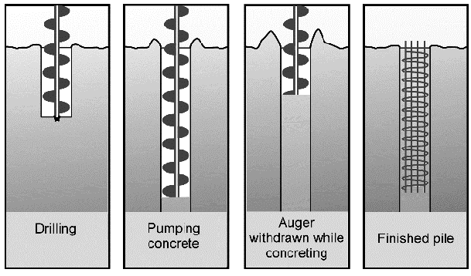

(Anthony Thorpe,2004)

6. Conclusion
This preliminary appraisal indicates that the site in question for this development is suitable however it is subject to an appropriate foundation design along with compliance of regulations linked to the site’s location and relations to nearby facilities e.g. residential buildings and the waterfront. Key constraints would come from the borehole results of the made ground in immediate depths, the potential risk of contamination from the area’s history and the flood risk from its coastal location. These factors could have an influence on the sites longevity as they could reduce the durability and safety of the development. It would be recommended that additional ground investigations are undertaken along with more boreholes and contamination testing to verify the use of deep pile foundations and the environmental and structural risks.

7. References
- AARSLEFF. (2025). What Are Deep Foundations? [Online]. AARSLEFF. Last Updated: 23 September 2025.
Available at: https://aarsleff.co.uk/deep-foundations/what-are-deep-foundations/ [Accessed 23 April 2026].
- Forestell, T. (2021). Shallow Foundations Explained. [Online]. DOZR. Last Updated: 14 December 2021.
Available at: https://dozr.com/blog/shallow-foundations-explained [Accessed 23 April 2026].
- Google Earth. (2024). Aerial shot of Swansea. [Online]. Google Earth.
Available at: https://earth.google.com/web/@51.61742512,-3.94468512,16.37437715a,1894.77412486d,35y,0h,0t,0r/data= [Accessed 16 April 2026].
- HM Government. (2013). The Building Regulations 2010: Approved Document A.
Available at: https://assets.publishing.service.gov.uk/media/5a80437640f0b623026927b2/BR_PDF_AD_A_2013.pdf [Accessed 20 April 2026].
- HM Government. (2013). The Building Regulations 2010: Approved Document C.
Available at: https://assets.publishing.service.gov.uk/media/5a8192a0e5274a2e8ab54b5f/BR_PDF_AD_C_2013.pdf [Accessed 20 April 2026].
- Stephen Metcalfe. (2026). Aerial view of Swansea Marina at blue hour with city lights. [Photograph]. Swansea: Istock.
- Lees, A. (2019). Geotechnical Settlement: Types and How They Work. [Online]. Tensar. Last Updated: 21 November 2019.
Available at: https://www.tensar.co.uk/resources/articles/understanding-settlement-in-geotechnical-engineering [Accessed 18 April 2026].
- Lindsey, R. (2023). Climate Change: Global Sea Level. [Online]. Climate.gov. Last Updated: 22 August 2023.
Available at: https://www.climate.gov/news-features/understanding-climate/climate-change-global-sea-level [Accessed 20 April 2026].
- Natural Resource Wales. (2026). Guidance and advice. [Online]. Natural Resource Wales.
Available at: https://naturalresources.wales/guidance-and-advice/?lang=en [Accessed 20 April 2026].
- Natural Resources Wales. (2026). Flood Map for Planning. [Online]. Natural Resources Wales.
Available at: https://flood-map-for-planning.naturalresources.wales/ [Accessed 18 April 2026].
- NGM 2016. (2004). EN 1997-1: Eurocode 7 – Geotechnical design – Part 1. [Online]. NGM 2016.
Available at: https://www.ngm2016.com/uploads/2/1/7/9/21790806/eurocode_7_-_geotechnical_designen.1997.1.2004.pdf [Accessed 20 April 2026].
- Price, M. (2024). Deep Versus Shallow Foundations. [Online]. The Austin Company. Last Updated: 24 May 2024.
Available at: https://theaustin.com/blogs/deep-versus-shallow-foundations/ [Accessed 23 April 2026].
- Reinforcement Products online. (2021). CFA Piling. [Online]. Reinforcement Products online. Last Updated: 14 December 2021. Available at: https://www.reinforcementproductsonline.co.uk/news/cfa-piling/ [Accessed 29 April 2026].
- Suliman Khan. (2024). What is Deep Foundations. [Online]. Medium. Last Updated: 15 November 2024. Available at: https://medium.com/@sulimanev95/what-is-deep-foundation-8e6864c8eeb9 [Accessed 27 April 2026].
- Swansea Council. (2026). Planning and building control. [Online]. Swansea.GOV.
Available at: https://swansea.gov.uk/planning?lang=en [Accessed 23 April 2026].
- Swansea Docks. (n.d.). A Brief History of Swansea Docks. [Online]. Swansea Docks.
Available at: http://www.swanseadocks.co.uk/docksnewsite/history.html [Accessed 16 April 2026].
- Swansea Docks. (n.d.). A Brief History of Swansea Docks. [Online]. Swansea Docks.
Available at: http://swanseadocks.co.uk/docksnewsite/aerial3.html [Accessed 18 April 2026].
- Swansea Museum. (n.d.). Copperopolis: Why Swansea? [Online]. Swansea Museum.
Available at: http://www.swanseamuseum.co.uk/whats-on/past-exhibitions/copperopolis/why-swansea/ [Accessed 16 April 2026].
- The Geological Society. (n.d.). A stroll along the prom – Swansea Bay. [Online]. The Geological Society.
Available at: https://www.geolsoc.org.uk/education-and-resources/16-18-education/fieldwork-resources/gower/gower-s [Accessed 18 April 2026].
- Thorpe. A. (2004). The Reuse of Site Data to Inform Business Processes. [Online]. Research Gate. Last Updated: October 2004. Available at: https://www.researchgate.net/publication/240630246_The_Reuse_of_Site_Data_to_Inform_Business_Process [Accessed 29 April 2026].
- WAB Designs. (2023). The Impact of Ground Conditions on Foundation Design. [Online]. WAB Designs. Last Updated: 19 February 2023.
Available at: https://www.wabdesigns.co.uk/the-impact-of-ground-conditions-on-foundation-design [Accessed 20 April 2026].

8. Appendices
Labelled map of site location, (Google Earth, 2024)

Flood map of Swansea Bay (Natural resources wales,2026)

Graph to show Sea level rise over time (Lindsey. R, 2023)
Borehole investigation used in section 3.1.
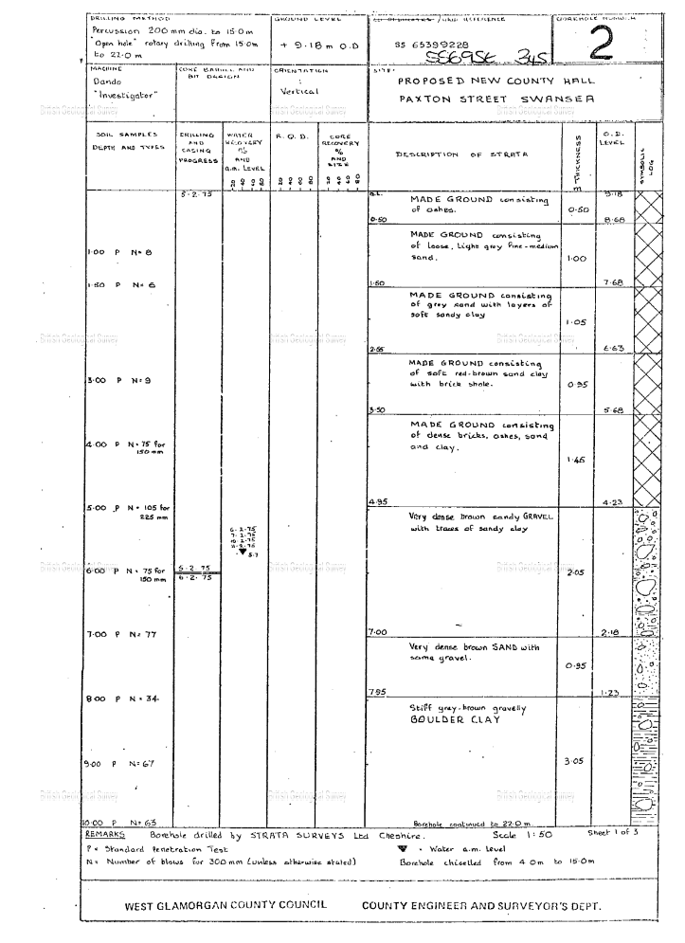

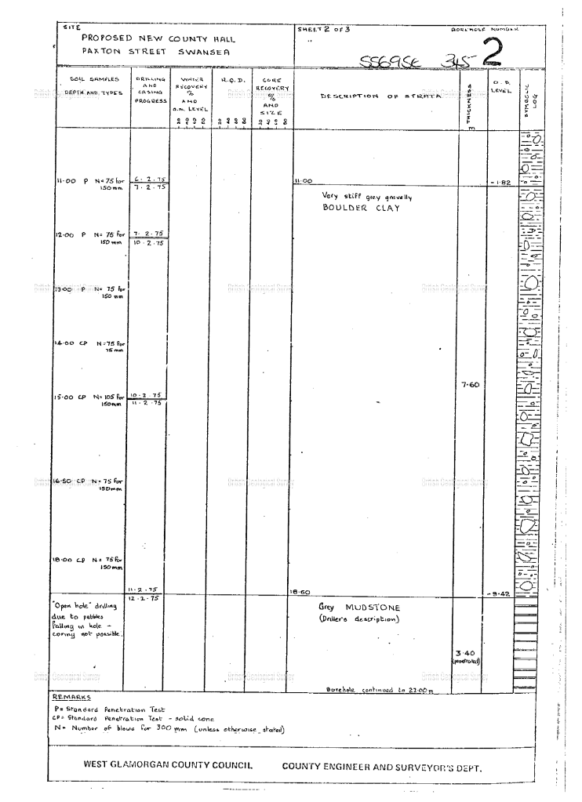

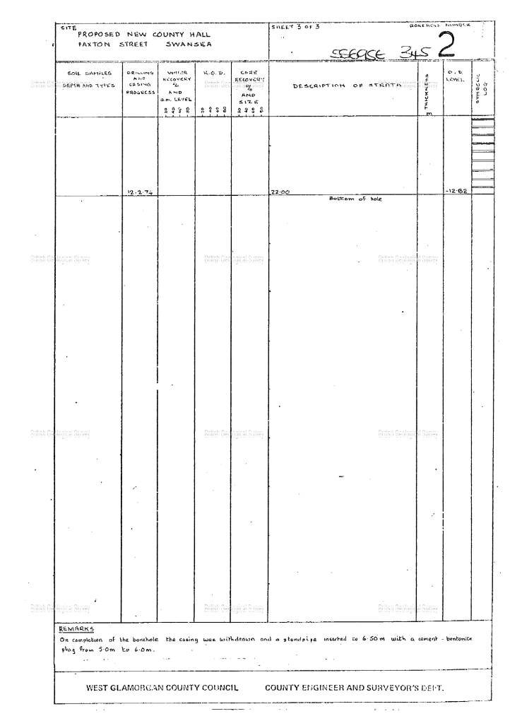

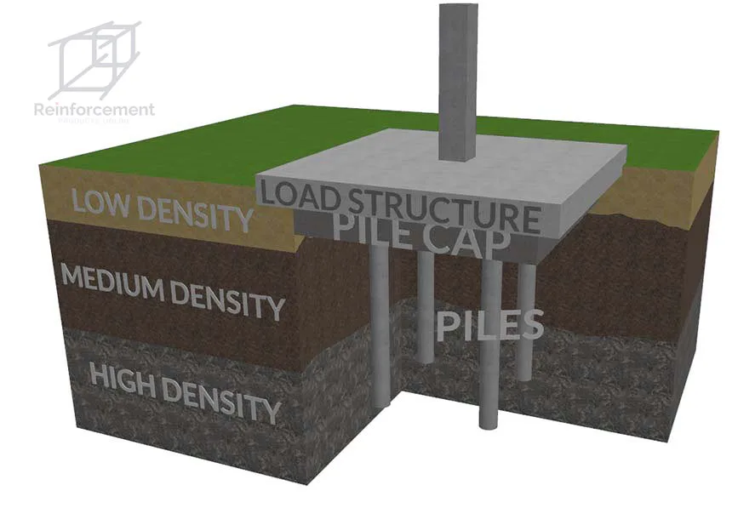

Cross-section drawing to illustrate how deep foundation piles are built (Medium,2024)
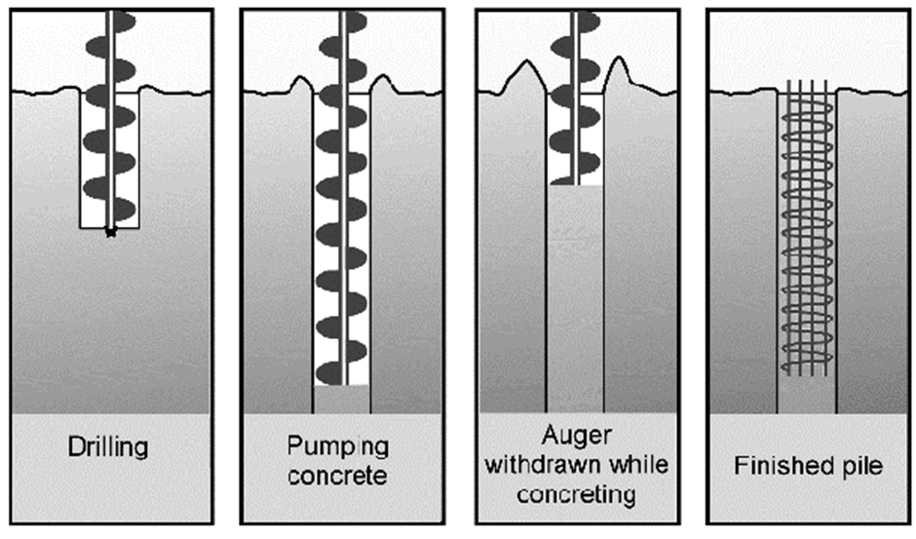
Image to demonstrate the process of CFA piles (Anthony Thorpe,2004)

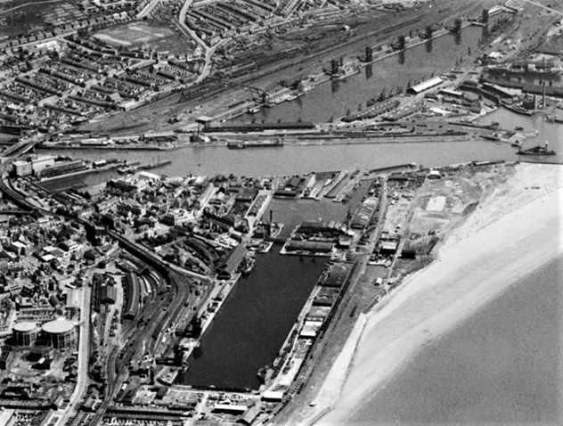

Aerial image of the South dock in the 1940s (Swansea Docks, N.D.)
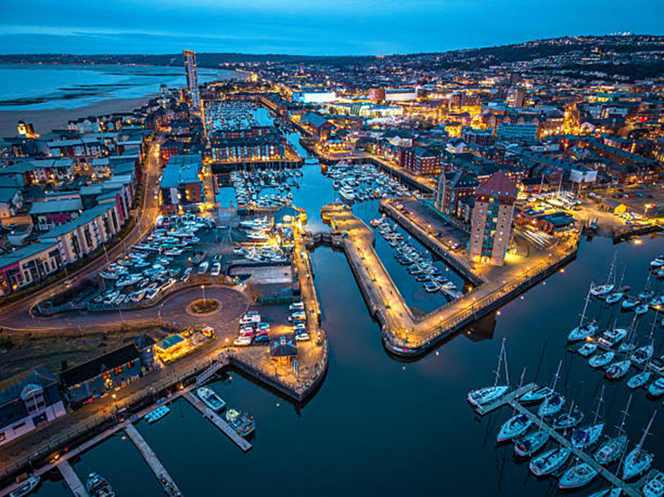
Aerial image of the south dock (Istock,2026)

