Student Name: | Pecos Dingu
Student Number: | 1605452
Module No: | EMPL4012
Module Title: | RESEARCHING AND ANALYSING DATA

Lecturer Name | Diola Bijlhout

Table of Contents

Table of Contents 2
1. Introduction 3
2. Assessment 4
3. Qustions from given articles 5
4. Research Methodology 6
4.1 Primary Research 6
5. Secondary research 10
5.1 Literature review: 10
5.2 Advantages & Disadvantages of Working from Home 10
5.3 Findings of secondary research 12
6. Conclusion 13
7. References 14
8. Appendix 15

- Introduction:
Working from home means whenever a person starts working from home without going to any office, also can be called as “Freelancing”. It’s a new opportunity for the people who don’t want to go office as the traditional way or people who want to give their time for home as well (Belbin, M.R. - 2012).
Different experts have different opinions for working from home, some experts think it’s easier for the people to make balance & they can use their time in a good way. On the other hand, some experts think only traditional office makes the concentrations & system of office that working from home can’t.

- Assessment:
I am going to discuss how working from home is easier for the people, advantages & disadvantages on the basis of four articles that are the basis of my research. I will also include some opinions of other researchers & the viewpoint of the people who are currently working from home.
Some findings from the given articles:
- In the first article, Alexandra Shulman believes that only working from office helps to build up the creativity, makes easier by working as a team in the office, helps to express the reaction to others & makes someone productive. She also agrees that working from home gives relaxation of work, can do all the household task as well, don’t have to stay on the boring meeting with formal dressed attire.
- The second article believes that working from home is essential for the new world of technology, it allows people to do all the team functions & not necessary to work from an office. All the talented people can do work from any place, so it's not necessary to come office. This article also describes importance of building the trust among all.
- Next article totally disagrees the banning of working from home by Yahoo CEO. In this world of telecommunication, there are various ways to connect with staffs by webcam, video conferencing. Smartphones, laptops have shortened the task in an easy way. From various surveys, this article also shows that people want to telework is rising day by day.
- The last article also thinks the decision of Marissa Mayer is wrong on the basis of her thinking. Her decisions are not proper for the writers who are doing all the tasks from home. Not only just writers, many people can concentrate all other work as well in spite of staying at home.

- Question from gives articles:
Is working from home is better than the traditional office?
I got the positive & negative response, but major people are agreeing that working from home is better than the traditional office.
- Research Methodology:
The data for the study has been collected from primary sources and secondary sources.
  - Primary Research
For primary research I have asked directly to the 50 people about working from home, here is some question I have represented below:

Above pie is describing peoples prefer about working from home, it shows 65% of people prefer working from home on the other hand only 35% of them said they are not interested in working from home.

Above bar is showing how working from home breaks someone concentrations of work by doing other household tasks, noise of around home & other things. Here 45% people said its break & 30% people said it’s not.

From my third question, I got 55% of people are spending 8-9 hours working from home by doing freelancing tasks or other research or writing tasks as a profession. 30% people spend 6-7 hours as part-time work who is taken working from as not a mandatory. And lastly 15% people who are just working on the traditional task and other tasks from home.

Above pie is showing how much people thinks that working from gives them more profit by reducing their costs and other travel expenses. 70% people agree that they give more benefits by staying at home on the other hand only 30% denies that they don’t get any benefits.

Above chart is showing 60% people thinks that traditional office is costlier than working from home, as it has more cost like rent & other utility bills. 30% thinks that it’s not on the basis of their traditional thinking.

On answering of making unsocial 80% people aggress that it has a negative impact on making you unsocial by making home seeking & staying only at home. 20% denies that it doesn’t make unsocial & makes your work more easier.

Above chart is showing how working from home helps to utilize someone’s performance, 55% people agrees that it utilize their performance. On the other hand, 45% thinks that it demotivates them to get more productive work.

Above chart is showing how working from office helps other to be more productive by teamworking & communication with each other on regular basis. 50% of them its good by working from the office, as it helps to be more social & more productive. 30% thinks that working from the office is not good. 20% are confused about which are good for them.
4.2 Findings from the primary research:
- Different people have different thinking about working from home. Some are really interested in working from home, where some are totally disagreeing with working from home. The employer is more interested in working from the office, as they already invested for business.
- Some believe that working from home doesn’t help them to utilize themselves by using their brain with others, they don’t want to communicate with others & don’t want to bond the social relationship.
- Some believe that working from home is more cost efficient for them, as it helps to utilize their money more. Working from home doesn’t need to pay daily travel rent, don’t need to buy many things that they have to wear to the office.
- There is different controversy on working from home, as some think that working from home helps them to spend much time at home & can get same or more money who are busy in office & can’t spend family time on daily basis.

- Secondary research:
5.1 Literature Review
Its increasing day by day
The number of people who are working from home is increasing day by day. According to recent research of the National Bureau of Economic found that around 3.6M people are currently working from home. Among them, 24% are interested in writing different types of article or research work (Morgan, P. - 2016).
Gives high satisfaction rates than working from office
People who work from office are found more satisfaction rate than who work from the office, as they get less pressure from work & can work independently. When productivity falls different types of organization are giving facilities to work from anywhere or can be called as remote access to make more productive for the organization without coming to office (Tuckman, B.W - 2012).
5.2 Advantages & disadvantages of working from home
Advantages:
- Productivity increases: Working from home helps to be more productive than working from the office, as it lets the worker work independently at any time. As some people want to work at night on the silent zone, but officials can’t provide this timing. An office has its own rules and regulations, but home doesn’t have (Adair, J.E. - 2009).
- Balancing family & work: Working from home helps to make a proper balance between work & family by giving time to both of them. On the other hand, there will be no field of compromise when one will be working from the office (Ercegovac, Z. - 2008).
- Independent: It gives independence to the employers, they can work any time they want, just need to concentrate the deadline of the work. It's not necessary to go office early in the morning sharply if late, boss has the rights to fire at any time.
- Cost reduction of the organization: Working from home allows the employer to reduce cost by not using any desk, pc or any rentals for office decorum. Millions of dollars are spending by the various organization for the decoration of the, working from home helps to reduce the investment as well.
- Sociality: As more individuals will work at home, fewer individuals will be out on the streets and hence there will be limited movement on the streets. This will even less air contamination and the necessity of powers each day.
- Holiday matters: Working from allows to make a holiday plan at any time, so it doesn’t require to make the plan on an off day or wait a long time to get the holiday from the boss. It just needs to finish the work on right time and make the holiday for your own to spend with family and friends (Collins, J.C. - 2001).
Disadvantages
- More relaxation: Working from home has a great disadvantage which is, it makes an individual be more relaxation by getting too much time for the household work like giving times to the children, doing household works, spending time by watching Tv or phones (Seely, J. - 2005).
- Teamworking: Teamworking helps to make someone utilize their brain with others. Working from home doesn’t let you work by teamworking, you have to do your task by yourself. No one will be there to inspire or motivate at the critical time.
- Less promotion or not: Working from home will give you fewer promotions or sometimes not, as lots of work remains unnoticed by others. That’s why it’s more difficult to get promotions by the organization. Some works have not any kind of promotions, it’s just have its own way, like freelancing (Mercer, N. - 2006).
- Official norms & values: There is no official norms & values for working from home. That’s why it doesn’t allow you to be social or make a good communication with others. Having parties with office collogue or spending times with them. There are no rules that you have to follow to get up early and finish the task as soon as you can.
- Corporate values: Working from home doesn’t require to go office with corporate values, that’s why social values will be reduced. It just can give someone amounts of money but will miss the social & corporate values (Cottrell, S. - 2010).

Preferable jobs for working from home
- Freelancing
- Article writing
- Content writing
- Call Representative
- Travel Agent
- Editor
- Translator
- Virtual Assistant
- Tech Support Specialist
- Franchise Owner
- Web Designer

5.3 Findings of secondary research
- From the secondary research, I have found both positive and negative impact of working from home. Working from home is increasing day by day that is found by different surveys that are conducted by researchers.
- It allows people to do something productive for the organization than the going to the office, helps to give more benefits to the organization. it helps to reduce the cost of the organization and investment as well.
- I have found disadvantages as well, lack of promotion, motivational power of teamworking, communications, norms & values that are required to make someone discipline are also not found in working from home.
- However, working from home is more suitable for lots of profession like freelancing, web designing, becoming a travel agent that allows someone to travel from one country to another.

- Conclusion:
Finally, I can say that working from home is really preferable in the new world of technology. It helps someone to stay at home & earn same or more money than going to the job. Though it has some disadvantages as well, it’s on the basis of someone’s perspectives. If someone can cover & wants to make money without going away than doing different types of jobs that are relevant for working from home is really good for them.

- References:

- Morgan, P. (2016). The Business Student’s Guide to Study and Employability. Sage Publications
- Belbin, M.R. (2012) Team roles at work. 2nd edition. Oxford: Butterworth-Heinemann.
- Tuckman, B.W. and Harper, B.E. (2012) Conducting educational research. 6th edn. United States: Rowman & Littlefield Publishers.
- Adair, J.E. (2009) Effective Teambuilding: How to make a winning team. London: Pan Books
- Ercegovac, Z. (2008) Information Literacy, search strategies, tools & resources for high school students and college freshmen, Linworth Pub. 2nd ed.
- Collins, J.C. and Jim, C. (2001) Good to great [why some companies make the leap and others don’t]. 4th edition. New York, NY: HarperCollins Children’s Book Group
- Seely, J. (2005) Oxford Guide to Effective Writing and Speaking (2nd edition). Oxford: Open University Press.
- Mercer, N. (2006) The Guided Construction of Knowledge: talk amongst teachers and learners. Clevedon: Multilingual Matters Ltd.
- Cottrell, S. (2010) Skills for Success: The Personal Development Planning Handbook (2nd edition). Hampshire: Palgrave MacMillan.

- Appendix
Research Questions:

- Do You Think Working from Home Is Good for You?
- Yes
- No
- Is Working from Home Breaks Your Concentration?
- Yes
- No
- Both
- How Much Time You Spend for Working from Home?
- Less than 6 hours
- 6-7 Hours
- 8-9 Hours
- Do You Think Working from Home Gives You More Profit?
- Yes
- No
- Do You Think Traditional Office Is More Costly?
- Yes
- No
- Maybe
- Is Working from Home makes you unsocial?
- Yes
- No
- Is Working from Home helps to utilize yourself?
- Yes
- No
- Is working from office is good for teamworking & communication?
- Yes
- No
- Maybe

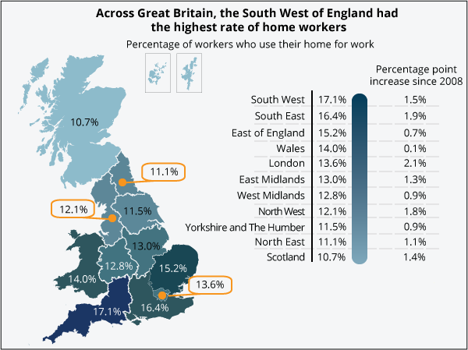
Source: http://webarchive.nationalarchives.gov.uk/20160107085358/http://www.ons.gov.uk/ons/resources/cht2forhwstory_tcm77-365838.png

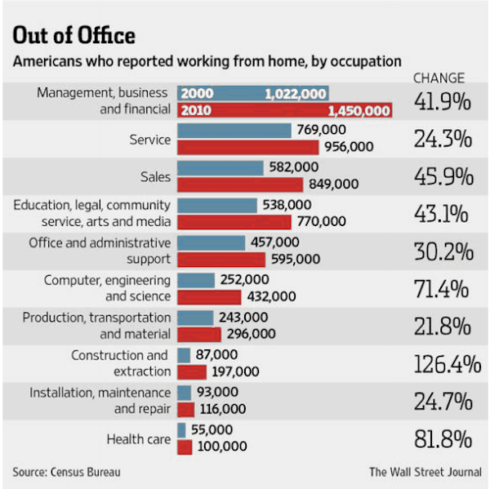
Source:
https://www.allbusiness.com/increase-the-productivity-of-your-remote-teams-12243-1.html

