

Assessment 1 – Reading Task Template
PART 1: Upload your photo of your A3 in-class notes here:
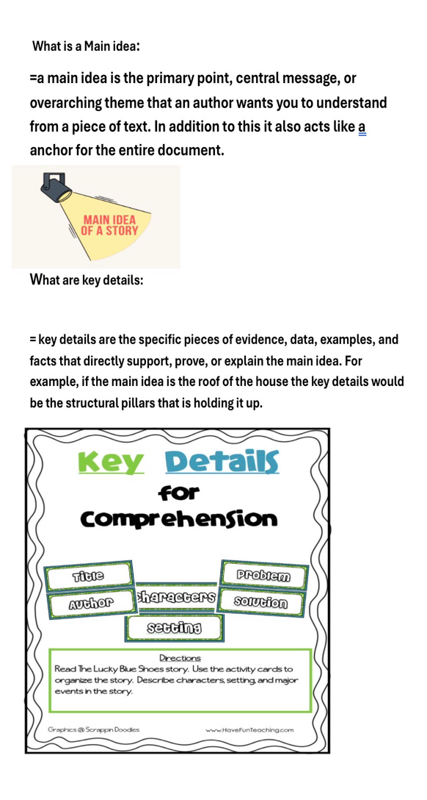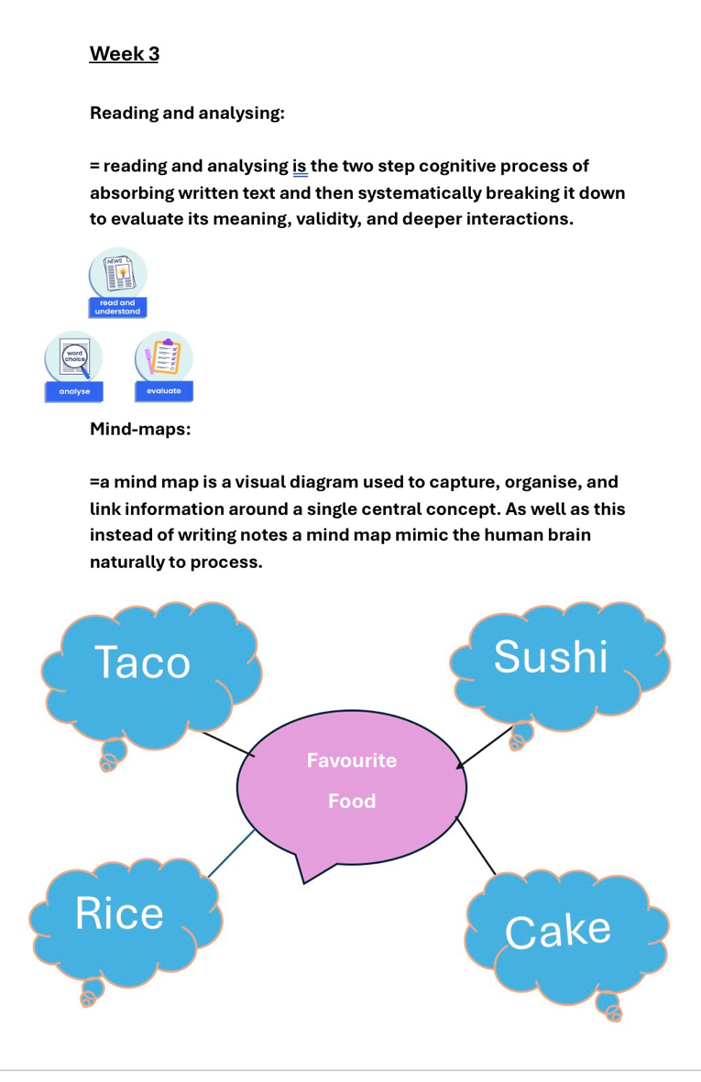

PART 2:
- Answer every question below in 1-3 full sentences.
- Use your own words. Do not use generative AI to answer these questions.
- Include a specific detail from the text when asked.
REMINDER
- The main idea is the overall message of the whole text.
- A key point helps to explain the main idea.
- A specific detail or example from the text shows that the key point is true.

- What is the main idea of the whole text?

= Platforms such as TikTok and Instagram which are well known social media apps give small local shops the ability to connect with massive, far-off audiences and turn that visibility into earnings and expansion. The piece highlights ventures including Honey wood Sandwich Shop, Lindy Loo’s Boutique, and Little Love’s Pamper Bus, all of which gained many more patrons thanks to these sites. This proves that social media acts as a great equaliser, giving independent small enterprises a strong advantage at having. Really good business and a heads-start

- What is one key point that supports the main idea, and which specific example from the text shows this?
= When shoppers share their experiences online, they can generate rapid, far-reaching exposure that businesses could never afford to buy on their own. Take Murat Mutlu’s Honey wood Sandwich Shop in Basildon: one customer’s online post drew people travelling more than three hours in car or bus just to taste his chicken burger. That single online mention brought in visitors from distant places and lifted his sales which made his business run very smoothly because he is getting more and more customers from different areas that love his food and are willing to travel really far just to taste his cooking.

- What is a different key point that supports the main idea, and which specific example from the text shows this?
= Sharing content directly on social media allows local traders to go beyond their immediate neighbourhood and serve customers nationwide which is really good because the more people that comes to the business the more profit the business will bring in or even internationally. Linda Hunter began using Instagram for Lindy Loo’s Boutique during the pandemic; today she sends clothing across the UK and as far as Australia, growing from a market stall into a full online operation which is really good because it is not only the UK that she is selling her clothes she is choosing different places. This shows that location no longer sets a limit on how far a business can reach.

- Which part of the text do you think is most important, and why?
= The real-world success stories stand out most because they show anyone can thrive this way and that u really do not really need a lot to make your business successful and u don’t need a lot of money to start with you can start from home — not just large corporations with big budgets. At Krystal Boutique in Leigh-on-Sea, owner Kristy Chamberlain notes that customers travel four or five hours from places like the Channel Islands and Cyprus after seeing her sketches of prom gowns online which made them impressive and that is really good because a lot of schoolgirls need their dresses for prom. This proves that genuine, straightforward content often outperforms polished, expensive advertising.

Reflection:
- What did you find difficult in this task (including in-class components), and why was it difficult?

= The most challenging part was deciding which specific example best illustrated the article’s main message because every featured business achieved success through social media in its own distinct way and made their businesses successful by doing so. It was hard to pick just one standout story for instance, Little Love’s Pamper Bus hitting roughly 45 million views in under a year felt incredibly impressive because that means that they know what they were doing and know how to bring in customers, yet Lindy Loo’s Boutique growing from a market stall to shipping internationally was equally powerful. I struggled to settle on which individual case best stood for the broader trend without leaving out equally meaningful examples.

- What helped you with this difficulty, and how did it help you?
= To work through this, I looked for what connected all the stories rather than focusing on just one every business saw its reach and sales grow directly from sharing content online. I also noted the key detail that over 200 million businesses globally now use Instagram to find customers, which confirmed this is a widespread pattern because instagram is a wide world app and a lot of peoples it to support their business not just a few lucky results. Once I realised every example reinforced the same main idea, it became much easier to see they all mattered equally and I could reference them together confidently because they are all talking bout how their business are successful and what they did to make that happen.

