LEVEL 7 ASSESSMENT SPECIFICATION
Student name: | Paul Amoh | Student ID number: | 2246297
Programme: | MSc Public Health and Social Care in Practice
Module: | Health Care System Organisation and Leadership
Module code: | LCHS7002 | Contribution to Overall Module Assessment (%): | 100%
Lecturer: | Dr Fahad Khan | Internal Verifier: | Dr Hamdi Hussain
Assignment Title: | Case Study Analysis Report | Word count (or equivalent): | 5000 words (+/- 10%)

Table of Contents
1. Introduction 2
1.1 Background and Context of the Lewis Blackman Case 2
1.2 Leadership, Organisational Systems and Report Overview 2
2. Identifying the Problem and Setting the System Context 3
2.1 The Lewis Blackman Case 3
2.2 System Context and Governance 4
2.3 Rich Picture and CATWOE Analysis 5
3. Centralisation versus Decentralisation within the Case Study 6
3.1 Centralisation 6
3.2 Decentralisation 7
3.3 Comparative Analysis 7
4. Leadership Theories and Their Application to the Case Study 8
4.1 Leadership Theories 8
4.2 Application to the Lewis Blackman Case 9
4.3 Leadership Evaluation 10
5. Improvement and Lessons Learned 11
5.1 Leadership and Governance 11
5.2 Evidence-Based Improvements 12
5.3 Lessons Learned 13
6. Recommendations 13
6.1 Leadership and Governance 13
6.2 Organisational Improvement 14
Conclusion 15
References 16

1. Introduction

1.1 Background and Context of the Lewis Blackman Case
The Lewis Blackman case is an important patient safety incident with implications for patient safety discussions about patient safety leadership, governance and organisational learning in healthcare systems. Lewis Blackman, 15, had elective surgery in 2000 at the Medical University of South Carolina. He had definite clinical deterioration during his post-operative recovery period and multiple concerns by Lewis and his mother were not properly noted or escalated. He died after not being treated for his medical condition (which could have been prevented) until he reached his senior years, according to the Patient Safety Movement Foundation (2024). The incident is reported as a multiple failure on a systems level, as reported by Reddy et al. (2022), which is not a clinical mistake, but a system failure relating to ineffective communication, insufficient supervision of junior clinicians, healthcare disruptions, and poor organisational accountability. The case is therefore a significant case of how the weaknesses of organisations affect patient safety and the quality of healthcare.
This report critically evaluates the Lewis Blackman Case to explore the impact of leadership, governance, organisational structures and thinking about systems on patient safety. Leadership is not just about managing staff, it should also be about leadership and influence within multidisciplinary teams towards common objectives that encompass safe, effective and patient-centred care (O'Donovan et al., 2021). Likewise, good governance puts accountability, transparency, clinical oversight and ongoing quality enhancement in place, which helps to minimise the risk of avoidable harm (NHS England, 2025).

1.2 Leadership, Organisational Systems and Report Overview
Leadership and decision making are greatly affected by a healthcare's organisational structure. Centralised systems are based on hierarchical control and can result in a slower response to escalation, and can also limit frontline decision making, while decentralised systems foster collaborative working, shared responsibility and responsive clinical practice. The efficacy of either is linked to the quality of leadership and governance in terms of supporting organisational performance.
The theories of Transformational Leadership, Transactional Leadership, Situational Leadership and Distributed Leadership are examined in the context of the Lewis Blackman case (Bass and Riggio, 2006). These viewpoints are combined with a systems thinking, a perspective that acknowledges that negative events emerge from a series of interconnected organisational processes, and not from a single failure in an individual or system (Lombardi, Cunha and Giustiniano, 2021). The report therefore draws on systems thinking and governance principles, considers healthcare organisational structures and leadership practices, reviews evidence of interventions that have been shown to improve patient safety and accountability, and recommends actions to enhance patient safety, accountability and organisational learning.

2. Identifying the Problem and Setting the System Context

2.1 The Lewis Blackman Case
The Lewis Blackman case illustrates a series of interrelated failures in leadership, communication and organisational systems that caused the patient to be harmed. Lewis Blackman, a healthy 15-year-old boy, has to undergo elective surgery to correct his pectus excavatum at the Medical University of South Carolina in November 2000. The operation is initially successful but the postoperative course is short and marked by progressive worsening of abdominal pain, tachycardia, abdominal distention, vomiting and decreased urine output. Despite these accepted signs of serious post-operative complications, healthcare staff do not conduct timely clinical evaluation or refer him to higher level medical staff members (World Health Organization, 2024).
A critical incident analysis suggests that the negative outcome is a combination of opportunities for improvement along the care pathway. Helen Haskell brings up several times a concern about the deterioration of her son but in a hierarchical clinical setting, junior doctors still run the patient without a consultant. Inadequate decision making, supervision and communication all hinder the early detection of Lewis' decline (Hungbo, Adeyemi and Ajayi, 2020). Lewis thus becomes septic due to an untreated perforated duodenal ulcer and dies of subsequent complications that would have been avoidable if the ulcer had been treated (Senior, 2024).
The key issue is not just delay in diagnosis but broader issues of leadership, governance and patient safety within the organisation. Accountability for identifying and escalating deteriorating clinical condition is not clear, and low-level co-ordination between nurses, junior doctors and consultants is undermining the accountability for co-ordinated care. The World Health Organization (2021) notes that the majority of patient harm is preventable and is not due to wrongdoing or negligence on the part of an individual, but rather stems from the failures of the health care system. In this context, the Lewis Blackman case is a prime example of how poor leadership and governance in organisations can impact patient safety, emphasising the importance of effective clinical supervision, multi-disciplinary working, timely escalation and communication to ensure that the quality of healthcare delivered is enhanced and avoid future incidents of similar severity (NHS England, 2024).

2.2 System Context and Governance
The Lewis Blackman case has happened in one hospital but it's indicative of issues in patient safety going on in healthcare globally. World Health Organisation (2024) report that almost 10% of people are harmed during health care service, many of which could be prevented if there were better systems and structures and leadership, governance. These findings imply that patient safety problems are linked to the flaws in the health care process rather than to specific incidents of health care failures.
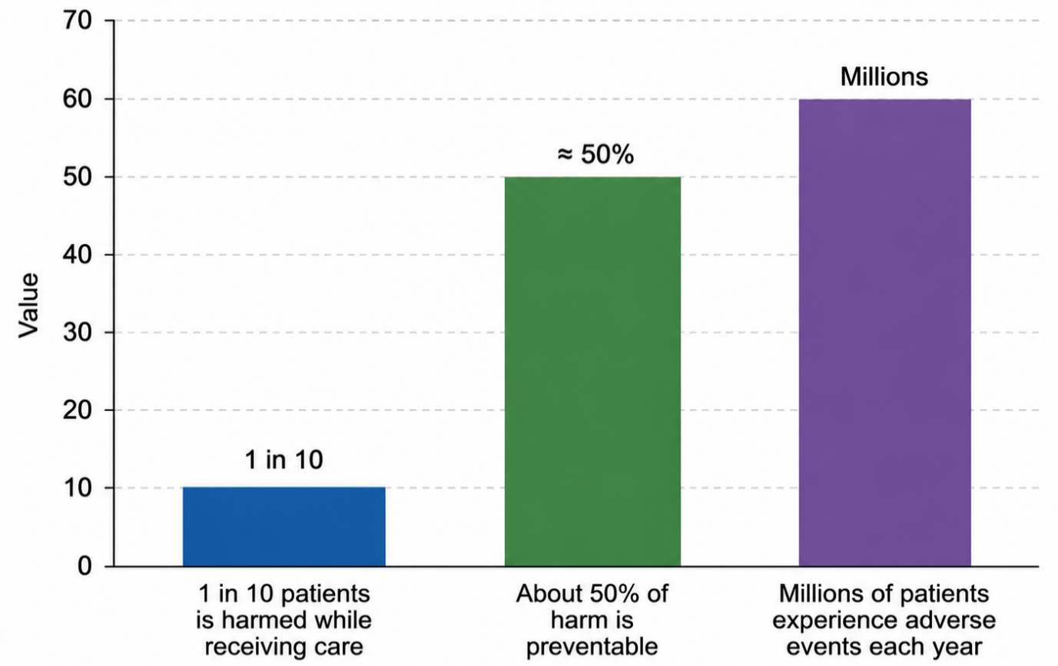
Figure 1. Global Patient Safety Statistics Reported by the World Health Organization (WHO)
Source: Author's Own illustration
This is supported with national evidence. Hungbo, Adeyemi and Ajayi (2020) cites communication issues, lack of patient deterioration recognition and lack of escalation as key factors contributing to serious patient safety incidents. In the same vein, Slawomirski, L. and Klazinga, N. (2022) has noted the high clinical and financial strains on health systems when patients suffer harm that could have been prevented, which is a reason for health systems to invest in governance and organizational learning. The Lewis Blackman incident, therefore, is not a stand out clinical incident, but a sign of greater systemic failings.
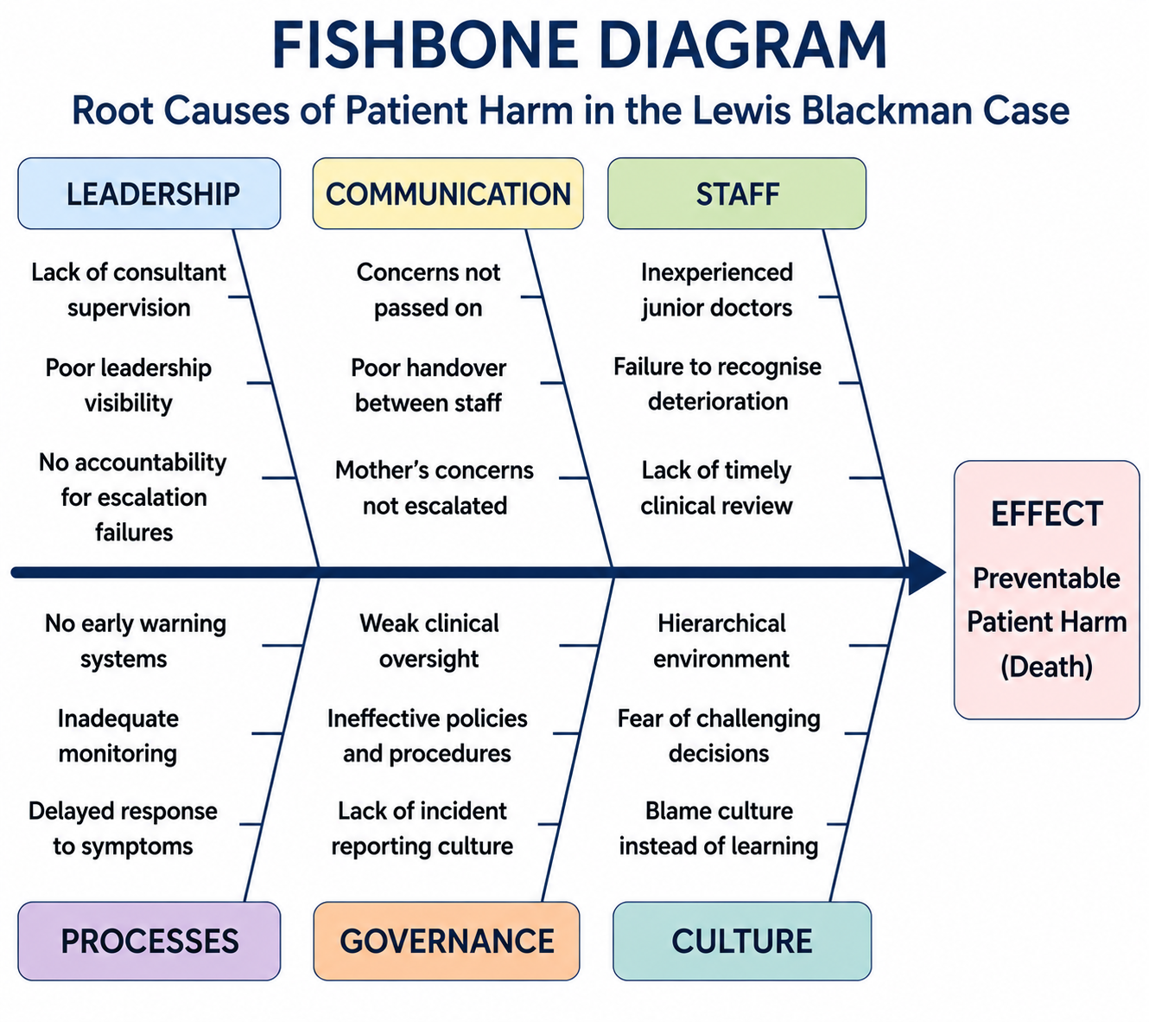
Figure 2. Fishbone (Ishikawa) Diagram of the Root Causes of Patient Harm in the Lewis Blackman Case
Source: Author's Own illustration
It brings up governance issues of communication, consultant supervision, accountability and decision making. Timely escalation takes time with these hierarchical structures and reduces multidisciplinary collaboration increasing the risk of preventable harm. Menear et al. (2019) discusses how the various components of an organisation create organisational outcomes through the interactions of the various parts, rather than the actions of individual components. Likewise, Altmiller (2022) believes that bad things happen when several organisational precautions are breached at the same time. The Lewis Blackman case therefore demonstrates the need to have a more integrated leadership, governance and learning in the whole system, and to have this as a core component of further raising patient safety and not just clinical performance.

2.3 Rich Picture and CATWOE Analysis
A Rich Picture gives a complete picture of the Lewis Blackman case by capturing the various interactions between patients, families, health care professionals, organisational structures and governance.
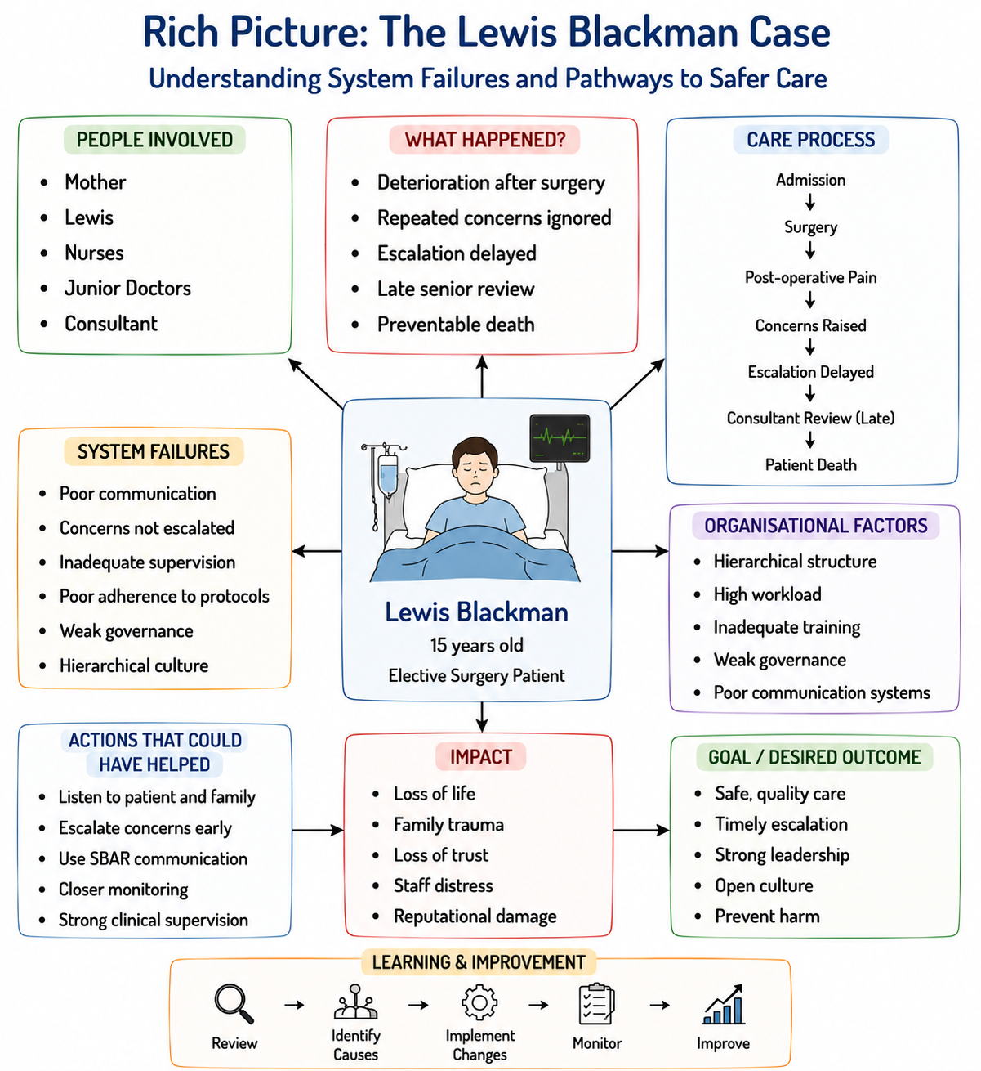
Figure 3. Rich Picture of the Lewis Blackman Case
Source: Author's Own illustration
The analysis shows that both Lewis and Lewis and his Mum communicate concerns about his condition multiple times, but they do not do so in an effective way through communication paths, as there is a lack of clear accountability for clinical decisions. Nurses are alert to patient deterioration, but junior doctors have very restricted powers to take definitive action, and consultant involvement is consequential due to hierarchy and poor escalation. As a result, poor communication, lack of accountability and delayed decision-making form reinforcing cycles that ultimately end up with poor patient safety (Hackman, 2026). The Rich Picture is thus an illustration of how organisational failure is a result of interconnected system failures, not single individual failures.
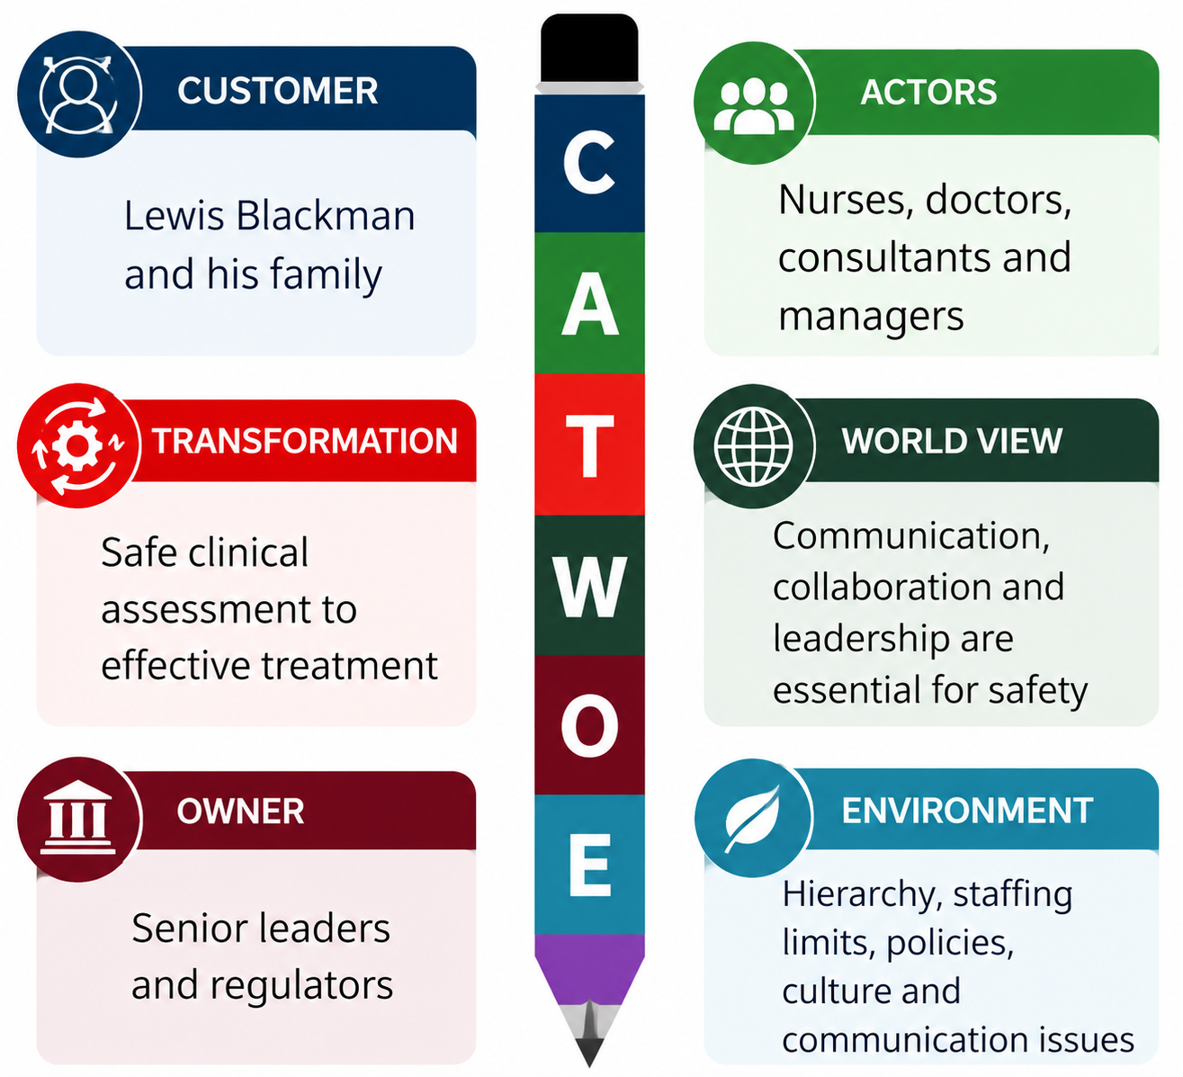
Figure 4. CATWOE Analysis of the Lewis Blackman Case
Source: Author's Own illustration
The CATWOE framework further reinforces this systems analysis by identifying the elements that are crucial to the performance of the organisation. The Customers (C) are the Lewis Blackman and his family where the clinical decisions directly impact health and wellbeing. The Actors (A) are nurses, junior doctors, consultants and hospital managers who are involved in delivery and co-ordination of care. The intent of the Transformation process (T) is to transform the safe clinical assessment into effective treatment, but organisational failures throughout disrupt this process. The Worldview (W) acknowledges that effective communication, collaboration and leadership are essential to patient safety. Owners (O) are senior hospital leaders and regulators having the power to redesign governance systems and enhance accountability. Finally, Environmental constraints (E) are hierarchical culture, staffing constraints, communication issues, and organisational policies that affect clinical decision making (Alderwick, Hutchings and Mays, 2024). Overall, the Rich Picture and CATWOE contribute to identifying that sustainable improvement goes beyond the procedural to system-wide leadership and governance changes.

3. Centralisation versus Decentralisation within the Case Study

3.1 Centralisation
Centralisation is an organisational structure that has decision-making power at the top level, which results in a uniformity of policy, consistency of governance and regulation (Baporikar, 2024). Centralised systems can enhance accountability by providing clear reporting lines, clinical procedures and good organisational oversight, according to NHS England (2023). These are especially important in providing uniformity in health care delivery, ensuring compliance to clinical guidelines, and minimizing unnecessary variations in practice. But there are risks of relying too heavily on hierarchical authority that could slow decision-making, limit autonomy for frontline staff and impede the ability of the organisation to respond to the changing nature of clinical contexts.
Lewis Blackman's case is an example of how a more centralised health care system has its drawbacks. Nurses repeatedly notice that Lewis is deteriorating, but they are unable to change his care, or seek his consultant's help immediately, because junior doctors have very little power to do so. Hierarchical decision making is associated with a reluctance to escalate and stifles communication between professional groups, which negatively impacts the time it takes to identify Lewis's illness. Thus, when he is involved as a consultant, he is in a very bad state and there is very little opportunity for effective clinical intervention.
Centralisation offers a uniformity of organisation and accountability, but the case shows how these benefits can be lost if leadership is not to promote open communication and joint clinical responsibility. Peadon (2024) state that patient safety benefits from the collaborative nature of governance structures, not the hierarchical. Likewise, Altmiller (2022) cite inadequate communications and delayed clinical decisions as ongoing patient safety risks and concerns. Hence, Lewis Blackman is a case whereby centralisation did not guarantee safety of patients. Effectiveness relies on leadership that enable frontline professionals, timely escalation, and governance and responsive clinical decision making.
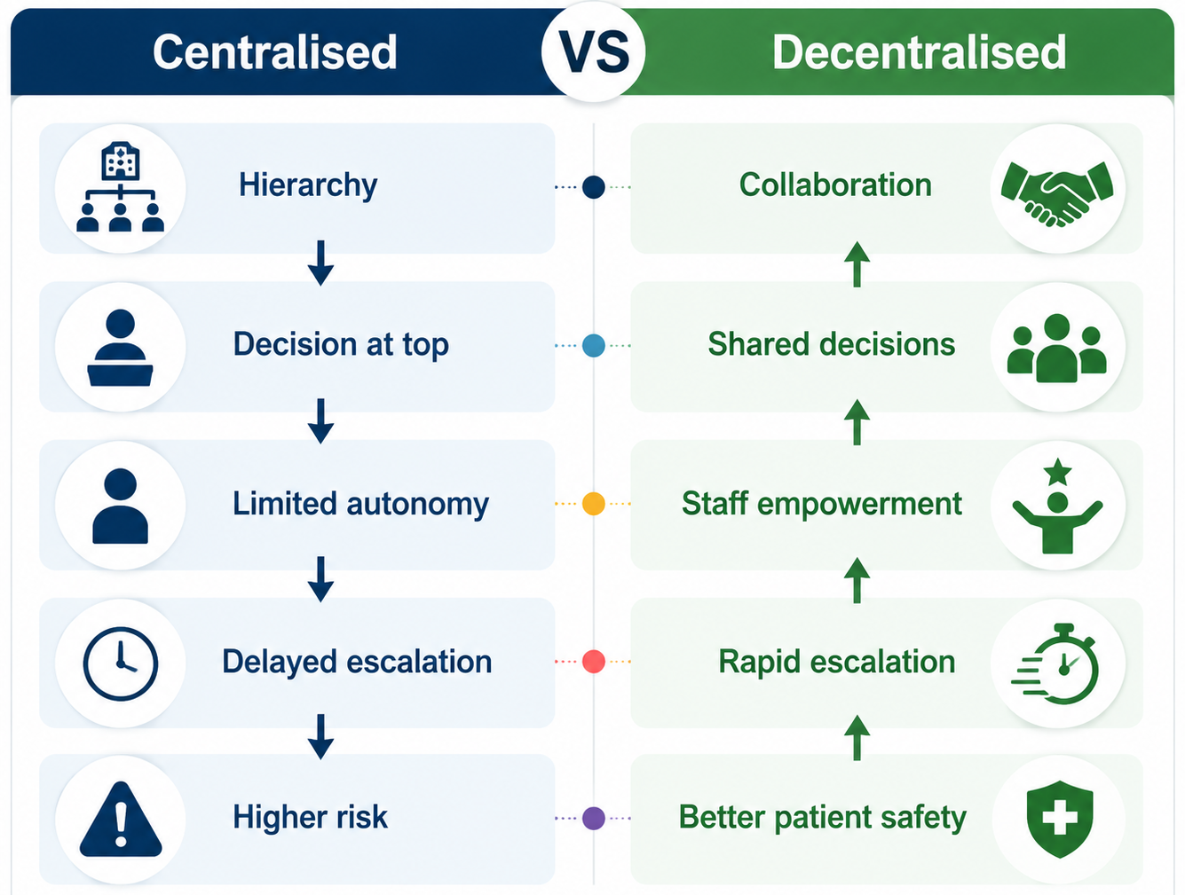
Figure 5. Centralised and Decentralised Decision-Making in Healthcare
Source: Author's Own illustration

3.2 Decentralisation
Decentralisation ensures decentralisation of decision-making power at various levels in an organization which allows the frontline healthcare worker to react quickly to the changing needs of the patient (Sellu, 2023). In health care, this fosters shared leadership, interprofessional collaboration, and enhanced professional autonomy, thereby enhancing responsiveness and innovation, and delivering patient-centred care (Kock, 2022). Decentralised systems enable timely clinical judgements and promote shared responsibility for patient outcomes by empowering clinicians who are most directly involved with the patient.
In the Lewis Blackman case, there was a possibility of having a more decentralised system so that nurses and junior doctors could have raised Lewis' case without unnecessary delay. Although Kandeya et al. (2025) reports that Lewis has repeatedly raised concerns with him, his mother, and nurses, their concerns are not addressed in a timely fashion, with decision making power stuck in the hands of the medical hierarchy. Staff at the point of care may have been empowered to escalate, or to seek consultation, earlier; this might have led to earlier diagnosis and treatment and less preventable harm. This indicates that clinical authority shared can enhance communication while addressing high-speed situations.
Although some of these benefits are there, decentralisation has its restrictions. With greater autonomy comes less consistency of clinical decision making if the roles, reporting and governance structures are not clear. NHS England (2023) should also stress the importance of decentralised practice being carried out within a well-defined clinical pathway, interprofessional communication and accountability structures, which all ensure patient safety. In addition, Keller et al. (2025) states that healthcare organisations that are more successful in providing collaborative decision making, where there are strong governance and a culture of continuous learning within the organisation, will deliver improved safety. Thus, although it is desirable to have a decentralised organisation, which can lead to quicker decisions and multidisciplinary teamwork, this must be balanced with consistent governance, clinical oversight and organisational accountability.

3.3 Comparative Analysis
The analysis of centralised and decentralised structures indicates that patient safety is neither achieved with a single structure, nor is it achieved without the presence of leadership, governance and communication. In centralisation, there is uniformity, regulation, and accountability, while decentralisation brings about collaboration, autonomy and timely clinical decision making (Stephanidis et al., 2019). It is therefore imperative that a balance is achieved between being in control and being responsive on the frontline in both these structures.

Table 1. Comparison of Centralised and Decentralised Healthcare Systems
Aspect | Centralised Healthcare System | Decentralised Healthcare System
Decision-making | Controlled by senior leaders | Shared across clinical teams
Leadership style | Hierarchical authority | Collaborative leadership
Communication | Vertical reporting | Open, multidisciplinary communication
Clinical response | May delay escalation | Supports rapid intervention
Frontline autonomy | Limited | Greater professional authority
Accountability | Clear managerial oversight | Shared with defined responsibilities
Main strength | Consistency and standardisation | Flexibility and responsiveness
Main limitation | Slow decision-making | Risk of inconsistent practice
Application to Lewis Blackman case | Delayed consultant review and restricted escalation | Earlier escalation and shared clinical decisions could improve outcomes
Patient safety impact | Depends on responsive leadership | Depends on effective governance and collaboration
Source: Author's Own illustration
For the Lewis Blackman case, a centralised decision-making process is delaying consultants' involvement, and reducing the role of nurses and junior doctors in escalating concerns OECD/European Commission (2024) notes that decision making in a hierarchy undermines accountability and timeliness of intervention. Collaboration may have been enhanced further through a more decentralised approach which might lead to earlier identification of patient deterioration, but with unclear governance may lead to role ambiguity (Olowomeye, 2025). Delayed escalation is identified by NHS England (2023) as a commonly reported serious patient safety incident and collaborative leadership and good governance are identified as aiding patient. So, it is crucial to have a balance between centralisation and decentralised clinical decisions for patient safety.

4. Leadership Theories and Their Application to the Case Study

4.1 Leadership Theories
Leaders are widely known to affect decision making, communication and team working in organisations and the delivery of high-quality health care, which all have a bearing on patient safety and organisational performance. Healthcare organisations do not always have to have a single leadership style; they may need to use different leadership styles, depending on the level of complexity in the organisation and the clinical context. There are four leadership theories that are applicable to the study of patient safety in the Lewis Blackman case.
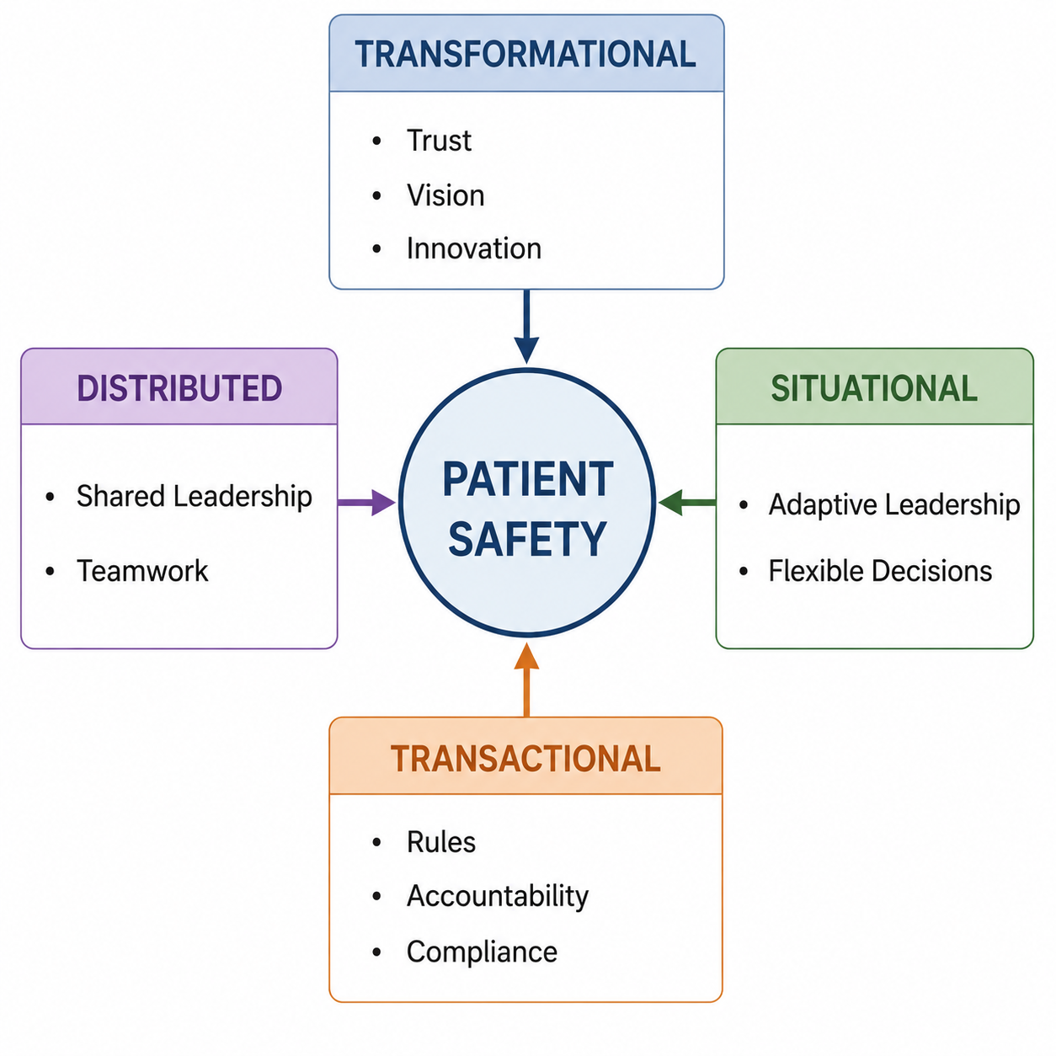
Figure 6. Leadership Theories Influencing Patient Safety
Source: Author's Own illustration
Transformational leadership is about building trust and teamwork, as well as innovation and a shared vision. Bass and Riggio (2006) suggest that transformational leaders foster a culture of open communication and ongoing enhancement, thus putting at ease healthcare workers to raise concerns without fear of hierarchy. Leadership of this type is linked to better staff engagement and better patient safety measures (Parr, Teo and Koziol-McLain, 2021).
Table 2. Comparison of Leadership Theories in Healthcare
Leadership | Communication | Decision Making | Teamwork | Suitability
Transformational | High | Shared | Excellent | High
Transactional | Moderate | Hierarchical | Moderate | Medium
Situational | High | Flexible | High | High
Distributed | Very High | Shared | Excellent | Very High
Source: Author's Own illustration
By comparison, transactional leadership is centred around containable supervision, defined roles and compliance with the organization. This method enhances accountability by means of policies and performance monitoring. While transactional leadership can help bring uniformity and regulation, too much hierarchy can diminish flexibility and inhibit proactive decision making in the face of complex clinical circumstances.
According to situational leadership, a good leader should modify his or her behaviour based on the situation and the competence of his or her team members (Issah, 2018). The flexibility allows leaders to give more direction during emergencies and allows autonomy when healthcare professionals have sufficient knowledge and experience.
Distributed leadership is based on a collaborative approach and defines leadership as a shared responsibility between multidisciplinary teams, not as a responsibility held by the senior manager. Eslahchi, M. (2023) recommends that the dissemination of leadership will enhance communication, collective decision making, and organisational learning. As a result, leaders are increasingly seeking to combine transformational, situational and distributed leadership to enhance team working, responsiveness, patient safety and effective governance and accountability.

4.2 Application to the Lewis Blackman Case
The Lewis Blackman case illustrates the negative impact of poor leadership, which has repercussions on poor communication, delayed decision making and the avoidable harm to patients. Healthcare professionals are aware of Lewis' declining health, but leadership does not support timely escalation, working across the disciplines and good clinical supervision. Forbes, Iyengar and Kay (2019) states that in hierarchical cultures, junior clinicians are not encouraged to seek senior clinicians, leading to a delay in diagnosis and treatment.
Transformational leadership promotes open communication, shared responsibility, empowerment and increased teamwork, that all lead to better organisational learning (Bass and Riggio, 2006). But these are not present in the case: staff autonomy is restricted and communication is not optimal, compromising patient safety. Transactional leadership offers accountability, but it works more on a hierarchical basis with less flexibility in times of changing and dynamic clinical situations (Sellu, 2023). In the same way, situational leadership is not demonstrated when the senior clinicians do not adjust to Lewis's poor. Distributed leadership is also missing, with decisions being made at the level of senior physicians and not spread throughout the multidisciplinary team.
In total, the leadership failures have a negative impact on communication, teamwork and patient safety. NHS England (2023) puts a key focus on the importance of leadership and timely escalation to drive up a good level of performance and help prevent serious patient safety incidents from occurring.

4.3 Leadership Evaluation
The Lewis Blackman case is a major example of a low-level leadership style, which is more reactive than proactive. Leaders do not respond to an early deterioration in Lewis's condition but wait until he has deteriorated significantly before taking action. Poor leadership leads to a lack of accountability and a patient-centred approach, as ineffective supervision, delayed consultant involvement and communication issues result in late clinical decisions, according to Peadon (2024).
The leadership style used during the incident is therefore not suitable to leading a complex and dynamic clinical situation. Although transactional leadership has a clear system of reporting, too much hierarchy may impede decision making on the front line and discourage junior clinicians from raising concerns (O'Donovan et al., 2021). Transformational and distributed leadership, on the other hand, promote open communication, shared responsibility, and collaborative problem solving, all of which are important for promoting patient safety.
Better results would be achieved with an alternative approach to emotionally intelligent leadership. Goleman (1998) suggests that leaders who exhibit emotional intelligence are empathetic, actively listening and self-aware, which helps them to identify concerns from patients, families and health care professionals. Sustaining an environment of emotional intelligence, as well as implementing practices of transformational and distributed leadership could have helped to improve communication, teamwork, and earlier escalation of Lewis's declining condition in the Lewis Blackman case. Patient safety therefore requires a mix of adaptive, collaborative and emotionally intelligent leadership and strong governance and organisation learning.

5. Improvement and Lessons Learned

5.1 Leadership and Governance
Effective leadership and governance are crucial to patient safety, not just clinical skills, in the Lewis Blackman case. Communication, decision making and responses to patient deterioration are all influenced by leadership and governance delivers accountability, clinical oversight and safe practice. If these elements are not functioning properly, predictable mistakes and delays in treatment occur.
The case reveals significant weaknesses both within the organisation, such as communication, escalation and lack of clinical supervision. Altmiller (2022) explains that the issues that nurses have and Lewis's mother raise are not addressed because a hierarchical culture does not promote collaboration nor prompt decision making in a timely fashion. Consequently, there is reduced accountability and needless delay in the consultant's involvement. This is also indicative of failings of clinical governance and monitoring systems.
This incident points to a number of missed opportunities, such as earlier escalation, better multidisciplinary collaboration, and higher senior involvement. World Health Organization (2021) states that avoiding blame, promoting learning and transparency, and continuous improvement are crucial to improving patient safety for organisations. Likewise, Hungbo, Adeyemi and Ajayi (2020) state that leadership should ensure that staff voice their opinions and work together with colleagues in other professions. Thus, patient safety must be led and governed to enhance accountability, effective communication and proactive clinical decision making for sustainable patient safety.

5.2 Evidence-Based Improvements
There is a need for healthcare organisations to adopt evidence-based improvement strategies to enhance leadership, governance and patient safety to prevent incidents like that of Lewis Blackman. Reinforcement of clinical governance, based on clear accountability, regular clinical audits and ongoing monitoring of patient outcomes will be a key priority. Reddy et al. (2022) states that good governance helps to keep patients safe as it helps identify, escalate and resolve clinical concerns in time.
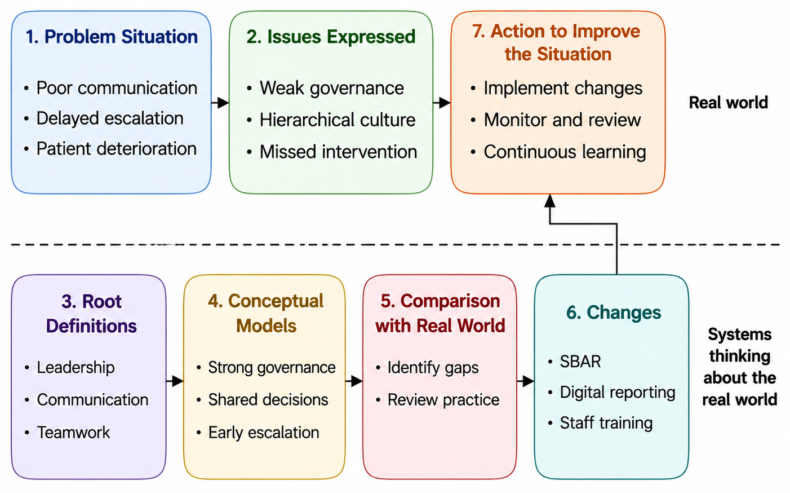
Figure 7. Soft Systems Methodology (SSM) for Improving Patient Safety
Source: Author's Own illustration
To minimise misunderstandings and ensure timely multidisciplinary decision making, communication and escalation should be strengthened within healthcare organisations using a standardised approach to communication, e.g. SBAR (Situation, Background, Assessment, Recommendation). Structured communication is a vital component of avoiding unnecessary untoward incidents and collaboration among teams, according to the World Health Organization (2024). Likewise, digital incident-reporting systems and electronic early warning scores allow for earlier identification of deterioration and quicker clinical response to patients.
Continuous staff and leadership development is as critical as leadership development. Slawomirski, L. and Klazinga, N. (2022) suggest spending investment in communication, emotional intelligence, collaborative decision-making training in leadership development. Staff capability and the risk to the safety of patients is further enhanced through regular simulation exercises, interprofessional education, clinical audits and organisational learning.
The framework of Soft Systems Methodology (SSM) is useful for implementing these improvements as it takes the leadership, governance, communication and organisational culture into account as interconnected. Issah (2018) have stated that SSM can be used to help facilitate sustainable organisational change as it attempts to solve complex problems in relation to system relationships rather than stand-alone issues. Therefore, the adoption of robust governance, communication, digital technologies, leadership development and continuous quality improvement (CQI) involves building organizational resilience, patient safety and mitigating further clinical risks.

5.3 Lessons Learned
The key to patient safety is the effective interaction of leadership, governance, structure and systems thinking and not clinical competence alone as illustrated in the Lewis Blackman case. These factors—poor leadership, poor governance, hierarchical decision making and ineffective communication—all contribute to the failure to recognise patient deterioration in a timely fashion and have a negative effect on patient outcomes. Healthcare organisations are system-wide, as Parr, Teo and Koziol-McLain (2021) states, and the failure in one part can have an impact on the other parts of the organisation.
One important thing to take away from the health and social care organisations is to encourage open communication, shared accountability and prompt escalation of clinical concerns. Organizations with cultures that support learning and collaboration have an effect on reducing preventable patient harm. Olowomeye (2025) also notes that patients and families must be seen as active partners of care and their observations could help warn clinicians to intervene earlier with care.
Finally, a successful culture of continuous improvement must involve effective leadership, strong governance, a multi-disciplinary team and evidence-based practice. These features are mentioned in NHS England (2023) as improving accountability, patient safety and the ability to learn from what has happened in the long term. Thus, the Lewis Blackman case is an important reminder of the need to take a systems-based approach to stopping more of these incidents and to improving the quality of healthcare delivery.

6. Recommendations

6.1 Leadership and Governance
This report suggests that the way to ensure patient safety needs to be based on leadership models that focus on collaboration, accountability and proactive decision making. A combination of transformational, distributed and situational leadership is better suited than a hierarchical leadership model. The culture of transformational leadership promotes trust, openness, and the learning process, which empowers healthcare workers to come forward with concerns without facing criticism (Bass and Riggio, 2006). Distributed leadership extends this concept by ensuring that there is shared responsibility within the multidisciplinary teams, and situational leadership will allow senior clinicians to make decisions based on the complexity and urgency of patient needs.
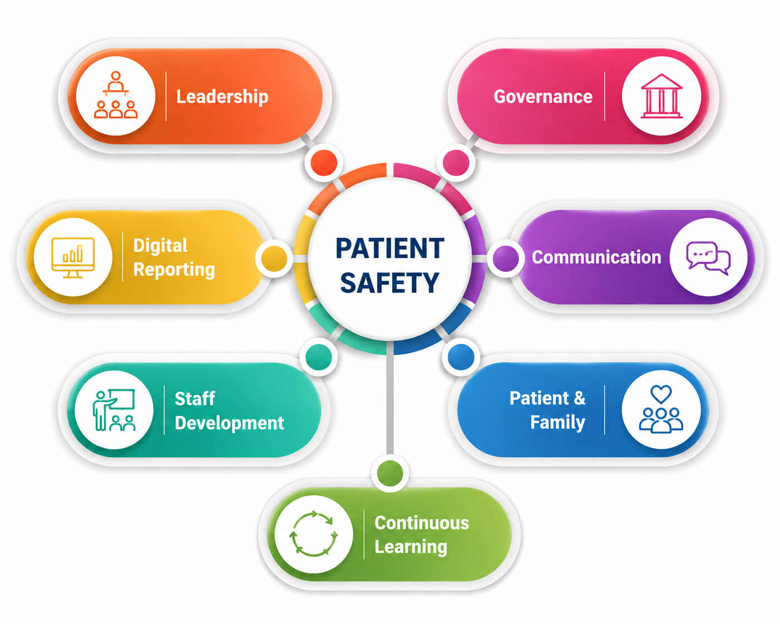
Figure 8. Framework for Sustainable Patient Safety Improvement
Source: Author's Own illustration
There should also be improvements in governance by clarifying the accountability frameworks and through more effective clinical supervision. Organisations that have strong governance systems are better placed to track clinical performance, recognise any patient safety risks and respond quickly to any patient safety issues. Healthcare organisations should, therefore, ensure there are regular clinical audits, robust consultant supervision of junior clinicians and clear reporting systems to support early escalation of patients who are deteriorating. Similarly, the World Health Organization (2021) highlights the importance of governance for learning, not for fault-finding, and for organisations to recognize the weaknesses and improve in a sustainable way.
Leaders must establish an organisational culture in which everyone involved in the health service grasps their accountability for patient safety to further improve accountability. Effective leadership is demonstrated by Eslahchi, M. (2023) not just by the decision-making but also by encouraging staff to communicate openly, challenge unsafe practice and to be involved in ongoing quality improvement. Therefore, the combination of effective governance and good leadership is key to enhancing patient safety, organisational resilience and service quality.

6.2 Organisational Improvement
Healthcare organisations need to enhance the communication process through developing a standardised process for escalation, including SBAR (Situation, Background, Assessment, Recommendation) to ensure that information is shared timely and between multi-disciplinary teams. According to the World Health Organization (2021), structured communication is an effective way to enhance teamwork and prevent patient harm. There is also the need to embed digital incident reporting systems and electronic early warning score technologies that can aid the early recognition of deteriorating patients and prompt actions to prevent complications reaching critical status (NHS England, 2023).
Technical and allocative efficiency are two other ways to improve organisational performance. Technical efficiency is the effective use of digital technologies, evidence based clinical pathways and continuous monitoring of performance that minimises delays and enhances service quality. Healthcare organisations need to utilise staff, money and clinical equipment in line with patient needs and service priorities (OECD/European Commission, 2024) to achieve allocative efficiency. In addition, the principles of ongoing organisational learning should be encouraged through frequent clinical audits, multidisciplinary training, leadership enhancement initiatives and through reflection.
Engage patients, families and frontline staff in service improvement and decision-making processes. The involvement of patients and families as active partners is important for health care delivery, accountability and for safer care. This will enhance organisational resilience, patient safety and minimise the risk of the type of incident that occurred with Lewis Blackman, as effective communication, digital innovation, continuous learning, stakeholder engagement and co-production are built in to the fabric of the organisation.

Conclusion
The Lewis Blackman case illustrates how patient harm is not just a result of individual clinical mistakes, but a failure in multiple areas including leadership, governance, communication and systems in the organisation. The analysis identifies that poor escalation, poor decision making, poor supervision and hierarchy is a combination that have an impact on patient safety and that creates avoidable adverse outcomes. These results confirm the need for a good co-ordination of organisational processes and prompt clinical decision making to ensure patient safety.
The report also illustrates how good leadership and strong governance can help to enhance the quality of healthcare, increase accountability and foster multidisciplinary working. Through systems thinking, there is a greater awareness of how communication, organisational culture, leadership practices and governance can impact on patient outcomes. Therefore, sustainable improvement means that health care organisations need to work on the weaknesses of their system, continuously and based on learning, evidence-based decision making and proactive risk management, and not just on individual performance.
The Lewis Blackman case highlights the importance of embedding effective leadership, good governance and systems thinking as key components to improving patient safety and organisational resilience, overall. Healthcare organisations that promote collaboration, accountability and continuous quality enhancement have a better chance of preventing incidents from recurring and providing safe, high-quality, patient-centred healthcare.

References
Alderwick, H., Hutchings, A. and Mays, N. (2024) 'Cross-sector collaboration to reduce health inequalities: a qualitative study of local collaboration between health care, social services, and other sectors under health system reforms in England', BMC Public Health, 24(1), p.2613. Available at: https://link.springer.com/article/10.1186/s12889-024-20089-5 (Accessed: 14 July 2026).
Altmiller, G. (2022) 'Patient safety and quality of care as measures of nursing competence', in Quality and Safety Education for Nurses: Core Competencies for Nursing Leadership and Care Management, pp.1–40.
Baporikar, N. (2024) 'Corporate entrepreneurship in public sector', Journal of Entrepreneurship & Management, 13(2).
Bass, B.M. and Riggio, R.E. (2006) Transformational leadership. 2nd ed. Mahwah, NJ: Lawrence Erlbaum Associates.
Eslahchi, M. (2023) 'Leadership and collective learning: a case study of a social entrepreneurial organisation in Sweden', The Learning Organization, 30(6), pp.815–833. Available at: https://www.emerald.com/tlo/article-pdf/30/6/815/2391989/tlo-11-2022-0133.pdf (Accessed: 14 July 2026).
Forbes, M.P., Iyengar, S. and Kay, M. (2019) 'Barriers to the psychological well-being of Australian junior doctors: a qualitative analysis', BMJ Open, 9(6), p.e027558. Available at: https://bmjopen.bmj.com/content/bmjopen/9/6/e027558.full.pdf (Accessed: 14 July 2026).
Goleman, D. (1998) Working with emotional intelligence. London: Bloomsbury Publishing.
Hackman, P. (2026) Unfinished nursing care and resident outcomes: A multimethod study in nursing homes. Doctoral dissertation. Itä-Suomen yliopisto. Available at: https://erepo.uef.fi/server/api/core/bitstreams/195b5750-766b-43b1-a789-bc2b531b8152/content (Accessed: 14 July 2026).
Hungbo, A.Q., Adeyemi, C. and Ajayi, O.O. (2020) 'Early warning escalation system for care aides in long-term patient monitoring', IRE Journals, 3(7), pp.321–345.
Issah, M. (2018) 'Change leadership: the role of emotional intelligence', SAGE Open, 8(3), p.2158244018800910. Available at: https://doi.org/10.1177/2158244018800910 (Accessed: 14 July 2026).
Kandeya, B., Chimwaza-Manda, W., Kaira, P., Hanson, C., Henriksson, D.K., Stones, W., Alvesson, H.M. and Chipeta, E. (2025) 'Unlocking the path to quality maternity care: a qualitative study on work environment dynamics, providers’ responsiveness, and professionalism in central region, Malawi', BMC Pregnancy and Childbirth, 25(1), p.410. Available at: https://link.springer.com/article/10.1186/s12884-025-07525-z (Accessed: 14 July 2026).
Keller, M.E., Watson, B., Kaye, S.A., King, M. and Lewis, I. (2025) 'Experts’ perspectives on shared responsibility for speed management: a thematic analysis informed by systems thinking', Accident Analysis & Prevention, 221, p.108185. Available at: https://www.sciencedirect.com/science/article/pii/S0001457525002714 (Accessed: 14 July 2026).
Kock, L. (2022) The development of guidelines that incorporate interprofessional practice principles into rehabilitation services at a primary health care facility. Doctoral dissertation. University of the Western Cape. Available at: https://uwcscholar.uwc.ac.za:8443/server/api/core/bitstreams/9f64476a-ee3c-4e03-9bcc-ef43a84d5cef/content (Accessed: 14 July 2026).
Lombardi, S., e Cunha, M.P. and Giustiniano, L. (2021) 'Improvising resilience: The unfolding of resilient leadership in COVID-19 times', International Journal of Hospitality Management, 95, p.102904. Available at: https://doi.org/10.1016/j.ijhm.2021.102904 (Accessed: 14 July 2026).
Menear, M., Blanchette, M.A., Demers-Payette, O. and Roy, D. (2019) 'A framework for value-creating learning health systems', Health Research Policy and Systems, 17(1), p.79. Available at: https://link.springer.com/article/10.1186/s12961-019-0477-3 (Accessed: 14 July 2026).
NHS England (2024) NHS England annual report and accounts 2023 to 2024. London: NHS England. Available at: https://assets.publishing.service.gov.uk/media/6709344a92bb81fcdbe7b728/nhs-england-annual-report-and-accounts-2023-to-2024.pdf (Accessed: 14 July 2026).
NHS England (2025) NHS England annual report and accounts 2024 to 2025. London: NHS England. Available at: https://assets.publishing.service.gov.uk/media/69036ef05c84b1206832a86f/nhs-england-annual-report-and-accounts-2024-to-2025.pdf (Accessed: 14 July 2026).
O'Donovan, R., Rogers, L., Khurshid, Z., De Brún, A., Nicholson, E., O'Shea, M., Ward, M. and McAuliffe, E. (2021) 'A systematic review exploring the impact of focal leader behaviours on health care team performance', Journal of Nursing Management, 29(6), pp.1420–1443. Available at: https://onlinelibrary.wiley.com/doi/epdf/10.1111/jonm.13403 (Accessed: 14 July 2026).
OECD/European Commission (2024) Health at a Glance: Europe 2024: State of Health in the EU Cycle. Paris: OECD Publishing. Available at: https://doi.org/10.1787/b3704e14-en (Accessed: 14 July 2026).
Olowomeye, E. (2025) 'Exploring interdisciplinary family medicine approaches to improve chronic disease management and patient-centered outcomes', International Journal of Research Publication and Reviews, 6(5), pp.12378–12395.
Parr, J.M., Teo, S. and Koziol-McLain, J. (2021) 'A quest for quality care: exploration of a model of leadership relationships, work engagement, and patient outcomes', Journal of Advanced Nursing, 77(1), pp.207–220. Available at: https://doi.org/10.1111/jan.14583 (Accessed: 14 July 2026).
Patient Safety Movement Foundation (2024) Lewis Blackman’s story. Available at: https://psmf.org/story/lewis-blackman/ (Accessed: 14 July 2026).
Peadon, R. (2024) Mechanisms influencing speaking up behaviours in the presence of witnessed error within the medical hierarchy: A critical realist perspective from regional New South Wales, Australia. Doctoral dissertation.
Reddy, B., Thomas, S., Karachiwala, B., Sadhu, R., Iyer, A., Sen, G., Mehrtash, H. and Tunçalp, Ö. (2022) 'A scoping review of the impact of organisational factors on providers and related interventions in LMICs: implications for respectful maternity care', PLOS Global Public Health, 2(10), p.e0001134.
Sellu, E.F. (2023) Ebola Virus Disease and COVID-19: A critical analysis of the healthcare response strategies and capacities in Sierra Leone. Doctoral dissertation. Oklahoma State University. Available at: https://www.proquest.com/openview/4eb2383cf8d7eff18352a765fd864f07/1?pq-origsite=gscholar&cbl=18750&diss=y (Accessed: 14 July 2026).
Senior, T.S.B. (2024) Surgical pathology. Available at: https://elearning.reb.rw/pluginfile.php/84843/mod_resource/content/2/ANP-SURGICAL%20PATHOLOGY-S6-TG.pdf (Accessed: 14 July 2026).
Slawomirski, L. and Klazinga, N. (2022) The economics of patient safety: From analysis to action. OECD Health Working Papers. Paris: OECD Publishing. Available at: https://www.oecd.org/content/dam/oecd/en/publications/reports/2022/08/the-economics-of-patient-safety_dda2a072/761f2da8-en.pdf (Accessed: 14 July 2026).
Stephanidis, C., Salvendy, G., Antona, M., Chen, J.Y., Dong, J., Duffy, V.G., Fang, X., Fidopiastis, C., Fragomeni, G., Fu, L.P. and Guo, Y. (2019) 'Seven HCI grand challenges', International Journal of Human–Computer Interaction, 35(14), pp.1229–1269. Available at: https://doi.org/10.1080/10447318.2019.1619259 (Accessed: 14 July 2026).
World Health Organization (2021) Building better while leaving no one behind: WHO Lebanon Country Office crises support. Cairo: WHO Regional Office for the Eastern Mediterranean. Available at: https://applications.emro.who.int/docs/9789292740405-eng.pdf (Accessed: 14 July 2026).
World Health Organization (2024) Global patient safety report 2024. Geneva: World Health Organization. Available at: https://iris.who.int/server/api/core/bitstreams/ae1caeae-bc04-4a71-a6b0-ab478f9a8c79/content (Accessed: 14 July 2026).

