Lonyé Browne (2114209)
UWTSD
ACBA4002
ASSESSMENT 2 L4

Introduction
This report covers a practical levelling exercise for a major road reconstruction around the city campus. It will explain the levelling process and the equipment used through photos and text. The report will also show the earthwork using graphs.

General Overview
Levelling is the process of attaining the elevations of different points and determining the differences in the elevations of those points. The elevation of a point refers to its vertical distance above or below the datum/benchmark. (Jamiu Dauda) (CEP)

The primary purpose of levelling is to:
- Determine the differences in heights between two or more points. (Jamiu Dauda) (CEP)
- Determine the height of discrete points. (Jamiu Dauda) (CEP)
- Provide spot heights and contours for maps or plans. (Jamiu Dauda) (CEP)
- Calculate earthwork volumes for designing site layouts of new foundations and drainage systems and to estimate the gradient for pipework. (Jamiu Dauda) (CEP)
- Assist in designing and constructing roads or highways, railways, sewers, and other infrastructure. (Jamiu Dauda) (CEP)
- Make note of the drainage characteristics of an area. (Jamiu Dauda) (CEP)
- Locate excavation levels. (Jamiu Dauda) (CEP)

Levelling can be open (starts and ends at two different points) or closed (starts and ends at the same point). Booking is done by either Height of Collimation or by Rise and Fall. At least two persons must carry out the process of levelling. (Jamiu Dauda)

Types of levelling
- Sectional levelling is used to produce ground profiles when designing roads, railways, and pipelines. (Schofield and Breach, 2007)
- Reciprocal levelling is used to obtain two points simultaneously when there is a gap between the two points, such as rivers or ponds. (Schofield and Breach, 2007)
- Precise levelling is common in construction for providing precise heights for large engineering projects like bridges and dams and in mining for measuring below the
earth. (Schofield and Breach, 2007)

Main Errors when levelling:
- Instrument not correctly levelled (Jamiu Dauda)
- Level not correctly focused (Jamiu Dauda)
- Staff is not held vertically, or it is read incorrectly (Jamiu Dauda)
- The staff readings are booked incorrectly (Jamiu Dauda)

Levelling Equipment

- Tape measure
It is a hand tool that is used to measure distances. It has both imperial and metric readings. (Toolstop)
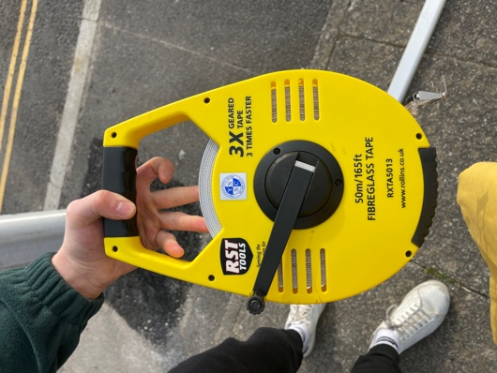
Fig 1.0
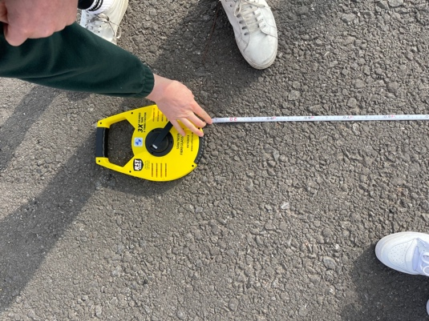
Fig 1.1

- Tripod and Level & Bubble
The tripod is used to support the level by providing a fixed base for it.
The automatic level is an optical instrument used to obtain the staff reading. The bubble aids in knowing whether the surface is horizontal (180°). (Jamiu Dauda)
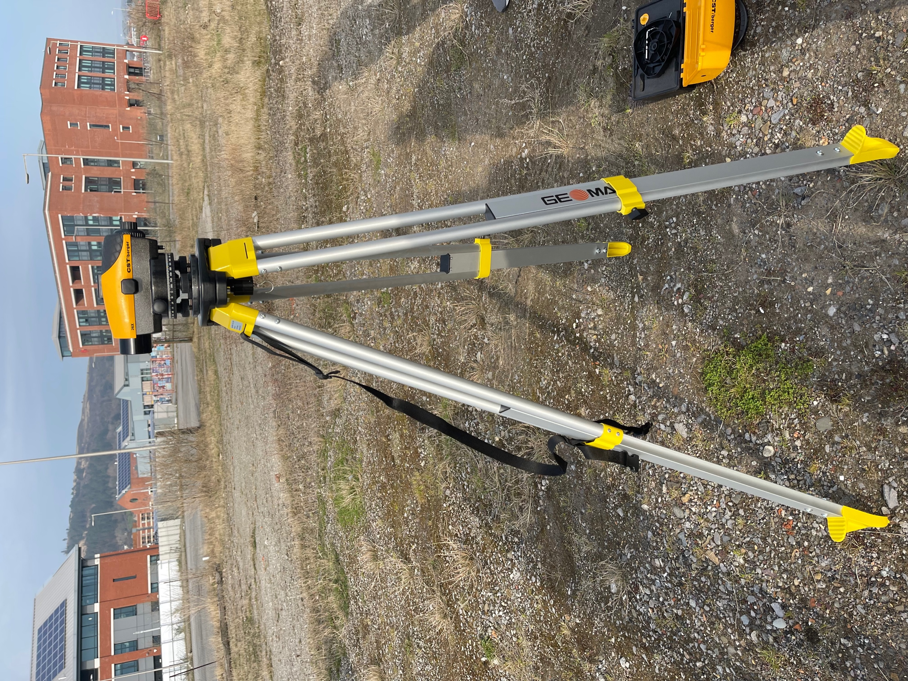
Fig 1.2
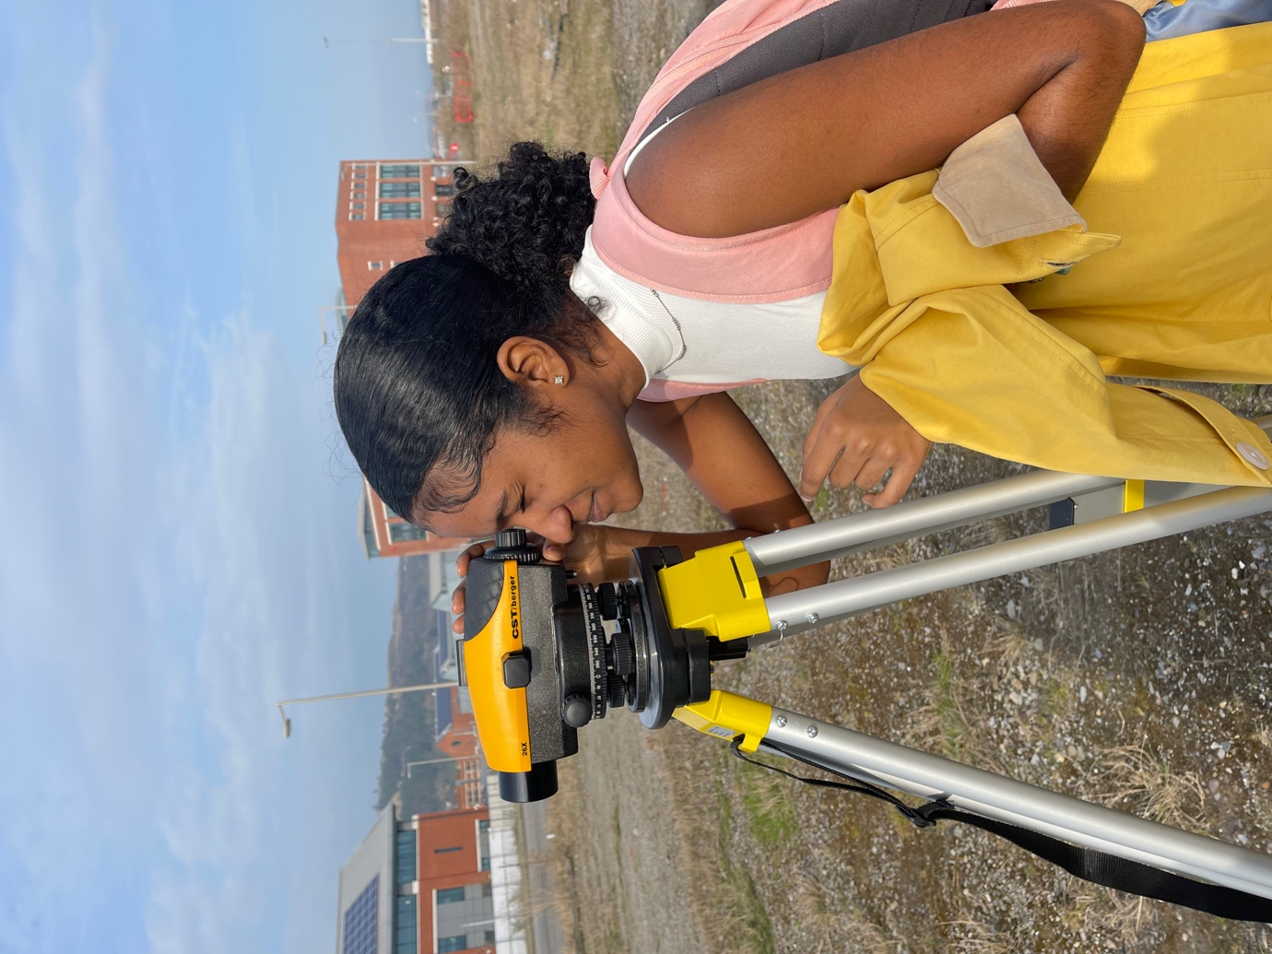
Fig 1.3

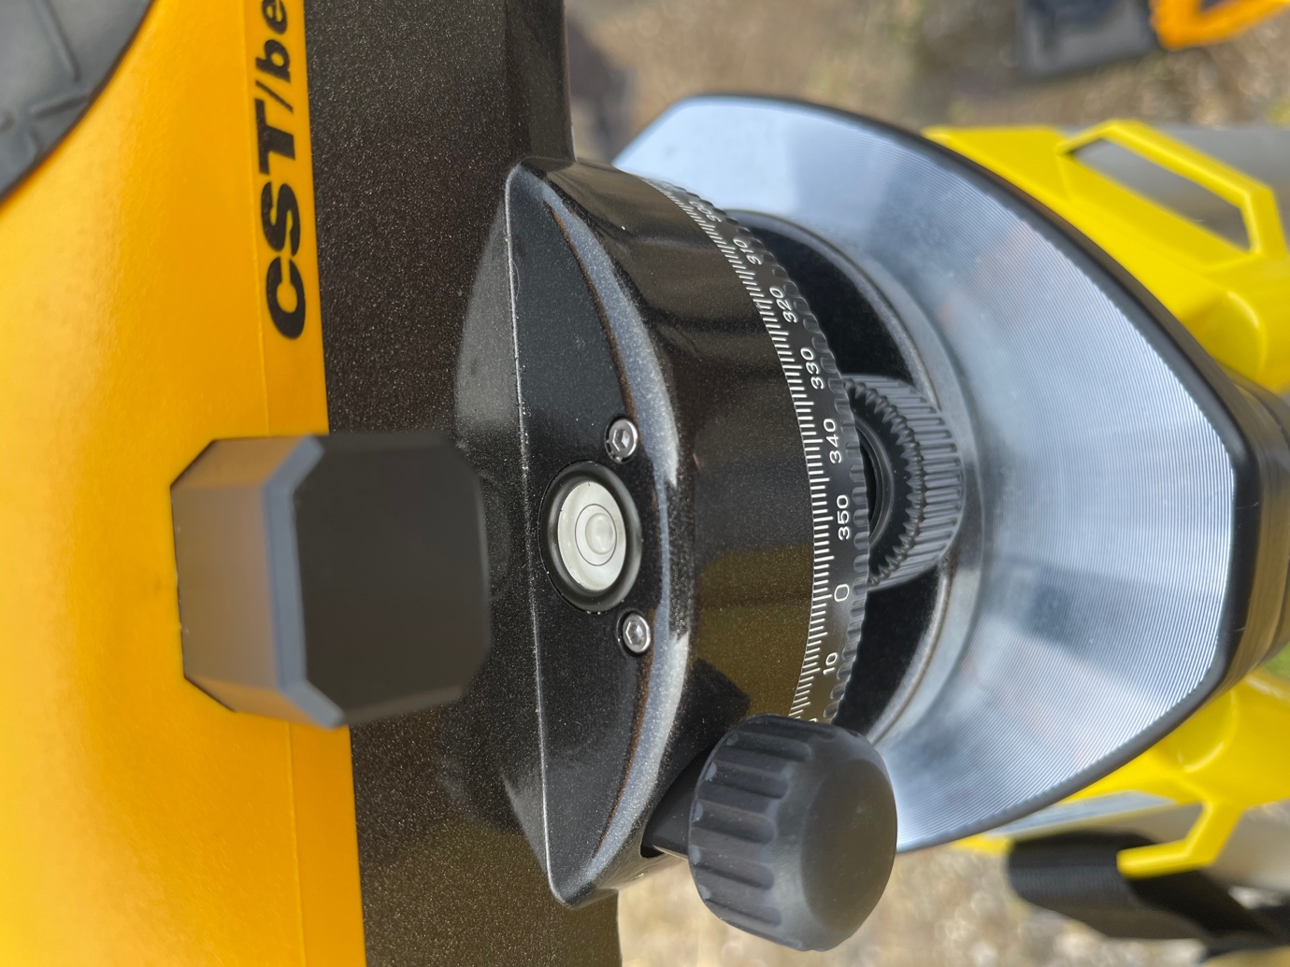
Fig 1.4

- Staff
It is a graduated scale that is held vertically at a point and the reading is viewed through the level. The graduations are in alternate blocks and spaces of 10m and it is numbered in meters and decimeters. (Jamiu Dauda)
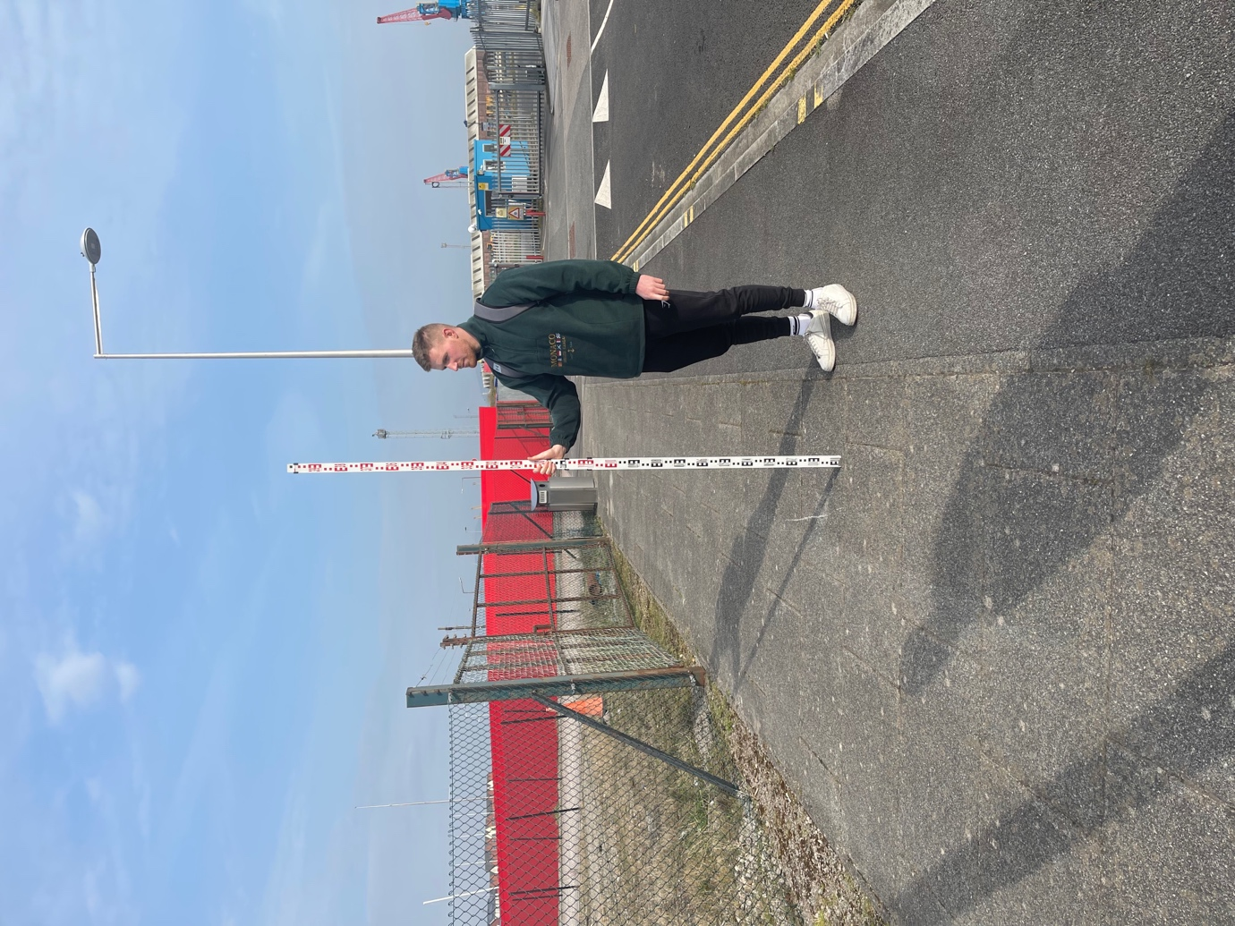
Fig 1.5

- Booking Sheet
All levelling must be booked in a levelling book or sheet, which is then stored permanently. The sheet/book has labelled columns: backsight, intermediate sight foresight, height of collimation, reduced level and remarks. The sheet also has the site details, work, date, and surveyors. The sheets are numbered and indexed. (Jamiu Dauda)
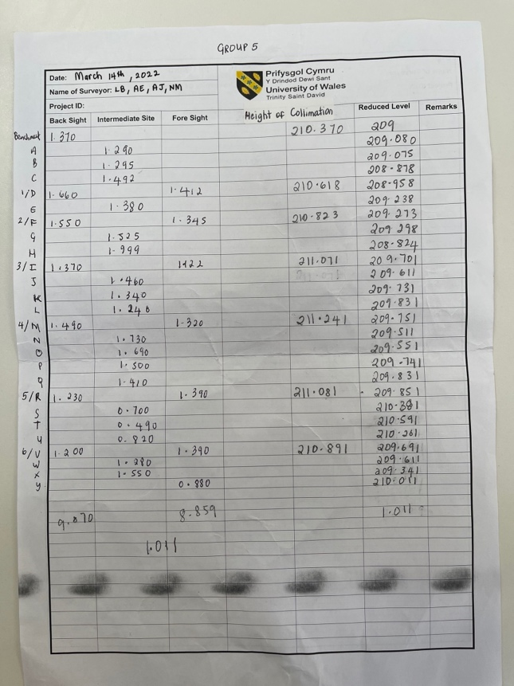
Fig 1.7
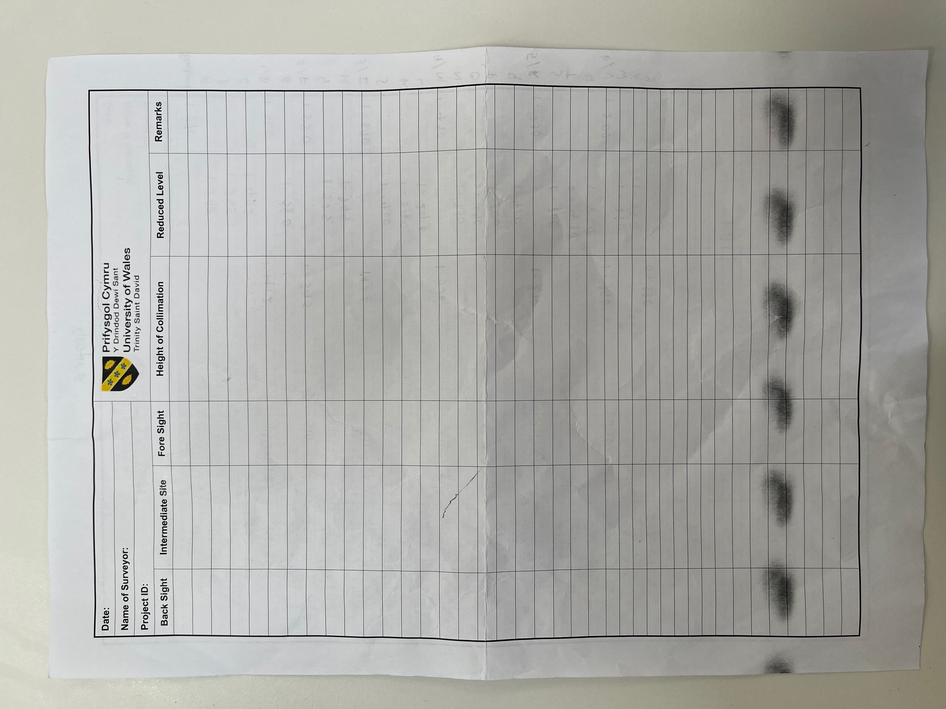
Fig 1.6

Levelling Procedure
The type of levelling conducted in the exercise is sectional, and it was open traverse. The measuring tape was always used to measure the 20m intervals. Setting up the tripod and level effectively means that the level bubble was always in the middle (fig 1.4). The level was always moved to a spot that would give at least three readings.

Method
Levelling position one.
- A benchmark was chosen; a garbage bin secured to the ground.
- The tripod and level were set up 20m from the benchmark.
- The levelling staff man set up at the benchmark, and the backsight reading (benchmark) was observed and booked on the sheet.
- The levelling staff man moved 20m forward from the level & tripod, and point “A” reading (intermediate) was taken.
- The other intermediate readings, “B” and “C”, were taken 20m from each last point.
- The foresight reading “D” was taken 20m from “C”.

Levelling position two/ D₁: change point one.
- The level and tripod were moved and set up 20m from “D”.
- The staff man stayed at point “D”, and the backsight reading was observed and booked.
- The staff man moved 20m forward from the tripod and level, and the intermediate reading “E” was taken.
- 20m from “E”, the foresight reading “F” was taken.

Levelling position three/ F₂: change point two.
- The level and tripod were moved and set up 20m from “F”.
- The staff man stayed at point “F”, and the backsight reading was taken.
- 20m forwards from the level and tripod, intermediate reading “G” was taken, and “H” was taken 20m from “G”.
- The foresight “I” was taken 20m from G.

Levelling position four/ I₃: change point three.
- The level and tripod were set up 20m from point “I”.
- The staff man remained at point “I”, and the backsight reading was taken.
- In a forward direction, intermediate reading “J” was taken 20m from the level and tripod.
- Readings “K” and “L” (intermediate) were taken 20m from the last point each.
- The foresight “M” was taken 20m from “L”.

Levelling position five/ M₄: change point four.
- The level and tripod were set up 20m from point “M”.
- The staff man remained at point “M” the backsight reading was booked on the sheet.
- 20m forward from the level and tripod, “N” (intermediate reading) was taken.
- Intermediate readings “O”, “P”, and “Q” were taken 20m from the point each.
- 20m from “Q”, foresight “R” was taken.

Levelling position six/ R₅: change point five.
- The tripod and level were moved 20m from point “R”.
- The staff man stayed at point “R”, and the backsight reading was observed and booked.
- 20m forward from the level and tripod, intermediate reading “S” was taken.
- Intermediate readings “T” and “U” were taken 20m from each previous point.
- The foresight “V” was taken 20m from “U”.

Levelling position seven/ V₆: change point six.
- The level and tripod were set up 20m from point “V”.
- The staff man remained at point “V” backsight reading was observed and booked on the sheet.
- 20m forward from the tripod and level, the intermediate reading “W” was taken, 20m away, “X” was observed and booked as IS.
- The foresight “Y” was taken 20m from “X”.
Figure 2.0 is a graphical representation of the process explained above.
Computation and Plotting
Station | Backsight | Intermediate sight | Foresight | Height of Collimation | Reduced Level | Comments
Benchmark | 1.370 |  |  | 210.37 | 209.000
A |  | 1.290 |  |  | 209.080
B |  | 1.295 |  |  | 209.075
C |  | 1.492 |  |  | 208.878
D | 1.660 |  | 1.412 | 210.618 | 208.958 | Station Moved - point 1
E |  | 1.380 |  |  | 209.238
F | 1.550 |  | 1.345 | 210.823 | 209.273 | Station Moved - point 2
G |  | 1.525 |  |  | 209.298
H |  | 1.999 |  |  | 208.824
I | 1.370 |  | 1.122 | 211.071 | 209.701 | Station Moved - point 3
J |  | 1.446 |  |  | 209.625
K |  | 1.340 |  |  | 209.731
L |  | 1.240 |  |  | 209.831
M | 1.490 |  | 1.320 | 211.241 | 209.751 | Station Moved - point 4
N |  | 1.730 |  |  | 209.511
O |  | 1.690 |  |  | 209.551
P |  | 1.500 |  |  | 209.741
Q |  | 1.410 |  |  | 209.831
R | 1.230 |  | 1.390 | 211.081 | 209.851 | Station Moved - point 5
S |  | 0.700 |  |  | 210.381
T |  | 0.490 |  |  | 210.591
U |  | 0.820 |  |  | 210.261
V | 1.200 |  | 1.390 | 210.891 | 209.691 | Station Moved - point 6
W |  | 1.280 |  |  | 209.611
X |  | 1.550 |  |  | 209.341
Y |  |  | 0.880 |  | 210.011
Fig 1.8 Table showing the levelling sheet information

The reduced level of each point was calculated using the Height of Collimation method.
Calculating using the height of collimation method:
- The backsight is added to the reduced level, the student number in this case (209), and that value is placed in the height of collimation column.
- Then, each intermediate sight is taken from the HC value (HC – A, HC – B) and these values are then placed in the reduced level column.
- The foresight is then subtracted from the HC and the value is placed in the reduced level column. (this is the last time that HC value is used)
- The reduced level value that is on the same line as a backsight, is then added to the backsight to create a new HC value.
- Steps 1-4 are repeated until the reduced level is found for the last foresight.

A check is done to ensure that the reduced level calculations and the levelling process (field) were correct. In this check, all backsight values were summed, then the foresight values were summed, and the difference was found. Then the difference between the first and last reduced level values was found. If the two differences are equal, then the calculations are correct.

Sum of BS | Sum of Foresight | BS - FS
9.870 | 8.859 | 1.011

Last Reduced Level | First Reduced Level | Difference in RL
210.011 | 209.000 | 1.011
Fig 1.9 The calculations check

The differences are equal, which confirms that levelling process in the field was accurate or was done with few errors and that calculations and booking are correct.

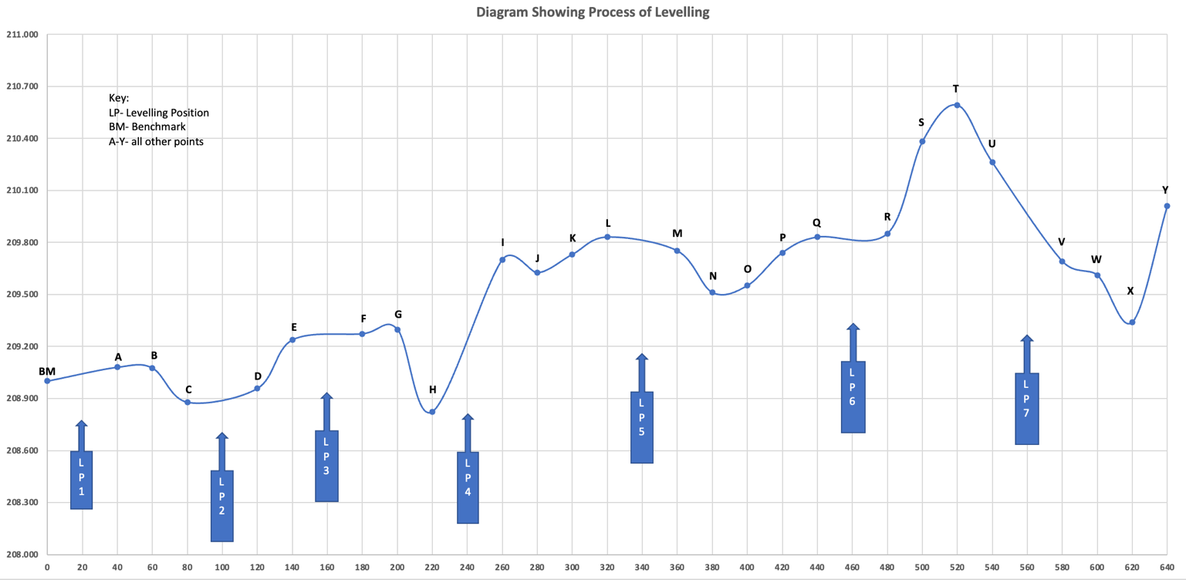
Fig 2.0 The land profile, points and levelling positions

The x-axis values are the chainage, which is the distance covered during the levelling process. The y-axis values are the reduced level values of each point.

Fig 2.1 The cut and fill areas

The red line (shown in fig 2.1) is the gradient made by connecting the first and last points. It is used to change the current profile and make the land even by determining the cut and fill. Everything that is above the line will be cut. Everything below the line is what must be filled with either imported materials or the materials obtained from the cut. The cut values are positive, and the fill values are negative.

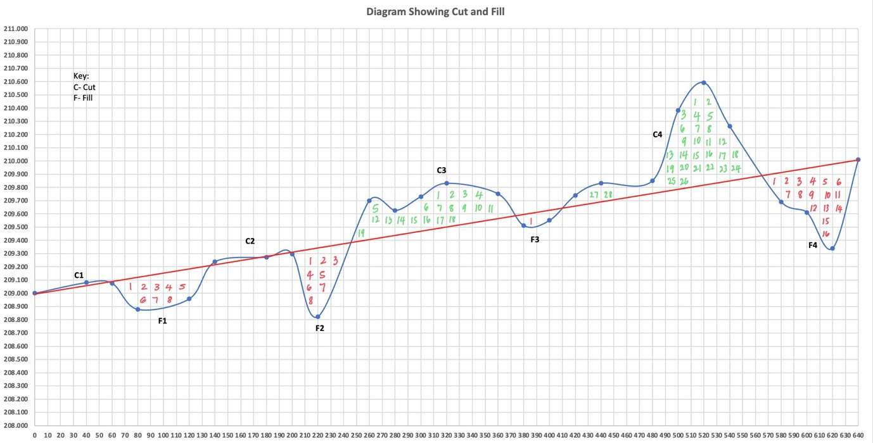
Fig 2.2 The cut and fill areas counted

The cut and fill shapes are irregular, and the counting squares method was applied to find the areas of these shapes. To facilitate the counting squares method, the scales of the axes were changed for easier and more accurate counting.

When counting the squares, all whole squares were numbered, as shown in Fig 2.2, and then the fractions were estimated and put together to make a whole square.

The unit constants (area of one square) were calculated to be 1m², as 10m*0.1m = 1m². The number of squares for the individual cuts and fills was multiplied by the unit constant to find the total volume of each cut and fill. Then, the total cut(m³) was found, and the total fill was found (m³). The unit is (m³) as the width of the road was assumed to be 1m.

The total cut and fill were summed to determine if the number would be negative or positive. A negative number means that there was more area to be filled than cut and that materials would have to be bought. A positive number means that there was more area/land to be cut and that there is more than enough land to be reused in the fill areas. This exercise had a positive value.

This is shown in figure 2.3.

 | Earthwork Computation
Cut | Unit Volume/Constant (m²) | Number/Quantity | Total Volume (m³)
C1 | 1 | 0.750 | 0.750
C2 | 1 | 1.000 | 1.000
C3 | 1 | 30.000 | 30.000
C4 | 1 | 40.000 | 40.000
 |  | Total Cut (m³) | 71.750
Fill | Unit Volume/Constant (m²) | Number/Quantity | Total Volume (m³)
F1 | -1 | 12.000 | -12.000
F2 | -1 | 12.000 | -12.000
F3 | -1 | 2.000 | -2
F4 | -1 | 21.000 | -21.000
 |  | Total Fill (m³) | -47.000
 | Total Volume Earthwork (m³) | Cut + Fill | 24.750

Fig 2.3 The cut and fill calculations

Conclusion
Levelling was defined, its uses and types were stated and some common errors that may occur when levelling were mentioned. The levelling process that this group used was explained and graphs and tables were used to show the profile of the land and calculations.

References
2022. [online] Available at: <https://readcivil.com/?s=types+of+surveying> [Accessed 5 April 2022].
Bestopbook. 2022. Bestopbook | Kumpulan Berita dan Informasi Akurat Terpercaya. [online] Available at: <https://bestopbook.info/> [Accessed 5 April 2022].
Civil Engineering Portal - Biggest Civil Engineering Information Sharing Website. 2022. Levelling | Purpose | Terminologies - Civil Engineering Portal - Biggest Civil Engineering Information Sharing Website. [online] Available at: <https://www.engineeringcivil.com/levelling-purpose-terminologies.html> [Accessed 5 April 2022].
Dauda, J.D., 2022. ‘Digital Surveying Lecture- SEM2 WK4’: Digital Surveying. UWTSD. [Accessed 5 April 2022]
Dauda, J.D., 2022. ‘Digital Surveying Lecture- SEM2 WK5’: Digital Surveying. UWTSD. [Accessed 5 April 2022]
Dauda, J.D., 2022. ‘Digital Surveying Lecture- SEM2 WK6’: Digital Surveying. UWTSD. [Accessed 5 April 2022]
Dauda, J.D., 2022. ‘Digital Surveying Lecture- SEM2 WK8’: Digital Surveying. UWTSD. [Accessed 5 April 2022]
leveling, T., 2022. The different types of leveling. [online] BrainKart. Available at: <https://www.brainkart.com/article/The-different-types-of-leveling_4623/> [Accessed 5 April 2022].
Schofield, W. and Breach, M., 2007. Engineering surveying. 6th ed. Amsterdam: Butterworth-Heinemann.
Toolstop. 2022. How to use a Tape Measure. [online] Available at: <https://www.toolstop.co.uk/blog/knowledge-base/how-to-use-a-tape-measure#:~:text=A%20tape%20measure%2C%20or%20measuring,readings%2C%20metric%20readings%20or%20both.> [Accessed 7 May 2022].

