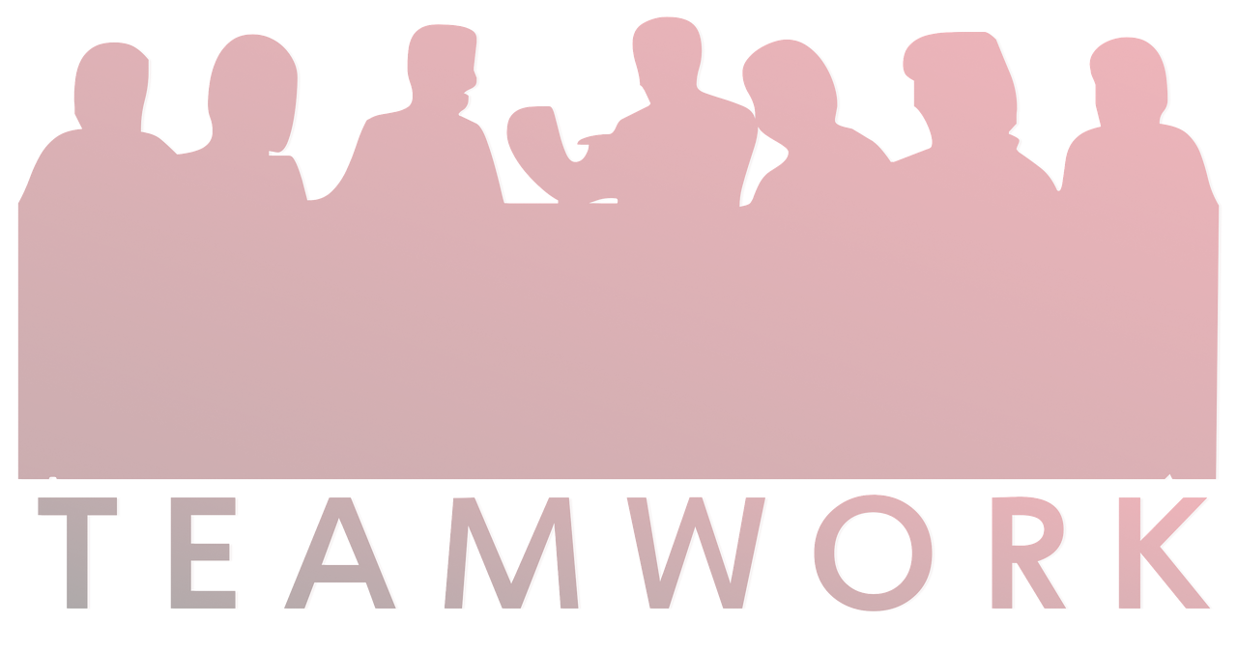Effective Team working and Communicatio
n
The Factors to a successful team working Lecturer’s name: Sayed Jaffery
Galina Cavacaliuc: 1916729 Donika Fidanova:1916890 Mariela Romanova:1916737 Miglena Vladimirova:1915916 Rositsa Kamenova:1915914

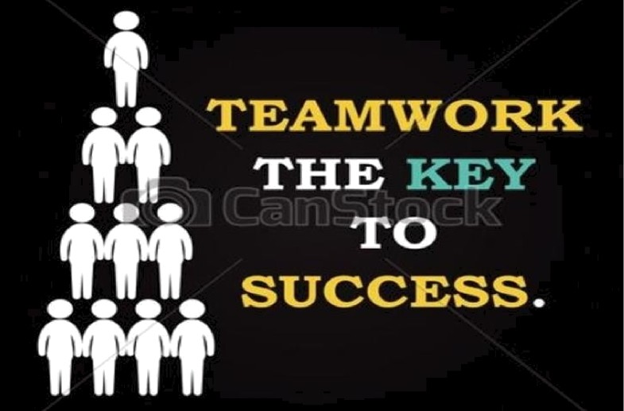

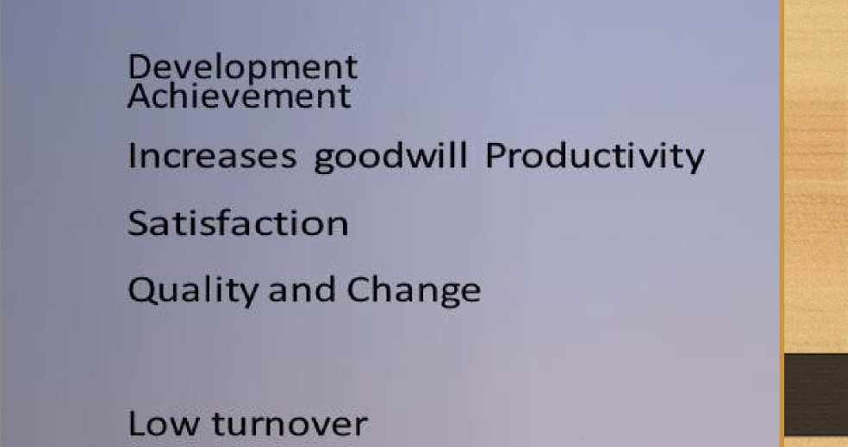
Relationship



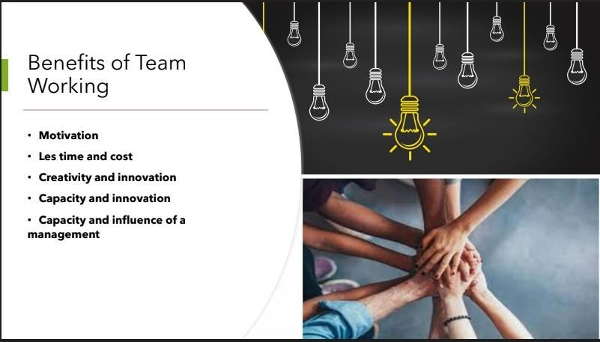

EFFECTIVE TEAM WORK AND BENEFITS

- Great ideas don't come from lone geniuses. ...
- Diverse perspectives help you come up with winning innovations. ...
- Teamwork can make you happier. ...
- When you work in a team, you grow as an individual. ...
- Sharing the workload eases burnout.
...
- Dividing the work lets you grow your skills.
•

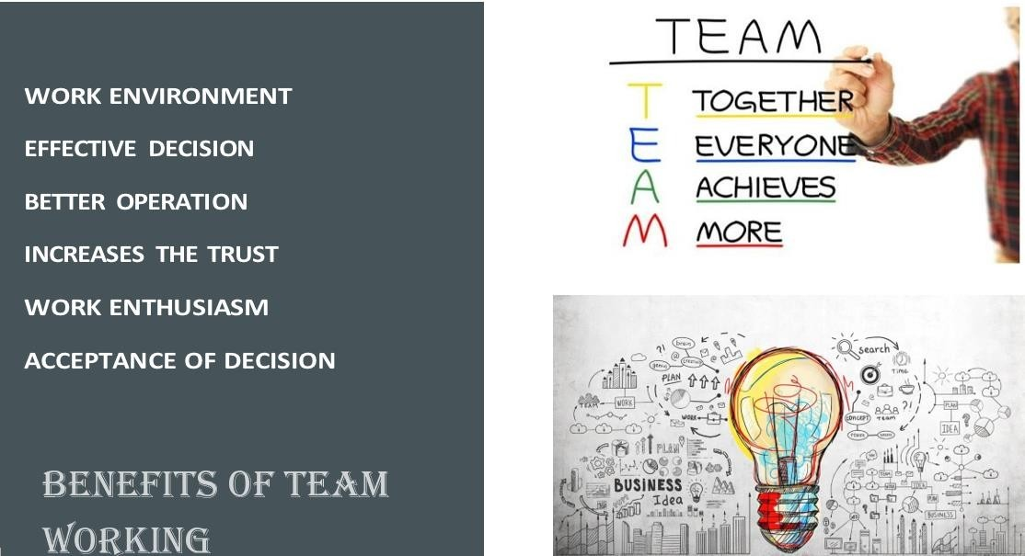

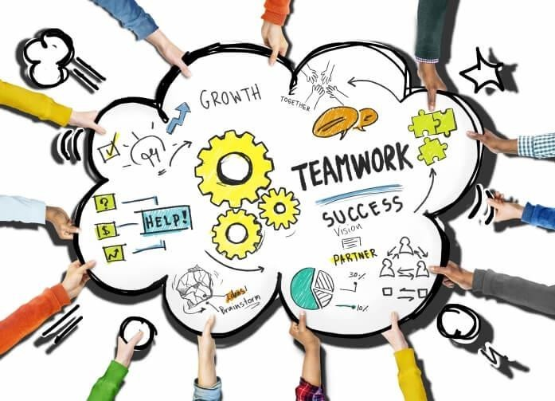Trust – Team members need to trust each other enough to be comfortable with sharing ideas an
feelings. As this trust builds, team members learn to be honest and respectful in their approach to each other.
Openness – Team members need to be willing to get to know each other and open up about themselves, so they realised that they all have diverse backgrounds and interests. This helps them to be more open to new ideas and
differing viewpoints.

Respect – It is important for the team not to focus on who to blame when something goes wrong, instead they need to work out how to fix it and how to learn from the mistake.
Constructive feedback and mutual respect rather than blame will help a team achieve results much faster.

EFFECTIVE TEAMWORK




Stages of Team Development

- 1 Forming
- 2 Storming
- 3 Norming
- 4 Performing

Polite
Forming

Watchful

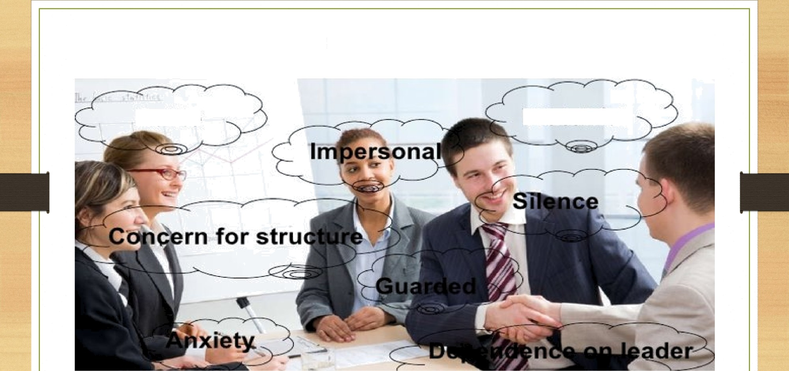

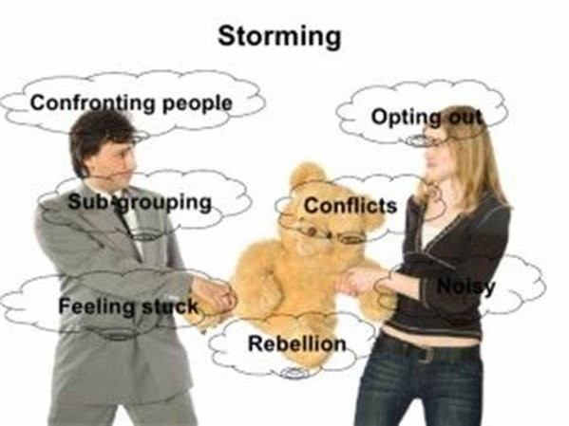



Norming Higher level of trust and respect between members.



Performing

Interdependent members rely on the
skills and knowledge of other members.

Team Roles

According to Dr M. Belbin’s Theory each of the members should own:

  - Intelligence
  - Dominance
  - Extroversion / Introversion
  - Stability / Anxiety
  - Team worker

student@1916737.uwtsd.ac.uk/ Mariela Romanova 11

Different Roles Based on this Theory:
- Plant-Strengths: Creative,, problem-solver, free-thinker.
-Allowable Weaknesses: May suggest unpractical ideas.
- Co-Ordinator- Strengths: Mature and confident.
-Allowable Weaknesses: Delegates work too easily and may even come off a manipulative to reach goals.
- Shaper- Strengths: Energetic, dynamic, enjoys challenges.
-Allowable Weaknesses: Blunt, may get irritated easily.
- Implementer – Strengths: Practical, systematic, efficient.
-Allowable weaknesses: Lack of flexibility.

student@1916737.uwtsd.ac.uk/ Mariela Romanova 12

- Completer/ Finisher- Strengths: Perfectionist, painstaking.
-Allowable Weaknesses: Worries too much.
- Resource investigator- Strengths: Enthusiastic, extroverted, optimistic.
-Allowable Weaknesses: Easily distracted, may lose quickly lose interest.
- Evaluator / Monitor: Strengths: Strategic and sober.
-Allowable Weaknesses: Lack of inspiration, critical.
- Specialist- Strengths: Knowledgeable and dedicated
-Allowable Weaknesses: Isolated, narrow base of knowledge. Team Worker-
Strengths- working perfectly in a team and helping others. Allowable Weaknesses- a tendency to be indecisive and tend to be uncommitted during discussions.

Leadership Roles

- A leader who has the ability to adapt to a different situations immediately
- Guiding the team what and how to be done
- Participant of the decision making

The four leadership styles
According to Hersey and Blanchard (1969)

- Selling 2.Participating 3.delegating 4.Telling
student@1916737.uwtsd.ac.uk/ Mariela Romanova 14

Maturity Levels :

  - M1.Experienced worker
  - M2. Non very experienced and skilled
  - M3.Enthusiastic, happy to do whatever been required for
  - M4, Knowledgeable and experienced person, who do not need a help to complete the tasks

References: Hersey P. and Blanchard H. (1969)’ Management of organizational behaviour’
- Dr Meredith Belbin – Father of Team role theory.

student@1916737.uwtsd.ac.uk/ Mariela Romanova 15

ommodating onding
d
Managing conflict (Thomas and Kilmann)
- Compromising an Collaborating
- Avoiding and Acc
- Competing
- Listening and resp
- Resolving differen

ces



Compromising and Collaborating

  - Compromising-Due to equally important goals neither of the parties get what they want from the other team.
  - Collaborating- and achieve the “win-win ”approach. Cooperate with the team to achieve both your goals.
  - Being able to provide time, trust and co-working in order to achieve goals.

Avoiding and Accommodating


  - Avoiding is a good method when the people on the other side of the table use their emotions more in their careers.
  - When is too risky and it will cost a lot the avoiding strategy is a perfect method.
  - Giving up on your goals due to a better expertise from the other party.



Listening and responding and
Resolving differences

- Listening comes first in every conflict you are trying to resolve.-Good communication and listening skills, appropriate gestures.
- Responding comes after you have acknowledged what the other party issue is and is your turn to be heard, questioned, challenged and explain yourself, show understanding.
- Resolving Differences- Look into everyone’s point of view ,analyse the problems and find a solution which will suit everyone's expectations.

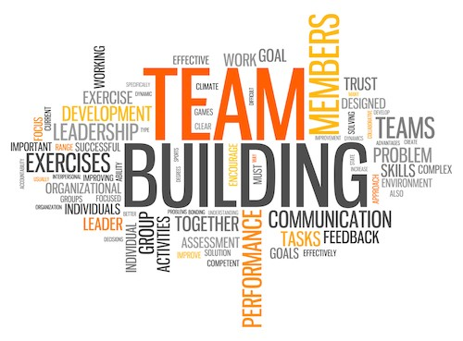rection
rs
g
Successful team development
- Clear sense of di
- Talented membe
- Clear and enticin responsibilities
- Reasonable and operating proced
- Constructive inte Relationship

efficient ures
rpersonal

  - Active reinforcement system

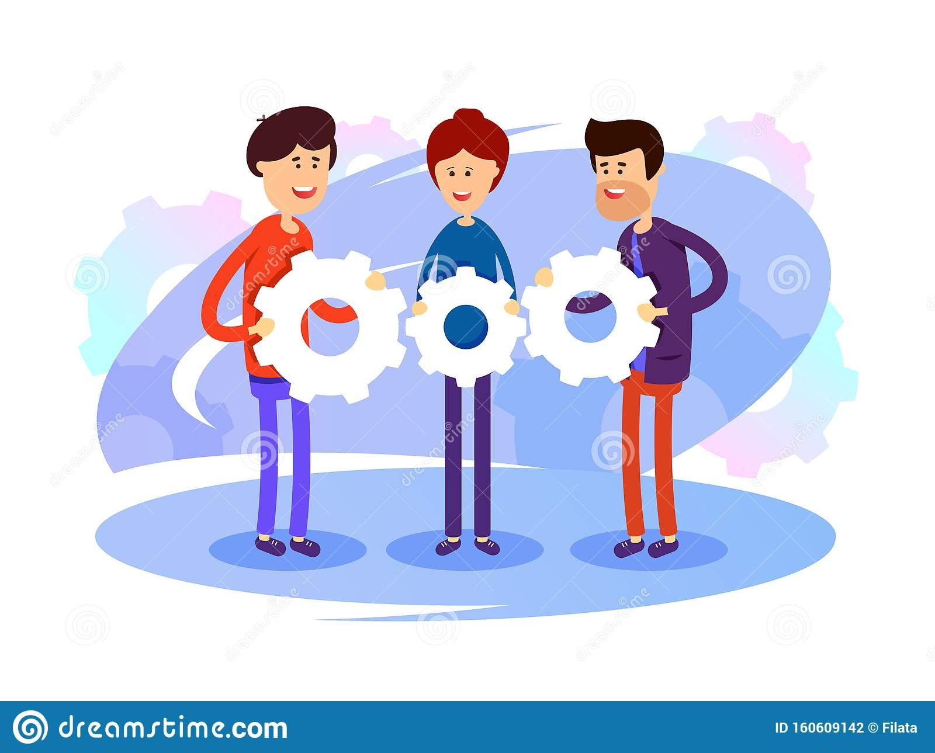Clear sense of direction
and Talented members

- Team members should have mutual goals and expectations towards the outcomes of the team.
- Putting a team of well organized and able to accomplish anything in order to successes people is also very important.



Clear and enticing responsibilities
and Reasonable and efficient
operating procedures

- Understanding what your role is and where to look for answers when a problem appears.
- System of getting tasks done should be in place.
- Makes the team’s work functional.
- Decisions making , planning, solving problems and evaluating progress.

Constructive interpersonal and external relationship
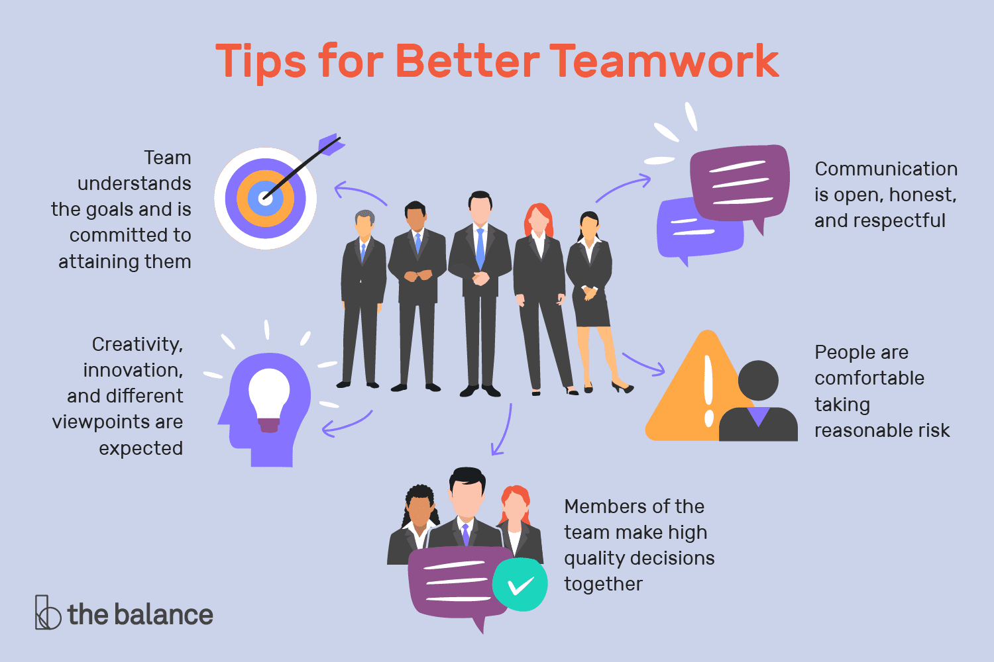
and Active reinforcement system

  - Being able to provide support, handle conflicts and support diversity.
  - Giving out rewards and keeping members accountable.
  - Good diplomatic relationship is also required in order for a team to be successful.

Thank you for listening !
Any Questions ?

