TITLE PAGE
PAGE 1

STUDENT NAME: Yasmin Azam
STUDENT NUMBER: 2013925
TUTORS NAME: DR Azora Hurd
MODULE NAME: Changemakers: creativity and value creation
MODULE CODE: BMHP5014_BIRM
ASSIGNMENT TILTLE: E-Portfolio evidence of learning comprising of 2 separate artefact items.

TABLE OF CONTENT
PAGE 2

TITLE PAGE ………………………………………………………………………… PAGE 1
TABLE OF CONTENT……………………………………………………………… PAGE 2
INTRODUCTION……………………………………………………………………. PAGE 3
POSTER…………………………………………………………………………….. PAGE 4
ELEVATED PITCH………………………………………………………………….. PAGE 5,6&7
REFRENCES………………………………………………………………………… PAGE 8

INTRODUCTION
PAGE 3

In my portfolio I am going to be using two artefacts one which will be a poster and the other being an elevated pitch. I am going to be promoting the awareness of Autism and also introducing my new project of a day centre that will be managed by myself so this way I will have an active role and I will be using my leadership skills to make this work to its full potential. I have a child with autism and I know from my personal experience how hard and challenging this can be and the effects it can have on yourself, your child and your family, I also know that it is not easy to sometimes access the help and support that you need and people find it hard as they do not know where to go for this help this is also a personal experience. I will use my experience to help people recognise the symptoms associated with autism and what to look out for. With opening a day centre for children and young people this will give them the happiness, interaction support and confidence that they need. It will offer help to them for coping and managing with the tasks that they may find difficult in their everyday life and help them build the confidence to move forward.
The day centre will also offer other activities to do throughout the day this will include cooking, washing, ironing, drawing and painting, sports activities and day trips. There will be designated areas for parents to stay and have a chat with qualified members of the team that can help with any problems they may have. Also will offer the use of a crèche so parents can feel at ease when using the facilities required.

Friday 25th March 2022
@ 1pm
Venue:
3 Stratford Road
Birmingham
B11 2SB
Contact number:07732675391
Email:yaz_786@hotmail.com

Autism Awareness for children and young people

Come along to our conference and learn more about what autism is feel free to ask any questions, get advice also get the help and support you need. Refreshments will be available hot and cold drinks biscuits and cake. Meet other people that are in the same situations, feel comfortable to speak about the issues you may have. You are not alone.

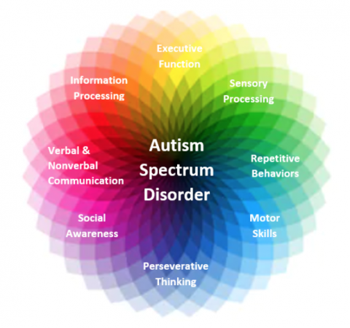
It’s ok to be different
Accept
Understand and love.

https://carmenbpingree.com(16 march 2022)
Repetitive movements speech and behavior patterns
Recurring sleep problems and sensitive to loud noises
Difficulty in understanding and expressing emotions. Feeling low in mood, depression and anxiety.
Development learning delays and difficulty communicating

Information regarding my new project of the new day center will be available, we are really excited about this as this will help families with children and young people with autism and disabilities, it will give them the chance to be their self and enjoy doing things that will help them become independent and gain those everyday life skills with the help and support they may require.
I am looking forward to meeting you all in person and if any more information is required contact details are on the top of the poster. We are offering a pick and drop service for people who are not able to make or find their way there please phone to book this service. There is wheelchair access and disabled facilities at the venue so please do come along and join us. Everyone is welcome.

ELEVATED PITCH
ELEVATED PITCH
PAGE 5
Hello everyone my name is Yasmin Azam and I would like to first of all thank you all for attending today this is just an amazing outcome. So before we get started I would like to ask if some of you would do the honours of helping handing out some leaflets that are just here on the table just so that you know a little about what we are going to be talking about today.
My aim of this conference today is to promote the awareness of autism, a lot of people do not know what it is, what it involves, what the effects are, what to look out for, how to deal with it and where to go for help so hopefully I can answer some of these questions for you.
ASD is a short term for Autism spectrum disorder and effects everyone differently. Although its effects are different for each individual there are some symptoms that most people will experience and are noticed more frequently some signs are easier to see then others. There is no cause or cure for ASD it effects 1 in 27 boys and 1 in 144 girls (autismspeaks.org).
Autism is not an illness or a disease children are born with it or appears at a very young age. People with autism can still have a good life and be good at things some people with autism have an above average intelligence.
Autism does not go away it is a lifelong diagnosis. Children with milder symptoms learn to manage it more effectively than others. Speech and occupational therapy helps manage symptoms and develops independence.
Around 700,000 people were estimated to have been diagnosed with autism in the U.K in September 2020. (NHS 10 MARCH 2022).
signs to look out for:
- Development learning delays
- Difficulty communicating
- Difficulty in social situations
- Attachments to unusual interests
- Difficulty in understanding emotions
- Over or under sensitivity to light, sound, or taste
- Recurring sleep patterns
- Repetitive movements
- Prefers to be alone
- Avoiding eye contact
- Child does not respond to their name
PAGE 6

- Depression and anxiety
Autistic people lack being able to explain things, they have problems with social, emotional and communicating skills, they repeat certain activities and cannot cope with changes to their daily routine. They have challenging behaviours, these things can also impact on the wellbeing of other family members.
Things we can do to help:
- Increase social interaction
- Consider interests and hobbies
- Use simple words
- Attach labels to things
- Make good eye contact
- Maximise ability
- Support development and learning
- Early intervention
We are opening a day centre on the 30/02/22 it will run Monday- Friday 9.30 am till 3.30pm everyone is welcome, lots of activities available and the aim is to promote children and young people with autism and special needs to interact, this will help them to be independent and learn new skills, and have some fun so please do come along and sign up. More information about the address and times is on the leaflet that was handed out.
Things available at the centre:
- Independent skills
- Sports activities
- Day trips
- Art and crafts
- Areas for parents to have a chat
- Qualified members of staff
- tea and coffee corner
- soft play for toddlers
- quiet rooms
- canteen

PAGE 7
So everyone please come along and sign up and thank you all once again for your support and attending, I hope this has helped you understand a little more. I will be available for any questions you may have now till 3pm. Thank you.

REFRENCES
PAGE 8

digital.nhs.uk
https://carmenbpingree.com/blog/what-is-autism-spectrum-disorder/
https://www.autism.org.uk/
https://www.autismspeaks.org/
https://www.bma.org.uk/a.org.uk
https://www.nhs.uk/conditions/autism/what-is-autism/
National Autistic Society
www.google.com
www.gov.uk

