

Assessment 1 – Reading Task Template
Upload your photo of your A3 in-class notes here:
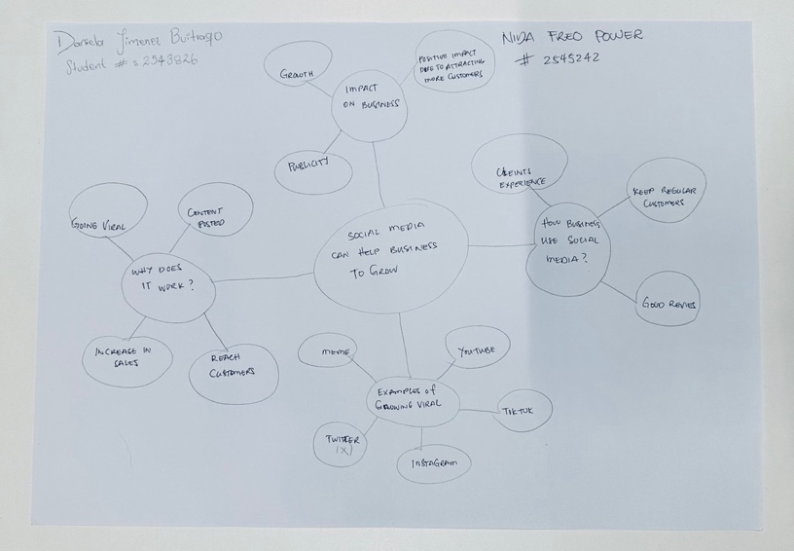

- Answer these questions using the sentence starters below

- What is the main idea of the text?
– The main idea is that BYD beats Tesla in sales by 28% (2.25 million).

b. What are two key points?
- One key point is BYD electric vehicle sales grew in sales.
- Another key point is Tesla electric vehicle sales dropped.

c. What part of the text did you find most important? Why?
– The most part of the text: Is that the company BYD had become the world’s top EV seller surpasses Testa.
– Why? BYD EV cars are cheaper than Tesla’s, and costumers are concerned about the political action involvement of Tesla’s owner, Elon Musk.

d. Was anything unclear or difficult to understand?
– I was not sure about: The government program that gave buyers $7,500 to incept help to pay for electric cars, it was not properly elaborated.

e. How did your group help you understand the text better?
– My group helped me: with the group collaboration, discussions of different ideas and suggestion regarding the context of the text.

- One sentence reflection
– I find this lesson to be challenging and educational. Having been transferred from Group 4 to Group 7 due to scheduling clashes, I enjoyed the class lessons.
I found the Tutor to be knowledgeable, firm in a nice way, professional and fun.

Question: What did you find challenging about this task?
– The hardest part was: Understanding the full context and identifying the relevant answers to the required questions for the designated tasks.

