3 Blogs On Children’s Development
I was unable to upload the Sway so here is the link to it:
https://sway.cloud.microsoft/edV6pDsdQq2zu8tO?ref=Link

The Impact of Neglect on a Child's Social and Emotional Development

What is Child Neglect?
Early childhood is possibly the most important stage in a child's life for their development, as this is when they start to develop relationships with their caregivers and other children. They also start to learn how to manage their emotions better and begin to understand the world around them. In these early years, children depend on their caregivers to provide them with the proper physical and emotional care that they need. However, when these needs are not consistently met, this can lead to a child feeling neglected. According to the NSPCC (2026), child neglect can be defined as "the ongoing failure to meet a child's basic needs and the most common form of child abuse". This can lead to a serious impact on a child's development and affect their life later on.
Neglect happens when a child's caregiver fails to meet their basic needs, such as giving the child proper supervision, providing them with food, cleanliness and a safe environment. It can affect many areas of development, including their physical health, their social development and their emotional wellbeing. Children who experience neglect can struggle to create trusted relationships and it can have an impact on their confidence and emotional regulation. Developmental and attachment theories help us to understand why care and relationships are so important for children's development from a young age. In this blog, I will explore how neglect can impact on a child's social and emotional development by examining these theories, such as Bowlby and Ainsworth's theories. I will also be looking at other factors that may contribute to this neglect and how practitioners are crucial to supporting children who are neglected.

Bowlby's Attachment Theory

One of the most well-known theories is Bowlby's attachment theory. Bowlby (1969) argued that children are born to form attachments to caregivers, as these relationships can provide them with safety, security, and emotional support at a young age. When a caregiver provides consistent care for a child's needs, the child is more likely to develop a secure attachment to that caregiver, which gives them the confidence to explore their environment and create positive relationships with others. However, if a caregiver is inconsistent in the care they give a child, it can create an insecure attachment between the caregiver and the child. This can lead to the child struggling to trust others or to regulate their emotions. Bowlby suggested that early attachment experiences can shape what he described as internal working models, which can influence how an individual views themself and others in relationships later in their life (Bowlby, 1969).There is also research that supports Bowlby's theory by showing that a child's early experiences with their caregivers can have long-term impacts on their development. For example, Egeland and Sroufe (1981) found that children who had experienced neglect or had inconsistent care were more likely to develop behavioural difficulties. This further demonstrated how important consistent early relationships are for a child's social and emotional development.

Ainsworth's Strange Situation

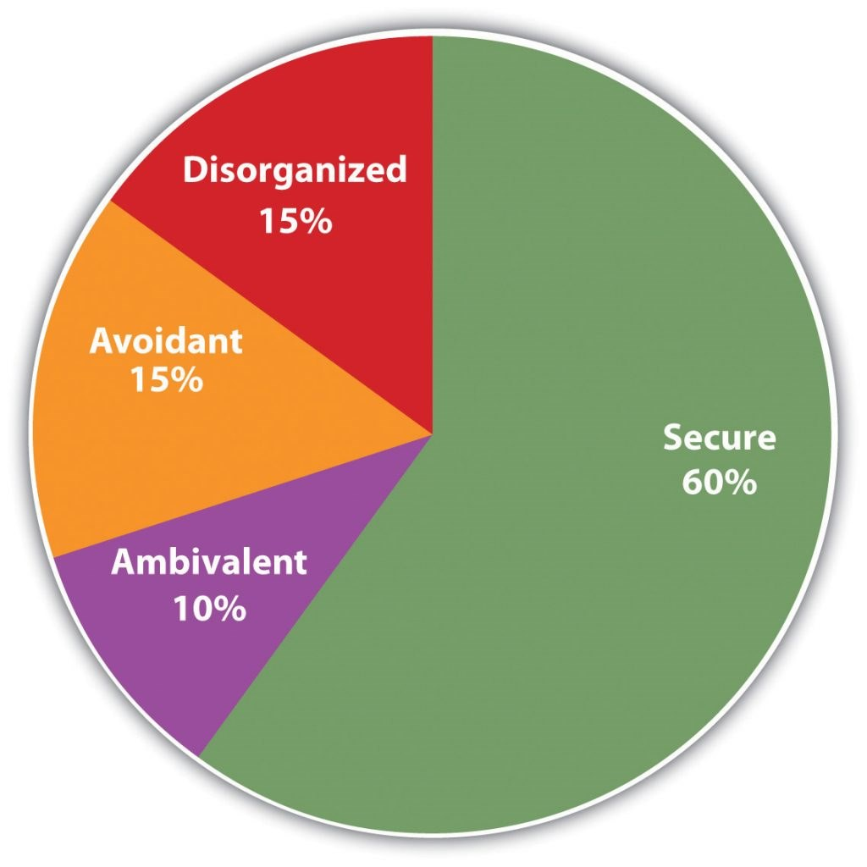
Mary Ainsworth worked alongside Bowlby and expanded on his ideas of attachment with her Strange Situation experiment. This experiment observed infants who were shortly separated and reunited with their caregivers. From this research, she identified that children have several attachment styles with their caregivers. These included secure attachments, insecure avoidant attachments and insecure resistant attachments. (Ainsworth et al., 1978).From the experiment, Ainsworth suggested that the children who were seen with a secure attachment to their caregiver would typically feel safe exploring their surroundings and would return to their caregiver if they needed reassurance. However, the children who would experience neglect or inconsistent care would be more likely to develop insecure attachment styles. For example, the children with an insecure-avoidant attachment might appear distant from their caregiver, and those with an insecure-resistant attachment might become extremely distressed when they are separated from their caregivers. Then, in 1990, another attachment style was identified by Main and Solomon called disorganised-insecure attachment for children who showed disorganised or inconsistent behaviours during the experiment. This attachment style is often associated with neglect or inconsistent care and can lead to the child feeling confused and anxious and having difficulty with regulating their emotions. Lyons-Ruth and Jacobvits (2016) suggested that children who develop a disorganised attachment might experience difficulties with their emotional regulation and relationships later on in life. These theories and research show how caregiving from an early age can influence a child's development throughout their life.
Both Bowlby and Ainsworth highlighted the importance of positive early relationships for children's development. Their theories suggest that when a caregiver is responsive and consistent with their care, children will be more likely to create secure attachments and will develop smoothly. However, Bowlby and Ainsworth took different approaches with their theories. Bowlby focused on the idea that children require a strong relationship with a primary caregiver to support their development. Ainsworth focused on identifying the different styles of attachment that a child might have with their caregiver, and she observed how a child would behave in response to the separation from caregivers. While Bowlby developed the foundation for attachment theories, Ainsworth's research expanded on this and helped us to learn how different attachment styles can affect the child's development.With both of these theories, we can gain a strong explanation of why neglect in early childhood can have such a strong impact on a child's social and emotional development throughout their life.

Factors For Neglect
Many factors in a child's life can increase the risk of neglect within a family. In most cases, neglect cannot be whittled down to a single issue. These issues tend to snowball together and create a strain on the caregiver to meet the child's needs.For example, poverty can be a big stress for a family and can limit a caregiver's access to resources such as housing, getting food and childcare. In my personal experience, when my family struggled with homelessness, my mum struggled to get food in for us. This can show that not all neglect is malicious, but the issues that lead to it can force people into that horrible situation of neglecting a child. Research also shows that children living in disadvantaged environments are at a higher risk of neglect due to the pressure placed on the families (Sidebotham et al, 2016).Other factors can include substance misuse, domestic violence or insufficient support nearby. Understanding these factors is important for practitioners or local enforcement because it shows that families may need additional support at this time.

The Role of Practitioners
Practitioners play a vital role in recognising neglect and working on supporting families through it. They often spend a large amount of time with the children and can notice changes in behaviour, their emotional wellbeing or social interactions. Personally, I tended to notice if a child was acting differently on some days and had the alarm bells going off in my head instantly. As practitioners, we are taught to think the worst and investigate. If a child appears withdrawn in activities or seems more anxious than usual, the safeguarding legislation in the UK highlights the professional's responsibility to protect children from harm. For example, the Children Act 2004 emphasises the importance of promoting children's welfare and reporting safeguarding concerns to the local authority. As a practitioner, it is their responsibility to create a safe and nurturing environment for children to feel confident and supported. During my childcare placement, I watched how other practitioners worked to make strong relationships with the children. For example, if an activity could be done for the whole class, they tended to do it 1-to-1 with the children to strengthen that relationship.
In conclusion, neglect can have significant effects on young children’s social and emotional development. The work of Bowlby and Ainsworth highlights the importance of secure attachments and responsive caregiving in early childhood. When children experience neglect, they may struggle with emotional regulation, confidence and relationships with others. However, practitioners play an important role in recognising signs of neglect and providing support for children who may be experiencing difficulties. By understanding the importance of early relationships and safeguarding children’s wellbeing, professionals can help promote positive developmental outcomes.
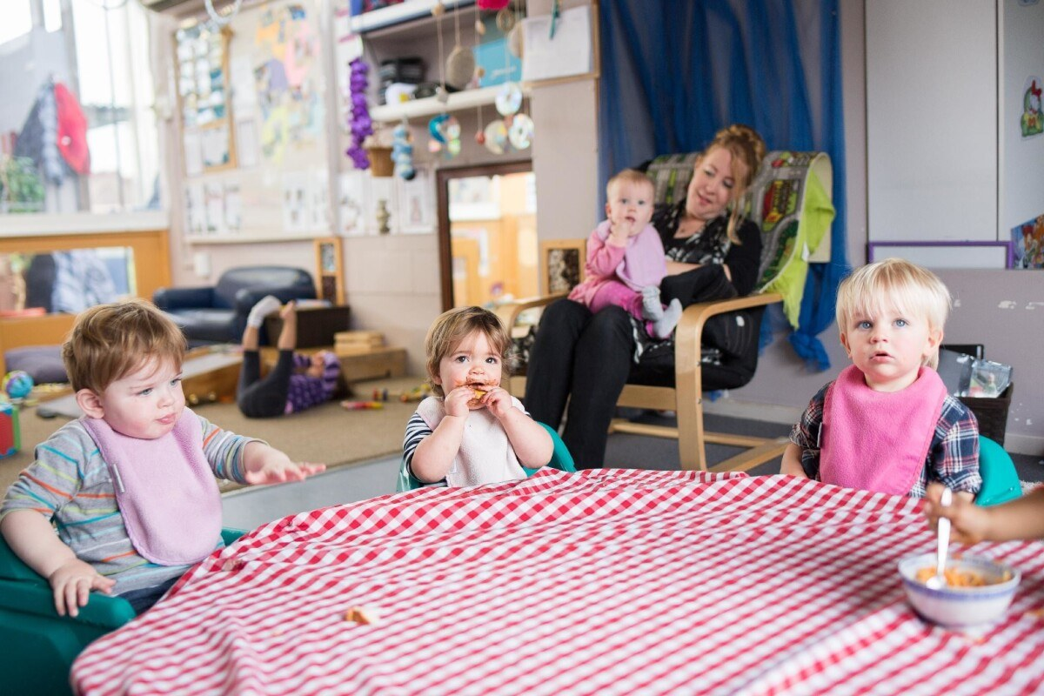

How Identity Forms During Adolescence
Adolescence is an important time in a young person’s life because it is when many young people begin to figure out who they are and where they fit in the world. During this stage, teenagers often start thinking more about their beliefs, values, interests and what they might want to do in the future. This process is known as identity development. Exploring their identity can help young people feel more confident and comfortable in themselves as they grow older. However, this stage can also be confusing and sometimes overwhelming. Young people are influenced by many different things, such as their friends, family, school and wider society, while they are trying to understand who they are. Because of this, there has been a lot of research on adolescence to better understand how identity develops. Two important theories that help explain this are Erikson’s psychosocial development theory and Marcia’s identity status theory. Both theories suggest that forming an identity often involves exploring different roles and experiences before deciding what feels right.

Erikson's Stages of Development
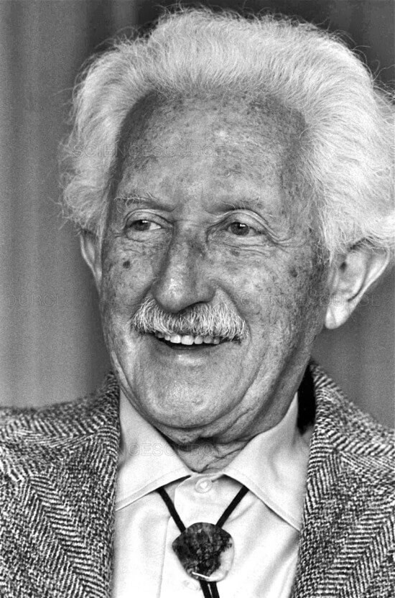
Erik Erikson believed that people go through several stages of development throughout their lives. Each stage included a challenge that individuals needed to work through. According to Erikson (1968), adolescence is the stage called 'Identity vs. Role Confusion'. At this point in their life, young people start asking themselves important questions about who they are and what their future might look like. They might try new hobbies, form different friendship groups or develop their own opinions about certain topics. For example, a teenager might become interested in sports, music or creative activities while trying to work out what they enjoy most. They may also start thinking about potential careers or what kind of person they want to become. In my experience, I found that I enjoyed helping people in high school which led me to find a passion for teaching when I got to college. If young people are allowed to explore these ideas, they are more likely to develop a strong sense of identity. However, if they feel too much pressure from others or do not have the chance to explore their interests, they may experience role confusion. This can leave them feeling unsure about themselves or their future.

Marcia's Identity Status Theory
James Marcia later expanded on Erikson’s ideas by looking more closely at how identity develops during adolescence. Marcia (1966) explained that identity development involves two key processes: exploration and commitment. Exploration means trying out different ideas, beliefs or roles, while commitment means making decisions about what feels right and sticking with those choices. Marcia suggested that young people may move through four identity stages during this process. Identity diffusion occurs when a young person has not yet explored their identity or made decisions about their future. Identity foreclosure happens when a young person adopts their parents’ beliefs or expectations without exploring other options first. Identity moratorium describes a stage where young people are exploring different possibilities but have not yet made a final decision. Finally, identity achievement occurs when someone has explored different options and eventually developed a clear sense of identity. Marcia’s theory shows that it is completely normal for young people to feel uncertain while they are figuring things out. Both Erikson and Marcia agreed that adolescence is one of the most important periods for identity development. They both believed that exploring different roles and experiences is a normal part of growing up. However, their theories focus on slightly different areas. Erikson looked at development across the entire lifespan, whereas Marcia focused more specifically on how identity develops during adolescence. Marcia’s work builds on Erikson’s ideas by explaining the different stages young people might experience while forming their identity.

Factors that can influence Identity Development
Many different factors can influence identity development. Family is often one of the strongest influences because parents and caregivers help shape a young person’s beliefs, values and expectations. For example, families may influence attitudes towards education, cultural traditions or career choices. Friends also become very important during adolescence. Many teenagers want to feel accepted by their peers, which can influence how they behave, dress or express themselves. Other factors such as culture, school and social media can also affect identity development. Social media in particular can sometimes influence how young people see themselves because they may compare their lives or appearance to those of others online (Steinberg, 2017). Although identity development is a normal part of adolescence, some young people face challenges during this stage. Experiences such as bullying, discrimination or social pressure can affect confidence and self-esteem, making it harder for young people to feel comfortable with who they are. Young people who struggle with their mental health or who lack supportive relationships may also find identity exploration more difficult. I found that in my gender identity journey, it was very difficult to go against the societal norms because of the judgement I would get from my peers. This highlights the importance of providing supportive environments where young people feel safe and accepted while they develop their sense of self.

The Role of Professionals
Professionals who work with young people, such as teachers, youth workers and childcare practitioners, can play an important role in supporting identity development. They can create environments where young people feel comfortable expressing themselves and exploring their interests without fear of judgment. Schools also aim to support personal development by encouraging independence, confidence and respect for others. Legislation such as the Equality Act 2010 helps protect young people from discrimination and promotes fairness in education and society (HM Government, 2010).
Overall, adolescence is a very important stage for a young person's identity development. The theories developed by Erikson and Marcia help explain how young people explore their beliefs, interests and values while forming their identity. Many factors, including family, peers and wider social influences, shape this process. Although adolescence can sometimes be challenging, supportive environments and positive relationships can help young people develop a strong and healthy sense of identity.

How Different Parenting Styles on Children's Behaviour
Parents and caregivers play a huge role in shaping how children behave and develop as they grow up. The way parents communicate, set rules and show support can influence how children manage their emotions and interact with others. Because of this, psychologists have spent many years studying parenting and how it affects children’s development. One of the most well-known researchers in this area is Diana Baumrind, who studied how different parenting styles influence children’s behaviour (Baumrind, 1967). Another theory that helps explain children’s behaviour is Bandura’s social learning theory, which suggests that children learn behaviours by observing and copying the people around them (Bandura, 1977). These theories help explain why parenting styles can have such a strong impact on children.

Baumrind's Parenting Styles

Diana Baumrind (1967) identified several different parenting styles based on how parents balance discipline and support. One of the most positive styles is known as authoritative parenting. Authoritative parents set clear rules and expectations for their children, but they also provide warmth, encouragement and emotional support. Children raised in this type of environment often develop strong social skills, confidence and independence because they understand boundaries while still feeling supported by their parents.Another parenting style is authoritarian parenting. Authoritarian parents tend to be very strict and expect children to follow rules without questioning them. While children raised in this environment may behave well in the short term, they may also become anxious or struggle with confidence because they are not encouraged to express their feelings or opinions.Permissive parenting is another style identified by Baumrind. Permissive parents are usually very caring and supportive, but may not set clear rules or boundaries. Because of this, children may struggle with self-discipline or understanding limits. They might find it more difficult to follow rules in settings such as school because they are not used to having firm boundaries. In my time working with young children, I found that a lot of children who grew up with permissive parents struggled with the rules of the classroom, and often getting frustrated if they didn't get their own way.The final parenting style is neglectful parenting, which involves low levels of both guidance and emotional support. In these situations, children may not receive the attention or structure they need from their caregivers. This can have a negative impact on both their behaviour and emotional development (Baumrind, 1967). Baumrind’s research highlights how important it is to find a balance between discipline and support when raising children.

Bandura's Social Learning Theory
Another way to understand children’s behaviour is through Bandura’s social learning theory. Bandura (1977) believed that children learn many behaviours simply by observing the people around them, particularly parents and other important adults. According to this theory, children watch how adults behave and often copy those behaviours. For example, if children regularly see their parents treating others with kindness and respect, they are more likely to behave in the same way. On the other hand, if they frequently witness anger or aggression, they may begin to copy those behaviours as well.Bandura demonstrated this idea through his famous Bobo Doll experiment. In this study, children watched adults behave aggressively towards a toy doll. The children who observed this behaviour were far more likely to behave aggressively themselves when they were later given the doll to play with (Bandura, 1977). This experiment showed how strongly children can be influenced by the behaviour they observe.Both Baumrind and Bandura highlight the important role parents play in shaping children’s behaviour. However, their theories focus on slightly different aspects. Baumrind focused on the overall parenting style and the balance between rules and support, while Bandura focused on how children learn behaviours through observation and imitation. When these ideas are combined, they provide a clearer understanding of how parenting influences children’s development.

Factors Influencing Parenting Styles
Many other factors can also influence parenting styles. For example, financial stress, work pressures or lack of support can affect how parents interact with their children. Parents who are under a lot of stress may find it more difficult to provide consistent attention or support. Cultural values can also influence parenting approaches, as different cultures may have different expectations regarding discipline and behaviour (Steinberg, 2017).

Role of Practitioners
Professionals who work with children, such as teachers and childcare practitioners, also play an important role in supporting children’s development and behaviour. They often work closely with families and may provide guidance or support where needed. Policies such as the Children Act 2004 emphasise the importance of promoting children’s wellbeing and ensuring they grow up in safe and supportive environments (HM Government, 2004).
In conclusion, parenting styles have a strong influence on children’s behaviour and development. Baumrind’s research shows how different parenting approaches can shape children’s confidence, behaviour and emotional wellbeing, while Bandura’s social learning theory explains how children learn behaviours by observing the adults around them. Understanding these theories helps highlight the importance of positive role models and supportive environments for children.
References:
Ainsworth, M., Blehar, M., Waters, E. and Wall, S. (1978) Patterns of Attachment: A Psychological Study of the Strange Situation. Hillsdale: Erlbaum.
Bandura, A. (1977) Social Learning Theory. Englewood Cliffs: Prentice Hall.
Baumrind, D. (1967) ‘Child care practices anteceding three patterns of preschool behaviour’, Genetic Psychology Monographs, 75, pp. 43–88.
Bowlby, J. (1969) Attachment and Loss: Volume 1 – Attachment. London: Hogarth Press.
Egeland, B. and Sroufe, L. (1981) ‘Attachment and early maltreatment’, Child Development, 52(1), pp. 44–52.
Erikson, E. (1968) Identity: Youth and Crisis. New York: Norton.
HM Government (2004) Children Act 2004. London: HMSO.
HM Government (2010) Equality Act 2010. London: HMSO.
Lyons-Ruth, K. and Jacobvitz, D. (2016) ‘Attachment disorganisation from infancy to adulthood’, in Cassidy, J. and Shaver, P. (eds.) Handbook of Attachment. New York: Guilford Press.
Marcia, J. (1966) ‘Development and validation of ego identity status’, Journal of Personality and Social Psychology, 3(5), pp. 551–558.
NSPCC (2023) Child Neglect: Signs, Indicators and Effects. Available at: https://www.nspcc.org.uk
Sidebotham, P., Heron, J. and Golding, J. (2016) ‘Child maltreatment in the United Kingdom’, Child Abuse & Neglect, 30(5), pp. 497–522.
Steinberg, L. (2017) Adolescence. 11th ed. New York: McGraw-Hill.

I declare that I have used ChatGPT to help me with my research and has checked my grammar with Grammarly.

