Series Hybrid Vehicle Requirements

Programme: BSc Automotive Engineering
Module: Electric and Hybrid propulsion control
Lecturer: Mark Sandford
Student N#: P131083
By: Miguel Clemente

Contents
1.0 Introduction 3
2.0 Research 4
2.1 Diverse types of HEV (Hybrid Electric Vehicles) 4
2.2 Batteries 5
2.3 Motor DC and AC 6
2.4 Controller 6
3.0 Analysis 7
3.1 Motor and Controller 7
Three Phase Electric Motor, 30kw, 40HP, FLANGE Mounted, (B5), 1500 rpm (4 Pole), 200L Frame, ALUMINIUM Body, IE2 7
HPEVS Curtis 1238e-6521 72V 550 AMP Controller 7
3.2 Battery 8
25Ah – 48V Lithium-Ion Battery Pack 8
3.3 Generator 8
4.0 Conclusion 9
Works Cited 9

Introduction

In the first assignment a duty cycle for an off road recreational and corporate entertainment sector was generated, this contained information on gradient resistance of the sector, rolling resistance of the vehicle to the sector, acceleration, tractive effort and more.
The company being worked with are considering producing a series hybrid version of their new buggy products.
With this assignment a look into alternative series hybrid technologies will be explored to make this possible, with and internal combustion engine (sufficient power to provide power to the wheels) a generator, energy storage device (battery) controller, motor with controller, final drive solutions and costing.

Research

Diverse types of HEV (Hybrid Electric Vehicles)

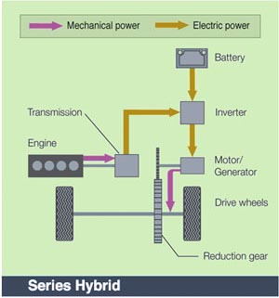
Series (Extended-Range) Hybrid
A series hybrid is like a battery driven electric vehicle, the combustion engine in this case drives and electric generator instead of it directly driving the wheels, with this the generator both powers and chargers and electric motor to move the vehicle, when dealing with copious amounts of power requirement the motor will pull electricity from both the battery and generator. (autocaat.org, 2015)
Figure 1 - Series Hybrid (autocaat.org)

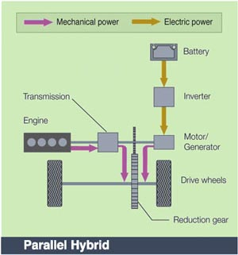
Parallel Hybrid
Parallel hybrid systems are propelled by both and internal combustion engine (ICE) and an electric motor connected to a mechanical transmission. With both internal combustion engine and electric motor running a power distribution can vary between them making for maximum operation as possible from both sides. With this system the vehicle can never run solely on electric mode it will always have the assistance of the internal combustion engine by its side, but mostly turns on when boost is required. (autocaat.org, 2015)
Figure 2 - Parallel Hybrid (autocaat.org)
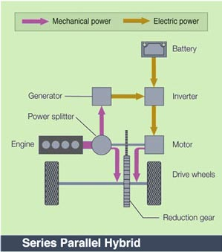
Series Parallel
With this system the vehicle can operate solely on its internal combustion engine alone or strictly electric motor running or both system running together, this helps the vehicle and engines to run at its maximum operation. (autocaat.org, 2015)

Figure 3 - Series Parallel Hybrid (autocaat.org)

Batteries

There are several types of batteries out there are currently being used in hybrid vehicle applications and many others are still being tested on, here will be stated some that can be used and are being used for such application.

Two main types of batteries are being used for the hybrid vehicles these days one is the Lithium-ion (Li-ion) Batteries and the other is the Nickel-metal-hydride (Ni-MH) Batteries, both good technologies but also with their own problems.

Lithium-ion (Li-ion) Batteries:
The advantages to this technology would be that it has a good energy-to-weight ratio which means that it has more energy density can than make the batteries weigh less than most, which for vehicle applications is considered an important thing making the vehicle weight less means less mass more miles, better performance overall. (Oagana, 2017)

The other advantage would be that this type of battery can be quickly charged, this can be an attractive attribute, but it probably won’t be as fast as we would like it to be for everyday charging, it would still require some time before the owner will be out their way. (Oagana, 2017)

Also, with memory effect being considered low means that it can hold its capacity and charging cycles for longer compared to other technologies out there. (Oagana, 2017)

Main disadvantage or one of the biggest down sides to this technology will be the manufacturing cost compare to Nickel-based batteries proximately a 40% more expensive to produce and this cost can come even higher for buyers. (Oagana, 2017)

Without proper storage these batteries can suffer, and its life cycle can decrease massively if proper use and storage is not considered. (Oagana, 2017)

Nickel-metal-hydride (Ni-MH):
The advantages to this technology is that it is much cheaper to manufacture compare to Lithium-ions. (Oagana, 2017)

Nickel based batteries are a lot tougher when comparing most modern technologies when taking proper care of them, these batteries can last a long time and in addition to its durability it takes less precautions to be recycled because it contains a smaller amount of mild toxins compared to other types, also with a high concentration of nickel it makes recycling somewhat profitable. (Oagana, 2017)

The disadvantage to this technology is their low density in energy, making it 40% lower than Li-ions making these batteries much heavier and larger than some, thus decreasing some performance in vehicles, also when discharge under high load it can heat up quiet a lot making need for a separate cooling in some cases adding even more weight. (Oagana, 2017)

Motor DC and AC

Both DC and AC motors have the same function principle, converting electrical energy to mechanical energy, but powered and controlled differently.
AC motors are powered from alternating current while DC motors are powered by direct current, DC motors can have a lower life expectancy and limit to speed constructed with brushes, AC motors don’t require brushes and have longer life expectancy, when it comes to control AC is controlled by difference in frequency and DC motors controlled by armature windings.

Controller

A controller must be used to make sure the motor runs properly so it doesn’t phase out, burn out, over speed, under speed etc, also it is for protection in cases of under/over voltage, short circuit, current limiter and other, without a controller it can result in permanent electrical damage. (Maxonmotor, 2015)

Analysis

Motor and Controller

Three Phase Electric Motor, 30kw, 40HP, FLANGE Mounted, (B5), 1500 rpm (4 Pole), 200L Frame, ALUMINIUM Body, IE2
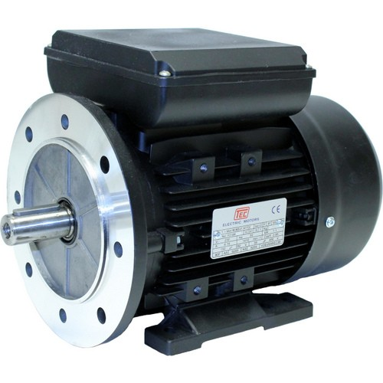
Figure 4 - Motor Used for this application (aceletricmotor)
KW: | 30
HP: | 40
Frame: | 200L
Mount: | FLANGE
Material: | ALUMINIUM
Input: | THREE PHASE
Output Speed: | 1500 rpm
Shaft Diameter: | Φ55
Shaft Length: | 110

(Acelectricmotor, n.d.)

This is the motor that will be used for this application enough power to make sure the vehicle rides properly.

HPEVS Curtis 1238e-6521 72V 550 AMP Controller

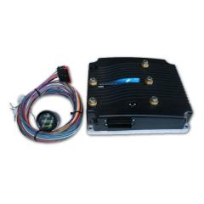
This is the controller for the motor.
Max Current: 550 Amps with Liquid Cooling (2 Min. Max)
Rated Power: 28 KW (37HP)
Input Voltage: 48-80 Volts
Adjustable Max Output Voltage: 72Adjustable Acceleration (Slew Rate): Yes
Idle Function: Yes, 500-1500 RPM (Modern Vehicles Idle from 600-800 RPM)

Figure 5- Controller (evwest)

Battery

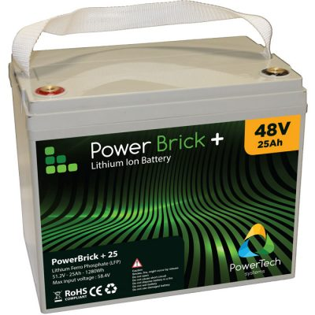
25Ah – 48V Lithium-Ion Battery Pack

48V battery pack – Lithium Iron Phosphate
Continuous Maximum discharge current: 50A
10s Maximum discharge current: 75A
Maximum charge current: 25A
Serial assembly can range from 48V to 96V (1S & 2S)
Minimum 3000 cycles at 80% DOD
13.6Kg
Figure 6 - Battery (powertechsystems)

Generator
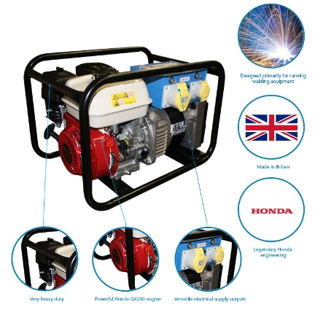
- 3.4 kVA kW / 2.7 KW
- Honda GX200 Engine
- 3.6 L fuel tank - 3 hours run time at 75% load
- Easy-start recoil mechanism
- Large muffler for quiet 70 dB operation
(SGS, 2016)
This generator should provide more than sufficient energy to charge up the battery when required. Cost of Generator = £500

Figure 7 - Generator (SGS)

The final drive ratio for the vehicle can be found by using the formula:
$(v/r)×60$
10/1.4 = 7.1 revs/s
7.1 x 60 = 426 RPM
This will give a value for wheel speed in revolutions per minute (RPM) from here we use:
$$\frac{MotorRPM}{Wheel RPM }$$
3000/462 = 7:1 Final Drive

Total cost

Motor £ 886.61
Controller £ 1450.58
Battery £ 750
Generator £ 500
Total cost £ 3,644

Conclusion

The concerns with this application will be on how well the HEV will perform in outdoors condition, there are possibilities of this system failing due to lack of protection from weather possible knocks and bumps provided by the buggy itself.

To conclude this system will keep up with the requirements asked and will have enough power to maintain the specifics should the vehicle be used for short periods of time as for cost after a short period the investment will start paying itself off.

Works Cited
Acelectricmotor. (n.d.). Motor . Retrieved from https://www.acelectricmotor.co.uk/products/Three-Phase-Electric-Motor-30kw-40HP-FLANGE-Mounted-B5-1500-rpm-4-Pole-200L-Frame-ALUMINIUM-Body-IE2/P100242
Autocaat. (2015). HEV Types. Retrieved from autocaat: http://autocaat.org/Technologies/Hybrid_and_Battery_Electric_Vehicles/HEV_Types/
Das Power bike. (n.d.). Retrieved 3 21, 2018, from http://gso.gbv.de/DB=2.1/SET=1/TTL=1/SHW?FRST=1&PRS=HOL&HILN=888#888
Evewest. (n.d.). Evewest. Retrieved from http://www.evwest.com/catalog/product_info.php?cPath=1&products_id=350
Maxonmotor. (2015, July 2). DC Motors. Retrieved from Maxonmotor: https://www.maxonmotor.co.uk/maxon/view/news/WhyuseaDCmotorcontroller
Oagana, A. (2017, December 27). Hybrid, Plug-ins and Electric Cars. Retrieved from autoevolution.com: https://www.autoevolution.com/

