
PROJECT MANAGEMENT
Assessment 1 - LCBB6006_LON

November 28, 2025
STUDENT: MARIA VIORICA COVETe id:2128947
Lecturer: Dr. Zainab Atta

FutureMetropolis
Smart City Development

Table of Contents
Project Purpose and Justification 3
Project Objectives 4
Project Scope 5
Key Stakeholders 7
Deliverables 8
Timeline / Milestones 9
Budget Estimate 13
Risks and Mitigation 16
Assumptions 17
Approval Signatures 18
References 19

List of Figures
Figure 1: Smart City Ecosystem 4
Figure 2: Smart City Landscape 4
Figure 3: Project Objectives Timeline 5
Figure 4: Public Safety 6
Figure 5: RACI Matrix 8
Figure 6: Community Engagement 9
Figure 7: WBS 10
Figure 8: Schedule Table 11
Figure 9: Gantt Chart 12
Figure 10: Network Diagram 13
Figure 11: Pie Chart for Budget Distribution 14
Figure 12: Bar Graph for Budget Allocation 15

List of Table
Table 1: Key Stakeholders Table 7
Table 2: Project Milestone Table 10
Table 3: Budget Estimate Table 13
Table 4: Risks and Mitigation Table 16

Project Purpose and Justification
The project will aim at development of FutureMetropolis which is a state-of-the-art Smart City that incorporates sustainable and innovative infrastructure to enhance urban living (Singh, 2025). The Smart City will incorporate and integrate IoT and AI technologies and green energy technologies to build an efficient, connected and environmentally friendly city (Zhang, Manogaran and Muthu, 2021). The specific goals of the project will help solve acute urban issues, including traffic congestion, the lack of efficient energy consumption, and waste management through the use of intelligent solutions to track and manage them in real-time. Through a technologically advanced city, FutureMetropolis will be able to offer an adequate quality of life to its inhabitants, improve sustainability, as well as offer an example to other urban planners to do so in future.
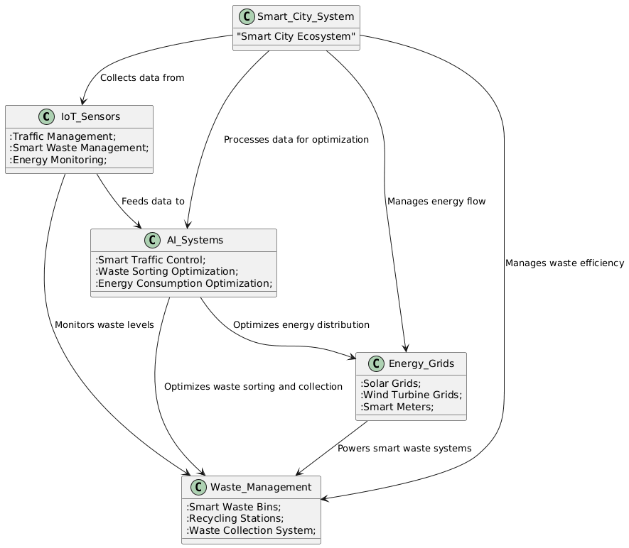
Figure 1: Smart City Ecosystem
Source: Self-Made (Adapted From: Zhang, Manogaran and Muthu, 2021)
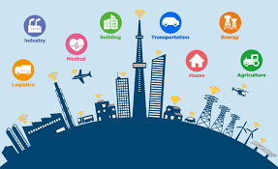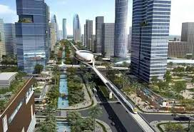
Figure 2: Smart City Landscape
Source: (OBSERVER RESEARCH FOUNDATION, 2019)

Project Objectives
The model of FutureMetropolis Smart City Development project has established clear and SMART goals in order to have a successful model and sustainable urban environment. The objectives include:
- Finalize the stage of the design of the Smart City infrastructure and approval by 01/12/2026, having all the architectural, technological, and regulatory plans completed.
- By 01/06/2027, deploy intelligent systems (traffic management based on IoT, smart grids, and automated waste management) that will make the initial part of the smart infrastructure completely functional.
- Cut the energy use by 25 percent in the first year of operation through incorporation of renewable energy solutions and streamlining of energy distribution.
- By 01/06/2028, 80 percent of smart services (traffic management, waste collection, energy-saving programs) are to be adopted.
- By 01/06/2028, streamline waste management systems 85 percent through the use of IoT sensors and AI to reduce the amount of manual work and enhance the sorting of waste.
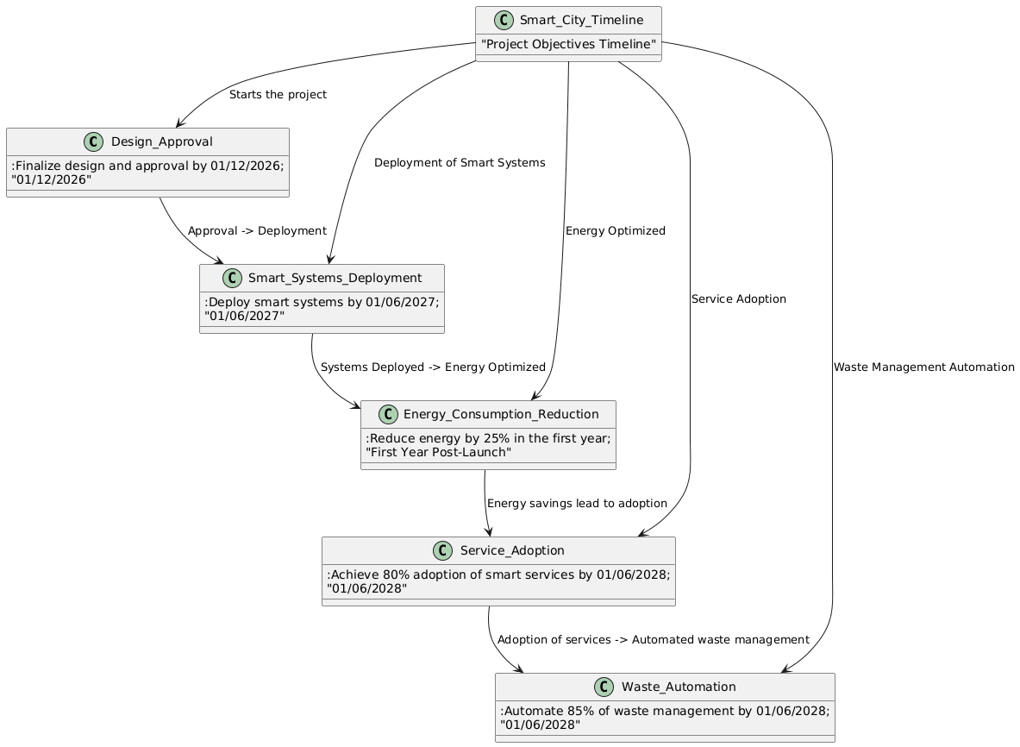
Figure 3: Project Objectives Timeline
Source: Self-Made (Adapted From: Zhang, Manogaran and Muthu, 2021)

Project Scope
The FutureMetropolis Smart City Development project consists of various central urban infrastructure systems that will work on building an efficient, sustained, and connected urban setting.
In-Scope Deliverables:
- Smart Traffic Management Systems: Introducing IoT-based systems in order to optimise the traffic flow, congestion, and enhance the overall transportation efficiency (Vadivel, Hussain and Sangeetha, 2023).
- Smart Energy Grids: Design of efficient grids with renewable power generation sources such as wind and solar in order to control the energy flow and energy usage in the city.
- Smart Waste Management Solutions: IoT-powered waste bins and automatic sorting devices are installed to enhance waste collection, recycling and disposal at minimum human intervention (Nayak et al., 2025).
- Public Safety Systems: A combination of AI-based surveillance cameras, intelligent streetlights, and emergency respondents systems to increase the safety and protection of the population.
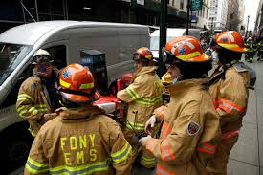
Figure 4: Public Safety
Source: (Rundle, 2022)
- Community Engagement Programs: Educational programs and outreach projects to make sure community is aware of the new smart infrastructure and can make good use.
- Testing and Post Implementation Support: Proceed to test the functionality of all systems and the final maintenance and upgrades, which should be done after implementation.

Out of Scope:
- Six Sigma Other Cities: This will be restricted to FutureMetropolis and expansion to other areas will be avoided.
- Mobile App Development: Mobile app development to facilitate interaction with the population will be dealt with in later stages.
- Home Integration: Technologies that include Smart homes technologies, including IoT devices in homes, are not part of this phase but can be brought up later.

Key Stakeholders
The FutureMetropolis Smart City Development project will be successful as it depends on the active involvement and cooperation of a number of key stakeholders (Hedeman and Seegers, 2009).These persons and entities will be in charge of management of various facets of the project and monitoring that every stage is well undertaken.
Table 1: Key Stakeholders Table
Role | Name | Responsibility
Executive Sponsor | Dr. Amelia Novak | Provides overall strategic direction, funding, and decision-making authority for the project. Ensures alignment with the city’s long-term vision.
Project Manager | Liam Grayson | Leads the day-to-day execution of the project, coordinates teams, manages timelines, and ensures project milestones are met.
Infrastructure Lead | Oliver Blake | Oversees the design and development of physical infrastructure (e.g., smart grids, energy systems, traffic management) and ensures that systems are implemented as planned.
Technology Partner | AetherTech Solutions | Provides and installs the technological infrastructure, including IoT devices, sensors, AI systems, and renewable energy solutions.
City Government | Marcus Thorne | Ensures regulatory compliance, provides necessary approvals, and supports city infrastructure planning and execution.
Community Outreach Lead | Elena Martinez | Manages communication and engagement with the community to educate residents about the smart infrastructure and encourage adoption of new technologies.
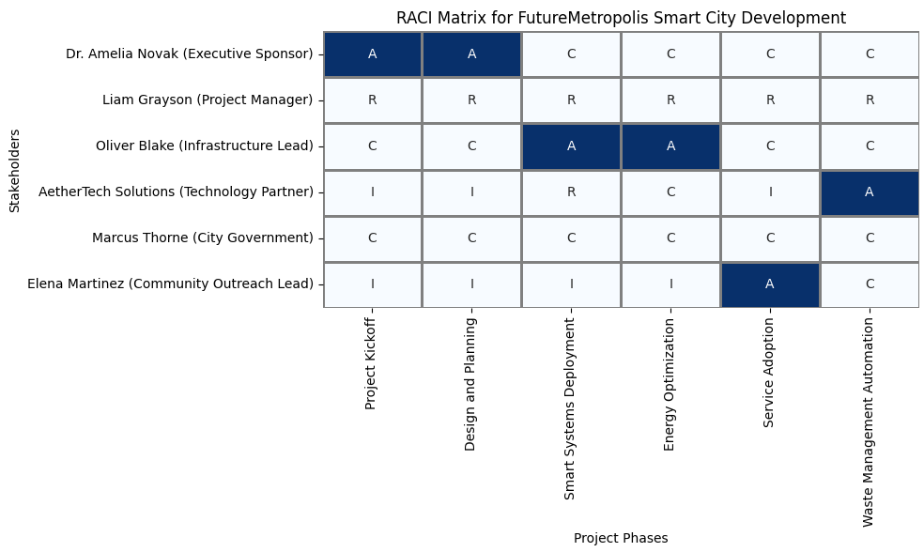
Figure 5: RACI Matrix
Source: Self-Made(Adapted From: Hedeman and Seegers, 2009)

Deliverables
The FutureMetropolis Smart City Development project will generate various critical deliverables that will form the sustainability, connected, and efficient urbanized environment. These deliverables include:
- Smart Traffic Management System: Fully operationalized Smart Traffic Management System constitutes a combination of IoT enabled traffic lights and real-time traffic control mechanisms to maximize traffic flow, minimize traffic congestion and improve commuter experience.
- Smart Energy Grids and Renewable Solutions: application of energy efficient smart grids that utilize renewable energy sources (solar, wind, etc.). These grids will also have smart meters to monitor the use of energy in order to maximize distribution and also to enhance efficiency of such systems (Lund, 2024).
- Automated Management Waste system: IoT enabled waste system solutions, which can be smart bins with sensors to detect waste rates and sort systems to learn to automatically sort waste to help recycle better and save man power (Sosunova and Porras, 2022).
- Public Safety Systems: AI-controlled surveillance cameras, motion sensor streetlights and emergency response systems to enhance security, prevent crimes and be able to respond to an emergency swiftly.
- Post- Implementation Evaluation Report: An overall analysis of the project evaluating the performance of smart system, energy saving, community satisfaction, and the perspectives of future expansion (Eby. 2019).
- Community Engagement and Education Campaign: a complete outreach plan that encompasses workshops, digital materials, and educational campaigns to make sure the residents know about the new smart technologies and are interested and engaged in them.

Figure 6: Community Engagement
All these deliverables are critical in bringing about a successful implementation of FutureMetropolis as a full-blown Smart City.

Timeline / Milestones
In order to meet the FutureMetropolis Smart City Development project requirements to deliver on time and scope, the following milestones have been stipulated (Simon and Murray-Webster, 2018). These major milestones will aid in keeping track of the progress of the project and to make sure that every stage of the project is accomplished successfully.
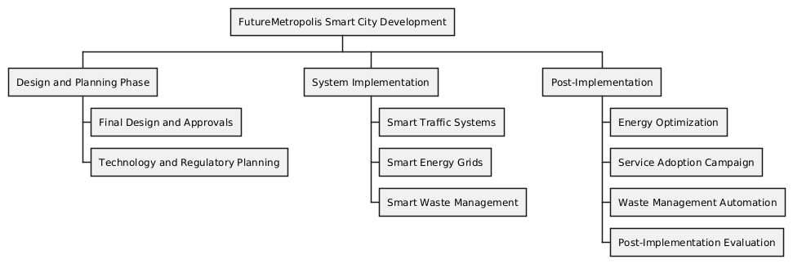
Figure 7: WBS
Source: Self-Made (Adapted From: Eby. 2019.

Table 2: Project Milestone Table
Milestone | Target Date | Owner
Project Kickoff | 01/06/2026 | Liam Grayson
Design and Planning Phase Completed | 01/12/2026 | Liam Grayson
Approval for Smart Traffic Systems | 01/03/2027 | Oliver Blake
Smart Traffic Systems Installed | 01/06/2027 | AetherTech Solutions
Smart Energy Grids Fully Operational | 01/12/2027 | Oliver Blake
Smart Waste Management System Operational | 01/06/2027 | Oliver Blake
Public Safety Systems Activated | 01/12/2027 | AetherTech Solutions
Full City Implementation Completed | 01/06/2028 | Liam Grayson
Post-Implementation Evaluation | 01/08/2028 | Liam Grayson

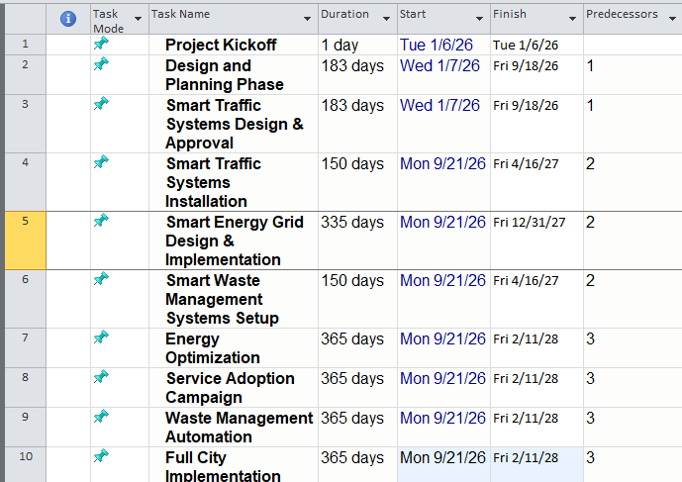

Figure 8: Schedule Table

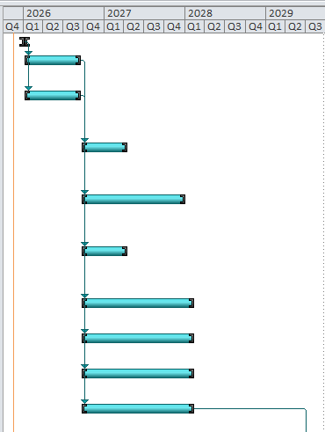
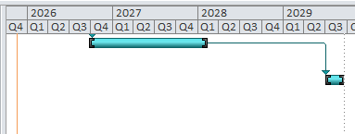
Figure 9: Gantt Chart
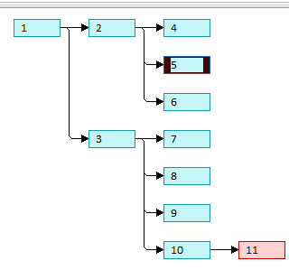
Figure 10: Network Diagram
The milestones are important milestones in the project and essential in ensuring that the project is being tracked. All these milestones will mean that FutureMetropolis infrastructure is deployed as scheduled and allows time to test and evaluate the implementation of the infrastructure prior to the final deployment.

Budget Estimate
The project of FutureMetropolis Smart City Development will imply a number of significant expenses, which will include the installation of smart technologies and designing the infrastructure. The following is an approximation of the budget that will be used in the different categories of the project.
Table 3: Budget Estimate Table
Category | Estimated Cost (£)
Smart Traffic Systems | 120,000
Smart Energy Solutions | 150,000
Smart Waste Management | 70,000
Public Safety Systems | 50,000
Community Outreach and Awareness Campaigns | 15,000
Contingency (10%) | 40,500
Total Estimated Budget | £445,500
Rationale behind Budget Allocation:
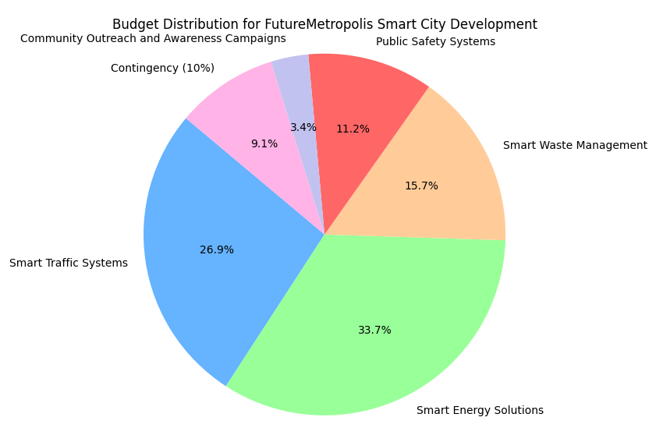
Figure 11: Pie Chart for Budget Distribution
Source: Self-Made (Adapted From: Eby. 2019)

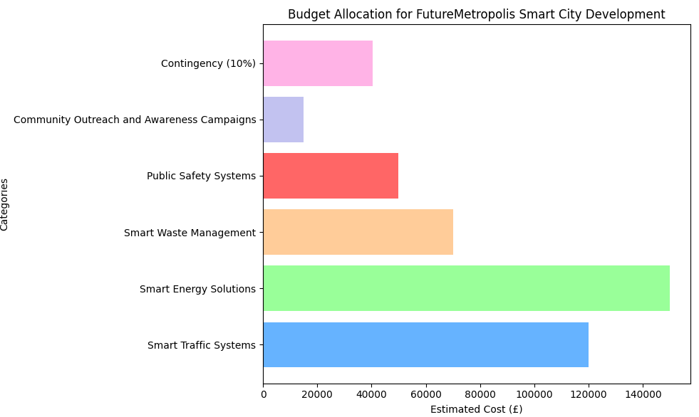
Figure 12: Bar Graph for Budget Allocation
Source: Self-Made (Adapted From: Eby. 2019)
- Smart Traffic Systems: The massive investment in smart traffic systems involves the implementation of the IoT device, traffic tracking systems, and AI-based routing technology so that urban mobility can be optimized.
- Smart Energy Solutions: This category involves installation of renewable energy grids, smart meters and energy efficient infrastructure which will be necessary to make a low-carbon city sustainable (Thornbush and Golubchikov, 2021).
- Smart Waste Management: To develop a smart efficient waste management, investing in IoT-based waste bins, automated sorting, and waste disposal technologies will be required.
- Public Safety Systems: AI-based surveillance, intelligent streetlights and emergency response systems will increase the level of safety and security among the citizens of the city.
- Community Outreach and Awareness: This is a necessary part of this initiative, as it will focus on providing the awareness of the new smart systems to the public. This budget will finance outreach, campaigns and digital materials that will ensure that residents participate.

- Contingency: 10 percent contingency fund will be given to cover any unexpected expenses, and therefore, make sure that any unforeseen setback does not halt the project.
This budget plan is complete and makes sure that each major part of the FutureMetropolis project is sufficiently covered in case it is also a safety net in a case of unforeseen costs.

Risks and Mitigation
The FutureMetropolis Smart City Development, as with any grand-scale infrastructure project, has a number of risks that it is likely to encounter. Early detection of such risks enables the project team to come up with measures of countering such risks and ensuring successful project completion. The major risks and mitigation plans are listed below.
Table 4: Risks and Mitigation Table
Risk | Impact | Mitigation Strategy
Delays in technology deployment | High | Work with multiple technology vendors to ensure backup solutions. Establish clear timelines and strict project management processes to track progress.
Public resistance to smart technologies | Medium | Engage the community early with awareness campaigns, educational workshops, and demonstrations to increase understanding and acceptance. Offer incentives for early adoption of smart services.
Budget overruns | High | Implement regular budget reviews, monitor expenses closely, and use the contingency fund wisely. Ensure all project phases are clearly defined to avoid scope creep.
Cybersecurity threats | High | Collaborate with cybersecurity experts to build secure systems. Regularly audit and update security protocols to ensure all smart systems and data are protected.
Supply chain disruptions | Medium | Identify secondary suppliers to avoid delays. Build flexibility into the supply chain to manage unforeseen disruptions. Establish a buffer time for critical supply deliveries.
Technological integration issues | Medium | Conduct pilot tests to assess system compatibility and integration before full-scale implementation. Ensure close collaboration between all tech partners for seamless integration.
Regulatory or compliance challenges | Medium | Work closely with city officials and legal teams to ensure all regulatory and compliance standards are met before proceeding with implementation.
These risks will allow the project team to provide FutureMetropolis Smart City Development with a stay on track, within budget and deployed successfully with limited unsuccessful implementation.

Assumptions
FutureMetropolis Smart City Development project relies on a number of core assumptions in carrying out such projects. These go in terms of timely obtaining all regulatory approvals by local and national authorities so as to have no delays in construction and technology permits. There is also an assumption that the financing will be gained on time without any delays without doubts about the initial investment and the contingency funds. The project is based on the use of the technology partners, such as AetherTech Solutions, to provide IoT devices, sensors, and AI systems on schedule and in specifications (Soma, 2025). In addition, effective community involvement is the key to successful adoption of smart systems by the population, and it is presupposed that citizens will attend educational courses. It is also assumed that the utility infrastructure will be compatible with its seamless integration with new smart systems (Exner and Andres, 2024). There will also be no significant supply chain interruptions, and all technology systems are supposed to be compatible and integrate with each other without a problem. The assumptions are essential towards the initiative and success of the project.

Approval Signatures
The last stage in the process of formalization of the FutureMetropolis Smart City Development project plan is the ability to receive consent of the main stakeholders involved (Project Management Institute, 2013). The following signatures reveal that the project manager and executive sponsor have read and agreed to the plan and that they have the commitment to the objectives, schedule, budget, and assumptions of the project.
Name | Title | Signature | Date
Dr. Amelia Novak | Executive Sponsor | [Signed] | 01/06/2026
Liam Grayson | Project Manager | [Signed] | 01/06/2026

References
Eby, K. (2019) Free Project Charter Templates and Guidelines, Smartsheet. Available at: https://www.smartsheet.com/blog/project-charter-templates-and-guidelines-every-business-need.
Exner, J.-P. and Andres, P. (2024) Sustainable Operation of Digital Infrastructure in the Smart City: Practical Experience and Implications - REAL CORP Repository, Corp.at. Available at: https://repository.corp.at/1121/1/CORP2024_33.pdf.
Hedeman, B. and Seegers, R. (2009) PRINCE2 2009 edition : a pocket guide. Zaltbommel: Van Haren Pub.
Lund, H. (2024) Renewable Energy Systems, Elsevier.
Nayak, M. et al. (2025) ‘Internet of Things (IoT) for Sustainable Resource Management’, Green Computational Intelligence, pp. 263–290. Available at: https://doi.org/10.1002/9781394383658.ch12.
OBSERVER RESEARCH FOUNDATION (2019) Smart cities mission: Four years of implementation, orfonline.org. Available at: https://www.orfonline.org/expert-speak/smart-cities-mission-four-years-of-implementation-56676.
Project Management Institute (2013) A Guide to the Project Management Body of Knowledge: PMBOK Guide. 5th ed. Project Management Institute.
Rundle, J. (2022) Motorola Launches Information Sharing Group for Public Safety Systems, The Wall Street Journal. Available at: https://www.wsj.com/articles/motorola-launches-information-sharing-group-for-public-safety-systems-11650452402.
‌Simon, P. and Murray-Webster, R. (2018) Starting Out in Project Management, 3rd ed. Buckinghamshire: Association for Project Management.
Singh, T. (2025) Project Charter_ Nikhil, Scribd. Available at: https://www.scribd.com/document/465671576/Project-Charter-Nikhil.
Soma, A.K. (2025) ‘Building Aether Sensor Network using LoRaWAN Network’, pp. 807–814. Available at: https://doi.org/10.1109/esic64052.2025.10962750.
Sosunova, I. and Porras, J. (2022) ‘IoT-Enabled Smart Waste Management Systems for Smart Cities: A Systematic Review’, IEEE access, 10, pp. 73326–73363. Available at: https://doi.org/10.1109/ACCESS.2022.3188308.
Thornbush, M. and Golubchikov, O. (2021) ‘Smart energy cities: The evolution of the city-energy-sustainability nexus’, Environmental development, 39. Available at: https://doi.org/10.1016/j.envdev.2021.100626.
Vadivel, G., Hussain, M.J.M. and Sangeetha, S.V.T. (2023) ‘SMART TRANSPORTATION SYSTEMS: IOT-CONNECTED WIRELESS SENSOR NETWORKS FOR TRAFFIC CONGESTION MANAGEMENT’, INTERNATIONAL JOURNAL OF ADVANCES IN SIGNAL AND IMAGE SCIENCES, 9(1), pp. 40–49. Available at: https://doi.org/10.29284/ijasis.9.1.2023.40-49.
Zhang, X., Manogaran, G. and Muthu, B. (2021) ‘IoT enabled integrated system for green energy into smart cities’, Sustainable energy technologies and assessments, 46. Available at: https://doi.org/10.1016/j.seta.2021.101208.

