Mycenaean Pottery Exports
Mycenaean pottery forms one of the most distinctive and largely distributed ceramic traditions of the Late Bronze Age Aegean and is a key source for analysing interactions across the Aegean and East Mediterranean. The corpus of pottery in the archaeological record spans the Late Helladic (LH) I-III periods and develops alongside the major transformations of Mycenaean civilisation, including the emergence of a ruling class (LH I), the expansion of palaces (LH IIIA-B) and the eventual collapse of these palaces (LH IIIC) (Mountjoy, 1993, pp. 5-30).
Importantly, Mycenaean pottery is distributed heavily in the Levant and Cyprus, being found in hundreds of sites in the former and in most Late Bronze Ages in the latter (Steel, 2013, p. 130). Analysis of provenance shows that wares were made of Greek fabric, proving that these were in fact exported as pots outside of mainland Greece (van Wijngaarden, 2010, pp. 10-11). The uneven distribution and the forms and styles in which they are found allow it to be seen as active participants in international interactions in the Late Bronze Age Mediterranean world, specifically through the frameworks of gifts, commodities, and exotica. This frames these objects as active participants in the creation of social networks of trade and interaction.

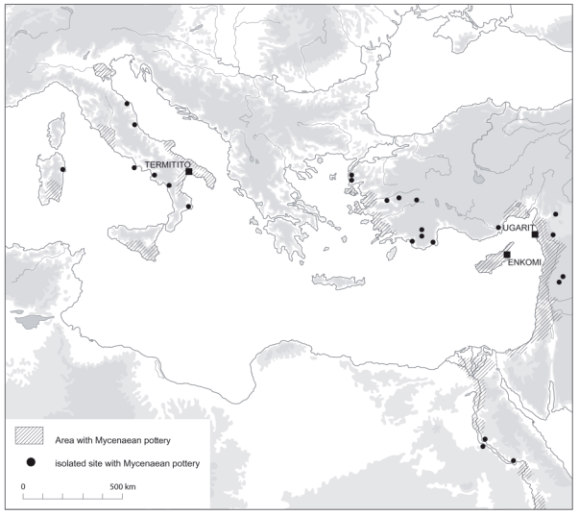
Figure 1: Distribution of Mycenaean pottery in the Mediterranean (van Wijngaarden, 2008, p. 127).

Chronology
Scholars working in Aegean archaeology divide the Aegean Bronze Age into three regional divisions: “Minoan” for the island of Crete: “Helladic” for the Greek mainland: and “Cycladic” for the Cycladic islands (Shelmerdine, 2008, p. 3). Each regional system is divided into Early, Middle, and Late phases, further subdivided into I, II, and III. In reality this is not quite so straightforward as ceramic development doesn’t fit into such neat categories as styles develop. This, combined with the fact that the Late Bronze Age saw great importation and exportation (Steel, 2013, pp. 130-131), makes it difficult to determine a strict relative chronology (Shelmerdine, 2008, p.3; Mountjoy, 1993, pp. 2-3) and there exists a great difficulty in determining an absolute chronology (Mountjoy, 1993, pp. 2-3). Mycenaean pottery fits into the Late Helladic I-III (see Figure 2: Mountjoy, 1993, pp. 5-30), and a discussion of each period is below.

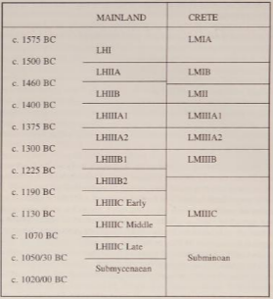
LH I
Figure 2: Chronology (Mountjoy, 1993, p.4)
During the late Middle Helladic phase a ruling class emerged in different areas of mainland Greece, with a particularly dominant centre in the north-east Peloponnese Mycenae (Mountjoy, 1993, p. 5). The first evidence for a Mycenaean pottery comes from this period, known as Late Helladic I (LHI) and is one several wares in use alongside Middle Helladic (MH) wares (ibid., p. 33). Here, distinguishing between vessels of Minoan or Mycenaean manufacture is difficult due to the undoubtable Minoan influence on Helladic styles, resulting in the development of a new style, a fusion of the two (Steel, 2013, pp. 53-55; Mountjoy, 1993, p. 33). This is exemplified best at the The Shaft Graves at Mycenae, where evidence of an emergent elite that had a preference for Minoan ideals is exhibited in the lavish goods found there (Steel, 2013, p. 54). The shapes of this time are relatively clumsily wheelmade wares and lack the same uniformity and standardisation of later wares (Lolos, 1985, pp. 221-222). The piriform jar and alabastron, two shapes relevant to exportation and later significance are first exhibited at this time. The pottery is a mixture of Middle Helladic and Minoan influences, taking features from the both of them (Mountjoy, 1993, p. 33).

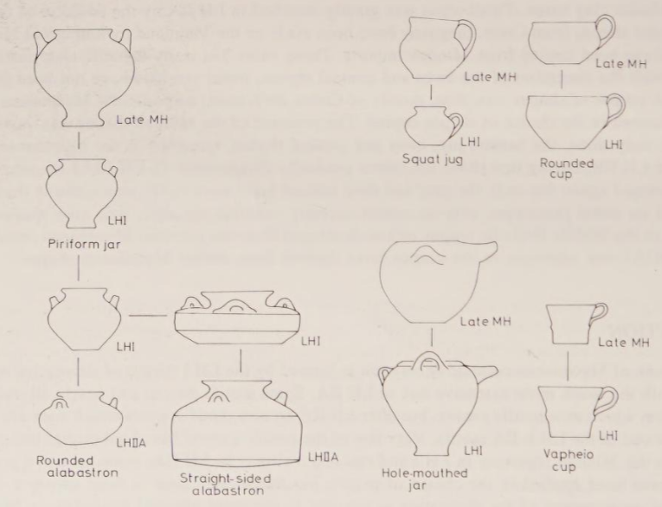
Figure 3: LH I shapes (not to scale) (Mountjoy, 1993, p. 32)

LH II
Pottery from LH II can be subdivided into LH IIA and IIB. Like LH I, the styles are Minoan influenced (Steel, 2013, p. 129). The archaeological record of pottery of this period is greater than LH I. This can be attributed to the falling of power at Crete, allowing Mycenae to gain power and realise themselves as part of greater trade networks in the Mediterranean (ibid.; Mountjoy, 1993, p. 10). For the first time Mycenaean wares are being exported to the Levant, Cyprus and Egypt (Steel, 2013, pp. 129-130), showcasing the growing power of Mycenaean Greece. Crucially, these exports are limited in number, discussed as being part of small scale gift exchange and not a fully realised mercantile trade (Steel, 2013, pp. 129-130). Key exported shapes are the alabastron and pithoid jar (Steel, 2013, p 129). The former of these is a purely Mycenaean invention, with it being valued by trading partners by the existence of them as grave goods such as the throne room of Knossos, and its form being adopted by Minoan and Mycenaean elites (ibid.)

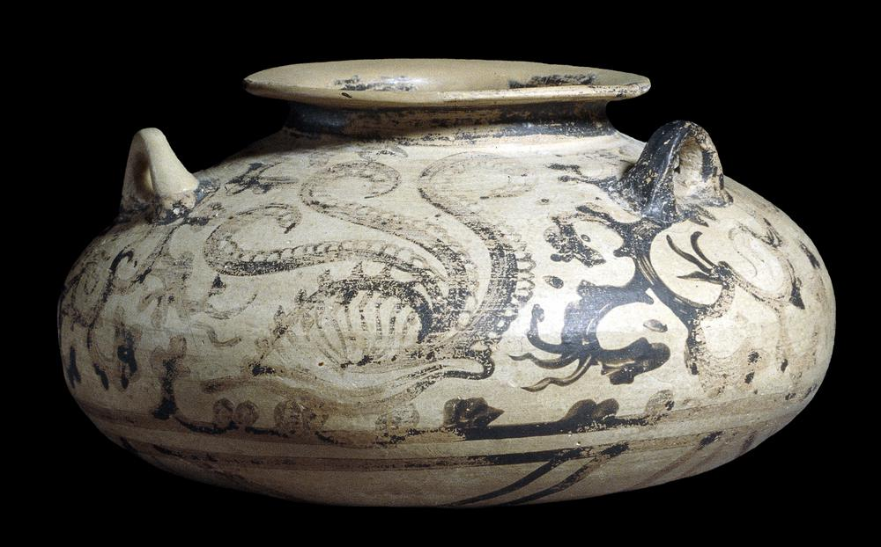
Figure 4: Alabastron, found in Armant, Egypt (The British Museum, no date a).
LH II wares saw much greater elaboration in terms of decoration, with both Minoan and Mycenaean motifs fully realised. The breadth of motifs is extensive, with styles largely fitting into plant, marine (such as Figure 4), object, and abstract styles (Mountjoy, 1993, pp. 42-52). These styles are largely Minoan influenced, but interestingly showcase the connectivity of the Late Bronze Age Mediterranean, with a focus on the sea, perhaps showcasing the maritime cognitive map they would have had (Steel, 2013, p. 4).

LH III
The main corpus of exported Mycenaean wares are of LHIIIA-B, with large quantities of it being found across the East Mediterranean in hundreds of sites in the Levant and most sites of this time in Cyprus (Steel, 2013, p. 130). This showcases a clear change and reorganisation of long distance Mediterranean trade, with them becoming seemingly ubiquitous and fundamental to social life and trade (ibid., p. 131).

LH IIIA1
This phase is marked by the foundationing of protopalaces, beginning a protopalatial period (Mountjoy, 1993, p. 11). This saw an influx of greater burials and settlements with greater numbers of goods, including pottery (ibid., p. 11-13). The first evidence of expanded trade with the east Mediterranean is of this period (ibid.; Steel, 2013, pp. 130-131; van Wijngaarden, 2008, p. 126), largely seen as a consequence of declining Minoan power with destruction on Crete and Mycenaean styles filling this gap (Mountjoy, 1993, p. 169).
The piriform jar, rounded alabastron and goblet are the most popular LHIII A1 shapes, with additions to the repertory of shapes and an influx of new styles (Mountjoy, 1993, p. 63). Importantly, the kylix first appears at this time, a shape which sees great development and influx in later LH III A2 (ibid., p. 71). LH III A1 is characterised by the mass production of artefacts, leading to the standardisation and formalisation of decorative motifs (ibid., p. 64; Steel, 2013, p. 131). Motifs were largely evolved from LH IIB, albeit now more standardised (Mountjoy, 1993, p. 64).

LH IIIA2

LH IIIA2 is characterised by a mainland Greece consisting of a number of small states with palaces at the large centres, like Mycenae, Tyrins and Pylos, entering now a palatial period and the largest development of exported pottery (Mountjoy, 1993, p. 15, 170). This expansion can be seen throughout the Aegean, Near East, Asia Minor and even Italy (ibid.). Shapes of this period largely correspond with that of LH IIIA1 (ibid., p. 71), with both open shapes being exported as fine table ware (ibid., p. 170) and closed containers being exported for the goods they contain (ibid.; Steel, 2013, p. 131). Stirrup jars, piriform jars and kylikes are the most heavily exported (Mountjoy, 1993, p. 170) and the closed aperture of the stirrup jar being suggested as evidence of the trade of oil (Steel, 2013, p. 131). Decorations continue to be standardised, with a seeming preference for chariot scenes as exports (Mountjoy, 1993, p. 170; see Figure 5).

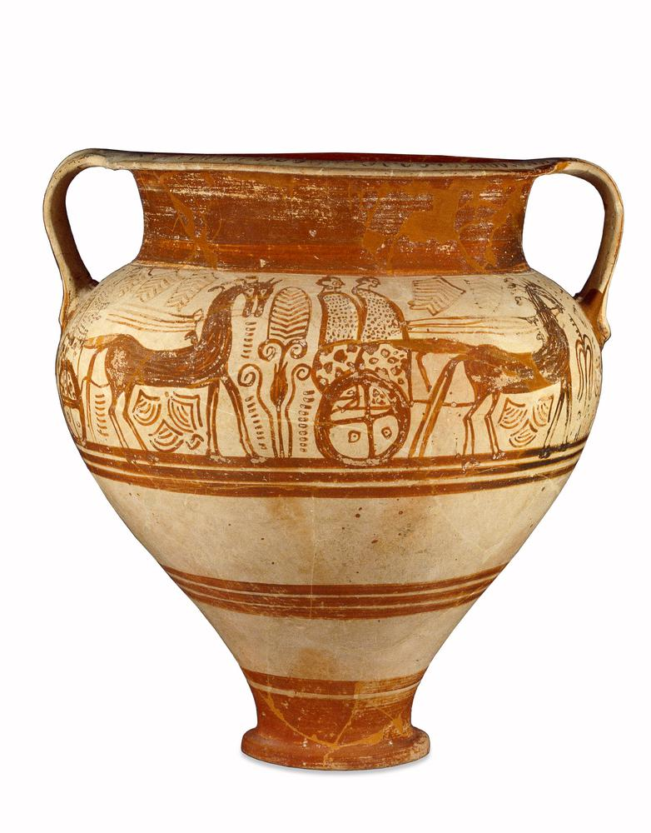
Figure 5: LH IIIA2 amphoroid krate with chariot scene (The British Museum, no date b)

LH IIIB
The prosperity of the palatial system continued during this period, with the palaces reaching their final form and exports of pottery continuing (Mountjoy, 1993, p. 19; van Wijngaarden, 2008, p. 127). A preference for the stirrup jar and closed shapes exists in this period (Mountjoy, 1993, p. 80) as part of a trade system of perfumed oils and unguents (Steel, 2013, pp. 132-133). Large quantities are found in Cyprus and the Near East (Mountjoy, 1993, p. 174), and a preference for emulation of Mycenaean styles in Cyprus is found (ibid.; Steel, 2013, p. 136). The Pictorial Style continues to decorate this period, with scenes of animals in particular (Mountjoy, 1993, pp. 83-84).

LH IIIC
LH IIIC is characterised by the collapse of the palatial system, and with that the decline of exportation (Mountjoy, 1993, pp. 22, 174). In particular the Near East seems to have experienced a decline in exports, with very little being found in the archaeological record (Mountjoy, 1993, p. 174; van Wijngaarden, 2008, p. 131). Evidence for the reproduction and preference for styles continues in Cyprus, with a suggestion of Mycenaean settlers on the island (Mountjoy, 1993, p. 175; Steel, 2013, p. 137). The collapse of palaces saw the great uniformity of before disappear, and localised decoration became dominant, such as the Close Style in the Argolid and the Pictorial Style in the Peloponnese (Mountjoy, 1993, p. 97).

Exportation and social value
Mycenaean pottery is one that is highly embedded in trade networks and the remains of such constitutes one of the key archaeological sources by which to study relationships between the Aegean and other areas of the Mediterranean (van Wijngaarden, 2002, p. 1). The earliest evidence of exportation is of the Late Helladic (LH) II styles, with limited evidence in the Levant, Cyprus and Egypt (Steel, 2013, p. 128). A marked peak in finds appears in the palatial (LH IIIA2-B) period, showcasing a key development in trade networks (van Wijngaarden, 2008, p. 126; Steel, 2013, pp. 130-131). Provenance analyses showcase that wares were made of Greek fabric, proving that these were in fact exported as pottery outside of mainland Greece. (van Wijngaarden, 2010, pp. 10-11). A great number of different styles and forms were exported (Steel, 2013, p. 131), with closed shapes exported for their contents and open shapes traded for themselves as vessels (Mountjoy, 1993, p. 163). Whilst the pottery has been found in many different sites, the distribution of them is not even and the proportion varies greatly (van Wijngaarden, 2010, p. 18). This variation in forms and variation in distribution allows exploration of these exported objects through different theoretical frameworks, in particular viewing them as commodities (see Appadurai, 1986; Kopytoff, 1986 and Steel, 2013), gifts (see Mauss, 2011 and Steel, 2013) and as forms of exotica (see Helms, 1988 and Steel, 2013).

Mycenaean Pottery as Gifts
Marcel Mauss (2011, p. 1), in his seminal anthropological text The Gift, discusses gift giving in preindustrial groups and postulates that gift giving is not simply voluntary but is in fact given and repaid under obligation. The text primarily focuses on Melonesian practices, in particular the kula, an intertribal practice in which sailors travel from island to island giving gifts (ibid., p. 20). As all islands participate in this exchange, an obligation to give and an obligation to receive is made, this is a form of total prestation, in which this give-and-take contains “all the threads of social order”, moral, religious and economic (ibid., pp. 1, 27). This differs from commodity trade by the existence of the obligatory dimension, tying social relationships between peoples, and not just merely a functional and economic one. This theoretical thinking can be applied to Cyprus specifically. In the earlier years of the Late Bronze Age, particularly LH II, it has been stated that before the increased circulation of pottery during the palatial period, the limited evidence of LH II wares in Cyprus is an example of elite gift exchange (Steel, 2013, pp. 128-130). Due to the small amount of them found, and the existence of them in new settlements and burial contexts, it can be argued that this is not an example of mercantile trade but is instead an example of small scale gift exchange, whereby the elites of Cyprus were potentially involved in prestations of a diplomatic and social nature as part of an attempt to solidify their status within the East Mediterranean world (ibid.). Textual evidence of gift exchange of this time also exists. Whilst not directly related to pottery, the Amarna archive in Egypt shows diplomatic letters between rulers of Egypt and other areas, most notably the Levant (Feldman, 2006, pp. 13-14). These letters showcase gifts that were sent between so called Great Kings, and showcases a reciprocal nature to them (ibid.). Whilst not direct evidence for pottery as gifts, it showcases that gift exchange systems were taking place in the Bronze Age Mediterranean, and the archaeological evidence of LH II pottery in Cyprus might be further evidence of such systems.

Mycenaean Pottery as Commodities
The movement of Mycenaean pottery across the Mediterranean may be better understood as commodity exchange. Arjun Appadurai (1986, p. 3) defines a commodity as “objects of economic value”, and stresses that this value is not inherent but is attributed through politics. This is fundamentally different from gifts, which are tied up in reciprocity, but is instead an economic and political exchange. Commodities also cross cultural boundaries, and the valuation of them can change from context to context (ibid., pp. 14-15). Importantly, commodities are discussed having an ability to move in and out of being a commodity, and that the value that is attributed to them is from the paths they take (ibid., pp. 16-17). These paths are clearly delineated over both land and sea: an overland route between Mesopotamia, Syria and Anatolia and a maritime route across the Mediterranean sea (Steel, 2013, p. 130). Commodity trade is exhibited through the great increase in Mycenaean pottery during LH III, particularly in Enkomi in Cyprus and Tell Abu Hawam in Ugarit (ibid.). Large quantities of closed forms are found at these sites, and in Cyprus appear alongside great numbers of Cypriot forms (ibid., pp. 130-131). Morphological analysis of these Mycenaean objects, particularly the pithoid jar and stirrup jar, suggests that they could have been traded for their contents, likely viscous oil based fluids (ibid., p. 132). A suggestion has been made that an export of Mycenae could potentially be perfume, of which these morphological features would attest to (ibid.; van Wijngaarden, 2002, p. 33). Textual evidence of production of commodities also exists in Linear B tablets. These tablets showcase accounting systems of palaces, for example the production of grain at Messenia, a textile industry at Pylos (Mountjoy, 1993, p. 21). They list raw materials, such as flax, bronze and grains as well as importantly listing the end products of them. Agricultural products of key note here are oil, wine, honey and olives (ibid.). Whilst pottery itself is not mentioned as a product, these exported goods would need vessels to be transported in, showcasing textual evidence of pottery as commodities, particularly the closed forms and what they would have held.

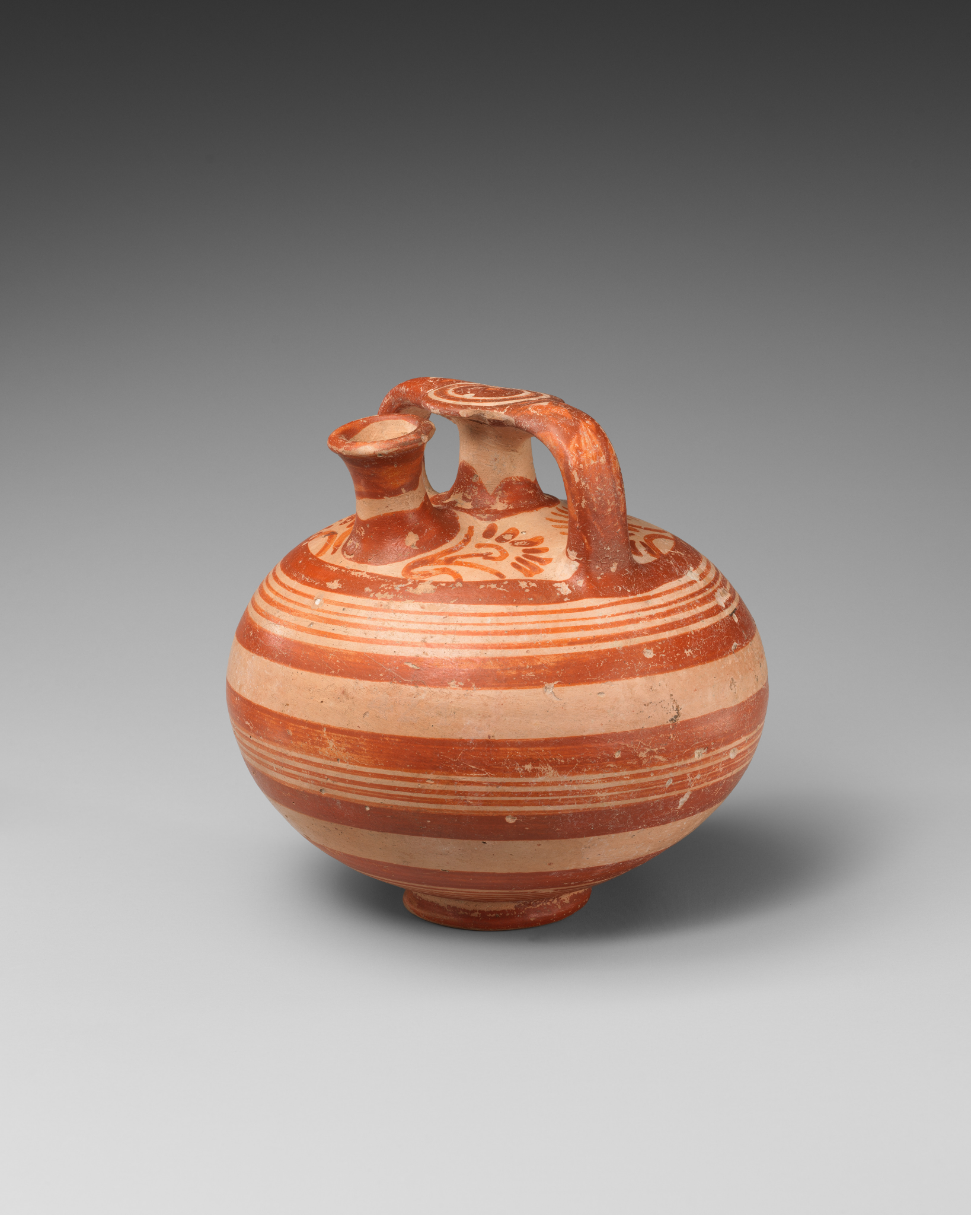
Figure 6: Stirrup jar (The Metropolitan Museum of Art, no date)

Mycenaean Pottery as Exotica
Mary Helms (1993, pp. 4-5) in her seminal ethnographic study Ulysses’ Sail, states that “space and distance are not neutral concepts, but are accorded sociological, political and ideological significance”. She states that geographical distant and unknown lands create a level of mysticism and aura, and the further away the land the more mysticism it holds (ibid.). This is applied to material culture, with Steel (2013, p. 127) stating that esoteric knowledge of distance by elites can be manipulated for social power and the construction of ideologies. This may have been manipulated by Mycenaean manufactures as a way to specifically target foreign markets in both Cyprus and the Levant and targeting their desire for luxuries (Sherratt and Sherratt, 1991, p. 356). Archaeologically, the amphoroid krater is seen in far larger quantities in the east than it is in the Aegean, as is the Pictorial Style (Steel, 2013, p. 135). Both the desire for the geographically distant styles, or exotica, by the east and the desire for Mycenae to target and manipulate this desire are exhibited through this evidence.

Mycenaean Pottery and Value
Viewing Mycenaean pottery through the lenses of gift-giving, commodity exchange, and exotica demonstrates how these vessels were deeply involved in social connections of the Late Bronze Age Mediterranean. Showcased through these lenses is the embedded social and religious worth of them, complex international trade and the manipulation and desire through its exoticness and geographical distance. This showcases this pottery not as a passive indicator of contact between civilisations but as an active participant in the construction of relationships between peoples. Its distribution shapes and is shaped by political, religious and social networks.

Bibliography
Appadurai, A. (1986) ‘Introduction: commodities and the politics of value’ in Appadurai, A. (ed.) The social life of things: Commodities in cultural perspective. Cambridge: Cambridge University Press.

The British Museum (no date a) Pottery ointment jar (alabastron) decorated in the 'Marine Style'. Available at: https://www.britishmuseum.org/collection/image/34744001 (Accessed on 29th of November 2025).

The British Museum (no date b) Amphoroid krater. Available at: https://www.britishmuseum.org/collection/image/34805001 (Accessed on 30th of November 2025).

Feldman, M.H. (2006) Diplomacy by Design: Luxury Arts and an “International Style” in the Ancient Near East, 1400-1200 BCE. London: University of Chicago Press.

Helms, M.W. (1988) Ulysses’ Sail: An Ethnographic Odyssey of Power, Knowledge and Geographical Distance. Guildford: Princeton University Press.

Kopytoff, I. (1986) ‘The cultural biography of things: commoditization as process’ in Appadurai, A. (ed.) The social life of things: Commodities in cultural perspective. Cambridge: Cambridge University Press.

Lolos, J.G. (1985) The Late Helladic I pottery of the southwestern Peloponnesos and its local characteristics. Unpublished PhD thesis. Royal Holloway, University of London. Available at: https://repository.royalholloway.ac.uk/items/7fa4e8a6-afd6-43ae-a892-f2a0ae700618/1/ (Accessed on 29th of November 2025).

Mauss, M. (2011) The Gift: Forms and Functions of Exchange in Archaic Societies. Connecticut: Martino Publishing.

The Metropolitan Museum of Art (no date) Terracotta stirrup jar. Available at: https://www.metmuseum.org/art/collection/search/240357 (Accessed on 30th of November 2025).

Mountjoy, P.A. (1993) Mycenaean Pottery: An Introduction. Oxford: Oxbow Books.

Shelmerdine, C.W. (2008) ‘Background, Sources and Methods’ in Shelmerdine, C.W. (ed.) The Cambridge Companion to The Aegean Bronze Age. Cambridge: Cambridge University Press.

Sherratt, A. and Sherratt, S. (1991) ‘From Luxuries to Commodities: the Nature of Mediterranean Bronze Age Trading Systems’ (from the Papers Presented at the Conference held at Rewley House, Oxford, in December 1989), Studies in Mediterranean Archaeology, 90, pp. 351-386.

Steel, L. (2013) Materiality and Consumption in the Bronze Age Mediterranean. Oxon: Routledge.

van Wijngaarden, G.J. (2002) Use and Appreciation of Mycenaean Pottery in the Levant, Cyprus and Italy (ca. 1600-1200 BC). Online: Amsterdam University Press. Available at: https://www.jstor.org/stable/j.ctt45kdgc (Accessed on 30th of November 2025).

van Wijngaarden, G.J. (2008) ‘The relevance of authenticity: Mycenaean-type pottery in the Mediterranean’ in Biehl, P.F. and Rassamakin, Y.Y. (eds.) Import and imitation in archaeology. Online: Beier and Beran. Available at: https://www.academia.edu/6851204/Biehl_P_and_Yu_Rassamakin_eds_2008_Import_and_Imitation_in_Archaeology_Schriften_des_ZAKS_11_Langenwei%C3%9Fbach_Beier_and_Beran_252_P (Accessed on 29th of November 2025).

Wikimedia Commons (2020) Late Helladic I potter cup, AM of Mycenae, 201639. Available at: https://commons.wikimedia.org/wiki/File:Late_Helladic_I_pottery_cup,_AM_of_Mycenae,_201639.jpg (Accessed on 29th of November 2025).

