


CUSTOMER SEGMENTATION DATA WAREHOUSE
by
GEORGE-ADRIAN APOSTOL
(1807626)

Supervisor: Dr Terry Walcott

Project submitted as part of the requirements for the award of BSc (Hons) Cloud Computing

July 2021

Declaration of Originality

I, George Adrian Apostol, declare that I am the sole author of this project; that all references cited have been consulted; that I have conducted all work of which this is a record, and that the finished work lies within the prescribed word limits.
This work has not previously been accepted as part of any other degree submission.

Signed: George Adrian Apostol
Date: 26.07.2021

Form of Consent

I, George Adrian Apostol, hereby consent that my project, submitted in candidature for the BSc Cloud Computing degree, if successful, may be made available for inter-library loan or photocopying (subject to the law of copyright) and that the title and abstract may be made available to outside organisations.

Signed: George Adrian Apostol
Date: 26.07.2021

Copyright Acknowledgement
I acknowledge that the copyright of this project report, and any product developed as part of the project, belong to the University of Wales Trinity Saint David.

Abstract
This report implicates one of the hottest topics in e-commerce, 'Retail'. A complete data warehouse has been designed for the retail store customer targeting, which includes why a retail data warehouse is needed and what targets could be achieved. The data warehouse helps us answer the question through which we can identify or segregate customers on different parameters. Thus, it enables us to increase our revenue and customer base. A visual representation is provided at the end to understand the analysis better.
In the business environment, most organisations utilise databases to document, gather, and deal with their records. Consistently, immense amounts of information are recorded in the organisations. The framework extends quickly, which makes specific information investigation and preparing issues. To play out certain imperative assignments crucial for the business's presence, like administrating, analysis, and organisations should survey the information accumulated appropriately and concentrate experiences. The previously mentioned points move designer experts to look for imaginative answers to help people associated with the dynamic stage and need proficient mastery. The possibility of the data warehouse has begun to develop in the previous years as a cutting-edge type of dynamic choice emotionally supportive networks. A data warehouse might be unmistakably portrayed as an archive of information that helps clients in dynamic cycles. The information has been organised to make it simpler to utilise and, simultaneously, gives extraordinary checking results.
The current work intends to make and plan a data warehouse dependent on a retailer business's prerequisites and value-based framework. Principal, the data warehouse and their improvement stages are laid out, trailed by the unveiled functional area.
As a method of supporting the Retail and Human Resources Office, a data warehouse has been created to accumulate information from the Retail Sector Organization of the business. The critical reason for developing a data warehouse is to assist with a more grounded checking of the Retail Staff from the Retail Business by the Retail Management to likewise work with the acquirement of reliable and exact information which can be used by the business owners or business development officers while building up a compelling insight framework. The information will be used by the Retail Office also for assessing the retail procedure of the business. In this paper, a solid and compelling Microsoft SQL Server 2019 apparatus will be utilised initially to transform information and insight extraction purposes.

Acknowledgement
Foremost, I would like to express my sincere gratitude to my advisor, Dr Terry Walcott, for the continuous support of this project study and research, for his patience, motivation, enthusiasm, and immense knowledge. His guidance helped me in all the time of research and writing of this thesis. I could not have imagined having a better advisor and mentor for my study. Last but not least, I would like to thank my family for their continuous support.

Table of Contents
Abstract
Acknowledgement
List of Figures
List of Tables
List of Definitions
List of Abbreviations
Chapter 1 1
1.1 Introduction: 1
1.2 Problem Statement 3
1.3 Study Objectives 3
Chapter 2 5
2.1 Literature Review 5
Chapter 3 8
3.1 What is a Data warehouse? 8
3.2 Data Warehouse Types 8
3.3 Data Warehouse Properties: 9
3.4 Data Warehouse Components: 9
3.5 Understanding ETL: 10
3.6 Data warehouse Methodologies: 12
3.7 Datawarehouse vs Database: 14
Chapter 4 15
4.1 Design Tools for Data Warehouse: 15
4.2 Data warehouse life cycle: 15
4.3 Data warehouse design: 16
4.4 Primary Key vs Surrogate Key: 29
4.5 Star Schema: 35
4.6 Risk analysis: 37
Chapter 5 38
5.1 Generating Reports using Tableau 38
5.2 Business Case Studies 38
Chapter 6 44
6.1 Conclusion 44
6.2 Future Work 44
References 45
Appendix: Gant Chart plan 49
Appendix: Source code preview 49

List of Figures

Figure 1. ETL Data Flow 10
Figure 2. ETL Pipeline 10
Figure 3. Stg_Customers 18
Figure 4. SSIS Customers Table Package 19
Figure 5. SSIS Customers Table Package (2) 19
Figure 6. Stg_Products 20
Figure 7. SSIS Products Table Package 20
Figure 8. Stg_Orders 21
Figure 9. SSIS Orders Table Package 22
Figure 10. Stg_Locations 23
Figure 11. SSIS Locations Table Package 24
Figure 12.. Stg_Stores 25
Figure 13. Dim_Customers 26
Figure 14. Dim_Products 27
Figure 15. Dim_Locations 28
Figure 16. Dim_Orders 28
Figure 17. Dim_Store 29
Figure 18. SSIS Dimension Package 30
Figure 19. SSIS Dimension Package (2) 30
Figure 20. Retail_Fact 33
Figure 21. Retail_Fact (2) 33
Figure 22. SSIS Fact Package 34
Figure 23. SSIS Fact Package (2) 34
Figure 24. Star Schema for Fact_Retail 35
Figure 25. Star Schema for Fact_Retail (2) 36
Figure 26. Customers Shipping Cost 39
Figure 27. Customers with most products 39
Figure 28. Customer Order Priority and Nature 40
Figure 29. Customer Analysis Dashboard 41
Figure 30. Most Profitable Countries 41
Figure 31. Productive Markets 42
Figure 32. Orders for each Year 43
Figure 33. Trend Analysis Dashboard 43

List of Tables
Table 1. Dimensions 13
Table 2. Facts 13
Table 3. Database vs Datawarehouse 14
Table 4. Dataset 16
Table 5. Schemas 17
Table 6. Dbo Schema Tables 17
Table 7. Stg Schema Tables 18
Table 8. Order Priority Table 22
Table 9. City Productivity Table 23
Table 10. Dim Schema Tables 26
Table 11. Primary vs Surrogate key 29

List of Definitions
- Data warehouse: A consolidated system to accumulate data from multiple sources in one place.
- Primary key: A key that distinguishes every entry in a table.
- Surrogate key: An artificially generated key that distinguishes every entry in a table.
- OLAP: System to analyse large chunks of data.
- OLTP: System to process large chunks of data focused on transaction-oriented tasks.
- SQL: Structured query language, pull data from relational DB.
- BI: Data-driven approach to analyse and provide powerful insights to the business.
- ETL: A process that fetches the data from various sources, transforms it and then dumps it into a data warehouse system.

List of Abbreviations
Acronym Abbreviation
AI Artificial Intelligence
BI Business Intelligence
DBMS Database Management System
DIM Dimension
DWH Data-Warehouse
ERP Enterprise Resource Planning
ETL Extract, Transform and Load
GB GigaByte
MB MegaByte
ML Machine Learning
OLAP Online Analytical Processing
OLTP Online Transaction Processing
PB Peta Byte
RDBMS Relational Database Management System
SQL Structured Query Language
SSIS SQL Server Integration Services
STG Stage

Chapter 1
This chapter of the report describes the data revolution age, the need for data for businesses and how it has become most important over the recent years. With the data growth, challenges have also appeared to handle the data and get insight. This chapter also enlightens how Decision Support Systems help manage the data for getting valuable insight out of it for reporting purposes.

1.1 Introduction:
Some 20 to 25 years ago, the Information Technology Industry had a huge advancement in the form of E-commerce. Since then, every type of business, big or small and of any category have tried to get its hands dirty by merging this concept with their business, therefore, increasing its profit, customer base and outreach. However, there are many hurdles faced, one being the size of data increasing at a rapid pace from MB to GB to PB. As data keeps on growing, it becomes extremely important to store this data somewhere in the retail industry, and customers are products considered key aspects. First, the OLTP approach was acquired, but with large amounts of data and different variety coming at different velocities, their OLTP systems started to get overheated, hence increasing the latency, which affects the performance of a retail system.
Businesses have evolved rapidly over time, thus creating a sense of urgency as there is great competition. Each business needs to make efficiency-based decisions so that the forecasted results and outcomes can be predicted in a short interval of time. This has been tackled by introducing data warehousing systems enabling the business to see the big picture and make rapid decisions, leading to fruitful results. These systems use not only the structured data but also data coming from multiple heterogeneous systems.
With the marvel of globalisation and consistent monetary development, the need to guarantee an effective administration is showed increasingly more strongly. The dynamism of the economy's advancement, which has expanded late, expects organisations to adjust to any change rapidly. Moreover, the spans of the organisations have expanded, as have the extents of the market. To settle on the best choices, organisations' administration needs information on the business advancement in the past based on which it is feasible to make quality conjectures in the short, medium or long haul. The opposition is unforgiving, and each off-base advance expense cash. The idiom utilised by financial experts to communicate this truth is extremely interesting: "what you do not know can hurt you". The outcome is a perpetual and intense yearning for data, an issue whose arrangement requires the preparing of a huge volume of information from various and frequently non-homogeneous sources. The old data set administration frameworks, intended for preparing current exchanges (OLTP), can presently don't adapt to these new prerequisites, from one perspective, since they do not hold in the data set recorded data, carefully fundamental during the time spent administrative dynamic. However, superfluous in doing current tasks and then again in light of the fact that they are advanced for handling generally modest quantities of data, while the way toward examining a business suggests the requirement for a worldwide vision of the whole business action, which must be accomplished by counselling a huge volume of information. To tackle the problem at hand, OLAP systems were used where all the data coming from different sources and of different variety was held and then consolidated into a heterogeneous system termed as Data Warehouse. It becomes extremely important for a business to keep track of its customers' nature, what type of products are sold to which customer, and what is the trend of the business only then a business can increase its revenue. For all this, a data warehouse plays a very important role because it keeps track of customers, products, sales and many more, enabling us to analyse the historical data and providing us with patterns so that a business can see improvement in its customer base.
The old database management systems, designed for the processing of current transactions (OLTP), can no longer cope with these new requirements, on the one hand, because they do not retain in the historical database information, strictly necessary in the process of managerial decision-making, but unnecessary in carrying out current operations and on the other hand because they are optimised for processing relatively small amounts of information, while the process of analysing a business implies the need for a global vision of the entire business activity, which can only be achieved by consulting a large volume of data.
To solve all these problems is built, according to the principle that between the structure of an entity and the functions it performs, there is always a close relationship, a new database, otherwise structured than the classic OLTP systems. A large amount of information that this database must contain has given it the name of the data warehouse, hence the name of this technology. All the historical information relevant to the economic analysis must be included in this database.
In fields where customer service is very important, such as commerce, a data warehouse is an essential tool for client fidelity. Supermarkets, in particular, try to keep information about their customers in their database to have a close relationship with them. The customer is welcomed with a familiar greeting, and his preferences are known, which makes him happy to return to the store. In these cases, the study of the market and the client's behaviour is very important, and the business's success depends largely on it. Working directly with many customers makes statistical methods of operating the data warehouse more important. In this case, the size of the database is very large, even if it is not a large company.
Nevertheless, the businesses world is not the only place where this technology finds its applications. After all, wherever efficient management is needed, which must be based on scientific criteria, the data warehouse can bring its contribution. Thus, in the United States, the tax authorities have built such a data warehouse and thus can provide taxpayers very quickly with information about the taxes they still have to pay. This is not the only advantage this investment has brought. By analysing how citizens pay their taxes, accountants can more easily determine possible fraud. Fraud detection is a problem that concerns not only tax collectors but also the management of large corporations. By studying the data of employees who have committed illegalities to the detriment of the company, behavioural patterns characteristic of those prone to do the same can be found, and thus new damage can be prevented.
Finally, it must be specified what the economic efficiency of this technology is. There was an average profit of about four dollars for every dollar invested in a data warehouse in some cases. Of course, the gain is not as great everywhere, but as this technology gains popularity and each company builds its data warehouse, the problem is no longer in terms of gains but in limiting losses. A data warehouse is becoming more and more a necessary tool, and whoever does not have it loses to the competition. In the long run, not using this technology (or an equivalent one) can even lead to the disappearance from the stage of companies that adopt such a managerial policy.

1.2 Problem Statement
With every second passing by, massive amounts of data are being generated, but such systems that may help us analyse it and draw powerful results from this raw data are lacking. Consider the example of a retail business having a large customer base.
The motivation behind this project is to devise such a mechanism so that this raw information can be turned into meaningful data and the relation between different variables can be figured out. The focal goal for any business is to increase its revenue. This is only possible if the business understands its customer base as the retail business is creating huge data sets, so it needs to analyse it to create a segment of customers regarding most beneficial, what products need to be available all the time in the store. What is the nature of a specific customer, the creation of such a system allows the business managers to quickly make decisions as an analysed piece of data is presented to them? This can be answered by creating an OLAP system, aka data warehouse and drawing the results, which helps the business grow.

1.3 Study Objectives
The motivation for this project comes from the fact that "Data is considered the fuel for 21st century”. Every second, with a huge compilation of data, it becomes critical to keep track of it and how it can be used for useful purposes. There is no benefit of this data if we do not know how to utilise it and et profits from it.
For this, OLAP systems are developed, authorising us to get powerful insight from the data. Well, data is only going to grow in coming times; therefore, developing this project may prove very fruitful for an individual by understanding the granularity of data and Deeping dive into it and presenting meaningful models.
The main intentions behind this project are to grasp data, understand its nature and how to achieve one’s business goals from it.
The overall objectives are classified as follows
- A better comprehension of data.
- Expansion in business income.
- The better grip of business items and their purchasers.
- To allow customers to change rough data into vital knowledge and improve the overall unique communication.
- To develop and house a brought together gathering of associated data and exhibiting resources from all sources.
- To outfit data warehouse managers and modellers with indispensable measures on business regard creation cost evading, progression, customer satisfaction, inward undertakings, efficiency, DW execution and strength, using the sensible scorecard approach.
- To encourages insightful and detailing measures that help clients make information upheld standard and vital business choices.

After discussing the objectives in this chapter, in the next chapters, this report will describe in detail the current methodologies in data warehousing and will also differentiate between them based on past research. A complete implementation of the data warehousing model will be described using tools like SSIS, Tableau and more. The most famous architectures in data warehousing, along with Business Intelligence use cases, will be part of this report.

Chapter 2

2.1 Literature Review
The current section talks about literature already conceived by different research. It describes the already advancements made in the methodology of a data warehouse. The emphasis is kept on the need for a data warehouse by looking at the problems it can solve as compared to traditional systems.
Data is the information framework. The offices generate, store, and process the data information from their business environment based on their business needs. The organisation is taking on innovation to give the apparatuses it needs to use reams of data concealed all through the goliath corporate store—information stores for an enormous measure of corporate information. At the point when we overview the market, so that investigate the business questions are reflected in reality like "How much income did the new item create and by period and locale shrewd, contrasted and the arrangement?"- One approach to set the multidimensional information model is to see it as cuboids and table structure.
For instance, a Garment organisation may have to dissect their benefits throughout the previous three years [1]. Taking a gander at the information from the most recent three years will permit the client to see the changes the organisation has gone through. Tragically, just having a current view will not permit the client to get the data they need. Perhaps the greatest test that information stockroom administrators face today is the issue of how to oversee dimensional tables throughout a given timeframe. Not just must they have the option to do this, yet they should likewise have the option to deal with this data with current information. At the point when you deal with your information distribution centre, you will need to accomplish more than essentially place accentuation on keeping up the information. You will need to keep up the information distribution centre in a manner which is straightforwardly identified with really focusing on your clients.
At the point when you keep up your information distribution centre, it is significant to pay attention to estimations. On the off chance that you do not take an opportunity to make estimations, your data and perspectives will be emotional. Estimating your data warehouse centre will permit you to decide whether you are improving as an organisation or then again association. In any case, there are explicit spaces of an information distribution centre that should be estimated. With the Kimball approach, the information structures that must be acquired before the dimensional introduction will be reliant on the source information and change. In most cases, the copy stockpiling of information is not needed in both dimensional and online information investigation apparatuses establishments. Because of its high demand performance, the Kimball technique is recommended but demands that customer needs are clearly defined straight away from the starting phase. This is a challenge to many relationships as the basics of customers frequently vary [26].
OLAP and data warehousing systems are essential elements for a decision. OLAP systems play an integral role when it comes to a decision making for any business [2]. Businesses need to segregate customer groups based on their behaviour and make powerful decisions by keeping an eye on the data. This report provides an extensive view of data warehouse systems by discussing different elements involved in them.
OLTP systems are most suitable for day-to-day tasks which need to be updated [27]. Banking tasks like daily transactions, which are bread and butter to the banking domain, needs to be available, consistent and updated with time. OLTP systems play an exceptional for such tasks. On the contrary, data warehouse systems are beneficial for decision making [28]. Since a data warehouse comprises large amounts of data from multiple heterogeneous sources, it takes a focal place in powerful insights and conclusion decisions. We should be very sensitive when querying a data warehouse as it contains millions of records, so we need to use ad hoc queries so that millions of records can be joined, scanned and aggregated, keeping in view the query performance [29].
As retail industry grows exponentially, the decision-making systems need to be maintained from time to time. There should be a proper logic and physical design topology [3], the architecture and all the important entities. Only then an effective dimensional model can be developed.
In its capacity to provide supervisors with a quality business option for determining the business demands of the organisation, the notion of business intelligence (BI) continues to play a key role [30]. BI applications come conveniently, which permits supervisors to question, understand, and assess existing information inside their associations to acquire useful information, which at that point help them in settling on improved and educated choices.
A data warehouse is crucial for Bi systems because it involves a number of various data sources, mostly organised data [31]. Notwithstanding, experts in the space of BI propose that information is not, at this point, consistently introduced in just to organised data sets or design; however, they likewise can be pulled from unstructured sources to make more force the directors' examination [4]. Thus, the capacity to deal with this current data is basic for the accomplishment of the dynamic interaction.
The operational information needs of an association are tended to by the online exchange preparing (OLTP) frameworks which is critical to the everyday running of its business. By and by, they are not entirely appropriate for supporting choice help questions or business questions that managers typically need to address. Such inquiries include examination, including collection, drill down, and cutting/dicing of information, which are best upheld by on the insightful web preparing (OLAP) frameworks [32]. Data warehouse centres support OLAP applications by putting away also keeping up information in multidimensional configuration. Information in an OLAP distribution centre is removed and stacked from various OLTP information sources (counting DB2, Oracle, SQL Server and more) utilising Extract, Transfer, and Load (ETL) apparatuses.
The data industry pays a priority to highly worthwhile data – just what business intelligence (BI) apparatuses (data storage, data mining and OLAP) the merchants can provide [33]. A nearby glance to the various commerce authority recommends that BI potentially assume a significant role in pretty much every position. It provides modern and constantly astounding customer behaviour perspectives, helping vendors to reach consistently their necessities and targets. On the stockpile side, BI can assist retailers with distinguishing their best sellers and figure out which isolates them from not very great merchants [5]. It allows businesses to further understand inventory and its evolution and, by means of improved client segmentation, may further improve client duties. By means of a big collection of examinations and analyses, BI may also boost merchants inward authoritative help capacities, like money and human asset the executives.
As multi-channel retailers work in dynamic and exceptionally serious economic situations, they are feeling the squeeze to put resources into new correspondence; what are more, data innovations that computerise or aid vendor exercises to build profitability, obtaining a serious benefit. Currently, merchants employ several software programmes to aid customer interactions, web operations and stock management., buying measures, money, what is more, human assets the executives. Those marketing apps produce a colossal amount of conditional and many types of data, such as customer feedback, and traffic counts. Retailers are confronting difficulties in using the created datasets to help chiefs in choosing an ideal stock, picking a beneficial cost, presenting new product offerings, and fulfilling clients [34]. The data warehousing is perhaps the most mainstream [6] and compelling arrangement to address these challenges since it incorporates all accessible information sources into a focal corporate information archive and puts together information in such a way that it addresses business questions effectively and rapidly planning, carrying out, and sending a data warehousing arrangement needs huge time, cash, and aptitude responsibility. Consequently, Small to Medium Enterprises is not able to contribute to an information warehousing project as monetary assets are scant [35].
In any case, in the present financial environment, it is hard to each organisation to stay serious in the industry avoiding the use of the information warehousing stage. In this report, we propose a general data warehousing arrangement that addresses the vendors issues which favour a half breed multi-divert plan of action in which nimbleness of decision making is vital for endurance and development. The common nature of our answer implies that it tends to be promptly applied to any purchaser hardware retailer with the least arrangement and will be prepared to do altogether, decreasing the time, cash, and skill needed to configure, execute, send and keep up a data warehousing arrangement.
In recent years research has been observed that every big corporation has set up a data warehouse along with OLAP systems. Where OLTP systems consist of updated data, OLAP systems contains historical data for decision making [7].
By all counts and proven results, it is no wonder that data warehousing resides at the core level of any business by providing us with systematic insights and powerful insights. As discussed above, much research has been done in warehousing, proving the vitality of this aspect for any business.

Chapter 3

3.1 What is a Data warehouse?
This section lays the basic foundations of a data warehouse by explaining it in layman terms. We get to know about the nuts and bolts of this domain by diving deep and studying the different aspects involved in data warehousing.
A data warehouse is a consolidated system that gathers data from multiple sources, manipulates and analyses the data and present us with meaningful business observations. A data warehouse resides at the core of any BI unit used for reporting and analysis purposes. A data warehouse connects to various heterogeneous data sources and runs queries on historical data for analysis gathered from transactional systems.
A data warehouse collects the historical data, which is loaded into it by an ETL process. After that, it performs transformations on the data and makes the data available to the end-user timely [9]. It enables an organisation to separate the analysis workload from the transactional workload and performs analysis by the methodology OLAP. A common example of a data warehouse is to predict future trends by using the existing data.
Datawarehouse, a central data repository, works by accumulating the data from varied sources and performing multiple functions, including data ingestions, data cleaning, data consolidation [36]. Once the data is integrated, it is then cleansed and manipulated, after which the data gets consolidated and summed. A data warehouse serves as a basis for data mining used for pattern finding in the data.
Before the Deeping dive, we need to understand the difference between database and data warehouse [10]. A database usually servers for recording the data and making the data available all the time using transactional technique OLTP but are complex as it is normalised. On the other hand, a data warehouse performs an analysis on the data using OLAP methodology but are simple as the tables are denormalised in the data warehouse.

3.2 Data Warehouse Types
- Enterprise Data Warehouse:
It provides an approach for the organisation and the representation of data.

- Data Mart:
It provides services for specific businesses like finance, sales etc.

- Operational datastore:
It is required when neither the OLAP nor the OLTP systems are required by the organisation. In these systems, data is refreshed in real-time.

3.3 Data Warehouse Properties:
- Time-Variant:
Any data which gets in the data warehouse is referenced with a period and cannot be updated [11].

- Non-volatile:
Datawarehouse is non-volatile in nature, meaning the existing data does not vanish when new data is inserted. You cannot perform the update, delete and insert in a data warehouse.

- Subject Oriented:
A data warehouse does not provide information about the ongoing processes but about the historical data of an organisation for analysis purposes.

- Integrated:
It means there is an entity that scales the data coming from different sources like relational, mainframe databases, the flat files.

Commonly used data warehouse architectures are single tier, double tier and three tiers. Among the three, the three-tier architecture is the most commonly used [15].

3.4 Data Warehouse Components:
- Extraction, transform and load (ETL):
These are the tools that pile up the information from various sources, transform it and loads it into the data warehouse.

- Metadata:
It means data about data. It contains the data about the data in the data warehouse.

- Data Warehouse Database:
These are the databases behind the data warehouse. These may be analytical or transactional.

- Reporting layer:
The end-user interacts with the BI interface by using this layer.

- Data Warehousing tools:
The tools used for data warehousing are OLAP Tools, Data Mining Tools, Query Tools and Reporting Tools.

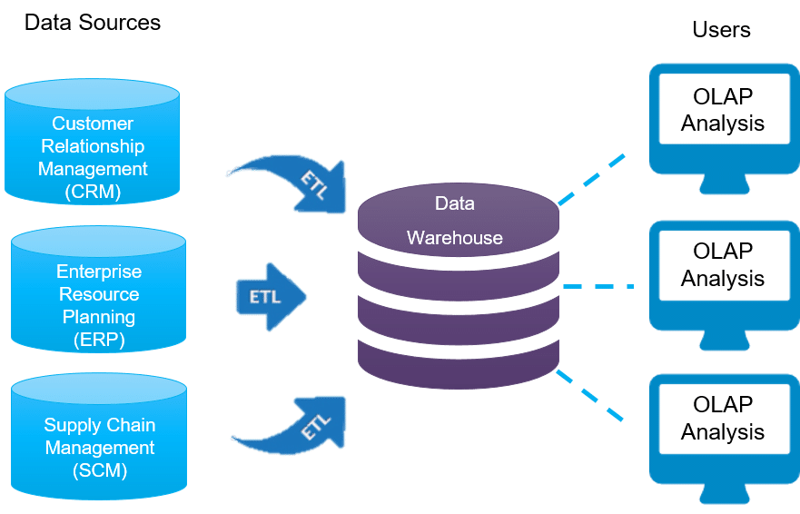
Figure 1. ETL Data Flow

The above figure intuitively describes the data flow from multiple sources into DWH through ETL, then used for analysis purposes.

3.5 Understanding ETL:
ETL is an acronym for Extract, Transformation, Load. ETL [14] is a method which first of all collects the data from multiple repositories, converts it (by the use of simulations and business logic), then dumping the data into the data warehouse. It needs to be clarified that our data warehouse consists of historical, derived and metadata.
The ETL pipeline is described as following.
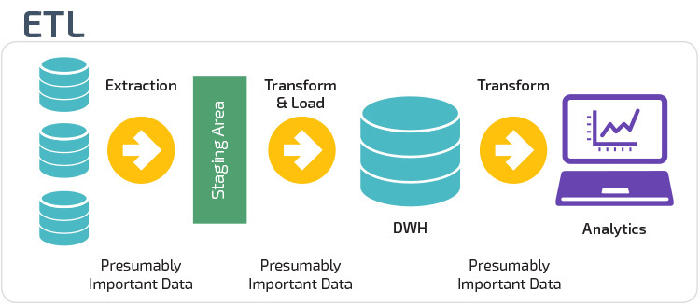
Figure 2. ETL Pipeline

The above figure explains the steps involved in an ETL Process by first gathering the data from multiple sources, dumping it into the staging area for transformations, then populating the DWH and finally performing analytics.
One can think that creating an ETL for a data warehouse is a straightforward process like just extracting, transforming and then simply dumping the data. However, in reality, ETL is a very complex process as it involved active inputs from multiple entities like stakeholders, developers, testers and more [37].
ETL, once developed, is a recurring step that executes daily and must be agile, properly maintained and highly well documented. Cane in the business logic also requires updating the ETL.

- Why do we need ETL?

- It assists organisations with dissecting their business information for taking basic business choices.
- Conditional data sets cannot address complex business addresses that can be replied to by the ETL model.
- ETL gives a strategy for moving the information from different sources into a data warehouse [16].
- As information sources change, the Data Warehouse will naturally refresh.
- All around, planned and reported ETL framework is practically vital for the achievement of a Data Warehouse project.
- Permit checks for the data transformation, aggregation and figures.

- Extraction:
Data are extracted from the source framework to the stage region in this step of ETL. Changes, if any, are made in the stage area to avoid corrupting the display of the source component. Likewise, if corrupted information is directly reproduced in the data warehouse from the source, it is reversed. The storage area provides the opportunity to approve detailed information before moving into the storage room.

- Transformation:
Data extracted from various sources is crude and not usable in its original form. Thusly it should be purged, mapped and changed. Indeed, this is the key advance where ETL measure adds worth and changes information to such an extent that insightful BI reports can be produced. It is one of the significant ETL ideas where you apply a bunch of calculations on extricated information. Information that does not need any change is called immediate move or pass-through information.

In the transformation step, you can perform customised procedures on data. For example, if the client needs the sum of sales income that is not in the data set. Alternatively, if the first and last names of a customer are concatenated, we can divide them into two columns, one for the first and one for the last name.

- Loading:
Loading data into the data warehouse is the last step of the ETL cycle. In most of the data warehouse systems, data is loaded in bulks at night, so our ETL procedure needs to be optimised in such a way that data should be available to businesses before an agreed time interval.

3.6 Data warehouse Methodologies:
Mainly there are two approaches when considering a data warehouse
- Kimball Approach
- Inmon Approach
This project focuses on Kimball’s [21] approach. Now let us discuss Kimball’s methodology in detail.

- Identification of the Process of Business:
We need to portray the major pattern of the proficient getting customer, getting the things, by then arrangement measure [12]. We similarly need to understand at what level arrangements data are summarised. Whether or not it is each day, step by step or month to month level. This movement helps in choosing the components and their relationship as indicated by business needs. Later on, these substances transform into parts of the business. The primary components are Customer, Product, Location, and time.

- Defining the Grain:
Grains mean at what significance we need to store the data for these estimations. It portrayed the granularity of the structure. In this endeavour, we will store arrangements of the thing at month level [13].

- Characterising the Dimensions:
Dimension table is the table that consists of all the textual quantities. They are used for descriptive analysis of the elements in our data warehouse. There are five dimensions tables for our data warehouse, as shown in the below table.

Dim.Customers
Dim.Products
Dim.Orders
Dim.Store
Dim.Locations

Table 1. Dimensions
- Characterising the Facts:
The fact table contains all the measurable quantities against the dimensions. It consists of surrogate keys from dimensions helping us to answer business questions. Our project comprises two fact tables.
Fact.Retail
Fact.Retail_2

Table 2. Facts

- Pros and Cons of Kimball Approach:
Pros:
- The advantages of dimensional displaying are that it is quick to build as no standardisation is included [22], which implies quick execution of the underlying period of the information warehousing configuration measure benefit of star composition is that the majority of the information administrators can without much of a stretch fathom it due to its denormalised structure, it rearranges questioning and examination.
- The information distribution centre framework impression is insignificant on the grounds that it centres around singular business territories and cycles as opposed to the entire undertaking. Along these lines, it takes less space in the information base, improving the framework of the executives.
- It empowers quick information recovery from the information stockroom as information is isolated into truth tables and measurements. For instance, the reality and measurements table for the protection industry would incorporate approach exchanges and claims exchanges.
Cons:
- In the Kimball plan, information is not altogether coordinated prior to announcing, the possibility of a 'solitary wellspring of truth' is lost [38].
- Inconsistencies can happen when information is refreshed in Kimball [23] DW engineering. This is on the grounds that, in denormalisation strategies, information data warehouse excess information is added to data set tables.
- In the Kimball DW engineering, execution issues may happen because of the expansion of segments in the fact table, as these tables are very top to bottom. The expansion of new segments can extend the reality table measurements, influencing its exhibition. Additionally, the dimensional information data warehouse model gets hard to adjust with any adjustment in business needs.
- As the model is business measure arranged, rather than zeroing in on the undertaking, all in all, Kimball configuration cannot deal with all the BI announcing necessities.
- The way toward joining a lot of heritage information into the data warehouse is unpredictable.

3.7 Datawarehouse vs Database:
Database | Datawarehouse
Data is stored in an organised manner in a tabular format | A central consolidated location storing data from multiple sources
Better suitable for Transactional Processing  (OLTP) | Better suitable for Analytical Purposes  (OLAP)
Transaction Oriented | Subject Oriented
Stores current data | Stores historical data
Normalised table structure | Denormalised table structure
Entity Relationship Modelling | Data modelling
Slow | Faster and accurate
Data available in real-time | Data must be refreshed when needed

Table 3. Database vs Datawarehouse

It can be concluded with great confidence that all aspects of the data warehousing have been discussed, providing the user a guideline to grasp it and understand the core concepts behind it by studying the two most used data warehouse implementation approaches and understanding the architecture behind warehousing at a basic level.

Chapter 4
The current chapter discusses the tools and presents the methodologies used for the construction of retail data warehouses. A number of tools are present, but the most familiar ones like SSIS, Tableau have been used for this purpose in this project.
Data warehouse design has been constructed very carefully by keeping the ins and outs in mind. Data has been accumulated and has been processed by moving it from the staging area and segregating the data into dimensions and facts.

4.1 Design Tools for Data Warehouse:
We all know we all need a set of equipment’s to carry out a job. On the same lines, we have used the most familiar tools for the creation of our data warehouse.
These tools are categorised as
- Microsoft SQL Server:
This is a well-known tool provided by Microsoft; we have created our data warehouse in it by the name “dwhretail”.

- SQL Server Integration Services (SSIS):
This is one of the most familiar tools used for the creation of ETL.

- Visual Studio:
In order to create ETLs, we have configured SSIS with the Visual Studio, which is then used for extracting the data from the source and dumping it into the SQL server table, transforming it and eventually loading the data.

- Tableau:
Tableau is a well-recognised tool for data visualisation; we also have used it for creating reports for our audience so that they can clearly understand our observations.

4.2 Data warehouse life cycle:
For the effective conception and execution of data warehouse projects, skilled or professional people are needed to recognise the analytical aspects together with organisations. For such data-warehouse development, as illustrated in the image below, various stages are required.
It is necessary for current data warehouse customers to evaluate the current systems, asking specific questions in order to gather the information.
A further essential element is client requirements gathering, including the collection of user requirements, which is the trickiest process since virtually all decisions have an impact on the project's creation and delivery [39].
The client records are created at the development stage. Testing is a critical step of the DW development to ensure effectively and smoothly system functionality. Once the user acceptance process is verified, the deployment stage will be the last step comprises training and assistance for the releasing and maintenance teams [39].

4.3 Data warehouse design:
- Data Sources:
In order to carry out this project, first of all, the data set is collected by doing some research data set was gathered from Kaggle. Kaggle is a well-known data set repository.

Our dataset comprises five CSV files named:

Dataset
Product
Customers
Store
Orders
Locations

Table 4. Dataset
- Product:
The product CSV file provides us information about different products, what amount of quantity of products are sold along with their prices and product id.

- Customers:
This customer CSV explains the generic information like customer id, customer name, customer segment like whether it is a corporate or individual customer, etc.

- Store:
The store CSV provides us with the store id, store name, the city of the store and the invoice number.

- Orders:
The orders CSV file consists of the order id, the shipping data and the shipping cost of the order to be sent.

- Locations:
The locations file gives information regarding the location id, city, country, market and region and postal code of the location.

- Schemas:
Our data warehouse design consists of four schemas.

Schemas
Dbo
Stg
Dim
Fact

Table 5. Schemas
- Dbo Schema:
In the first step, we have loaded our CSV files into dbo schemas, thus creating five following tables.

Dbo
Dbo.Customers
Dbo.Products
Dbo.Orders
Dbo.Locations
Dbo.Orders

Table 6. Dbo Schema Tables
- Stg Schema:
A staging region or landing zone is a middle zone utilised for data handling during the extract, transform and load (ETL) measure. The data staging sits between the information source(s) and the information target(s), which are frequently warehouses, data marts and other data repositories. We have a basic data warehouse that takes data from a couple of RDBMS source frameworks and populates the dimensions and facts of a data warehouse. The staging region is where you hold tables for temporary in the data warehouse. Staging tables are associated with fact tables. We essentially need a staging zone to hold the data, clean it and merge it prior to loading it into the warehouse.
If the target and source data sets are distinct, and the target table volume is large, it contains a large number of records in this case without temporary tables, we need to check if the record exists or not in the target table because the target has huge quantities of information and it is very time-consuming while querying. If we create staging tables in the target data set, we can simply conduct external involvement in the source to determine whether to integrate this technique to deliver excellent execution. It will keep away from full table output to decide embed/refreshes on track. And furthermore, we can make a list of arranging tables since these tables were intended for explicit application, and it will not affect compositions/clients. While handling level records to data warehousing, we can perform purging. Information purifying, otherwise called information scouring, is the way toward guaranteeing that a bunch of information is right and exact. During information purging, records are checked for exactness and consistency.
Data is migrated from dbo tables to stg tables, the data is transformed, and stg tables are populated using SSIS. There are five tables in this schema.
Stg.Customers
Stg.Products
Stg.Orders
Stg.Store
Stg.Locations

Table 7. Stg Schema Tables
- Stg.Customers:
This table comprises customer id, customer name and other information. We have applied the transformation here by splitting the customer’s name into first and last name. As you can see, we also have some other information not regarding customers in the below table, and these are the fields that will be removed when data is being loaded into dimension tables.
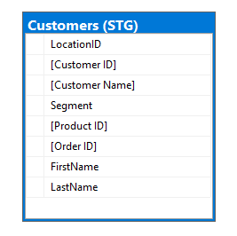
Figure 3. Stg_Customers
The above diagram shows the attributes involved in a customer’s staging table.

Transformation:

For our customers stg table, we have derived two columns (first name and last name) by using derived column transformation in SSIS.
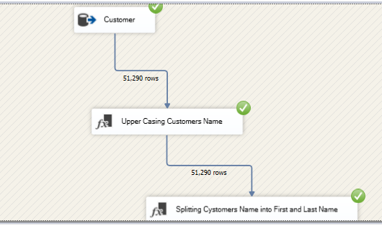
Figure 4. SSIS Customers Table Package
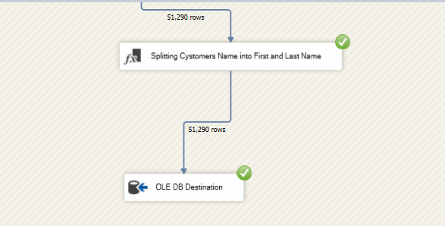
Figure 5. SSIS Customers Table Package (2)

The above figure is recorded from the SSIS package while splitting the customer's name into first and last name and populating the dim customer's table.

- Stg.Products:
This table provides us with information about the products we have. These table columns are product id, product name, price, quantity and category.
We have performed a transformation here by adding a new column called Product Frequency by using some hypothesis logic which tells whether a specific product frequency is frequent, usual or most frequent, which present us with an understanding of which product to focus on.
As you can see, we also have some other information not regarding products in the below table. These are the fields that will be removed when data is being loaded into dimension tables.
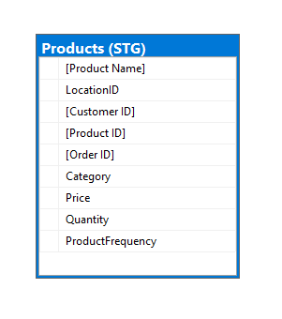
Figure 6. Stg_Products
The above table depicts the staging products table with common product attributes.

Transformation:
We have added the column product frequency.

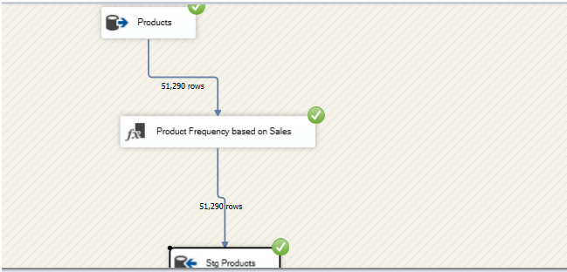
Figure 7. SSIS Products Table Package

Transformations are applied to the staging products table by finding out the product frequencies by splitting them into different categories bases on sales of a product.

- Stg.Orders:
As this table is loaded from "dbo. orders" initially, it contains many columns, which are then reduced. This table provides us information about order id, order shipping date and shipping cost and what type of priority does an order have.
We need to keep an eye here on order priority. Often in cases for a specific customer, there are multiple orders pending, and each has its nature that what type of priority is the order having.
We have identified the priority as follows:

Critical
High
Medium
Low
Critical, as the name suggests, is an order having the most priority; high is the second from the top, meaning it should also be shipped quickly. After that, we have medium and low, representing the priority levels.
As you can see, we also have some other information not regarding orders in the below table, and these are the fields that will be removed when data is being loaded into dimension tables.
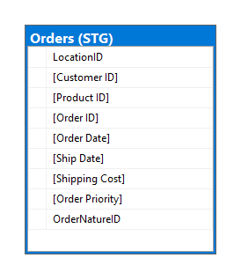
Figure 8. Stg_Orders
Above is the snapshot for the orders stage table defining the order date against a specific id, its shipping date and cost.

Transformation:
We have performed a derived column transformation here by adding a column named OrderNatureId, which gives us information regarding the id against a specific priority of a customer.
As we have four types of priorities so we have four different nature id. Specific order having specific nature id is described below.

Order Priority | Order Nature Id
Critical | 3
High | 2
Medium | 1
Low | 0

Table 8. Order Priority Table

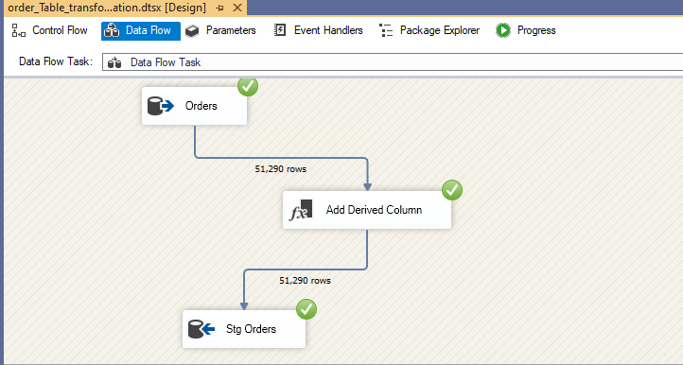
Figure 9. SSIS Orders Table Package

- Stg.Locations:
This stg table provides us with information locations where the store exists. It consists of columns like location id, city, country, the market and region to which the store belongs.
As you can see, we also have some other information not regarding locations in the below table, and these are the fields that will be removed when data is being loaded into dimension tables.

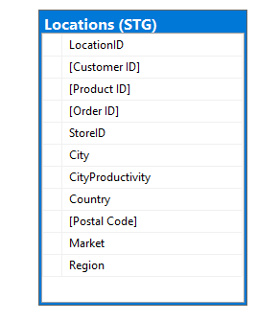
Figure 10. Stg_Locations

The above snapshot records the city location, the country, and the postal code for the locations table.

Transformation:

We have performed a derived column transformation here by adding a column named CityProductivity. Basically, we have the following productivity of the city.

High
Medium
Low

Table 9. City Productivity Table

High productivity of a city means that multiple orders are being ordered from this city; the medium and low productive city is also derived from the same fact above, i.e., depending upon the sales from a specific city.

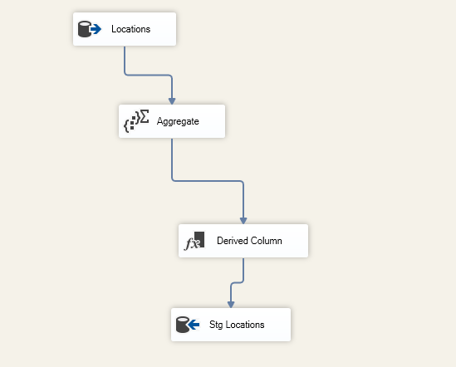
Figure 11. SSIS Locations Table Package

- Stg.Store:
This table contains information regarding the different stores, their names, in which city they reside, the invoice number of orders. As you can see, we also have some other information not regarding locations in the below table, and these are the fields that will be removed when data is being loaded into dimension tables.
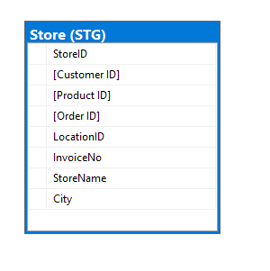
Figure 12.. Stg_Stores

Stage Stores tables attributes are explained by the above diagram like the store name its city.

- Dim.Schema:
A Dimension table is a table in a star schema of a warehouse. Data warehouses are built using dimensional facts fashions which encompass dimension and measurement tables. Dimension tables are used to explain dimensions; they contain size keys, values and attributes.

As an example, the time dimension might comprise each hour, day, week, month, area and year that has befallen since you started out your commercial enterprise operations. Product size could contain a name and description of products you promote, their unit price, shade, weight and different attributes as relevant. Attributes could be, for example, a customer's first and remaining name, age, gender. Dimension tables are typically small, starting from some to numerous thousand rows. Occasionally dimensions can develop fairly big, but. For instance, a massive credit score card employer may want to have a purchaser size with hundreds of thousands of rows. Dividing a data warehouse assignment into dimensions provides dependent information for reporting purposes.

While a dimension is created, you logically create a structure for your projects. This dimension table may be applied throughout for reports and its approximately re-usability. If there are any adjustments to be made, it is miles obvious that most effective, a selected table gets affected. When an organisation desires to create a report, they could read the records from the dimension table for the reason that table includes necessary records.

For example, an e-trade enterprise can create a dimension table with various columns depending on distinct subjects they would really like to gain records from, as the call of the person, deal with, date of order, cargo. This form of information will become very vital because, in case of any explanation, the company can refer to this dimension table. Commercial enterprise customers who generate those reports hearth queries on these measurement tables as they contain descriptive statistics.

The Slowly Converting Dimensions (SCD) represents dimensions that trade slowly through the years, rather than converting on a normal timetable, time-base. In a data warehouse, there is a need to keep an eye on modifications in measurement attributes that allows you to report historical data. In different words, enforcing one of the SCD types should permit users to enable dimensional attributes for the given time. Examples of such dimensions could be purchaser, geography, employee.

For our retail data warehouse, we have created five dimensions described below.

Dim.Customers
Dim.Products
Dim.Locations
Dim.Orders
Dim.Store

Table 10. Dim Schema Tables

In this section, we will take a look at the structure of each dimension. Populating the dimensions is a whole another task which will be explained later.

- Dim.Customers:
The dimension customers contain the information regarding customers, their names, their ids and segment. The segment field describes what type of customer it is. Here we have three segments consumer, corporate or home office.

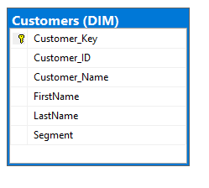
Figure 13. Dim_Customers
This table only contains relative information about the customers gathered from stage customers and pulling it into the customers' dimension table.
We can see that we have added another field customer key. So, what is the purpose of this field? Actually, the customer key is our primary key which will auto-increment whenever a new entry is registered in this dimension. More technically, we have a concept of a surrogate key in dimensions, which is a unique non-repetitive constraint. Our customer key is a surrogate key that will be used to populate our facts.

- Dim.Products:
Suppose from an owner of retail store perspective that what does your store contains. So, you will be having generic information regarding every product. On the same lines, this dimension provides us information about products, what are their IDs, names, product frequency, product category, price and quantity.
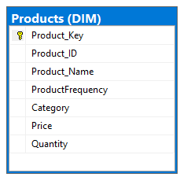
Figure 14. Dim_Products

The above table only depicts the products specific information in the dimension products table.

As discussed above product key is our surrogate key which is used to populate facts.

- Dim.Locations:
This dimension tells us about different locations from where the product arrives, what is the city or country name, from which market region does it comes, what is the location ID. We need to remember that the column City Productivity is our derived column, as explained above in "stg. locations".
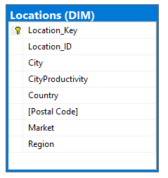
Figure 15. Dim_Locations

Only location-based information is gathered in the above table. Location key is our surrogate primary key auto-incremented by one whenever a new entry comes into this dimension.

- Dim.Orders:
For a retail store, one of the most important things is to keep track of its orders, and only then the store can improve its products and services. This dimension tells us about the order id, the order data and shipping cost, the order nature and their priority.

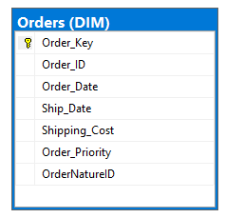
Figure 16. Dim_Orders

The above figure describes the orders dimension table attributes. Order key is the surrogate primary key used for populating fact.

- Dim.Store:
This dimension provides us information regarding the store name, its city and its id.

Figure 17. Dim_Store
The above figure emphasis on specific dimension that store table attributes.

4.4 Primary Key vs Surrogate Key:

Primary Key | Surrogate Key
Set of attributes uniquely identifying rows. | A non-natural key that uniquely identifies each row in a table.
Used in OLTP. | Used in OLAP.
These keys have some business meaning. | These keys do not have business meaning.

Table 11. Primary vs Surrogate key

How to populate dimensions:
Initially, our all-dimension tables were empty, so we have to derive a logic on how to populate them. We can observe that all of our stg tables have ids respective to each (Customer id for stg. customers, product id for stg. products, locations id for stg. locations, orders id for stg. orders, store id for stg. store).

Our logic is to populate dimensions by joining the business keys from dimensions with the primary keys from the stg tables. What we have done actually is that we have taken the primary keys from stg tables (ID field) and then inserted them into dim tables by using the SSIS data flow task.
After that, we have populated the dimension table by writing a SQL query and using SSIS executing SQL tasks for dimension populations.
The flow for populating the dimension tables is the same so let us see, say, for customer and orders SSIS package.

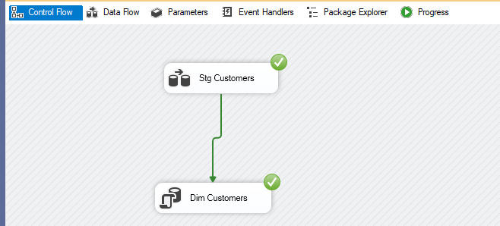
Figure 18. SSIS Dimension Package

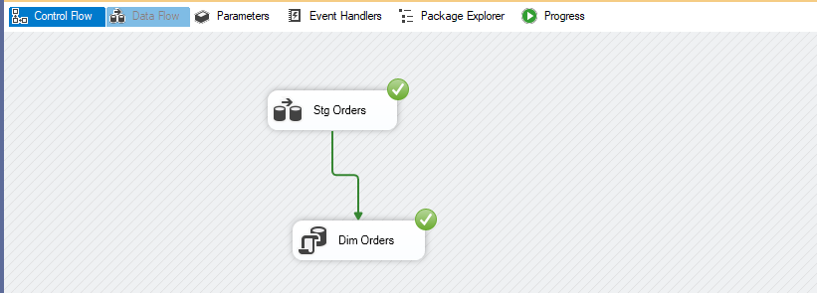
Figure 19. SSIS Dimension Package (2)

The above figures explain the SSIS package for moving the data from stage customers and orders tables into respective dimension tables.

Fact Schema:
A Fact Table is a focal table in a star diagram of a data warehouse. It is a vital concept used for Data Warehousing and BI Certification. A fact table holds and routinely denormalises quantitative data for inspection and deals with dimension tables, holding the dimensions to be investigated and examined.

Consequently, a fact table comprises two kinds of entities. The foreign keys section permits to get together with dimension tables, and the measure attributes contain the data that is under consideration.
A fact table is utilised in the dimensional model in the data warehouse.

A fact table can store various kinds of measures like added substance, non-added substance, semi-added substance.

- Additive:
As its name inferred, added substance measures will be measures that can be added to all measurements.

- Non-added substance:
Not quite the same as added substance measures, non-added substance measures will be measures that cannot be added to all measurements.

- Semi-added substance:
Semi-added substance measures are the activities that can be added to just a few measurements and not across others.

All Fact tables are ordered by the three most fundamental types.

- Transactional:
Transactional certainty table is the most basic one that each grain-related with it demonstrated as "one column for each line in an exchange", e.g., each detail shows up on a receipt. The exchange certainty table stores information of the most itemised level; in this manner, it has a high number of measurements related with.

- Periodic snapshots:
Periodic snapshots fact table stores the information that is a depiction in a timeframe. The source information of the intermittent previews certainty table is information from an exchange reality table where you pick a period to get the yield.

- Accumulating snapshots:
The Accumulating snapshots reality table portrays the movement of a business cycle that has a clear start and end. This kind of fact table, subsequently, has various date sections to address achievements all the while. A genuine illustration of aggregating snapshots fact table is handling of material. As steps towards dealing with the material are done, the relating record in the aggregating depictions fact table gets refreshed.

Design of a Fact Table:

Here is the outline of four stages to planning a reality table portrayed by Kimball:

- Choosing business interaction to demonstrate:
The initial step is to choose what business cycle to display by social event and understanding business needs and accessible information.

- Declare the grain:
By proclaiming a grain implies portraying precisely what a fact table record addresses.

- Choose the measurements:
When a grain of actuality table is expressed plainly, the time has come to decide measurements for the reality table.

- Identify realities:
Cautiously distinguish which facts will show up in the fact table.

For our data warehouse, we have two facts tables:

Retail_Fact
Retail_Fact_2

First, let us discuss the structure of these tables and then we will look at how to populate them.

Fact.Retail_Fact:
A fact table comprises foreign keys from dimension tables and the quantities which are to be analysed. In a fact table, we can either add a primary key but typically, what happened is all the foreign keys act as the primary key, but these foreign keys should have a counterpart in dimension tables.

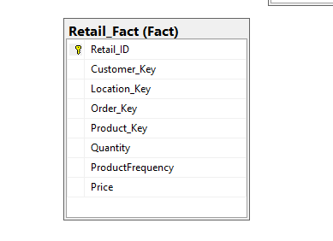
Figure 20. Retail_Fact

As we can see, Retail_Id plays the role of the primary key here, but still, we can manage a fact table if there is no primary key. We need to shed some light on the measurable quantities, which are quantity, product frequency and price. Actually, all these fields give us the ability to write down our business queries and analyse them.

Fact.Retail_Fact_2:
As discussed above, this fact table also contains foreign keys as well as measurable quantities.

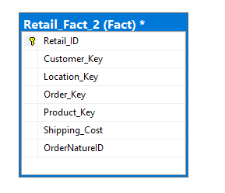
Figure 21. Retail_Fact (2)
We can see that we have added Retail_Id as the primary key, but it is not necessary as foreign keys can also play the role of the primary key. We see that we have two types of quantities here; one is Shipping Cost which describes the shipping cost against each order, and also the Order Nature ID. Both these fields serve the purpose of calculations, and we can drive meaningful results from them.

Populating the Fact Tables:
In the fact table, we have foreign keys against dimensions. In order to populate the fact tables, the SSIS package has been developed [40]. In this package, the execute SQL task is used, which will run a custom written SL query, which in turn will populate the fact table.

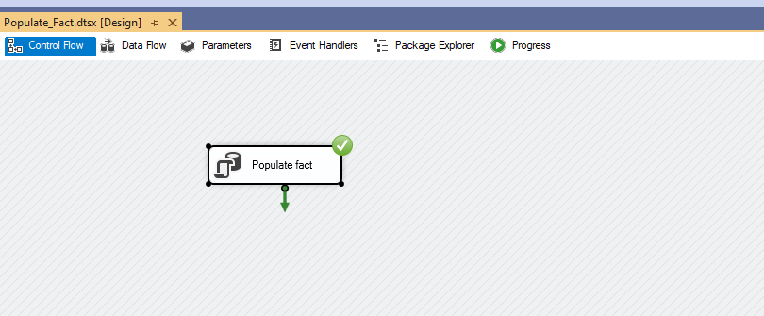
Figure 22. SSIS Fact Package

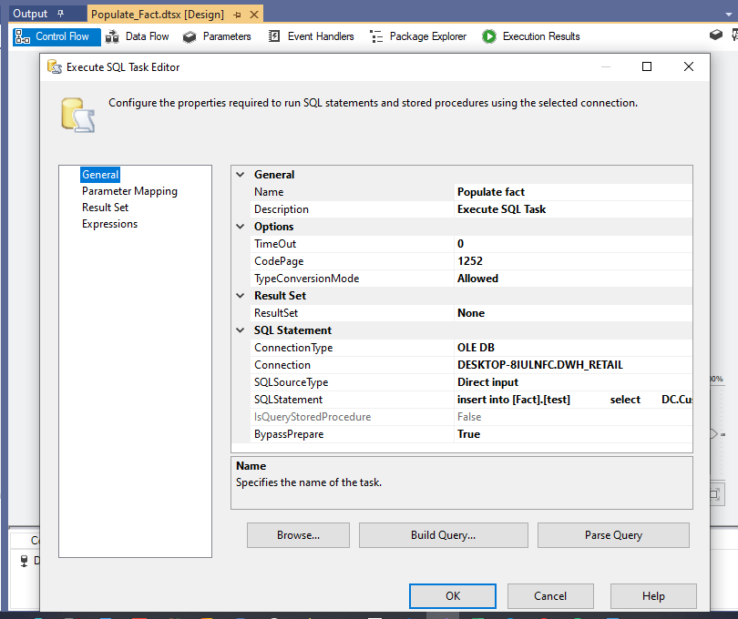
Figure 23. SSIS Fact Package (2)

4.5 Star Schema:
Star Schema in a data warehouse, in which the focal point [17] of the star can have one fact table and various related dimension tables, is referred to as star composition as its construction looks like a star. The Star Schema [18] information model is the easiest sort of Data Warehouse pattern. It is otherwise called Star Join Schema [19] and is improved for questioning huge data sets.

- Fact_Retail

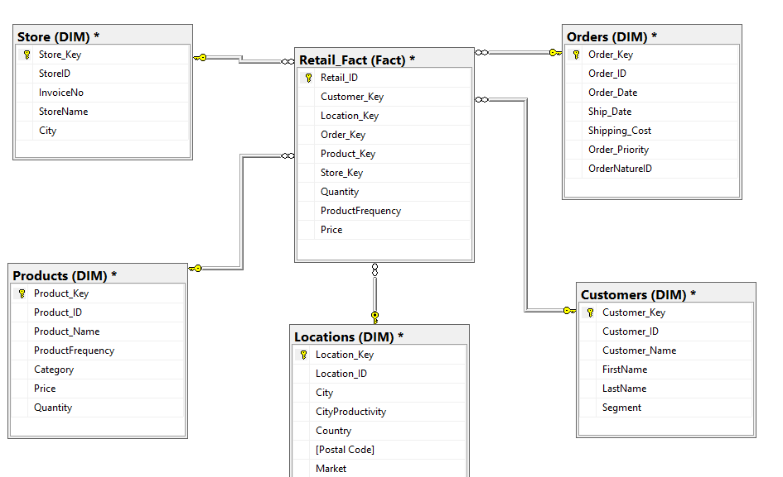
Figure 24. Star Schema for Fact_Retail

- Fact_Retail_2

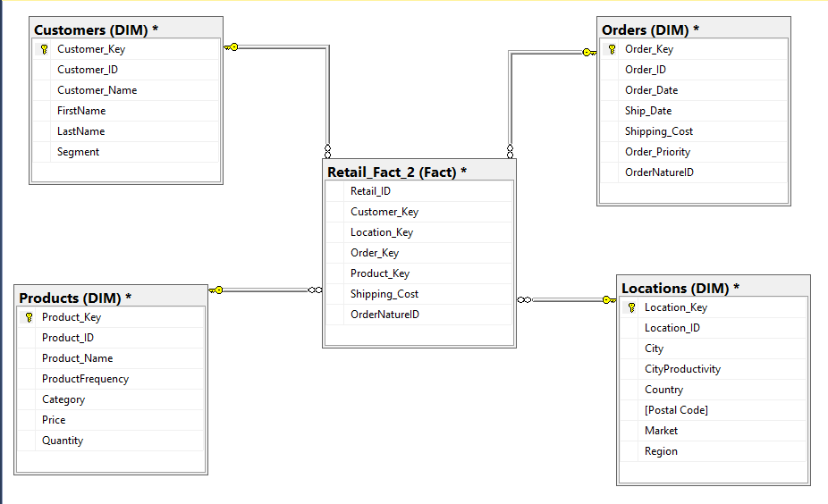
Figure 25. Star Schema for Fact_Retail (2)

The above diagrams are our star schemas for the fact tables we have created. In a star schema, the fact table is surrounded by the dimension tables, making a star-like structure.

The above-detailed study exclusively narrates and concludes the whole architecture of our model. Data movement along with transformations and finally dumping the data into MS SQL server has been described. Additional aggregations and transformations have been made and explained above in this chapter.

4.6 Risk analysis:
Before the official start of a data warehousing operation, possible hazards have been assessed. Risks are often elements above management and have negative consequences on the capacity to meet the targets set.
Many elements influence the destiny of successful data storage. Certainly, their impacts can be more generic despite the sorts of data systems. Those characteristics were often explored under the strategical success aspects paradigm. The many include good organisational guidance, suitable leadership, efficient connection on each level, suitable coordination of marketing strategy and data innovation architecture, relevant payback structures for software developers and consumers, stakeholder engagement, clients' recruitment and retention [24].
The shortage of expertise utilising resources, techniques or practises, a loss of sponsorship, unachievable timelines because of improperly defined deliverables and insufficient budgets might represent a few of the biggest threats [25].

Chapter 5
This chapter introduces us to one of the major prospective of any data warehouse model is reporting as it shows the trends and patterns in an eye-catching manner. Different visualisation has been used on the data warehouse model through Tableau so that businesses can easily understand the findings for insight purposes.

5.1 Generating Reports using Tableau
After populating our dims and facts, it is time to generate reports so that our business can easily find patterns from them. Reporting is one the most important tasks in any sort of project as this describes how our systems compete with others.
Here we have Tableau to generate reports. It is one of the most common tools used for reporting purposes. Let us first understand why data visualisation is important in brief.
Data visualisation is the process of converting the data into graphical interfaces for better understanding. It plays a very important role to derive insights and make decisions.
Data visualisation [19] provides us with a clear view of what our data means, thus helping us to observe the patterns, trends and outliers from a large dataset. Data visualisation [20] presents us with graphics, thus enabling us to understand the complexity of data and defining the distribution of data. It makes us capable of finding the factors which may affect the data and the variables which correlate with each other, defining a relationship of data.
“A picture is worth a thousand words.”

5.2 Business Case Studies
- Case Study 1
We know that with each order which is ordered by any customer, there is some shipping cost associated, our business requires to find customers with max shipping cost. In our data warehouse, we have different customers who are related to different segments like consumer, corporate and home office.

We can segregate these customers upon their segments and find the customer who pays the maximum shipping cost prior to the order. This enables the business to derive specific offers for these customers and see the trend. Following is the snapshot recorded from Tableau.

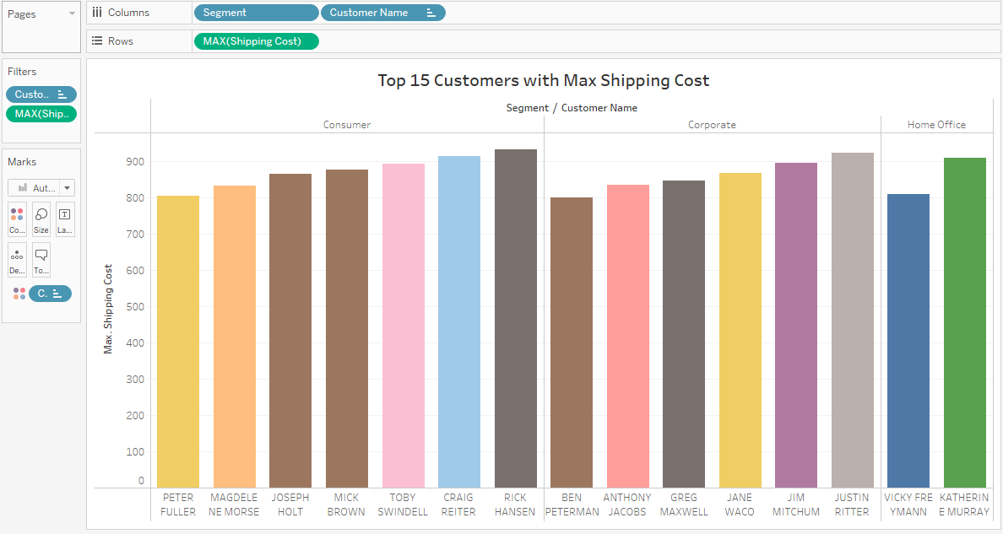
Figure 26. Customers Shipping Cost

- Case Study 2
In our data warehouse, different customers order different products from different countries, so analysing our customers’ orders from each country can provide us powerful insights so that we can know which products are most ordered from the country and these products should be restocked with time so that customers are entertained without any delay. Following is the snapshot recorded from Tableau against this question.

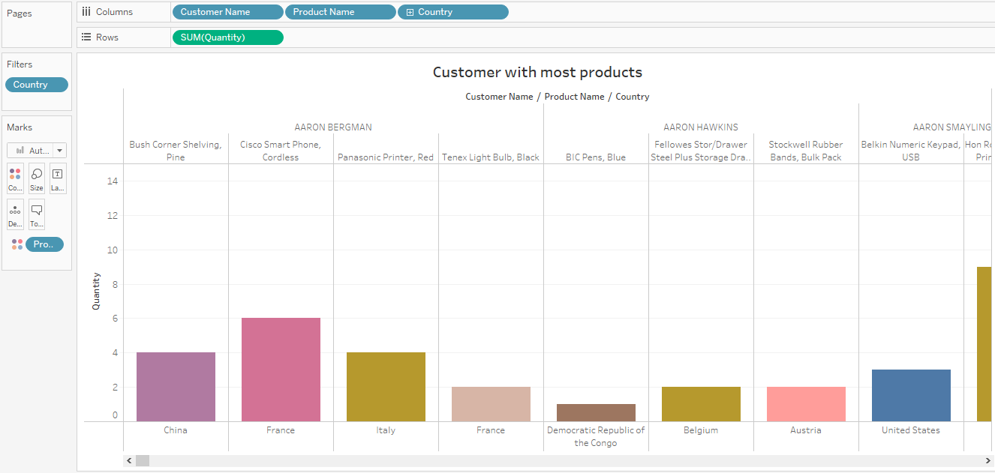
Figure 27. Customers with most products
- Case Study 3
Our data warehouse system comprises of different types of order priority and their nature. Our business needs to analyse the customers and see their order nature.
As discussed above, we have three types of orders with nature critical, medium, low.

The following snapshot exactly answers this question by providing us with the customer names, their order nature and how many such nature orders are pending.

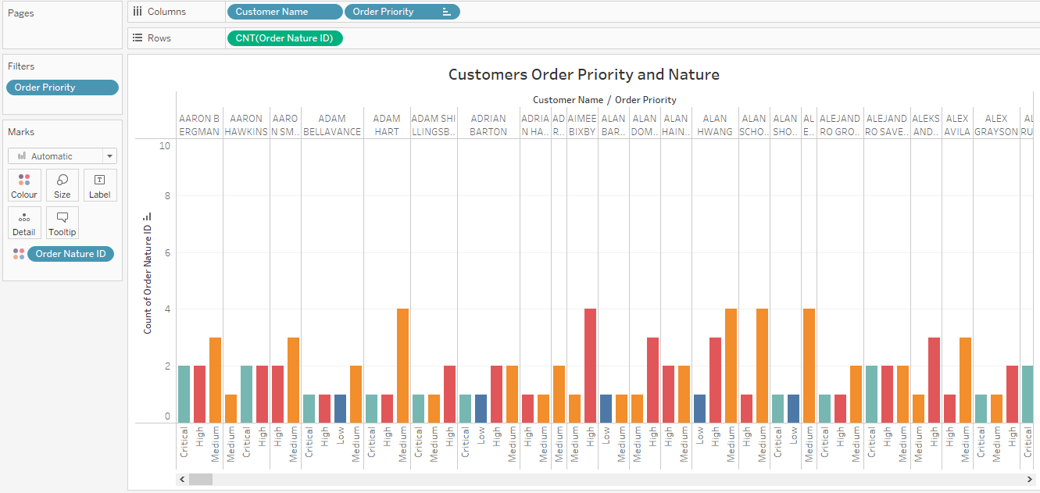
Figure 28. Customer Order Priority and Nature

- Customer Segmentation Dashboard
Tableau provided us with the facility to customise our reports in a single dashboard so that we can see our all reports relating to a specific scenario in one place.

In the above use cases, we observe that we are segmenting our customers on different aspects, so we have developed a single dashboard here where we can see all this analysis. The following snapshot is recorded from Tableau against this dashboard.

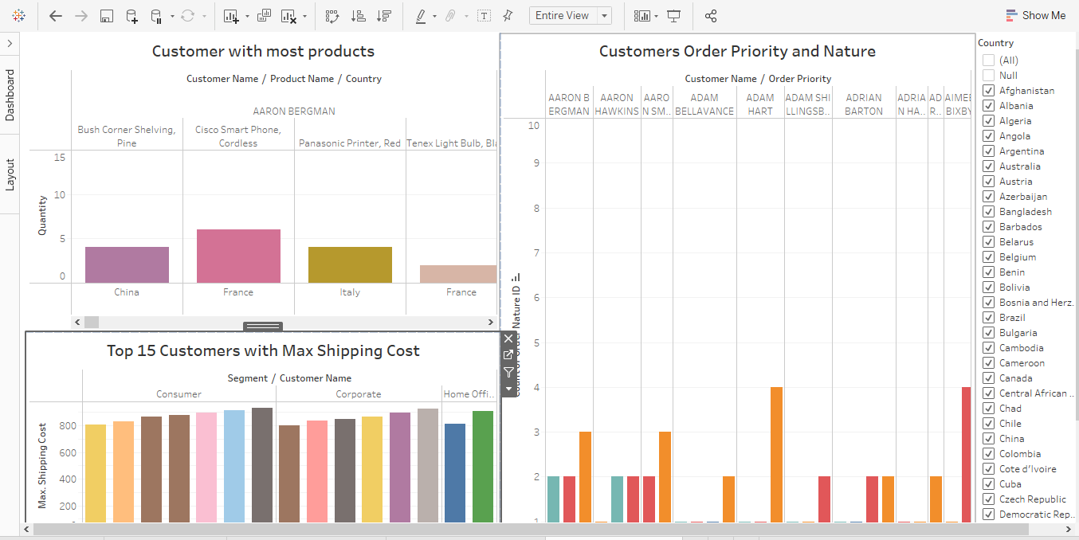
Figure 29. Customer Analysis Dashboard

- Case Study 4
Products are ordered internationally from different countries; our business wants to get a view of which countries are generating the most revenue for them.

To answer this query, we have generated a report from Tableau, which provided us with the analysis of countries giving us with max benefit.

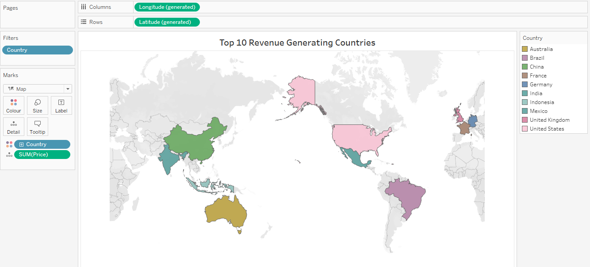
Figure 30. Most Profitable Countries

- Case Study 5
Our data warehouse maintains records for markets present in different regions. Our business has this requirement where it needs to group different regions and their markets by revenue. This query is explained by the following tableau snapshot.

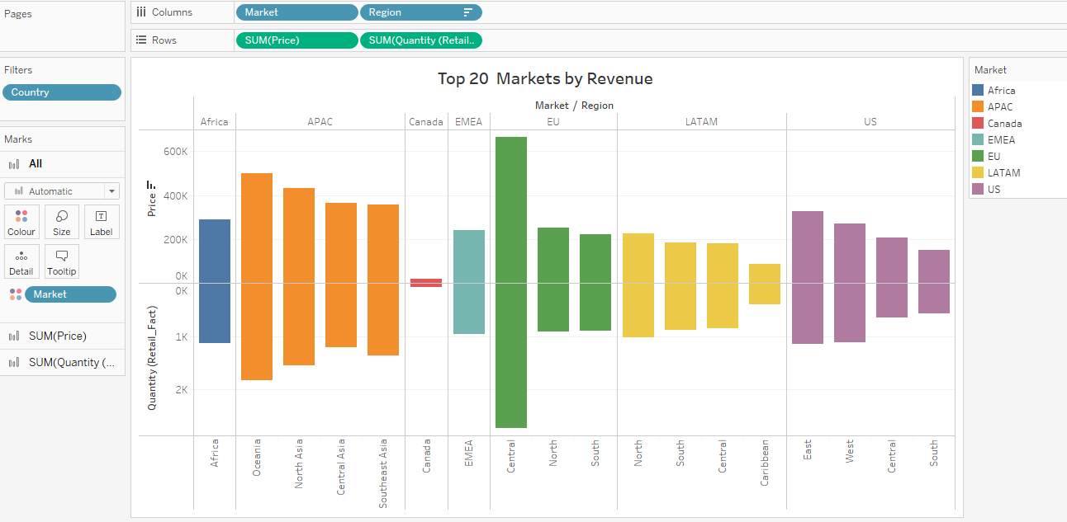
Figure 31. Productive Markets

- Case Study 6
As We know, our data warehouse consists of large amounts of previous data. The business requires us to provide them with a report that describes which previous four years got most orders.
This is done by generating a snapshot from Tableau as following.
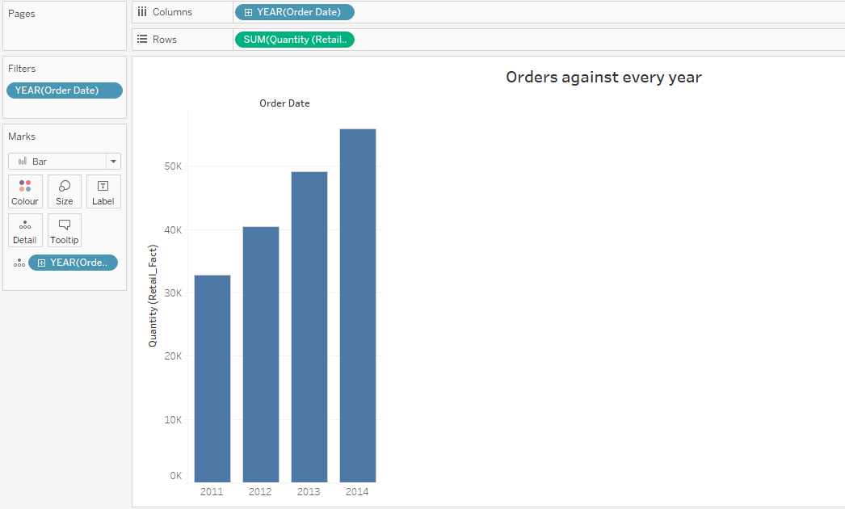
Figure 32. Orders for each Year

- Trend Analysis Dashboard
A dashboard is a place where we can gather all our reports in one place so that all can be viewed at a place respectively. For the above three reports, we have generated this dashboard.

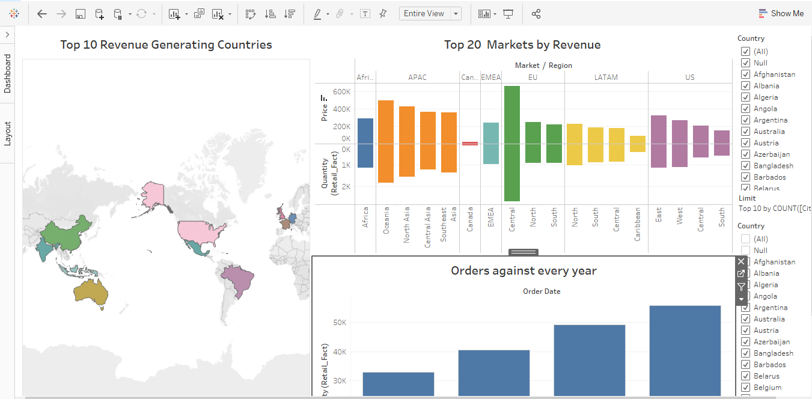
Figure 33. Trend Analysis Dashboard

Chapter 5 concluded the reporting perspective study by preparing easy and understandable visualisations, which is a very integral output of a data warehouse implementation.

Chapter 6

6.1 Conclusion
Data warehousing and Business intelligence is the most trustworthy technology used today by organisations for scheduling, forecasting, and management of data. The goal behind this research is to develop a system for transforming this raw information into useful data and for identifying the relationship between various factors. The main objective of every company is to expand its sales, only if the company knows its client base. Since the retail company creates enormous data sets, it must analyse them to establish a segment of customers with regard to which items should always be available.
A whole data warehouse has been created for retail customers to identify why and what objectives may be achieved through a retail data warehouse. The data storage system enables us to answer the query by identifying or dividing consumers into distinct criteria. Thus, the income and client base may be increased. In order to comprehend the analysis better, a visual representation was presented. The present work aims to create and plan a warehouse based on the conditions and the structure of a retail company. The main elements are the data warehouse and its stages of progress, traced by the functional area. A data warehouse has been built to collect information from the company's retail sector organisation in order to help the retail and human resources office. The main objective for creating a warehouse is to support the Retail Management's ground-based assessment of the Retail Personal by gaining reliable and accurate information that the firm owners or the development executives may make use of while creating a strong understanding of architecture. The Retail Office will utilise the data additionally to evaluate the company's retail strategy.

After the evolution of the concept of data warehousing through this project, it is clear now that what is the major step of implementing a data warehouse and business intelligence for a retail data use case. Concluding our report by trying to cover most of the aspects of data warehouse, I am pretty sure that this project may prove to be fruitful for every kind of business from a data warehouse implementation perspective. The concept, terminologies, strategies explained and implemented are the core of any data warehouse. Any data generating business can gain powerful insights by accumulating the data in one data warehouse.

6.2 Future Work
Present work in this project only focused on data warehouse created for retail business data and created accordingly. Challenges of data warehouse implementation differ from domain to domain.
Indeed, Big Data with high Volume, Variety and Velocity is one of the challenges for classical Datawarehouse. In a future study, we can compare different challenges which a data warehouse solution cannot resolve and prepare a data lake for big data use-cases. Further, studies may involve the creation of such data warehouses and data lakes by using artificial intelligence and machine learning models for predictive analysis.

References
[1] N. Sharma and S. Gupta, “DESIGN AND IMPLEMENTATION OF ACCESS THE CONTENTS IN THE DATA WAREHOUSE,” International Journal of Information Technology, vol. 6, no. 1, pp. 61–64, 2012, Accessed: Jun. 05, 2021. [Online]. Available: http://www.csjournals.com/IJITKM/PDF%206-1/Article_15.pdf.
[2] S. Chaudhuri and U. Dayal, “An overview of data warehousing and OLAP technology,” ACM SIGMOD Record, vol. 26, no. 1, pp. 65–74, Mar. 1997, doi: 10.1145/248603.248616.
[3] I.-Y. Song and L.-S. Kelly, “Data Warehouse Design for E-Commerce Environment,” ResearchGate, Apr. 2000. https://www.researchgate.net/publication/2359314_Data_Warehouse_Design_for_E-Commerce_Environment (accessed Jun. 12, 2021).
[4] T. A. Oketunji and R. O. Omodara, “Design of Data Warehouse and Business Intelligence System A case study of a Retail Industry,” 2011. [Online]. Available: https://www.diva-portal.org/smash/get/diva2:831050/FULLTEXT01.pdf.
[5] H. Li, “Applications of data warehousing and data mining in the retail industry,” IEEE Xplore, Jun. 01, 2005. https://ieeexplore.ieee.org/document/1500153 (accessed Jun. 20, 2021).
[6] S. Habte, K. Ouazzane, P. Patel, and S. Patel, “Generic data warehousing for consumer electronics retail industry,” World Academy of Science, Engineering and Technology, vol. 11, no. 7, pp. 828–831, Jul. 2017, Accessed: Jun. 21, 2021. [Online]. Available: http://repository.londonmet.ac.uk/1268/.
[7] Y. Kambayashi, D. L. Lee, E.-P. Lim, M. K. Mohania, and Y. Masunaga, Advances in Database Technologies: ER ’98 Workshops on Data Warehousing and Data Mining, Mobile Data Access, and Collaborative Work Support and Spatio-Temporal Data Management, Singapore, November 19-20, 1998, Proceedings. Springer, 2004.
[8] R. Jindal and S. Taneja, “Comparative Study of Data Warehouse Design Approaches : A Survey,” International Journal of Database Management Systems, vol. 4, no. 1, pp. 33–45, Feb. 2012, Accessed: May. 24, 2021. [Online]. Available: https://www.academia.edu/14360352/COMPARATIVE_STUDY_OF_DATA_WAREHOUSE_DESIGN_APPROACHES_A_SURVEY.
[9] R. Kimball and M. Ross, The Data Warehouse Toolkit: The Deﬁnitive Guide to Dimensional Modeling, 3rd ed. John Wiley & Sons, Inc., 2013.
[10] R. Kimball and R. Merz, THE DATA WEBHOUSE TOOLKIT. Building the web-enabled data warehouse - Richard Merz,Ralph Kimball. New York, Chichester: John Wiley & Sons, 2000.
[11] D. Mankad and P. Dholakia, “The Study on Data Warehouse Design and Usage,” International Journal of Scientific and Research Publications, vol. 3, no. 3, 2013, Accessed: May. 15, 2021. [Online]. Available: http://www.ijsrp.org/research-paper-0313/ijsrp-p1597.pdf.

[12] T. Sahama and P. R. Croll, “A Data Warehouse Architecture for Clinical Data Warehousing,” ResearchGate, Jan. 2007. https://www.researchgate.net/publication/27473559_A_Data_Warehouse_Architecture_for_Clinical_Data_Warehousing (accessed Jul. 10, 2021).
[13] P. A. Bernstein and E. Rahm, “Data Warehouse Scenarios for Model Management,” Conceptual Modeling — ER 2000, pp. 1–15, Oct. 2000, DOI: 10.1007/3-540-45393-8_1.
[14] C. Todman, “Designing a Data Warehouse: Supporting Customer Relationship Management,” ur.zlibcdn2.com, Dec. 01, 2000. https://ur.zlibcdn2.com/book/636513/95c9ff (accessed Jul. 11, 2021).
[15] N. Tryfona, F. Busborg, and J. Christiansen, “starER: A Conceptual Model for Data Warehouse Design,” 1999. Accessed: Jul. 11, 2021. [Online]. Available: http://cci.drexel.edu/faculty/song/dolap/dolap99/paper/dolap99_Nectl.pdf.
[16] M. Golfarelli and S. Rizzi, “Designing the Data Warehouse: Key Steps and Crucial Issues,” Semantic Scholar, 1999. https://www.semanticscholar.org/paper/Designing-the-Data-Warehouse%3A-Key-Steps-and-Crucial-Golfarelli-Rizzi/76e54353254787f47ef009eecbbe54a4008630a5 (accessed Jun. 19, 2021).
[17] M. Kirmani, “Dimensional Modeling Using Star Schema for Data Warehouse Creation,” ResearchGate, 2017. https://www.researchgate.net/publication/322410950_Dimensional_Modeling_Using_Star_Schema_for_Data_Warehouse_Creation (accessed Jul. 20, 2021).
[18] G. Garani and S. Helmer, “Integrating Star and Snowflake Schemas in Data Warehouses,” ResearchGate, 2012. https://www.researchgate.net/publication/262239999_Integrating_Star_and_Snowflake_Schemas_in_Data_Warehouses (accessed Jul. 03, 2021).
[19] M. Sandhu, A. Kaur, and R. Kaur, “Data Warehouse Schemas,” International Journal of Innovative Research in Advanced Engineering (IJIRAE), vol. 2, no. 4, pp. 47–51, 2015, Accessed: Jul. 08, 2021. [Online]. Available: https://www.ijirae.com/volumes/Vol2/iss4/08.APAE10098.pdf.
[20] M. N. O. Sadiku, A. E. Shadare, S. M. Musa, and C. Akujuobi, "DATA VISUALISATION," ResearchGate, Dec. 2016. https://www.researchgate.net/publication/311597028_DATA_VISUALIZATION (accessed Jul. 06, 2021).
[21] K. Salim, L. Damayanti, M. Puspita, S. Liujaya, and A. S. Girsang, "Data warehouse using Kimball approach in computer maniac," IOP Conference Series: Materials Science and Engineering, pp. 1–9, Jan. 2020, DOI: 10.1088/1757-899x/725/1/012099.
[22] L. Yessad and A. Labiod, “Comparative study of data warehouses modeling approaches: Inmon, Kimball and Data Vault,” ResearchGate, Nov. 2016. https://www.researchgate.net/publication/312486486_Comparative_study_of_data_warehouses_modeling_approaches_Inmon_Kimball_and_Data_Vault (accessed Jun. 28, 2021).

[23] Widianty Widianty, “Data Warehouse Design with Kimball Method: Case Study of Fahrenheit Manufacturing Systems,” ComTech, vol. 6, no. 4, pp. 604–612, 2015, DOI: https://media.neliti.com/media/publications/165960-ID-data-warehouse-design-with-kimball-metho.pdf.
[24] B. Shin, “Risk Assessment Of Data Warehousing, A Case Study,” www.semanticscholar.org, 2000. https://www.semanticscholar.org/paper/Risk-Assessment-Of-Data-Warehousing%2C-A-Case-Study-Shin/f56a3f74c23d43fae778d65a7199be948b4ad624 (accessed Jun. 29, 2021).
[25] Admin, “Data warehouse risk identification | The Project Diva,” The Project Diva, Oct. 18, 2016. http://www.theprojectdiva.com/data-warehouse-risk-management-identification/ (accessed Jun. 29, 2021).
[26] P. T. Makele and S. Doss, “A Survey on Data Warehouse Approaches for Higher Education Institution,” ResearchGate, May 2018. https://www.researchgate.net/publication/325045531_A_Survey_on_Data_Warehouse_Approaches_for_Higher_Education_Institution (accessed Jul. 16, 2021).
[27] J. Schaffner, A. Bog, J. Krüger, and A. Zeier, “A Hybrid Row-Column OLTP Database Architecture for Operational Reporting,” Business Intelligence for the Real-Time Enterprise, vol. 27, pp. 61–74, 2009, DOI: 10.1007/978-3-642-03422-0_5.
[28] K. W. Chau, Y. Cao, M. Anson, and J. Zhang, “Application of data warehouse and Decision Support System in construction management,” Automation in Construction, vol. 12, no. 2, pp. 213–224, Mar. 2003, doi: 10.1016/s0926-5805(02)00087-0.
[29] J. Chmiel, T. Morzy, and R. Wrembel, “Multiversion join index for multiversion data warehouse,” Information and Software Technology, vol. 51, no. 1, pp. 98–108, Jan. 2009, DOI: 10.1016/j.infsof.2008.01.003.
[30] M. Almeida, M. Ishikawa, J. Reinschmidt, and T. Roeber, “Getting Started with Data Warehouse and Business Intelligence,” 1999. Accessed: Jul. 13, 2021. [Online]. Available: http://ps-2.kev009.com/rs6000/redbook-cd/sg245415.pdf.
[31] E. B. Alhyasat and M. Al-Dalahmeh, “Data Warehouse Success and Strategic Oriented Business Intelligence: A Theoretical Framework,” Journal of Management Research, vol. 5, no. 3, pp. 170–179, Jul. 2013, doi: 10.5296/jmr.v5i3.3703.
[32] Z. Abdullah and T. Obaid, “Design and Implementation of Educational Data Warehouse Using OLAP,” IJCSN International Journal of Computer Science and Network, vol. 5, no. 5, pp. 824–827, 2016, Accessed: Jul. 18, 2021. [Online]. Available: http://eprints.rclis.org/30201/1/Design-and-Implementation-of-Educational-Data-Warehouse-Using-OLAP.pdf.
[33] R. Chikati, “How Business Intelligence Can Influence the Delivery of Excellence in Botswana Accountancy College (BAC),” International Journal of Sciences: Basic and Applied Research (IJSBAR), vol. 50, no. 2, pp. 75–86, 2020, Accessed: Jul. 18, 2021. [Online]. Available: https://core.ac.uk/download/pdf/288306486.pdf.
[34] S. Mohanty, M. Jagadeesh, and H. Srivatsa, Big Data Imperatives: Enterprise “Big Data” Warehouse, “BI” Implementations and Analytics. Apress, 2013.
[35] R. Raj, S. H. S. Wong, and A. J. Beaumont, “Business Intelligence Solution for an SME: A Case Study,” Proceedings of the 8th International Joint Conference on Knowledge Discovery, Knowledge Engineering and Knowledge Management, vol. 3, pp. 41–50, 2016, DOI: 10.5220/0006049500410050.
[36] T. Oketunji and O. Omodara, "Design of Data Warehouse and Business Intelligence System: A case study of Retail Industry," DIVA, 2011. https://www.diva-portal.org/smash/record.jsf?pid=diva2%3A831050&dswid=8680 (accessed Jul. 22, 2021).
[37] S. Sharma and R. Jain, “Modeling ETL Process for Data Warehouse: An Exploratory Study,” IEEE Xplore, Feb. 01, 2014. https://ieeexplore.ieee.org/abstract/document/6783463 (accessed Jul. 22, 2021).
[38] M. Breslin, “Data Warehousing Battle of the Giants: Comparing the Basics of the Kimball and Inmon Models,” citeseerx.ist.psu.edu, 2004. https://citeseerx.ist.psu.edu/viewdoc/download?doi=10.1.1.602.3393&rep=rep1&type=pdf (accessed Jul. 23, 2021).
[39] S. Vithal, “Data Warehouse Project Life Cycle and Design,” DWgeek.com, Mar. 15, 2018. https://dwgeek.com/data-warehouse-project-life-cycle-design.html/ (accessed Jul. 23, 2021).
[40] R. Root and C. Mason, “Concluding the ETL Process with SSIS,” Pro SQL Server 2012 BI Solutions, pp. 301–334, 2012, DOI: 10.1007/978-1-4302-3489-0_8.

Appendix: Gant Chart plan

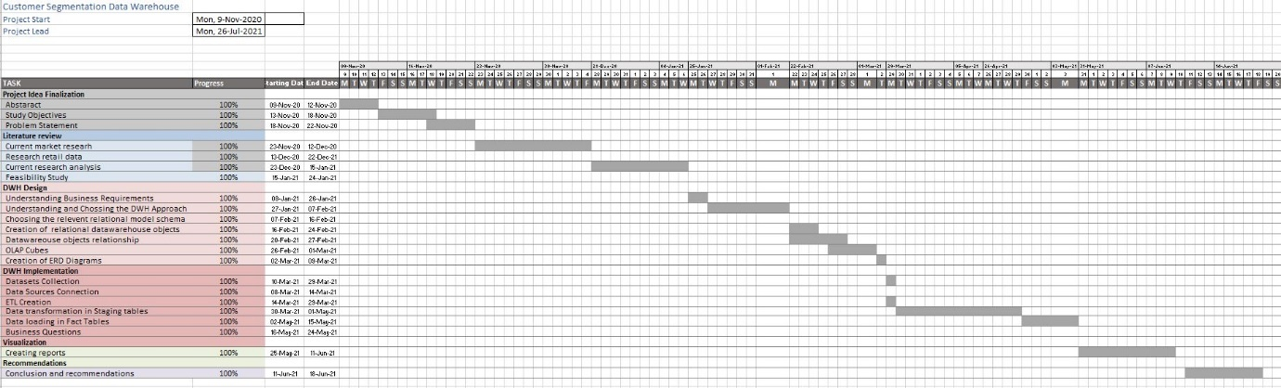

Appendix: Source code preview
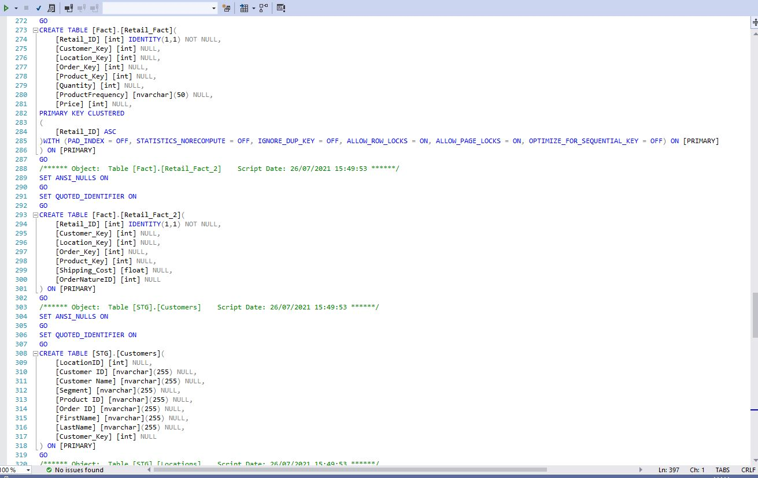

PROJECT RESEARCH Approval Form (Ethics)

Have you considered whether there are any problematic ‘ethical issues’ in your proposed research project? If not, you really should talk to your Course Tutor or Supervisor to discuss if there are any issues you need to address.

If you have already completed an 'Ethics Approval Form' within your Faculty/School, you do not need to complete this form. However, you have not considered the ethics issues in your proposal, you need to complete this form.

Not all details necessarily apply to your area of study, so you may leave some boxes blank, but do try and complete it as fully as you can. All sections deal with potential ethical issues which need careful consideration before you commence your research, to ensure you deal with them properly (in accordance with the law, for example). You may find it easier to complete the form with assistance from your tutor/supervisor.

Name: | George Adrian Apostol
Project/Research Title: | Customer segmentation data warehouse
Name of Supervisor: | Dr Terry Walcott
School/Dept. | Cloud Computing
Faculty: | University of Wales Trinity Saint David
Proposed Start Date: | October 2020 | End Date: | July 2021

1. Summary of planned research, please indicate briefly below the purpose of your planned project/research, together with your aims, main research questions and research design – you can continue onto a separate sheet if necessary
To determine why and what goals a retail data warehouse may achieve, a complete data warehouse was developed for retail consumers. The data storage system enables us to respond to the inquiry by identification or division into different categories. The income and customer base can therefore be enhanced. A graphic depiction was given in order to understand the analysis better. The current effort is aimed at establishing and designing a warehouse based on retail firm circumstances and structure. In order to aid the retail and human resource offices, a data warehouse was established to collect information from the retail sector organisation.

2. Methodology you need to be clear about the methodology you intend to use in your study; this could include any number of methods, so either tick those shown below (where appropriate) or put the details in the box marked *

 | Interviews |  | Participant Observation |  | Use of personal data
 | Focus groups |  | Questionnaire | x | Literature Review
 | Performance |  | Presentation | x | Other (state below)*

Resources from Kaggle data set repository and Tableau resources.

3. Participants - Does your proposed project/research involve human participants?

 | 1. Yes, as a primary source* |  | 2. Yes, as a secondary source* | x | No- go to section 4

*If you have ticked yes, you are likely to need an Advanced CRB check before undertaking your study

If yes, indicate who your participants are:

 | Early years/Pre-School children |  | Adults - give details below
 | School age children |  | Vulnerable people - give details below
 | Young People aged 17-18
 | Unknown at this stage

4. Other Ethical issues (tick all that may apply to your research)

 | Administration of drugs incl. alcohol |  | Deprivation
 | Unpleasant stimuli in any manner or form |  | Active deception or withholding information
 | Collection of highly personal information |  | Payment

5. Are there any ethical concerns other than those listed above?

6. If there are any ethical concerns, please state how you intend to minimise any risk of harm or distress that could be caused

You should enclose the research proposal form, together with any materials (e.g., questionnaire, interview schedule) when submitting this form to your tutor/supervisor.

Student Signature _George Adrian Apostol________________Date___26.07.2021

***************************************************************************
Supervisor’s Signature _ Dr. Terry Walcott_______________ Date___26.07.2021
_
Ethics clearance given at Faculty Level
Clearance not given at Faculty level – forwarded for discussion at the next meeting of the University Ethics Committee. Details below:
Comments:

Chair’s Initials |  | Date

Details on this form will always be dealt with in accordance with the terms of the Data Protection Act 1998. The completed form will be retained on the student’s file after approval (for audit purposes) and may be forwarded firstly to the Faculty Board and thereafter to the University Ethics Committee for a discussion of the issues highlighted.

