

BSc (Hons) Professional Police Practice

LEVEL 6 - 40 Credits

Workbook title: Competency Based Workbook 3 (PCDA)
8000 Words

(SOUTH WALES POLICE, GWENT POLICE AND UWTSD)

Learner name: Lee David Richards

Learner’s University Registration Number:
2117781

FACULTY OF BUSINESS AND MANAGEMENT
PUBLIC SERVICE PROGRAMME

Module title: Professional Police Practice 3 (PCDA) BMPP6000D

Workbook Guidance

Please read these notes carefully; they provide essential information.

What is the workbook for?

The purpose of this workbook is to enable learners to demonstrate and provide evidence of how they meet the learning outcomes set by the College of Policing, for the BSc programme. Essentially, you are being asked to outline your experiential learning based upon your theoretical understanding in a range of operational situations.

- Understanding the Police Officer role
- Modern Professional Police Officer
- Strategic Role of the College of Policing
- Communication Skills
- Social Media
- Leadership and Team Working
- Leadership style
- Flexibility and Leadership Strategy
- Coaching
- Mentoring
- Professional and Organisational goals
- Assessment

You may wish to use the same incidents as you’ve outlined in the Occupational Competence Portfolio.

How should the workbook be presented?

Blank electronic copies can be found on Moodle of this workbook. You must submit this document electronically therefore it is important that you save your work regularly and upload the final typed version through Turnitin on Moodle.

Word count policy can be found in chapter 7 of the Academic Quality under section 7.7 (this applies to presenting work above and under the specified word count).

(https://www.uwtsd.ac.uk/media/uwtsd-website/content-assets/documents/academic-office/aqh-chapters/chapters---en/Chapter_07_Assessment_Taught_Programmes_Pages_72-79-UPDATED-05-11-2019.pdf)

Reflective practice is a core aspect for your workbooks and although there is a variety of useful resources on Moodle, there is one particular book, that is specifically based on reflective practice in policing, here is a link to one chapter from Selina Copley’s Reflective Practice for Policing Students:

https://moodle.uwtsd.ac.uk/pluginfile.php/298870/mod_resource/content/1/Reflective%20Practice%20for%20Policing%20Students%20-%20Selina%20Copley%20Chapter5.pdf

How is the workbook assessed?

Advice and support about the completion of this workbook was provided by university staff as part of your initial training day and further help and advice is available on Moodle.

Your tutor constable and in-force training staff will not be involved in assessing or marking your workbook after it has been submitted.

Dates of workbook submission will be made available and posted on Moodle.

Once submitted your workbook will be assessed and marked independently.

Confidentiality

It is important that no individual can be identified either directly or indirectly from the information in the workbook. Therefore, you must:

- adhere to guidance in the Student Handbook about unfair practice and plagiarism.
- not identify individuals including witnesses, victims or offenders by name.
- not write information that enables any individual to be identified indirectly through the description you provide. This includes references to names, colleagues, places (including hospitals, schools, town, villages, streets) specific incidents which were high profile and could be identified due to past publicity, other professionals or any other personal information including medical or other conditions;
- take personal responsibility for adhering to confidentiality rules.
- not include any dates of any incidents or anything that specifically identifies an actual incident.

Please be aware that any content that is deemed to be inappropriate, disrespectful, or abusive will not be tolerated. Following review of any content of this nature the information will be shared with the employer of the student responsible.

Should any health and wellbeing concerns be raised because of disclosures made by the student within this workbook, the employer of the student will be informed.

NOTE

Your workbook will be submitted electronically via Turnitin on Moodle. Guidance on this is in the Student Handbook.

Remember that the workbook is YOUR responsibility you must not rely on the assessor or anyone else to pick up any confidentiality breaches as this is your work and you must accept full responsibility for confidentiality. Meeting all the confidentiality requirements is very important.

Dyslexia and other special circumstances

If you have any condition that you feel may affect your ability to deal with any part of the programme, please see the Student Handbook for further guidance. The University has a Student Services Unit that may be able to help but it is the learner’s individual responsibility to contact them.

Guidance:

- Your workbook must contain the items specified in the table below (clearly identified and in the order given).
- You should use this document (electronically on Moodle) - insert your text / answer within each section of this workbook.
- You should upload your completed document as a saved pdf file of this workbook; if this is not possible then a Word Doc file is acceptable. Do not send a scanned file from a photocopier, an apple.dot file, or a Microsoft publisher file as Turnitin will not be able to assess them despite you being able to upload them.

Contents

Workbook | Area of Professional Practice | Word count
Task 1 | Understanding the Police Officer Role | 2000
Task 2 | Communication Skills – social media | 2000
Task 3 | Leadership and Team Working | 2000
Task 4 | Coaching, Mentoring, Assessment | 2000
 | Bibliography
 | Total | 8000

Task 1

Relevant areas of the National Policing Curriculum:
Understanding the Police Officer Role.

You must choose a policing incident in which you played a significant role with an offender/service user/victim and reflect on what happened.

Critically evaluate the strategic role of the College of Police in professionalising policing in the U.K.

Evidence how you are working to fulfil the role of a modern professional police officer now that you are in your final year of probation.

Critically reflect upon how your final year of probation has seen your role as a police officer change.

Consider the strategic Policing requirement, Policing Vision 2025, the Workforce Transformation 2018 and the College of Policing’s 5 Year Strategy.

2000 words (+/- 10%: include your actual word count at the end of each section)

ANSWER:

I will assess my first two years of my career in policing, including the implementation and administration of the PCDA programme, in this essay. I'll talk about striking a balance between the demands of launching a new career and the additional demands of learning a new role in the workplace, studying for a degree, and managing a family. It will then look at the justifications given by organisations for the decision to require professional qualifications for police officers, as well as the advantages and long-term necessity of doing so. I'll go through the methods I used to control my stress levels, the support systems I turned to, and the organisational assistance I received from Gwent police inspectors and sergeants. I will describe a situation where I have used my experience and training to support a vulnerable person, involving other agencies support. In the end, I'll assess the advantages and disadvantages of the PCDA programme as well as how it has affected my policing approach overall. This will be completed using a well-established reflection tool.

During the first six months of joining Gwent Police, my time was spent in a classroom environment where the foundations of policing were provided and reinforced with examinations used to establish and verify knowledge and understanding. The purpose of the examinations provided by Extra Marks. (2023) Exams are used in education for many purposes, not just performance evaluation. In addition to providing insightful information about students' educational journeys, they offer a thorough evaluation of students' abilities. The six primary goals are still being served, including evaluating knowledge retention, fostering a sense of accomplishment, identifying learning gaps, giving feedback that promotes consistency and discipline, and getting ready for obstacles in real life.

Since I was a mature student and had not encountered this kind of setting or the pressure of an exam for a good length of time, I have found that I have struggled with the stress and pressure of this process. One of the main methods I used to manage my stress levels was to complete a daily gym workout. This is supported by Select Health. (2024), which provides the following explanation on how stress can be reduced by exercise: One of the best strategies to manage stress and anxiety is to exercise. Exercise-induced stress triggers the release of endorphins, which are your body's natural analgesics. When you exercise three times a week or every day, regular exercise causes your brain to release endorphins, which can lift your spirits. The academic background and legal foundation I had received during my six-month training proved useful once I started working shifts, but I was feeling very limited by the unfamiliar way I had to create files and use the computer system. More practical instruction on the administrative side, in my opinion, would have been beneficial. Katajavuori, N., Lindblom-Ylänne, S., and Hirvonen, J. (2006) discuss the importance of practical training and the perceived confidence that the study's participants gained from it, allowing them to tackle more complex tasks. It also discusses complacency and how ongoing self-reflection, combined with theory-based methods, is required for continuous improvement. The College of Policing. (2014) five-year plan highlights the need of guarantee that law enforcement personnel have the abilities and understanding required to uphold elevated standards. All police personnel will be required to participate in ongoing professional development, according to the college. This will be connected to the advancement of knowledge, and The College of Policing, by means of the training, education, and professional development we offer, licence, or accredit, will elevate the bar for professionalism in law enforcement.

I found it challenging to maintain this level of exercise after I started working at the station because of the shift schedule and the amount of introspection and paperwork I had to complete during the ten-week tutorship. The network of support from my co-workers, university tutors, and sergeants helped me manage my stress levels. Knowing that there were people I could confide in who were going through or had recently gone through similar experiences gave me a sense of understanding and advice. The benefits of group therapy are listed by Citizen Advocates (2020) and include a sense of camaraderie, the opportunity to gain new perspectives, accountability, confidence, self-discovery, transition, and confidentiality. Together, we have developed strong bonds with team members, a proactive support system, and effective teamwork as a result of this shared experience.

Year two of the police constable degree programme was even more difficult for me because of my family, the increasing workload, and the workbooks and assignments from the university. Through the Police Constable Degree Apprenticeship, candidates can join the police force while receiving compensation, gaining academic theory and knowledge, and receiving hands-on training. The University of South Wales, Trinity Saint David. (2023), continues to explain the PCDA. The Bachelor of Science (Hons) in Professional Policing Practice degree is linked to the PCDA. Participants will range in age from 18 to 55. The day the police officers start working is when the programme will start recruiting. Completing the PCDA usually takes three years. With the support given by Gwent police and the university, I managed to complete year two, but this was a struggle, and the added pressure of a work action plan and the worry of losing my job were mentally and physically exhausting.

Having completed the first two years of the PCDA, it has helped me understand the workings and research behind some of the situations and behaviours of individuals I found myself dealing with, a better understanding of how my interactions affected the situation, and the confidence that members of the public have in the police force in general.

The PCDA requirement stems from the 2025 police vision, which was developed by the Association of Police, the Crime Commissioner, and the National Police Chiefs Council, also known as the NPCC. The National Police Chiefs Council's. (2016) 2025 policing vision, which includes the rationale for transformation, explains how police forces use their resources to implement key strategies for future programmes. The PCDA programme will eventually result in a more professional representation of the police force in England and Wales. The 2025 policing vision places a strong emphasis on providing members of the community with vulnerability support and effective risk management through aligned methods and, where possible, integration with other public services.

I recently dealt with a sixteen-year-old who was reported missing to the police by her grandparent after attending the home address and conducting missing persons checks such as circumstances, house search, medical history, medication, previous history, acquaintances, drug or alcohol issues, access to back cards or money, access to a motor vehicle, and questions related to child sexual exploitation. Following the checks, a risk assessment was completed, and she received a high grade due to her vulnerabilities and risk of child exploitation. When conducting a risk assessment, vulnerability is an important factor. According to the College of Policing (2021), a person is vulnerable if, due to their circumstances or situations, they are unable to care for or safeguard themselves or other people from harm or exploitation. The vulnerabilities identified were age, a history of crack cocaine addiction, attempts at self-harm in the past, relationships with older males, and an accusation that sex was a trade-off for drugs or money. The missing person became at high risk of child sexual exploitation, and the appropriate referrals would be required. According to the NSPCC. (2024), one type of sexual abuse is child sexual exploitation (CSE). It occurs when a young adult or kid is misled, persuaded, or forced into engaging in sexual activity in return for a range of needs and goals, such as gifts, drugs, cash, status, or affection. This kind of maltreatment is called grooming. They could not even be aware that they were being mistreated since they still believed their abuser's words. The use of technology can support child sexual exploitation in the same way that face-to-face communication can.

The missing person was found, and once an intervention interview and public protection notice were completed, the police service provided notification and support to public support agencies. As a result, social services and her grandparents provided shared care for the missing person, with the missing person occasionally receiving a 24-hour care order at an out-of-area support facility for her own safety. The missing individual was able to receive multiple agencies help and be safeguarded to the highest standard thanks to the support, training, and expertise I had gained over the previous two years. According to NHS England. (2024), safeguarding means ensuring individual health, welfare, and human rights are safeguarded, allowing them to live without fear of injury, abuse, or neglect. It is essential to delivering top-notch medical treatment. Ensuring the safety of children, adolescents, and adults is a shared obligation. Young people, teens, and adults who are in danger, such as those getting care at home, those with physical, mental, or sensory impairments, and those with learning problems, are the groups who most require protection.

The Gibbs Reflective Model from the University of Edinburgh. (2024) will help me explore, reflect on, and analyse my professional development throughout my time in law enforcement. This will include an examination of how the PCDA programme's requirements align with the professional standards outlined in the policing vision for 2025.

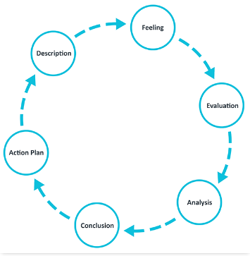
Figure 1.1 - Gibbs' Reflective Cycle (Source: University of Edinburgh 2024)

The first step in the Gibbs reflective model is to describe the situation this is depicted in figure 1.1.

This essay demonstrated the effects of increased workload on my mental health and family life. However, during a high-risk missing person case, I used the knowledge I gained from training to provide exceptional service. By conducting a thorough investigation and coordinating with various agencies, I was able to protect and assist an extremely vulnerable person.

Throughout my participation in the university's PCDA programs, I have experienced challenges stemming from the significant commitment and workload, which have also affected my personal life. Despite these obstacles, the fulfilment of delivering professional service and supporting individuals during difficult times has brought me a profound sense of pride and satisfaction.

After assessing the situation, I recognise the benefits of the PCDA programme and acknowledge that, without extensive knowledge and understanding, the missing person may not have received the necessary level of assistance. However, I've discovered that the significant amount of additional work and learning has resulted in mental and physical fatigue, which occasionally impairs my ability to perform to the high standards I strive for. Fan, J., and Smith, A. (2017) found that high workloads and fatigue can have a negative impact on performance, and when people are overwhelmed and exhausted, their decision-making abilities may suffer.

In conclusion, I recommend taking a more gradual approach to training so that participants can effectively balance their learning with their increasing work responsibilities. Throughout my school training, I made numerous professional connections, some of whom struggled with the demanding workload and left the organisation. I must admit that I have faced similar struggles at times.

Moving forward, my goal is to successfully complete the PCDA programme. This will allow me to streamline my academic learning while also focusing on improving my physical and mental health. I intend to use the knowledge gained from the programme to improve my professional approach to policing for the rest of my career.

Word count 1889

Task 2

Relevant areas of the National Policing Curriculum:
Communication Skills, social media, Communication Strategy

You must choose a policing incident in which you played a significant role with an offender/service user/victim and reflect on what happened.

Critically evaluate your experience of the use of social media as a means of informing and engaging with the community and promoting policy initiatives.

Consider the force policy on using social media for professional information and engagement purposes.
What social media platforms are used by policing?
What are the benefits and risks of using social media?

2000 words (+/- 10%: include your actual word count at the end of each section)

ANSWER:

In this essay, I will discuss an incident in which social media assisted in identifying witnesses and offenders, followed by an analysis of the social platforms used by the police. I will then look into how police departments use social media to interact with communities, as well as the positive and negative consequences of doing so. I will look into the current police force's policies regarding media interactions. I'll also talk about how to evaluate the engagement and effectiveness of a social media post. The essay will also go over the incident and the lines of inquiry prompted by the social media appeal, as well as the subsequent investigation and support for the victim. The findings of this investigation and their potential impact on the community and community engagement. Finally, I will use a well-established reflection model to fully evaluate, learn, and develop an action plan for when I find myself in a similar scenario in the future.

A local closed-circuit television operator dialled 999 to report a male laying on the floor following what they believed to be an assault; however, by the time officers arrived, the male had fled the scene, and there were no witnesses willing to provide any information to the police. The next day, I responded to a call from a male who claimed to have been assaulted the night before, but he couldn't remember anything because of his intoxication.
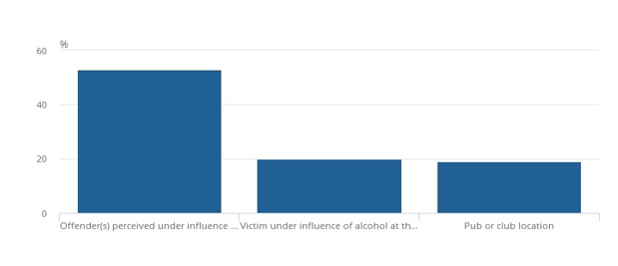

Figure 2.1 - Violent Crime and Sexual Offences - Alcohol-Related Violence (Source: Office for National Statistics, Crime Survey for England, and Wales 2021)

Figure 2.1 indicates that alcohol is a contributing factor in more than half of violent incidents. The Office for National Statistics' Crime Survey for England and Wales. (2021) provides more information. I would definitely agree that alcohol contributes to more than fifty percent of threats or acts of physical violence, and if you include drugs as a contributing factor, my experience as a police officer will lead me to believe that the percentage is closer to ninety percent.

At this point, I had not connected the two incidents, so I relied on an approximate timeline and any information provided by the male. The male had sustained serious injuries, including a broken jaw that necessitated surgery involving the retraction of twelve teeth and the use of a metal plate to properly position the jaw. While I conducted the inquiries, I requested the closed-circuit television footage that had been reported, matching the timeline the male provided me. An unknown male assaulted the male, who suffered a broken jaw, with one punch, according to the footage. The assault would be classified under Section 47 of the Person Act 1861, which states that a person is guilty of an offense if he assaults any person, thereby occasioning him actual bodily harm.

I was presented with an investigation in which I was the officer in charge. I had a named victim who had sustained serious injuries, no witnesses, and no identified offender. I conducted the rest of the investigation inquiries to progress the investigation, which included house-to-house inquiries, capturing any other CCTV footage available, speaking to rota'ed staff members of businesses in the time frame, and speaking to the victim’s friends who he was with at the start of the night. According to the College of Police. (2023), the goal of an investigation is to identify the culprit and make sure that, after a thorough, ethical, and professional investigation, they are brought to justice. This will lessen crime and the public's fear of crime, enhance public confidence in the police, and help prevent future offenses. My main priorities in this investigation were to identify the offender and possible witnesses to the assault. The Metropolitan Police. (2024) states that retrospective facial recognition is available to help with investigations and incidents post-event where there is still imagery or a brief video of an unknown offender. I used a screen grab of the offender and sent it to facial recognition. CCTV is usually the source of the images or brief videos that are searched in this system. After that, those pictures can be compared to some of our custody picture collections. Every time the system flags a match, a human will assess the information and determine whether or not they believe there is a match. Although I've used this procedure successfully in the past, it wasn't effective this time, and the individual responsible was still unidentified.

I requested that our Gwent police social media team create a social media appeal to gather information about this incident. Gwent Police uses four main social media platforms, which are Facebook, Twitter (now known as X), YouTube, and Instagram. Facebook is a social networking platform that allows users to have profiles that are updated live and shared with followers and friends. It enables users to interact with each other, and Facebook is important for police forces to establish their corporate identity at all levels.

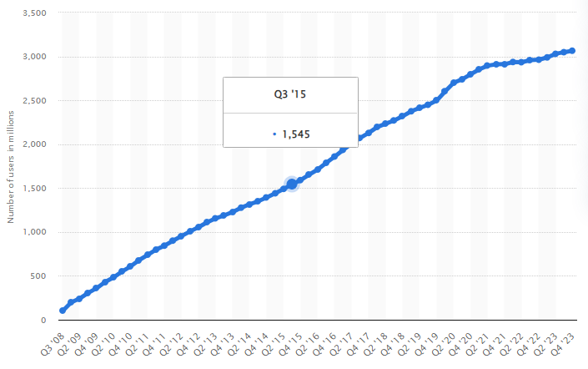

Figure 2.2 - Number of monthly active Facebook users worldwide (in millions) (Source: Statista 2024)

Figure 2.2 depicts the growing number of active Facebook users. As of the fourth quarter of 2023, there were over 3,000,000,000 users on the social networking site, indicating the potential to engage with a sizable target audience. Webwise. (2018) describes Facebook as having a website that allows individuals, groups, or organisations to create free profiles and connect with friends, colleagues, and strangers online. It enables users to share pictures, music, videos, and articles, as well as their own ideas and opinions, with as many people as they want.

A messaging app called Twitter/X is especially helpful for disseminating breaking news, usually before it is covered by mainstream media. Additionally, private messaging is possible with it. The dissemination of misleading information on Twitter and X with the intent to influence people is one of the main problems with the platform. According to Soroush V., Deb R., and Sinan A. (2018), on the Twitter/X platform, false information tends to spread more widely than the truth. The network structure and distinct characteristics of spreaders, in contrast to expectations, favour and propagate false information. People are more likely to retweet false information than the truth, so false news spreads more quickly despite network and individual factors that favour the truth.

Police departments have also found YouTube to be helpful, and according to GCFGlobal. (2024), YouTube is a free video sharing website that makes it easy to watch videos online. You can even create and upload your own videos to share them with others. Almost 6 billion hours of video are viewed on YouTube each month, making it one of the most popular websites on the Internet since it was founded in 2005. Due to YouTube's widespread appeal, police departments find it especially helpful to convey messages about road safety, provide updates regarding public order situations, and other messages that are thought to be essential to policing issues.

Instagram is a popular social media platform that is also used by police departments. Instagram's mobile app allows users to edit, post, and share images and short videos. According to TechTarget. (2017), users can index their posts and allow other users to search them within the app by including location-based geotags and hashtags, as well as a caption. This gives audiences a brief overview of their local policing teams and encourages community engagement.

We were able to identify a named offender and witness by engaging with the larger community through the aforementioned social media platforms, particularly Facebook and Instagram. According to The College of Policing (2013), community engagement is the process of allowing individuals and communities to participate in policing to the extent that they choose. This includes providing information and assurance, assisting communities in identifying and implementing local problem solutions, and influencing strategic priorities and decisions. The loss of public support and engagement can result in serious incidents and community tensions. Identifying witnesses and offenders was not forthcoming through face-to-face inquiries. The reason for this is that some people find face-to-face communication difficult, and providing this digital approach helps to remove those barriers. This positive outcome was made possible by engaging with social media; however, not all aspects of social media are positive. According to Amedie., J. (2015), while social media can facilitate information sharing, it can also result in the formation of false identities, depression, and criminal and terrorist recruitment. Social media is a relatively new phenomenon, so impact studies tend to focus on its benefits rather than its drawbacks.

The offender was interviewed based on witness statements and CCTV footage, and he identified himself as the person in the footage and explained why the altercation occurred. A case file was created using CCTV footage, medical records, witness statements, victim statements, and interview recordings, and it was then forwarded to the Criminal Prosecution Service for charging advice. The criminal prosecution service quickly responded and advised charging the offender with the alleged offence, which would not have been possible without the assistance of a social media appeal, providing the victim with a positive experience and instilling public confidence.

Increasing public confidence promotes community engagement and builds trust in the police, as demonstrated in the confidence cycle below.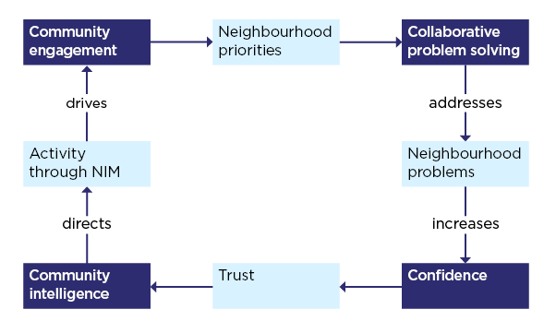
Figure 2.3 - The confidence cycle (College of Policing 2024)

Figure 2.3 of the above confidence cycle illustrates how the incident I had to investigate evolved and played a role. We had an incident involving a community problem with anti-social behaviour outside a local public house, which resulted in an assault, and we were unable to identify the offender, so we engaged the local community through a media appeal. A positive outcome is then shared on social media, which boosts confidence, trust, and community engagement.

The Gibbs Reflective Model, developed by The University of Edinburgh (2024), will assist in examining, reflecting on, and analysing the impact of utilising social media in my investigative work. This approach has led to a favourable outcome, ultimately boosting community engagement.

The first step in using the Gibbs Reflective Tool is to provide a detailed account of the situation, as illustrated in Figure 1.1. I was assigned a case involving a severe assault that resulted in serious injuries. Despite unsuccessful attempts to identify the offender using internal police procedures, I was able to locate CCTV footage from the incident. I was able to successfully identify the perpetrator after engaging with the community and using social media.

When first handling this investigation, there was frustration due to a lack of information and in-person interaction with those involved. Using social media and electronic communication with the community helped identify the perpetrator, resulting in a sense of relief and satisfaction.

When an analysis is conducted without using social media to allow the public to engage at their preferred level, the investigation has a low chance of producing positive results.

I believe that this essay emphasises the importance of using all available tools to raise public awareness and encourage community engagement. It is critical to recognise both the advantages and disadvantages of these tools in order to effectively improve community participation.

Going forward I will consider the benefits and drawbacks of social media appeals, taking into consideration of the bigger picture and potential consequences. I will also aim to continue learning in the development of technology and how it could potentially aid investigation and community engagement.

Word count 1886

Task 3

Relevant areas of the National Policing Curriculum:
Leadership and Teamworking

You must choose a policing incident in which you played a significant role with an offender/service user/victim and reflect on what happened.

Critically evaluate and evidence your flexibility in leadership style.

Critically analyse leadership strategies that you have developed to manage a range of different operational situations.

Consider leadership models commonly used in policing.
How were you able to apply a change in leadership style/strategy to reflect changing circumstances?

2000 words (+/- 10%: include your actual word count at the end of each section)

ANSWER:

In this essay, I will discuss a domestic violence incident that I experienced with a less experienced officer. I'll look at what decisions were made and explain how I used a well-known decision model to help deal with this incident, as well as how the model works. I'll look at how I dealt with de-escalating the situation when I first arrived, as well as techniques I used to ensure the safety of everyone involved. I will investigate the leadership styles I used, evaluate their effectiveness, and compare them to other styles available. I will go into detail about various leadership styles, including their benefits and drawbacks. Finally, I will use a well-established reflection model to fully evaluate, learn, and develop an action plan in case I find myself in a similar situation in the future.

There was a 999 call for a domestic incident, and control requested that an officer respond to this emergency-graded call. I was available and requested to be assigned to this call; additionally, an officer who had recently gained independent patrol status offered to assist with this call. Domestic abuse is defined by Women's Aid. (2022) as an incident or pattern of incidents of controlling, coercive, threatening, degrading, and violent behaviour, including sexual violence, perpetrated primarily by a partner or ex-partner but also by a family member or carer. It is extremely common. In the vast majority of cases, women are the victims and men are the perpetrators. While on the way to the call, our control provided a summary of the circumstances, which included the address where the incident occurred, the names of the reporting person or victim, and the alleged offender, as well as the fact that the alleged offender had several warning signs, including violence, domestic abuse aggressor, drugs, mental health (anxiety, depression, and self-harm), and having assaulted officers previously. The victim/reporting person told the call taker that her partner had pulled her to the ground by her hair, kicked her in the face, causing her lip and nose to bleed, and is now smashing up the house. The caller also said she believed he was off his head on crack cocaine.

While driving, I would begin to devise a strategy and use a tool I had grown accustomed to, the national decision model, illustrated below.
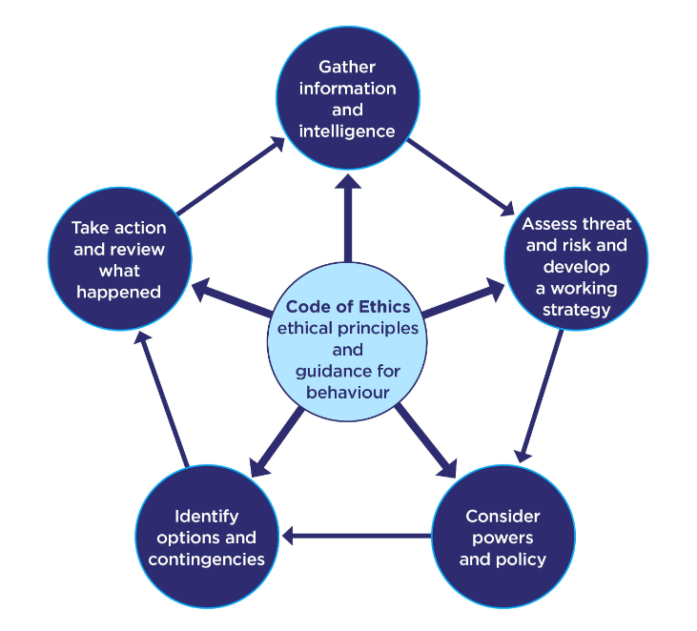

Figure 3.1 - National decision model (College of Policing 2024b)

From figure 3.1 it clearly displays at the core of the National decision model and is an integral part to every step of the national decision model, the code of ethics also known has policing principles this has recently been updated and depicted below.

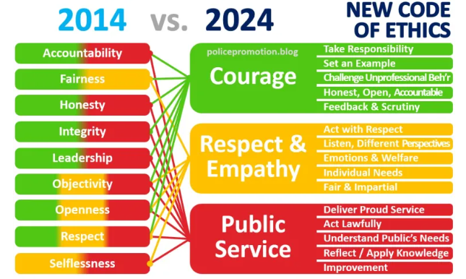

Figure 3.2 - Policing with Principles: The NEW Code of Ethics 2024 (RANK SUCCESS BLOG 2024)

When working my way through the national decision model, I would first consider the information and intelligence that was provided. For example, there has been a report of domestic violence, injuries have been reported, the incident is still ongoing, the victim and offender have been identified, intelligence from the offender's markers has been provided, and I also have an officer who has recently obtained independent patrol status present.
Next, I began to consider the risks. An incident is ongoing that involves a violent offender who has already injured someone, an injured person who is still on the scene, going to an unknown location where there could be a possible weapon, an inexperienced officer present, and the offender's history with police officers.
Then I considered the powers and policies that were available to me. I considered our police safety training and previous experiences with this type of incident, the Gwent police domestic violence policy, the Police and Criminal Evidence Act, common law, powers of entry, use of force, and what first aid might be required and how it could be administered safely.
A plan begins to develop, which includes a joint officer approach that separates the victim and the offender. If the offender is in an irate state, ensure he is assigned an area where there are no identifiable weapons. Get the offender to sit down. Make sure I can see the other attending officer, and they can see me. Speak with the perceived victim in confidence; because of my experience and larger body type, I will attempt to de-escalate the perceived offender; consider which leadership approach to use; and consider arresting and using handcuffs.

When I arrived, I could hear signs of disturbance, and given the reports of violence and injuries, I entered the property under Section 17(e) of the Police and Criminal Evidence Act 1984, which states that a constable may enter and search any premises for the purpose of saving life or limb or preventing serious property damage. To separate the victim and perceived offender, I would need to adopt a leadership style that would allow me to take command of the situation and lead the perceived offender, the victim, and the other officer present. Sethuraman., K. and Suresh., J. (2014) argue that as a leader, you bear a significant responsibility to lead others. This becomes a significant challenge because the outcome or output is contingent on the performance of their followers.

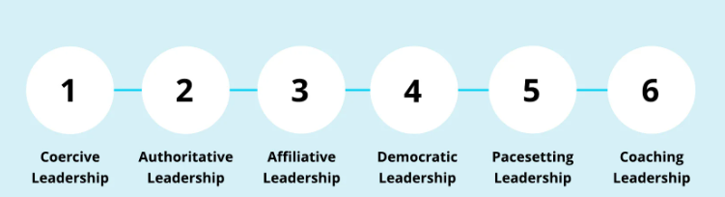

Figure 3.3 - The 6 Goleman Leadership Styles: Which Is Yours? (Personio 2024)

Gorman identified six basic leadership styles, which are illustrated in Figure 3.3. The first type of leadership style is coercive, also known as directive or commanding, and it has been shown to be more effective in difficult situations where specific tasks must be completed in an ordered fashion.
The authoritative leadership style, also known as the visionary style, is one in which the outcome is described, and the participants devise their own path to achieve it.
Affiliative leadership style: in this style, you sympathise with everyone involved and offer praise but not providing clear constructive advice or instructions.
Democratic leadership style. This is also known as a participative leader, and it entails giving everyone an equal say. This can be time-consuming and lead to prolonged debates.
Pacesetting leadership style involves leading by example, inspiring, and encouraging others to follow.

Coaching leadership style: this style is used to build and develop others, typically one-on-one, and is most beneficial to someone who is willing to learn and improve.

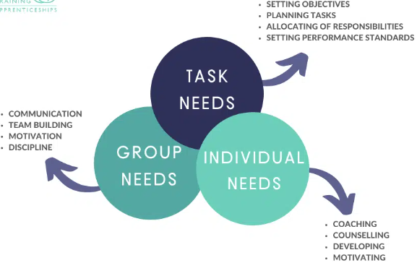

Figure 3.4 - John Adair’s Action Centered Leadership: Learn How to Be A Leader (TWS Training 2021).

Looking at John Adair's leadership theories from TWS Training. (2021) in figure 3.4, leadership skills are essential for resolving conflict and keeping the team on track to progress through the stages of team development. John Adair rejected the idea that leaders were born, believing that leadership skills could be learned, developed, and improved. John Adair created a leadership model to help aspiring leaders gain control. The model is made up of three circles that are connected in the centre, overlap separately, and have individual sections.

Given the incident's time and risk-sensitivity, I employed a coercive approach to ensure everyone's safety and gain control of the situation, giving clear and assertive instructions to the perceived offender, victim, and attending officer. I told the perceived offender to stay with me by the stairs and directed the victim and the other officer through the door into the living room. The perceived offender already presenting in an aggressive manner and initially provided resistant to this style of leadership.

My training have provided me with a number of tools to deal with confrontation and two that I most commonly use are the LEAPS model and Betari’s box model.

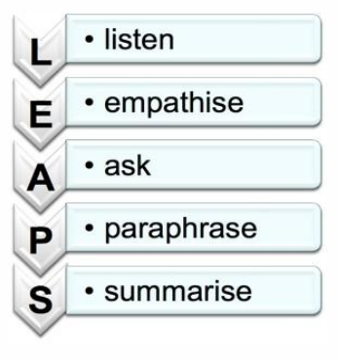
Figure 3.4 - NHS Conflict Resolution (LEAPS) (NHS 2015)

LEAPS is a popular acronym that is used to assist when confronted with aggressive behaviour (NHS. 2015). The L is for listening to what the person has to say, the E is for empathising with what has been said, and the A is for asking questions to learn more about the situation, paraphrasing the facts as you have heard them to demonstrate complete understanding, and finally summarising what has happened and developing a clear action plan for moving forward.

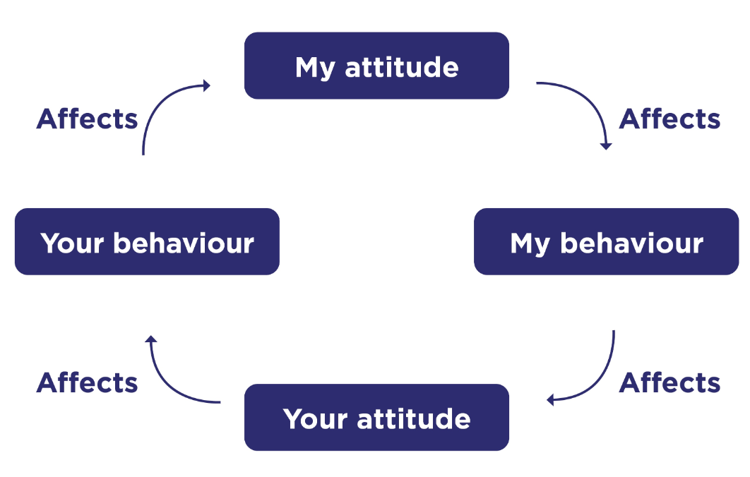
Figure 3.5 - Conflict management skills (Betari's Box) (College of Policing 2020)

Figure 3.5 shows that when confronted with an aggressive person, your behaviour and attitude must be adjusted and managed to break the cycle of aggression (College of Policing, 2020).

Once I had managed the initial dynamic incident using the conflict management techniques depicted and discussed in Figures 3.4 and 3.5, I could focus on the next stage. With the disclosure of an assault, criminal damage, and visual evidence of the criminal damage and the victim's injuries, appropriate action was required. During my time at British Airways, I took an Institute of Leadership and Management level 3 and 4 course, which revealed that my preferred leadership style was pacesetting. Due to the outstanding actions and time frame, I reverted to my preferred leadership style, which included conducting the arrest and initiating the golden hour inquiries. I was assisted by the other attending officer in completing all of the outstanding inquiries. Once this was completed, victim support was required, and being pushy with a pacesetting approach was not appropriate. There was also a need for understanding and working with the victim at their own pace, so I adopted an affiliated leadership style. This leadership style allowed to provide the empathy and support to take a victim statement, personal victim statement and a domestic abuse, stacking and harassment and honour-based violence risk assessment also known as a DASH. The DASH model is the most commonly used risk-led policing model for domestic abuse in the United Kingdom. In 2008, a multi-agency expert panel created the risk identification and assessment tool that serves as the foundation of the DASH model for police (College of Policing. 2016).

When I left the scene, the other officer and I discussed what had happened, what we thought went well, what we could have done better or differently, the possible outcomes, and a plan of action for subsequent incidents. This was accomplished through a combination of coaching and democratic leadership, with a new team member eager to learn and grow. In this one incident, I used five of Goleman's six leadership styles, each of which was appropriate for the situation.

The Gibbs Reflective Model, created by The University of Edinburgh. (2024), will help me examine, reflect on, and analyse my use of different leadership styles while responding to a domestic abuse emergency call.

The first step in using the Gibbs Reflective Tool is to provide a comprehensive description of the situation, as shown in Figure 1.1. I recently received a call to respond to an emergency situation involving a reported domestic incident. During this response, I worked with a less experienced police officer. I chose a commanding leadership style at first to ensure that clear instructions were given to ensure the safety of all parties involved. As the situation progressed and order was restored, I switched to a pacesetting leadership style, which I am more comfortable with, to efficiently conduct necessary investigations. When interacting with a vulnerable and injured victim, I shifted my leadership style to be more empathetic, then finally when reflecting on the incident with a less experienced officer I adapted a mixture between coaching and democratic leadership style.

Reflecting on my emotions during the incident is difficult to articulate, and the actions taken appeared to be a result of the challenging environments that police officers frequently face.

Examining the situation reveals that a one-size-fits-all leadership approach is inappropriate in a dynamic and changing environment. It is critical to be able to modify one's leadership style accordingly. Evaluating and considering the best leadership style for different situations can help you understand the benefits and drawbacks of each style.

In conclusion, throughout my experience as a police officer, I have demonstrated the ability to effectively adjust my leadership approach in response to rapidly evolving and dynamic circumstances.

Moving forward, I am committed to improving my understanding of various leadership styles and implementing personal development strategies to enhance each one. This will allow me to successfully navigate rapidly changing workplace conditions.

Word count 2009

Task 4

Relevant areas of the National Policing Curriculum:
Coaching, Mentoring, Assessment

Critically reflect upon your three-year probation:

How have you benefited from mentoring and coaching?
How has it helped you to meet personal, professional and organisational goals?
How has it aided you to learn, develop and perform in the workplace?

Consider relevant coaching and mentoring definitions along with current coaching and mentoring theories used in policing.

How do you provide and receive feedback?

2000 words (+/- 10%: include your actual word count at the end of each section)

ANSWER:

This essay will detail my experience in the policing field over the past three years, beginning with the application process and progressing through police training school, university coursework, ten-week practical training, and ongoing professional development following the attainment of independent patrol status. Throughout this report, I will explore and analyse the distinctions between coaching and mentoring, as well as identify the various mentors and coaches who have guided me during this period.

I am committed to furthering my education in order to gain a thorough understanding of the benefits and variances between coaching and mentoring. This report will highlight the invaluable support and guidance I have received from respected mentors and coaches, which have greatly contributed to my personal growth and competence as a police officer.

I will also discuss the importance of reflective learning in identifying and addressing areas of strength and improvement, enabling me to continuously enhance my skills. Lastly, I will utilise a reputable reflection model to thoroughly evaluate my experiences, extract key learnings, and develop an action plan to guide me in similar situations in the future.

In 2020, I worked as a material planner for British Airways for seventeen years. During this time, I developed a desire to pursue a career focused on aiding others. At the age of eighteen, I sought to join the police force; however, my application was unsuccessful. A former colleague from British Airways, who had recently been accepted into the Gwent Police, generously offered to assist me in navigating the application process. I viewed this individual as a mentor, someone with extensive experience who provides guidance, advice, and support to aid in personal and professional growth (CIPD, 2024).

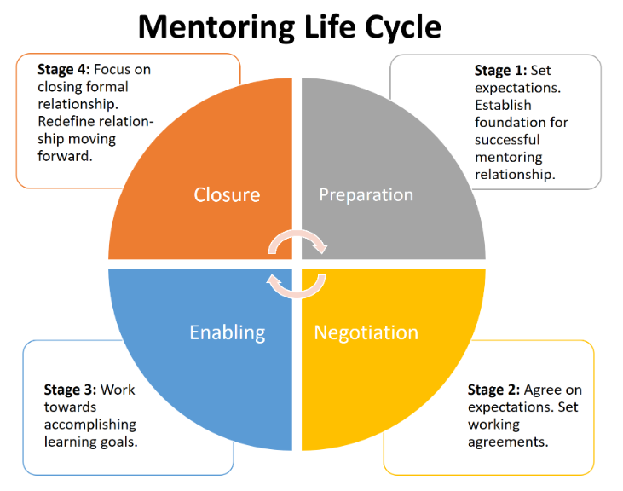

Figure 4.1 – Mentoring life cycle (University of Johannesburg & University of Helsinki 2016).

As illustrated in Figure 4.1. I went through this cycle with a friend, which involved altering our relationship so that my friend was the meteor, and I was the one receiving mentoring. This provided a solid foundation from which to work; this is referred to as the preparation stage.
We then discussed how it would work, as well as our expectations, and established the goal of a successful application. I explained where I was and my expectations, and my friend offered guidance, advice, and explanations of his previous experiences; this would be considered stage two of the mentoring cycle the negotiation stage.
My application to Gwent Police involved six stages: a behaviour test, a situational judgement test, an application form, an online assessment centre, a force interview, and a fitness test. At each of these six stages, we would have check-in sessions in which I would discuss what I was expecting and my thoughts on how I would approach them, and my mentor would provide his experience and assist me in turning my thoughts into a structured action plan. This activity is referred to as stage three, the enabling stage in the mentoring life cycle.
I then met my goal, was successful in the entire application process, and was given a start date of October 4th, 2021. This provided a successful and natural conclusion to the mentoring life cycle, re-establishing our friendship with colleagues at Gwent Police and this would be considered has the closure stage.

As a result, while attending police training school, I found myself in a classroom setting with extensive learning and examinations. Due to my age, this seemed extremely alien to me, so I sought the support and guidance of an experienced tutor. This tutor became a mentor, and the life cycle of this relationship was completed. Due to his support, guidance, and structure he provided, I had a tremendously positive experience at the police training school.

After completing my police training school, I was assigned a tutor for ten weeks to provide personalised and professional guidance. To operate independently during patrols, the tutor needed to endorse me. This individual provided me with the necessary knowledge to respond to calls autonomously, use appropriate tools, and effectively handle a variety of scenarios. The tutors are provided formal training and a specifically and organically required to facilitate and improve students to the required level over a ten-to-twelve-week period also using they reflective methods of learning that tends to be a coaching approach this is supported below with a description of what is coaching.

Coaching is a professional method utilised to improve performance and facilitate progress in the workplace. It focuses on specific skills and goals. Typically, coaching is carried out over a designated period or as an ongoing management strategy.
While there are various definitions, there are shared principles of coaching in organisational settings. It is primarily a non-directive approach intended to enhance performance and personal growth. While personal aspects may be considered, the main emphasis is on workplace performance. Coaching activities are structured to achieve organizational and individual goals, allowing individuals to recognize strengths and areas for improvement.
Effective coaching demands specialised skills and should be conducted by individuals with training in coaching techniques (CIPD, 2024).

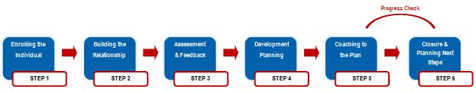

Figure 4.2 - Turning Point Coaching Process (Paradigm Group 2024)

During the twelve weeks of tutoring, I will utilise my experience to clarify and understand the coaching process outlined in Figure 4.2. The process began with enrolling the individual, after which the tutor was formally introduced to both me and my station sergeant. We had a thorough discussion about the process and expectations for both the tutor and the station sergeant.

Following the enrolment stage, we moved on to the second phase, which involved developing a professional relationship between myself and the tutor. We talked about how the process worked, which included a matrix with specific tasks that needed to be completed to a satisfactory standard.

My tutor and I participated in several calls together, where we developed action plans based on the National Decision Model (NDM). The College of Policing. (2024b) provides additional information on the NDM. Following each shift, I reflected on the incidents in which I was involved, identifying both strengths and areas for improvement. My tutor used his observations and my reflections to provide professional and constructive feedback, as part of the assessment and feedback step of the process.

During scheduled intervals, my tutor and I would meet one-on-one to discuss completed tasks, outstanding work, strengths and weaknesses, areas for improvement, questions, and concerns. The tutor advised on which areas to focus on and identified knowledge gaps that should be addressed. This process provided me with a clear plan for progress, indicating the development and planning stages of the coaching process.

I was almost finished with the matrix, with only a few areas left to address, when my tutor mentioned the need for improvement in the vehicle search section. We had a thorough discussion and decided that a virtual vehicle search would be useful in a controlled environment. Through a role-playing scenario, I received targeted coaching and valuable feedback, which helped me refine the matrix and move on to the planning stage of the coaching process.

After successfully completing the predetermined criteria outlined in the matrix, my tutor conducted a thorough evaluation and consultation with their reviewing sergeant before granting me independent patrol status. This process included a thorough review and feedback session that aimed to encourage reflection and growth. We also talked about potential opportunities for growth and advancement in our careers. The completion of the ten-to-twelve-week tutorship programme marked the achievement of independent patrol status, which will be discussed during the upcoming closure session and planning for the next phase of the coaching process.

After following the structured process steps of both mentoring and coaching, I have determined that the coaching experience felt more formal, with clear milestones and a structured target. On the other hand, the mentoring experience felt more informal and focused on a holistic approach to personal development. The formal approach of coaching is confirmed by the police force appointing a tutor, as the mentor was selected by myself, providing the personal touch helping refine specific area I believed necessary or vital. Coaching and mentoring have the obvious similarity that both methods are utilised to enhance and develop my progress in my policing career. This is supported by Gonzales, M. (2021), who suggests that mentoring and coaching are both effective tools for employee development, each with their own distinct approach. Mentoring occurs when employees actively seek personal guidance from a chosen mentor within the organisation, whereas coaching is typically initiated by a manager or supervisor to address specific behaviours. Both approaches have been shown to improve employee performance and contribute to the overall success of the organisation.

After conducting a thorough analysis of the similarities and differences between coaches and mentors, I now have a better understanding of the various coaching and mentoring relationships I've had while working in law enforcement, whether through formal assignment or personal selection. Based on this evaluation, I recognise that, following my instructor's advice, I sought out a senior officer on my shift who had a wealth of experience, was highly respected, and demonstrated behaviour that I aspired to emulate. This person serves as a mentor for me, providing personal guidance and support. In addition, my shift sergeant has coached me, giving me formal objectives, targets, and areas for professional development. During the academic side of the policing degree, I have struggled due to dyslexia and not completing any type of academic work for a long period and 1:1 coaching sessions provided by the university have enabled me to complete task that I was finding impossible.

The Gibbs reflective model from The University of Edinburgh. (2024) will help investigate, reflect, and analyse the benefits of different coaches and mentors during my policing career.

The first step in using the Gibbs Reflective Tool is to provide a detailed description of the situation, as illustrated in Figure 1.1. I've had discussions and reflections on my personal development and improved understanding of police procedures, thanks to the guidance and support of various coaches and mentors who have helped me achieve my goals. I've articulated the importance of this tool since the start of my law enforcement career, and I believe it will continue to be relevant in the future.

I have felt fully supported by friends, colleagues, Gwent police, and university staff enabling personal and organisational goals and targets. This support has felt essential and at times where I have felt lost or unsure there is always the required support.

On analyses when at times when I have really strangled academically, mentally or required personal development the structure in place provides the additional support via coaches or mentors at every stage of my policing career.

On conclusion without the support of the coaches and mentors, there would have been zero chance of a successful policing career and me not achieving a goal I set from a young age.

Going forward I will look for guidance and support that become available to continue my growth and development and strive to provide the same help and support to others who may require my support.

Word count 1835

Bibliography
The bibliography should only include sources referenced within the workbook using the Harvard referencing system. Information about referencing in written assignments and how to avoid plagiarism can be found on Moodle. It is important that you are aware of the importance of ensuring that the work submitted is your original work.

Amedie,, J. (2015), The Impact of Social Media on Society Available at: https://scholarcommons.scu.edu/engl_176/2/ (Accessed 15 March 2024).

CIPD. (2024) Coaching and mentoring Available at: https://www.cipd.org/uk/knowledge/factsheets/coaching-mentoring-factsheet/ (Accessed 1st April 2024).

Citizen Advocates. (2020) 7 benefits of group therapy Available at: https://citizenadvocates.net/blog/7-benefits-of-group-therapy/#:~:text=With%20group%20therapy%2C%20you%20are,stress%20you%20may%20be%20feeling. (Accessed 3 January 2024).

College of Policing. (2013), Engagement Available at: https://www.college.police.uk/app/engagement-and-communication/engagement (Accessed 15 March 2024).

College of Policing. (2014) Five-Year Strategy Available at: https://library.college.police.uk/docs/college-of-policing/Five-Year-Strategy-2014.pdf (Accessed 20 January 2024).

College of Policing. (2016) Risk-led policing of domestic abuse and the DASH risk model Available at: https://library.college.police.uk/docs/college-of-policing/Risk-led-policing-2-2016.pdf (Accessed 20 March 2024).

College of Policing. (2020) Conflict management skills Available at: https://www.college.police.uk/guidance/conflict-management/conflict-management-skills (Accessed 20 March 2024).

College of Policing. (2021) Introduction to vulnerability-related risk Available at: https://www.college.police.uk/guidance/vulnerability-related-risks/introduction-vulnerability-related-risk#:~:text=exploited%20or%20abused.-,THRIVE,others%20from%20harm%20or%20exploitation. (Accessed 10 January 2024).

College of Police. (2023) Investigation process Available at: https://www.college.police.uk/app/investigation/investigation-process (Accessed 10 March 2024).

College of Policing. (2024). Engagement Available at: https://www.college.police.uk/app/engagement-and-communication/engagement (Accessed 15 March 2024).

College of Policing. (2024b) National decision model Available at: https://www.college.police.uk/app/national-decision-model/national-decision-model (Accessed 17 March 2024).

Extra Marks. (2023) Importance Of Exam And How They Can Be Simplified Using Technology Available at: https://www.extramarks.com/blogs/importance-of-exam (Accessed 3 January 2024).

Fan, J., and Smith, A. (2017) The Impact of Workload and Fatigue on Performance Available at: https://link.springer.com/chapter/10.1007/978-3-319-61061-0_6 (Accessed 20 January 2024).

GCFGlobal. (2024), What is YouTube? Available at: https://edu.gcfglobal.org/en/youtube/watching-youtube-videos/1/ (Accessed 15 March 2024).

Gonzales, M. (2021) Coaching Vs. Mentoring: Do you know the difference? Available at: https://imagine.jhu.edu/blog/2021/06/21/coaching-vs-mentoring-do-you-know-the-difference/#:~:text=Mentoring%20is%20a%20proactive%20approach%20where%20an%20employee,of%20an%20employee%2C%20as%20well%20as%20the%20organization. (Accessed 1st April 2024).

Katajavuori, N., Lindblom-Ylänne, S. & Hirvonen, J. (2006) The Significance of Practical Training in Linking Theoretical Studies with Practice Available at: https://doi.org/10.1007/s10734-004-6391-8 (Accessed 10 January 2024).

Metropolitan Police. (2024) Facial Recognition Technology Available at: https://www.met.police.uk/advice/advice-and-information/fr/facial-recognition-technology/ (Accessed 10 March 2024).

National archives. (2011) Offences against the Person Act 1861 section 47 Available at: https://www.legislation.gov.uk/ukpga/Vict/24-25/100/section/47 (Accessed 10 March 2024).

National Police Chiefs Council. (2016) Police chiefs and PCCs set out a vision for policing in 2025 Available at: https://news.npcc.police.uk/releases/police-chiefs-and-pccs-set-out-a-vision-for-policing-in-2025 (Accessed 10 January 2024).

NHS. (2015) NHS Conflict Resolution Available at: https://www.elearningrepository.nhs.uk/sites/default/files/lms/3726/CR%20L1%20Reader%20Ver3%20Jan2015.pdf?title=Popup%20Window (Accessed 17 March 2024).

NHS England. (2024) About NHS England Safeguarding Available at: https://www.england.nhs.uk/safeguarding/about/#:~:text=Safeguarding%20means%20protecting%20a%20citizen%27s,adults%20is%20a%20collective%20responsibility. (Accessed 20 January 2024).

NSPCC. (2024) Child sexual exploitation Available at: https://www.nspcc.org.uk/what-is-child-abuse/types-of-abuse/child-sexual-exploitation/ (Accessed 20 January 2024).

Office for National Statistics, Crime Survey for England, and Wales. (2021) Available at: https://www.ons.gov.uk/peoplepopulationandcommunity/crimeandjustice/compendium/focusonviolentcrimeandsexualoffences/2015-02-12/chapter5violentcrimeandsexualoffencesalcoholrelatedviolence (Accessed 10 March 2024).

Paradigm Group. (2024) Turning Point Coaching Process Available at: https://paradigmgroupcoaching.com/turning-point-coaching-process/ (Accessed 1st April 2024).

Police and Criminal Evidence Act 1984 section 17 (e) Available at: https://www.legislation.gov.uk/ukpga/1984/60/section/17 (Accessed 17 March 2024).

RANK SUCCESS BLOG. (2024) Policing with Principles: The NEW Code of Ethics 2024 Available at: https://policepromotion.blog/2024/02/02/policing-with-principles-the-new-code-of-ethics-2024/ (Accessed 17 March 2024).

Select Health. (2024) How Exercise Reduces Stress And Anxiety Available at: https://selecthealth.org/blog/2019/06/how-exercise-reduces-stress-and-anxiety (Accessed 3 January 2024).

Sethuraman., K. and Suresh., J. (2014) Effective Leadership Styles Available at: https://www.ccsenet.org/journal/index.php/ibr/article/view/39790 (Accessed 17 March 2024).

Soroush V., Deb R., and Sinan A. (2018), Fake news spreads faster than true news on Twitter—thanks to people, not bots Available at: https://www.science.org/content/article/fake-news-spreads-faster-true-news-twitter-thanks-people-not-bots (Accessed 10 March 2024).

Statista. (2024) Number of monthly active Facebook users worldwide as of 4th quarter 2023(in millions) Available at https://www.statista.com/statistics/264810/number-of-monthly-active-facebook-users-worldwide/ (Accessed 10 March 2024).

TechTarget. (2017), Instagram Available at: https://www.techtarget.com/searchcio/definition/Instagram (Accessed 15 March 2024).

TWS Training. (2021) John Adair’s Action Centered Leadership: Learn How To Be A Leader Available at: https://www.tsw.co.uk/blog/leadership-and-management/john-adairs-action-centered-leadership/#:~:text=The%20effectiveness%20of%20Adair%27s%20Action,of%20any%20successful%20leadership%20journey. (Accessed 20 March 2024).

The University of South Wales Trinity Saint David. (2023) Police Apprenticeships Available at: https://www.uwtsd.ac.uk/apprenticeships/police-apprenticeship/ (Accessed 3 January 2024).

University of Edinburgh. (2024) Gibbs' Reflective Cycle Available at: https://www.ed.ac.uk/reflection/reflectors-toolkit/reflecting-on-experience/gibbs-reflective-cycle (Accessed 20 March 2024).

University of Johannesburg & University of Helsinki, (2016) Mentoring life cycle available at: https://myllyviita.fi/Mentoring/orientation/mentoring_lifecycle.html (Accessed 1st April 2024).

Webwise. (2018), Explained: What is Facebook? Available at: https://www.webwise.ie/parents/explained-what-is-facebook-2/#:~:text=Facebook%20is%20a%20website%20which,however%20many%20people%20they%20like. (Accessed 15 March 2024).

Women’s Aid. (2022) What is domestic abuse? Available at: https://www.womensaid.org.uk/information-support/what-is-domestic-abuse/ (Accessed 17 March 2024).

CONFIDENTIALITY and PLAGIARISM

This is automatically checked via Turnitin submission of your workbook.

Please sign below to confirm that the work submitted is your own.

Sign L D Richards

Date 08/04/2024

