
Networks and Cyber Security Essentials
Module Code: ACCA4024
Cybersecurity Framework for Vigilant Trust & Asset Management
A Zero Trust Approach

- Report Title: Synthesize a solution to a potential real-life scenario
- Student Name: Lucian Ilie
- Student ID: 2126669
- Lecturer Name: Munyaradzi N Murira

I confirm that I have not used any AI tools in the research and creation of this
assignment. I confirm that I have not presented any AI generated materials as my own work. I confirm I have copies of my drafts, notes, and other resources I used, which I may be asked to provide in evidence.

Executive Summary
In reaction to the recent cyber-attacks, this report details an all-inclusive security architecture of Vigilant Trust and Asset Management (VTAM), a financial service company. A ransomware attack and complex phishing campaigns have taken place at the company, which has demonstrated the necessity of having an effective security strategy.
The report defines the threats of the modern age, like Ransomware-as-a-Service (RaaS), AI-powered social engineering (vishing) and the threats associated with cloud adoption and the hybrid working model. The Zero Trust model is suggested as the main security framework to deal with these threats, with the focus on the least privilege access, continuous authentication, and micro-segmentation.
Multi-Factor Authentication (MFA), Security Information and Event Management (SIEM), and Cloud Security Posture Management (CSPM) are also suggested as technical measures to prevent possible threats. Moreover, a 24/7 incident response and monitoring plan, with the use of SIEM and SOAR, is described.
By acting pre-emptively in managing the change in cyber threats, ensuring a culture of security consciousness, and compliance with industry standards, the application of these measures will provide strong financial, operational and reputational resilience to VTAM as it actively responds to changing cyber threats.

Table of Contents
Executive Summary 2
1. Introduction 5
2. Identification of Modern Threats 5
3. Modern Security Policies Aligned with Zero Trust 7
Introduction to the Zero Trust Model 7
Development of Security Policies for VTAM 8
Alignment with Frameworks 10
4. Technical Mitigation Measures 10
Introduction to Technical Mitigation 10
5. Proactive Monitoring and Incident Response 11
Tools and Techniques 11
Incident Response Plan 12
6. Continuous Training and Awareness Program 12
7. Conclusion 13
8. Bibliography 14
Appendix 16

List of Figures
Figure 1: Threat Landscape Diagram 5
Figure 2: Risk Assessment Matrix 6
Figure 3: Zero Trust Architecture Diagram 8
Figure 4: Cybersecurity Policy Implementation Framework 9
Figure 5: SIEM Process Flow Diagram 11

List of Tables
Table 1: Threat Landscape 7
Table 2: Security Policies Aligned with Zero Trust 10
Table 3: Continuous Training Program Schedule 13

1. Introduction
Vigilant Trust and Asset Management (VTAM) is a medium-sized financial services organization with a wealth management focus, that has faced security challenges such as a high-tech phishing attack that evaded email filters and a ransomware attack that was foiled. Such events have sparked concerns about the effectiveness of the company's existing security measures in safeguarding its critical financial information and operations. The design of a comprehensive security framework for the VTAM, based on the Zero Trust architecture, is the subject of this report. It will identify internal/external threats, establish a security policy, describe mitigation strategies, provide for continuous monitoring and response, and put in place a security awareness training program throughout the organization [4].

2. Identification of Modern Threats
There are a variety of modern cyber threats that Vigilant Trust and Asset Management (VTAM) must deal with because of the nature of the information they manage. Key threats include:
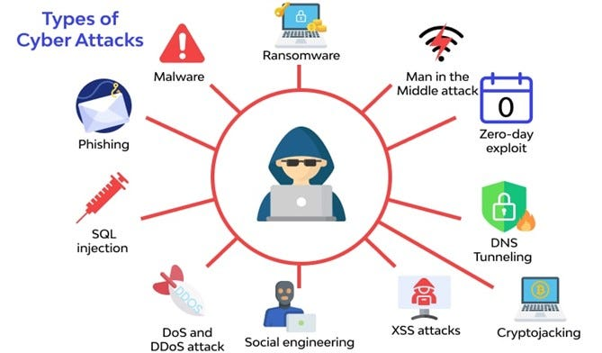
Figure 1: Threat Landscape Diagram
Source: [1]
Ransomware-as-a-Service (RaaS): Cybercriminals rent the ransomware to carry out attacks that can lead to encrypted data and a high ransom demand, disrupting operations and harming the firm's reputation [5].
Social Engineering: AI technologies can be used to improve attacks such as “voicelessing” and “spear phishing,” which rely on readily available personal data to send convincing messages that can lead to a breach of employee credentials and access to sensitive information [6].
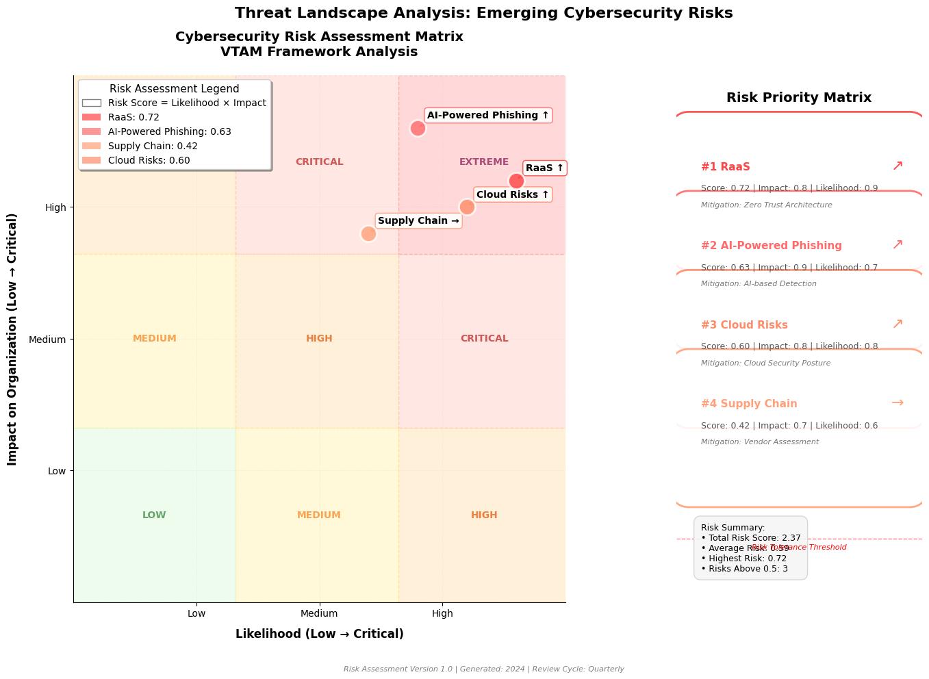
Figure 2: Risk Assessment Matrix
Source: Self-made
Supply Chain Compromise: Cybercriminals often target third-party suppliers to gain access to client systems, putting VTAM at risk of data theft or financial fraud, as seen in the SolarWinds breach [7].
Cloud Services and Hybrid Work Models: Adopting cloud services and hybrid models can pose risks, as cloud environments may not be secured adequately, potentially leading to unauthorized access and data breaches for VTAM [8].
Table 1: Threat Landscape
Threat | Impact on VTAM | Mitigation Strategy
Ransomware-as-a-Service (RaaS) | Data encryption, downtime, ransom demand. | MFA, Immutable Backups, Patching
AI-powered Social Engineering | Data breaches, credential theft, and financial losses. | Phishing Simulations, MFA, IAM
Supply Chain Compromise | Data theft, fraud, and reputation damage. | Vendor Risk Management, Micro-Segmentation
Cloud Adoption & Hybrid Work Risks | Unauthorised access, data breaches, and misconfigurations. | CSPM, Zero Trust Policies, MFA

3. Modern Security Policies Aligned with Zero Trust

Introduction to the Zero Trust Model
This course is designed to provide an introduction to the Zero Trust Model.
Zero Trust is based on the premise of "never trust, always verify," a philosophy in cybersecurity. The approach of Zero Trust is different from traditional perimeter security, which assumes that threats can infiltrate from the outside in. It requires constant verification of identity, devices and network traffic, anywhere in the world. This will decrease the risk of unauthorized access and provide a guarantee that every access to VTAM systems will be authenticated, authorized and encrypted [9].
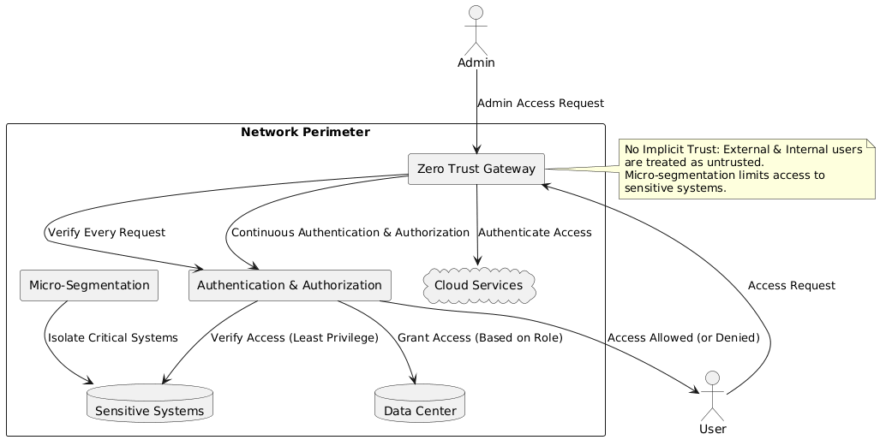
Figure 3: Zero Trust Architecture Diagram
Source: Self- made

Development of Security Policies for VTAM
Least Privilege Access
- Policy: Confidential systems and information will be limited to roles and responsibilities. The resources an employee, contractor, and/or third-party vendor needs to perform their job function will be made available.
- Rationale: This policy reduces the likelihood of insider threats; while also limiting the ability to breach security and give access to others, should it occur [10].
Identity and Access Management (IAM)
- Policy: Strong user authentication and authorization is put in place, including Multi-Factor Authentication (MFA) for all users, contractors and vendors within a robust IAM system. Access control will be implemented using role-based access control (RBAC) from VTAM's active directory or other identity management system.
- Rationale: IAM is a tool used to ensure that only those who have been verified are given access to the systems based on their role (as advocated by the Zero Trust principle), meaning that the right people get access to the right systems at the right time.
Micro-Segmentation
- Policy: VTAM's network will be segmented and isolated from each other according to sensitivity and functionality. Financial transaction data and payroll systems will be separated from less sensitive systems, among others.
- Rationale: Micro-segmentation restricts lateral spread of threats in the network. If one segment is breached, the other segments of the network are not vulnerable.
Continuous Authentication
- Policy: User will be continually authenticated during session. For high-risk operations and/or access to critical systems, other methods including biometric scans or One-Time Passwords (OTP) might be necessary [11].
- Rationale: Continuous authentication means that users are continuously authenticated during their session to prevent session hijacking or ensure the continuous security.
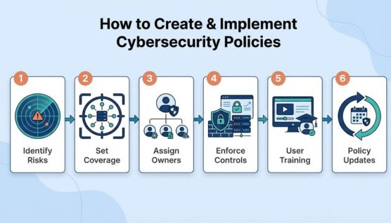
Figure 4: Cybersecurity Policy Implementation Framework
Source: [2]

Alignment with Frameworks
The proposed security policies are consistent with well-defined cyber security standards such as NIST Cybersecurity Framework (CSF) and ISO 27001 [12]. The Detect feature of the NIST CSF helps to enforce IAM and network segmentation, and continually monitors for abnormal activity, while the Protect feature helps to support policies such as least privilege access and IAM.
Table 2: Security Policies Aligned with Zero Trust
Zero Trust Policy | Implementation at VTAM | Link to Frameworks
Least Privilege Access | Role-based access, permission restrictions. | NIST CSF, ISO 27001
Identity and Access Management | MFA, RBAC integration. | NIST CSF, ISO 27001
Micro-Segmentation | Segment critical data and systems, restrict inter-network access. | NIST CSF, ISO 27001
Continuous Authentication | Periodic MFA challenges during critical actions. | NIST CSF, ISO 27001

4. Technical Mitigation Measures

Introduction to Technical Mitigation
- Multi-Factor Authentication (MFA): MFA will be required to access VTAM systems – more factors of authentication (password, smartphone, biometrics) means more risks of unauthorized access will be reduced [13].
- Security Information and Event Management (SIEM): SIEM systems will centralize security event data in real-time, enabling quick detection and response to network threats.
- Cloud Security Posture Management (CSPM): CSPM tools will monitor VTAM’s cloud environment, ensuring compliance and identifying vulnerabilities, crucial as the firm increases its reliance on cloud services.
- Immutable Backups & Patching: Immutable backups will thwart ransomware deletion and regular patching will eliminate vulnerabilities to minimize the risk of being exploited and ensure swift recovery from attack [14].
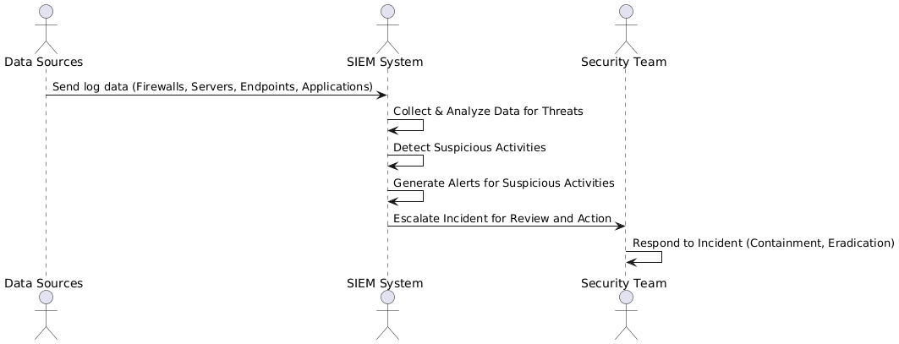
Figure 5: SIEM Process Flow Diagram
Source: Self-made

5. Proactive Monitoring and Incident Response
A 24-hour monitoring plan will be used to ensure that VTAM’s security infrastructure is constantly being protected. This plan will feature ongoing network, system and application audits for possible threats or security breaches. Logs, traffic and endpoints will be analyzed in real time, and all security data will be collected in a Security Information and Event Management (SIEM) tool. This will enable rapid detection of anomaly or threats, and prompt action. In addition, the monitoring system will be utilized to connect to Cloud Security Posture Management (CSPM) tools to assess cloud services for misconfigurations and/or vulnerabilities.

Tools and Techniques
- SIEM (Security Information and Event Management): IEM systems will gather and analyze real-time data from network devices, servers, firewalls, and endpoints. It will identify threats like unauthorized logins, malware or limited file access [15]. The centralized data will give the security team a full picture of the network activity and help them to identify and block threats quickly.
- SOAR (Security Orchestration, Automation, and Response): SOAR tools will automate incident response processes, seeing to it that a threat is detected, the response is immediate and effective. SOAR will be connected to SIEM to start automatic responses like quarantining compromised systems or filtering out malicious IP addresses, which will minimize response time and damage caused by attacks [16].

Incident Response Plan
VTAM will have an incident response plan that prescribes procedures for common incidents:
- Phishing: Employees report suspected phishing emails, which are then analyzed, and malicious domains are blocked.
- Ransomware: Systems affected will be isolated right away, data will be backed up and recovered.
- Data Breach: An investigation will begin, and those concerned will be advised to follow the rules such as GDPR.

6. Continuous Training and Awareness Program
In response to the increasing threats from cyber, VTAM will create a Continuous Training and Awareness Program. Regular phishing and vishing simulations will be conducted with this program to help employees learn to recognize and prevent phishing. These simulations will reproduce and reflect real-life scenarios as used by cybercriminals and feedback will be offered for strengthening the responses.
Training is to be provided to employees based on their roles, and various departments will have their own training needs [17]. IT and security personnel will be trained at an advanced level regarding incident response and malware analysis, and customer-facing personnel will have advanced training in how to identify phishing and social engineering attacks. Executives will also be trained in the importance of cybersecurity threats to enable them to make informed decisions on investing in cybersecurity.
Table 3: Continuous Training Program Schedule
Training Activity | Frequency | Target Audience
Phishing and Vishing Simulations | Monthly | All Employees
Role-Specific Cybersecurity Training | Annually, Refresher Every 6 Months | IT, Security, Customer-Facing Employees, Executives
Security Culture Workshops | Quarterly | All Employees
Micro-Learning Sessions | Monthly | All Employees

7. Conclusion
This report highlights the current cyber threats that VTAM is facing and suggests a course of action to implement security policies, technical controls such as MFA, SIEM and CSPM, and a strong incident response plan, all aligned with the Zero Trust model. The ongoing training program will help shape a security culture, making VTAM more resilient to cyber threats.

8. Bibliography
[1] O. F. Sanlialp, “Explain the threat landscape (Exercise),” Medium, Sep. 26, 2023. https://medium.com/@ofsanlialp/explain-the-threat-landscape-exercise-d37a7a99370e
[2] Cybersecurity Policies, “What Are Cybersecurity Policies? Types and Key Components | CloudSEK,” Cloudsek.com, 2025. https://www.cloudsek.com/knowledge-base/what-are-cybersecurity-policies
[3] A. S. George, T. Baskar, and P. B. Srikaanth, “Cyber Threats to Critical Infrastructure: Assessing Vulnerabilities Across Key Sectors,” Partners Universal International Innovation Journal, vol. 2, no. 1, pp. 51–75, Feb. 2024, doi: https://doi.org/10.5281/zenodo.10639463.
[4] A. Dalal, “Building Comprehensive Cybersecurity Policies to Protect Sensitive Data in the Digital Era,” SSRN Electronic Journal, 2025, doi: https://doi.org/10.2139/ssrn.5424094.
[5] J. Tamminen, “Cybercrime business evolved: A concept analysis of Ransomware-as-a-Service,” Jyx.jyu.fi, 2025. https://jyx.jyu.fi/jyx/Record/jyx_123456789_104807
[6] S. Singh, S. Jaiswal, and Snehlata, “A novel approach to combating social engineering attacks with AI-powered threat detection,” Artificial Intelligence and Sustainable Innovation, pp. 674–681, Nov. 2025, doi: https://doi.org/10.1201/9781003731689-99.
[7] J. Wright, “Healthcare cybersecurity and cybercrime supply chain risk management,” Sumdu.edu.ua, 2023. https://essuir.sumdu.edu.ua/items/736c34e3-b817-44a5-b178-7ed4fcab3feb
[8] N. H. Anh, “Hybrid Cloud Migration Strategies: Balancing Flexibility, Security, and Cost in a Multi-Cloud Environment,” Transactions on Machine Learning, Artificial Intelligence, and Advanced Intelligent Systems, vol. 4, no. 2, pp. 61–73, 2024. Available: View of Hybrid Cloud Migration Strategies: Balancing Flexibility, Security, and Cost in a Multi-Cloud Environment. Accessed: May 10, 2026.
[9] M. J. Khan, “Zero trust architecture: Redefining network security paradigms in the digital age,” World Journal Of Advanced Research and Reviews, vol. 19, no. 3, pp. 105–116, Sep. 2023, doi: https://doi.org/10.30574/wjarr.2023.19.3.1785.
[10] N. Khan, R. J. Houghton, and S. Sharples, “Understanding factors that influence unintentional insider threat: a framework to counteract unintentional risks,” Cognition, Technology & Work, vol. 24, no. 3, Oct. 2021, doi: https://doi.org/10.1007/s10111-021-00690-z.
[11] S. Ayeswarya and K. J. Singh, “A comprehensive review on secure biometric-based continuous authentication and user profiling,” IEEE access, vol. 12, pp. 82996–83021, Jan. 2024, doi: https://doi.org/10.1109/access.2024.3411783.
[12] M. Alshar’e, “CYBER SECURITY FRAMEWORK SELECTION: COMPARISION OF NIST AND ISO27001,” Applied computing Journal, vol. 3, no. 1, pp. 245–255, Feb. 2023, doi: https://doi.org/10.52098/acj.202364.
[13] K. Prasath Sivam, “Understanding the behaviour of business users in multi-factor authentication adoption,” Lutpub.lut.fi, 2025, doi: https://lutpub.lut.fi/handle/10024/169612.
[14] J. Koskinen, “Cloud Security Architecture,” www.theseus.fi, 2023. https://www.theseus.fi/handle/10024/798752
[15] A. R. Muhammad, P. Sukarno, and A. A. Wardana, “Integrated Security Information and Event Management (SIEM) with Intrusion Detection System (IDS) for Live Analysis based on Machine Learning,” Procedia Computer Science, vol. 217, no. 1, pp. 1406–1415, Jan. 2023, doi: https://doi.org/10.1016/j.procs.2022.12.339.
[16] U. Bartwal, S. Mukhopadhyay, R. Negi, and S. Shukla, “Security Orchestration, Automation, and Response Engine for Deployment of Behavioural Honeypots,” IEEE Xplore, Jun. 01, 2022. https://ieeexplore.ieee.org/abstract/document/9888808/authors#authors (accessed May 13, 2023).
[17] A. Kempf and S. Bengtsson, “Identifying Cybersecurity Training Strategies Across Companies: A Descriptive Study,” Lub.lu.se, 2024. https://lup.lub.lu.se/student-papers/search/publication/9152164

Appendix


