

Methods and Search Strategy Academic Poster

Student name: Sana Ahmed
Student ID: 2314455

Module name: Independent Project
Module code: BMHP6020
Socioeconomic and Cultural Factors Influencing Caesarean Section Rates and Experiences in the United Kingdom.
01 Introduction and Research Aim  This poster summarises the methodology adopted to investigate how socioeconomic and cultural factors influence caesarean section (CS) rates and women's experiences of maternity care in the United Kingdom. A desk-based secondary research approach was used to systematically identify, select, evaluate and analyse relevant academic literature (Aveyard, 2014; Booth, Sutton and Papaioannou, 2016). The methodology presented provides a transparent overview of the search strategy, study selection, source validation and thematic analysis undertaken to address the research aim. | 02 Search Strategy  A systematic search strategy was developed to identify relevant literature addressing the research aim. Following Aveyard (2014), the search process involved selecting appropriate databases, developing keywords and search terms, and applying predefined inclusion criteria to identify high-quality evidence relevant to the topic. Booth, Sutton and Papaioannou (2016) further informed the systematic approach to database searching and literature retrieval.  Electronic databases searched were PubMed, CINAHL, MEDLINE, Scopus, and Google Scholar. Keywords included "caesarean section", "caesarean birth", "socioeconomic factors", "deprivation", "cultural influences", "ethnicity", "women's experiences", "maternity care" and "United Kingdom". These were combined using Boolean operators (AND/OR) to improve the relevance of the search results. Filters were applied to retrieve peer-reviewed, English-language, UK-based studies published between 2016 and 2026.
Planning the Search:  Research Aim  To systematically assess how socioeconomic and cultural determinants influence caesarean section (CS) rates and women's experiences with UK maternity services, using an evidence-based approach.  Step 1: Identified key concepts from the research aim, including caesarean section (CS), socioeconomic factors, cultural factors, and women's experiences.  Step 2: Selected relevant databases (PubMed, CINAHL, MEDLINE, Scopus, and Google Scholar) to ensure access to high-quality health and social care literature.  Step 3: Developed keywords and alternative search terms, such as:  - Caesarean section OR caesarean birth  03 Searching for Information  - Socioeconomic factors OR deprivation  - Cultural factors OR ethnicity  - Women's experiences OR maternity experiences  - United Kingdom OR UK  Conducting the Search:  Step 4: Combined keywords using Boolean operators (AND/OR) to refine searches and increase relevance (Booth et al., 2016).  Step 5: Applied inclusion criteria including UK-based studies, peer-reviewed articles, English language publications, and studies published between 2016 and 2026 (Boland, Cherry and Dickson, 2017).  Selecting the Literature:  Step 6: Screened titles and abstracts to assess relevance before reviewing the full-text articles (Aveyard, 2014).  Step 7: Reviewed full-text articles to determine eligibility and extract relevant findings (Boland, Cherry and Dickson, 2017).  Step 8: Organised the selected literature into themes by identifying recurring patterns relating to socioeconomic inequalities, cultural influences, CS rates and women's experiences of maternity care using thematic analysis (Braun and Clarke, 2006).  Step 6: Screened titles and abstracts to assess relevance before reviewing the full-text articles (Aveyard, 2023). | 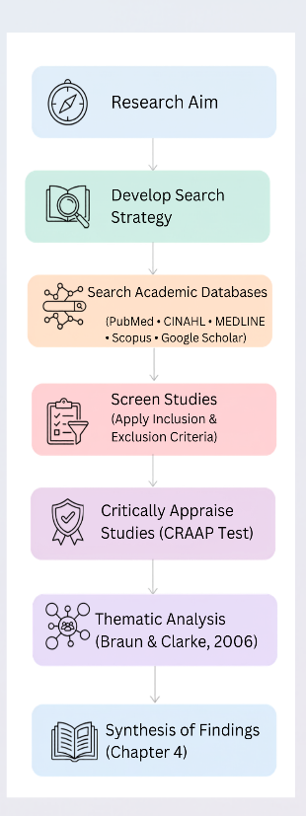  04 Picture/Graph/Visual Aid/ Statistics  Figure 1 illustrates the systematic methodology employed in this dissertation. The flowchart summarises the key stages undertaken to identify, select, critically appraise and analyse the literature. This structured process ensured that only relevant, credible and high-quality evidence was synthesised to address the research aim.  Figure 1: Research methodology flowchart adapted from Aveyard (2014), Booth, Sutton and Papaioannou (2016), Boland, Cherry and Dickson (2017), and Braun and Clarke (2006).
Research Validation:
Definition
Research validation is the process of assessing the quality, credibility and relevance of published literature to ensure that only reliable evidence is included within a literature review (Aveyard, 2014).

Importance:
Ensuring that the evidence included within this dissertation is credible and reliable strengthens the trustworthiness of the findings, reduces the risk of bias and supports evidence-based conclusions (Snyder, 2019).
05 Research Validation and Analysis

Research Analysis:

Definition
Secondary research analysis involves examining and synthesising findings from existing published literature to answer the research question (Aveyard, 2014).

Importance:
Braun and Clarke's (2006) thematic analysis was used to identify recurring patterns across the selected studies. Similar findings were grouped into broader themes relating to socioeconomic inequalities, cultural influences, CS rates and women's experiences of maternity care. These themes formed the basis of the findings presented in Chapter 4.

✅Benefit:
Structured framework for assessing source quality.

Limitation:
Relies on research judgement and cannot eliminate bias.

Study Characteristics:
- Full -text articles available through academic databases
- UK Based
- Qualitative Research
- Quantitative Research
- Mixed Methods

- Inclusion Criteria  Publication:  - UK Studies  - Between 2016 – 2026  - English Language  - Peer- reviewed | 07Exclusion Criteria  Publication:  - Before 2016  - Non – peer – reviewed Articles  - Non – English papers  Research Relevance:  - Papers that are not relevant to the research aim
08 Ethical Considerations
Study Type:
- Non – UK Studies
- Conference Abstracts
- Editorials / Opinion
- Dissertations
- Full text unavailable

Research Focus:
- Socioeconomic Factors
- Cultural Influences
- CS Rates
- Women’s Experiences

Ethics in secondary research involves the responsible and transparent use of existing published literature while ensuring accuracy, honesty and academic integrity throughout the research process (Aveyard, 2014).

References
Aveyard, H. (2014). Doing a literature review in health and social care: a practical guide. 3rd edn. Maidenhead: Open University Press.
Boland, A., Cherry, M.G. and Dickson, R. (2017). Doing a systematic review: A student's guide. 2nd edn. London: SAGE Publications Ltd.
Booth, A., Sutton, A. and Papaioannou, D. (2016). Systematic approaches to a successful literature review. 2nd edn. London: SAGE Publications Ltd.
Braun, V. and Clarke, V. (2006). ‘Using thematic analysis in psychology’, Qualitative Research in Psychology, 3(2), pp. 77–101. Available at: https://doi.org/10.1191/1478088706qp063oa (Accessed: 20th June).
Snyder, H. (2019). Literature review as a research methodology: An overview and guidelines. Journal of Business Research, 104(1), pp.333–339. Available at: https://doi.org/10.1016/j.jbusres.2019.07.039 (Accessed: 20th June).

