Digital Skills and Research Methods

Name: Nkechi Jefia

ID: 1714551

Lecturer: Renuga Jayakumar

Table of Content
Introduction....................................................
Modern Technology/suitable topic................
Technology 1...................................................
Technology 2....................................................
Social Media in Marketing................................
Safety and security...........................................
Conclusion........................................................

Introduction
The aim of this report is to evaluate the effectiveness of the use of digital modern technologies in the workplace used in daily life such as Smart devices and communication storage devices by comparing and contrasting the features of theses modern technologies. The digital modern technologies are now becoming an essential part of every person. Digital Technology is used to describe the use of digital resources to effectively find, analyse, create, communicate, and use information in a digital context. This includes the use of web tools, digital media tools, programming tools and software applications. (Quora, 2018). In focusing on this I will be evaluating the impact of social media in marketing and its effect in the workplace and creating my own professional online presence, For example Facebook online presence.
Different technologies used in daily life such as smart devices and storage devices
Smart devices: Smart devices are interactive electronic gadgets that understand simple commands sent by users and help in daily activities. Some of the most commonly used smart devices are smart phones, tablets, smart watches, smart glasses and other personal electronics. While many smart devices are small, portable personal electronics, they are in fact defined by their ability to connect to a network to share and interact remotely (Techopedia, 2018). An example of a Smart device would be smartphones such as IPhone, Samsung galaxy’s and LG as it has many advantages within the workplace. Advantages such as Productivity benefits in the workplace as the ‘bring your own device’ saves employees time and boosts productivity, connecting to a wireless internet network allows employees to be connected anywhere and are given the opportunity to complete tasks in ways that do not limit to sitting at the desk or office and also allows smooth communication such as making and receiving calls or checking and recording voicemails. However, disadvantages of smart phones in the workplace are that they could be used for unrelated work such as browsing the internet, social networking, tweeting or listening to music. This leads to smart phones being a major distraction in the workplace for employees and may prevent them from performing well in the workplace and lowering productivity.
Smart watches are another form of smart devices such as the Apple watch which also has its advantages. It makes tasks easier and more convenient boosting productivity; it solves problems quicker due to the immediate access to the internet and software applications which benefits both the workplace and its employees. Employee satisfaction is at the heart of the workplace and the right technology can raise the spirits of employees which can improve engagement in the workplace. But on the other hand, disadvantages of smart watches are that it can be a distraction because it is small, making it easier to use discreetly this can led to attention being taken away from important situations that may be going on within the workplace such as important meetings.
Storage devices: Storage devices are computing hardware that are used for storing, porting and keeping data files for long periods of time. Types of storage are Primary storage devices which are Hard disks, RAM and Cache memory these types of storage devices are often already on the computer and are seen as the standard type of storage due to the smaller capacity of memory that can be held. Secondary storage refers to both external storages such as USB and memory cards, internal storage such as cloud storage where data is maintained, managed, backed up and made available to users over the internet (Rouse, 2016). The most commonly used storages are dropbox and iCloud storages which is a new and improved way of storing information via the internet. Advantages of storage devices in the workplace are that it can be accessed on any device such as a laptop, smartphones and tablet and it is easy to transport and use for anyone who is not coherent in storage devices. However, disadvantages of storage devices in the workplace are that some may have a small capacity compared to other storages, some storage devices are very costly when it comes to purchasing large storage space and also storage devices have a limited life as they could expire at any time and the data/information could be lost but this type of issue is more commonly associated with traditional storage devices.

Features of the modern and digital technology tools
Smart devices | Iphone  The iphone is a Smartphone that is made and manufactured by Apple. It combines a cellular device, digital camera, iPods and computer in one device. | Percentage of people using the iphone  As of 2017, the amount of people using an iphone in the UK stands at 51.49% in Feb 2018, 52.85% in march 2018, 49.85% in April 2018 and 49.37% in may 2018. This means the percentage of people using iphone is almost half of the population in the UK. | Advantage and disadvantage  An advantage of iphone is the free service of Icloud which shares data, music, photos and contacts with all products. This allows the transferring of data between different products. For example, Iphone macbook.  Apple pay is a popular form of making mobile payments by just scan your finger over the home button.  Easiest phone to use as there are no learning curves. Iphone is easy for first time apple users.  Disadvantages of an iPhone could be that it may be used for other things that are not work related, for example social networking, tweeting or listening to music.  Smartphones such as iPhone could distract employees in the workplace and prevent them from performing well within the workplace and this may lead to low productivity.
 | Smartwatches  The Smartwatch is a ‘portable device’ that is designed to be worn on the wrist but have attributes of smartphones such as supporting apps and touchscreen features (Lifewire, 2018). | Percentage of people using smartwatches  Despite, the wearability of the smartwatches (such as the apple watch) the statistics show that from 2016 onwards only 7.9% people in Great Britain own a smartwatch. While 92.1% do not own a wearable device (Statista, 2017). | Advantage and disadvantage  Smartwatches make everyday tasks easier or more convenient and solve problems quicker which benefits both the company and its clients.  The right technology can often raise the spirits of employees. Employers will then see a significant uplift in the satisfaction and engagement.  However, disadvantages of smartwatches are that it can be a distraction due to its size and the ability to play with it discreetly. For instance, paying attention to the technology instead of the important meeting or deadlines that must be met.
Storage devices | Dropbox  Dropbox storage is an online storage where you can share and store projects and work at any size (big or small). These files are accessible from a range of different platforms computers, phones or tablets. | Percentage of people using dropbox  500 million users of current are using dropbox (Smith, 2018). Outside of the US there are 75% of dropbox users. | Advantage and disadvantage  Advantage of having dropbox as a personal cloud is because it is free. There are no additional charges. 2GB of storage is given.  It is easy to use and beginners can learn how to use it quickly. Dropbox being connected to the internet makes it even easier to use.  However, disadvantages of dropbox is the right that administrators or developers have to delete information for free, from accounts that are not active.  Security issues with dropbox include concerns with accounts being hacked and information being stolen.
 | ICloud drive  Similar to dropbox, iCloud is used for storage where you can upload, share and store documents and data. iCloud storage is managed by apple and is usually compatible with iPhones and MacBook’s. | Percentage of people using iCloud drive  Has more than 250 million active iCloud users (Appleinsiderstaff, 2013) | Advantage and disadvantage  Advantage of using iCloud drive lets you save files and application data.  Available on iOS devices, Macs and windows PCs this allows you to access all your files and data from any device.  Disadvantages is the cost after using the 5GB of storage, you will be paying around £0.79p a month. (is it really cost effective?)

Social media in marketing
Social media is a collective online communication channels dedicated to community-based input, interaction, content-sharing and collaboration (Rouse, 2016). Different types of social media platforms include Facebook, Twitter, Snapchat, LinkedIn, YouTube and Instagram. The impact that social media has had on the performance in the workplace and growth of businesses are very significant and has been a driving force for marketing. Both small and big businesses have benefited from social media and it’s many benefits from boosting brand awareness as a way to build a brand to helping businesses find their target audience (customers) as a way to start a conversation via social media making it a very powerful tool and also the ability to reach more people through social media as google search is no longer as useful as the latter. Aswell, as in business, social media has taken over aspects of the workplace because it has allowed for better communication and higher engagement but on the flipside negative connotations of social media can lead to a loss of productivity and a major distraction in the workplace.
Social media has revolutionized marketing in today’s society as a result the relationship between brands and consumers have changed a lot. Through, social media marketing businesses or even workplaces can figure out the likes and preferences of customers as well as the latest trends that may happen within society that will then be translated to social media. Social media has many benefits as a marketing tool from bettering customer service which allows businesses to respond to customer queries and concerns immediately or social media being a cost-efficient way of marketing and promoting a business. Facebook and twitter allows businesses to share their content for no extra cost making it an affordable advertising platform. Major advantages of social media marketing are the more inbound traffic that businesses will receive when putting content of the business on as many social media platforms as a range of customers have a different way of searching for products (Blue fountain media, 2016). A disadvantage of social media marketing is the attraction of spammers and internet trolls (phpyouth, 2017), as social media attracts all types of audience both bad and good. Also, social media marketing requires time to execute as social media marketing is a consuming activity as 64% of digital market users spend around 6 hours on social marketing. (phpyouth, 2017).

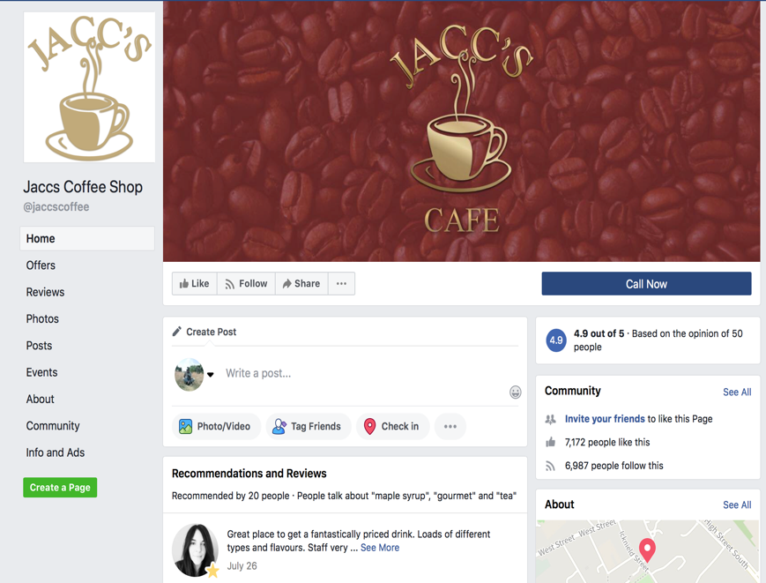
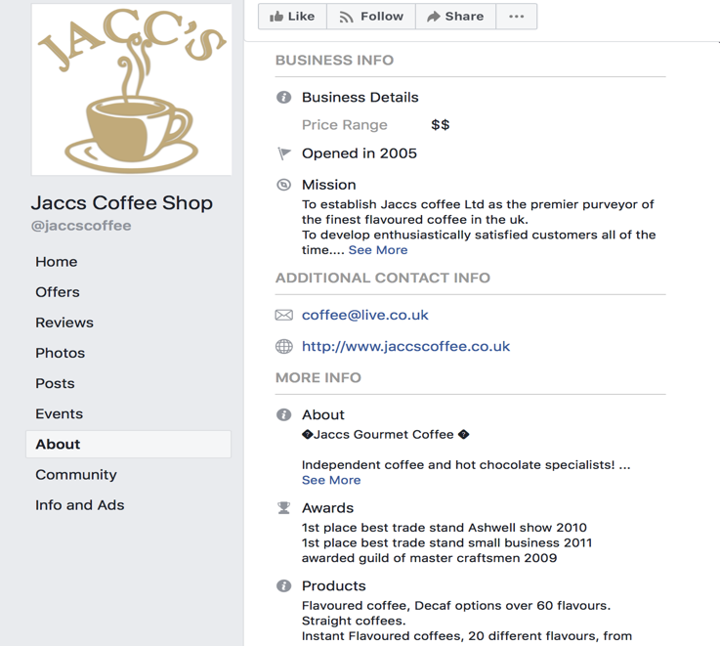
Social media marketing has enhanced businesses like Jaccs Coffee shop, who utilize social media platforms like Facebook to help grow and improve their business. Facebook has a feature where businesses are able to create their own page allowing them to make use of the Business information section, additional contact and more information (in this Facebook business page the owner has demonstrated the ranges of accolades that the business has received). This improvement in Facebook has given businesses the opportunity to optimize the social media platform to bring brand awareness and build a respectable target audience in this case those who are lovers of coffee or coffee shops.

In conclusion, this report has aimed to highlight and evaluate the effectiveness of the use of digital modern technologies in the workplace and in businesses used in daily life. Looking at the range of examples given, from smart devices such as smartphones to storage devices such as iCloud file storage (also known as iCloud drive) and dropbox, it is clear that the use of modern technology is very essential and has an ability to enhance a person. Aswell, as Social media platforms such as Facebook, Twitter and others are important features in the way everything on the internet is marketed from businesses, as a result that is why big businesses such as McDonalds and Starbucks are now using social media as a way to market and connect with customers on an informal level. Social media has changed the way that people now search for information and has made a way for more consumer consumption.

References
https://lifewire.com/an-introduction-to-smart-watches-3441381
https://searchstorage.techtarget.com/definition/cloud-storage
https://whatis.techtarget.com/definition/social-media
https://www.quora.com/What-are-digital-technologies
https://www.slideshare.net/Devon26/smartphones-and-their-impact-on-the-workplace-education-and-social-engagment
https://www.statista.com/statistics/236550/percentage-of-us-population-that-own-a-iphone-smartphone/
https://www.statista.com/statistics/271195/apple-ios-market-share-in-the-united-kingdom-uk/
https://www.techopedia.com/definition/31463/smart-device
https://www.thearmadagroup.com/it-infrastructure/the-pros-and-cons-of-allowing-personal-devices-in-the-workplace

