Marketing Fundamentals Analysis and Evaluation
Assessment 1

ZARA-Marketing Analysis
(Individual Report)

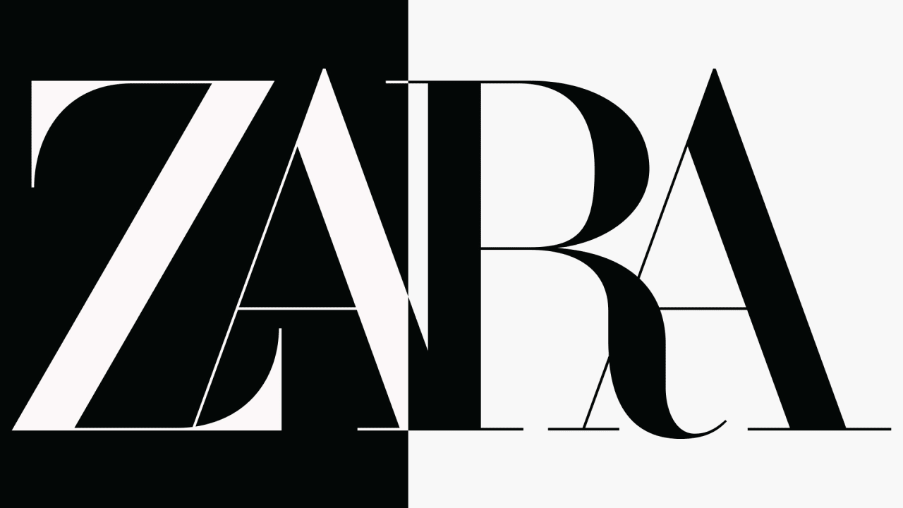

Yani Yanakiev
1920744
BABM LEVEL 4 GROUP 1
Lecturer: Tushara Balendran
25.08.2020

Contents:

Introduction……………………………………………………………………….. 3
1.Processes and stages of marketing, including the role of the marketing mix.
(Definitions and diagram) ………………………………………………………... 4
1.1 SWOT Analysis-advantages and disadvantages …………….……………….. 5
1.2 Porters five force-advantages and disadvantages ……………………….…… 7
1.3 Marketing segmentation, targeting and positioning process……………….… 9
1.4 Marketing Mix-Analysis …………………………………………………….. 10
Conclusion …………………………………….………………..……………….. 11
References …………………………………….…………………………..…….. 12

INTRODUCTION:

Marketing is the process of getting potential clients or customers interested in your products and services. The key word in this definition is "process"; marketing involves researching, promoting, selling, and distributing your products or services. This discipline centres on the study of market and consumer behaviours and it analyses the commercial management of companies in order to attract, acquire and retain customers (hopefully instilling brand loyalty) by satisfying their wants and needs. (Cyberclick)
Marketing is a cleaver, Inventive and effective way to promote the sale of a product or brand through extensive research and brand management, to ensure the correct endorsement of the product(s).

ZARA is a brand that was created by Amancio Ortega and Rosalía Mera in 1975. ZARA is a family-owned brand that was founded in Spain and who's target market is young, price-conscious, trendy and who's brand has a distinct advantage over other traditional retailers in the market, due to the fact that they are not defined by their target or segmenting age. This gives them a much broader market.
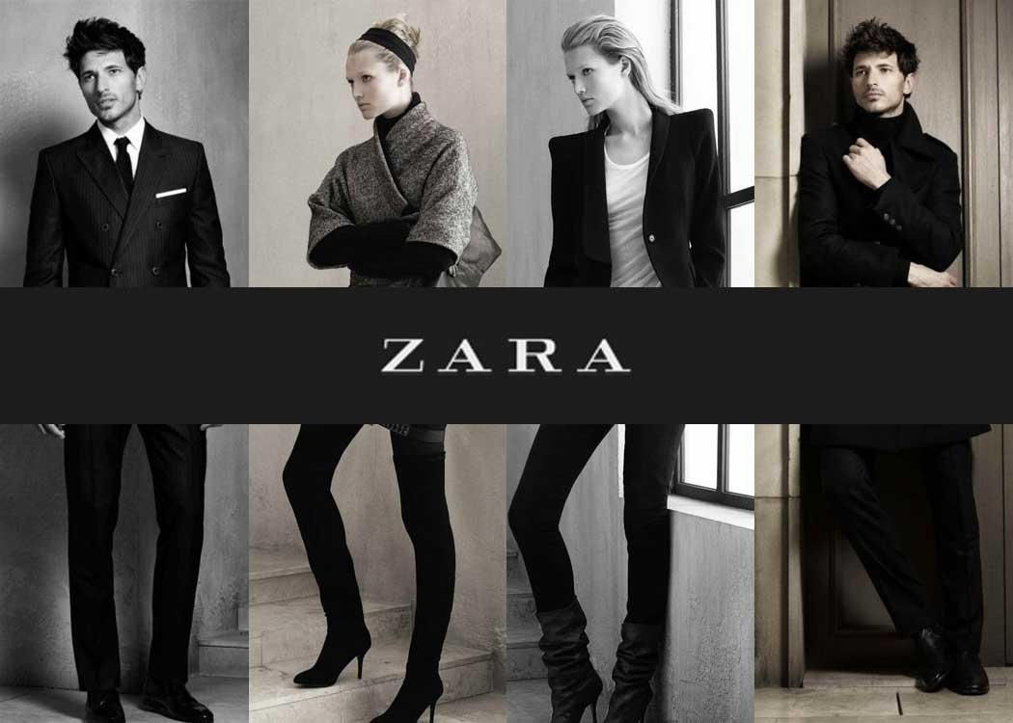
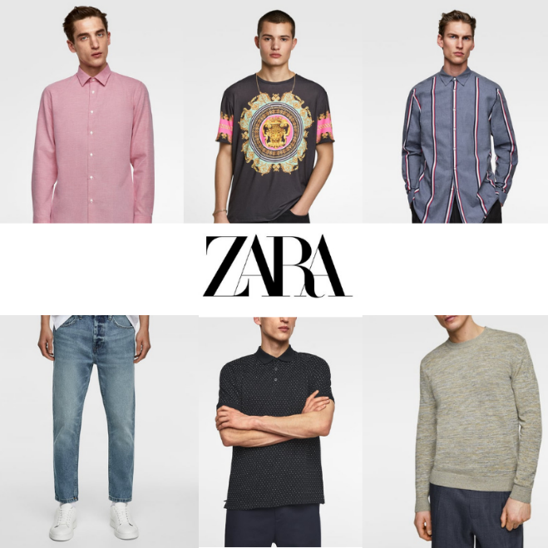

1.Processes and stages of marketing, including the role of the marketing according to ZARA.

Definition of Marketing Process
Marketing is a step by step process which allows companies to analyse strategies and marketing opportunities to promote their brand. This allows the brand to be able to appeal to a certain type of person or demographic that will best suit their product and/or services. To achieve the best results, companies must regularly monitor their findings and results in order to complete the best strategy plan for their customer's needs.

Below is a diagram outlining the five stages of the process that is used in strategic marketing planning. (Fig 1)
Mission

Situation Analysis ​

Marketing Plan

Marketing Mix

implementation and Control.

(Fig.1 Source: Yani Yanakiev)

Situation analysis:
A situation analysis is a collection and evaluation of the past and present economical, political, social, and technological data. It is aimed at identifying the internal and external factors that can influence the brand and organisation's performance and marketing strategies. It also assesses the organisation's current and upcoming weaknesses, opportunities, strengths and threats. Some examples of situation analysis are SWOT, Pestel and Porter Five Forces.
I will be focusing on two models, SWOT and Porters Five Forces.

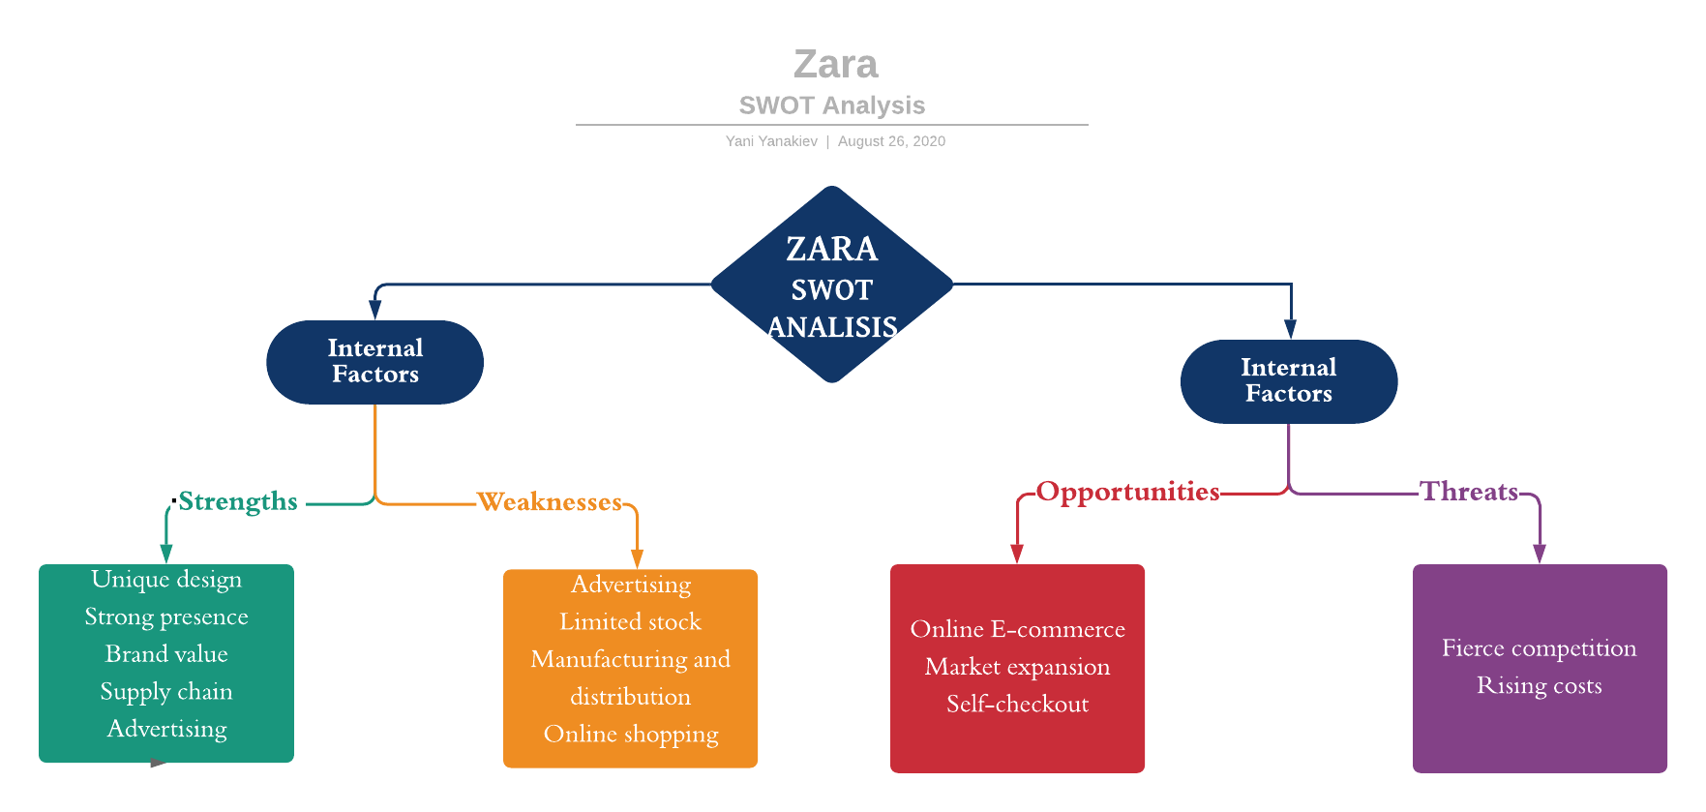
  - SWOT analyses – The SWOT analysis provide a framework for analysing strengths and weaknesses (internal), and opportunities and threats (external). It helps to focus on strengths, to minimise weaknesses, and to take the greatest possible advantage of opportunities available. (Pahl and Richter 2007 p.4)

(Fig.2 Source: Yani Yanakiev)

- Internal Factors
    - Strengths
Unique design – there is a lot of different type of designers in Zara which are understanding the brand and Zara customers in a different way. In the end, there a few models, and each one is with superior quality and elegant. The finished products have a different variety which is including office and party wear, for men, women and kids.

Strong presence – Zara is known around the world and present a strong sale in each country. Zara is expanding the brand on different markets and open new stores each year, which generates a huge revenue each year.

Brand value – Zara brand is ranked under number 41 by Forbes, with a total value of 14.7 billion dollars. The quality of Zara product was proven over the years and boost the brand. During the years, Zara is trying to stay away from arguments and humbles, which is a successful strategy.

Supply chain – The consumers are visiting the stores often because they know that Zara has the latest fashion trends and changing their collections more often from their competitors. After products are designed, it takes 2 weeks to be in Zara stores, and for their competitors, it takes more than 6 weeks to bring the latest designs in their stores.

Advertising – Zara is one of the companies which doesn't spend a lot on adverting. Their brand doesn't need from advertising. People know the brand; they know the product quality and doesn't need from the introduction.

- Weaknesses
Advertising – As I said above the Zara advertising is one of the strengths, but there is also have a weakness. Zara can double its profit if they start advertising their products which their competitors do.
Limited stock – One of the main Zara weaknesses is that they have low inventory in their stores and if the customer wants to buy a size which is out of stock have to wait to be delivered to the store and collect it on the next day, or the customer has to buy it online.
Manufacturing and distribution – the brand has only one manufacturing and distribution centre.
Online shopping – The brand doesn't provide online shopping to its customers in some countries. They have physical stores but not and online once.
- External factors
- Opportunities

Online E-commerce – That will be a good opportunity for Zara if they make available their products not only in their online stores but to other e-commerce stores.

Market expansion – The company can expand the brand to the Asian market.

Self-checkout – Zara has to invest more in self-checkout services which will be easier for the employees and for the customers, especially in those pandemic times.

- Threats
Fierce competition with brands like H&M, River Island, Bershka, Top Shop, etc.
Rising costs – expensive workers, expensive raw materials, government taxes
An economic recession or new lockdown can impact the purchasing power in stores.

  - Porters Five Forces – The five forces model is an essential tool for understanding the competitive structure of an industry. This simple analytical tool is effective for identifying the competitors- in the broad sense- of a company, but also for understanding how they can reduce its ability to generate profit.
The complete analysis examines five forces: customer bargaining power, supplier bargaining power, the threat of substitute products, the threat of new entrants, and intra-industry competition. (Michaux and Cadiat, 2015, p.6)

Fig.3 Source: Yani Yanakiev:
Competitive Rivalry
Threat of New Entry
Threat of Substitute
Buyer Power
Supplier Power

- High Supplier Power
Zara is using vertical integration to be sure that the whole supply chain is working smoothly and control the process. The fashion industry is growing fast; suppliers must be monitored closely, be more flexible and to react quickly. The production and design teams are cooperating and working with limited materials which can limit the creativity but eliminate the delays from suppliers to deliver the goods.
- Moderated Buyer Power
Zara has created a variety of apparels and accessories which providing to their customers. The price must be reasonable because there is a tendency of decreasing of the loyal customers and which are attracted more from good quality and lower price than good quality and high price.
- High Competitive Rivalry
The company has a few big competitors such as H&M, Gap, etc. which closely monitoring Zara and their products. Every wrong step or strategy can cost a lot to Zara and to give a big opportunity to the competitors to go further. The brand has to keep a good reputation, or otherwise, they can lose loyal customers and positions.
- High threat of new entry
The force of new companies entry is high because the apparel and retail are very profitable, unique and attractive. There is a lot of big brand on the market which are fighting for customers, lower the product prices and make it hard for new entrants. Zara already established the brand name on the market and which makes difficult the new brands to enter.
- Threats of substitutes
Zara has a loyal customers base, which is returning again and again to attract new customers; they have to do something more and to stand out from their competitors. That's why Zara include in their collections handmade and vintage elements which make them different. Duplicates of styles are often in the industry and which can also attract new customers. This doesn't have to be a barrier and also can attract more customers. There is a possibility to lower the quality, but the clothes must be with extremely bigger similarity with the originals.

1.3 Marketing process
- Segmentation
Zara is using a collaboration between demographic, geographic and psychographic segmentation strategy.
Demographic segmentation includes customers age, gender and income. Zara is focusing on customers between 20 and 40+ years old. Zara main target is a fashionable woman and classic men. Zara is a brand which is preferred from women's which would like to look well at their workplace or for a night out. Men's prefers Zara because the apparels are not too extravagant but trendy.
Geographic segmentation is used to divide the markets depending on the geographic areas such as cities, countries and regions.
Psychographic segmentation dividing the customer's groups by lifestyle, value and interests.
- Positioning
The company providing and position the brand into the young group of customers who love high fashions at a low price. The price is crucial for customers. The physical company stores are located on significant locations which usually are the high streets next to their competitor, but the difference between Zara and the other brands are most likely visual such as well-designed showcases. The power of the brand needs to be shown, and that's what Zara is doing.
- Targeting
The main Zara customer target is the customers interested from the high fashion, not too extravagant, elegance, affordable and in line with the latest fashion trends. The company is changing their in-store collections on every 4-5 weeks, which allow the customers to turnover. The target is the young people hungry for fashion, to look good and to be individual.
- Objectives
Zara objectives are to increase the size of their store in the large cities and to increase the customers. The company is focusing on removing the chemicals from the supply chain and putting donation boxes in the stores.

1.4 Marketing mix elements
- Product
The brand is offering a huge variety of products with a different design, and all the time, they are trying to improve their product quality. Zara is now focusing more over the recyclable, greener and cleaner fashion products. With this move, Zara is trying to help in the fight with climate changes and at the same moment is adapting new investors and customers.
- Price
Zara is providing to the customer's high fashion clothes at lower prices. Their products can be purchased from different income range of people and affordable for every pocket. Zara applies psychological price strategy, which can be seen on their price tags. Most of their prices are ending on 99, and they mainly use this strategy when they have sales.
- Place
The company is positioning their stores on commercial streets, around offices or places where the people are often passing and spending their free time. The company stores look almost the same, their apparels and accessories are in the same order, divided by floor levels and which is really helpful for their clients.
- Promotion
The brand is making specific promotions every year, such as clearance sales and Christmas sales and other campaigns depending on the country. The company is not spending a lot on advertising their product. The brand is not using any famous celebrity or models to advertise their product. The brand is concentrated over outdoor marketing and people reactions. If the product is good enough, will be recognised or people will find from where to buy it – Zara.
- Implementation
Zara marketing plan is using different marketing tools to minimise the risk in their business and to maximise the profit. The plan and the primary tasks need to be clear and agreed with the management implementing all in the required process and procedures to reach company goals.
- Control
In every organisation must have control of the whole production process, raw materials quality and the resources spend for them. If the control is implemented correctly, the manufacturing expenses will be less, and the profit will be more significant.

Conclusion
In those days it is good to be different, and Zara proof this! Thanks to the different thinking and vision, Zara is one of the leaders on the clothing market. Their stores are inspired by the customers and their needs. Zara is an innovator on the market, designers who are working for the brand must be encouraged, creative, and the product at the end to be with high quality. The advertising is almost "zero", and that's one of the strong company strategies. Their product doesn't need to be advertised because Zara is well known from the consumers. They are developing a new product more often then their competitors and the customers visit the stores more often.
The company is controlling the whole process from the choosing of the raw materials, designs, supply chains to the distribution process and store displays/showcases.
Zara target group is young people who want trendy clothes at affordable prices. The loyal customers are many and expecting the brand to stay as it is and respond to the customer requirements.

References:
Cyberclick, Marketing: What is Marketing? What it is and how is works.
Available at: https://www.cyberclick.net/marketing (Accessed:10/08/2020)

Inditex
Available at: https://www.inditex.com/about-us/our-brands/zara?p_auth=QU6UuwjF&p_p_id=buscadorportlet_WAR_buscadorportlet&p_p_lifecycle=1&p_p_state=maximized&p_p_mode=view&_buscadorportlet_WAR_buscadorportlet_javax.portlet.action=buscar
(Accessed: 18/08/2020)

Forbes (2020) Zara 27th July, Forbes
Available at: https://www.forbes.com/companies/zara/#e5c103d74877
(Accessed: 20/08/2020)

Michaux S. and Cadiat A. (2015) Porter's Five Forces Brussels: Lemaitre Publishing

O'Marah K. (2016) Zara uses supply chain to win again, Forbes, 09th March
Available at: https://www.forbes.com/sites/kevinomarah/2016/03/09/zara-uses-supply-chain-to-win-again/#2ac1865e1256
(Accessed:20/08/2020)

Pahl N. and Richter A. 2007 SWOT Analysis- Idea, Methodology, And A Practical Approach Norderstedt: Druck und Bindung: Books on Demand GmbH

Ross L. (2020) How the Zara Supply Chain Taps into Top Clothing, Retail Trends
Available at: https://www.thomasnet.com/insights/zara-supply-chain/
(Accessed:26/08/2020)

Sarsby A. (2016) SWOT Analysis England: The Leadership Library

Sword A. (2020) 'Zara owner says supply chain flexibility "pivotal" in reducing Covid impact', Internet Retailing, 10th June
Available at: https://internetretailing.net/operations-and-logistics/operations-and-logistics/zara-owner-says-supply-chain-flexibility-pivotal-in-reducing-covid-impact-21533
(Accessed:25/08/2020)

Zara
Available at: https://www.zara.com/uk/en/z-company-corp1391.html?v1=11112
(Accessed:25/08/2020)

ZARA LOGO
https://www.brandknewmag.com/zaras-new-logo-may-be-the-future-of-branding-love-it-or-hate-it/#prettyPhoto

ZARA PIC 1
https://blog.healyconsultants.com/zero-zara-secret-fast-fashion/

ZARA PIC 2
https://www.fashionstock.hu/latest-offers/params/post/1729134/

