

Domestic violence in a policing context
By Jacob Parkinson
Student number: 2023962
BSc (Hon) Professional Policing Practice
Acknowledgements:
I would like to thank my partner Danielle for her constant support during this degree as it has given me the motivation to push through during the difficult times.
I would also like to thank my tutor Fay Cosgrove for her support and guidance as this was vital to helping me complete my studies.
Declaration
This work has not previously been accepted in substance for any degree and is not being concurrently submitted in candidature for any degree.
Signed: Date:08/10/2023
Statement 1 – This dissertation is being submitted in partial fulfilment of the requirements for the degree of BSc.
Signed: Date:08/10/2023
Statement 2 – This dissertation is the result of my own independent work/investigation, except where otherwise stated. Other sources are acknowledged by footnotes giving explicit references. A bibliography is appended.
Statement 3 – I hereby give consent for my dissertation, if accepted, to be available for photocopying and for interlibrary loan, and for the title and summary to be made available to outside organisations.
Signed: Date: 08/10/2023
Statement 4- I hereby give consent for my dissertation, if accepted to be available on the university’s IT system to those who have consent to use the system.
Signed: Date: 08/10/2023

Abstract
This paper examines domestic abuse in a policing context and examines the different types of abuse that victims can suffer as well as the aftercare that they receive after their interactions with the police.
The paper also looks at the police response to domestic incidents and the evolution of how they have dealt with it through the years.
A questionnaire was made and sent to specific groups of people who had some form of experience with domestic abuse whether it would be on the policing side, victim side or those who specifically deal with victims of domestic abuse in charities.
The paper also looks at certain famous cases of domestic abuse to examine how the police responded to these and highlights the failures that have occurred in these famous cases.
Table of Contents
- Introduction . . . . P4
- Literature Review . . . . P5
  - Introduction . . . . P5
  - A Brief History of Domestic Abuse . . . . P5
  - What is Domestic Abuse? . . . . P6
  - Coercive or Controlling Behaviour . . . . P6
  - Physical Violence . . . . P6
  - Domestic Abuse During the Covid-19 Pandemic . . . . P7
  - The Evolution of Domestic Violence . . . . P7
  - Aftercare . . . . P7
  - The Cycle of Domestic Abuse . . . . P8
  - Tension . . . . P8
  - The Incident of Abuse . . . . P8
  - The Honeymoon Phase or Reconciliation . . . . P8
  - Calm . . . . P8
  - The Policing Response to Domestic Violence . . . . P9
  - Claire Throssell Case . . . . P9
  - Sally Challen Case . . . . P9
  - Conclusion to Literature Review . . . . P9

- Research Methodology . . . . P11
3.1 Introduction to Research Methodology . . . . P11
3.2 Quantitative Research . . . . P11
3.3 Research Design . . . . P11
3.4 Strategy . . . . P11
3.5 Sampling Groups . . . . P12
3.6 Data Collection . . . . P12
3.7 Ethical Considerations . . . . P12
3.8 Conclusion to Research Methodology . . . . P13

- Results and Analysis . . . . P14
4.1 Introduction . . . . P14
4.2 Profile of Participants . . . . P14
4.3 Gender . . . . P14
4.4 Types of Domestic Abuse . . . . P15
4.5 Involvement in Domestic Incidents . . . . P16
4.6 Effective Response to Domestic Incidents . . . . P17
4.7 Aftercare Response . . . . P17
4.8 Adequate Aftercare and Collaboration . . . . P18
4.9 Training and Evolution . . . . P19
4.10 Famous Cases . . . . P21
4.11 Further Information . . . . P22

- Findings, Conclusions and Recommendations . . . . P24
5.1 The Police Response to Domestic Violence . . . . P24
5.2 Aftercare Reviewed . . . . P24
5.3 Adapting to the Change . . . . P24
5.4 Famous Cases . . . . P25
5.5 Conclusion . . . . P25
5.6 Recommendations . . . . P25
5.7 Targeting Specific Police Officers . . . . P26
5.8 Collaboration . . . . P26
5.9 The Media and Famous Cases . . . . P26
5.10 Conclusion . . . . P26
6. Bibliography . . . . P27
7. Appendix . . . . P32

- Introduction
This research will examine the policing response to domestic abuse incidents and cover the different aspects of how the police approach them as well as the aftercare involved for victims of domestic violence and the different types of domestic abuse.
One of the main type of incidents that police officers deal with is domestic related calls and this is a priority area of focus for every police force due to the high risk and high volume of calls that they deal with (College of Policing, n.d.). Domestic abuse is an issue that comes in different forms and is something that can be more than physical violence, in recent years there has been an increase in sexual abuse financial abuse and more recently coercive control. The damaging effects of abuse can be the same in different types of abuse in terms of how they affect a victim (Plumptre, 2022).
The policing response to domestic violence is something that has rightfully become more of a priority as time has passed by due to it being recognised as a serious issue that puts its victims in a place of danger and this has been highlighted in many cases that are considered to be famous. The issue with cases of domestic violence that are highlighted in the media is that they tend to show the police in a poor light as famous cases of domestic violence are usually famous for the wrong reasons, however this is not always the case as highlighted in the case of Kiranjit Ahluwalia (Baksi, 2019), where she was released from prison after it was discovered that she was the victim of horrific abuse at the hands of her husband who she had married in an arranged marriage.
This study will also look at the aftercare that is provided to victims of domestic violence and how it supports them through and after domestic abuse. The police collaborate with different organisations that support vulnerable people who require help and this is what is usually referred to as multi-agency referral where different organisations come together and collaborate to support victims of crime or specifically domestic abuse during these MARAC (Multi-Agency Risk Assessment Conferences) which look to provide safeguarding for those in need (SafeLives, n.d.).
The aim of this study is to look at how the policing response is perceived from both within the job by gaining an opinion from police officers who work within the realms of domestic violence daily, victims of domestic violence who have sadly experienced this type of behaviour and those who support victims from within the charities that are aimed at domestic abuse survivors. Policing domestic violence is something that sadly continues every day and it is very important that the police work to their best to constantly improve their standards and learn the patterns of behaviour that will allow them to effectively combat domestic abuse and work alongside different organisations that can support the victims of domestic abuse.
Objectives
- To see if the police provide an effective response to domestic related incidents.
- To evaluate the different types of domestic abuse and see if people are aware of them.
- To explore if the police treat domestic violence more seriously than in previous years.
- To explore the collaboration between the police and how they approach the aftercare of victims of domestic violence.
- To research famous cases of domestic violence and the polices involvement in these.

- Literature Review

  - Introduction to Literature Review
Policing domestic violence is something that has become a lot more prominent in the public’s attention in recent years due to it gaining attention in the media (Jefferies, 2022). The role of a police officer in recent years has demanded that they are well informed with how to deal with domestic abuse and recognise the signs of a person that is being domestically abused (GOV.UK, 2020). During this study I will be reviewing literature that supports the topic I am writing about.
The way that policing has progressed in recent years has led to domestic abuse becoming recognised and understood to a higher level, which has led to a huge increase in the reports of domestic related violence and this could be due to several reasons with them being an increase in the quality of policing regarding domestic violence, the focus on recording crimes relating to the issue and the confidence of victims of domestic related violence increasing due to the campaigns that the police would run regarding the issue (HMICFRS, 2019). The PEEL inspection was an annual report that basically assessed how each police force in the United Kingdom was performing in terms of effectiveness, efficiency and legitimacy, which includes how they effectively deal with domestic violence (HMICFRS, n.d.).
The constant change in the subject matter of domestic abuse demands that an effective policing response matches that specific change in domestic violence in terms of more incidents of it being reported. The police also face challenges such as underreporting of domestic incidents and people who refuse to engage with the law enforcement agencies such as the police, which is why the policing response to these incidents must be done in a manner that encourages victims to come forward and feel comfortable speaking to people who can help them whether it be the police or other third-party support agencies.

  - A Brief History of Domestic Abuse
To start I will be providing context around the subject and a history of how the subject has evolved. Domestic violence has evolved in many different ways since the inception of the police force and despite it only being recognised as a serious problem in recent history, abuse was once something that was supported or even justified (betterhelp, 2023). This topic was something that mainly involved men abusing women, but it has become a lot more common against men in recent years although the statistics still say that it is more common in women (NCADV, n.d.). Domestic violence is more prominent in being perpetrated against women due to how the world wrongfully perceived them in previous times and laws supported the use of domestic chastisement, and this was prevalent during the 1800s where the offences against a person act 1861 (Legislation.gov.uk, n.d.) was introduced. Despite the introduction of that law judges did little to nothing to support women who were victims of domestic abuse.

  - What is Domestic Abuse?
In 2013 a new definition for domestic abuse was introduced by the government to include younger people at the age of sixteen and seventeen, which addressed the concern that younger people experience domestic abuse and not just those eighteen years old and over (NPCC, 2013). Prior to 2013 it only covered those over eighteen years of age. Abuse on minors under the age of sixteen are covered by other laws such as the Children and Young Persons Act 1933 (Legislation.gov.uk, n.d.) where it makes it an offence to assault a child. Abuse can come in many forms such as insults or name calling, physical violence such as punching, kicking and spitting, sexual violence, attempts to control how you act or behave and emotional manipulation.

2.4 Coercive or Controlling Behaviour
There are different categories of abuse, such as coercive control which is a relatively new offence and is something that was campaigned for by women’s aid to make it an offence, which they successfully managed to do. (Women's Aid, n.d.). Coercive control is something whereby the aggressor makes the victim dependant on them by isolating them from all kinds of support and depriving them of any form of independence. Coercive control is now viewed as an offence by the government and due to their support of the Women’s aid campaign they did this in 2015 and they explain that it relates towards the psychological and emotional abuse more than physical (GOV.UK, 2015). The campaign to make coercive or controlling behaviour an offence came from the rise in reports related to domestic abuse and since coercive or controlling behaviour was made an offence there were just over 7,000 arrests made, but this resulted in just over a thousand of these being charged as the majority of cases would end up being dropped by the victim (BBC, Cowling P, 2018). This form of domestic abuse requires a more in-depth investigation due to the nature of it as in some cases it may have happened for several years and therefore a longer investigation may be required as there will be more outstanding enquiries and it may involve several family members who have witnessed this.

2.5 Physical Violence
This type of domestic abuse relates to the physical abuse of a victim, and this can include abuse such as hitting, pushing and punching and in severe cases choking and burning, and this type of violence can show up as bruises, black eyes, broken bones and even fatigue. There are many warning signs that can lead to physical abuse such as damaging property, threatening to harm animals. Some victims tend to be embarrassed when it comes to physical violence and can attempt to conceal this by making excuses and dressing in clothing that hides the bruising, they have (National Centre for Domestic Violence, n.d.). The issue with physical violence is that once a perpetrator commits this type of abuse, they are highly likely to repeat this behaviour as is the same with coercive control. Physical violence can sometimes lead to serious injuries being sustained by victims and in some cases it has led to the death of a victim. Physical abuse is something that the police have acted on and are trained to deal with effectively at the scene when responding to a domestic related incident, a positive approach is usually the way forward as they look to safeguard the victims from the perpetrator and investigate the incident to ensure that the victim is protected at all costs (College of Policing, 2015).

2.6 Domestic Abuse During the Covid 19 Pandemic
The covid 19 lockdown had a huge effect on an increase in services being used during the early stages of the pandemic and this could have indicated that people who were already in domestic violence based relationships experienced an increase in this due to spending more time around their abusers (Rushton, 2021). The numbers related to incidents reported between March and June, which were the early months of the lockdown were 7% higher than in the previous year 2019 (Office for National Statistics , 2020). The police record incidents relating to the general term of domestic abuse rose and this was mainly aimed at incidents that were recorded as domestic related incidents, but that is not to say that the amount of reports regarding domestic incidents that resulted in injury went down, because there was an increase in this as well as standard domestic related incidents (BBC News, 2020). The pandemic unfortunately made a lot of victims of domestic abuse or violence feel trapped in their own homes, which is why it was vital for the police force to work alongside several different organisations to recognise those in need (HMICFRS, 2021). The police were wary of how the lockdown would affect those who are currently trapped in a domestic violence-based relationship, because it would be more difficult for them to seek support and escape the relationship, however there was an increase in so-called lower level domestic related incidents, which was more than likely due to the stresses of the pandemic creating tension between couples that were usually not in a relationship that involved domestic violence and this could be due to the fact they had to spend more time with each other therefore creating a more hostile environment (Women'said, 2021). Despite the increase in low level domestic related incidents the police were expecting a surge in high-risk subjects of domestic violence after the pandemic due to the aggrieved parties feeling as if they had more freedom to speak about the violence.

  - The Evolution of Domestic Violence
Domestic violence or abuse is something that has become a bigger priority for the police as time has passed and this is due to changes in policy and comprehension in society as well as advocacy by women’s movement groups as explained in (Matczak, et al., 2011), some of these support groups who advocate for better support such as women’s aid who continue to push for awareness regarding the evolution of domestic violence and support victims accordingly.

  - Aftercare
Aftercare when dealing with any form of domestic violence is important to provide victims with the knowledge that they can safely disclose any form of abuse so that it can be dealt with effectively by the services that strive to support them such as the police, charities and even the NHS who can direct a victim to the services themselves (NHS, n.d.). The collaboration between the police and domestic violence related organisations is of the utmost importance when combatting the issue itself as it creates an evens stronger wall of support for victims, such as cases where victims may be unwilling to disclose information to the police, but fine to disclose these issues to support groups such as women’s aid and the domestic abuse matters programme which aims to effectively train police officers to deal with these issues to a high level (SafeLives, n.d.). Aftercare provides victims with the safeguarding that they need and deserve after they have experienced domestic abuse.

2.9 The Cycle of Domestic Abuse
Domestic abuse is split into four different stages that will allow people to be able to clearly understand how people ill behave when they are in an abusive relationship or are observing one, there are four stages that are involved in the cycle of domestic abuse. The concept of this began in the 1970s in a book entitled “The Battered Woman” (Bottaro, 2022).

2.10 Tension
This is the stage where the tension towards a domestic incident builds over time and external factors can have a big impact on how the abuser begins to act towards their partner such as work life, family issues or physical illness. The tension period is where the person who is being abused may take steps to try and stop this tension from building by making attempts to please the abuser and this may make them feel as if they are “walking on egg shells”, and this can sometimes delay the tension but unfortunately when it is a part of the cycle of domestic abuse it is inevitable (healthline, n.d.).

2.11 The Incident of Abuse
This phase is where all the tension from the abuser is released resulting in the abuse itself. The incident can range from small to severe, but always involves the abuser taking their tension out on their partner. This incident almost always involves the abuser blaming the person for this behaviour and making them feel bad for their outburst, the abuser can also attempt to isolate the person from family members or friends (Center4research, n.d.).

2.12 The Honeymoon Phase or Reconciliation
Following the main incident tends to come what is known as the honeymoon phase and this is after the building of tension towards the incident itself and post incident where the abuser attempts to apologise and may lavish them with gifts and appear genuinely ashamed of their behaviour, which can be a tactic to get the person who is being abused to forgive them, this can result in the abuser acting in a romantic way or supportive in an attempt to apologise. All of the actions within this phase are usually attempts to from the abuser to get the person who is being abused to give them another chance (PsychCentral, n.d.).
2.13 Calm
The calm phase is where the abuser will make attempts to justify their behaviour and could potentially blame their behaviour on external factors such as work or stress. This period has no timeframe and depends on the abuser and how often the abuse occurs, it can be as little as a few hours for this phase to pass by, but during it they will attempt to make excuses for their behaviour and lull the person into a false sense of security until the cycle restarts (domesticviolence.org, n.d.).

2.14 The Policing Response to Domestic Violence
One of the most important ways to combat domestic violence is through a policing response, because they are usually first on scene for any incidents regarding the subject matter, however, there have been many famous cases that have highlighted a need for improvement within the police. The college of policing are constantly looking at ways they can improve and learn from specific cases of domestic violence, and it is important they do so in an effective way to be able to reduce domestic violence.

2.15 Claire Throssell Case
In 2014 the two sons of Claire Throssell were killed in a house fire started by her abusive ex-partner Darren Sykes who was their father after he was granted five hours of unsupervised access to them by the courts after a custody battle (Oppenheim, 2020).
Throssell had been involved in an abusive relationship with Sykes and was against him having contact with them due to him being a domestic abuse aggressor for several years during their sixteen-year marriage, when they eventually separated the police were called on a few occasions after Sykes had sent threatening texts (Vanapalli, 2021). Despite a policing response to this concerning behaviour Sykes was still allowed unsupervised contact with his children, which sadly led to their deaths at his hands. Throssell is now a staunch advocate for women who have been domestically abused and has campaigned for a change in the way custody battles are handled.

2.16 Sally Challen Case
In 2011 Challen was convicted of killing her husband Richard after forty years of psychological abuse. In 2019 she was granted a retrial after new evidence suggested that Challen was the victim of coercive control after her son led a campaign for her release (Wilson, 2019).
This case served as a catalyst for recognising coercive control as a form of domestic abuse, which would help services such as the police recognise it going forward, however there are still issues with the offence being correctly recorded, which can have a poor effect on those who want to report it if they feel it is not being effectively handled (Challen, 2020).

2.17 Conclusion to Literature Review
In conclusion, this literature review explains domestic abuse in a policing context and explains the most known process that a domestic abuse aggressor goes through when they are abusing a victim.
Policing domestic violence has always been a topic of discussion because of how the understanding of the subject matter has increased in recent years, however there are still several high-profile cases which have involved the victims sadly dying due to a lack of support specifically in the Claire Throssell case.
The most productive manner to combat the ever-changing nature of domestic abuse and the different types that the police must research different and effective ways to minimise domestic abuse by increasing engagement with victims and making it easier to access support for those who struggle to seek it or are in some cases stopped from doing so.
Finally, I would say that the police are making positive steps to combat domestic violence, however there is still a long way to go before this subject is tackled effectively.

- Research Methodology

  - Introduction to Research Methodology
This section of this dissertation will outline the approach that will be used to investigate the main objectives within this study, which involves domestic violence in a policing context. The data collection will involve the method of a questionnaire, which is the most effective way to compile the data that is required to answer the questions that relate to the research objectives of this study due to it being easily accessible and most efficient way of looking at the data. There are many different types of research styles that can be used such as interviews, however on this occasion the most efficient way of collecting data is through the use of a questionnaire due it being an effective approach of collecting data and the most efficient method of collecting data. Research methodology is explaining how the data has been collected and what methods have been used to collect it and creates a sense of reliability and validation in the study (Scribbr, 2022), and this will be done by aiming it towards specific participants. Using a questionnaire will enable to collection of what is known as quantifiable data that will be collected and analysed from a range of variety of people with knowledge from inside and outside of the police force.
  - Quantitative Research
Quantitative research is a research method that allows for the collection of data that is structured in the form of a questionnaire or survey and the data is usually collected in numbers from a diverse range of people that can range from those who have experience in the study or none at all whereas a qualitive design would be looking to gather data that is non-numeric, which would be useful if there were specific cases to study. The aim of quantitative research is to be clear from the outset what is expected so that it can assist in the analysis of the results when the data has been collected (Imperial College London, n.d.), which will assist the collection of data in this study.
  - Research design
The approach to this will involve a quantitative style one to enable a response that will be large in numbers, which is a benefit of quantitative research (Grand Canyon University, 2021). The questionnaire includes questions based on the study of domestic violence and how people feel about the current state of how it is dealt with in a policing context. This approach is necessary for this study due to the ability to be able to reach a broad and diverse range of people, but also including a small number of people from within the police force as they have experience with the subject matter.
  - Strategy
The strategy that will be deployed is one that provides a lot of time for a person to access this by giving them a two week window to submit their answers and I will be ensuring that people have some form of experience with the subject matter of domestic violence in a policing context from a person who works within the policing organisation as they have direct involvement with the subject matter itself on a regular basis, domestic violence advocacy organisations who deal with victims and finally victims of the subject matter, however there will be no names provided by them to ensure their information is not shared.
  - Sampling groups
The sampling strategy will be important in providing the answers that will fulfil the objectives of the study and provide an accurate account of how people feel about the subject matter of domestic violence in a policing context. Purposive sampling (Dudovskiy, n.d.) is a strategy that will be used due to the importance of people having some knowledge of the matter to be able to provide answers that will assist with the research objectives, however the purpose is to maximise the diversity of perspective, so there will be other groups that are not involved within the policing organisation, but the target is to select a specific group who have dealt with the subject matter (Mcleod, 2023) . The sampling groups I will aim to use are as follows:
- Police officers
I believe this is an important perspective to gain due to the subject matter being of a policing context and domestic violence is something that police officers deal with on a daily basis and are specially trained in how to deal with the matter effectively. This is a necessary group for the study to gain other perspectives.
- Members of third-party organisations that deal with domestic violence.
This is a group that will provide an opinion that may differ from the previous group and is important to gain another perspective from a group that deals directly with victims after they have experienced domestic abuse.
- Victims of domestic violence
This is the group that will be carefully chosen and their identities will remain anonymous due to the nature of the questionnaire which will not include any personal information on any level. I believe this is necessary because it will provide an insight from the most important group associated with domestic violence due to them being the group that requires safeguarding and their opinion on the subject matter is the most important in providing information on the matter.

  - Data Collection
The data collection will involve a structured questionnaire that will serve as the primary data collection tool. The questionnaire itself will include questions that relate to the topic of domestic violence and how it is perceived in a policing context from groups that are on different sides of the subject matter and as explained in the sampling section of this. The questionnaire will contain both open ended questions that allow the participants to give their opinion on the matter and close ended to ensure they understand the different forms of domestic abuse.
The questionnaire will be distributed electronically from google forms.
  - Ethical Considerations
The subject matter of domestic violence is one that includes a vast amount of vulnerable people, which is why it is of the utmost importance to ensure that those who consent to take part in this study, do so with a full explanation of what the study is about and a guarantee that their information will not be used and any person who takes part in this will not be named.
  - Conclusion to Research Methodology
In conclusion this survey is necessary to compile data that relates to the subject matter and will assist in providing an unbiased outcome due to the groups involved dealing with different sides of domestic violence.

- Results and Analysis

  - Introduction
The purpose of the questionnaire was to ask questions relating to domestic violence and how it is perceived in a policing context. The questionnaire was created by using google forms as it was the most efficient tool to be able to gather information, which would assist in answering the questions related to the subject matter of domestic violence in a policing context.

  - Profile of Participants
The participants were specifically targeted to people who have either been involved in a domestic incident in some capacity or had dealt with people who have been involved in domestic incidents.
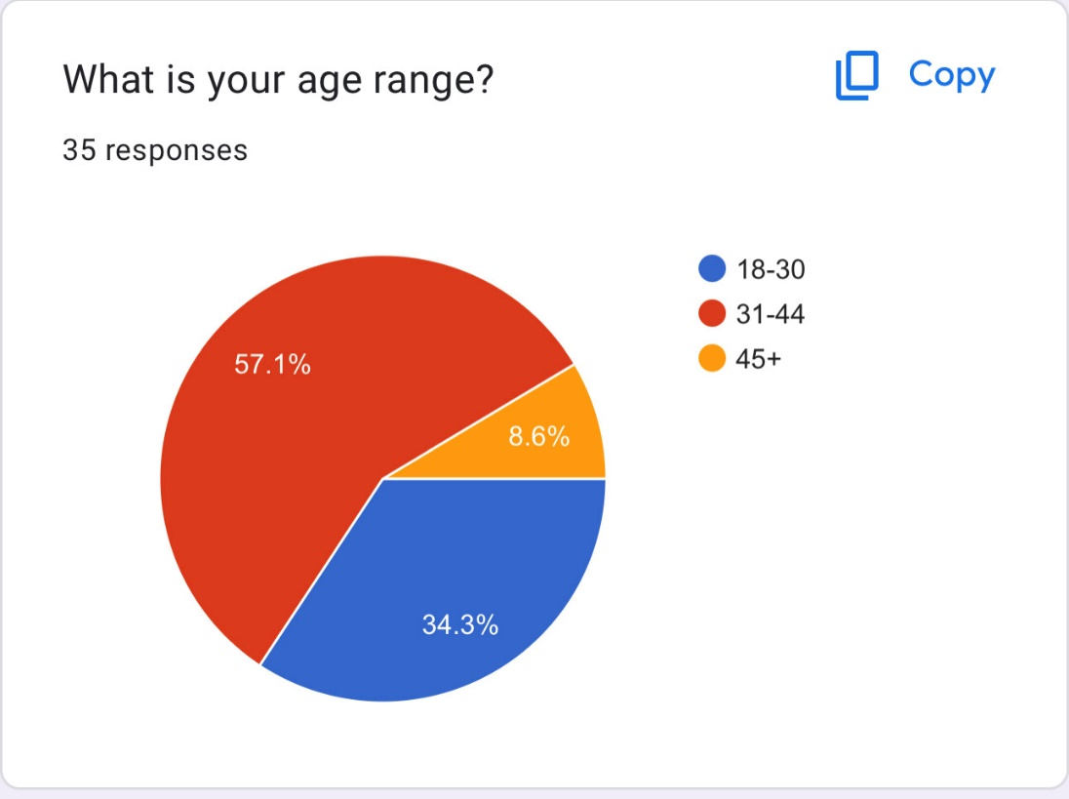

The opening question relates to age and as you can see the majority fall into the 31-44 age category.
  - Gender
No specific gender was targeted for this due to the nature of domestic violence being something that can cover all genders.
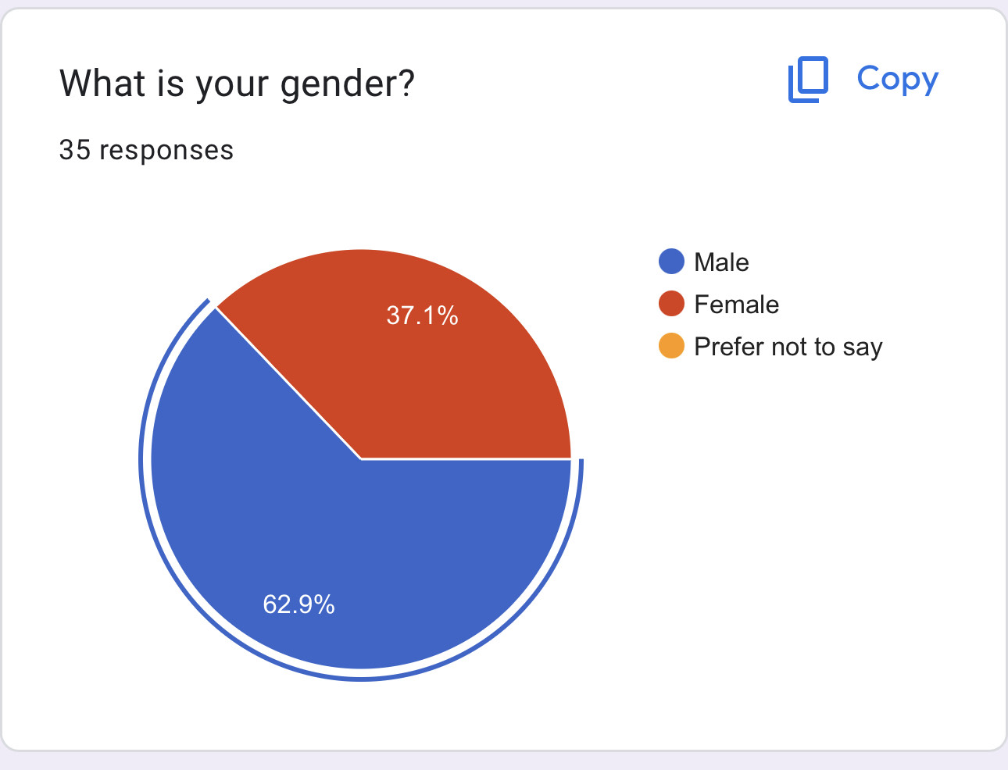

The results show that most of the participants were male and this was not specifically targeted as the participants were chosen by their experience with domestic violence, although there were significantly more female participants who had been the victims of domestic violence.
4.4 Types of Domestic Abuse
The third question of the survey was a question to show each participant understanding of the different types of domestic abuse.
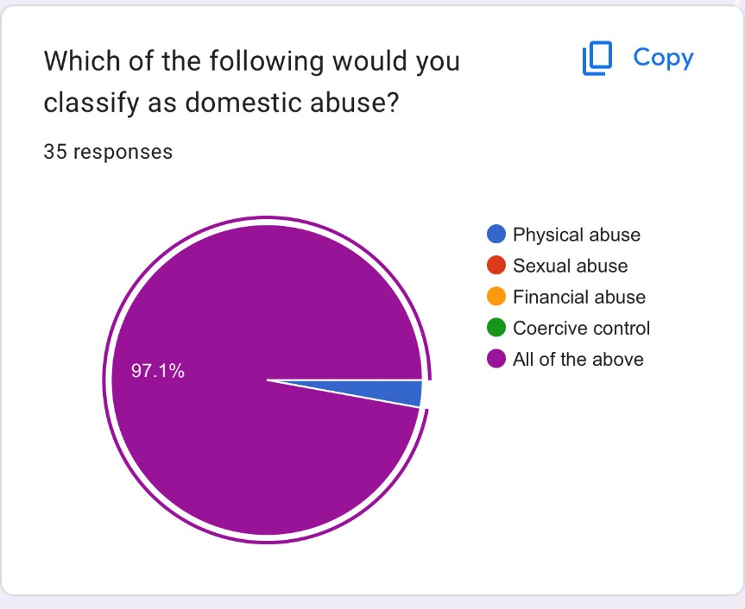

The results show that every participant understood that every answer was a form of domestic abuse.
4.5 Involvement in Domestic Incidents
The next question was to gauge if any of the participants had been involved in a domestic incident in any capacity.

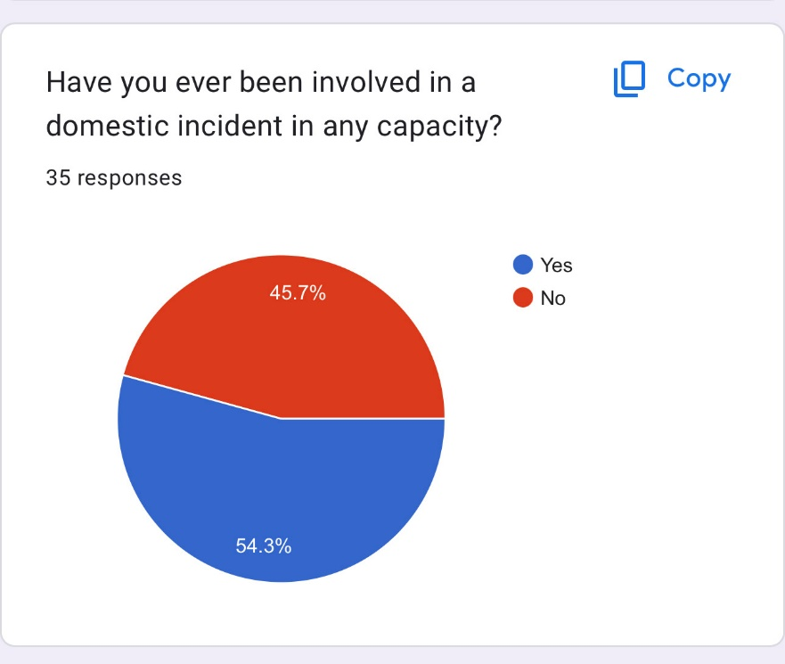
The majority of the participants answered yes to this, but not by a large margin and this is due to some of the participants either misunderstanding the question or the fact that some of the targeted groups were either police officers and assumed this question was aimed at their personal life or the other group being those who work with victims of domestic violence and have experience of dealing with them, but not being involved in an incident themselves.

4.6 Effective Response to Domestic Incidents
Due to the subject matter being domestic violence in a policing context the next question was related to whether the participants thought the police provided an effective response to domestic incidents and this question was designed to be broad so that the participants would not have to think about to many aspects of the side of responding to incidents and the aftercare. The response showed that the participants strongly believe that the police provide an effective response to these incidents.

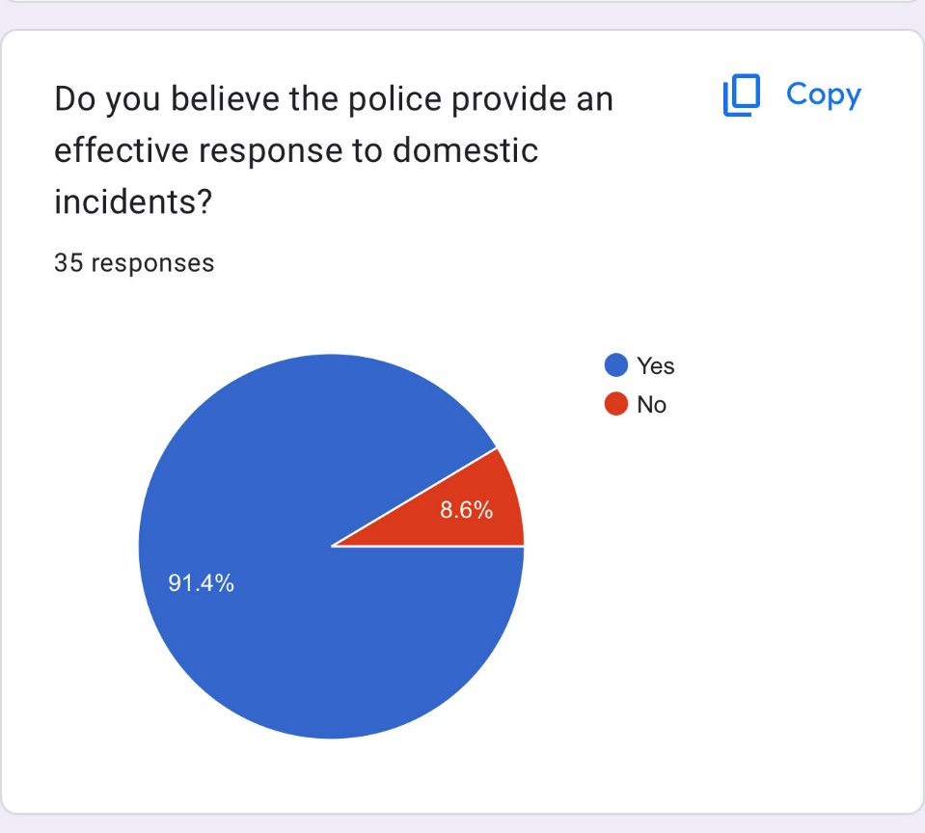

  - Aftercare Response
Almost 80% of the participants were aware of aftercare, which is probably because most of them are involved with the police or charities in some way.
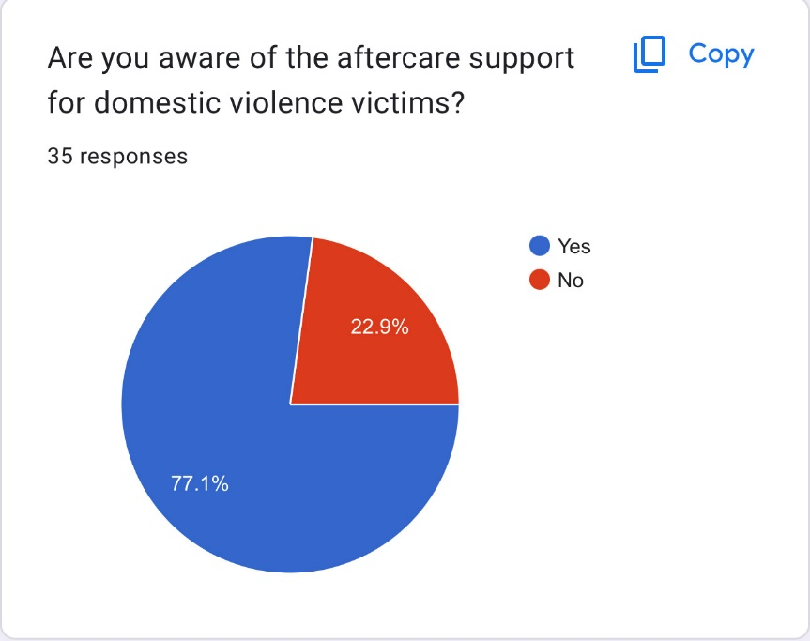

The 22% category is related to the victims of domestic violence who are solely involved with the charity and have not had the experience of dealing with the police.

  - Adequate Aftercare and Collaboration
The next question as aimed at asking the participants if there was adequate aftercare provided by the police themselves and as you can see most of the participants said yes, but that there was room for improvement.
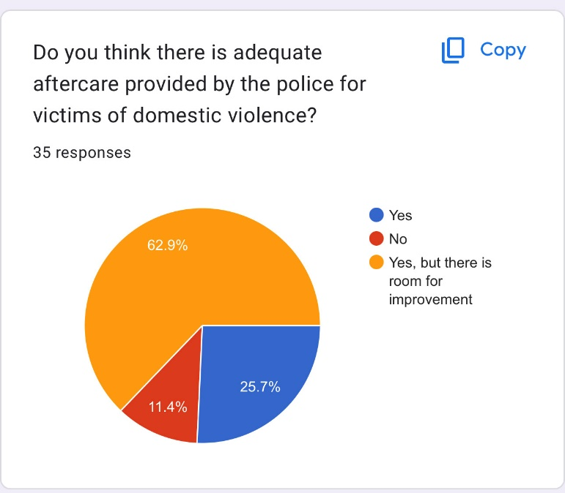

This is more than likely due to the ever-changing nature of domestic violence and could be due to the stress of emergency service workers struggling with lack of support and low numbers. The room for improvement could be due to some victims feeling as if they have had a negative experience from the police like in this article from the guardian where victims who are specifically female have felt ignored by the police (Topping, 2021).

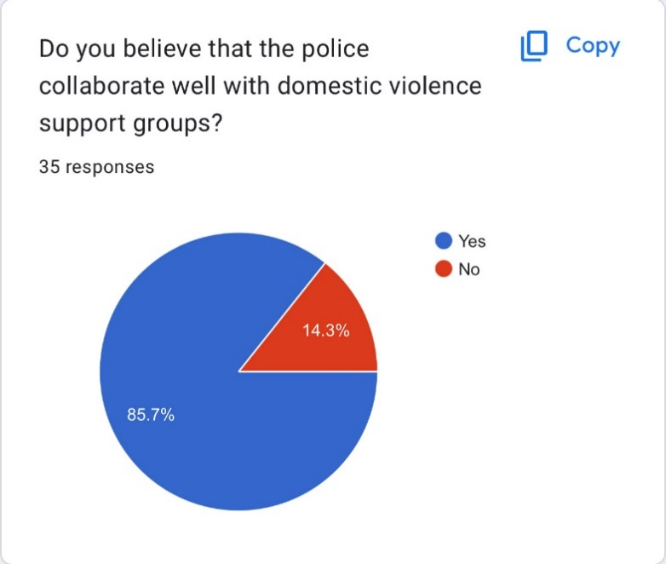

Those who answered no to the question above were victims that were involved with the charity I spoke to and contacted the charity themselves as opposed to the police organising it.
  - Training and Evolution
The next question as related to whether the participants believed the police were sufficiently trained to deal with all forms of domestic abuse with them being the types of abuse from the earlier question and this result could be due to the amount of effort the police have put into improving their services when regarding the response to domestic abuse incidents as highlighted in (HMICFRS, 2019).

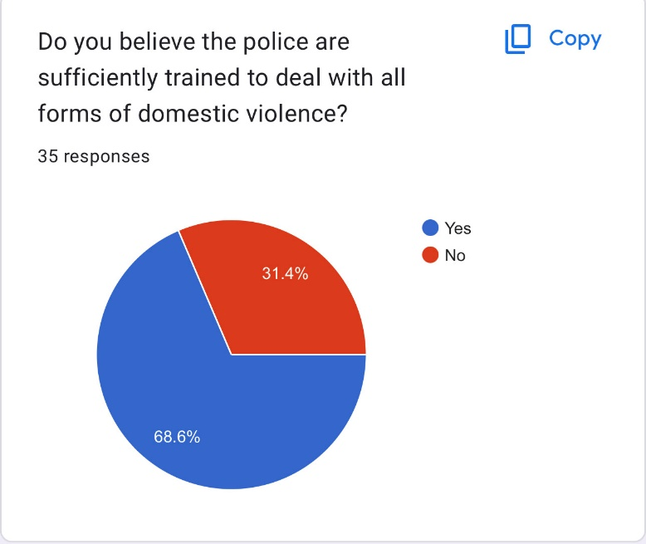

The no category is surprisingly responses provided by some police officers as well as the people related to the charity, this could be due to the police officers having extra knowledge of how the training is conducted.

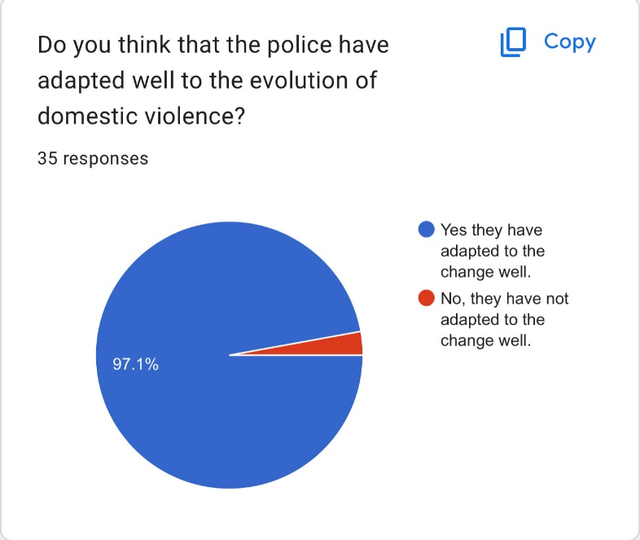

The no category is very smll and was provided by a member of the charity and this could be due to their knowledge of dealing with the police referrals.
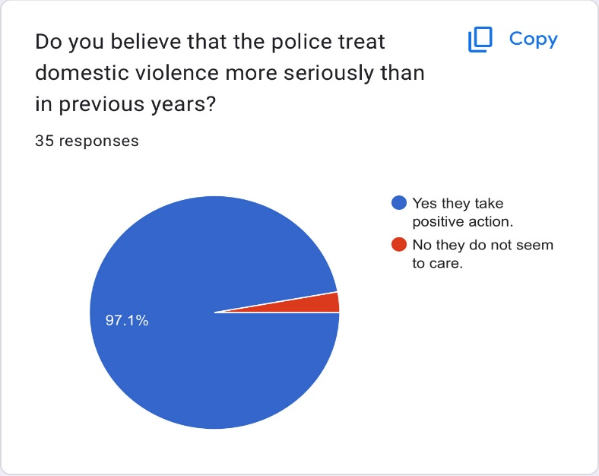
The no category contains a response from one of the victims who has more than likely had a poor experience with the police.

  - Famous cases
The participants were asked the question of whether or not they kept up to date with famous cases of domestic violence with the answers being if they were interested in how the police dealt with them, if they were interested but not regarding the police involvement and finally no.

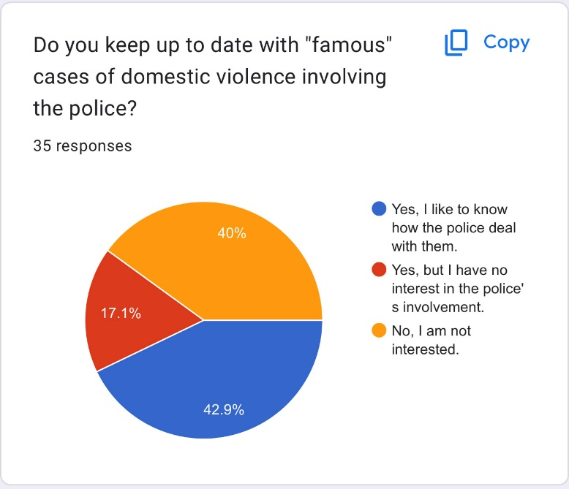

The purpose of this was to see which of the participants were interested in the famous cases, because the cases of domestic violence that are usually high profile mean that the police have either failed to miss, such as in the case of Jeanette Goodwin where the police failed to respond urgently (The Guardian, 2012). Most of the participants not interested were in fact police officers and this could be due to them being exposed to domestic violence daily.
  - Further information
The final question was to see if the participants wanted to add anything further, so I have picked out two of the most informative from either side of the participant groups.




This is from one of the victims who says that there is a major room for improvement and that they have had a bad experience with some police officers. A single bad experience can affect a whole persons view of the police for life.
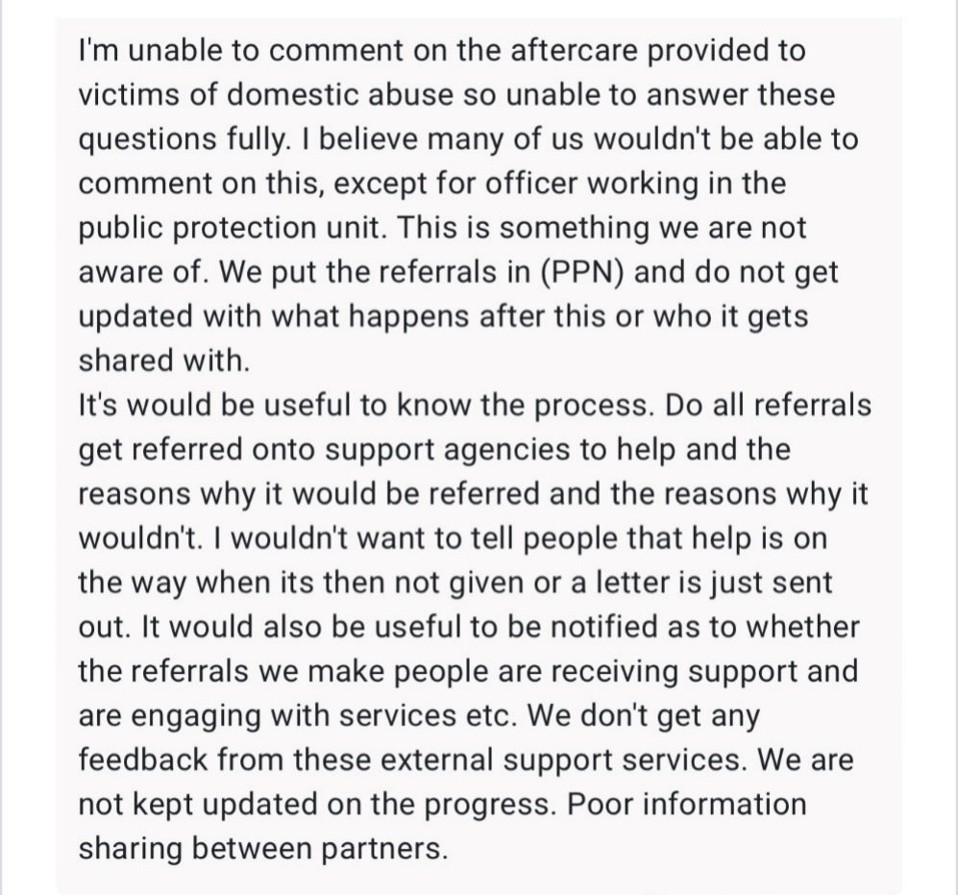

This is an in-depth account from an officer who is questioning the aftercare process and says that there is no communication between partner agencies and the police, which is frustrating. They then state that it would be useful to receive a notification that the referral is helping people, which is a valid take.

- Findings, Conclusions and Recommendations
Domestic abuse will sadly always be a major issue that exists within the policing world and this study is unfortunately something that is not going to solve the issue of it, but the main aim was to look at how it is perceived in a policing context from different sides of the subject such as victims, police officers and those who support victims.
5.1 The Police Response to Domestic Abuse Incidents
The fact that domestic abuse is such a topic of relevance in modern day society means that the police will rightfully have to address the issue with utmost importance and combat it to the highest level, which has been an issue in recent years despite the steps the police have taken to improve their services there has been times where the media have talked about the failings of domestic violence victims such as (Cooper, 2021) where it shows how many victims of domestic abuse have been let down due to the statute of limitations being exceeded.
One of the main focuses of this study was not only find out if there was evidence that supported the fact that the police provide an effective response to domestic related incidents, but that they did so in the eyes of the victims of domestic abuse and this was something participants obviously felt that the police did so due to the overwhelming result in favour of the police providing an effective response to domestic violence related calls, although as stated above there is evidence that suggests the police struggle to deal with them in the appropriate time and within the six month time period. Although this particular study does not show the overall picture of the policing response to domestic violence with there being multiple different forces, it does partially answer one of the aims of this study by asking do the police provide an effective response to domestic violence calls.
  - Aftercare Reviewed
The aftercare is something that is vital in policing as it can help stop a person suffering in silence and the findings show that those who were aware of the aftercare were police officers and those who work for charities and the reasoning for this question was to see if any of the victims related to the charities were aware of the aftercare provided specifically by the police, which some of them did not. The study showed that the most popular service that people were aware of was women’s aid, which is a service that works alongside the police to effectively reduce the number of domestic abuse cases, which has been done through the introduction of a training pilot in collaboration with the college of policing (women's aid, n.d.) and despite this collaboration the majority of the participants of the questionnaire said that there was a room for improvement in the aftercare provided by the police.
The need for a strong collaboration between the services is vital and the findings included in this survey would show an overwhelming result for a good collaboration, but underneath that is shows the participants who voted no were the victims of domestic abuse, which is important because they are the main focus of any domestic abuse case.
Regarding the question posed in this study of whether or not people are aware of aftercare relating to domestic violence in a policing context it suggests that it has, but that there is room for improvement regarding the services themselves.
  - Adapting to the Change
The police have adapted to the change of domestic violence in recent years to a competent level and the participants were pretty much in complete agreement that the police had adapted to the change of domestic violence in a competent manner, which is understandable due to the amount of effort that the police put into domestic violence training, but this is something that has not always been the case due to primitive patriarchal beliefs that were engrained in certain societies where women were viewed as beneath men and had to serve them as explained in (Dobash & Dobash, 1979) which delves into how old societies supported the right of a man to dominate and chastise a woman.

  - Famous Cases
The findings in relation to famous cases of domestic violence were mixed from the participants, but those that were interested in these famous cases were predominantly victims and this is something that will only add to their opinion of the police in a negative manner if they do so, because they are almost never shown in a good light in these cases such as the Sally Challen and Claire Throssell cases which have shown the police in a poor way.

  - Conclusion
In conclusion the issue of domestic abuse is something that will always be prominent in the policing world, but after conducting this study it shows that there has been major improvements in how the police approach and respond to domestic incidents by putting a lot of effort into training and understanding the different types of abuse such as financial abuse, sexual abuse and coercive control, which is a relatively new offence and has been compared to a person being taken hostage by professor Evan Stark (BBC News, 2018), however that is not to say that the police are now completely in control of eliminating domestic violence as there are still many cases where the police have failed to recognise specific signs of abuse and based off the questionnaire provided in this study the victims of domestic abuse did not tend to hold a strong opinion of the police, which is likely due to failings in their own experiences with the police. Despite the fact that domestic violence will always be an issue it is important for the police to constantly evolve in a way where it provides their workforce with the tools and knowledge to be able to limit this issue to the maximum extent possible and this includes collaboration with other services to be able to provide the highest level of safeguarding and improve response times.
  - Recommendations
The main recommendation would be to consider expanding the questionnaire to cover a lot more topics of domestic abuse that could assist in gaining an opinion from the participants who took part in this study. The study could have also benefitted from a bigger input from more victims of domestic abuse as they have the main interactions and deal with all of the services themselves whereas the police officers who attend the domestic related incidents do not specifically speak to the charities related to domestic violence and merely submit forms for them to view with no face-to-face interaction. The study did however benefit from the participants that were willing to answer the questions and there is a potential that contacting more victims would have been a lot more difficult if they were unwilling to take part, but luckily the victims in this study were more than happy to assist. The majority of the participants were male in the police officer group , so another option would be to increase the number of female participants from the police.

  - Targeting specific Police Officers
The police force contains many different departments and this study could maybe have benefitted from gaining an input from a specific department of police officers who deal solely with domestic violence victims and calls. These departments are known as specialist departments due to having specific knowledge of a subject and in this case, it would be domestic violence. These police officers may have been able to provide specific information within the open-ended questions that allowed the participant to comment in.
  - Collaboration
An improvement in collaboration would benefit the police because despite most of the participants being aware of aftercare, they said that an improvement in the aftercare department. A direct line between these organisations would benefit and improve the system to ensure complete safeguarding of victims and improvement in the service. A direct line between these organisations and frontline officers would improve safeguarding and an improved knowledge of how the system works in aftercare.
  - The Media and Famous Cases
The issue with famous cases of domestic violence is that they are usually portraying the police in a negative light and this could be rectified by the police being a lot more open with their findings and efforts regarding certain cases. Certain famous cases occur because of poor investigation techniques and this is obviously something that cannot be defended.
  - Conclusion
Domestic violence is a complex issue in policing as it usually garners a lot of widespread attention when it is not dealt with effectively. The main recommendation would be for policing organisations to be a lot more transparent when providing the public with information regarding certain cases as it is usually them cases that the public will base their opinion off and could lead to a life of resent towards the police.

- Bibliography

Bibliography
Baksi, C., 2019. Landmarks in law: the case that shone a spotlight on domestic violence. [Online]
Available at: https://www.theguardian.com/law/2019/jun/18/landmarks-in-law-the-case-that-shone-a-spotlight-on-domestic-violence
[Accessed 25 September 2023].
BBC News, 2018. Coercive behaviour: How to tell if your partner's controlling you. [Online]
Available at: https://www.bbc.co.uk/news/newsbeat-46347957
[Accessed 29 September 2023].
BBC News, 2020. Coronavirus: Domestic abuse offences increased during pandemic. [Online]
Available at: https://www.bbc.co.uk/news/uk-55073229
[Accessed 20 March 2023].
BBC, Cowling P, 2018. Domestic abuse: Majority of controlling cases dropped. [Online]
Available at: https://www.bbc.co.uk/news/uk-46429520
[Accessed 12 March 2023].
betterhelp, 2023. A History Of Domestic Violence: Has Anything Changed?. [Online]
Available at: https://www.betterhelp.com/advice/domestic-violence/a-history-of-domestic-violence-how-much-have-things-changed/
[Accessed 18 April 2023].
Bottaro, A., 2022. How to Recognize and End the Cycle of Abuse. [Online]
Available at: https://www.verywellhealth.com/cycle-of-abuse-5210940
[Accessed 2 April 2023].
Center4research, n.d. The Cycle of Domestic Violence. [Online]
Available at: https://www.center4research.org/the-cycle-of-domestic-violence/
[Accessed 4 April 2023].
Challen, D., 2020. After Sally Challen, we now have a chance to tackle coercive control. [Online]
Available at: https://www.theguardian.com/society/2020/jun/07/coercive-control-sally-challen-domestic-abuse-bill
[Accessed 10 April 2023].
College of Policing, 2015. First Response. [Online]
Available at: https://www.college.police.uk/app/major-investigation-and-public-protection/domestic-abuse/first-response
[Accessed 16 March 2023].
College of Policing, n.d. Policing domestic abuse – case study of an English police force. [Online]
Available at: https://www.college.police.uk/research/projects/policing-domestic-abuse-case-study-english-police-force
[Accessed 23 September 2023].
Cooper, Y., 2021. The law is failing domestic abuse victims in England and Wales. But we can change i. [Online]
Available at: https://www.theguardian.com/commentisfree/2021/nov/19/law-uk-domestic-abuse-victims-assaults-justice
[Accessed 21 September 2023].
Dobash, R. & Dobash, R., 1979. Violence Against Wives: A Case Against the Patriarchy. New York: Free Press.
domesticviolence.org, n.d. STEP BY STEP GUIDE TO UNDERSTANDING THE CYCLE OF VIOLENCE. [Online]
Available at: https://domesticviolence.org/cycle-of-violence/
[Accessed 3 April 2023].
Dudovskiy, J., n.d. Purposive sampling. [Online]
Available at: https://research-methodology.net/sampling-in-primary-data-collection/purposive-sampling/
[Accessed 30 September 2023].
GOV.UK, 2015. Coercive or controlling behaviour now a crime. [Online]
Available at: https://www.gov.uk/government/news/coercive-or-controlling-behaviour-now-a-crime
[Accessed 12 March 2023].
GOV.UK, 2020. How to recognise domestic abuse in a relationship. [Online]
Available at: https://www.gov.uk/government/publications/domestic-abuse-recognise-the-signs/domestic-abuse-recognise-the-signs
[Accessed 29 September 2023].
Grand Canyon University, 2021. Why Is Quantitative Research Important?. [Online]
Available at: https://www.gcu.edu/blog/doctoral-journey/why-quantitative-research-important
[Accessed 30 September 2023].
healthline, n.d. Understanding the Cycle of Abuse. [Online]
Available at: https://www.healthline.com/health/relationships/cycle-of-abuse#the-cycle
[Accessed 1 April 2023].
HMICFRS, 2019. The police response to victims of domestic abuse continues to improve. [Online]
Available at: https://www.justiceinspectorates.gov.uk/hmicfrs/news/news-feed/the-police-response-to-victims-of-domestic-abuse-continues-to-improve/#:~:text=Data%20collected%20during%20the%202017%20PEEL%20inspection%20shows,in%20the%20police%20with%20more%20victims%20co
[Accessed 12 February 2023].
HMICFRS, 2019. The police response to victims of domestic abuse continues to improve. [Online]
Available at: https://hmicfrs.justiceinspectorates.gov.uk/news/news-feed/the-police-response-to-victims-of-domestic-abuse-continues-to-improve/
[Accessed 1 September 2023].
HMICFRS, 2021. Review of policing domestic abuse during the pandemic – 2021. [Online]
Available at: https://www.justiceinspectorates.gov.uk/hmicfrs/publication-html/review-of-policing-domestic-abuse-during-pandemic/
[Accessed 26 March 2023].
HMICFRS, n.d. PEEL assessments. [Online]
Available at: https://www.justiceinspectorates.gov.uk/hmicfrs/peel-assessments/peel-2017/
[Accessed 12 February 2023].
Imperial College London, n.d. Questionnaires. [Online]
Available at: https://www.imperial.ac.uk/education-research/resources/educational-research-methods/methods/questionnaires/
[Accessed 10 June 2023].
Jefferies, 2022. Domestic Violence Awareness: Media portrayal and how to get help. [Online]
Available at: https://jefferieslaw.co.uk/news/domestic-violence-awareness-media-portrayal-and-how-to-get-help/
[Accessed 29 September 2023].
Legislation.gov.uk, n.d. Children and Young Persons Act 1933. [Online]
Available at: https://www.legislation.gov.uk/ukpga/Geo5/23-24/12/contents?lang=en
[Accessed 29 September 2023].
Legislation.gov.uk, n.d. Offences against the Person Act 1861. [Online]
Available at: https://www.gov.uk/government/publications/domestic-abuse-recognise-the-signs/domestic-abuse-recognise-the-signs
[Accessed 29 September 2023].
Matczak, A., Hatzidimitriadou, E. & Lindsay, J., 2011. Review of Domestic Violence Policies in England & Wales. [Online]
Available at: https://eprints.kingston.ac.uk/id/eprint/18868/1/Matczak-A-18868.pdf
[Accessed 15 August 2023].
Mcleod, S., 2023. Sampling Methods In Reseach: Types, Techniques, & Examples. [Online]
Available at: https://www.simplypsychology.org/sampling.html
[Accessed 18 June 2023].
National Centre for Domestic Violence, n.d. Domestic Physical Abuse. [Online]
Available at: https://www.ncdv.org.uk/domestic-physical-abuse/
[Accessed 16 March 2023].
NCADV, n.d. Statistics. [Online]
Available at: https://ncadv.org/STATISTICS#:~:text=1%20in%203%20women%20and,be%20considered%20%22domestic%20violence.%22&text=1%20in%207%20women%20and,injured%20by%20an%20intimate%20partner.
[Accessed 2 April 2023].
NHS, n.d. Domestic violence and abuse. [Online]
Available at: https://www.nhs.uk/live-well/getting-help-for-domestic-violence/
[Accessed 27 August 2023].
NPCC, 2013. ACPO comment on the new definition for domestic abuse. [Online]
Available at: https://news.npcc.police.uk/releases/acpo-comment-on-the-new-definition-for-domestic-abuse
[Accessed 13 February 2023].
Office for National Statistics , 2020. Domestic abuse during the coronavirus (COVID-19) pandemic, England and Wales: November 2020. [Online]
Available at: https://www.ons.gov.uk/peoplepopulationandcommunity/crimeandjustice/articles/domesticabuseduringthecoronaviruscovid19pandemicenglandandwales/november2020
[Accessed 17 March 2023].
Oppenheim, M., 2020. Campaigner whose sons were murdered by her abusive ex-husband made MBE. [Online]
Available at: https://www.independent.co.uk/news/uk/home-news/mbe-claire-throssell-domestic-abuse-sons-killed-b1780558.html
[Accessed 7 April 2023].
Plumptre, E., 2022. What are the Types of Domestic Violence?. [Online]
Available at: https://www.verywellmind.com/different-types-of-domestic-violence-5119884
[Accessed 25 September 2023].
PsychCentral, n.d. The 4 Stages of the Cycle of Abuse: From Tension to Calm and Back. [Online]
Available at: https://psychcentral.com/health/cycle-of-abuse#reconciliation
[Accessed 3 April 2023].
Rushton, J., 2021. Understanding the Cycle of Violence in Domestic Abuse. [Online]
Available at: https://cpdonline.co.uk/knowledge-base/safeguarding/understanding-cycle-violence-domestic-abuse/#domestic-abuse-during-the-pandemic
[Accessed 16 March 2023].
SafeLives, n.d. For police: Domestic Abuse Matters. [Online]
Available at: https://safelives.org.uk/training/police
[Accessed 3 September 2023].
SafeLives, n.d. Frequently asked questions. [Online]
Available at: https://safelives.org.uk/sites/default/files/resources/MARAC%20FAQs%20General%20FINAL.pdf#:~:text=A%20MARAC%20is%20a%20meeting%20where%20information%20is,other%20specialists%20from%20the%20statutory%20and%20voluntary%20sectors.
[Accessed 26 September 2023].
Scribbr, 2022. What Is a Research Methodology? | Steps & Tips. [Online]
Available at: https://www.scribbr.com/dissertation/methodology/
[Accessed 9 June 2023].
The Guardian, 2012. Domestic violence victim was failed by police, report finds. [Online]
Available at: https://www.theguardian.com/society/2012/oct/30/domestic-violence-victim-failed-police
[Accessed 3 September 2023].
Topping, A., 2021. ‘No support’: domestic abuse survivors on feeling ignored by police. [Online]
Available at: https://www.theguardian.com/society/2021/sep/17/no-support-domestic-abuse-victims-on-being-ignored-by-police
[Accessed 19 August 2023].
UKEssays, 2018. History of Domestic Violence and Legislation in the UK. [Online]
Available at: https://www.ukessays.com/essays/criminology/literature-review-domestic-violence.php
[Accessed 3 March 2023].
Vanapalli, V., 2021. Where is Claire Throssell Now?. [Online]
Available at: Where is Claire Throssell Now?
[Accessed 9 April 2023].
Wilson, C., 2019. Sally Challen case: The first Christmas with my Mum after she's freed from jail. [Online]
Available at: https://www.bbc.co.uk/news/newsbeat-50673081
[Accessed 8 April 2023].
women's aid, n.d. The right response to domestic abuse saves lives. [Online]
Available at: https://www.womensaid.org.uk/what-we-do/training/police-training/#:~:text=Women%E2%80%99s%20Aid%20has%20worked%20with%20the%20College%20of,works%20holistically%20to%20offer%20whole%20force%2C%20sustainable%20change.
[Accessed 23 September 2023].
Women's Aid, n.d. What is coercive control?. [Online]
Available at: https://www.womensaid.org.uk/information-support/what-is-domestic-abuse/coercive-control/
[Accessed 14 March 2023].
Women'said, 2021. How Covid-19 is impacting domestic abuse reports to the police. [Online]
Available at: https://www.womensaid.org.uk/how-covid-19-is-impacting-domestic-abuse-reported-to-the-police/
[Accessed 4 April 2023].

- Appendix



