Ed Bulpitt 2317250

Screenshots, schematic circuits, code, and simulation results

Q1

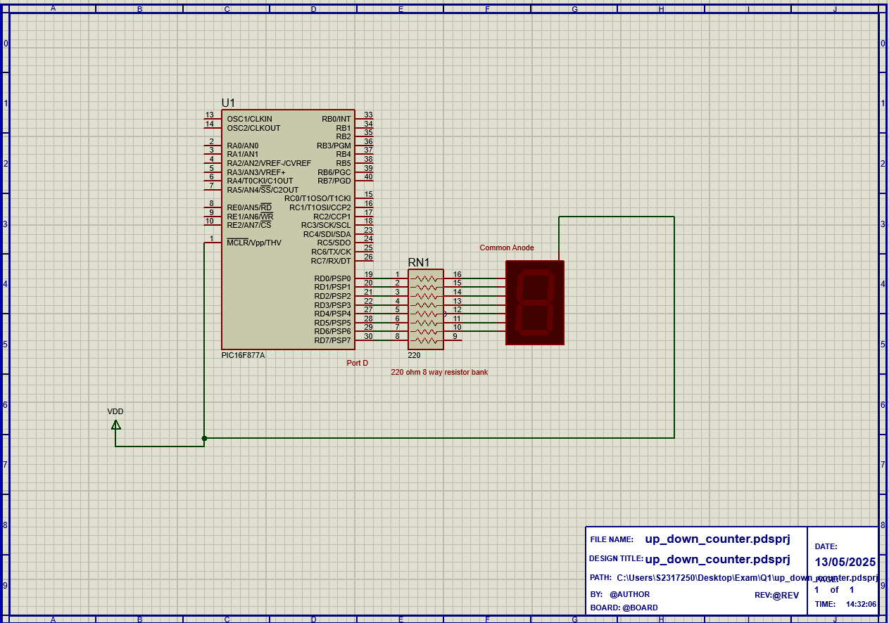

1. #include <16F877A.h> // PIC16F877A header file
2. #use delay(clock=4000000) //clock 4Mhz as set too in Schematic, (Real will need crystal oscillator)
3.
4. unsigned int sevenseg[10] = {0xC0, 0xF9, 0xA4, 0xB0, 0x99, 0x92, 0x82, 0xF8, 0x80, 0x90}; //hex array of 7 seg digits encodes onto pin outputs
5.
6. void main(void) //Main
7. {
8. set_tris_d(0x80); //Setting all port except last in port d as outputs aka. no d7
9. int count = 0; //init of counter setting it to 0
10.
11. while(true) //while loop
12. {
13. {
14. output_d(sevenseg[count]); //outputting corresponding hex from array indexed by count to the port d pins
15. count++; //incrementing count
16. delay_ms(2000); //2 second delay
17. if(count > 9) count = 0; // Reset after 9
18. } // end loop go back
19. }
20. }
21.

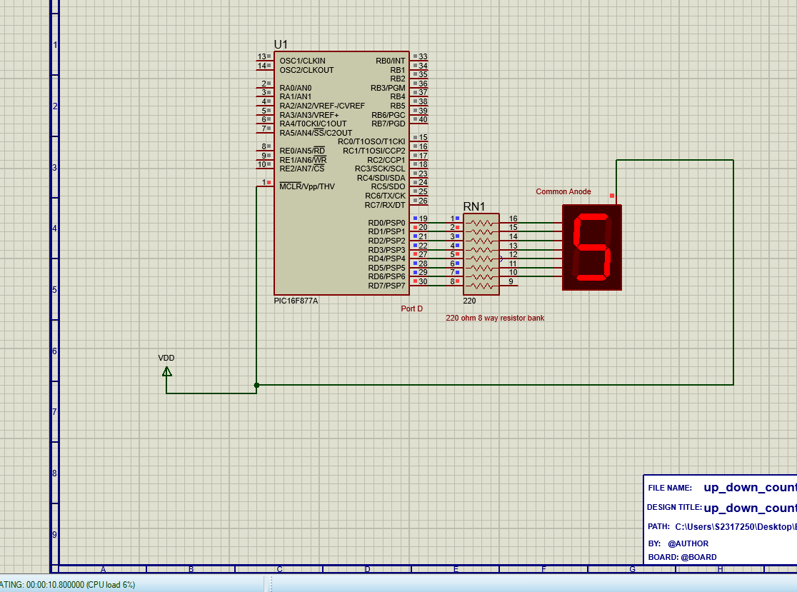
SHOWING 5 AT 10 seconds simulation time,
1 digit every 2 seconds

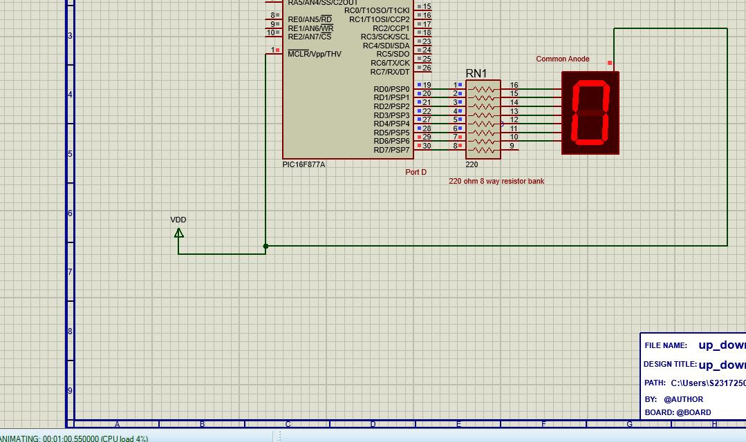 SHOWING Loop back to 0,

Q2
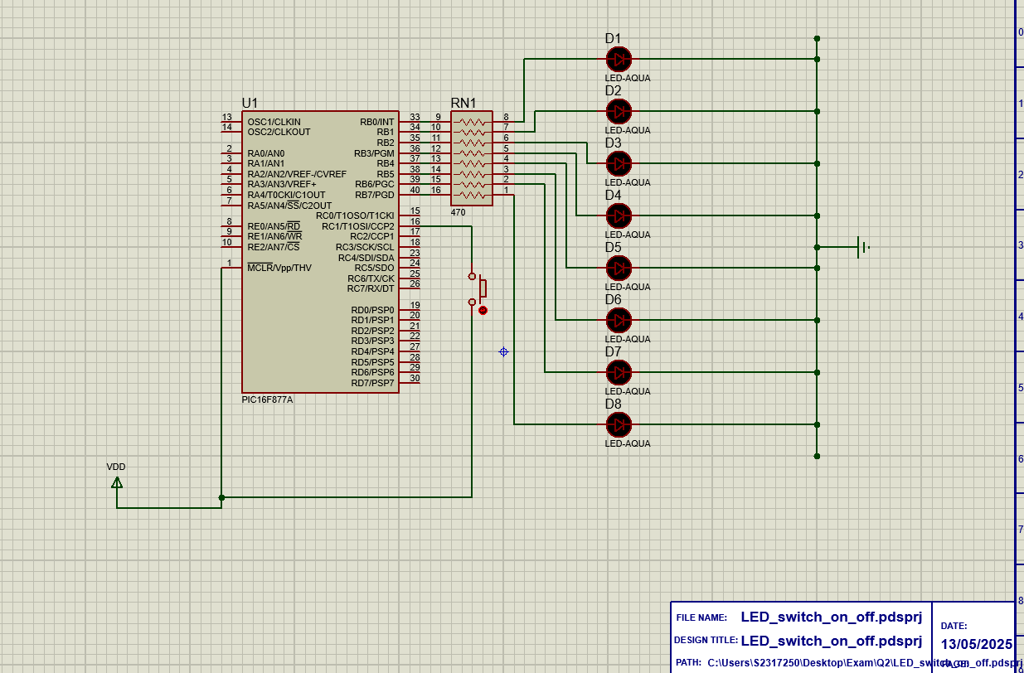

1. #include <16F877A.h>
2. #use delay(clock=4000000)
3.
4. void main(void)
5. {
6. while(TRUE) // loop
7. {
8. if(input(PIN_C1))
9. {
10. delay_ms(50); // 50ms software debounce
11. output_b(0xFF); // Turn on all PORTB pins in turn turning all lights ON simultaneously
12. }
13. else
14. {
15. output_b(0x00); // Turn off all PORTB pins in turn turning all lights OFF simultaneously
16. }
17. } // end loop
18. }
19.
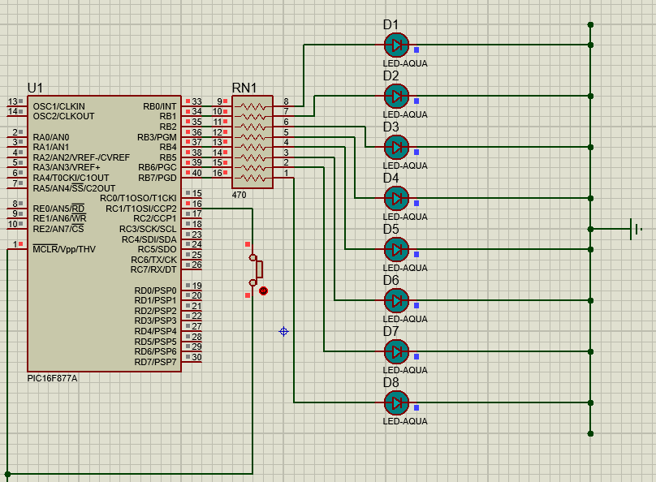
Button pressed all lights on
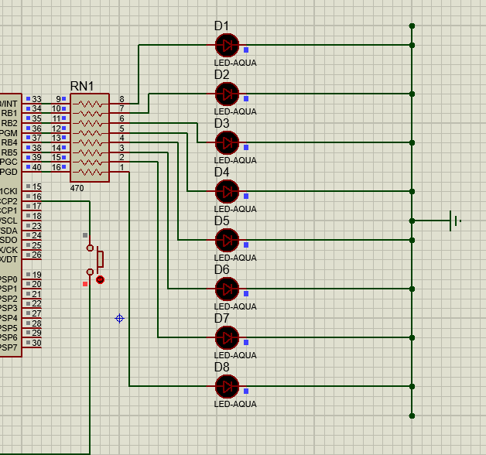
Button off all lights off

Q3
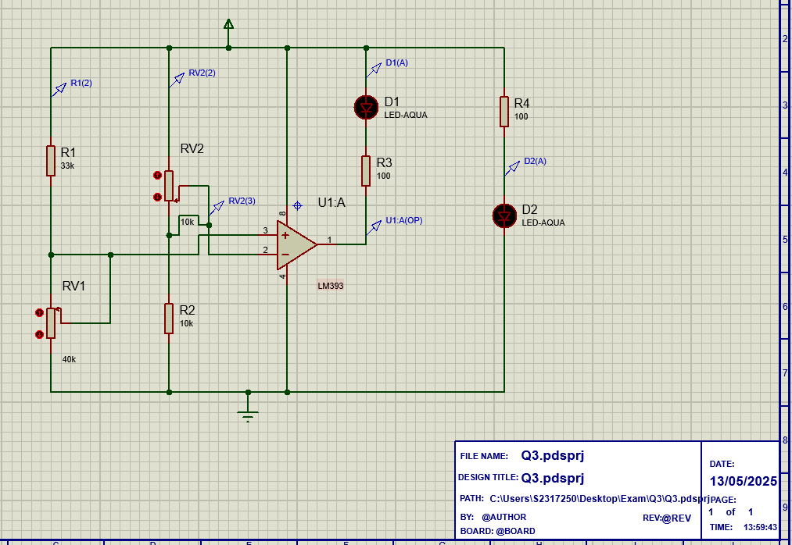
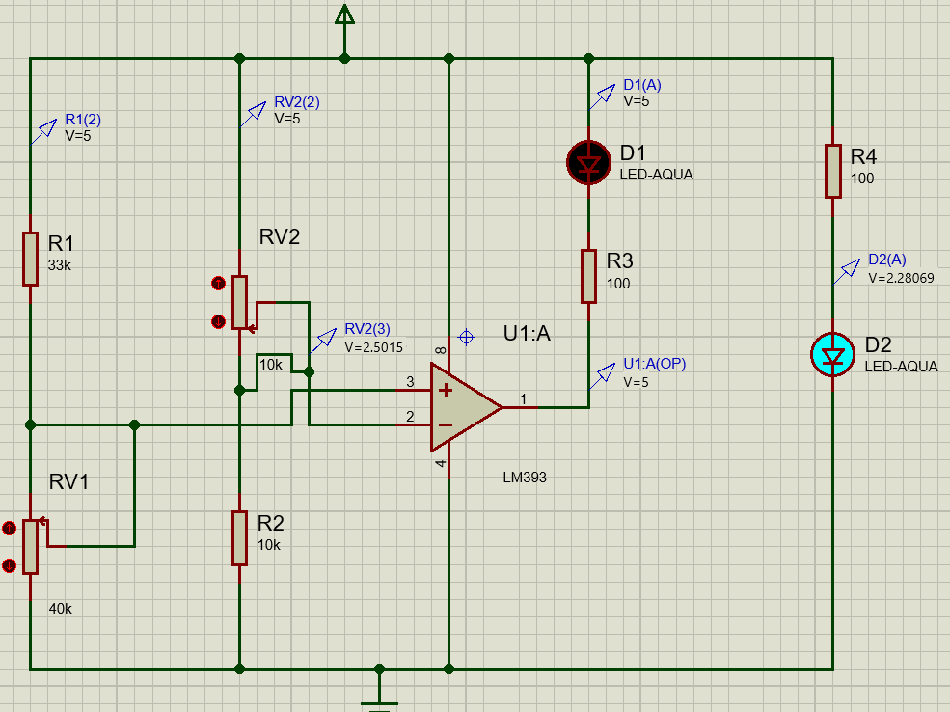
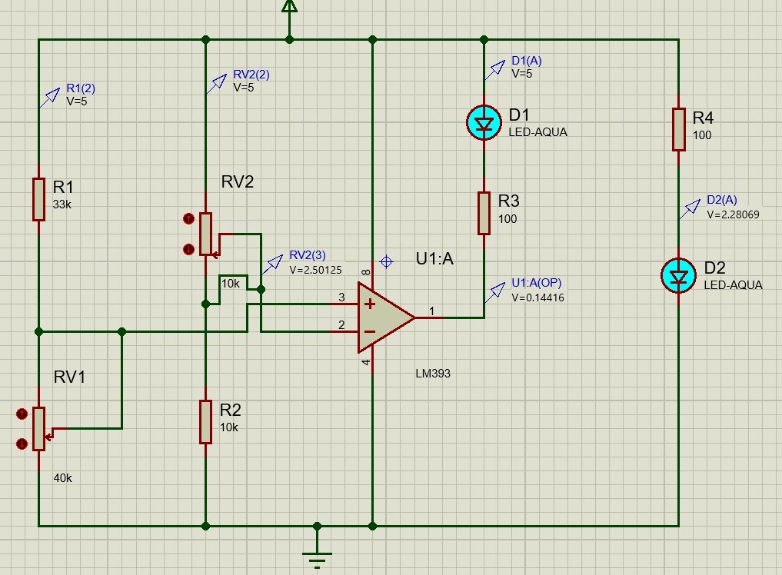

Q4
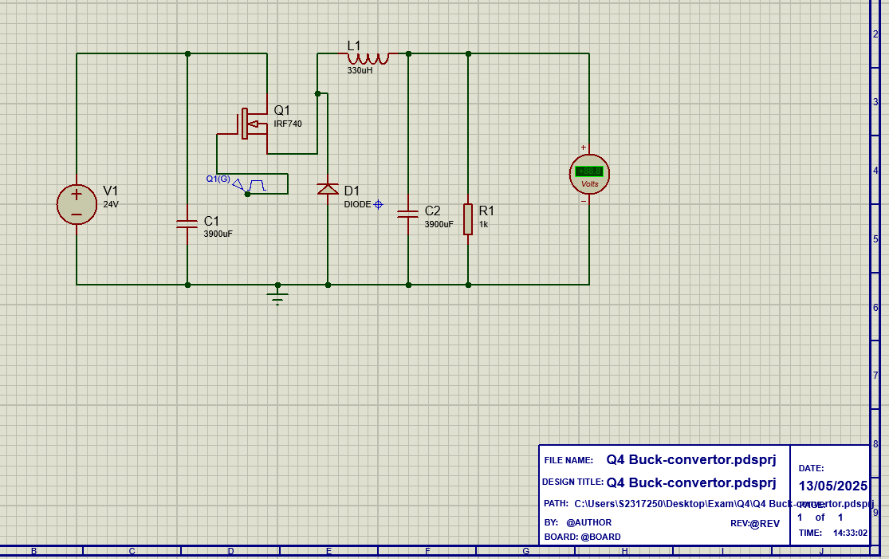
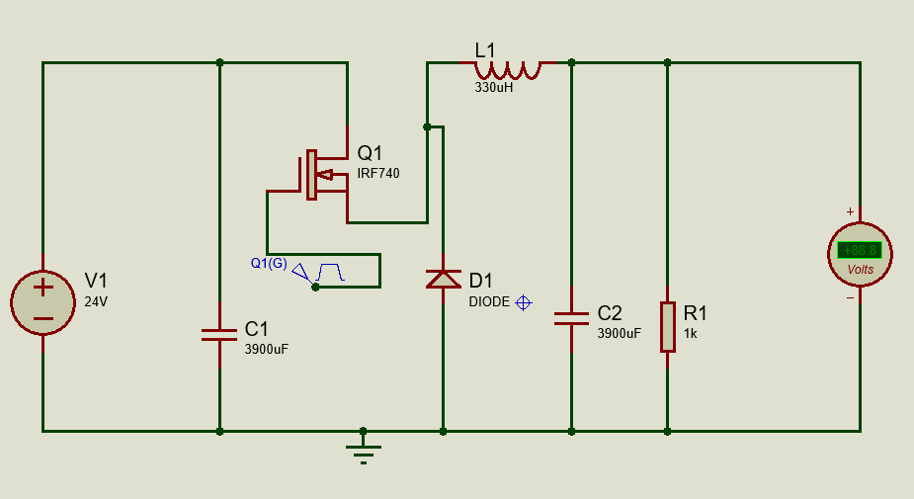

End. (see answer booklet for others) thank you

