
Rats to Classrooms.
(Freepik, 2024).

Welcome and congratulations for clicking on this blog, you have just applauded an author to keep on writing on. Without even knowing it your doing exactly what Skinner set us out to do as people and children. People who know who B.F.Skinner or maybe you don’t… look no further here it is. Skinner was known for the man who trapped rats in a box to train them. Imagine using that method today to train the little people today? We would not have a job, that’s for sure. In fact sometimes I sit there and think are we all living in a massive box produced by Skinner? Lets face it were all learning something new everyday and most of the time we don’t even realise it. Now go ahead, carry on reading and you might even find getting yourself a reward.
Who was B.F. Skinner?
Burrhus Frederic Skinner (March 20, 1904 – August 18, 1990) was an American psychologist, behaviourist, inventor, and social philosopher. He was the Edgar Pierce Professor of Psychology at Harvard University from 1948 until his retirement in 1974 (Wikipedia Contributors (2019). Skinner was known to be a behaviourist. He taught operant conditioning, this occurs when an something is made between a particular behaviour and a consequence for that behaviour. This association is built upon the use of reinforcement and/or punishment to encourage or discourage behaviour (Vinney, 2018).
What he did.
B.F. Skinner also conducted an experiment that explained negative reinforcement. Skinner placed a rat in a chamber in the similar manner, but instead of keeping it hungry, he subjected the chamber to an unpleasant electric current. The rat having experienced the discomfort started to desperately move around the box and accidentally knocked the lever. Pressing of the lever immediately seized the flow of unpleasant current. After a few times, the rat had smartened enough to go directly to the lever in order to prevent itself from the discomfort (Shrestha, 2017).
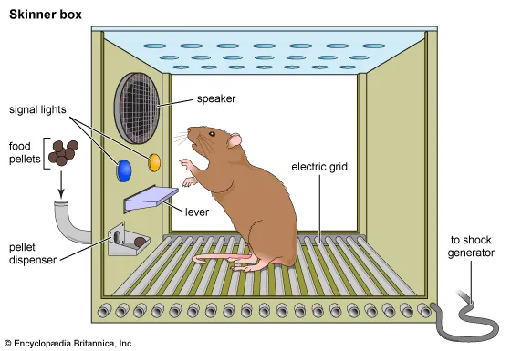
(Britannica, 2025).

Example of his theory put into practice.
This is something that I am sure we all use every day as parents, grandparents, friends, family and teachers. From something as simple as getting a child to put their shoes on to go outside.
Using his theory we can put it into practice. Here is how:
First, we establish the behaviour, the child is learning as with young children this may be something new. I know as a mother myself use continuous praise when little one attempts to put the shoes on. This is known as positive reinforcement. Teaching them to put on a shoe can be a real struggle for the little people who are starting to learn new things in life. We know as adults that we cannot expect the results in a split second, that would be silly of us. Instead you go through things step by step and leave that final big part of putting the velcro across to last, this would give them immediate thought of if I complete this I will get the reward straight away. We want to slow the process down and train how to do this patiently but educationally at the same time.
Principles
- Consistency is key, always use the same reward for the same behaviour especially when you first start off.
- If they are struggling, then you stay patient and you guide them through it repeatedly. As they get used to doing things they will need less help, this is where the real reinforcement comes in.
- Focus on rewarding them for every little part they get right, remember not to punish any mistakes.
Now give yourselves a pat on the back you’ve achieved something massive here and although you may have wanted to throw a tantrum yourself, I bet you kept calm and achieved what you wanted out of this too. Give yourself a reward you deserve it.
Next we will look into Froebel, I promise that you will want to carry on reading this one.

References for blog 1

Britannica.com. (2025). Welcome To Zscaler Directory Authentication. [online] Available at: https://cdn.britannica.com/23/242523-004-D04012E5/skinner-box-operant-conditioning-chamber.jpg [Accessed 5 Dec. 2025].
Freepik. (2024). Colorful rat portraits in hyperrealist style with a zany twist | Premium AI-generated image. [online] Available at: https://www.freepik.com/premium-ai-image/colorful-rat-portraits-hyperrealist-style-with-zany-twist_187060880.htm [Accessed 5 Dec. 2025].
Shrestha, P. (2017). Skinner’s Theory on Operant Conditioning. [online] Psychestudy. Available at: https://www.psychestudy.com/behavioral/learning-memory/operant-conditioning/skinner [Accessed 12 Nov. 2025].
Vinney, C. (2018). What Is Operant Conditioning? Definition and Examples. [online] ThoughtCo. Available at: https://www.thoughtco.com/operant-conditioning-definition-examples-4491210 [Accessed 4 Nov. 2025].
Wikipedia Contributors (2019). B. F. Skinner. [online] Wikipedia. Available at: https://en.wikipedia.org/wiki/B._F._Skinner [Accessed 4 Nov. 2025].

The garden for children.

Have you ever seen a child get more excited over a cardboard box than what is inside? This means you have already witnessed the Froebel philosophy. Whether you are a parent, childcare worker, or none of these then I would like to welcome you to the garden.

Who is he?
You could say he was the Bjork of then 19th century education. Bjork had an album that was based on nature released in 2011 (Wikipedia Contributors, 2019).
Friedrich Froebel (1782-1852) was a German educator, inventor of the "kindergarten" (children's garden) in 1837, who revolutionized early childhood education by championing learning through play, nature, and self-activity using specific toys called "Gifts" (blocks) and "Occupations" (clay, weaving, folding). He believed in holistic development, fostering a child's inherent spiritual essence through guided freedom and interconnectedness, with his ideas spreading globally despite early German opposition, influencing modern pedagogy (EBSCO, 2023). Froebel was only 9 months old when his mother died (Wikipedia Contributors, 2019). leading him to have a very lonely childhood. He didn’t perform very well in school which showed him turning to nature as the outdoors made him feel positive.
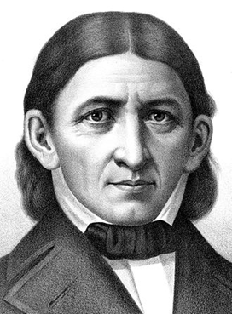 (Wikipedia Contributors, 2025).
What was his theory?
Central to Friedrich Froebel’s theory is the belief that education should nurture the natural unfolding of a child’s abilities, rather than impose rigid structures. His Froebelian approach is rooted in the idea that young children learn best through exploration, creativity, and meaningful interactions with their environment. This child-centred philosophy reinforces the importance of play, nature, and holistic learning experiences (Ryan, 2025).
Principles
• To help children see patterns between different objects. They may explore how a geometric shape looks by being out in the nature looking at the flowers following this it can be recreated through drawing using chalk or outdoor paints (Cupboard, 2019).
• Froebel argued that through gardening children could begin to see a connection between the growth of the plants and animals and their own lives such as the shared need for food, water, shelter and care (Lilley, 1967).
• Nature & Outdoors: Engaging with the natural world is vital for wonder, well-being, and understanding one's place in the world.
• Freedom with Guidance: Children need freedom to explore but with thoughtfully prepared environments and supportive adults.
• Self-Activity & Creativity: Children learn best by doing (self-activity), reflecting, and expressing themselves creatively, using symbols.
• Holistic Development: Nurturing all aspects of the child (physical, emotional, social, intellectual) (Ryan, 2025).
• Value of Childhood: Childhood is a valid stage in itself, not just preparation for adulthood (Ryan, 2025).
• Autonomous Learners: Fostering self-discipline, self-motivation, and the ability to learn from mistake (Ryan, 2025).
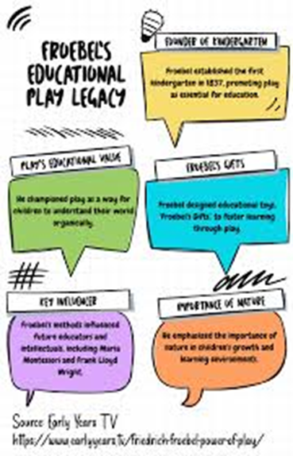(Brodie, 2024).

So, I bet your now getting to understand why Froebel was the man who came up with the idea Kindergarten!
It is referred to as the” garden of children.” The children of early years could go outdoors and are nurtured to grow like plants through play and enjoyment. This is far from modern schooling, but it is still used today in some areas.

Where things took a turn for the worse.
In 1851, the Prussian government – conflating progressives like Froebel with revolutionary socialists like his nephew – banned the kindergarten. Froebel died the following year, but his work and principles lived on, travelling outside Prussia in order to survive, notably to the UK, France, the Netherlands and later the United States. His influence is now recognised around the world – though his principles are not always deeply understood (The University of Edinburgh, 2025).
This overturned in 1860 an the reopening of the kindergarten was reformed.
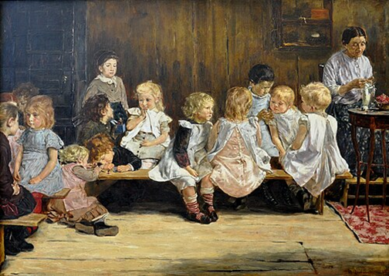 (Wikipedia Contributors, 2019).

So every time we see a child building a tower of blocks or sticks outside, or making patterns with different seeds, we are seeing a Froebel’s theory in education. If a child is playing on their own or in a group don’t just go over and spoil their play or change the rules, pause and wait to be invited. Froebel has shown to us today that he was ahead of his time as we still use his theory today in education by having forest schools, parental involvement including springboard and foundation phase program. We as people of the 21st century owe it to him to keep the garden watered and encourage that play remains in the planning of all early years classrooms.

Ever wondered how skinner and Froebel are compared?

References for blog 2

A FROEBELIAN APPROACH. (n.d.). Available at: https://files.froebel.org.uk/production/documents/FT-Froebels-principles-and-practice-today.pdf [Accessed 19 Dec. 2025].
Brodie, K. (2024). Friedrich Froebel and the Power of Play - Early Years TV. [online] https://www.earlyyears.tv/. Available at: https://www.earlyyears.tv/friedrich-froebel-power-of-play/ [Accessed 19 Dec. 2025].
Cupboard, M.T. (2019). My Teaching Cupboard. [online] My Teaching Cupboard. Available at: https://www.myteachingcupboard.com/search?q=froebels+priciples [Accessed 19 Dec. 2025].
EBSCO. (2023). Friedrich Froebel | Research Starters | EBSCO Research. [online] Available at: https://www.ebsco.com/research-starters/history/friedrich-froebel [Accessed 18 Dec. 2025].
Friedrich Fröbel and Lilley, I.M. (1967). Friedrich Froebel : a selection from his writings. Cambridge: Cambridge University Press.
Froebelian futures. (n.d.). Froebel: an introduction. [online] Available at: https://www.froebel.ed.ac.uk/froebel-an-introduction/ [Accessed 20 Dec. 2025].
Ryan, P. (2025). Friedrich Froebel: His Principles, Play Theory, and Legacy in Education. [online] Early Excellence. Available at: https://earlyexcellence.com/friedrich-froebel-theory/ [Accessed 19 Dec. 2025].
Wikipedia Contributors (2019). Biophilia (album). [online] Wikipedia. Available at: https://en.wikipedia.org/wiki/Biophilia_(album) [Accessed 20 Dec. 2025].

Wikipedia Contributors (2019). Kindergarten. [online] Wikipedia. Available at: https://en.wikipedia.org/wiki/Kindergarten [Accessed 20 Dec. 2025].

Wikipedia Contributors (2019). Friedrich Fröbel. [online] Wikipedia. Available at: https://en.wikipedia.org/wiki/Friedrich_Fr%C3%B6bel [Accessed 19 Dec. 2025].

Wikipedia Contributors (2025). Friedrich Fröbel. [online] Wikipedia. Available at: https://en.wikipedia.org/wiki/Friedrich_Fr%C3%B6bel [Accessed 17 Dec. 2025].

