
NAME: - RAVJEET KAUR
STUDENT ID: - 2421160
Programme: - BSc Health and Social Care
Module: - Changemakers: Creativity and Value Creation
Module code: - BMHP5014
Assignment Title: - Component 2: Written Assignment (Report)

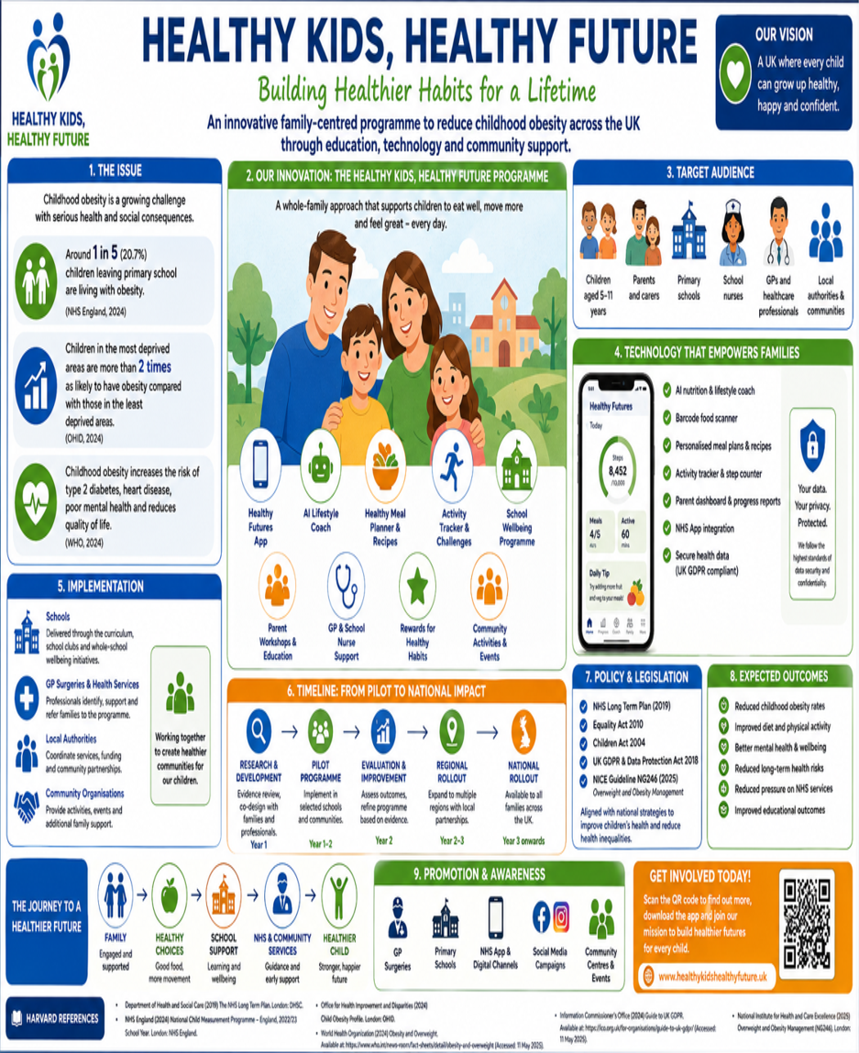
Poster about: - Childhood Obesity Prevention Programme
Pitch: - Healthy Kids, Healthy Future: A National Childhood Obesity Prevention Programme
Introduction
Childhood obesity is one of the biggest public health challenges facing the UK today. Despite government campaigns and NHS initiatives, obesity rates among children remain high, especially in disadvantaged communities. According to the National Child Measurement Programme, 22.1% of Year 6 children in England were living with obesity during the 2023/24 school year (NHS England, 2024). Children living in the most deprived areas are more than twice as likely to experience obesity compared with those in the least deprived communities (Office for Health Improvement and Disparities (OHID), 2024). These figures show that childhood obesity is influenced by much more than personal choice.
The effects of obesity extend beyond physical health. Children are at greater risk of developing conditions such as Type 2 Diabetes and cardiovascular disease, while also experiencing lower self-esteem, anxiety and bullying (National Institute for Health and Care Excellence (NICE), 2025). If left unaddressed, these health problems often continue into adulthood, increasing pressure on NHS services (World Health Organization (WHO), 2024).
This proposal introduces Healthy Kids, Healthy Future, an innovative programme that combines digital technology, schools, healthcare professionals and community support to encourage healthier lifestyles through prevention and early intervention.
Why Childhood Obesity Remains a Challenge
Although the UK has introduced several initiatives to tackle childhood obesity, including the National Child Measurement Programme and improvements to school food standards, progress has been slow. Many interventions focus on supporting children after weight problems have developed rather than preventing them in the first place. As a result, obesity continues to affect thousands of children each year.
A major reason for this is that childhood obesity is closely linked to wider social factors. Families on lower incomes may have limited access to healthy food, safe places to exercise or affordable leisure activities. These social determinants of health have a significant impact on children’s lifestyles and help explain why obesity rates remain highest in deprived communities (Marmot, 2010).
Technology also presents challenges. While many health apps are available, they often target adults and rarely involve schools, parents or healthcare professionals. Some families may also lack access to digital devices or the confidence to use them. This highlights the need for an approach that combines digital innovation with face-to-face support, ensuring that all children have an equal opportunity to benefit regardless of their background.
Healthy Kids, Healthy Future: An Innovative Solution
Healthy Kids, Healthy Future has been designed to address the gaps in current childhood obesity services by taking a whole-system approach. Rather than focusing only on weight management, the programme aims to help children and their families build healthier habits that can be maintained throughout life. It recognises that lasting behaviour change is more likely when schools, healthcare professionals, families and local communities work together.
At the centre of the programme is the Healthy Kids App, which provides personalised advice on healthy eating and physical activity. Using artificial intelligence (AI), the app can suggest meal ideas, healthy recipes and simple ways for families to become more active. It also includes a Healthy Lunchbox Scanner, allowing parents to scan food items and receive easy-to-understand nutritional information and healthier alternatives. This helps families make informed choices without feeling overwhelmed by complex dietary advice.
The programme also introduces Healthy Schools Champions. Teachers and school nurses would work together to deliver healthy eating sessions, physical activity challenges and wellbeing events involving parents and carers. These activities reinforce the messages children receive through the app while creating a positive culture around healthy living within schools.
Healthcare professionals, including GPs, school nurses and dietitians, would be able to refer families into the programme and monitor progress where needed. Community organisations would support the initiative by providing cooking classes, family exercise sessions and local wellbeing activities, making healthy lifestyles more accessible and affordable.
To ensure the programme is inclusive, families without access to smartphones or the internet would still receive support through schools, community centres and printed resources. Personal information would be stored securely in line with the UK GDPR and the Data Protection Act 2018, protecting children’s privacy while allowing professionals to provide appropriate support (Information Commissioner’s Office, 2024).
By combining technology with education, healthcare and community support, Healthy Kids, Healthy Future offers a practical and realistic way to reduce childhood obesity while promoting healthier lifestyles for future generations.
Benefits and Impact
Healthy Kids, Healthy Future has the potential to improve the lives of children, families and healthcare professionals by encouraging healthier lifestyles through prevention rather than treatment. For children, the programme promotes healthy eating, regular physical activity and emotional wellbeing in a positive and supportive way. Instead of focusing on body weight, it encourages confidence and healthy habits that are more likely to continue into adulthood (NICE, 2025).
Parents and carers also benefit by receiving practical advice that is easy to understand and apply at home. Features such as meal planning, shopping tips and activity challenges help families make healthier choices without requiring expensive diets or major lifestyle changes. This is particularly important for families living in deprived areas, where healthy food and leisure opportunities may be less accessible (Marmot, 2010).
Schools benefit by strengthening health education and encouraging pupils to become more active. Healthier children are more likely to attend school regularly, concentrate better in lessons and participate confidently in school life (Department for Education, 2023).
Healthcare professionals also gain from earlier intervention and improved partnership working. GPs, school nurses and dietitians can identify children who need additional support before obesity becomes more serious, helping to reduce demand for specialist services. In the longer term, preventing childhood obesity could reduce NHS spending on obesity-related illnesses
while improving the overall health of future generations (Department of Health and Social Care, 2019).
Implementation and Conclusion
To ensure the programme is effective, Healthy Kids, Healthy Future would first be introduced as a 12-month pilot in primary schools located in areas with the highest childhood obesity rates. Schools would work closely with GPs, school nurses, dietitians, local authorities and community organisations to deliver the programme. During this phase, teachers and healthcare professionals would receive training, while parents would be invited to workshops demonstrating how to use the Healthy Kids App and support healthy habits at home.
The programme would be evaluated using both health data and user feedback. Success would be measured through changes in childhood obesity rates, physical activity levels, school attendance and family engagement. Feedback from children, parents and professionals would also be collected to identify areas for improvement before the programme is expanded across England through Integrated Care Systems (ICSs).
Although challenges such as funding and digital exclusion may affect implementation, these can be reduced by providing face-to-face support alongside digital services. Offering community workshops and printed resources would ensure families without access to technology are not excluded.
Overall, Healthy Kids, Healthy Future offers a practical and sustainable approach to tackling childhood obesity. By combining education, technology, healthcare and community support, the programme encourages healthier lifestyles from an early age while helping to reduce health inequalities. If implemented successfully, it could improve children’s health, reduce future pressure on NHS services and contribute to healthier communities across the UK.
Recommendation
Based on the evidence presented, it is recommended that Healthy Kids, Healthy Future is piloted within selected primary schools before being rolled out nationally. The programme supports current NHS priorities by promoting prevention, reducing health inequalities and encouraging partnership working between education, healthcare and local communities. With appropriate funding and evaluation, it has the potential to make a meaningful contribution to improving children’s health and reducing childhood obesity across the UK.
Reference List
Bandura, A. (1986) Social Foundations of Thought and Action: A Social Cognitive Theory. Englewood Cliffs, NJ: Prentice-Hall.
Department for Education (2023) The School Food Standards: Guidance for Governors, Headteachers, School Leaders, School Food Providers and Local Authorities. Available at: https://www.gov.uk/government/publications/school-food-standards-resources-for-schools (Accessed: 01 July 2026).
Department of Health and Social Care (2019) The NHS Long Term Plan. Available at: https://www.longtermplan.nhs.uk/ (Accessed: 04 July 2026).
Department of Health and Social Care (2021) The NHS Constitution for England. Available at: https://www.gov.uk/government/publications/the-nhs-constitution-for-england (Accessed: 05 July 2026).
Department of Health and Social Care (2022) Health and Care Act 2022. Available at: https://www.legislation.gov.uk/ukpga/2022/31/contents (Accessed: 06 July 2026).
Information Commissioner's Office (2024) Guide to UK GDPR. Available at: https://ico.org.uk/for-organisations/uk-gdpr-guidance-and-resources/ (Accessed:7 July 2026).
Marmot, M. (2010) Fair Society, Healthy Lives: The Marmot Review. Available at: https://www.instituteofhealthequity.org/resources-reports/fair-society-healthy-lives-the-marmot-review (Accessed: 10 July 2026).
National Institute for Health and Care Excellence (2025) Overweight and Obesity Management (NG246). Available at: https://www.nice.org.uk/guidance/ng246 (Accessed: 10 July 2026).
NHS England (2024) National Child Measurement Programme: England, 2023/24 School Year. Available at: https://digital.nhs.uk/data-and-information/publications/statistical/national-child-measurement-programme (Accessed: 10 July 2026).
Office for Health Improvement and Disparities (2024) Obesity Profile: Statistical Commentary. Available at: https://fingertips.phe.org.uk/profile/national-child-measurement-programme (Accessed: 10 July 2026).
Public Health England (2018) Whole Systems Approach to Obesity: A Guide to Support Local Approaches to Promoting a Healthy Weight. Available at: https://www.gov.uk/government/publications/whole-systems-approach-to-obesity (Accessed: 10 July 2026).
World Health Organization (1986) Ottawa Charter for Health Promotion. Available at: https://www.who.int/publications/i/item/ottawa-charter-for-health-promotion (Accessed: 10 July 2026).
World Health Organization (2024) Obesity and Overweight. Available at: https://www.who.int/news-room/fact-sheets/detail/obesity-and-overweight (Accessed: 10 July 2026).

