Documentary: Assessment 1

In this document I am going to research into the field and modes of my chosen documentary and explain how it will inform my production.

For my production I have chosen to create a sport documentary in the expository mode, looking at the die-hard passion for the extreme sport of skateboarding that people have. I am going to be interviewing skateboarders from the Carmarthenshire area from a range of different back grounds and explore what got them into skateboarding and why they find it so addictive.

The documentary that I am creating falls under the category of expository, with elements of the performative and reflexive modes. My skateboarding documentary is going to be informative as well as being visually engaging by following the traditional qualities of expository documentary. As I am going to be creating an emotionally driven documentary that I am passionately involved in, it can be argued that my project is a crossover between performative and expository. There will also be elements of the reflexive mode because there will be a lot of fieldwork for the action shots and interviewing for the voice overs, but at the heart, my film is expository. I will be using elements from all three modes but in the end my documentary does not set out to reach an end truth but focus mostly on what it is like to be a skateboarder.

Expository documentary was first developed by the American documentary theorist, Bill Nicholls and generally has a main focus on a person or topic, but in my case, it will be the lifestyle and identity of people involved in the local skateboarding community. There are many sub genres that come from this mode of documentary, such as science, nature, music, sport, health and many more. The narration of an expository documentary typically comes from verbal commentary and voice overs from interviews, this narration is used to inform, the sole purpose of it is to highlight what is actually happening on screen. By having this form of interview voice over narration I will be creating a much greater sense of intimacy with my audience as my subjects will be speaking to the viewer directly about their strong passion for this sport.
Another conventional style of narration used in expository documentary is the ‘voice of God’ commentary, where the person narrating is heard but never actually seen on screen. This omniscient ‘voice of God’ style voiceover is usually a richly toned male voice, mostly used as an authoritative commentary when the documentary is proposing a strong argument and/or a point of view. A good example of this narration style is how it is used a lot in nature and animal documentaries such as ‘The Blue Planet’.
This mode of narration is effective but not appropriate for my production, as my documentary is more about being emotive and informative instead of educational or thought provoking. My project does not revolve around a specific argument but more of a chosen lifestyle. The story will be told from the subjects themselves and them being shown on screen is an essential part of the documentary because there will be a lot of action shots with the subjects skateboarding and close up shots from interviews showing their honest expressions whilst they are talking about something that means so much to them.

The relationship between the visuals and voice over is an extremely important part of an expository documentary because the commentary is providing the context and the visuals are backing up what is being said or explained. In terms of how this relationship informs my project, I am going to be delving into the strong theme of community within skateboarding and showing how the sport connects people from completely different walks of life. As my subjects are talking about why they love skateboarding so much I will be showing clips of them doing their favourite tricks. The flow between showing my subject being interviewed and them actually skateboarding is the key to keeping my production entertaining and visually pleasing for my audience. Another reason for my chosen choice of expository documentary mode is that whilst being informative, there is always a purpose to show the audience what is happening, this will be particularly important for the sections where my subjects are talking about their favourite skateboarding trick. I will be showing clips of them doing the trick on different obstacles whilst they are explaining what exactly the trick is and how they do it.

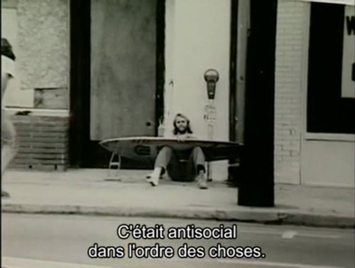
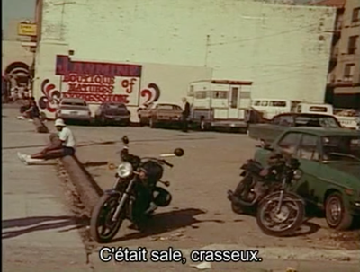
A good example of how this strong relationship between commentary and visuals is effective and serves its purpose is in Stacey Peralta’s award-winning cult classic ‘Dog town and Z-Boys’ 2001. This documentary is set in California during the 1970’s, where skateboarding first originated through surfers.
Throughout this documentary the history of Dog Town is being explained and it is often described as ‘dirty, filthy’ and a ‘paradise for skateboarders and surfers’ these statements are being backed up by vintage video footage and images of Dog Town.

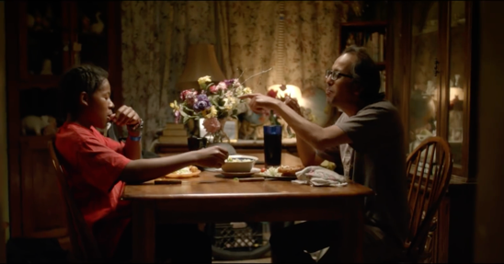
Another example of this being used is in a short documentary called ‘Tailwhip’ 2017, By ‘Uninterrupted’ that follows 14-year-old BMX rider Erik Aguilar on his road to becoming a professional rider. This documentary has a strong focus on the relationship between Erik and his father. Whilst a voiceover of Erik’s mother is being played where she is talking about the strong bond between Erik and his father, emotive visuals are shown of the son and father laughing together. These shots are being informed by the commentary of the Mother.

In terms of editing in the expository documentary mode, it is traditional to maintain continuity of the spoken perspective, this is called ‘Evidentiary’: “The voice indicates the way of conveying a perspective or point of view by giving tangible expression to the filmmaker” – Bill Nicholls, 2005. It is important for my voice over to be linear with the visuals being shown on screen. When my subjects start to speak deeply about what skateboarding means to them and what it does for them in relation to being an outlet, I will focus on close up shots of them in the interview to emphasize the emotion and enthusiasm for the sport.

When looking at ethical and theoretical debates surrounding documentaries in the expository style, it can be argued that the mode was born from the inaccurate arguments that the poetic mode of documentary is vulnerable to presenting. Expository documentaries have a main goal of educating their audience and encouraging them to want to learn about the subject matter being presented. One argument about the authenticity of expository documentaries is that when the voice of God style of narration is being used, which is typically the most traditional mode of narration in this mode, it can be said that the filmmaker themselves can be objective to the subject matter. It can also be said that when the filmmaker is narrating it themselves, it is more about teaching through their perspective and beliefs, making it seem like the filmmaker is trying to persuade the audience into siding with their own beliefs. An example of this can be seen in the 2006 American documentary about global warming, ‘An Inconvenient Truth’ directed by Davis Guggenheim. While this film did incredibly well at raising awareness of climate change, one of the biggest critical responses is that the risks described by President Albert Arnold Gore Jr in the film are “exaggerated”. The film was also questioned on its scientific and political grounds. MIT atmospheric physicist Richard Lindzen even went as far as to say that Albert was exploiting the fear of his audience for a personal gain. Another sceptical argument about this documentary was that Albert could have been trying to set himself up for another run at being president. These are just some observations at how the expository mode of documentary can be argued against for being biased or persuasive by the narrator.
Whilst it can be said that expository documentary portrays accurate representations of the subject matter through facts and research, it can be argued that the voice over narration takes away from the actual reality and does not let it naturally speak for itself.

‘Who We Are’ 2013, is an award-winning short skateboarding documentary produced by Nelson Mustain, I found this documentary extremely inspiring towards my own project and I can see a lot of things within it that I would like to implement into my documentary. Much like my project, Who We Are is a combination of different modes, mainly expository, reflexive and performative. The documentary focuses on the way that the sport defines people and brings them together to form rare friendships. Who We Are relies on the narration of the skateboarders and as they are speaking we are shown footage of them doing different tricks.
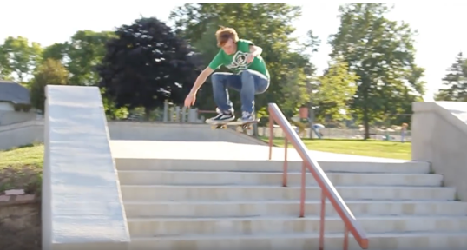
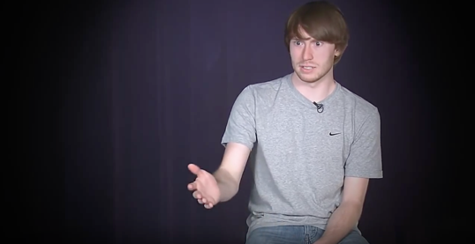
Referring back to the important relationship between commentary and visuals in expository documentaries, this is evident throughout Who We Are. Particularly in one section where one of the skateboarders, Tyler Vermillion, is talking about skateboarder vision, by this he is talking about how being a skateboarder changes your perception of the world around you and how you look at objects in a completely different way. He talks about how when he sees a set of stairs the first thought he has is if he can skateboard down it, as he mentions this the visuals change from a mid-shot of him in an interior home-made interview room to him actually skateboarding down stairs. This is done to further inform what he is saying to the audience.

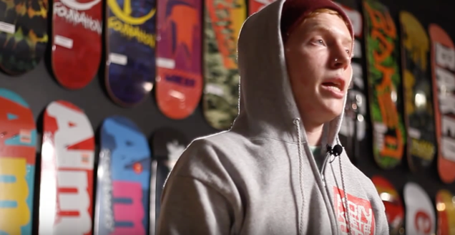
Who we are uses a lot of emotive language, and really lets the subjects in the documentary directly speak to the audience about their deepest feelings towards skateboarding. In this shot of Steven Page, he is talking about how he has left several jobs because they didn’t allow him to pursue skateboarding as much as he would like to. He continues to say in this low angle shot that he has purposefully altered his life so that he can be around skateboarding as much as possible.
Much like how I would like to do in my project, the camera cuts from the action and focuses on the skateboarder themselves when they start to talk deeply about their love for the sport and how it has impacted their everyday life.

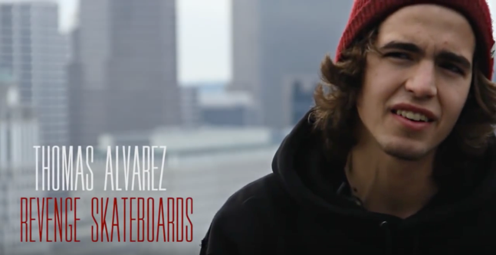
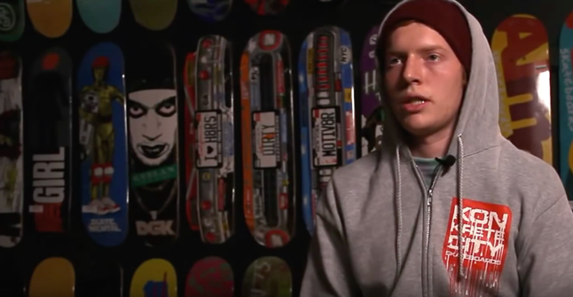
This documentary uses a lot of simplistic titles and colours to inform the production and highlight the emotive nature of the film. The chosen style of animation for the titles is continuous throughout, as well as the colours chosen and this gives the documentary a certain style and sense of branding. This is something that I will be incorporating into my project. Keeping the colours and anything added in post-production simplistic stays true to the tone of a documentary like this and doesn’t counteract the moving tone of it.
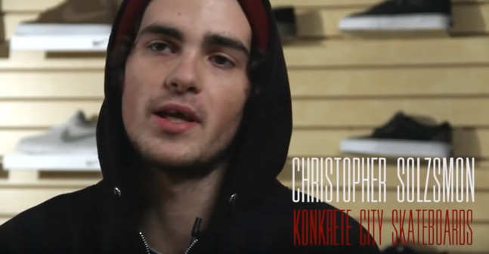
Who We Are places the different subjects in different places, using back drops and natural artistic back grounds for the interviews to add variety and to keep the audience engaged with new cinematic settings. In these three examples we see Steven Page, from two different angles inside the skateboard shop he works at. We see Thomas Alvarez on a bench with a close-up shot focused on his face with a low aperture used to blur out the background slightly, creating a more emotive and cinematic scene. In the last example we see Christopher Solzsmon in the skateboard shop he works at. In my project I will also be using meaningful locations for my subjects, such as a close up of them with their local skatepark in the background. I would also like to create a home studio environment using mobile LED’s and coloured gels, much like the director did with Tyler Vermillion for his interview.

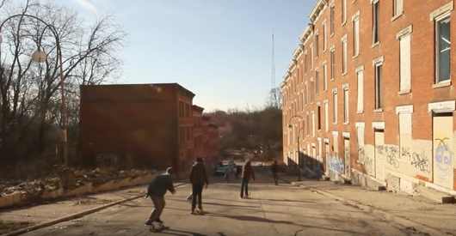
Who We Are concludes on a high note, all of the skaters involved speak about the sense of community in skateboarding and how it has benefitted them in life and to highlight this narration the documentary finishes with a shot of all of the skateboarders riding down a hill together in slo mo before fading into the credits.

Bibliography

https://www.slideshare.net/idlknmz/expository-documentary-34103281

https://epowdocumentary.wordpress.com/documentary-modes/expository-mode/

https://www.dailymotion.com/video/x1197y8

https://moodle.uwtsd.ac.uk/pluginfile.php/188559/mod_resource/content/1/Types%20of%20Documentary-Ch6.pdf

https://www.youtube.com/watch?v=jZBqYqcQDBw

https://sites.stedwards.edu/comm4399fa2013-jhender4/2013/10/03/expository-documentary-mode/

Filmography

DogTown and Z Boys 2001 – Stacy Peralta
https://www.dailymotion.com/video/x1197y8

Tailwhip 2017 – Uninterrupted
https://www.youtube.com/watch?v=zmu_ERYVJ7M

An Inconvenient Truth 2006 – Davis Guggenheim

Who We Are⎥ A Short Skateboarding Documentary 2013 – Nelson Mustain https://www.youtube.com/watch?v=jZBqYqcQDBw

