Food and Beverage Operations
Reflective Essay
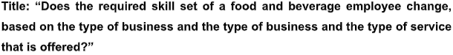
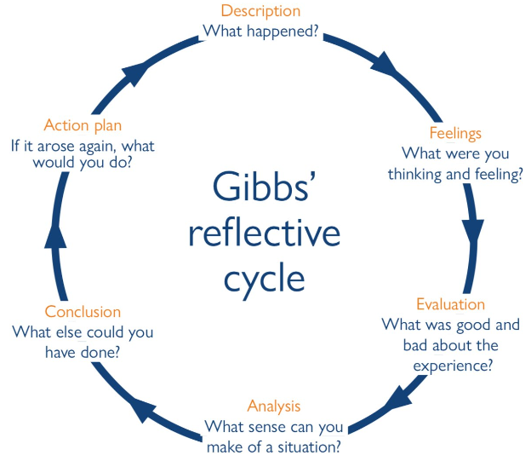
Figure 1: Gibb's reflective cycle
Source: (Wikström, 2012)
Description: Working in two different restaurants having different two cultural backgrounds is a unique experience (Johnston et al., 2021). The restaurants are Nola and Berenjak Borough where the bar manager’s responsibilities are quite the same. In these restaurants, two different cultures in these two restaurants can help me gain lots of knowledge, skills, and competencies because the job responsibilities of a bar manager in these restaurants have both similarities and dissimilarities. I found that Nola is an American bar-restaurant that can indulge in offering a similar southern vibe to the original including a sweet Creole drink, fruit juice, syrup, and so on (Smith, 2022). Besides, I found that the bar manager needs to ensure an eclectic program of live music in this bar restaurant. On the other hand, Berenjak Borough is an Iranian bar restaurant that offers home-style Persian food in a mesmerizing setting and keeps serving up plates with delicious Iranian food. This is one kind of Romily Street restaurant that can create a friendly atmosphere and is the most enticing dining destination for visitors (Lazarri, 2023). In these two restaurants, I observed two different bar manager and their responsibilities are quite similar to each other but the backgrounds were different. I found that they indulge in supporting the operations managers in the development of financial budgets, business plans, and management of outlets so that they can meet service productivity and revenue generation targets. Besides, they are also responsible for the delivery of service where the visitors are welcome and can experience services that match the expectation of discerning and experienced travelers from international and local markets. Furthermore, they need to provide training and development of Food and Beverage Supervisors including management of department career succession plans. I also found some differences between their job responsibilities (Kurtuy, 2023). Like, in Nola, the bar manager’s dress code is casual but he or she must ensure a decent dress code that can make a positive impression among the guests in the bar. On the other hand, in Berenjak Borough, the bar managers are also allowed to any decent dress code except for sleeveless shirts and shorts in the bar but this dress code is allowed in Nola. I came to know that both bar managers are to ensure staff understands local and liquor laws but the bar manager in the Iranian bar was to prioritize their home country’s culture rather than exploring Western culture to the bar staff.
Feelings: I was quite happy when I was learning about the job responsibilities of a bar manager in two different restaurants pragmatically through the visit to those bar restaurants. I used to believe that both restaurants’ bar managers are to ensure the quality of drinks in their restaurants and support assisting the operations managers in producing and serving such drinks to the guests. But I was shocked when I came to know that the bar manager of Berenjak Borough needs different roles in this case. From the research, I found that Berenjak indulges in following Islamic culture where alcoholic items are fully prohibited. The guests can enjoy non-alcoholic items that are called ‘Halal or allowed or no restriction’ (Lazarri, 2023). In this case, the bar manager of Berenjak needs to ensure this particular quality and feature of its drink that cannot be found in Nola.
Evaluation: The good things that I found in the bar managers of those restaurants are that they both indulge in creating and sustaining a work environment that always concentrates on fair and equitable treatment and associates’ satisfaction to enable business success. Besides, they also need to assist in developing a marketing strategy for targeting internal and external customers (Davis et al., 2018). But they were facing challenges in managing service delivery in outlets that were creating negative impressions among such particular customers, especially those who are not their targeted segments.
Analysis: From the visit, I realized that I can also be an effective bar manager in any of those restaurants. In that case, I would like to monitor department performance, especially with respect to the bars’ budget. Besides, I would focus on acquiring my distinct goals, objectives, budget revenue, average check, and several covers.
Conclusion: If I were a bar manager in any of those bars, I could have managed a service delivery outlet and for this, I could have provided greetings and increased the speed of order taking and food and beverage delivery as the bar managers in those bar restaurants were facing.
Action plan: Within 1 year, I will pursue additional training in bar management from a well-efficient teaching institute.

References
Burnett, E. (2023) Outlet Cafe Bar Van ordered to improve after low food hygiene score, Yahoo! News. Available at: https://uk.news.yahoo.com/outlet-cafe-bar-van-ordered-040700579.html?guccounter=1&guce_referrer=aHR0cHM6Ly93d3cuZ29vZ2xlLmNvbS8&guce_referrer_sig=AQAAAKzqMkecTLcnZcdd33Tm63H4nkEpTKON3TPzQxwXnI6SXRd499IYGBJ5r7irt953k3QrkUBeiRzCZUk_FT7PWUoWksvL1YAXlv39aYM2hgJ2jf90ahcsVLUnok0Gfk16HLP3XqndQAMooSb_x0iGwIK28PVOxGFUnhb3c0SnyFdl (Accessed: 23 May 2023).
Cousins, J.A. et al. (2020) Food and beverage service. London: Hodder Education.
Davis, B. et al. (2018) Food and beverage management. 6th edn. London: Routledge.
Jobber, D. and Ellis-Chadwick, F. (2020) Principles and practice of marketing. Maidenhead: McGraw-Hill Education.
Johnston, R. et al. (2021) Service Operations Management: Improving Service Delivery. Harlow, England: Pearson.
Kurtuy, A. (2023) Bar manager resume example - update yours for 2023, Novorésumé. Available at: https://novoresume.com/career-blog/bar-manager-resume-example (Accessed: 23 May 2023).
Lazarri, N. (2023) Babylon’s bar manager on why 2023 is significant for Dubai ... Available at: https://www.caterermiddleeast.com/outlets/babylons-bar-dubai-nightlife-and-beverage-sector-2023 (Accessed: 23 May 2023).
Smith, E. (2022) 5 American bars in London to visit now, Country and Town House. Available at: https://www.countryandtownhouse.com/food-and-drink/american-bars-in-london-to-visit-now/ (Accessed: 23 May 2023).
Tesone, D.V. (2017) Principles of Management for the Hospitality Industry. Taylor & Francis Ltd.
Wikström, B.-M. (2012) ‘A visual art museum in Sweden as Pedagogical Scenery: Gibbs’ reflective cycle guiding student nurses in the reflective process’, Open Journal of Nursing, 02(02), pp. 130–137. doi:10.4236/ojn.2012.22020.

