Scott Jones
1803767@student.uwtsd.ac.uk
Smart and connected devices
Visualisation of IoT Data

Table of Contents
Table of Contents 1
Log In 2
Graphs 4
Data Transfer 5
Searching 6
Sorting 7
Styling 8
Linking to the Database 9
Log Out 9

Log In
A second table within the database stores the user’s data. Containing the Username and password that allows the user to log in.
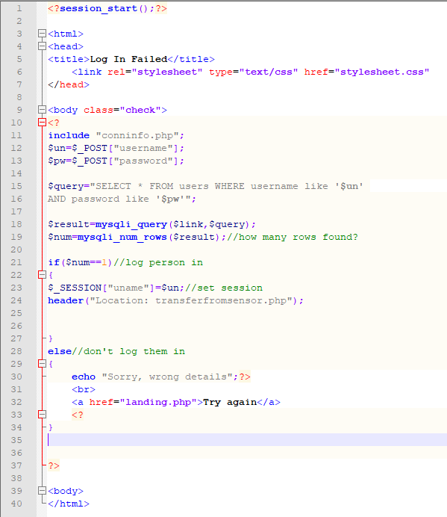
The above code is what checks the username and passwords to see if they match with the credentials in the database, if the details are incorrect, the page will reload and prompt the user to try and log in again. If the details are correct, the user will be able to log in and be redirected to the web page.

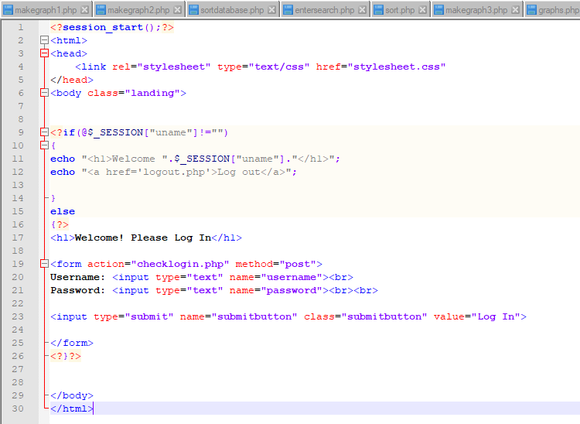
Here is the structure of the log in page. We can see the link to the style sheet at the top of the code. There is a heading which welcomes the user to the page and prompts them to log in. Then, a form is used to allow the user to input the username and password. Once the user has entered their details, they press the submit button, which then checks the details against the details in the database. This decides whether the user is successful in their log in.

Graphs
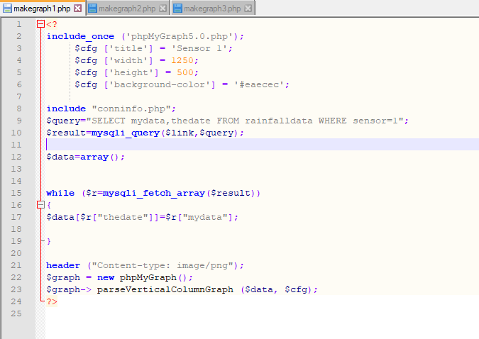
Using a graph, the user can see and understand the data a lot better than taking it at face value. The above code shows the graph being made using PHP. It takes the data from the database and converts it into a graph. We can see the query (line 9) which takes the data (mydata, thedate) for rainfall and date/time respectively from the table ‘rainfalldata’. ‘Sensor 1’ has also been selected, the above code is for Sensor 1 only, and the other 2 tabs on top are for Sensors 2 and 3.
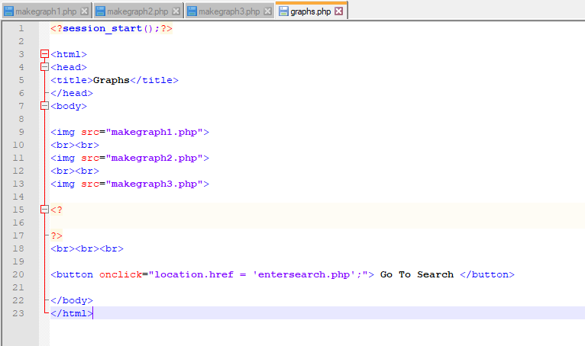
Since all the graphs have been created on different pages, we need to put them together. This is what the above code is for. The code is a mix of PHP/HTML for possible expansion in the future. This puts all the graphs in one place, there is also a button to return the user to ‘Search’ page.

The graphs used are Vertical Column Graphs. These are very easy to understand and read the data, the user can easily see the highest value. The graphs also have a set width and height to ensure they are all the same.

Data Transfer
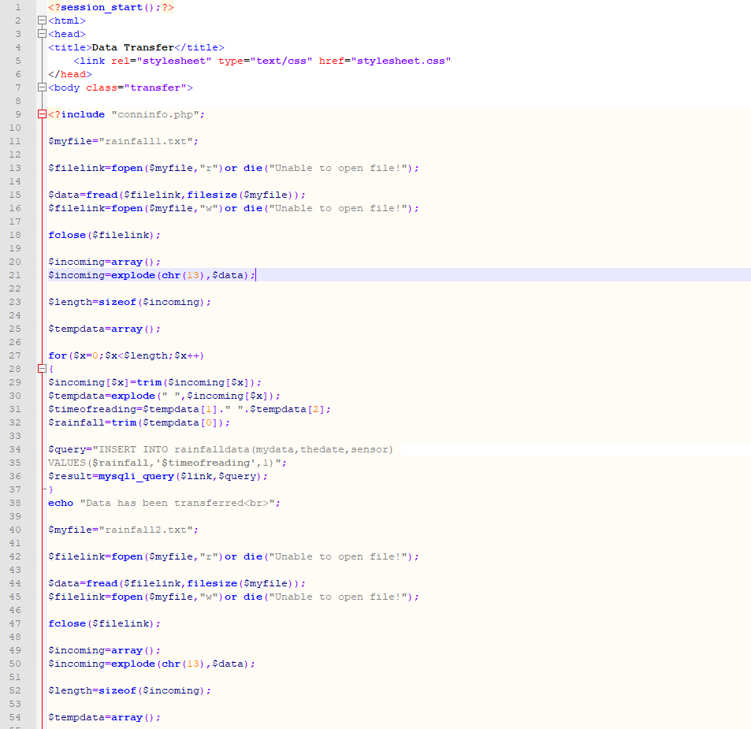
Here is the code that transfers the data from the text files into the database.
Once the files have been transferred it gets deleted from the text files, so it doesn’t get duplicated in the database. This would cause a multitude of problems when it comes to reading and/or presenting the data.
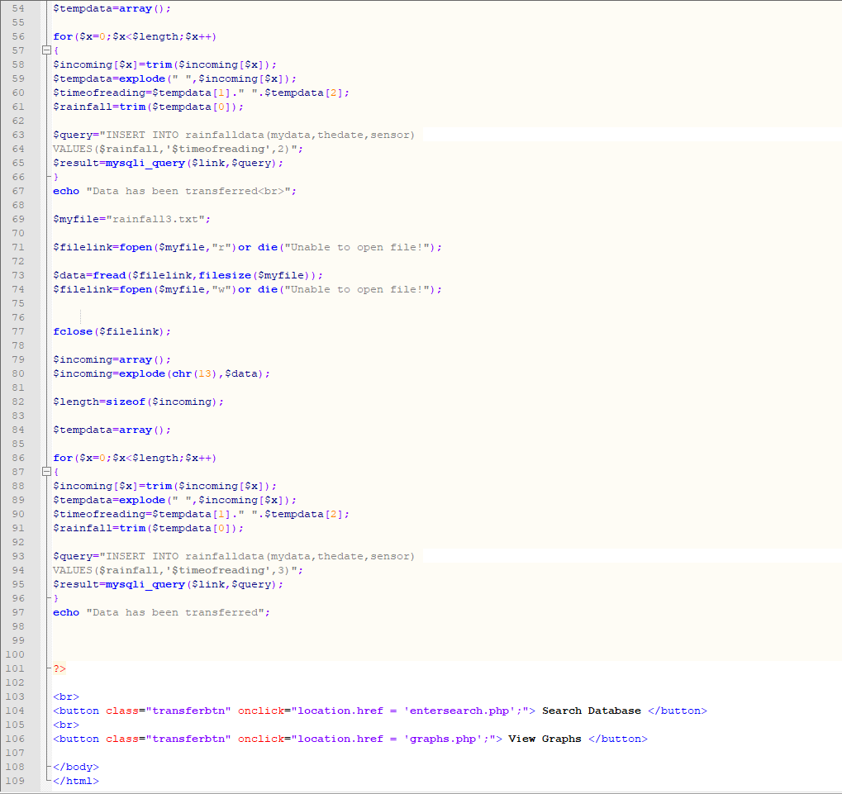
Another big advantage of this is storage, if the text file kept getting updated every hour with 3 different entries, this would quickly add up.

Searching
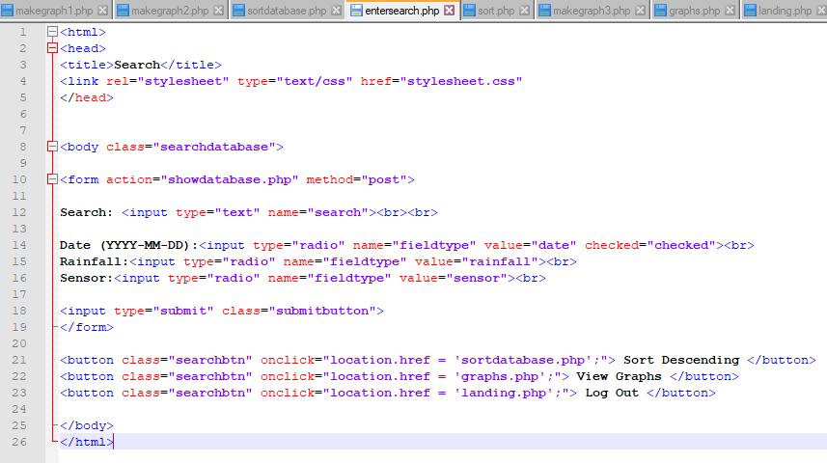
This allows the user to search the database for specific data within the database. The user selects one of the radio buttons for ‘Rainfall’, ‘Date’ or ‘Sensor’ and then use the search bar to search within the field they previously selected.
Once the user presses the submit button, the database gathers and displays data matching the search criteria. This allows the user to quickly find whatever data the need, whether it may be specific to a sensor, or a certain amount of rainfall in this case.
There are also buttons on the page that allows the user to navigate through the webpage. They can go from one page to the other, easily being able to transition between pages.

Sorting
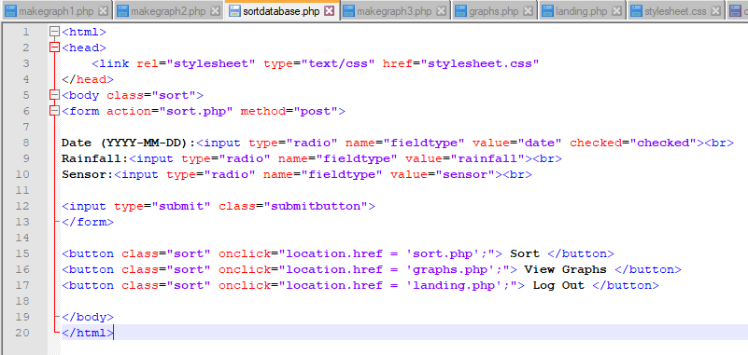
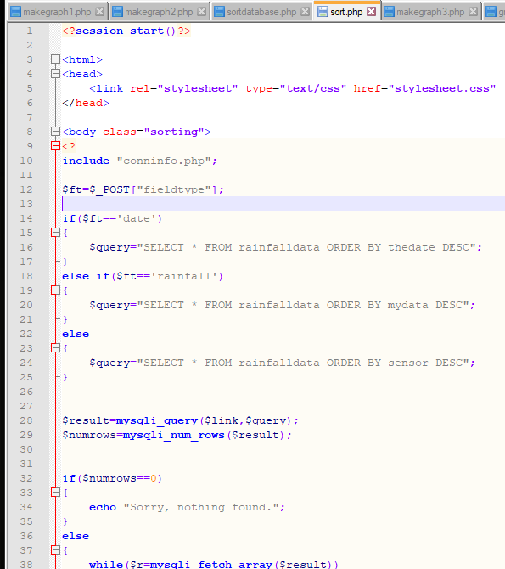
The sorting feature allows the user to order the data into a specific order. In this example, the user can sort either the rainfall, date, or sensor in descending order. For the sensors this is pointless, unless the sensors are specifically located, and the user would like to find out the results from that specific place.
The descending order is best for either the date or the amount of rainfall. Sorting the date by descending order will show the user the most recent results and ordering the rainfall in descending order shows the user what time on what day had the most rainfall.

Styling
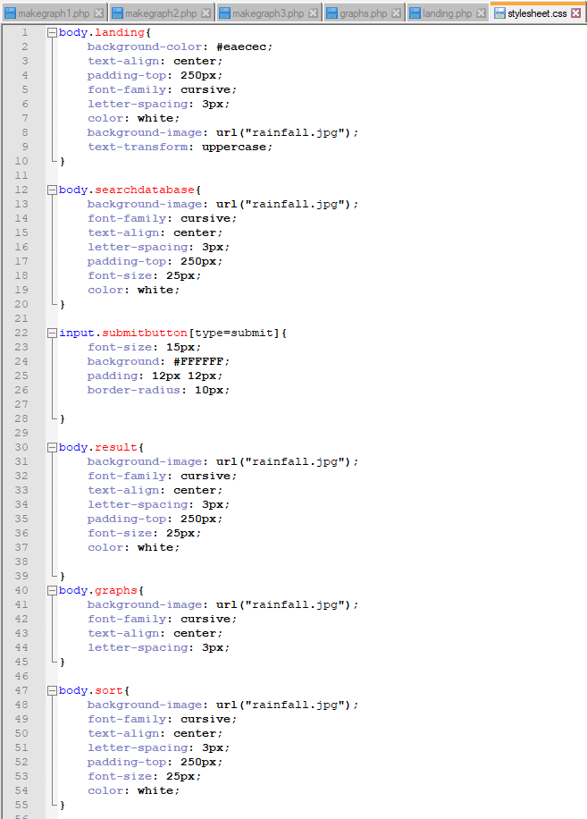
The styling is a Cascade Style Sheet file (CSS). With this, the webpage can look a lot better than just plain, dull text. Using the correct techniques, the webpage can look a lot more like a website as opposed to the standard database layout. You need to link the CSS to each different page of code that you would like to use it on in order to work. Also, if you want to use only one CSS, you need to identify the class in which you are editing.

Linking to the Database
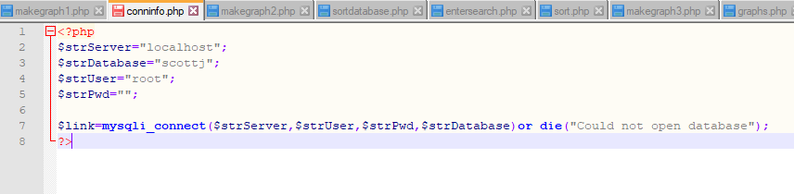
This is the code that connects/links the database to the webpage. Each page of code that isn’t specifically linked to another page (except the CSS file) has a line of code which says
include “conninfo.php”;
we can see this at the top of most pages, for example the ‘transferfromsensor’ page. Without this code, the other pages wouldn’t know where it is linked to and wouldn’t work.

Log Out
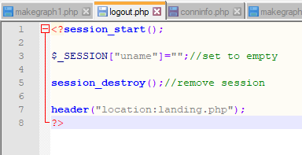
This is the code that logs the user out of the session. The log out buttons throughout the webpages are directly linked to this php file. This will end the session and redirect the user to the landing page. This is where the users log back in.

A big problem with all the code is that the user can directly connect to a page within the webpage by inserting the correct path into the URL path without necessarily being logged in. A possible way to fix this would be to use an IF statement to check if the user is logged in or not, if the user is logged in they can proceed. IF not, they will not be able to access the page.

