Cloud Engineering Assessment
Docker Containerisation, Cloud Scalability and Serverless Web Services

Module: Cloud Engineering
Assessment type: Individual report
Word count: 5000 equivalent
Student name: Daudul Islam
Student number: 2507415
Submission date: 11.05.2026
Video demonstration link:
Declaration: This report discusses cloud engineering concepts and Docker-based class exercises. Before final submission, replace all square-bracket placeholders with your details and add your own screenshots or video link where requested.

Table of Contents
1. Introduction
2. Cloud Technology: Virtualisation, Docker and Containerisation
2.1 Principles of virtualisation
2.2 Principles and benefits of containerisation
2.3 Class exercise: building a Docker image with a Dockerfile
2.4 Images and publishing images to Docker Hub
2.5 Container volumes
2.6 Container networking
2.7 Overall Docker process demonstration
2.8 Good practice, limitations and cloud relevance
3. Cloud Computing Concepts: Load Balancing, Scalability and Application Gateways
3.1 Selected application: cloud-based online learning platform
3.2 Cloud provider approach using AWS
3.3 Why load balancing and scaling are complementary
3.4 Benefits of combining all three technologies
4. Main Driving Forces Behind Cloud Expansion and Serverless Functions
4.1 Cost, flexibility and business agility
4.2 What serverless functions are
4.3 Serverless functions compared with containerisation
5. Video Demonstration Plan and Link Placeholder
6. Conclusion
References
Appendix A. Summary of Docker commands used in the demonstration

Report
1. Introduction
Cloud computing provides the latest digital products of service by enabling organisations to rather than purchase and maintain all the hardware on their end, they utilise the computing resources as a service. According to NIST, the concept of cloud computing is on-demand network access to shared, configurable information (servers, storage, networks and applications) that can be brought forth and released quickly, and with relatively less supervision [1]. This demonstrates the value of cloud engineering in that it provides common resources, elastic capacity, measured usage and access through the network.
This evaluation shows why containerisation with Docker is valuable in facilitating effective deployment to the cloud and why it is important along with virtualisation, load balancing, scalability, application gateways and serverless functions. It introduces the concept of Docker including images, Dockerfiles, Docker Hub and volumes and networking using class-like examples. It then presents the example of online learning platform to demonstrate how the load balancing, auto scaling and API gateways collaborate. Lastly, it examines drivers to cloud growth, particularly cost and flexibility, and makes a comparison of containers versus serverless computing like AWS Lambda and AWS Azure Functions.
The point of view is that containerisation enhances cloud deployment processes by ensuring that applications are made portable, repeatable and simpler to scale or upgrade. Containers are however not the only cloud-native method. A powerful cloud solution deploys the appropriate model to the workload: virtual machines to ensure strong isolation, containers to portable services and serverless functions to event-driven tasks.
2. Cloud Technology: Virtualisation, Docker and Containerisation
2.1 Principles of virtualisation
Cloud computing is based on the concept of virtualisation to a large degree. Some physical server model An example of a traditional physical server model is where a single operating system and a single set of applications runs on a single machine. This would not be very efficient since not all servers are busy utilizing their complete CPU, memory and storage all the time. Virtualisation has the solution: a software layer (commonly referred to as hypervisor) is used to partition a single physical server into a number of isolated virtual machines. All the virtual machines are independent computers that have their own operating system, virtual CPU, virtual memory, virtual disk and a virtual network interface.
The primary one is abstraction. Its hypervisor hides the hardware of a system beneath and the hypervisor introduces virtual hardware to each of the guest operating systems. This enables multiple workloads to be on the same physical machine but is logically isolated. Resource pooling, multi-tenancy and flexible provisioning are all made possible by this in a cloud data centre. A portal or API can allow a customer to request virtual servers, and the provider can assign capacity out of a vast pool of physical hardware without the customer being informed of what is the exact physical location of the server.
The concept of shared-hardware is depicted in Figure 1. Next to the figure, it should be stated that there is a guest operating system in each of the virtual machines. It provides good compatibility and isolation, but has the downside of each VM having additional overhead compared to a container since the guest OS needs to be booted and maintained.
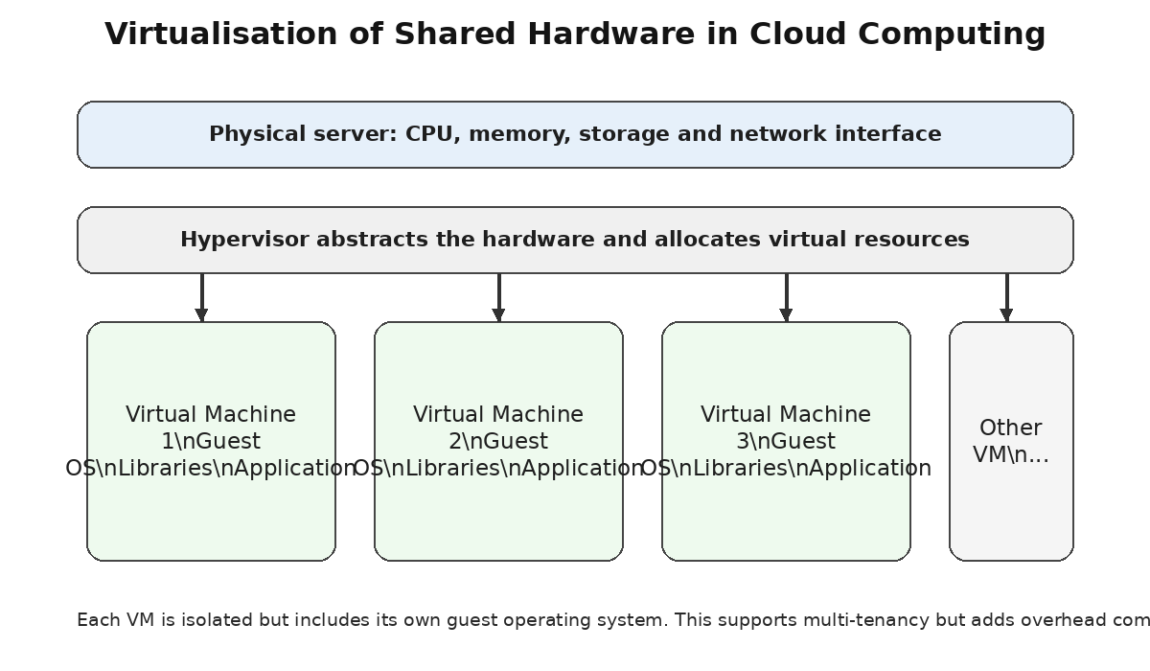
Figure 1. Sharing hardware by means of virtualisation on a hypervisor and several virtual machines.
Cloud engineering has a number of benefits using virtualisation. First, it enhances the utilisation of hardware since lots of systems can be operated by a single host. Second, it aids in isolation since failure or security issue in one virtual machine will not necessarily impact another VM. Third, it allows fast provisioning since cloning of virtual machine templates can be done at a higher rate than the time taken in acquiring and configuring physical server. Fourth, it facilitates migration and disaster recovery as the VM images can be copied, backed up or relocated among the hosts.
Nonetheless, virtualisation has its limits, as well. Virtual machines are slower than containers since they come with a complete guest operating system. They are also more difficult to boot, they consume more storage and have to be patched more. This does not render VMs useless, rather, it indicates the reasons why containers were significant. Both are frequently applied with cloud platforms. A typical architecture is to place containers within virtual machines, providing the isolation and schedulability of VMs to the cloud provider and the development team with the performance of containers that containers provide.
2.2 Principles and benefits of containerisation
Containerisation is a type of operating-system-level virtualisation. Containers do not have to make a full-fledged guest operating system per application but instead share the host operating system kernel but isolate processes, file systems, environment variables and network interfaces. Docker is a popular framework of creating, distributing and implementing container applications. Documentation of Docker explains that a Dockerfile is a text file with the commands that are used to build an image and that an image can be run as a container [2].
The most important is packaging. A container image is composed of an application code, its runtime, libraries, system tools and configuration required to execute the application. This is useful as it makes sure that an application that is known to be working in one machine does not fail in a different machine because of the lack or variation in dependencies. According to Merkow, Docker is described as a lightweight method of containerizing and deploying application uniformly [3], and Felter et al. discovered that Linux containers have the ability to offer the same or even superior performance with many applications, despite the fact that I/O-intensive tasks require specific attention to tuning [4].
Containerisation advantages in cloud engineering are feasible and quantifiable. Containers boot very fast as they are not required to boot a guest OS. They are portable since the same image may be transferred in a laptop of the developer to a test server and to a cloud platform. They also support continuous delivery and DevOps as images can be generated using a pipeline, and be tagged with versions. They can be easily scaled as platforms like Kubernetes, Amazon ECS, Azure Kubernetes Service or Docker Swarm are able to execute numerous instances of the identical picture and substitute containers that have failed. They also promote microservice design where a large system is broken down into smaller services which can be deployed separately.
Containers enhance reproducibility, too. When the source files and Dockerfile are versioned in version control, a different developer can re-create the same image and environment of the application. This helps with the assessment work, classroom activities and industry projects since the deployment process is included in the application, rather than an undocumented process. Reproducibility is required in cloud environment since it can be used to redeploy applications multiple times in development, staging and production.
Limitations exist as well. Containers do not give an isolation boundary equivalent to that of a complete virtual machine as they share the host kernel. BASE images may also be a source of vulnerabilities (when the container images used are old). Secret management should be done with care since passwords will not be written in the Dockerfiles or images. Containers too are ephemeral in nature meaning that the data stored in a container can be lost once it is removed, unless volumes are used or external storage. The value of containers is not eliminated through these restrictions but demonstrates the necessity of appropriate image management, networking, volumes and security scanning.
2.3 Class exercise: building a Docker image with a Dockerfile
The simplest yet complete class activity would be to give a pure web server which displays an HTML page. It illustrates the general procedure that the evaluation will demand: creating a HTML file, creating a Dockerfile, creating an image, launching a container, browsing the web page with a browser and setting up the image to be published to Docker Hub. Figure 2 represents the workflow. The reference implies that the figure must be mentioned first as the evaluation is supposed to contain figure references in the text.
The initial one is to make a small project folder. The folder in this case is referred to as cloud-html-web. It includes index.html page, and Dockerfile. The artefact of the application that is created in the course of the classes is the HTML page. A real-life project might have a React application, Node.js API and Python Flask application or Java service. The test case is necessarily minimal to get a glimpse of the cloud engineering process.
cloud-html-web/
index.html
Dockerfile
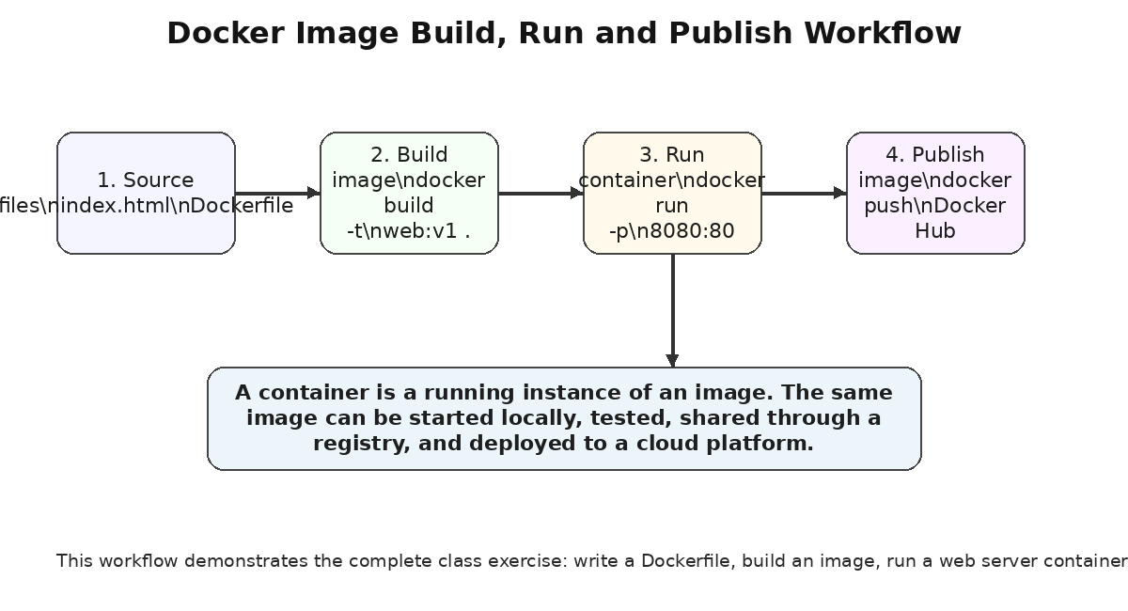
Figure 2. Docker workflow showing source files, image build, container run and Docker Hub publication.

The following HTML file could be written. It has a heading and short text message in order to ensure that the browser content of the page shows that the container is loading the correct class page.
<!DOCTYPE html>
<html>
<head>
<meta charset="UTF-8">
<title>Cloud Engineering Docker Demo</title>
</head>
<body>
<h1>Cloud Engineering Docker Web Server</h1>
<p>This page is served from a Docker container using Nginx.</p>
</body>
</html>
The Docker file has the official light-weight Nginx Alpine image as a base image and transfers the HTML file to the web root. The contents of the EXPOSE instruction files indicate that the container has a port open at port 80 and the bottom base Nginx image is already aware of how to start the web server. According to Docker documentation, Docker images are built by reading a definition (Dockerfile) and thus, a Dockerfile has become the reproducible build script of an image [2].
FROM nginx:alpine
LABEL maintainer="[your-name]"
COPY index.html /usr/share/nginx/html/index.html
EXPOSE 80
It is possible to then construct the image with the contents of the folder by means of docker build. The final dot is the build context which implies that the Docker will look at the folder it is within and forward the required files to the build engine. This is helpful as a tag should be easy to distinguish and identify by its version.
docker build -t cloud-html-web:v1
Once the image has been constructed, it is possible to run it as a container. Its default start mode is -d, which is detached; -name is used to give the container a readable name, and -p 8080:80 is used to map a port on the host machine (port 80) to a port on the container (port 80), default. As the user opens the URL of the server, e.g., localhost:8080 on the browser, the HTML page ought to be displayed.
docker run -d --name cloud-web-demo -p 8080:80 cloud-html-web:v1
docker ps
Through this exercise you are able to distinguish an image and a container. The packaged template is the image and the container is an instance of the image that is running. Whereas the removal of the container will leave the image, it can still be used to build another container. This simplifies the process of rollback and re-deployment of a cloud. As an example, when version v2 of the web page fails version v1 can be re- started based on the existing image tag.
2.4 Images and publishing images to Docker Hub
The more useful the container image is the more it can be shared. The Docker Hub is a publicly accessible image repository, whereby images can be stored and accessed by other machines. According to Docker documentation, pushing content to Docker Hub only requires a tagging of the local image with the Docker Hub namespace and repository name with the subsequent push to the repository [5]. The identical concept is applied to cloud platforms, whereas the production systems can utilize their own registries like Amazon Elastic Container Registry, Azure Container Registry or GitHub Container Registry.
The first step in the publication procedure is to log in the Docker Hub. This will have to be tagged with the account name and repository. The basic process is presented in the form of the following commands. Before it is submitted, the name of the user should be changed as well as the name of the repository.
docker login
docker tag cloud-html-web:v1 [dockerhub-username]/cloud-html-web:v1
docker push [dockerhub-username]/cloud-html-web:v1

The web server can be pushed and ran by another machine after being pushed; it only takes a single command. This will show the importance of registries in cloud computing. The image does not specify to be rebuilt manually on all the servers but rather, the platform downloads a known image version and initiates it. This is what provides repeatable deployment. When the replicas of an application are run on 3 different cloud platforms, then these replicas can be derived using a common image digest.
docker run -d --name cloud-web-from-hub -p 8082:80 \
[dockerhub-username]/cloud-html-web:v1
This can also be aided by publishing pictures to facilitate teamwork. The image can be drawn to check the result by the tutor or another pupil in the classroom. An image can be built whenever a code change is made in the industry, only when the build succeeds the image is built, tests are run and a tagged image is pushed. This enhances reliability since deployments are done based on tested artefacts as compared to manual copying of files.
2.5 Container volumes
Containers are made in a way that they can be substituted. This scales and recovery is good, but poses an issue with persistent data. When only data is written within the container layer it can be lost when the container is removed. Docker volumes can fix this by offering long-lasting data stores that are managed by Docker. Docker documentation refers to the volumes as persistent data stores of containers, and elaborates that containers can be explicitly created with the docker volume create command or can be created automatically when creating the containers [6].
An exercise of classes would be to do a volume of Nginx logs. The image can hold the web page itself and log files will be held in named volume. This illustrates the partitioning of prevailing data and application package.
docker volume create cloud-nginx-logs

docker run -d --name cloud-web-volume -p 8083:80 \
-v cloud-nginx-logs:/var/log/nginx \
cloud-html-web:v1

docker volume ls
docker volume inspect cloud-nginx-logs
The volume can still exist in case the container is taken away by replacing it with a new one with the same capacity. This can be achieved in cloud engineering since the production containers are typically meant to be disposable. Important data needs to be maintained in volumes, managed databases or object storage or other persistent services as opposed to storing them within a single container. As an example, WordPress container can be substituted in an update, saving its database and uploaded files.
Back up and portability are also supported by volumes. The data can be copied out to a temporary helper box by mounting a named volume into the helper box. With the deployment of enterprise clouds, the same can be expanded into persistent volume claims with Kubernetes or managed storage volumes with cloud providers. The hidden meaning is that stateless containers are simpler to scale and stateful information needs to be handled consciously.
2.6 Container networking
Networking can be used to interact between containers and users, and among themselves. Docker has a number of network drivers and bridge driver is generally utilized in one Docker host. According to Docker documentation, a bridge network made use of a software bridge to enable containers on the same bridge network to interact but isolate them to containers that are not on the same bridge network [7]. Bridge networks are defined by users, but bridge networks come in particularly handy as the containers determine each other by name.
A user-defined network can be developed as a class exercise and can run the web container within this network. As a second test, a temporary container can be can be used to test connectivity using the service name. This will be more like a real cloud-native design as compared to linking everything with host ports.
docker network create cloud-demo-net
docker run -d --name web-a --network cloud-demo-net cloud-html-web:v1
docker run --rm --network cloud-demo-net curlimages/curl:latest \
http://web-a
The command above indicates that a container(called web-a), can be accessed by another container on the same user-defined network. This is critical with multi-containers applications. As an example, an API container might be called by a web application container and a database container may be called by an API container. Docker Compose networks Services autojoin a project network and can be accessed with a name. The principle is referred to as service discovery, virtual private cloud networking, security groups and internal load balancer in cloud platforms.
The end user of Docker will require a port publishing when other users who are not within the Docker require access to a container. The web server of the host machine was vulnerable in the previous run command -p 8080:80. The web container can also be accessible to other containers in the same Docker network, but cannot be accessed in the browser without port publishing. This difference explains cloud networking: internal traffic involving service to service, and external traffic information involving a customer often is treated differently.
2.7 Overall Docker process demonstration
The process that the assessment as a whole requires can be exhibited in the form of one scenario. The student develops a static web page, develops a Docker image, starts the image in a container, opens the page in a browser, develops a volume to store logs, develops a network to interact with each other and deploys the image to Docker Hub. The above situation illustrates key Docker principles in a coordinated process as opposed to single instructions.
An appropriate illustration sequence is as shown below. Begin by demonstrating the project folder and index.html, and Dockerfile. Second, execute docker build to build the picture. Third, start the container port mapping and launch the browser. Fourth, press and delete the picture to demonstrate that the picture is still there. Fifth, mount a volume and start the container, to which the volume is mounted to /var/log/nginx. Sixth, develop a network and test another container by name which reaches the web container. Seventh, push and label the picture to Docker Hub. Eighth, demonstrate the bagpage in the Docker Hub or execute the image in the registry.
# 1. Build
docker build -t cloud-html-web:v1 .
# 2. Run locally
docker run -d --name cloud-web-demo -p 8080:80 cloud-html-web:v1
# 3. Test in browser
# Open: http://localhost:8080
# 4. Volume example
docker volume create cloud-nginx-logs
docker run -d --name cloud-web-volume -p 8083:80 \
-v cloud-nginx-logs:/var/log/nginx cloud-html-web:v1
# 5. Network example
docker network create cloud-demo-net
docker run -d --name web-a --network cloud-demo-net cloud-html-web:v1
docker run --rm --network cloud-demo-net curlimages/curl:latest http://web-a
# 6. Publish
docker login
docker tag cloud-html-web:v1 [dockerhub-username]/cloud-html-web:v1
docker push [dockerhub-username]/cloud-html-web:v1
This is a clear indication as to why Docker is important in cloud. The web server is not emanatized on the target machines. Rather, the installation instructions are packaged into the Dockerfile, and developed into an image and are offered in a registry. The identical image could be tested on-site with a classroom or by someone else to ensure correctness, or on a cloud system when it is put into service. This minimizes configuration drift, and encourages faster release cycles.

2.8 Good practice, limitations and cloud relevance
Best practice of Docker enhances performance, reliability and security. Images: They have to be kept small through appropriate base images and unnecessary packages should be avoided. Only necessary files should be copied only in its Dockerfile. The image should not be written with any secrets like passwords and API keys. Image tags are supposed to be relevant e.g. v1.0.0 or a commit hash rather than just latest. Base images should also have security updates by periodically updating on images. The written logs must have the potential to be written to standard output to ease their collection in one place by cloud platforms.
The assessment sample is Nginx Alpine since it is lightweight/simplistic. In more complicated cloud application, multi-stage might be used against the Dockerfile. An example is that an application written in Node.js or Java can be built during a single build phase then the final built artefact simply copied into a lower-level runtime image. This will minimise the image size and minimise the attack surface. Recommended docker build best practices guide promotes image development in the most proficient way possible and reuse of reused cache layers that are appropriate [8].
The key cloud applicability is that containers make the deployment of applications infrastructure independent artefact. Clusters Cloud platforms are able to schedule containers and restart failed containers as well as deploying replicas in other availability zones and link them together via load balancers. Microservices can also fit into containers, with the ability of an individual service to be updated. Containers though are not safe and scaleable in and of themselves. They require good image governance, image network plan, monitoring, storage plan and orchestration. Thus, Docker is to be seen as a component of a broader cloud engineering community.
3. Cloud Computing Concepts: Load Balancing, Scalability and Application Gateways
3.1 Selected application: cloud-based online learning platform
The selected application will be an online student/tutor learning platform based on the cloud. The user is able to log in, view the recorded lesson, online submission of coursework, view announcements and assessment feedback. The amount of work is flexible. The peak traffic can be minimal during the night time, moderate during any regular teaching week and peak right at the deadline or a live online lesson. This contributes to its being an appropriate case study on illustrating load balancing, scalability and application gateways.
The application is envisioned as being composed of a number of services: a web front end, an authenticator service, coursework upload service, notification API and database. Containers can be used to run the front end and the APIs. Object storage can be used to store static files and the database can be a managed cloud database. The demand fluctuation should result in a visible reliable service by the customer. The figure 3 indicates that one can combine API Gateway, load balancing and auto scaling to apply in this application.
3.2 Cloud provider approach using AWS
3.2.1 Load balancing
Load balancing is implemented by a cloud provider in front of numerous application targets by putting a managed service in front of them. In AWS, Elastic Load Balancing will automatically spread the incoming traffic to targets (e.g. EC2 instances, containers and IP addresses) in an Availability Zone(s) and IP addresses to a minimum of one or more Availability Zones; it will also monitor the health of targets and send traffic only to healthy targets [9]. In the case of the online learning platform, the HTTPS requests can be sent to an Application load balancer that in turn forwards it to multiple container tasks that are executing the web application.
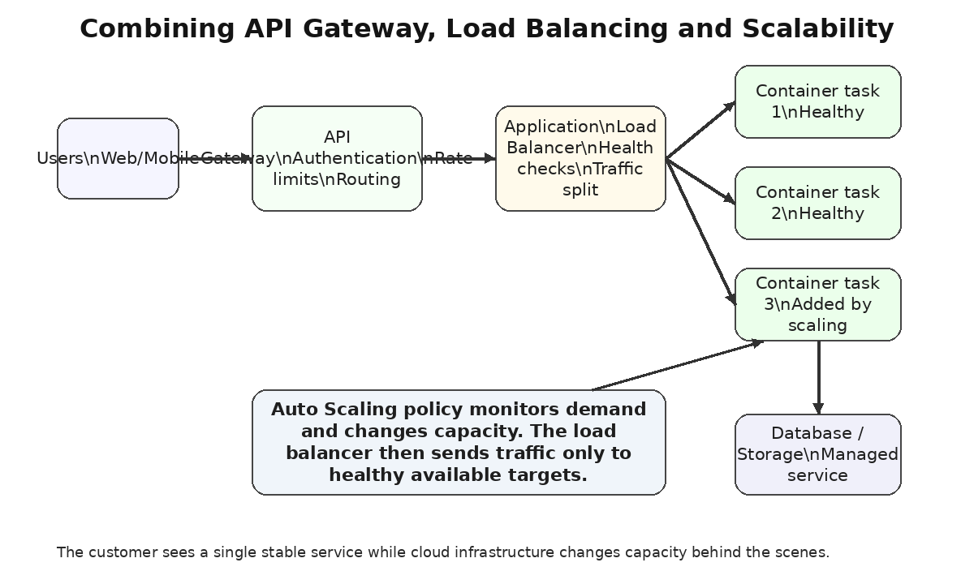
Figure 3. Example architecture for an online learning platform using API Gateway, load balancing and auto scaling.
Load balancing enhances availability since failure of one instance of an application does not imply the entire service is not available. When a container gets unhealthy, the load balancer will cease to send traffic to the unhealthy container and switches to healthy ones. Load balancing assists in maintenance as well. One can deploy a new version of the application to new containers and traffic could be shifted progressively when health checks are positive.
3.2.2 Scalability
Scalability refers to the capacity of a system to enable it to respond to variations in demand. Vertical scaling enhances power of one server, such as adding CPU or memory to a server. Horizontal scaling can be used to add additional instances of the service. Cloud-native applications tend to favor horizontal scaling since it is possible to arrange multiple smaller instances available in more availability zones, and these are easily replaced.
The simulation of AWS offers scaling services like EC2 Auto Scaling, Application Auto Scaling. According to AWS documentation, EC2 Auto Scaling can be used to ensure the availability of the application, as well as to lower the cost by adding capacity during peak loads and removing capacity when the demand is decreased [10]. In the context of a container-based learning platform, the cloud platform might be able to add more running container tasks as CPU utilisation, number of requests (or queue depth) rises. In case of decreased demand, it has the capability of cutting down the number of tasks so as not to pay on the run to nothing utilized.
Scalability is a technical attribute but that influence user experience as well. When a coursework is due they might at the same time submit hundreds of files. In the absence of scaling, requests can easily have a time out or the server can be overloaded. More replications of the applications can be initiated with scaling. This does not eliminate consideration of careful database design or file storage planning but the application layer can take changes in the traffic.
3.2.3 Application gateways
Application gateway is placed in front of an application and calculates the access to the backend services. In AWS, the Amazon API Gateway is a managed service that provides a scaling of creating, publishing, maintaining, monitoring, as well as securing of REST, HTTP and WebSocket APIs [11]. The API Gateway can be used to expose API endpoints like /login, /courses, /submissions and /notifications in the online learning platform.
Application gateway does not just add value to mere forwarding of traffic. It is able to perform authentication, throttling or rate limiting, validate request format, offer API versioning and gathering monitoring data. It also isolates the public API agreement as well as the internal service plan. This can be illustrated by the students calling a single public endpoint, and the gateway making the request go to various services within the interior based on the route and approach used. This enhances maintainability since identity services do not require any internal addresses to be learnt by the users.
Application gateways prove to be particularly significant when APIs are used by a number of consumers like web browsers, mobile apps and third-party systems. This can be achieved without a gateway so all backend services could be required to provide their own security, throttling and monitoring. It is possible to centralise many cross-cutting to a gateway. **********
3.3 Why load balancing and scaling are complementary
Load balancing and scaling are complementary in that scaling varies the available capacity whereas with load balancing, the traffic is distributed over the available capacity. A scaling of its own is insufficient. When the platform is initiated with 3 extra containers but all requests would be sent to a single old server, then the new capacity would go to waste. It is not sufficient to do load balancing. Assuming that there are only two instances and a doubling of traffic, the load balancer will be able to evenly share the traffic, but it is still possible that both instances will be overloaded.
The two technologies complement each other to form elasticity. In case of high demands, auto scaling is used to add targets. The load balancer identifies new targets which appear to be healthy and routes the traffic to them. and when there is less demand, auto scaling ends up disabling superfluous targets, and the load balancer ceases to utilize them. This relationship among demand, capacity and routing is a fundamental cause as to why cloud computing has the potential of providing performance and cost efficiency.
In the case of the online learning platform, load balancing will prevent the connection of all the students to a single application container. Scaling will be to ensure that there are sufficient containers in peak times. The customer advantage is a consistent customer experience during peak times and discount during off peak times.
3.4 Benefits of combining all three technologies
A combination of API Gateway, load balancing and scalability offers better service compared to the use of either of the technologies. The API Gateway provides a secure and regulated more entry point. It is able to authenticate requests, throttle up abusive clients as well as make API calls. The load balancer offers resilien traffic load to healthy targets of applications. Auto scaling varies using capacity to enable the service to address demand variations.
With the online learning platform, an HTTPS request to the API Gateway is made by a student who clicks on the mobile app. The gateway checks the request and forwards it to the appropriate path to the backend. The load balancer requests a healthy container with the request. Auto scaling will make sure that there are sufficient containers that are online to match the demand. In case of failure in one container, then the load balancer eliminates it. In case there is an increase in traffic, close to the deadline, auto scaling will begin to create additional containers. Unutilised containers are eliminated in the event of traffic being less than the deadline.
The outcome of the integrated customer is the reliability, performance, security and cost control. This enhances reliability since there is no instance of application that needs to deal with all the traffic. This enhances performance since the traffic can be spread onto a number of healthy instances. It enhances security since centralisation of API access controls is possible. It also has benefits in control of costs since scaling could minimize capacity in the situations when there are no demands. This is among the reasons why cloud services are ideal with variable-need web applications.
4. Main Driving Forces Behind Cloud Expansion and Serverless Functions
4.1 Cost, flexibility and business agility
The growth of cloud computing is caused by both the technical and business drives. One of the significant driving forces is cost. The conventional IT involves capital spending on servers, storage, and network equipment, and data centre space and management. Cloud computing alters a lot of this to operational expenditure since organisations are able to pay as they consume them. One of the key attributes of cloud computing described by NIST is measured service, i.e., the usage of the resources can be observed, regulated and recorded [1].
Another prominent driver is flexibility. There is an ability to release the cloud resources fast. This enables the organisations to do experimental applications by not having to wait months before hardware is obtained. Gartner predict that global market consumption of public cloud end users will amount to $723.4 billion in the year 2025 which is an increase on 595.7billion as of the year 2024 indicating the ongoing strategic relevance of cloud service in organisations [12]. Such expansion not only signifies cost saving but also the requirement to be elastic, robust, data analytics, AI services and access around the globe.
Scalability is directly related to flexibility. A company should not have to design to the maximum extent that the demand may reach. Rather, when demand increases it is able to scale out whereas when it decreases it is able to scale in. This can be applied to e-commerce, learning, media streaming, healthcare portal and government portal. This can also be applied to a student project: a demonstration which runs on the cloud can be initially scaled small yet can apply the patterns which would trough larger traffic.
The other value is the efficiency of operation. The number of infrastructure that teams would have to maintain directly is minimized by managed services. E.g., a team that employs managed databases, operated container platforms, and operated gateways can allocate a greater time towards functions of the application. Cost does not however go down automatically due to cloud. Unmanaged cloud infrastructure may result in the wastage of money in idle resources, oversized or idle storage. The State of the Cloud report released by Flexera indicates that organisations still place a lot of emphasis on cloud cost management and efficiency [13].
Cloud facilitates a global outreach as well. Provisioners have regions/availability of different parts of the world. An application can be scaled out and brought nearer to the users thereby minimizing latency as well as enhancing resilience. Automation of cloud environment is also promoted via APIs and infrastructure-as-code tools in cloud systems, which implies the fact that the environments can be recreated. These are the reasons that are behind the growth of containerisation and serverless functions: both are forms to enhance the levels of portability, as well as automation and resource efficiency.
4.2 What serverless functions are
The term serverless computing is not to imply that there are no servers. It implies that the cloud-computer company runs the servers, the runtime environment, the scaling and much of the work. Developers put up little bits of code known as functions, and the provider executes such functions in the event of a response. AWS Lambda is defined as a compute service, a service on which AWS can execute codes, and automatically scale up and down smoothly and cost-per-use priced [14]. Azure Functions according to Microsoft are a serverless solution to create applications that use fewer code, less infrastructure and lower costs with the cloud infrastructure supplying the resources to operate the application [15].
The invocation of a serverless function can be in response to an HTTP request, a queue message, an uploaded file, a timer or a database event. To give an illustration, under the online learning platform, serverless will be used to generate a thumbnail as a tutor uploads a video, an email as a coursework is submitted, scan an uploaded file or update analytics when a student has finished a lesson. These workloads are event based, and do not necessarily need a continuously running container.
The approaches relating to containers and serverless functions are compared in Figure 4. The reason why the figure is added here is that both approaches package and run application logic, differing in the activity they allocate different degrees of control and responsibility to the developer.
4.3 Serverless functions compared with containerisation
Both containerisation and serverless functions aid in cloud growth, but they meet various demands. Complete applications services are bundled by containers and are ideal in the cases of long running web applications, APIs, background workers and microservices that require access to the control of runtime, dependencies, and networking. Serverless functions consist of smaller chunks of event-driven code, and can be used when work occurs in bursts, or in reaction to particular events.
In terms of cost, serverless functions can be enticed where there are intermittent workloads since the organisation is not required to retain a server or container alive all the time. As an illustration, when the learning platform only delivers confirmation of submission e-mails when students upload coursework, a function can be executed only when necessary. Containers can prove to be more predictable and optimisable to a constantly busy API, however.
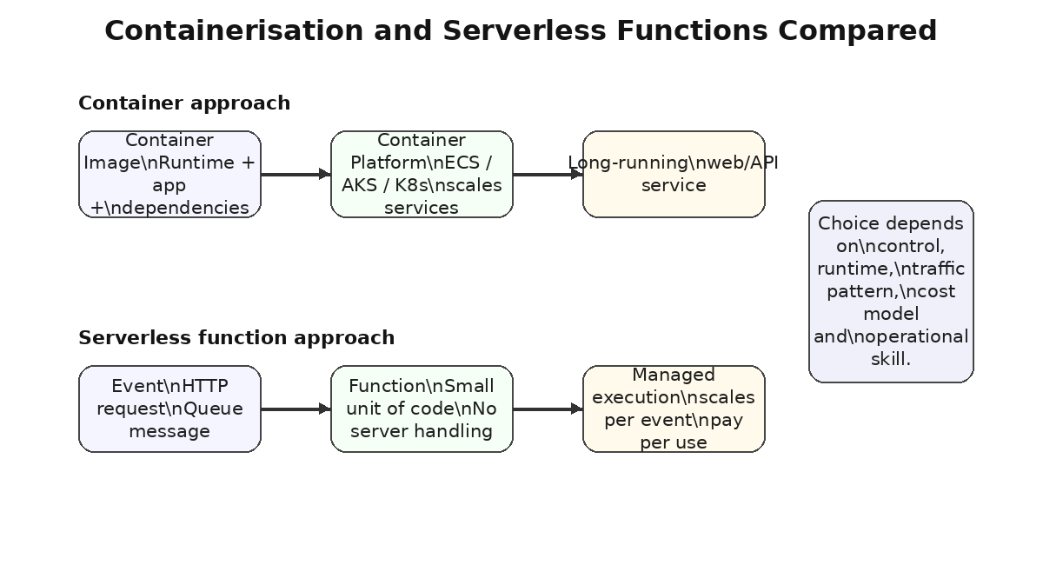
Figure 4. Comparison of container-based services and serverless function execution
In terms of flexibility, containers provide flexibility to developers. They have a choice of the base operating system, mounting system packages, opening ports and running long running processes. This causes containers to be compatible with purpose-built applications which require a particular dependency. Convoluting Serverless functions lessen operational control and quicken simple occasion-driven duties. Instead of a developer writing a function to provide much of the scaling and infrastructure, a developer can leave it to the provider.
Area | Containerisation | Serverless functions | Cloud driving force
Operational control | High control over image, runtime, libraries, ports and process model. | Less control over underlying server and runtime lifecycle. | Flexibility versus simplicity.
Scaling model | Usually scales by increasing or decreasing service replicas. | Scales per event/request according to provider limits and configuration. | Elasticity and demand matching.
Cost model | Pays for running container infrastructure while tasks are active, even if lightly used. | Usually pays per request and execution time, which can be efficient for intermittent workloads. | Cost optimisation.
Portability | Images can run across many container platforms with fewer changes. | Functions may depend more strongly on provider triggers and services. | Avoiding lock-in versus managed productivity.
Best fit | Web APIs, microservices, long-running services, custom runtimes. | Event processing, scheduled tasks, file processing, lightweight APIs. | Agility and reduced operations.
Limitations | Requires image management, orchestration, patching and network design. | Cold starts, execution limits, provider-specific design and monitoring complexity. | Performance and governance trade-offs.
Table 1. Comparison of containerisation and serverless functions in relation to cloud expansion drivers.
Intuitively speaking as a cloud engineer, a combination of the two is usually the greatest option. The online learning platform could be deployed in the form of containers having their main web application and APIs that will run on a load balancer, and serverless functions that file processing, notifications, and scheduled cleanup. The central forces of cloud growth are supported by this hybrid approach which includes costs and flexibility, fast deployment, high resiliency and decreased operating overhead.
Architectural dangers are present as well. Serverless functions have the potential to generate vendor lock-in when the function relies on provider specific event formats, or identity service or storage triggers. Containers are portably more convenient, yet not impeccable due to the possibility of networking, storage and orchestration features between providers. Monitoring monitoring, logging and security design is necessary in both approaches. Thus, the decisions between them must be made on the basis of the workload features, instead of being trendy.
5. Video Demonstration Plan and Link Placeholder
Video demonstration link:
The video should be under 15 minutes and should demonstrate the examples used in this report. A suitable structure is:
• 0:00-1:00: Introduce the project folder, objective and tools used.
• 1:00-3:00: Explain the Dockerfile and index.html file.
• 3:00-5:00: Build the image using docker build and explain the image tag.
• 5:00-7:00: Run the container with port mapping and show the HTML page in a browser.
• 7:00-9:00: Create and inspect a Docker volume, then run the container with the volume mounted.
• 9:00-11:00: Create a Docker network and test container-to-container communication.
• 11:00-13:00: Tag and push the image to Docker Hub.
• 13:00-15:00: Summarise how the demonstration proves virtualisation/containerisation concepts and links to cloud deployment.
For presentation marks, the video should speak clearly, show the terminal commands, show the browser output, and briefly explain why each command matters. The video does not need advanced editing. It should be understandable to someone who has not watched the class exercise. Screenshots from the video can also be inserted into the final report if required by the lecturer.
6. Conclusion
This report has indicated that Docker containerisation is a significant cloud engineering solution since it packages applications and dependencies into repeatable images which can be repeatedly built, tested, shared and deployed. The basis of cloud computing has been virtualisation since it enables shared physical machines to be partitioned into single virtual machines. Containerisation elaborates on this by offering a model of application packaging that is lighter in nature to support portability, fast-start and efficient scaling.
In the example that outlined the class style, the entire process involving making a web page, making a Dockerfile, building an image, running a container, using a volume, making a network and publishing the image to Docker Hub were demonstrated. These steps demonstrate how an application can be transitioned through a series of practical steps starting with a local exercise, to a cloud-ready artefact. The problem of persistence solved by volumes can be addressed by disposable containers and networks by services interacting in a regulated manner.
How load balancing, scalability and application gateways collaborate in an online learning platform supported by a cloud was also described in the report. Load balancing allocates to healthy targets, capacity is adjusted to demand using scaling of capacity and an application gateway gives distributed API access. When combined these technologies can provide a more reliable, secure, responsive and cost-efficient service to the customers.
References
[1] P. Mell and T. Grance, The NIST Definition of Cloud Computing, NIST Special Publication 800-145. Gaithersburg, MD, USA: National Institute of Standards and Technology, 2011. [Online]. Available: https://csrc.nist.gov/pubs/sp/800/145/final.
[2] Docker, "Dockerfile reference," Docker Docs, 2026. [Online]. Available: https://docs.docker.com/reference/dockerfile/.
[3] D. Merkel, "Docker: Lightweight Linux containers for consistent development and deployment," Linux Journal, vol. 2014, no. 239, 2014. [Online]. Available: https://www.linuxjournal.com/content/docker-lightweight-linux-containers-consistent-development-and-deployment.
[4] W. Felter, A. Ferreira, R. Rajamony, and J. Rubio, "An updated performance comparison of virtual machines and Linux containers," in Proc. 2015 IEEE Int. Symp. Performance Analysis of Systems and Software (ISPASS), 2015, pp. 171-172. [Online]. Available: https://research.ibm.com/publications/an-updated-performance-comparison-of-virtual-machines-and-linux-containers.
[5] Docker, "Push images to a repository," Docker Docs, 2026. [Online]. Available: https://docs.docker.com/docker-hub/repos/manage/hub-images/push/.
[6] Docker, "Volumes," Docker Docs, 2026. [Online]. Available: https://docs.docker.com/engine/storage/volumes/.
[7] Docker, "Bridge network driver," Docker Docs, 2026. [Online]. Available: https://docs.docker.com/engine/network/drivers/bridge/.
[8] Docker, "Building best practices," Docker Docs, 2026. [Online]. Available: https://docs.docker.com/build/building/best-practices/.
[9] Amazon Web Services, "What is Elastic Load Balancing?," AWS Documentation, 2026. [Online]. Available: https://docs.aws.amazon.com/elasticloadbalancing/latest/userguide/what-is-load-balancing.html.
[10] Amazon Web Services, "What is Amazon EC2 Auto Scaling?," AWS Documentation, 2026. [Online]. Available: https://docs.aws.amazon.com/autoscaling/ec2/userguide/what-is-amazon-ec2-auto-scaling.html.
[11] Amazon Web Services, "Amazon API Gateway," AWS Documentation, 2026. [Online]. Available: https://docs.aws.amazon.com/apigateway/latest/developerguide/welcome.html.
[12] Gartner, "Gartner forecasts worldwide public cloud end-user spending to total $723 billion in 2025," Gartner Newsroom, Nov. 19, 2024. [Online]. Available: https://www.gartner.com/en/newsroom/press-releases/2024-11-19-gartner-forecasts-worldwide-public-cloud-end-user-spending-to-total-723-billion-dollars-in-2025.
[13] Flexera, "The latest cloud computing trends: Flexera 2025 State of the Cloud Report," Flexera Blog, 2025. [Online]. Available: https://www.flexera.com/blog/finops/the-latest-cloud-computing-trends-flexera-2025-state-of-the-cloud-report/.
[14] Amazon Web Services, "What is AWS Lambda?," AWS Documentation, 2026. [Online]. Available: https://docs.aws.amazon.com/lambda/latest/dg/welcome.html.
[15] Microsoft, "Azure Functions overview," Microsoft Learn, 2026. [Online]. Available: https://learn.microsoft.com/en-us/azure/azure-functions/functions-overview.
Appendix A. Summary of Docker commands used in the demonstration
# Build the image
docker build -t cloud-html-web:v1 .

# Run the web server container
docker run -d --name cloud-web-demo -p 8080:80 cloud-html-web:v1

# View running containers
docker ps

# Stop and remove a container
docker stop cloud-web-demo
docker rm cloud-web-demo

# Create a volume
docker volume create cloud-nginx-logs
docker volume inspect cloud-nginx-logs

# Run with volume mounted for logs
docker run -d --name cloud-web-volume -p 8083:80 \
-v cloud-nginx-logs:/var/log/nginx \
cloud-html-web:v1

# Create a Docker network
docker network create cloud-demo-net

# Run the web container in the network
docker run -d --name web-a --network cloud-demo-net cloud-html-web:v1

# Test container-to-container communication
docker run --rm --network cloud-demo-net curlimages/curl:latest http://web-a

# Publish to Docker Hub
docker login
docker tag cloud-html-web:v1 [dockerhub-username]/cloud-html-web:v1
docker push [dockerhub-username]/cloud-html-web:v1

