Groups for assessment two

Group number | Members of the group | MS Teams code for groupwork
Group one | Barbu Iulia Cosmina | x2ns723
Group one | Mahamud Ali Jaylani | x2ns723
Group one | Ardelean Viorel | x2ns723
Group two | Petrea Dragos Mihai | blyvbew
Group two | Andronache Florin -Alin | blyvbew
Group two | Mocanu Paula Georgiana | blyvbew
Group three | Raza Muhammad Usman | st93084
Group three | Syed Muhammad Zahoor Shah | st93084
Group three | Miron Ciprian Florin | st93084
Group four | Barrier Wendy | bw2gv1k
Group four | Styler Nicole Marie | bw2gv1k
Group four | Valkanov Georgi Todorov | bw2gv1k
Group five | Ackah Bozo Cristina | hgrydao
Group five | Akhtar Minaaz | hgrydao
Group five | Majid Mohammed | hgrydao
Group six | Choudhury Modud | nptyc6t
Group six | Garcia Vaz Wilangela Da Graca | nptyc6t
Group six | Akhtar Minaaz | nptyc6t
Group seven | Bagl Gannah Abdo Sattar | 3jkfloc
Group seven | Kosar Soniya | 3jkfloc
Group seven | Vartolomei Gabriel - Florin | 3jkfloc
Group eight | Kosar Rukhsana | t3gilp5
Group eight | Phipps Reuben Sylvester | t3gilp5
Group eight | Blair Jeffry Junior | t3gilp5

Instructions on how to join your team
Step1: Identify your group number and find your teams code in the last column of the table above
Step 2: Open Microsoft teams and click on the teams tab on the left hand side
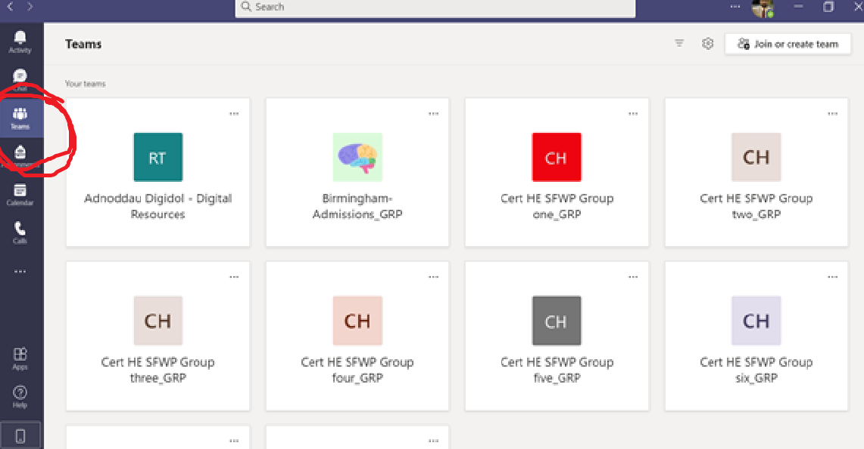
Step 3: Click on the “Join or create team” button at the top right-hand side
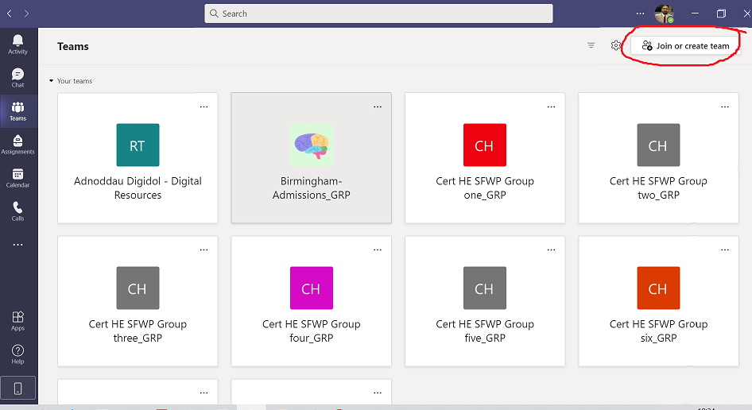

Step 4: Select join teams with code and enter the code above
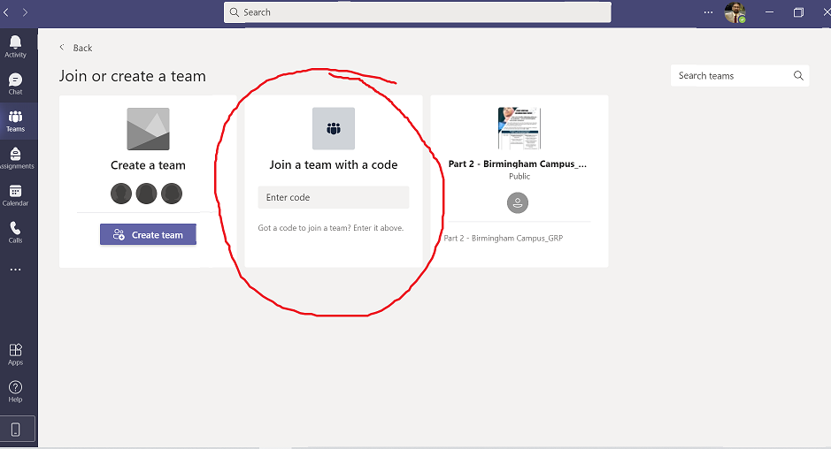
You have joined your team for assessment two!

ONLY join the group that you are part of. If you are having issues with any of the steps above your tutor will help you in the main session. It is important that you join your group on MS Teams and perform the groupwork there towards successful completion of assessment two.
Best of luck with your teamwork!!!

