Report
Lyubomira Andreeva (1914971)
1914971@student.uwtsd.ac.uk
Abstract
Part A Understanding, Part B Interpretation, Part C Implementation.
Exercise 1,2 and 3
[Software Development]
[Assignment Section 1]

Table of Contents
Introduction 3
Part A (Understanding) The difference between variables and constant: 4
How to covert one type to another 6
Control structures and Loops: 8
Operators in C# 12
Part B (Interpretation) Appendix A 13
Part C Implementation: Exercise 1: 16
Exercise 2: 20
} 22
Exercise 3: 24
Flowchart: 25
References 26
References 27
References 27

Introduction

C # is a modern, general purpose, object-oriented programming together with the. NET language, produced and developed by Microsoft server. The programme built with C # based on the. NET is highly diverse. Programs in C # workplace, mobile apps, blogs, desktop applications, mobile applications, games and many others, and so on. All C # programming is object-oriented. These consist of a set of class definitions containing methods and the methods include the logic of the system-the instructions that the machine executes. I will look at in details many of base programming key words, where we store the information under the key words name(string, char, bool), and data type-double,int,float,short,long (when we keep the information as a integer-different size of numbers, or string as a characters, array – set of words). The different between variable and constant I will mention here: Constants have a form, a name and a value, as with variables. In comparison to variables, constants must be initialised at the same time as declared and must be prefixed with the const keyword, and more deeply I will explain them in the pages below. We can convert one type to an other as well when we want the programme to read from string to integer for example. The command, which we use is ConvertTo and then data type can we ConvertToInt32 and so on. In the last part I will talk about Control Structures. They are essentially a way of defining control flow in programmes. Any algorithm or system, if they use self-contained modules known as logic or control structures, may be simpler and more understandable. It essentially analyses and selects the path in which a programme flows, depending on certain parameters or conditions. There are 3 types of logic control: Sequence logic, Selection logic and Iteration logic. Simply pick logic requires a variety of conditions or criteria that agree on one out of many written modules. The systems that use this kind of logic are called Conditional Systems. When we have condition like a while loop and they are different options If the condition is true write 1 statement, if is false write other one, else when the condition is neither true nor false there is different options. The third type repletion, where the programme will repeat the structure until is true. This and many others examples and explanation I will look in the pages below as well a different exercise to show how this works on practise.
(book: Fundamentals of computer programming in C#, Svetlin Nakov & Co., 2013)

Part A (Understanding) The difference between variables and constant:

“Variable means name of a memory location. Variables are simply places in computer memory reserved to store the data an application requires. The programmer gives each attribute a name, and assigns a value. In the C # code, the name assigned to the variable may then be used to access the value assigned to the variable. Such access can entail either reading the variable value, or altering the value. Of course it is the ability to change the value of variables that gives them the variable name. A variable should be declared as a specific type such as an integer, a character, or a string. C # is what is known as a strongly typed language, in that once a variable is declared as a particular type it can not be changed to a different type afterwards. Variable declarations require assignment of a type, name and, optionally, value.” (techotopia.com, 27, October, 2016)
“A constant is similar to a variable in that it provides a specified location for storing a data value in memory. Constants vary in one important way in that once a value is assigned to a constant it can not be modified afterwards. Constants are particularly useful when there is a value that is frequently used in the application code. Instead than use the value every time, if the value is first assigned to a constant which is then referenced in the code, it makes the code easier to read. For example, if anyone reads your C # code it may not be obvious why you used the value 5 in an expression. If you use a constant named interestRate instead of the value 5 the purpose of the value becomes much clearer. Constants also have the advantage that if the programmer needs to change a commonly used value, it has to be changed only once in the constant statement and not every time it is referenced. Constants have a form, a name and a value, as with variables. In comparison to variables, constants must be initialised at the same time as declared and must be prefixed with the const keyword” (techotopia.com, 27, October, 2016)
Table lists of the various types in C#
“This table lists the various types of C # integer variable along with descriptions of the number of bytes of physical memory used by each type and the appropriate ranges of values.”
Type | Size | Value Range
byte | 1 byte | 0 to 255
short | 2 bytes | -32,768 to 32,767
int | 4 bytes | -2,147,483,648 to 2,147,483,648
long | 8 bytes | 0 to 2 x 10²⁰
(techotopia.com, 27, October, 2016)
Floating point variables:
Type | Size in Bytes | Value range | Digit Accuracy
float | 4 bytes | 1.5 * 10⁻⁴⁵ to 3.4 * 10³⁸ | 6-7 digits
double | 8 bytes | 5.0 * 10⁻³²⁴ to 1.7 * 10³⁰⁸ | 15-16 digits
(techotopia.com, 27, October, 2016)
“Integer types store absolute, positive or negative numbers (such as 123 or -456) without decimals. True types are long and int. Depending on the numeric value, which type you can use.
Types of floating points represent numbers with a fractional part which contains one or more decimals. Important forms are Double and Float. Although there are many numeric types in C #, int (for whole numbers) and double (for floating point numbers) are the most used for numbers.” (w3schools.com)
Examples:
- Int myFavoriteNum = 1000;
Console.Writeline(myFavoriteNum); output 1000

- Long myPayment = 15000000000L;
Console.Writeline(myPayment);
- Float myGrade 6,95F;
Console.Writeline(myGrade);
- Double myNum = 21,25D;
Console.Writeline (myNum);

Character data types:
Data type | Size | Description
Bool | 1 bit | Stores true or fales
Char | 2 bytes | Stores a single character/letter, surrounded by single quotes
String | 2 bytes per character | Stores a sequence of characters, surrounded by double quotes.
(Created by w3schools.com)
“Boolean values are often used for check the condition . Using the bool keyword a boolean data form is declared and can only take the values true or false.
The type of char data is used to store a single character that has to be enclosed by single quotes.
The data form string is used to store a sequence (text) of characters. String values have to be surrounded by double quotes.” (w3schools.com)
Examples of boolean:
- Bool youAreOver18 = true;
Bool youAreUnder18 = false;
Console.Writeline (youAreOver18); output true
Console.Writeline (youAreUnder18); output false
- Char myLevelofEnglish = ‘B’;
Console.Writeline (myLevelofEnglish); output B
String name = “Lyubomira”;
Console.Writeline (name); output Lyubomira

And here the question arises: “why we not use just the biggest data store type, which is Long? Because we prepare the computer for a large data storage space and that means for example 8 bytes only for number 100. On this way we lose a large space, which we can use for store data not for nothing. That space cost money. Is not good idea to store small data type in large data space. Then our memory would run out quickly and my project would not be completed yet maybe.”
(Sep 23, 2019 at 8:07AM by Scott Hanselman, Kendra Havens, youtube video number 7 of 19)

How to covert one type to another

“Since at compile time C # is statically-typed, once a variable has been declared, a value of another type can not be declared again or allocated unless that type is implicitly convertible to the type of variable. For instance the string can not be translated to int implicitly. So you can't assign the string "Hello" to it after you announce I as an int. Often, however, you may need to copy a value into another type variable or function parameter. You may have an integer variable, for example, which you need to pass to a method whose parameter is typed as double. Or you can need to allocate a class variable to an interface-type variable. Such types of operations are called conversions of sort. There is two kinds of conversion:
- Implicit conversions: No special syntax is required because the conversion is always successful and no data is lost. Types include conversions from smaller to larger types of integrals, and conversions from derivative classes to base classes.
- Explicit (casts) conversions: Explicit conversions require a cast word. Casting is needed when conversion information may be lost, or the conversion may not be effective for other reasons. Typical examples include numerical conversion to a less accurate or smaller-range type, and conversion of a base-class instance to a derived class.
User-defined conversions are performed using special methods that you may specify to allow explicit and implicit conversions between custom types that do not have a class relationship derived from the base class. You may use the System. BitConverter class, System. Convert class, and the Parse methods of the built-in numeric types, such as Int32.Parse, to convert between non-compatible types such as integers and System. DateTime objects or hexadecimal strings and byte arrays. An implicit conversion may be made for built-in numeric forms where the value to be stored will fit into the variable without being truncated or rounded off. This implies, for integral types, that the source type range is a proper subset of the target type range. A long form variable (64-bit integer) for example can store any value an int (32-bit integer) can store. Nevertheless, if you can not make a conversion without the risk of losing details, the compiler needs you to perform an explicit conversion, which is called a cast. A cast is a way to tell the compiler directly that you plan to make the conversion, and that you are aware that data loss may occur, or that the cast may fail at run time. Specify the type to which you cast in parentheses before the value or attribute to be converted, to perform a cast.”
(docs.microsoft.com, 07/06/2020)
“Casting is when you assign a value of one type of data to another type. For example:
Implicit Casting (automatically) - converting a smaller type to a larger type size
Char -> Int -> Long -> Float -> Double
Int yourInt = 7;
Double myDoble = yourInt;
Should convert automatic int to double
Console.Writeline (yourInt);
Console.Writeline (myDouble);

Explicit Casting (manually) - converting a larger type to a smaller size type
Double -> Float -> Long -> Int -> Char
Double yourDouble = 7,73;
Int yourInt = (int) yourDouble;
Converting manual double to int
Console.Writeline(yourDouble); output 7,73
Console.Writeline(yourInt); output 9

You can also directly convert data types using built-in methods like Convert. ToBoolean, Convert. ToDouble, Convert. ToString, Convert. ToInt32 (int) and Convert. ToInt64 (long):
int yourInt = 20;
double yourDouble = 7.31;
bool yourBool = true;

Console.WriteLine(Convert.ToString(yourInt)); // convert int to string
Console.WriteLine(Convert.ToDouble(yourInt)); // convert int to double
Console.WriteLine(Convert.ToInt32(yourDouble)); // convert double to int
Console.WriteLine(Convert.ToString(yourBool)); // convert bool to string”
(w3schools.com)

Control structures and Loops:
“Control Structures are essentially a way of defining control flow in programmes. Any algorithm or system, if they use self-contained modules known as logic or control structures, may be simpler and more understandable. It essentially analyses and selects the path in which a programme flows, depending on certain parameters or conditions. There are 3 types of logic control:” (Programming Language, geeksforgeeks.org, 16/01/2020)
Sequence logic | Selection logic | Iteration logic
“As the name suggests, sequential logic follows a serial or sequential flow, in which the flow depends on the sequence of instructions provided to the machine. In the obvious sequence the modules will be executed unless new instructions are given. The sequences can be provided directly, via numbered steps. Even the order in which modules are written is implicitly followed. Most of the processing should usually obey this simple flow pattern, including some complex problems.” | “Simply pick logic requires a variety of conditions or criteria that agree on one out of many written modules. The systems that use this kind of logic are called Conditional Systems.  Examples:  - Single Alternative:  If (condition) then:  [Module A]  [End of if structure]  - Double Alternative:  If (condition) then: [Module A]  Else:  [Module B]  [End if structure]  - Multiple Alternative:  If (condition A),  Then:  [Module A]  Else if (condition B), then:  [Module B]  Else if (condition N), then:  [module N]  [End If structure]”  Switch is a multiple selection statement | “Repetitive flow logic - While, For, Do while  The Iteration logic uses a loop that contains a repeat statement followed by a module known as a loop core.  These structures are of two types:  - Repeat-For structure:  Repeat for I = A to N by A  [Module]  [end of loop]  Here the initial value is A, the end value is N and the increment is I. If A > B terminates the loop. K increases or decreases respectively according to the positive and negative I meaning.  - Repeat While Structure:  Use a condition to control the loop, too. This structure comes in the form of:  Repeat While condition:  [Module]  [End of loop]”

(Created by Programming Language, geeksforgeeks.org, 16/01/2020)

There is one more condition called do while loop:
“Unlike for and while loops at the top of the loop checking the loop condition, the do ... while loop programming in C tests its state at the bottom of the loop.
A do ... while a loop is identical to a while loop, with the exception of being expected to run at least once.
Syntax of a do….while loop:
Do {
statement(s);
} while (condition);
Note that the conditional expression appears at the end of the loop, so the statement(s) in the loop will execute once before testing the condition.
If the condition is valid, the control flow hops back to do, and the state(s) in the loop are executed again. The cycle continues until the statement in question is incorrect.”
(tutorialspoint.com; 2020)

Selection statement:
“The break statement terminates the closest loop or switch statement it appears in. Control is moved, if any, to the declaration that follows the terminated sentence. We use break to terminate repetition statements.
Example:
class BreakTest
{
static void Main()
{
for (int i = 1; i <= 100; i++)
{
if (i == 5)
{
break;
}
Console.WriteLine(i);
}

// Keep the console open in debug mode.
Console.WriteLine("Press any key to exit.");
Console.ReadKey();
}
}
/*
Output:
1
2
3
4
*/
The next example shows how to use break in switch statement:
class Switch
{
static void Main()
{
Console.Write("Enter your selection (1, 2, or 3): ");
string s = Console.ReadLine();
int n = Int32.Parse(s);

switch (n)
{
case 1:
Console.WriteLine("Current value is 1");
break;
case 2:
Console.WriteLine("Current value is 2");
break;
case 3:
Console.WriteLine("Current value is 3");
break;
default:
Console.WriteLine("Sorry, invalid selection.");
break;
}

// Keep the console open in debug mode.
Console.WriteLine("Press any key to exit.");
Console.ReadKey();
}
}
/*
Sample Input: 1

Sample Output:
Enter your selection (1, 2, or 3): 1
Current value is 1
*/
We use continue to terminate the current iteration for example:
For int number = 1; number<= 10; number ++)
{
If (number==5)
Continue
Console.Write(“{0}, number);
}

(docs.microsoft.com; 07/20/2015)

Switch statement
“Switch is a selection statement that selects a single switch segment to execute from a list of candidates based on the match expression pattern. When one single phrase is evaluated against three or more conditions, the switch statement is sometimes used as an alternative to an if-else construct.
In case labels the match expression provides the meaning to match the patterns. The syntax consists of:
- A char
- A string
- A bool
- An internal value, like an int or a long
One or more switch sections include a switch statement. -- portion of the switch includes one or more case labels (whether a case or default label) followed by one or more statements. The switch statement may include a default label inserted in any portion of the switch at most. A switch statement may include any number of switch sections and may have one or more case labels for each section.” (docs.microsoft.com; 04/09/2019)

Operators in C#
“Binary operators in C#
Addition; Subtraction; Multiplication; Division; Modulus (operator returns the remainder when first operand is divided by the second. For example, x%y).
Unary operators:
Increment – The ++ operator is use to increment the value of an integer;
Decrement – The – is use to decrement the value of an integer.
Relational operators:
The operator '= =' (Equal To) checks whether or not the two operands given are identical.
‘! = '(Not Equal To) operator checks whether or not the two operands in question are equivalent.
The operator '>' (Greater Than) tests if the first operand is larger than the second.
The operator '<' (Less Than) tests if the first operand is less than the second.
> = '(Greater Than Equal To) The operator checks whether the first operand is larger than or equal to the second.
The operator '< =' (Less Than Equal To) tests if the first operand is less than or equal to the second.
Logical operators:
Logical AND: If all conditions are met, the '&&' operator returns true. Otherwise it would come back wrong. For example, if both a and b are true (i.e. non-zero), a & & & b returns true.
Logical OR: When one (or both) of the conditions in question are met, the '||' operator returns valid. Otherwise it would come back wrong. For eg, if one of an or b is true (i.e., non-zero) a b returns true. Of example, when both a and b are true it returns true.
NOT Logical: The '! 'Operator returns true not satisfied with the condition in consideration. Otherwise it would come back wrong. For instance,! If an is false, i.e. if a=0, the returns true.”
(Created by geeksforgeeks.org, 19/01/2019)

Part B (Interpretation) Appendix A
This is a class method to calculate The leng of the wood and The area of the glass represent by do while loop, which test its state at the bottom of the loop. The difference between while loop and do while loop that do while loop will execute the code inside of a loop, before check the condition is true or false. Firs will execute a code and then check the condition. First we give a instructors for a program, then the program implement before check the condition. After that check the condition, then again do while loop, then check the condition.

Flowchart:
Static void main
Start

Statement inside of a loop: double width, height, woodLength, glassArea; const double MAX_WIDTH = 5.0; const double MIN_WIDTH = 0.5; const double MAX_HEIGHT = 3.0; const double MIN_HEIGHT = 0.75; string widthString, heightString;
While the condition is true do the statements:
Console.Write("Give the width of the window between " + MIN_WIDTH + " and " + MAX_WIDTH + " : "); widthString = Console.ReadLine(); width = double.Parse(widthString);
Console.Write("Give the height of the window between " + MIN_HEIGHT + " and " + MAX_HEIGHT + " : "); heightString = Console.ReadLine(); height = double.Parse(heightString);

Check the condition.
Do while (width < MIN_WIDTH || width > MAX_WIDTH);
Do while (height < MIN_HEIGHT || height > MAX_HEIGHT);
False

stop
Statements outside of a loop
woodLength = 2 * (width + height) * 3.25; glassArea = 2 * (width * height); Console.WriteLine("The leng of the wood is " + woodLength + " feet"); Console.WriteLine("The area of the glass is " + glassArea + " Square metres");

Step by Step explanation of a codes:
- Using System – everything what we should use is in the system as integer and more option. Using system is like a console library and make a scope for a console. Name is used to group and organize code. If you have multiple different classes and they are very relative just will group them in a name space. The namespace hold other commands below and give a name of a project. This is class program project and we start with main method which is the start of a writing program and it is as a go and start in a main place. Static means will not change when the programming executing. Void it doesn't really return anything. The arguments may have any programme and take them and do something with them, this arguments you can call variable and implement it into a programme. You can have multiple arguments.
- We declaration of statement and condition to a program as first chose the correct name space where we will store the information. In this case it is double, because it used to hold floating point values. Then we declarant a value width, height, woodLength, glassArea; as a double. Why not a string? Because this word will be in connection to a numbers. Then we declare min and max width, and min and max height. Then we have to declare a string for widthString for first do while loop below and highString for 2d while string to readline a console.
- Now do while loop first do Console.Writeline with that allow to a user entry the number between min and max value of a width. Then Console.Readline the name reference to a data store string. Then do a action as a check the condition if width a less than min or (||) width is grater than max. This operator means only one side can be true.
- Do next action again allow to a user entry the value between min and max Height. Then again reference where store the heightString and read that line. Then Parse means converts a number's string representation to its corresponding floating-point number in double-precision. Then again check the condition if height is less than min height and height is grater than max height.
- Then outside of a while loop we give a formula to calculate woodLength and glassArea
- Then Console.Writeline will execute a code for a given condition in step 5.
- Implementation
When I run the code the program first ask me to give the width to window between 0,5 and 5: I put 3
Then ask me to write the height of the window between 0,75 and 3: I put 2
Then show me the result of my input as a output :
The leng of the wood is 32.5 feet
The area of the glass is 12 Square metres
Then we are ready with our needs bases on a Glazier app where we have width, height parametres, and then the formula to calculate woodLength, glassArea.
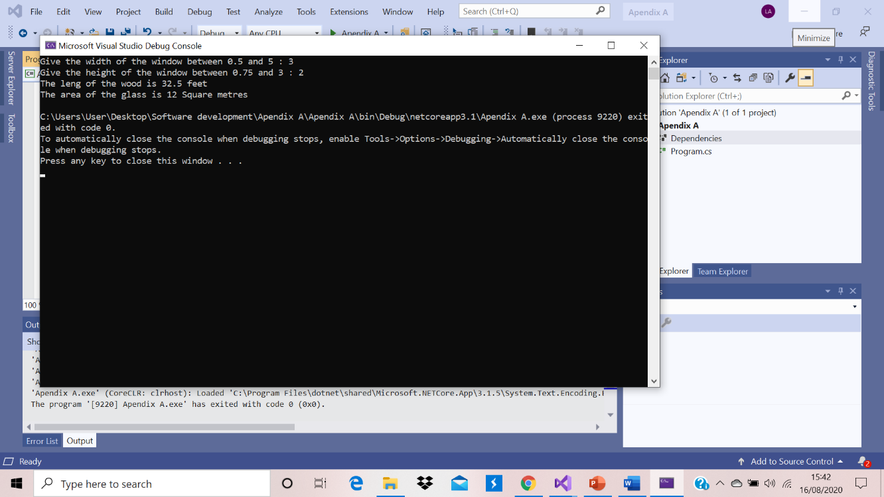
Return type
“The return type of a function establishes the size and type of the value returned by the function and corresponds to the type-specifier in the syntax. The type-specificator can specify any form of fundamental, structure, or union. If the type-specifier is not used, then the return form int is assumed.

The return type given in the function definition must match the return type elsewhere in the programme's function declarations. A function returns a value when executing a return statement which contains an expression. If necessary, the expression is evaluated, converted to the type of return value and returned to the point at which the function was called. When a function is declared with return type void a alert is created by a return statement containing an expression and the expression is not evaluated.
Syntax
unction-definition:
declaration-specifiersopt attribute-seqopt declarator declaration-listopt compound-statement

/* attribute-seq is Microsoft-specific */

declaration-specifiers:
storage-class-specifier declaration-specifiersopt
type-specifier declaration-specifiersopt
type-qualifier declaration-specifiersopt

type-specifier:
void
char
short
int
__int8 /* Microsoft-specific */
__int16 /* Microsoft-specific */
__int32 /* Microsoft-specific */
__int64 /* Microsoft-specific */
long
float
double
signed
unsigned
struct-or-union-specifier
enum-specifier
typedef-name” (docs.microsoft.com, 11/04/2016)
Return explanation in Appendix A
In our example the return function is to check the condition while (width < MIN_WIDTH || width > MAX_WIDTH), then
In secund do while case return is while (height < MIN_HEIGHT || height > MAX_HEIGHT).
The examples defines width type with double declaration and defines the function double to has width return type. The method selects one of its two structure statements, and returns it. The compiler checks for width of the argument types in subsequent calls to the function.
And other one defines height type as a double declaration and defines the function double to has height return type. The function select and returns one of its two structure arguments. The compiler checks for height of the argument types in subsequent calls to the function.

Part C Implementation:
Exercise 1:

using System;
using System.Collections.Generic;
using System.ComponentModel.DataAnnotations.Schema;
using System.Linq;
using System.Runtime.Intrinsics.X86;
using System.Text;

public class Exercise12
{

static void Main(string[] args)
{
if (per >= 50)
//Declarate subjects and theier marks

string nm, div;
string studentName = " ";
double per;
double COT = 0.0;
double AES = 0.0;
double IE = 0.0;
double total = 0.0;
double yourMark = 0.0;
int totalMarks = 200;

// On a new line calculate marks of three subjects

Console.Write("\n\n");
Console.Write("Calculate the total, percentage and division to take marks of three subjects:\n");
Console.Write("-------------------------------------------------------------------------------");
Console.Write("\n\n");

// Allow to the user to entray their name
Console.WriteLine("Please enter the student name: " + studentName);
nm = Console.ReadLine();

//Allow to the user to input their marks and convert them to intiger
Console.WriteLine("Input the marks of a AES: ");
AES = Convert.ToInt32(Console.ReadLine());
Console.WriteLine("Input a marks of a COT: ");
COT = Convert.ToInt32(Console.ReadLine());
Console.WriteLine("Input the marks of a IE: ");
IE = Convert.ToInt32(Console.ReadLine());
per = Convert.ToDouble(totalMarks);
yourMark = Convert.ToDouble(totalMarks);

//then calculate their total marks
Console.WriteLine("This is your total marks:" + totalMarks);

// formula to calculate the averge marks and condition for output
total = COT + AES + IE;
per = total / 3.0;
div = "First";
else
if (per < 50 && per >= 40)
div = "Second";
else
if (per < 40 && per >= 30)
div = "Pass";
else
div = "Fail";

//Implementation/Answers

Console.Write("\nName of Student : {1}\n", AES, nm);
Console.Write("Marks in AES : {0}\nMarks in IE : {1}\nMarks in COT : {2}\n", COT, IE, AES);
Console.Write("Total Marks = {0}\nPercentage = {1}\nDivision = {2}\n", total, per, div);

}
}

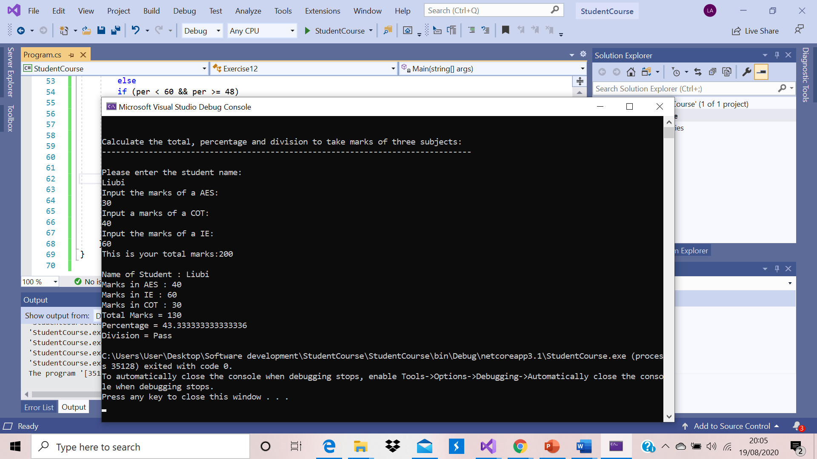

Flowchart:
Static void main
(string[]args)

Start

//Declarate subjects and theier marks

string nm, div;
string studentName = " ";
double per;
double COT = 0.0;
double AES = 0.0;
double IE = 0.0;
double total = 0.0;
double yourMark = 0.0;
int totalMarks = 200;

// On a new line calculate marks of three subjects

Console.Write("\n\n");
Console.Write("Calculate the total, percentage and division to take marks of three subjects:\n");
Console.Write("-------------------------------------------------------------------------------");
Console.Write("\n\n");

// Allow to the user to entray their name
Console.WriteLine("Please enter the student name: " + studentName);
nm = Console.ReadLine();

//Allow to the user to input their marks and convert them to intiger
Console.WriteLine("Input the marks of a AES: ");
AES = Convert.ToInt32(Console.ReadLine());
Console.WriteLine("Input a marks of a COT: ");
COT = Convert.ToInt32(Console.ReadLine());
Console.WriteLine("Input the marks of a IE: ");
IE = Convert.ToInt32(Console.ReadLine());
per = Convert.ToDouble(totalMarks);
yourMark = Convert.ToDouble(totalMarks);

//then calculate their total marks
Console.WriteLine("This is your total marks:" + totalMarks);

// formula to calculate the averge marks and condition for output
total = COT + AES + IE;
per = total / 3.0;

if (per >= 50)
div = "First";
else
if (per < 50 && per >= 40)
div = "Second";
else
if (per < 40 && per >= 30)
div = "Pass";
else
div = "Fail";

checking
Condition

Exercise 2:
//Implementation/Answers

Console.Write("\nName of Student : {1}\n", AES, nm);
Console.Write("Marks in AES : {0}\nMarks in IE : {1}\nMarks in COT : {2}\n", COT, IE, AES);
Console.Write("Total Marks = {0}\nPercentage = {1}\nDivision = {2}\n", total, per, div);
End
using System;

namespace CircleCalc
{
class Program
{
public class circle
{
//Pi is constant
//double radius and double area are variables
public static double PI = 3.142;
private double radius = 0.0;
private double area = 0.0;

//Constructor
public circle()
{
radius = 2.0;
}// end constructor

// There is two methods one to get Radius
public void setRadius(double newValue)
{
Console.WriteLine("setRadius: " + radius);
radius = newValue;
}//End setRadius

//Method to return the radius

public double getRadius()
{
return radius;
}//End getRadius

public double calcArea()
{
area = radius * radius * PI;
return area;
}//End calcArea

}// Class Circle

static void Main(string[] args)
{
string valueEntered = " ";
double enteredRadius;

// Instances of classes are created using the new operator,
//which allocates memory for a new instance, invokes a constructor
//to initialize the instance, and returns a reference to the instance.
//We store the reference information in two variables

circle c = new circle();
circle c2 = new circle();

// Alow from the user to set a radius and then the program will convert and implement the result
//getRadius is Returning radius

Console.WriteLine("Radius is: " + c.getRadius());
Console.WriteLine("Please enter a value for the radius:");
valueEntered = Console.ReadLine();
enteredRadius = Convert.ToDouble(valueEntered);

c.setRadius(enteredRadius);
Console.WriteLine("New Radius: " + c.getRadius());

Console.WriteLine("Area: " + c.calcArea());

Console.WriteLine("Radius for c2 is: " + c2.getRadius());

Console.WriteLine("Please enter a value for the radius:");
valueEntered = Console.ReadLine();
enteredRadius = Convert.ToDouble(valueEntered);
c2.setRadius(enteredRadius);

Console.WriteLine("Area: " + c2.calcArea());
}

}

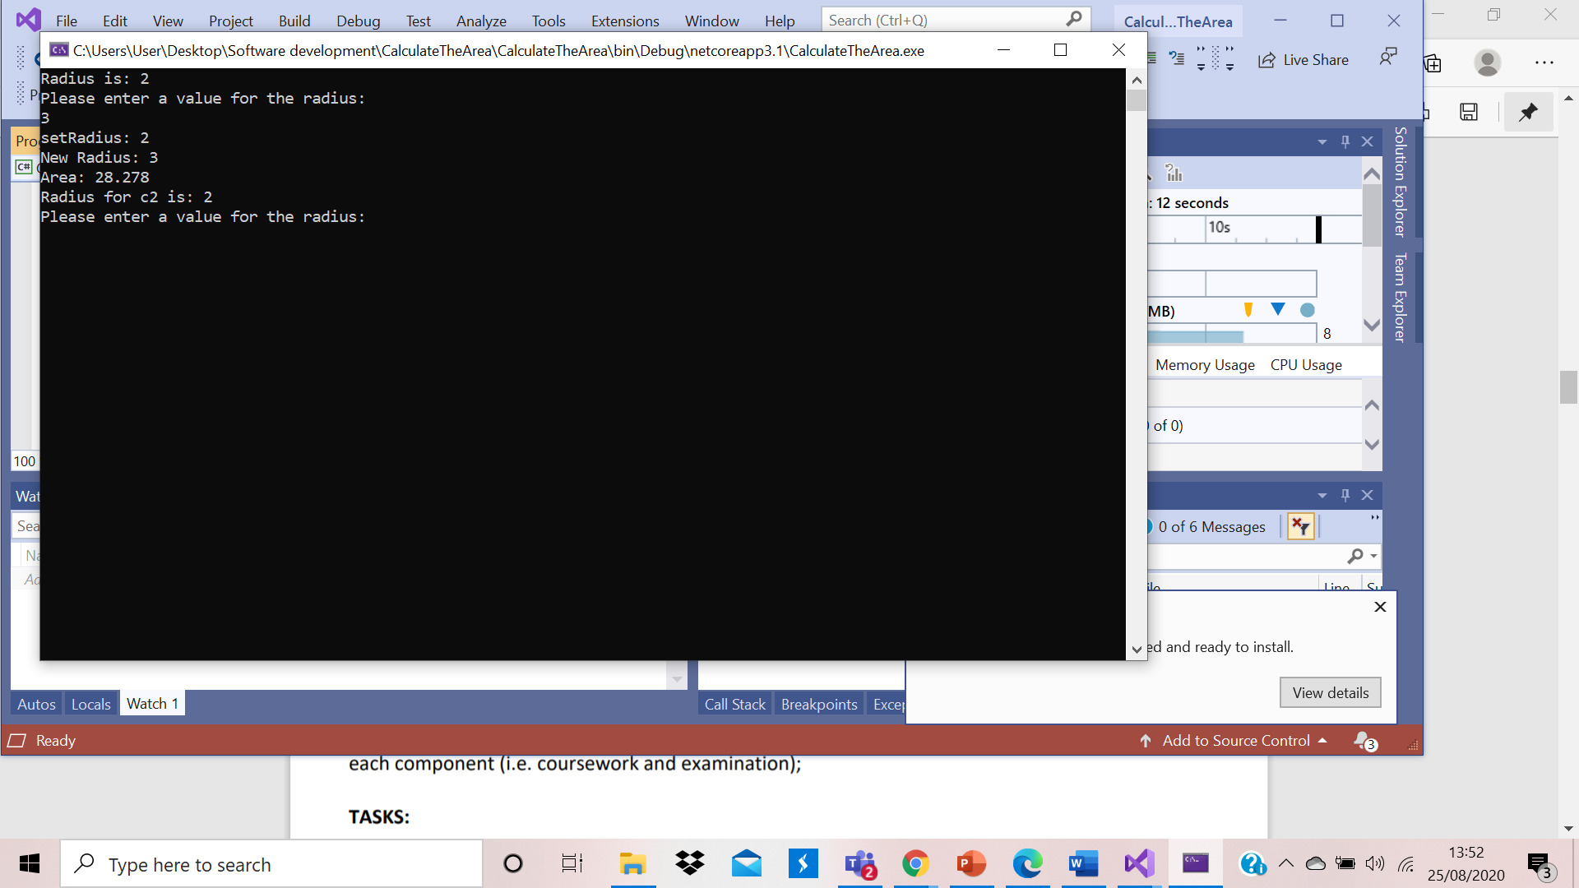
Flowchart:
Start
public circle()

Class programme
Read: public static double PI = 3.142;
private double radius = 0.0;
private double area = 0.0;

Second method is to get the value of radius:
public double getRadius()

First method is to set the value of radius:
public void setRadius(double newValue)
{
Console.WriteLine("setRadius: " + radius);
radius = newValue;

Console.WriteLine("Radius is: " + c.getRadius());
Console.WriteLine("Please enter a value for the radius:");
valueEntered = Console.ReadLine();
enteredRadius = Convert.ToDouble(valueEntered);

c.setRadius(enteredRadius);
Console.WriteLine("New Radius: " + c.getRadius());

Console.WriteLine("Area: " + c.calcArea());

Console.WriteLine("Radius for c2 is: " + c2.getRadius());

Console.WriteLine("Please enter a value for the radius:");
valueEntered = Console.ReadLine();
enteredRadius = Convert.ToDouble(valueEntered);
c2.setRadius(enteredRadius);

Data store:
circle c = new circle();
circle c2 = new circle();

static void Main(string[] args)
{
string valueEntered = " ";
double enteredRadius;

Return radius, public double calcArea()
{
area = radius * radius * PI;
return area;

Console.WriteLine("Area: " + c2.calcArea());

END

Exercise 3:

using System;
using System.Transactions;

namespace StudentCourseAndExamMarks

{
public class StudentCourseAndExam
{

//We tell the programme to start
static void Main(string[] args)
{
//we decleare data in data type and show where we will store the information
int m1, m2, m3, t;
float p;
string n;

//Allow the user enter his details

Console.WriteLine("Enter Student Name :");
n = Console.ReadLine();
Console.WriteLine("Mark of Subject1 : ");
m1 = Convert.ToInt32(Console.ReadLine());
Console.WriteLine("Mark of Subject2 : ");
m2 = Convert.ToInt32(Console.ReadLine());
Console.WriteLine("Mark of Subject3 : ");
m3 = Convert.ToInt32(Console.ReadLine());
//Using formula calculate the total and percentage
t = m1 + m2 + m3;
p = t / 3.0f;
Console.WriteLine("Total : " + t);
Console.WriteLine("Percentage : " + p);
//Check the condition
if (p < 40 && p > 0)
{
//Output if condition is true
Console.WriteLine("You are Fail");
}
if (p >= 40 && p < 50)
{
Console.WriteLine("You are third");
}
if (p >= 50 && p <= 60)
{
Console.WriteLine("You are Lower Secound");
}
if (p > 60 && p <= 80)
{
Console.WriteLine("You are upper secound");
}
if (p > 80 && p <= 100)
{
Console.WriteLine("You are first");
}
Console.ReadLine();
}
}
}
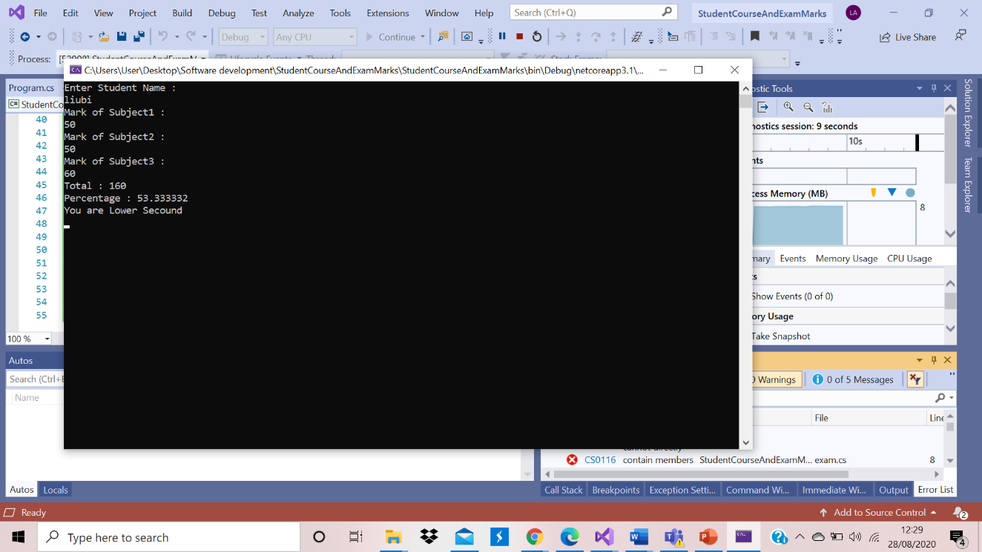

Flowchart:
static void Main(string[] args)

Start

Console.WriteLine("You are Fail");

t = m1 + m2 + m3;
p = t / 3.0f;
Console.WriteLine("Total : " + t);
Console.WriteLine("Percentage : " + p);

int m1, m2, m3, t;
float p;
string n;

Console.WriteLine("Enter Student Name :");
n = Console.ReadLine();
Console.WriteLine("Mark of Subject1 : ");
m1 = Convert.ToInt32(Console.ReadLine());
Console.WriteLine("Mark of Subject2 : ");
m2 = Convert.ToInt32(Console.ReadLine());
Console.WriteLine("Mark of Subject3 : ");
m3 = Convert.ToInt32(Console.ReadLine());

If (p < 40 && p > 0)

END
Console.WriteLine("You are first");
}
Console.ReadLine();

Console.WriteLine("You are upper secound");

Console.WriteLine("You are Lower Secound");

if (p > 80 && p <= 100)

if (p > 60 && p <= 80)
if (p >= 50 && p <= 60)

if (p >= 40 && p < 50)

Console.WriteLine("You are third");

Exercise 3

using System;

using System.Collections.Generic;

using System.Text;

using System.Runtime.InteropServices;

namespace CSMarkList

{

class CStudent

{

public string name;

public int[] marks = new int[5];

public int total;

}

class CStudents

{

public List<CStudent> m_studList = new List<CStudent>();

public int m_nMaxStudents;

public int AddRecord(string name, int[] marks)

{

CStudent stud = new CStudent();

stud.name = name;

stud.marks = marks;

stud.total = 0;

for (int i = 0; i < 5; i++)

stud.total += stud.marks[i];

m_studList.Add(stud);

m_nMaxStudents = m_studList.Count;

return 1;

}

}

class Program

{

static public CStudents theStudents = new CStudents();

static public void ViewRecords()

{

Console.WriteLine("_______________________________________________________________");

Console.WriteLine("SNo Student Name Sub1 Sub2 Sub3 Sub4 Sub5 Total");

Console.WriteLine("_______________________________________________________________");

for (int i = 0; i < theStudents.m_nMaxStudents; i++)

{

Console.Write("{0, -5}", i + 1);

Console.Write("{0, -19}", theStudents.m_studList[i].name);

Console.Write("{0, -7}", theStudents.m_studList[i].marks[0]);

Console.Write("{0, -7}", theStudents.m_studList[i].marks[1]);

Console.Write("{0, -7}", theStudents.m_studList[i].marks[2]);

Console.Write("{0, -7}", theStudents.m_studList[i].marks[3]);

Console.Write("{0, -7}", theStudents.m_studList[i].marks[4]);

Console.Write("{0, -7}", theStudents.m_studList[i].total);

Console.WriteLine();

}

Console.WriteLine("_______________________________________________________________");

}

static public void InputRecords()

{

Console.Write("Student Name: ");

string name;

int[] marks = new int[5];

name = Console.ReadLine();

for (int i = 1; i <= 5; i++)

{

Console.Write("Sub " + i.ToString() + " Mark: ");

marks[i - 1] = Convert.ToInt32(Console.ReadLine());

}

theStudents.AddRecord(name, marks);

}

static void Main(string[] args)

{

Console.WriteLine("Welcome to Student MarkList Application");

Console.Write("Enter the number of students: ");

int numStudents = -1;

string s = Console.ReadLine();

numStudents = Convert.ToInt32(s);

for (int i = 1; i <= numStudents; i++)

{

Console.WriteLine("\nEnter " + i.ToString() + " Student Information\n");

InputRecords();

}

ViewRecords();

char ch = Console.ReadKey().KeyChar;

}

}

}

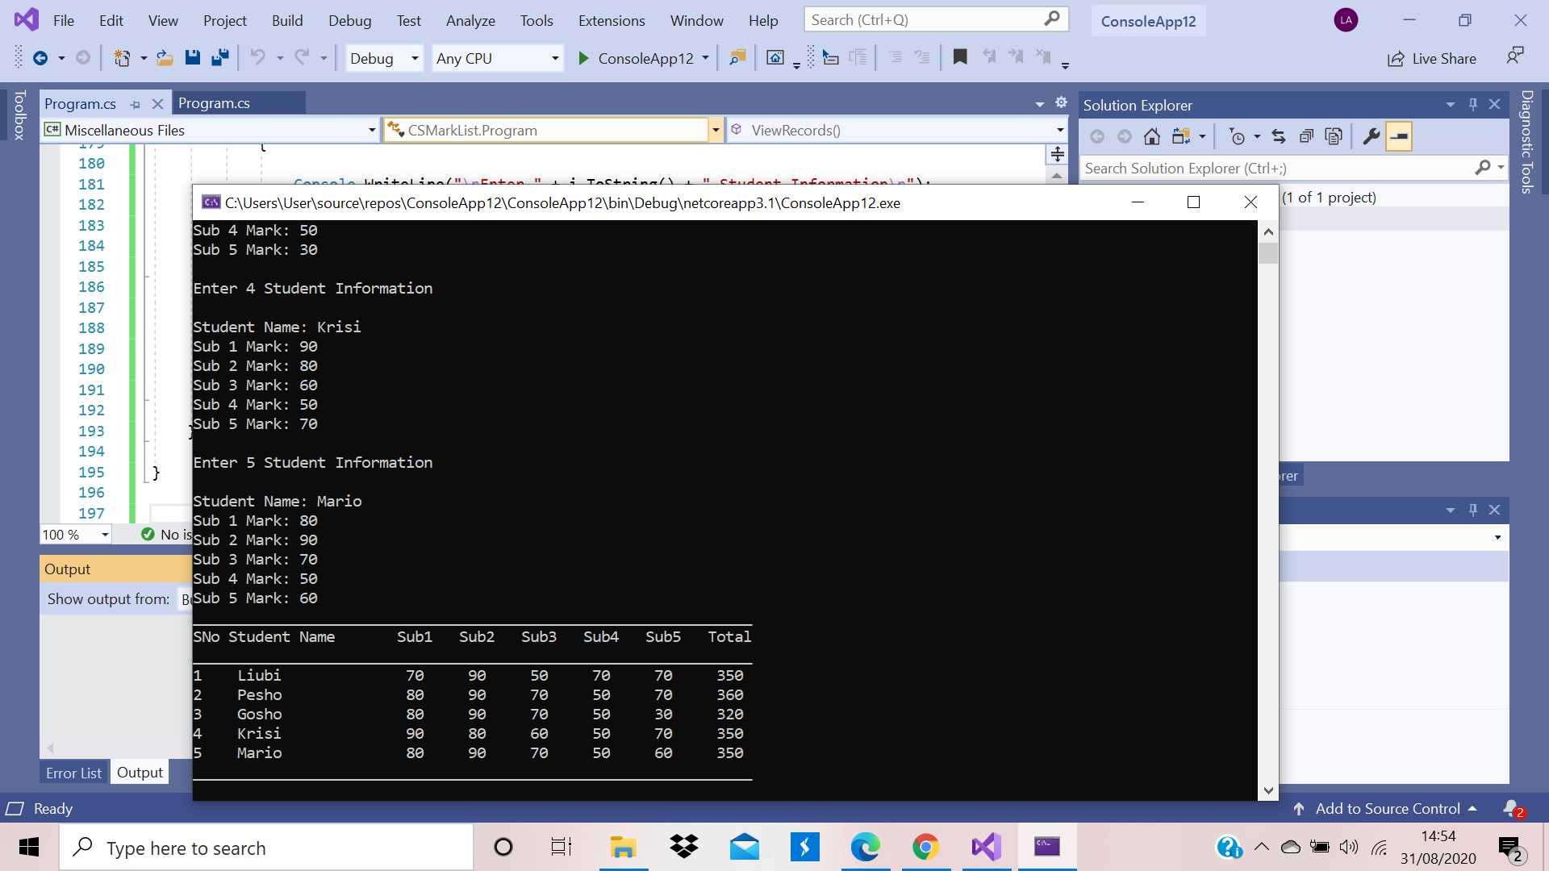

References
Anon., n.d. www.w3schools.com. [Online]
Available at: https://www.w3schools.com/
Break, 2015. docs.microsoft.com. [Online]
Available at: https://docs.microsoft.com/en-us/dotnet/csharp/language-reference/keywords/break
[Accessed 07 20 2015].
Co., S. N. &., 2013. Fundamentals of computer programming in C#. First ed. Sofia: The Bulgarian C# Programming Book.
Constants, V. a., 2016. www.techotopia.com. [Online]
Available at: https://www.techotopia.com/index.php/C_Sharp_Variables_and_Constants
[Accessed 27 10 2016].
guide, p., 2020. docs.microsoft.com. [Online]
Available at: https://docs.microsoft.com/en-us/dotnet/csharp/programming-guide/types/casting-and-type-conversions
[Accessed 06 07 2020].
loop, D. w., 2020. www.tutorialspoint.com. [Online]
Available at: https://www.tutorialspoint.com/cprogramming/c_do_while_loop.htm
Operators, 2019. www.geeksforgeeks.org. [Online]
Available at: https://www.geeksforgeeks.org/c-sharp-operators/
[Accessed 19 01 2019].
Scott Hanselman, K. H., 2019. channel9.msdn.com. [Online]
Available at: https://channel9.msdn.com/Series/CSharp-101?page=2
[Accessed 23 09 2019].
Structures, C., 2020. www.geeksforgeeks.org. [Online]
Available at: https://www.geeksforgeeks.org/control-structures-in-programming-languages/
[Accessed 16 01 2020].
Switch, 2019. docs.microsoft.com. [Online]
Available at: https://docs.microsoft.com/en-us/dotnet/csharp/language-reference/keywords/switch
[Accessed 04 09 2019].

References
Comments, C. B., 2020. www.w3resource.com. [Online]
Available at: https://www.w3resource.com/c-programming/c-basic.php
[Accessed 26 02 2020].

References
Co., S. N. &., 2013. Fundamentals of computer programming in C#,. First ed. Sofia: The Bulgarian C# Programming Book.

