University of Wales Trinity Saint David
School of engineering
Materials and introduction to manufacturing technologies
M4X01163
Lewis Millard (1903544)
Manufacturing process and material selection

Abstract

A demand for high performance crank arms used on racing bicycles like those seen in the Tour De France are high. This report details the functional requirements, raw materials and current production process that produce current high-performance bicycle crank arms. Secondly to this the report explores the ideas that an additive manufacturing process can create a different look on which current designs for crank arms appear. This process is called laser powder bed fusion (LPBF). This type of additive manufacturing process differs from others such as electron beam direct manufacture and laser directed energy deposition. LPBF deposits the metallic powder prior to production instead of being injected into the melting pool. The raw material that is used is a titanium powder because of the high stiffness and strength properties that are associated with this material. This process selection and material choice are explained in detail to outline their relationship to the functional requirements of the crank arm.

Contents
Abstract 2
Introduction 3
Discussion (task 1) 4
Discussion (task 2) 6
Conclusion 7
Works Cited 8
References 9

Introduction

High performance bicycles are currently being used by professions cycling teams in events such as the Tour De France. There has been a massive effort from these teams to create a design for their bike that is light, aerodynamic, user friendly and safe. In the first section of this report, the focus will be on the bicycle crank, its functional requirements, current production process and the materials used for production. In the second section of the report, the focus will be on how an additive manufacturing technique can be used to improve the crank and the benefits that would be gained with this new production technique.
A crank set or crank arms are connected by an axle that are mounted 180°C to each other. Pedals will then be attached to then ends of the crank arms so the rider can propel the bike in a forward motion. Crank arms can be made from various materials depending on which type of bike the customer demands. The expensive but low weight carbon fibre cranks are used for racing bikes, steel cranks are used for older and BMX bikes and aluminium cranks are used in the low to mid-priced ranged bicycles. The critical requirements when manufacturing a crank arm is to make sure it is tough, stiff, light and reasonably priced depending on which grade of bike is being produced. Some producers have even started to use hollow cranks by forging excess metal away.

Discussion (task 1)

It is critical for the that the design and material choice of the crank arms correlates to the requirements of the system and also requirements of the rider. The requirements of a racing bicycle crank arm are;
- Lightweight.
- High stiffness.
- Tailored length for rider’s optimum performance.
- Safety.
A lightweight crank arm is an important factor for a high-performance racing bike [1]. This is because the rider will use less energy when pushing down on the pedal and achieve a greater speed for a prolonged distance. Another important requirement is for the crank arm to have a high stiffness. This will allow the rider have an increased force on the pedal that will generate higher speeds on the rear wheel. It is also important to choose the length of a crank arm correctly as depending on what cycling event is being performed will need a different type of cycling cadence [2]. Cycling cadence is a term used for how many turns your wheel can spin in a minute. Pedalling at a high cadence means using a lower gear to pedal above 90mpm to the same power as when using a lower cadence (higher gear). As this crank arm design is for a Tour De France rider, the crank arm length will be shorter to aid a high cadence performance as the cyclist will be challenged with a mountainous route. Another critical requirement is safety. The crank arm must have a high strength to adhere to the stresses placed on it by the rider. If fatigue occurs the crank arm will snap without any warning which will cause harm to the rider [2]. Also, the use of filets on the crank arms edges are being used to stop cuts from sharp edges [3].
The factors for material selection of current crank arms are Youngs modulus, yield strength and density [4]. The material selection will be depending on what type of bike is needed. For a high-performance racing bike, the current materials in use are below;
- Carbon fibre
- Glass fibre reinforced plastic (GFRP).
- Aluminium & titanium alloys
Aluminium and steel are both highly stiff and strong but are heavy which is why they are only now used in older crank arms. Carbon fibre and glass fibre reinforced plastics are light and also have high stiffness and strength qualities [5]. Although not as strong as aluminium or titanium, GFRP has better overall performance due to the lower weight. In some instances, GFRP has had its mechanical properties increased by having titanium or aluminium inserts placed into the design [5].

There are three types of manufacturing routes currently being used to produce crank sets. Die casting is one method. Die casting involves the use of a furnace, metal die casting machine and die. The usual type of material that gets processed by die casting is non-ferrous. This is usually your aluminium crank arms etc. Two types of die casting machines are used. Hot chamber, which is used for materials with low melting temperatures. Cold chamber machines, which are used for aluminium that has a higher melting point. This is a process whereby pouring molten metal under high pressure into a mould cavity [6]. The molten material rapidly cools and solidifies into the part. Two steel dies have been machined into the shape of a crank arm which shapes the mould cavity.

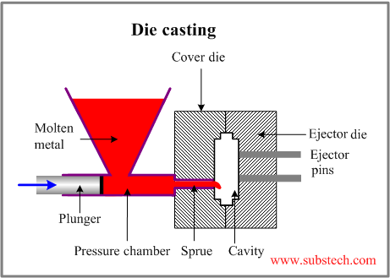
Figure 1
The second method is hot forging. Hot forging is where a metal is taken above the recrystalising temperature and then deformed via a stamping or crushing method and allowed to cool [7]. The last method is cold forging. Cold forging is similar to hot forging but it is completed by squeezing the metal between two dies at room temperature [8]. Many high-performance crank arm manufacturers prefer to use cold forging due to the advantages of surface quality and higher tensile strengths which is created during the press [2]. Other benefits of cold forging are that it doesn’t need further heat treatment which stop the risk of warping and shape degradation defects [9].

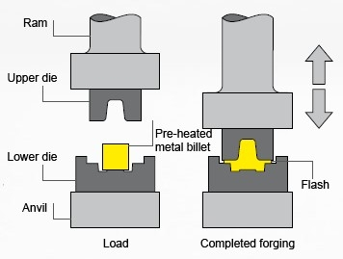
Figure 2

Discussion (task 2)

The additive manufacturing process that has been chosen to aid the performance of the crank arm is called laser powder bed fusion (LPBF). Laser power bed fusion is an additive manufacturing technique that creates are part on a layer by layer basis [5]. Laser powder bed fusion was created in Texas, America in the 1990’s. LPBF is growing exponentially in recent years due to the release of patents and companies exploring the technology. This type of additive manufacturing process differs from others such as electron beam direct manufacture and laser directed energy deposition. LPBF deposits the metallic powder prior to production instead of being injected into the melting pool. To get the part to a fully dense geometry, the heat source travels across the pre placed powder causing it to melt and then solidify. Once solidified, the build platform drops another step and a new layer of metallic powder is set up. This process repeats unit the part geometry is completed [5]. The build chamber is protected with a flow of gas, usually nitrogen or argon as they are inert. This will protect the part from oxidisation.
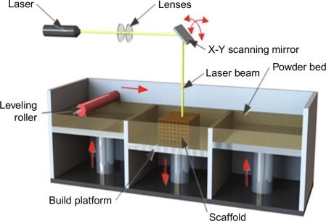
Figure 3
The mass of the crank arm is a major factor in the rider’s overall performance when riding a racing bicycle. Another major factor is the stiffness of the crank arm [2]. The higher the stiffness, the greater power transferred through the pedals to the rear wheel resulting in improved performance and energy efficiency. A large section of the research and development into decreasing the crank arms weight and increasing the stiffness has come by means of changing the raw material. Very little change has occurred in the geometry of the crank arm due to complex manufacturing processes [2]. Laser powder bed fusion additive manufacturing process will allow the chance to create a more complex geometry that will reduce the surface area thus reducing the mass of the crank arm. Using a metallic power such as titanium will give the design maximum strength and stiffness. Mower and long (2016) found that additive manufactured SLM AlSi10Mg and DMLS Ti6Al4V exhibited lower fatigue than machined common metals [10]. Therefore, the research promotes that additive manufacturing can improve the mechanical properties of a bicycle crank arm. The factors above will create a product that will achieve ultimate performance by increasing the mechanical properties and changing the geometry.
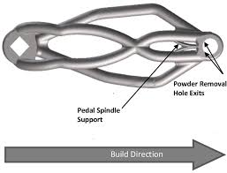
Figure 4
When undergoing the material selection process, it is critical that the material selected can correlate with the functional requirements of the design [4]. In the case of a crank arm, the material needs to have high strength and high stiffness with the lowest possible mass. The crank arm has to be strong so it can withstand the load of the rider pushing down on the pedals. The factors like youngs modulus, ultimate tensile strength and density are all parameters that can used to make sure the material is fit for purpose [4]. The material must be able to be processed by the additive manufacturing technique laser powder bed fusion. This is why titanium powder will be used to make this crank arm due to the factors listed above [5]. This material will enhance the rider’s performance due to its mechanical properties which has been explained previously.

Conclusion

In this document, prototype ideas have been discussed for a high-performance crank arm for racing bicycles like those seen in the Tour De France. Currently crank arms are produced from casting and forging methods and the materials selection will differ depending on the budget, aspirations and needs to the customer. If the customer needs a less expense and low efficient crank arm it will be made from aluminium or steel. If the customer needs a highly efficient crank arm and has a high budget the material will usually be a titanium alloying metal. Massive research and development have gone into the material choice and weight reduction but the geometry of the crank arm has never really changed. The reason why the geometry has stayed very similar is due to the limitations on the current production processes ability to produce complex shapes. This protype uses a different type of manufacturing process called laser powder bed fusion which is an additive manufacturing technique. This different production process allows to change the geometry of the crank arm whist keeping a low mass and high mechanical properties for ultimate performance. The raw material that will be used in the process is powdered titanium, this is due to titanium’s high strength and high stiffness properties.

Works Cited

[1] | A. Cantrell, “Bicycle Materials Case Study,” Bicycle Materials Case Study, pp. 1-4, 2003.
[2] | I. McEwen, D. Cooper, J. Warnett, N. Korra, M. Willaims and G. Gibbons, “Design And Manufacture of a High-Performance Bicycle Crank by Additive Manufacturing,” Applied Sciences, pp. 1-16, 2018.
[3] | P. Vairakanna and M. Chandran, “Design and material study of race bike crank,” Internation Journal of Engineering Sciences & Research Technologies, pp. 102-107, 2017.
[4] | M. Pfeifer, “Selecting Materials,” Material Enabled Designs, pp. 51-58, 2009.
[5] | J. Tong, C. Bowen, J. Persson and A. Plummer, “Mechanical properties of titanium-based Ti–6Al–4V alloys manufactured by powder bed additive manufacture,” Materials Science and Technology, pp. 138-148, 2016.
[6] | A. Stark, “Technologies: What is Die Casting?,” 9 April 2019. [Online]. Available: https://www.spotlightmetal.com/what-is-die-casting-development-processes-and-materials-in-die-casting-a-818604/.
[7] | SteelForging, “CFS Forge,” 23 May 2018. [Online]. Available: http://www.steelforging.org/hot-forging-process-and-its-applications/.
[8] | H. Quang-Cherng and L. Rong-Shean, “Cold forging process design based on the induction of analytical knowledge,” Journal Of Materials Processing Technology, pp. 264-272, 1997.
[9] | D. Earle, “PRAXIS,” 15 10 2018. [Online]. Available: https://praxiscycles.com/history-with-aluminum/. [Accessed 24 01 2020].
[10] | T. M. Mower and M. J. Long, “Mechanical behavior of additive manufactured, powder-bed laser-fused materials,” Material and Science Engineering: A, vol. 651, no. 2, pp. 198-213, 2016.

References

[1] | A. Cantrell, “Bicycle Materials Case Study,” Bicycle Materials Case Study, pp. 1-4, 2003.
[2] | I. McEwen, D. Cooper, J. Warnett, N. Korra, M. Willaims and G. Gibbons, “Design And Manufacture of a High-Performance Bicycle Crank by Additive Manufacturing,” Applied Sciences, pp. 1-16, 2018.
[3] | P. Vairakanna and M. Chandran, “Design and material study of race bike crank,” Internation Journal of Engineering Sciences & Research Technologies, pp. 102-107, 2017.
[4] | M. Pfeifer, “Selecting Materials,” Material Enabled Designs, pp. 51-58, 2009.
[5] | J. Tong, C. Bowen, J. Persson and A. Plummer, “Mechanical properties of titanium-based Ti–6Al–4V alloys manufactured by powder bed additive manufacture,” Materials Science and Technology, pp. 138-148, 2016.
[6] | A. Stark, “Technologies: What is Die Casting?,” 9 April 2019. [Online]. Available: https://www.spotlightmetal.com/what-is-die-casting-development-processes-and-materials-in-die-casting-a-818604/.
[7] | SteelForging, “CFS Forge,” 23 May 2018. [Online]. Available: http://www.steelforging.org/hot-forging-process-and-its-applications/.
[8] | H. Quang-Cherng and L. Rong-Shean, “Cold forging process design based on the induction of analytical knowledge,” Journal Of Materials Processing Technology, pp. 264-272, 1997.
[9] | D. Earle, “PRAXIS,” 15 10 2018. [Online]. Available: https://praxiscycles.com/history-with-aluminum/. [Accessed 24 01 2020].
[10] | T. M. Mower and M. J. Long, “Mechanical behavior of additive manufactured, powder-bed laser-fused materials,” Material and Science Engineering: A, vol. 651, no. 2, pp. 198-213, 2016.

