

APPENDIX GA36c

LEVEL 6 ASSESSMENT SPECIFICATION

Student name: | Jared Wilkinson | Student ID number: | 237488
Programme: | BSc Applied Computing
Module: | Big Data
Module code: |  | Contribution to Overall Module Assessment (%): | 50%
Lecturer: | John Williams | Internal Verifier: | Jeanette Adams
Assignment Title: | Big Data Report | Word count (or equivalent): | 3000
Submission deadline: | 19/04/2019 | Return date of provisional marks & written feedback: | 26/04/2019
Submission method: | All written assessments, where practical and possible, must be submitted via Turnitin unless otherwise instructed by the Lecturer. (Please DO NOT put this assessment specification into Turnitin or it will match many similarities with other students’ submissions.)  Alternative submission method (if applicable):  Late submission of the assessment will result in a late penalty mark. Penalties for late submission: Up to one week late, maximum mark of 40%. Over one week late, 0%. Only the Extenuating Circumstances Panel may approve a change to submission dates.
Academic honesty / referencing: | Academic honesty is required. In the main body of your submission you must give credit to authors on whose research and ideas your work is based. Append to your submission a reference list that indicates the books, articles, etc. that you have used, cited or quoted in order to complete this assessment.

Module Learning Outcomes
(from module syllabus)
1. Critically discuss the concepts behind, sources of and problems related to Big Data
2. Design, build and professionally document a small data warehouse suitable for use with Big Data
3. Perform data analysis and reporting on complex data within a Big-Data data warehouse
4. Demonstrate a creative use of appropriate data mining and data visualisation techniques within a Big Data context.

TASK DESCRIPTION

Design and produce professional-standard reports based upon the Skewen News Big-Data data warehouse using appropriate tools and techniques. Select and apply appropriate data mining processes to Big Data within a given problem domain and produce effective visualisations of the results.
Skewen News, are a local news provider. News articles are posted on the company's news feed. Their USP is that they have a local bias, and concentrate mainly on local interest stories whilst still reporting on some major national and international stories. The data provided is an indicative sample of the type of data collected by Skewen news.
Using this data you should do the following:
- Design and develop an appropriate data warehouse structure to store the data provided.
- You should justify all of your design decisions.
- Upload the data into your data warehouse, documenting the ETL process in a professional manner.

Design, develop and critically evaluate reports that can be run to retrieve and display the
Following data:
- All stories on a user-defined topic
- All stories within a user-defined geographical area
- A timeline showing the development of a complex story over a period of at least a week
- Stories that are related to a user-defined story by location, content or other features.’

The reports should be appropriately referenced and should include the appropriate tables of contents, tables of figures and tables of tables. Any figures should have titles and identification labels. The document should also be spellchecked and grammar-checked.
The report should be submitted via Turnitin.

GUIDANCE FOR Students IN THE COMPLETION OF TASKS

NOTE: The guidance offered below is linked to the five generic assessment criteria overleaf.

- Engagement with Literature Skills
Your work must be informed and supported by scholarly material that is relevant to and focused on the task(s) set; you should make use of scholarly reviews and primary sources, where appropriate (for example, refereed research articles and/or original materials appropriate to the discipline). You should provide evidence that you have accessed a wide range of sources, which may be academic, governmental and industrial; these sources may include academic journal articles, textbooks, current news articles, organisational documents, and websites. You should consider the credibility of your sources; academic journals are normally highly credible sources while websites require careful consideration/selection and should be used sparingly. Any sources you use should be current and up-to-date, mostly published within the last five years or so, though seminal/important works in the field may be older. You must provide evidence of your research/own reading throughout your work, using a suitable referencing system, including in-text citations in the main body of your work and a reference list at the end of your work.

Guidance specific to this assessment:

- Knowledge and Understanding Skills
At level 6, you should be able to demonstrate coherent and detailed knowledge and a systematic understanding of the subject area, at least some of which is informed by the latest research and/or advanced scholarship within the discipline. You should be aware of the uncertainty, ambiguity and limits of knowledge. Your work must demonstrate the growing extent of your knowledge and systematic understanding of concepts and underlying principles associated with the subject area. Knowledge relates to the facts, information and skills you have acquired through your learning. You demonstrate your understanding by interpreting the meaning of the facts and information (knowledge). This means that you need to select and include in your work the concepts, techniques, models, theories, etc. appropriate to the task(s) set. You should be able to explain the theories, concepts, etc. meaningfully to show your understanding. Your mark/grade will also depend upon the extent to which you demonstrate your knowledge and understanding; ideally each should be complete and detailed, with comprehensive coverage.

Guidance specific to this assessment:

You will need to demonstrate detailed knowledge and understanding of the design and development strategies employed when building a data warehouse.

- Cognitive and Intellectual Skills
You should be able to: critically evaluate evidence, arguments, assumptions, abstract concepts and data some of which are at the forefront of a discipline (and that may be incomplete) to devise and sustain arguments, to make judgements and/or solve problems; describe and comment upon particular aspects of current research, or equivalent advanced scholarship, in the discipline Your work must contain evidence of logical, analytical thinking, evaluation and synthesis. For example, to examine and break information down into parts, make inferences, compile, compare and contrast information. This means not just describing what! But also justifying: Why? How? When? Who? Where? At what cost? At all times, you must provide justification for your arguments and judgements. Evidence that you have reflected upon the ideas of others within the subject area is crucial to you providing a reasoned and informed debate within your work. Furthermore, you should provide evidence that you are able to make sound judgements and convincing arguments using data and concepts. Sound, valid conclusions are necessary and must be derived from the content of your work. Where relevant, alternative solutions and recommendations may be proposed.

Guidance specific to this assessment:

- Practical Skills
At level 6, you should be able to apply the methods and techniques that you have learned to review, consolidate, extend and apply your knowledge and understanding, and to initiate and carry out projects. You will deploy accurately established techniques of analysis and enquiry relevant to the discipline, and apply them in complex and unpredictable contexts, to devise and sustain arguments and/or to solve problems. You should be able to frame appropriate questions to achieve a solution - or identify a range of solutions. You should be able to demonstrate how the subject-related concepts and ideas relate to real world situations and/or a particular context. How do they work in practice? You will deploy models, methods, techniques, and/or theories, in that context or circumstances, to assess current situations, perhaps to formulate plans or solutions to solve problems, or to create artefacts, some of which may be innovative and creative. This is likely to involve, for instance, the use of real world artefacts, examples and cases, the application of a model within an organisation and/or benchmarking one theory or organisation against others based on stated criteria. You should show awareness of the limitations of concepts and theories when applied in particular contexts.

Guidance specific to this assessment:
You should build your data warehouse using an appropriate large database platform such as Oracle. You will need to demonstrate advanced DDL and DML skills in order to effect the ETL process. You will deploy complex SQL queries to extract data to generate reports, data mining analysis and visualisation techniques.

- Transferable Skills for Life and Professional Practice
Your work must provide evidence of the qualities and transferable skills necessary for graduate-level employment requiring the exercise of initiative and personal responsibility and decision-making in complex and unpredictable circumstances. This includes demonstrating: the learning ability for professional development to advance existing skills and acquire new competences of a professional nature that will enable you to assume significant responsibility within organisations; that you can initiate and complete tasks and procedures, whether individually and/or collaboratively; that you can use appropriate media to effectively communicate information, arguments and analysis in a variety of forms to specialist and non-specialist audiences; fluency of expression; clarity and effectiveness in presentation and organisation. Work should be coherent and well-structured in presentation and organisation.

Guidance specific to this assessment:

Student FEEDBACK FORM

This section details the extent to which the assessment criteria are demonstrated by you, which in turn determines your mark. The marks available for each category of skill are shown. Lecturers will use the space provided to comment on the achievement of the task(s), including those areas in which you have performed well and areas that would benefit from development/improvement.

Generic Assessment Criteria | Marks available | Marks  awarded
1. Engagement with Literature Skills  . | 0
2. Knowledge and Understanding Skills | 10 | 7
Excellent coherent and detailed knowledge and systematic understanding of the principles and theories of current research and scholarship. Clear awareness of challenges to established views and the limitations of the knowledge base.
3. Cognitive and Intellectual Skills | 20 | 15
Excellent critical thinking, analysis, synthesis and evaluation. Ability to investigate contradictory or incomplete information and make strong, persuasive, arguments and judgements. Some evidence of independent thought and ability to ‘see beyond the question’, suggesting a grasp of the broader field and wider concepts.
4. Practical Application Skills | 60 | 45
An advanced application of a range of methods, materials, tools and techniques. The context of the application is well considered, and insightful. Can identify complex problems and propose excellent solutions. Innovation and creativity evident.
5. Transferable Skills for Life and Professional Practice | 10 | 8
Can communicate professionally confidently and consistently in a suitable format.
Work is coherent, very fluent and is presented professionally. Demonstrates excellent graduate employment skills and an appetite for further development.

Assessment Mark (Assessment marks are subject to ratification at the Exam Board. These comments and marks are to give feedback on module work and are for guidance only until they are confirmed. ) | Late Submission Penalties (tick if appropriate) |  | 75%
 | Up to 1 week late (40% Max) |  | 75%
 | Over 1 week late (0%) |  | 75%

Contents
Introduction 11
Determining Business Objectives 11
Collecting and Analysing Information 11
Constructing a Data Model 11
Proposed Data Warehouse Schema (DWS) 12
Data Warehouse Entity Relationship Diagram 13
Data Definition 14
ETL: Data Transition Processes: 23
Creating the Data Warehouse 32
Extracting the Data 32
Creating the Dimension Tables 36
Creating the Fact Table 37
Querying the Fact Table 38
Importing the Data Warehouse 40
Querying the Data Warehouse 42
Creating an Application 47
Conclusion 48

Introduction

This report will be looking into the various steps and processes that will be used in order to create a data warehouse for a local news provider called Skewen News and will involve several different steps. First, the objectives for the data warehouse will be outlined. The processes that the data warehouse needs to perform will then be drawn up. Then, the data that is required for the data warehouse will be gathered and transformed. At the end of the report, a conclusion will be made to summarise what has been done in the report and what has been found as a result of creating the data warehouse.

Determining Business Objectives

The data warehouse will be created for Skewen News, a small local news provider. Their unique selling point is that they mainly focus on local news stories although they occasionally report on national and international stories. They want a data warehouse that will enable them to have a greater understanding of their data as well as what they can do with it. They want a system that will allow them to see:
- All stories on a user-defined topic
- All stories within a user-defined geographical area
- A timeline showing the development of a complex story over a period of at least a week
- Stories that are related to a user-defined story by location, content or other features.

Collecting and Analysing Information

In order to be able to create a data warehouse, it is necessary to gather data from appropriate data sources. This data will usually be present in systems used by the client. Skewen News has provided data for use in the data warehouse in the form of an Access database containing news information and an Excel spreadsheet containing journalist information.

Constructing a Data Model

The next step in creating a data warehouse was to construct a data model. The data model will consist of a single large fact table and several smaller dimension tables that are related to the fact table. The dimension tables will each consist of two fields including an ID and a field containing data. The fact table will contain all of the ID’s from the dimension tables as foreign keys. The dimension tables then need to be related to the fact table and any errors or missing data will need to be fixed before this can be done. One important point to mention is that the primary key in the fact table is in fact a composite key created from a foreign key of each dimension table.

Proposed Data Warehouse Schema (DWS)

Fact Table: FactNews (FactID#, TimeID#, ReporterID#, TopicID#, LinkID#, StoryID#, Title, Date)

Dimension Table: Dimdate (DateID#, Date)
Dimension Table: Dimreporters(ReporterID#, Reporter)
Dimension Table: Dimtopics(TopicID#, Topic)
Dimension Table: Dimlocation(LocationID#, Location)
Dimension Table: Dimstory(StoryID#, Story)
Dimension Table: Dimtitle(TitleID#, Title)
Dimension Table: Dimtime(TimeID#, Time)
Dimension Table: Dimlink (LinkID#, Link-REF)

Data Warehouse Entity Relationship Diagram

This entity relationship diagram shows how the Skewen News data warehouse will be structured. This shows the main Fact table as well as all of the tables that are related to it. This includes reporter, title, topic, location, story, time and data tables.

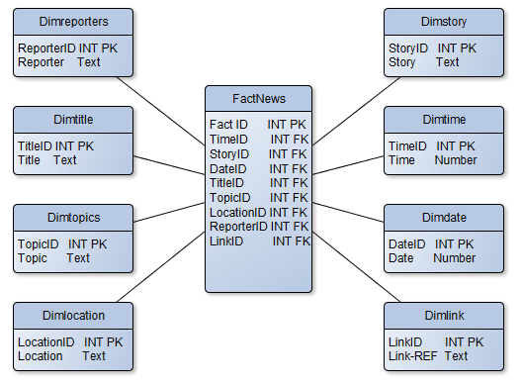

Data Definition
Application Name  Data Source Name  Primary Key |  | Skewen News Data Warehouse  FactNews  ReporterID#
Connection | Details |  |  |  | Comments
Database Location  Database Platform  Dataset  SQL  Access Method | http://10.100.96.100:8080/apex  Oracle  FactNews  Select * from FactNews  Select |  |  |  | Fact Table
File Name | Type |  | Size | Format |  | Description | Validation | Key
FactID# | AutoNumber |  | Integer | # |  | Primary Key | Must be Unique | P
TimeID# | AutoNumber |  | Integer | # |  | Foreign Key | Must be Unique | F
StoryID# | AutoNumber |  | Integer | # |  | Foreign Key | Must be Unique | F
TitleID# | AutoNumber |  | Integer | # |  | Foreign Key | Must be Unique | F
TopicID# | AutoNumber |  | Integer | # |  | Foreign Key | Must be Unique | F
LocationID# | AutoNumber |  | Integer | # |  | Foreign Key | Must be Unique | F
ReporterID# | AutoNumber |  | Integer | # |  | Foreign Key | Must be Unique | F
LinkID# | AutoNumber |  | Integer | # |  | Foreign Key | Must be Unique | F
DateID# | AutoNumber |  | Integer | # |  | Foreign Key | Must be Unique | F

Data Definition

The diagrams below will show the data definitions for the fact table and each of the dimension tables. This will show the different fields, the type, size, format and whether or not they are primary or foreign keys.
Data Definition
Application Name  Data Source Name  Primary Key |  | Skewen News Data Warehouse  Reporters  ReporterID#
Connection | Details |  |  |  | Comments
Database Location  Database Platform  Dataset  SQL  Access Method | http://10.100.96.100:8080/apex  Oracle  Dimreporters  Select * from Dimreporters  Select |  |  |  | Reporter Dimension
File Name | Type |  | Size | Format |  | Description | Validation | Key
ReporterID# | AutoNumber |  | Integer | # |  | Primary Key | Must be Unique | P
Reporter | Text |  | 20

Data Definition
Application Name  Data Source Name  Primary Key |  | Skewen News Data Warehouse  Title  TitleID#
Connection | Details |  |  |  | Comments
Database Location  Database Platform  Dataset  SQL  Access Method | http://10.100.96.100:8080/apex  Oracle  Dimtitle  Select * from Dimtitle  Select |  |  |  | Title Dimension
File Name | Type |  | Size | Format |  | Description | Validation | Key
TitleID# | AutoNumber |  | Integer | # |  | Primary Key | Must be Unique | P
Title | Text |  | 20

Data Definition
Application Name  Data Source Name  Primary Key |  | Skewen News Data Warehouse  Topics  TopicID#
Connection | Details |  |  |  | Comments
Database Location  Database Platform  Dataset  SQL  Access Method | http://10.100.96.100:8080/apex  Oracle  Dimtopics  Select * from Dimreporters  Select |  |  |  | Topic Dimension
File Name | Type |  | Size | Format |  | Description | Validation | Key
ReporterID# | AutoNumber |  | Integer | # |  | Primary Key | Must be Unique | P
Reporter | Text |  | 20

Data Definition
Application Name  Data Source Name  Primary Key |  | Skewen News Data Warehouse  Location  LocationID#
Connection | Details |  |  |  | Comments
Database Location  Database Platform  Dataset  SQL  Access Method | http://10.100.96.100:8080/apex  Oracle  Dimlocation  Select * from Dimlocation  Select |  |  |  | Location Dimension
File Name | Type |  | Size | Format |  | Description | Validation | Key
LocationID# | AutoNumber |  | Integer | # |  | Primary Key | Must be Unique | P
Location | Text |  | 20

Data Definition
Application Name  Data Source Name  Primary Key |  | Skewen News Data Warehouse  Story  StoryID#
Connection | Details |  |  |  | Comments
Database Location  Database Platform  Dataset  SQL  Access Method | http://10.100.96.100:8080/apex  Oracle  Dimstory  Select * from Dimstory  Select |  |  |  | Story Dimension
File Name | Type |  | Size | Format |  | Description | Validation | Key
StoryID# | AutoNumber |  | Integer | # |  | Primary Key | Must be Unique | P
Story | Text |  | 20

Data Definition
Application Name  Data Source Name  Primary Key |  | Skewen News Data Warehouse  Time  TimeID#
Connection | Details |  |  |  | Comments
Database Location  Database Platform  Dataset  SQL  Access Method | http://10.100.96.100:8080/apex  Oracle  Dimtime  Select * from Dimtime  Select |  |  |  | Time Dimension
File Name | Type |  | Size | Format |  | Description | Validation | Key
TimeID# | AutoNumber |  | Integer | # |  | Primary Key | Must be Unique | P
Time | Text |  | 20

Data Definition
Application Name  Data Source Name  Primary Key |  | Skewen News Data Warehouse  Date  DateID#
Connection | Details |  |  |  | Comments
Database Location  Database Platform  Dataset  SQL  Access Method | http://10.100.96.100:8080/apex  Oracle  Dimdate  Select * from Dimdate  Select |  |  |  | Date Dimension
File Name | Type |  | Size | Format |  | Description | Validation | Key
DateID# | AutoNumber |  | Integer | # |  | Primary Key | Must be Unique | P
Date | Text |  | 20

Data Definition
Application Name  Data Source Name  Primary Key |  | Skewen News Data Warehouse  Links  LinkID#
Connection | Details |  |  |  | Comments
Database Location  Database Platform  Dataset  SQL  Access Method | http://10.100.96.100:8080/apex  Oracle  Dimlink  Select * from Dimlink  Select |  |  |  | Reporter Dimension
File Name | Type |  | Size | Format |  | Description | Validation | Key
LinkID# | AutoNumber |  | Integer | # |  | Primary Key | Must be Unique | P
Link | Text |  | 20

ETL: Data Transition Processes:

Before creating the fact table, it was necessary to extract the data from the various data sources that were provided by Skewen News. This would involve identifying its origins as well as the methods that would be used to extract the data. This will also show the process that was used to transform the data into a uniformed state and then to import it into the data warehouse. The first step in creating the dimension tables was to extract the necessary data into temporary tables with a FactID. These tables would then be turned into the dimension tables by replacing the FactID with a new ID and grouping the data together to avoid duplication of data.

Dimension: Date

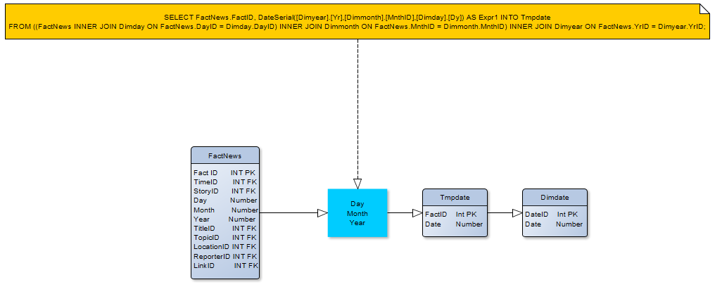
As the Fact Table was initially created using separate day, month and year fields, it was necessary to join them together into a single data field. This involved gathering the FactID, the Day, the Month and the Year from the Fact table. The dimension table that was created with this would later be inserted into the fact table instead of the separate day, month and year fields.

Dimension: Reporters

The Tmpreporters table made use of the FactID and the Reporters field from the RouiterData table.

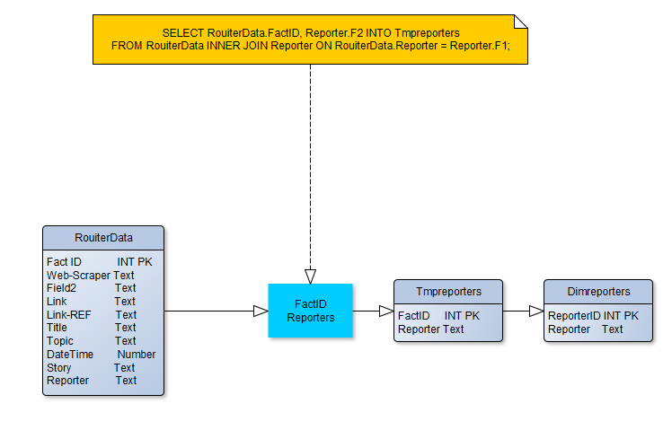

Dimension: Topics

The Tmtopics table made use of the FactID and the Topic field from the RouiterData table.

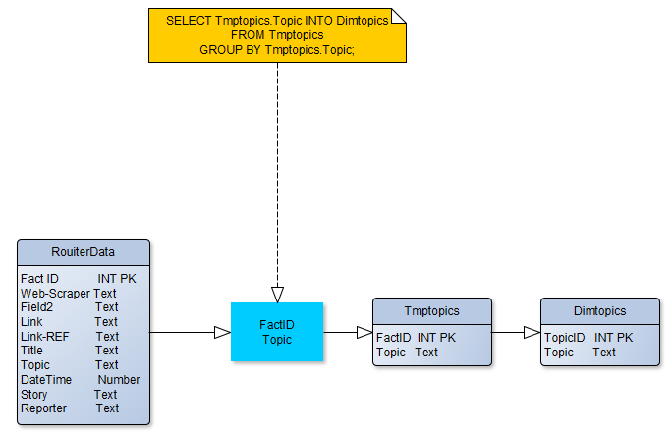

Dimension: Location

The Tmplocation table made use of the FactID and the Location field from the RouiterData table.

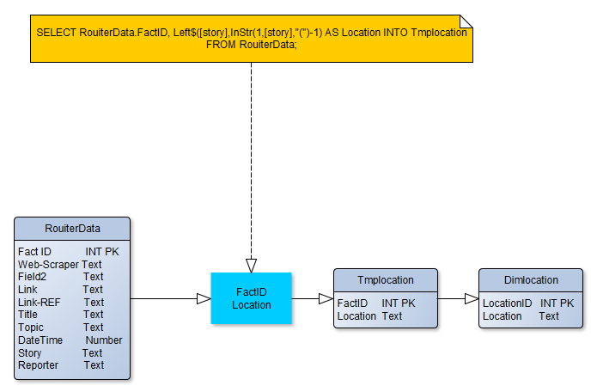
Dimension: Story

The Tmpstory table made use of the FactID and the Story field from the RouiterData table.

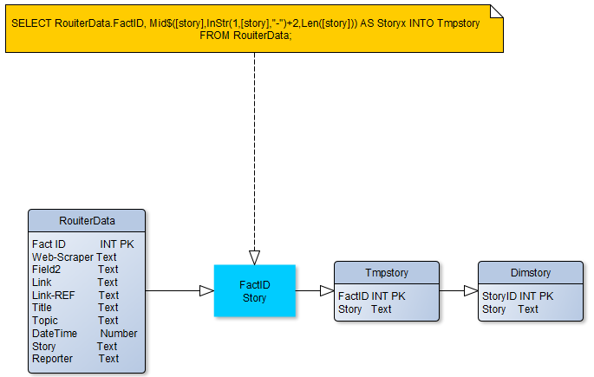
Dimension: Title

The Tmptitle table made use of the FactID and the Title field from the RouiterData table.

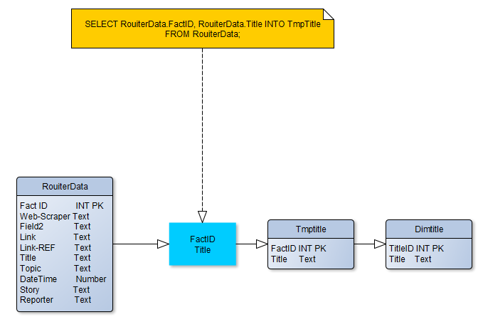

Dimension: Time

The Tmptime table made use of the FactID and the DateTime field from the RouiterData table. The query was used to extract the times from the DateTime field and to place them into their own field.

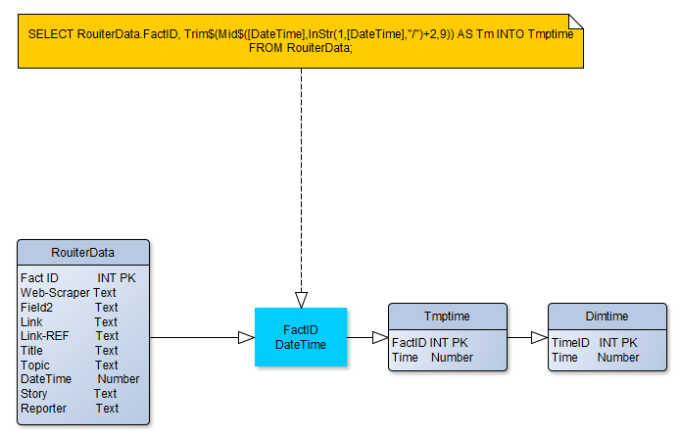

Dimension: Link

The Tmplink table made use of the FactID and the Link-REF field from the RouiterData table.

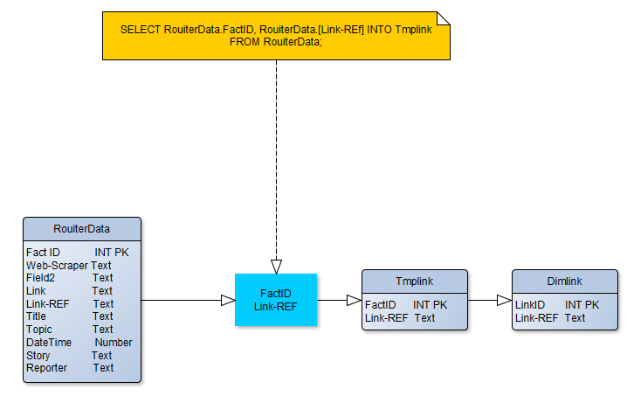

Fact Table

The Fact Table contains all of the IDs from the dimension tables as well as the FactID from the RouiterData table.
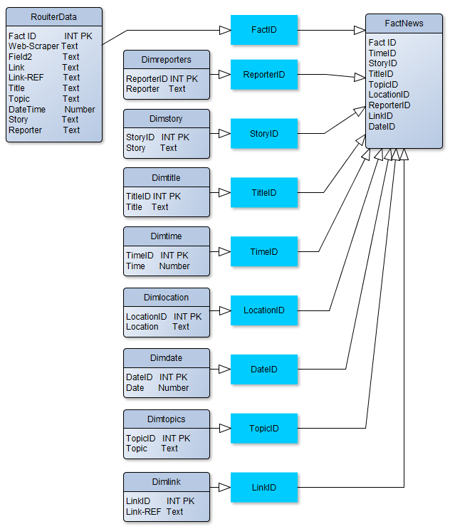
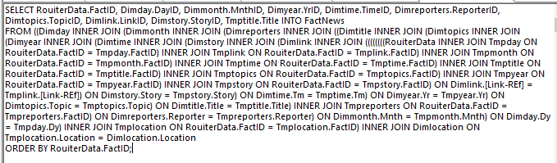

Creating the Data Warehouse

The first few steps in creating the data warehouse involved using Microsoft Access. This was used to extract the data from the necessary data sources and transform the data. This data would then be used to create the fact table and the dimension tables. Several queries would also be made in Access to show what Skewen News wants to see. This work carried out in Access was done in preparation for creating the data warehouse in Oracle as all of the tables and queries made using Access would then be imported into Oracle.

Extracting the Data

Before the data could be transformed, it was necessary to extract the data from the various data sources that had been provided by the client. This included the News Access database as well as the Reporters Excel spreadsheet.
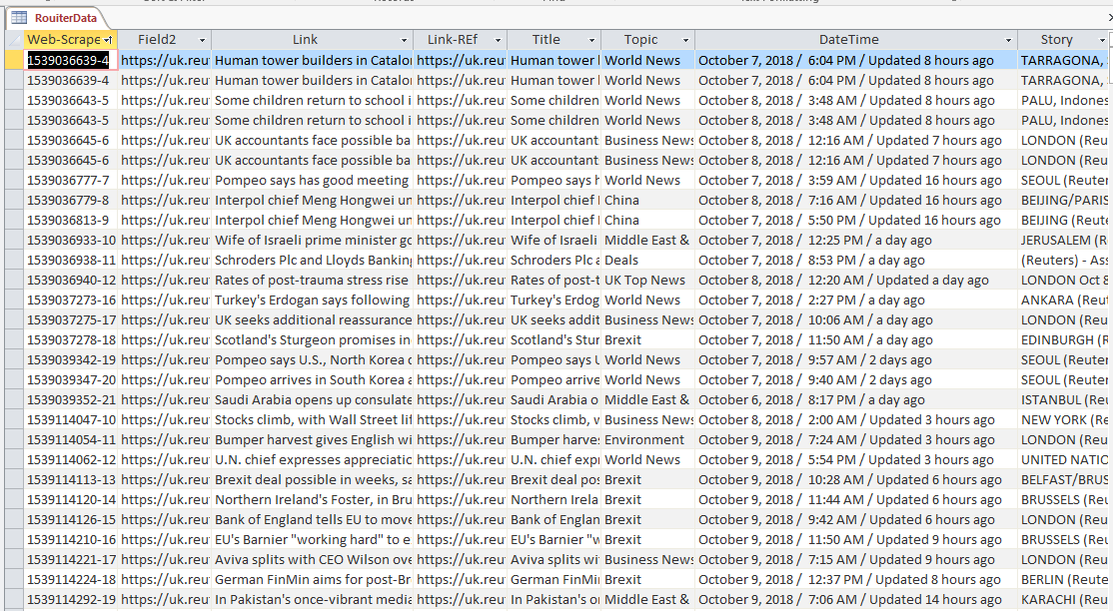

The RouiterData and the Reporters tables were taken from the News database and placed into their own database.

Make Tmp Title
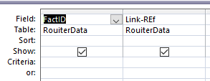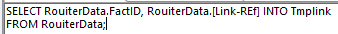

Make Tmp Link
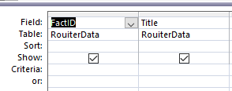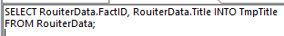

Make Tmp Topics
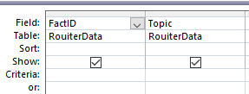 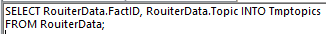#

The three queries shown above simply involved extracting the FactID and a particular field from the RouiterData table.

Make Tmp Year
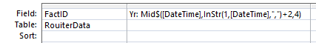

Make Tmp Month
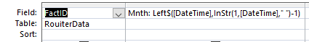

Make Tmp Day
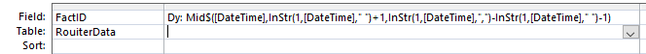

Make Tmp Time
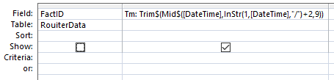

The four queries shown above were more complex and involved extracting particular pieces of data from the DateTime field in the RouiterData table which were days, months years and the time. The day, month and year data would later be joined back together in a data field which would end up replacing those separate tables in the fact table.

Make Tmp Date
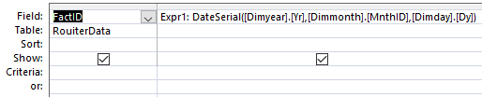
Make Tmp Reporters

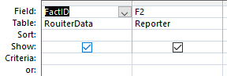

This query involved extracting the RouiterData FactID as well as the reporter names from the Reporters table.

Make Tmp Location
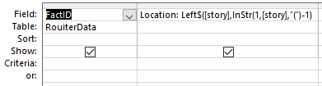

Make Tmp Story
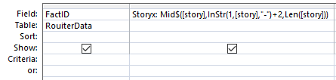

The two queries shown above involved extracting different pieces of data from the Story field in the RouiterData table.

Creating the Dimension Tables

Once the temporary tables were created, it was necessary to create dimension tables. This would involve removing the FactID from each of the temporary tables and creating a new ID for each table. The data would also be grouped to avoid any duplication of data.

Make Tmp Location
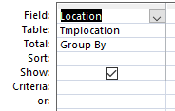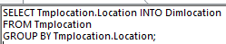

As can be seen, the dimension table is essentially the temporary table without the FactID. The data has also been grouped to avoid duplication of data. Once each table had been created, a new ID was added to those tables.

The location dimension table required some additional steps as there were several gaps in the data. If left alone, this would result in missing records in the fact table. This was solved by entering NULL into those black records. Also, at the end of each location name, there was a space. If left alone, this would cause problems later when trying to create queries that were based around locations. This was solved by simply removing those spaces.

Creating the Fact Table

Once the dimension tables had been created, it was then necessary to create a fact table. This would consist of the FactID from the RouiterData table as well as all of the IDs from each of the dimension tables.

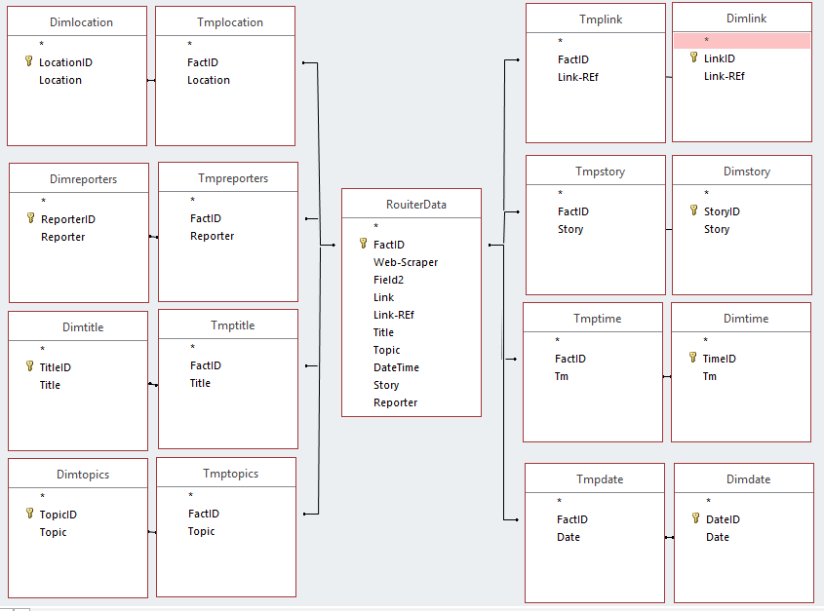

As can be seen, in order to create the fact table, the Tmp tables are linked back to the RouiterData table through the FactID and each of the dimension tables are linked back to the Tmp tables through the second fields in each of those tables.

Querying the Fact Table

One of the requirements of the data warehouse is that Skewen News is able to extract and display data based on their needs. This was achieved with several queries.

FactQuery1

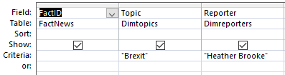

The first query was created to filter the data based on a particular topic and a particular reporter.

FactQuery2

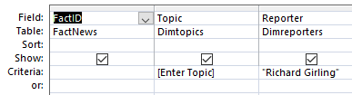

The second query was similar to the first as it filters the data by reporter however it allows the user to search for stories by topic, making it user defined.

FactQuery3

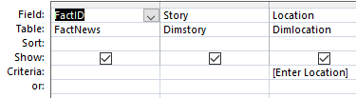

The third query is another user defined query as it allows a user to search for stories by location.

FactQuery4

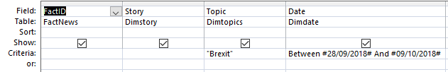

The fourth query shows all of the stories related to Brexit between two dates.

FactQuery5

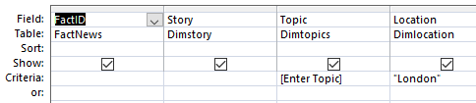

The final query that was created shows all of the stories originating from London and allows the user to search for stories by a particular topic.

Importing the Data Warehouse

At this point, all of the work that needed to be done in access was complete. The next step was to import all of the tables into Oracle. This was done by exporting the tables as text files and then uploading those text files into Oracle.

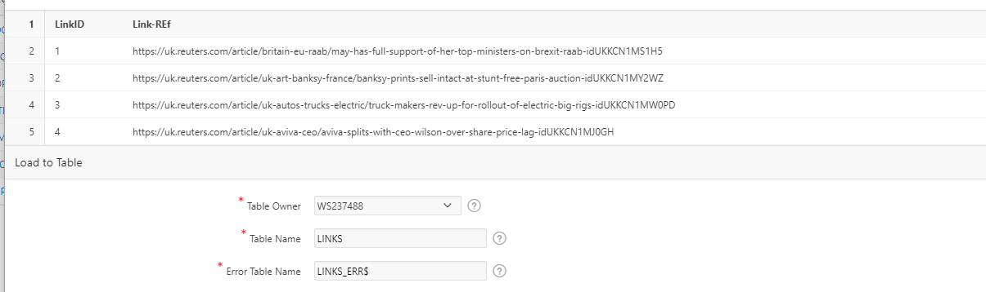
This is how the data appears when being imported.

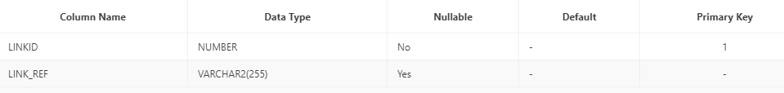
When importing each text file into Oracle, a new ID was created that replaced the existing ID that was created in Access. Once each table was created, the ID was dropped and the existing ID was made a primary key. When the fact table was uploaded, it was necessary to also specify all of the other fields as foreign keys so that they would relate back to the primary keys in the dimension tables.

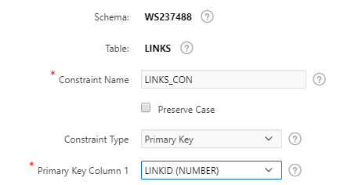

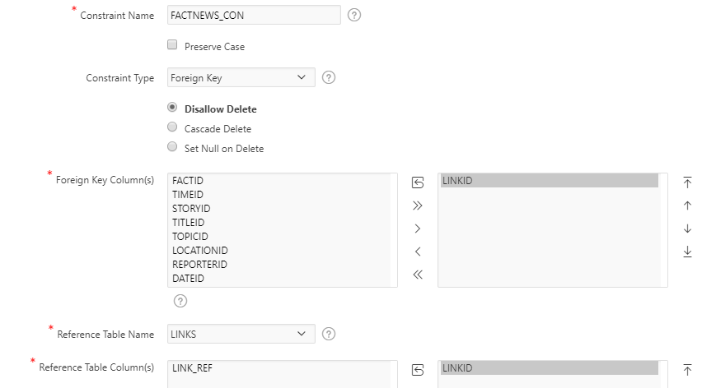

Querying the Data Warehouse

As before in Access, queries were created to extract particular pieces of data from the data warehouse and show the client different aspects of the data. These queries would show the same things as those created in Access. As stated above, several queries needed to be created that would show:
- All stories on a user-defined topic
- All stories within a user-defined geographical area
- A timeline showing the development of a complex story over a period of at least a week
- Stories that are related to a user-defined story by location, content or other features.

FactQuery1

The first query was created to show news stories on a particular topic that were also written by a particular topic. As a result, all of the stories related to Brexit that were written by Heather Brooke were shown.

SQL

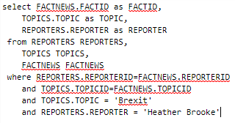

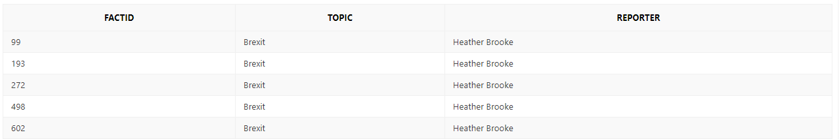
Results

FactQuery2

The second query was similar to the first query in that it looks for stories from a particular reporter. However, it allows a user to search for stories by a particular topic.

SQL

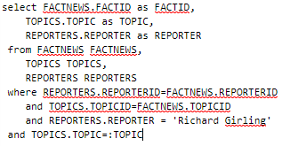

Results
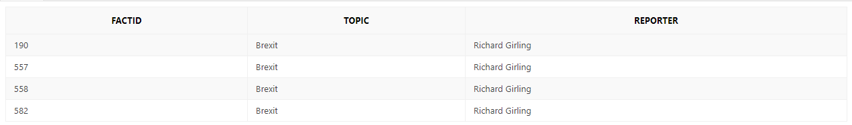
FactQuery3

The third query allows a user to search for stories from a particular location.

SQL

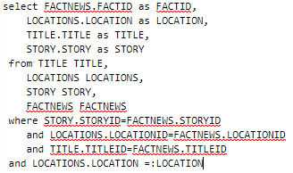

Results
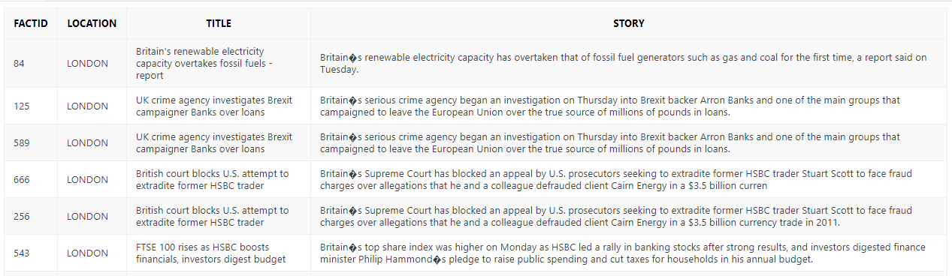
FactQuery4

The fourth query was created to show stories belonging to a particular topic between two dates. This would show Skewen News how particular stories can develop over a period of time.

SQL

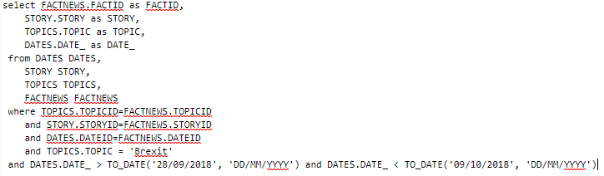

Results
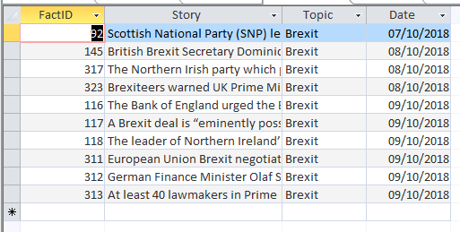
FactQuery5

The fifth query was created to show user defined stories from a particular location.

SQL

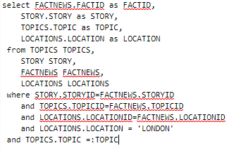

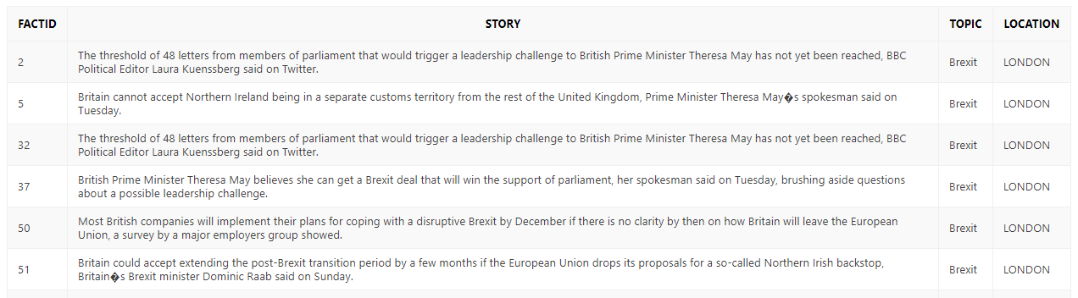
Results

Creating an Application

Once the tables had been imported and the queries had been created, it was then necessary to create an application. This would be used to create a report that would show the data in a visual way. The application was created by using the App Builder in Oracle. Once the application had been created, a report was created that would show the number of Brexit storied from each location. This report would be displayed as a pie chart.

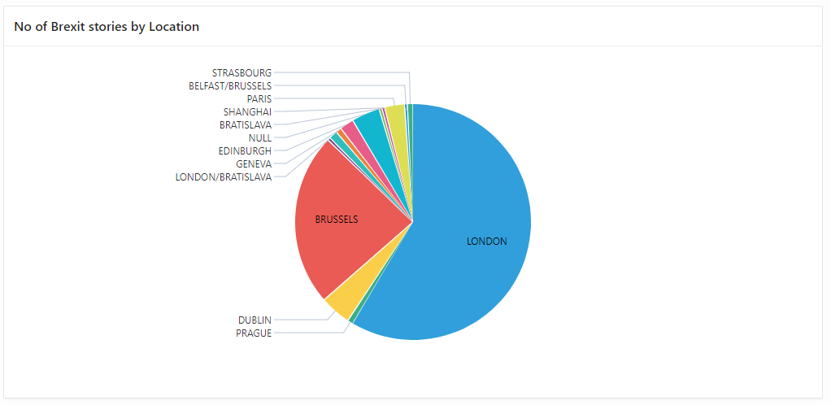

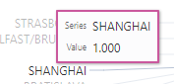
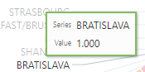
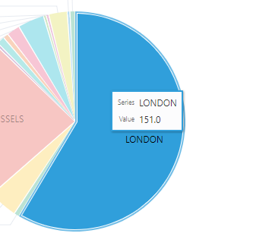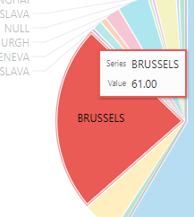

As can be seen from the chart, the majority of Brexit stories have come from London with 151 stories. The second largest amount of stories have come from Brussels with 61 stories with the lowest amounts coming from Shanghai and Bratislava with just 1 story each. This report will therefore give Skewen News an understanding of what topics are more prevalent in particular areas.

Conclusion

To conclude, it is clear that a lot can be gained from Skewen News using a data warehouse as it will enable them to gain a greater understanding of the data that they have. They will therefore be able to use this knowledge to help them make better decisions in the future and to gain an advantage over their competitors.

