Learning in the Digital Era Assignment 1
Student Number:2003948
Student Name: Ashleigh Simons

Contents
Page 3 – E-Portfolio Link
Page 4 – Written Summary Link
Page 5 – Mind Map Link
Page 6 – Video Presentation Link
Page 7 – Academic Poster Link
Page 8, 9, 10 – Collaborative Working Evidence

To use any of the links please press them whilst using the Ctrl key on your keyboard OR Copy the link and paste it into an internet browser and search.

Below is the link to access my E – Portfolio:
https://sites.google.com/view/learning-digital-era-a1/home

(All the other links can be found on the E-Portfolio. However, if they cannot be accessed or the E-Portfolio itself cannot be accessed, you can use the links within this document.)

Below is the link to access my Written Summary:
https://drive.google.com/file/d/1pqlkPgelNA8t6s7EcpzWZDUYvxtX7ODy/view?usp=sharing

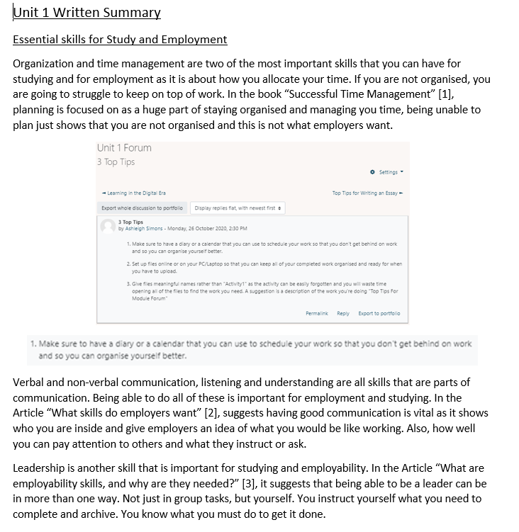

Below is the link to access my Mind Map:
https://mm.tt/1707920955?t=5leSRNa4QZ

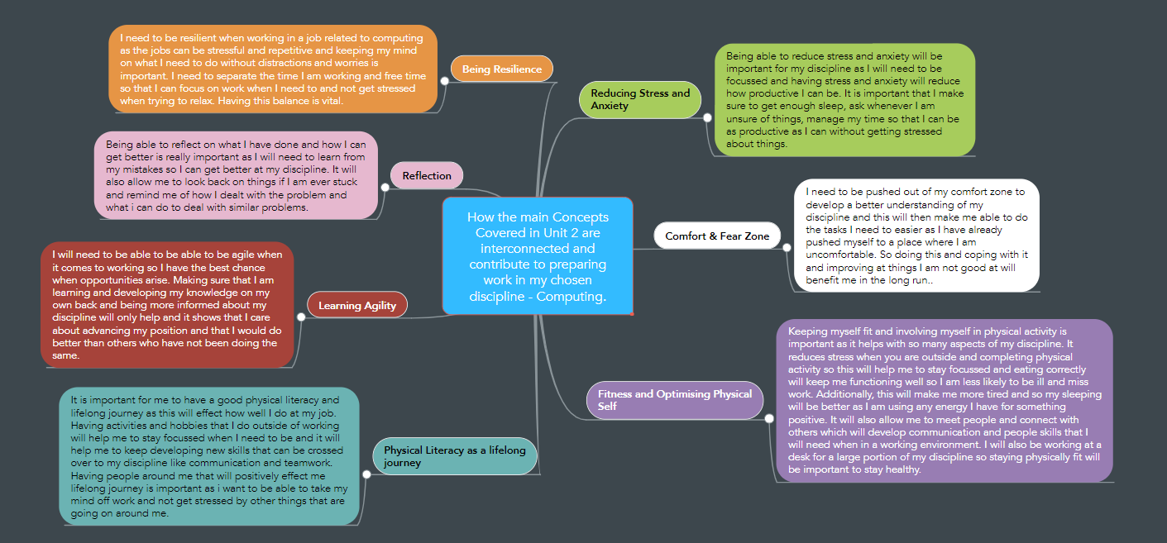

Below is the link to access my Video Presentation:
https://spark.adobe.com/video/Fjs8xATRqOCfI

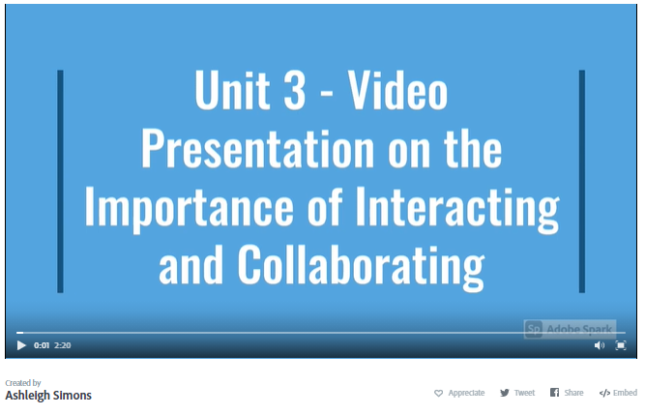

Below is the link to access my Academic Poster:
https://drive.google.com/file/d/14Gy8iBYHxiCD8FeQ1Awfui1o8VA0ODb4/view?usp=sharing

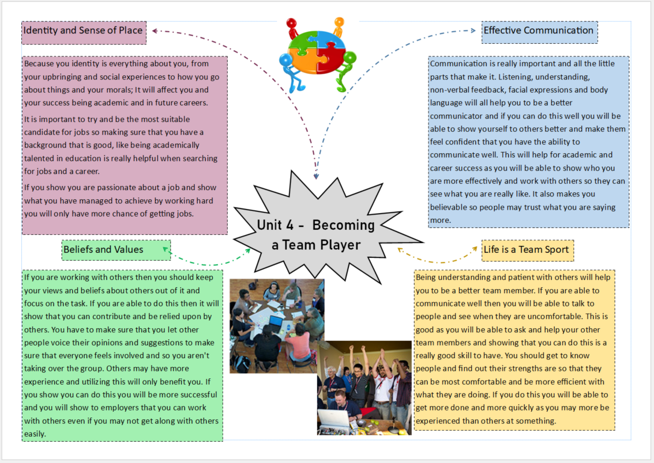
Below is the link to access my Collaborative Evidence:
https://docs.google.com/document/d/15SxohMqG45evviwCm0kdtJnWBuVw1DF-0H9LummGaYU/edit?usp=sharing



